Titre de votre article

Auteur(s)

Abstract

1 Introduction

2 Methods

A questionnaire was developed as a data collection strategy. Students from several high schools were invited to participate in the study. 493 students from 4 high schools participated in this study (Tables 1 and 2 )

School 1`ere 2nd Term TermP Total

Craponne 24 0 23 21 68 Diderot 25 0 63 0 88 Pasquet 48 41 27 0 116 Victor Hugo 101 92 28 0 221

Total 198 133 141 21 493

Table 1: Number of Survey Participants by High School

Note: N = 246 used for EFA + N = 247 used for CFA = 493 Total

Femmes Hommes Nombre % Nombre %

Total 274 55.6 219 44.4 1`ere 113 41.2 85 38.8 2nd 77 28.1 56 25.6 Terminale 73 26.6 68 31.1 Terminale Pro 11 4.0 10 4.6

Table 2: Distribution of Responses by Gender and Education Level

The questionnaire comprised two sections. The first section, concerning the quality of a course, contained 23 questions, and the second section, on physical literacy, contained 27 questions. Participants were asked to respond to these questions using a positive 5-point Likert scale (i.e., strongly disagree = 1, disagree = 2, neither agree nor disagree = 3, agree = 4, and strongly agree = 5). The aim was to confirm the models and then understand the relationships between the quality of a physical education course and its impact on physical literacy.

2.1 Exploratory and Confirmatory Factor Analysis

Exploratory Factor Analysis (EFA) is used to identify the underlying structure of a set of observed variables. In this study, EFA was applied to determine the number of factors necessary to explain the observed variance in the data.

2.1.1 Identification of the Number of Factors

To identify the number of factors, several criteria were used, including the examination of eigenvalues (Kaiser criterion) and the scree plot. These methods allow for determining an optimal number of factors by considering the model’s parsimony and the explained variance.

1

2.1.2 Item Selection

Once the number of factors was identified, we proceeded to select items based on their factor loadings. The following criteria were applied:

• Absence of Cross-Loadings: Items with significant loadings (> 0.30) on multiple factors were excluded to avoid ambiguity.

• Minimum Number of Items per Factor: We ensured that each factor included at least four items to guarantee the stability and reliability of the identified factors.

2.1.3 Item Elimination Procedure

The elimination of items was conducted iteratively:

1. Initially, all items were included in the model.

2. Items with high cross-loadings were identified.

3. Items with lower factor loadings (< 0.40) were examined carefully. However, to maintain an adequate number of items per factor (four items per factor in our case), we decided to defer any final decisions on item elimination to the Confirmatory Factor Analysis (CFA). Specifically, in cases of indecision between multiple items, we plan to evaluate the lowest factor loading during the CFA before proceeding with their elimination.

4. Problematic items were successively removed, ensuring that each factor retained at least four items after each iteration.

5. The model was re-evaluated after each elimination to verify the coherence of the remaining factors.

2.1.4 Model Validation

Once the items were selected and the factors identified, indices such as RMSEA, SRMR, CFI, and TLI were examined to ensure a good model fit.

2.2 Confirmatory Factor Analysis (CFA)

Confirmatory Factor Analysis (CFA) is used to test the hypothetical factor structure identified from Exploratory Factor Analysis (EFA). In this study, CFA was applied to confirm the factor structure and refine the model by eliminating non-relevant items.

2.2.1 Model Specification

We will examine the initially specified model for the LESSON and IMPACT sections.

2.2.2 Initial Model Evaluation

Initial model evaluation was performed using several fit indices, including:

• RMSEA (Root Mean Square Error of Approximation)

• SRMR (Standardized Root Mean Residual)

• CFI (Comparative Fit Index)

• TLI (Tucker-Lewis Index)

These indices assess the model’s adequacy to the observed data.

2.2.3 Item Selection and Elimination

To improve the model, an iterative item elimination procedure was implemented. The following criteria were applied:

• Low Factor Loadings: Items with the lowest factor loadings were identified for elimination.

• Minimum Number of Items per Factor: Each factor needed to retain at least four items after elimination.

2

2.2.4 Item Elimination Procedure

The procedure proceeded as follows:

1. The initial model was evaluated to identify items with the lowest factor loadings.

2. Problematic items were eliminated one by one, ensuring each factor retained at least four items after each elimination.

3. After each elimination, the model was re-evaluated to assess overall fit improvement.

2.2.5 Validation of the Final Model

Once items were selected and factors confirmed, the validity of the final model was assessed using:

• Factor Reliability: Measured by Cronbach’s alpha for each factor, ensuring adequate internal consis-tency.

• Fit Indices: Indices such as RMSEA, SRMR, CFI, and TLI were examined to ensure good model fit.

2.3 Correlation Between Factors 2.3.1 Score Calculation

The QPE4PElesson questionnaire is divided into five dimensions. Scores for each dimension are calculated by summing responses to corresponding questions. Similarly, the QPE4PLimpact questionnaire is divided into four dimensions, with scores calculated in the same manner.

2.3.2 Correlation Analysis

Correlation matrices were computed to examine relationships between scores of different dimensions and total scores for each questionnaire. Spearman’s method was used for these analyses.

In a positive correlation, both variables move in the same direction. The following classifications for positive correlations were distinguished:

The scale of correlation strengths ranges from Perfect (r = +1) and Strong (0.7 ≤ r < 1) to Moderate (0.3 ≤ r < 0.7) and Weak (0 ≤ r < 0.3).

To assess the correlation between two variables, Spearman’s correlation test with a significance level α of 0.05 was employed.

The hypotheses for this test were:

H0: There is no correlation between the two variables.

H0 : ρ = 0

H1: There is a correlation between the two variables.

H1 : ρ = 0

2.3.3 Structural Equation Modeling

The study was conducted with imputed data from responses of 493 participants to the QPE4PL questionnaire. For imputation of missing data in our QPE4PL dataset, we utilized the estim ncpPCA and imputePCA functions

from the missMDA library in R. This method is based on Principal Component Analysis (PCA) and effectively estimates missing values.

2.3.4 Measures

The questionnaire included multiple items for each factor, validated by exploratory factor analysis (EFA) and confirmatory factor analysis (CFA).

2.3.5 Procedure

The data were analyzed using Structural Equation Modeling (SEM) following these steps:

1. Conducting EFA on the IMPACT and LESSON parts to identify underlying factors.

2. Performing CFA on the IMPACT and LESSON parts to confirm the factorial structure.

3. Specification and estimation of the SEM model.

3

2.3.6 Structural Model Improvement

Initially, we will enhance the structural aspect of the model using the modindices command in R. This command helps identify and correct potential specification problems in our confirmatory factor analysis (CFA) model.

2.3.7 Statistical Model Validation

Once structural improvements are made, we will examine statistical indices to validate the model integrating all questions and factors from both LESSON and IMPACT parts. Model fit will be assessed using measures such as RMSEA, SRMR, CFI, and TLI.

2.3.8 Analysis of Links Between Factors

Finally, we will analyze the links between factors using the summary command. This command provides a comprehensive overview of model fit, including:

• Fit quality measures

• Variable coeficients

• Standard errors

• Test statistics

These insights are crucial for understanding the model’s fit to the data and interpreting relationships between latent and observed variables.

2.3.9 Model Estimation

To fit the model, we will use Structural Equation Modeling (SEM) with the ”MLM” (Maximum Likelihood Mean-adjusted) estimator. This approach is robust to violations of normality and provides accurate estimates of model parameters.

2.3.10 Creation of Latent Variables and Linear Regression

Next, we will create two new latent variables: lesson and impact. The lesson variable will connect the five factors from the LESSON part, while the impact variable will connect the four factors from the IMPACT part. We will examine the relationship between these two latent variables through linear regression. This analysis

will help understand how factors from the LESSON part influence factors from the IMPACT part.

2.4 Clustering

This study aims to apply the K-means method to analyze student data and identify distinct clusters.

2.4.1 Data Preprocessing

For clustering purposes, we used the entire dataset after imputation and standardization.

2.4.2 K-means Clustering Algorithm

1. Choosing the Number of Clusters: The optimal number of clusters was determined using the elbow method and silhouette score.

2. Evaluation: The obtained clusters were evaluated using silhouette, Dunn, Davies-Bouldin, and Calinski-Harabasz indices.

Once the decision on the number of clusters is made, we will proceed to analyze the model.

4

2.4.3 Cluster Identification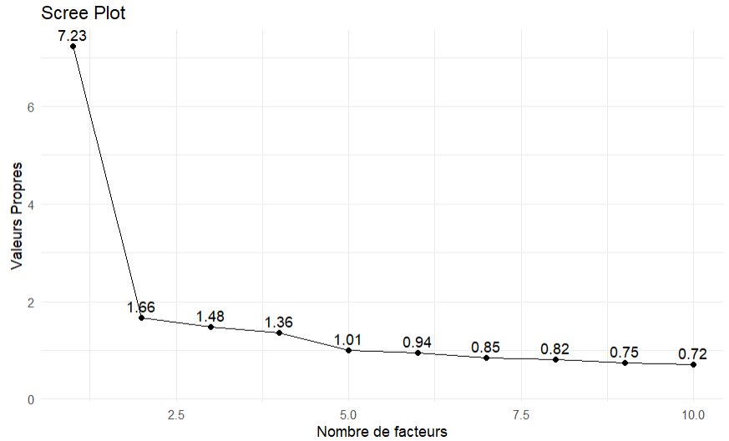

To understand the nature of the clusters, we will utilize descriptive statistics.

Furthermore, we will analyze the relationship between clusters and qualitative variables to identify individ-uals belonging to each cluster. This methodology will enhance our understanding of how qualitative variables influence cluster composition and enable more precise characterization of individuals.

In our study, we will employ the G test with a significance level of 0.05 if Cochran’s rule is satisfied and expected frequencies are suficiently large. If these conditions are not met, we will use Fisher’s exact test with a significance level of 0.05.

Here are the null and alternative hypotheses for these two tests:

• H0: Variables are independent of clusters.

• H1: Variables are not independent of clusters.

In case of dependence, we will identify which variables are most associated with each cluster using residuals, with absolute values close to 2 considered significant.

3 Results

A total of 0.64% of cases were missing across the dataset. Therefore, data imputation was performed to utilize the entire dataset available. Missing values were imputed using Principal Component Analysis (PCA) with the estimated number of principal components. This was achieved using the imputePCA function, which replaces missing values with estimates based on linear relationships between variables in the PCA-defined principal component space. Statistical and empirical techniques were used for question selection.

Exploratory Factor Analysis (EFA) was conducted to determine factor dimensionality for both parts and to remove questions loading on multiple factors. Additionally, confirmatory factor analysis (CFA) using the mean-adjusted maximum likelihood (MLM) estimator examined the model structure associated with each part.

Model fit was evaluated using several statistical indices, including Comparative Fit Index (CFI), Tucker-Lewis Index (TLI), Root Mean Square Error of Approximation (RMSEA), and Standardized Root Mean Square Residual (SRMR). Acceptable model fit criteria include CFI and TLI greater than 0.85, and RMSEA and SRMR less than 0.08.

3.1 Exploratory Factor Analysis of the LESSON Part

In this study, we utilized the following R libraries: psych, dplyr, and tidyverse for conducting our data analyses.

To determine the number of factors, several criteria including the Kaiser criterion and the scree plot (see Figure 1) were used.

Figure 1: Scree plot for Part 1 of the questionnaire.

This study confirms the 5-factor structure of the lesson quality section. The factors are as follows: Learning Objectives, Teaching and Classroom Management, Teaching Climate, Cognitive-Motor Activation, and Cogni-tive and Reflective Activation.

The factor loadings table after question cleaning is summarized in Table 3,Question 14 was removed during this process.

The model fit assessment revealed a Tucker-Lewis Index (TLI) of 0.899, indicating acceptable factorial reliability. Additionally, the Root Mean Square Error of Approximation (RMSEA) is 0.053, with 90% confidence intervals ranging from 0.041 to 0.066, suggesting a good fit of the model to the observed data.

5

Table 3: Table of coeficients

MR1 MR3 MR4 MR2 MR5 Q1 0.728

Q2 0.730

Q3 0.701

Q4 0.112 0.654 -0.142

Q5 0.263 0.335 0.115 0.132 Q6 0.317 0.122 Q7 0.507 0.187 -0.167 0.238

Q8 0.475 0.180 0.187

Q9 0.510 0.184 -0.148 0.277

Q10 0.619 0.166 Q11 0.744 0.118 -0.134

Q12 0.868

Q13 0.311 0.113 0.169 Q15 0.117 0.113 0.231

Q16 0.179 0.266 0.382 Q17 0.263 0.137 0.290 0.143 Q18 0.576 0.140 -0.110 0.232

Q19 0.118 0.782

Q20 -0.102 0.103 0.689 0.146 Q21 0.203 0.479

Q22 0.114 0.357 0.137 0.436 Q23 0.354 0.239 0.254

3.2 Confirmatory Factor Analysis of the LESSON Part

In this study, we used the following R libraries: psych, dplyr, lavaan, and tidyverse for our data analyses. To analyze which questions can be removed while retaining 4 items per factor in the model, we will use the

standardized factor loadings summarized in Table 4, as previously described, along with several fit indices. The model exhibits the following fit indices (scaled): RMSEA of 0.061, SRMR of 0.069, CFI of 0.858, and

TLI of 0.835.

For the initial model, factor loadings suggested removing items 6 and 15, resulting in the model shown in Figure 2.

To verify the loading of items in the retained model (Figure 2), several fit indices were evaluated, including CFI, TLI, RMSEA, and SRMR (see Table 5).

Additionally, Cronbach’s alpha values for each latent factor are summarized in Table 10. The results indicate the following:

• APP (0.626): A value of 0.626 indicates acceptable internal consistency for this factor, although it is slightly below the generally recommended threshold of 0.70.

• ENS (0.744): With an alpha of 0.744, this factor demonstrates good internal consistency, exceeding the threshold of 0.70.

• CLIM (0.787): A value of 0.787 suggests good internal consistency, indicating that items in this factor are well correlated.

• COMO (0.630): This factor shows acceptable internal consistency, similar to APP, but could benefit from revision to improve reliability.

• CORE (0.661): The internal consistency of this factor is acceptable but falls below the 0.70 threshold, suggesting potential for improvement.

In this study, we utilized R libraries including psych, dplyr, and tidyverse for data analysis.

To determine the number of factors, several criteria including Kaiser’s criterion and the scree plot (Figure 3) were employed.

6

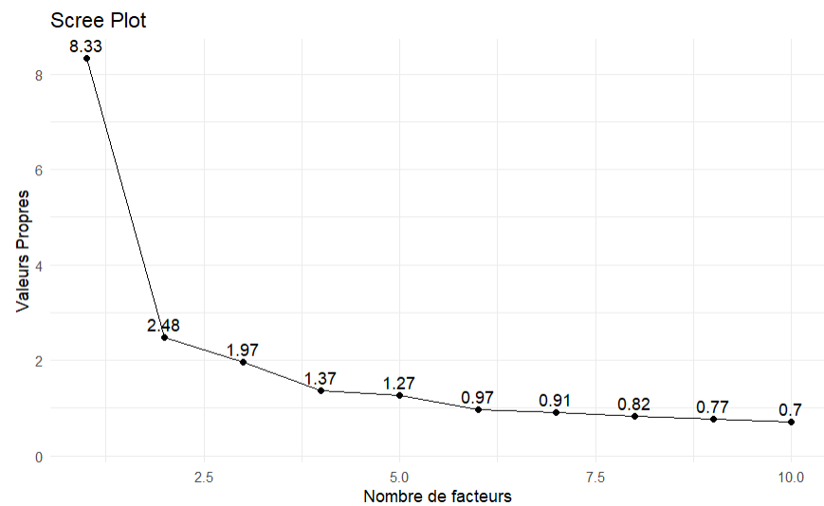

Table 4: Standardized factor loadings of latent variables

Factor

Learning Objectives Learning Objectives Learning Objectives Learning Objectives Teaching

Teaching Teaching Teaching Teaching Teaching Climate Teaching Climate Teaching Climate Teaching Climate

Cognitive-Motor Activation Cognitive-Motor Activation Cognitive-Motor Activation Cognitive-Motor Activation Cognitive-Motor Activation Cognitive and Reflective Activation Cognitive and Reflective Activation Cognitive and Reflective Activation Cognitive and Reflective Activation

Indicator

Q1 Q2 Q3 Q4 Q5 Q6 Q7 Q8 Q9 Q10 Q11 Q12 Q13 Q15 Q16 Q17 Q18 Q19 Q20 Q21 Q22 Q23

Factor Loadings

0.539 0.407 0.605 0.657 0.571 0.487 0.655 0.669 0.670 0.759 0.762 0.765 0.510 0.340 0.435 0.564 0.620 0.633 0.615 0.433 0.599 0.624

Index Scaled Value

RMSEA 0.060 (0.051 - 0.069) SRMR 0.068

CFI 0.880 TLI 0.858

Table 5: Model fit indices (Scaled)

Figure 3: Scree-plot for the IMPACT section

This study confirmed a structure with 4 factors for the physical literacy section. The factors include: physical dimension, psychological dimension, social dimension, and cognitive dimension.

The factor loadings table after cleaning questions is summarized in Table 7, where questions 30, 34, 40, and 39 were removed.

In this analysis, the Tucker Lewis Index (TLI) for factor reliability is 0.899. Additionally, the RMSEA is 0.053 with a 90% confidence interval ranging from 0.041 to 0.066. These measures indicate a reasonably good fit of the model to the observed data.

7

Table 6: Cronbach’s Alpha for each latent factor Factor Cronbach’s Alpha

APP 0.626 ENS 0.744 CLIM 0.787 COMO 0.630 CORE 0.661

Table 7: Factor Loadings

MR1

Q24

Q25 0.136 Q26

Q27

Q28 0.521 Q29 0.820 Q31 0.907 Q32 0.761 Q33 0.531 Q35 0.128 Q36

Q37

Q38 0.140 Q41

Q42 Q43 Q44

Q45 0.190 Q46

Q47 Q48 Q49 Q50

MR2 MR3 MR4

0.794 0.411

0.113 0.567 0.743

0.169 0.139 -0.149

0.150 0.227

0.379 0.259 0.427 0.199

0.351 0.258 0.180 0.471 0.128 -0.203 0.700

0.745 -0.108

0.572 0.210 0.442 0.268

0.506 0.133 0.641

0.790 0.762

0.511 0.232 0.444 0.197

3.3 Confirmatory Factor Analysis of IMPACT Section

In this study, we utilized R libraries including psych, dplyr, lavaan, and tidyverse for data analysis.

To determine which questions to remove while retaining 4 items per factor in the model, we will use the factor loadings summarized in Table 8, as done previously, along with several fit indices.

The model exhibits the following scaled fit indices: RMSEA of 0.063, SRMR of 0.070, CFI of 0.855, and TLI of 0.837.

For the first model, based on factor loadings, it was suggested to remove item 35, and thus we will retain the model shown in Figure 7.

To verify the loading of retained items, the model in Figure 7 was evaluated using several fit indices including CFI, TLI, RMSEA, and SRMR (see Table 9).

Additionally, Cronbach’s alphas are summarized in Table 10 for each latent factor. The results obtained indicate the following:

• PHY (0.769) :A value of 0.769 suggests good internal consistency for this factor, surpassing the commonly recommended threshold of 0.70.

• PSY (0.827) :With an alpha of 0.827, this factor demonstrates very good internal consistency, indicating strong correlations among its items.

• SOC (0.783) : A value of 0.783 also suggests good internal consistency, indicating that items in this factor align well.

• COG (0.800) : This factor shows good internal consistency with an alpha of 0.800, indicating high reliability of its items.

8

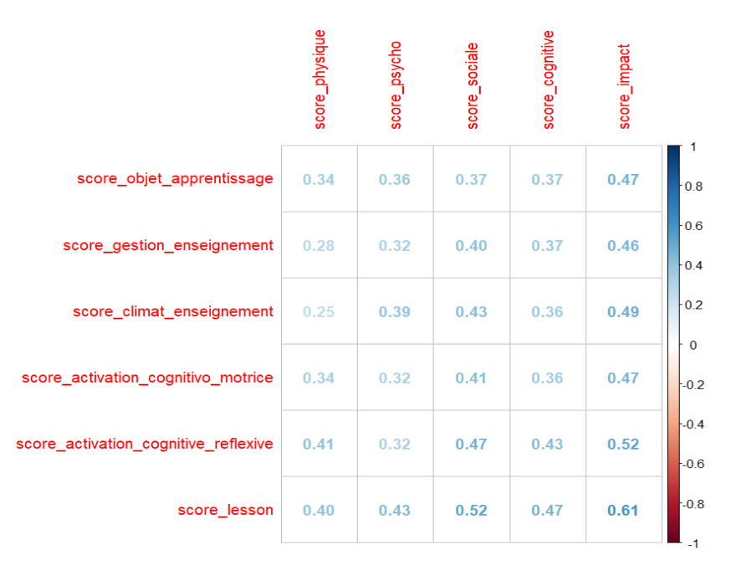

Table 8: Factor Loadings for Each Item and Factor

Factor Item

PHY Q24 PHY Q25 PHY Q26 PHY Q27 PSY Q28 PSY Q29 PSY Q31 PSY Q32 PSY Q33 PSY Q35 SOC Q36 SOC Q37 SOC Q38 SOC Q41 SOC Q42 SOC Q43 SOC Q44 SOC Q45 COG Q46 COG Q47 COG Q48 COG Q49 COG Q50

Factor Loading

0.795 0.694 0.532 0.688 0.710 0.675 0.753 0.800 0.573 0.446 0.401 0.582 0.440 0.596 0.559 0.587 0.632 0.640 0.571 0.703 0.772 0.626 0.657

Index Scaled Value

RMSEA 0.061 (0.053 - 0.069) SRMR 0.066

CFI 0.872 TLI 0.854

Table 9: Fit Indices of the Model (Scaled)

3.4 Correlations

In this study, we utilized the following R libraries: factoExtra, dplyr, lavaan, FactoMineR, cluster, stats, caret, DescTools, car, and tidyverse to conduct our data analyses.

The correlation matrix revealed significant relationships between certain dimensions from both question-naires. The results are presented in the form of correlation matrices and correlation plots.

Figure 5: Correlation matrix of factor scores

9

Table 10: Cronbach’s Alpha for Each Latent Factor Factor Cronbach’s Alpha

PHY 0.769 PSY 0.827 SOC 0.783 COG 0.800

It is observed that the correlations are often significant, with the strongest correlation occurring between the ”lesson” and ”impact” dimensions.

3.5 Significance

To assess the correlation between the variables score impact and score lesson, we used the Spearman’s rank correlation test.

The Spearman’s rank correlation test indicated a significant positive correlation between the two variables (S = 7820398, p-value < 2.2e-16, ρ = 0.6084014). The alternative hypothesis, that the Spearman correlation coeficient is different from zero, is therefore accepted.

3.6 Structural Equation Modeling (SEM)

In this study, we utilized the following R libraries: semPlot, dplyr, semTools, lavaan, lavaanPlot, and tidyverse for our data analyses.

The modindices results suggested adding the following correlations to the model: Q3 and Q4, Q19 and Q20, Q26 and Q27, Q41 and Q42, and Q49 and Q50.

The data were analyzed to investigate the relationships between the different factors from the 1st and 2nd parts.

Figure 6 depicts the path diagram of the SEM model.

The SEM analysis yielded the following results: RMSEA = 0.045, SRMR = 0.065, TLI = 0.865, and CFI = 0.879.

We are examining the standardized correlations from the table. 11.

10

Table 11: Results of SEM Analysis

Variable 1

APP APP APP APP APP APP APP APP ENS ENS ENS ENS ENS ENS ENS CLIM CLIM CLIM CLIM CLIM CLIM COMO COMO COMO COMO COMO CORE CORE CORE CORE PHY PHY PHY PSY PSY SOC

Variable 2

ENS CLIM COMO CORE PHY PSY SOC COG CLIM COMO CORE PHY PSY SOC COG COMO CORE PHY PSY SOC COG CORE PHY PSY SOC COG PHY PSY SOC COG PSY SOC COG SOC COG COG

Estimate

0.190 0.276 0.244 0.192 0.184 0.234 0.126 0.162 0.316 0.208 0.163 0.128 0.171 0.111 0.122 0.395 0.278 0.193 0.366 0.207 0.189 0.276 0.252 0.261 0.161 0.174 0.247 0.190 0.134 0.143 0.460 0.219 0.278 0.316 0.217 0.165

Std. all

0.786 0.605 0.788 0.727 0.357 0.423 0.480 0.547 0.822 0.795 0.730 0.295 0.367 0.502 0.488 0.801 0.662 0.235 0.415 0.498 0.400 0.966 0.452 0.437 0.558 0.542 0.519 0.373 0.556 0.522 0.463 0.463 0.522 0.625 0.378 0.610

We agree to see that the factors of the first part are not strongly correlated with the factors of the second part.

To study the impact of the quality of a physical education course on physical literacy, we will examine the model shown in Figure 7, with the following results: RMSEA = 0.045, SRMR = 0.070, CFI = 0.867, TLI = 0.857.

We will study the linear regression of LESSON on IMPACT, which are listed in Table 12

Table 12: SEM Regression Results

Independent Estimate P(> |z|) Std. all Variable

LESSON 0.923 0.000 0.700

The table above presents the results of the regression between the dependent variable IMPACT and the independent variable LESSON.

These results indicate that LESSON has a positive and significant influence on IMPACT, suggesting that lessons (LESSON) are an important factor in explaining impact (IMPACT) in this regression model.

The Structural Equation Modeling (SEM) regression between the latent variables IMPACT (impact) and

11

LESSON (lesson) is represented by the equation: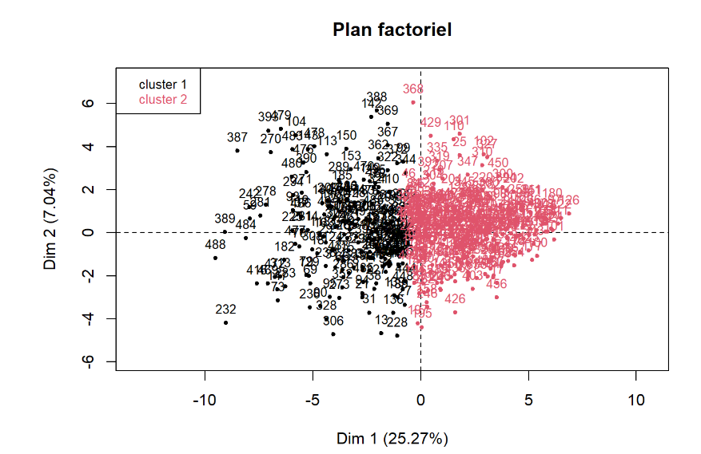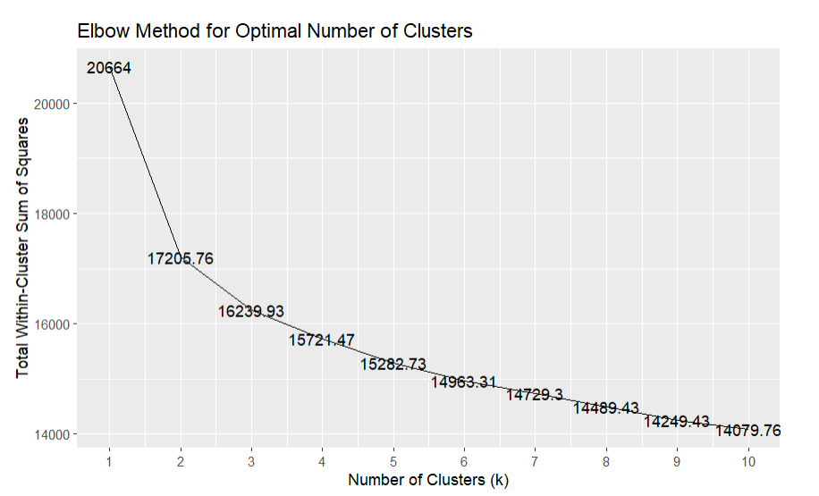

IMPACT = 0.923 · LESSON

where 0.923 is the estimate of the regression coeficient (slope) and 0.700 is the standardized estimate of the slope.

This relationship is statistically significant with a very low p-value (p < 0.001), indicating an extremely low probability that this relationship is due to chance. Additionally, the standardized estimate of 0.696 shows that the effect of LESSON on IMPACT is moderately strong.

3.7 Clustering

3.7.1 Determination of the Optimal Number of Clusters

The elbow method suggested that the optimal number of clusters is 2, as shown in Figure 8. This conclusion is supported by a mean silhouette score of 0.17, indicating reasonably well-separated clusters, a Dunn coeficient of 0.22, a Davides-Bouldin index of 2.221 suggesting fairly good cluster separation, and a Calinski-Harabasz index of 98.63 confirming the good separation of clusters.

Figure 8: Elbow Method for Optimal Number of Clusters

3.7.2 Description of Clusters

The factorial plot for two clusters is shown in Figure 9

Figure 9: Factorial plot for two clusters

The summary of descriptive statistics can be found in Tables 13 and 14.

3.7.3 Cluster Identification

First, we analyze the relationship between APSA and Cluster. Here is the contingency table between cluster and APSA:

12

Q1 Q2 1st Qu. 4.00 4.00 Median 4.00 4.00 Mean 3.98 3.97 3rd Qu. 5.00 5.00

Q14 Q15 1st Qu. 3.00 3.00 Median 3.00 4.00 Mean 3.20 3.75 3rd Qu. 4.00 4.00

Q27 Q28 1st Qu. 2.00 1.00 Median 3.00 2.00 Mean 3.09 2.28 3rd Qu. 4.00 3.00

Q40 Q41 1st Qu. 1.00 1.00 Median 3.00 3.00 Mean 2.43 2.85 3rd Qu. 3.00 4.00

Table 13: Descriptive Statistics for Cluster 1

Q3 Q4 Q5 Q6 Q7 Q8 Q9 Q10 Q11 Q12 Q13 3.00 2.00 3.57 2.00 3.00 3.00 3.00 2.00 2.00 2.00 3.00 4.00 3.00 4.00 3.00 4.00 3.00 3.00 3.00 3.00 3.00 3.00 3.51 2.76 3.93 3.13 3.42 3.27 3.21 2.75 2.91 3.00 3.16 4.00 4.00 5.00 4.00 4.00 4.00 4.00 4.00 4.00 4.00 4.00 Q16 Q17 Q18 Q19 Q20 Q21 Q22 Q23 Q24 Q25 Q26 2.00 3.00 2.00 3.00 3.00 3.00 3.00 2.00 2.00 3.00 2.00 3.00 4.00 3.00 4.00 4.00 4.00 4.00 3.00 3.00 4.00 3.00 3.21 3.41 3.14 3.46 3.66 3.88 3.44 3.10 2.98 3.36 3.12 4.00 4.00 4.00 4.00 4.00 5.00 4.00 4.00 4.00 4.00 4.00 Q29 Q30 Q31 Q32 Q33 Q34 Q35 Q36 Q37 Q38 Q39 1.00 1.00 1.00 1.00 1.00 2.00 2.00 3.00 2.00 3.00 1.00 1.00 2.00 2.00 2.00 2.00 3.00 3.00 4.00 3.00 4.00 3.00 1.84 2.37 2.18 2.09 2.06 3.13 2.87 3.58 2.96 3.31 2.84 3.00 3.00 3.00 3.00 3.00 4.00 4.00 4.00 4.00 4.00 4.00 Q42 Q43 Q44 Q45 Q46 Q47 Q48 Q49 Q50

2.00 2.00 2.00 2.00 3.00 3.00 3.00 3.00 3.00 3.00 3.00 3.00 3.00 4.00 4.00 4.00 4.00 4.00 2.84 3.10 2.90 2.95 3.84 3.62 3.44 3.61 3.69 4.00 4.00 4.00 4.00 5.00 4.00 4.00 4.00 4.00

Cluster 1 Cluster 2

Acrosport 1

12

Table 15: Distribution of activities by cluster Badminton Basketball Crosstraining

12 22 2 Cluster 1 24 18 6 Cluster 2

Dance Discus Throw 23 13 21 10

Rock Climbing 7

41

Cluster 1 Cluster 2

Lifesaving Step 9 51

21 68

Table Tennis 5

17

Volleyball 18 23

3.7.4 Expected Frequencies of Activities by Cluster

Here are the expected frequencies of activities by cluster:

Table 16: Expected distribution of activities by cluster Acrosport Badminton Basketball

Cluster 1 5.089 14.093 15.659 Cluster 2 7.911 21.907 24.341

Cluster 1 Cluster 2

Crosstraining 3.132 4.868

Dance Discus Throw 17.225 9.004 26.775 13.996

Rock Climbing 18.791 29.209

Cluster 1 Cluster 2

Weightlifting 27.012 41.988

Lifesaving 11.744 18.256

Cluster 1 Cluster 2

Step Table Tennis 46.586 8.613 72.414 13.387

Volleyball 16.051 24.949

Table 17: Expected distribution of activities by cluster (continued)

3.7.5 Fisher’s Test

According to the method, Fisher’s test is recommended. The p-value obtained is 0.0009995, which is smaller than the predefined threshold. Therefore, we reject H0, indicating that the cluster is not independent of APSA.

13

Q1 Q2 Min. 1.00 1.00 1st Qu. 4.00 4.00 Median 5.00 5.00 Mean 4.57 4.55 3rd Qu. 5.00 5.00 Max. 5.00 5.00

Q14 Q15 Min. 1.00 1.00 1st Qu. 4.00 4.00 Median 4.00 5.00 Mean 4.20 4.38 3rd Qu. 5.00 5.00 Max. 5.00 5.00

Q27 Q28 Min. 1.00 1.00 1st Qu. 3.00 3.00 Median 4.00 4.00 Mean 3.90 3.79 3rd Qu. 5.00 5.00 Max. 5.00 5.00

Q40 Q41 Min. 1.00 1.00 1st Qu. 3.00 3.00 Median 4.00 4.00 Mean 3.42 4.01 3rd Qu. 4.00 5.00 Max. 5.00 5.00

Table 14: Descriptive Statistics for Cluster 2

Q3 Q4 Q5 Q6 Q7 Q8 Q9 Q10 Q11 Q12 Q13 1.00 1.00 2.00 1.00 1.00 1.00 1.00 1.00 1.00 1.00 1.00 4.00 4.00 4.00 3.00 4.00 4.00 4.00 3.00 4.00 4.00 3.00 4.16 4.00 5.00 4.00 4.16 5.00 4.00 4.00 4.00 4.00 4.00 4.28 4.07 4.61 3.92 4.29 4.29 4.21 3.93 4.13 4.15 4.03 5.00 5.00 5.00 5.00 5.00 5.00 5.00 5.00 5.00 5.00 5.00 5.00 5.00 5.00 5.00 5.00 5.00 5.00 5.00 5.00 5.00 5.00 Q16 Q17 Q18 Q19 Q20 Q21 Q22 Q23 Q24 Q25 Q26 1.00 1.00 1.00 2.00 1.00 1.00 1.00 1.00 1.00 1.00 1.00 4.00 4.00 4.00 4.00 4.00 4.00 4.00 4.00 4.00 4.00 3.00 4.00 4.00 5.00 5.00 5.00 5.00 5.00 4.00 4.00 4.00 4.00 4.09 4.23 4.34 4.44 4.50 4.49 4.41 4.10 4.02 4.24 3.90 5.00 5.00 5.00 5.00 5.00 5.00 5.00 5.00 5.00 5.00 5.00 5.00 5.00 5.00 5.00 5.00 5.00 5.00 5.00 5.00 5.00 5.00 Q29 Q30 Q31 Q32 Q33 Q34 Q35 Q36 Q37 Q38 Q39 1.00 1.00 1.00 1.00 1.00 1.00 1.00 1.00 1.00 1.00 1.00 2.00 3.00 3.00 3.00 3.00 4.00 3.00 4.00 4.00 4.00 3.00 3.00 3.00 3.00 4.00 3.00 4.00 4.00 4.00 4.00 4.00 4.00 2.83 3.41 3.33 3.55 3.19 4.13 3.81 4.18 4.01 4.02 4.01 4.00 4.00 4.00 4.00 4.00 5.00 5.00 5.00 5.00 5.00 5.00 5.00 5.00 5.00 5.00 5.00 5.00 5.00 5.00 5.00 5.00 5.00 Q42 Q43 Q44 Q45 Q46 Q47 Q48 Q49 Q50

1.00 1.00 1.00 1.00 3.00 2.00 1.00 2.00 1.00 3.00 3.00 4.00 3.00 4.00 4.00 4.00 4.00 4.00 4.00 4.00 4.00 4.00 5.00 5.00 4.00 4.00 5.00 3.91 4.15 3.88 3.94 4.61 4.44 4.26 4.27 4.41 5.00 5.00 5.00 5.00 5.00 5.00 5.00 5.00 5.00 5.00 5.00 5.00 5.00 5.00 5.00 5.00 5.00 5.00

3.7.6 Standardized Residuals

Below are the tables of standardized residuals by cluster:

Cluster 1 Cluster 2

Table 18: Standardized residuals by cluster for APSAs (Part 1) Acrosport Badminton Basketball Crosstraining Dance DF Escalade

-1.813 -0.558 1.602 -0.640 1.391 1.332 -2.720 1.454 0.447 -1.285 0.513 -1.116 -1.068 2.182

Musculation 0.575

-0.461

Cluster 1 Cluster 2

Dance DF 1.391 1.332 -1.116 -1.068

Escalade -2.720 2.182

Musculation 0.575

-0.461

Cluster 1 Cluster 2

Lifesaving Step -0.801 0.647 0.642 -0.519

Table Tennis -1.231

0.987

Volleyball 0.487

-0.390

3.7.7 Sexe Analysis

We will now perform the same process for the variable Sex.

Table 19: Observed data by cluster F M

Cluster 1 103 90 Cluster 2 171 129

14

Table 20: Expected (mean) data by cluster F M

Cluster 1 107.266 85.734 Cluster 2 166.734 133.266

The data were analyzed using the Likelihood Ratio Test (G-test) to assess the independence between vari-ables. The test yielded a G statistic of 0.627 with 1 degree of freedom. The p-value associated with this test is 0.4285, which is greater than the threshold α. Therefore, we retain H0.

4 Discussion

5 Conclusion

References

15

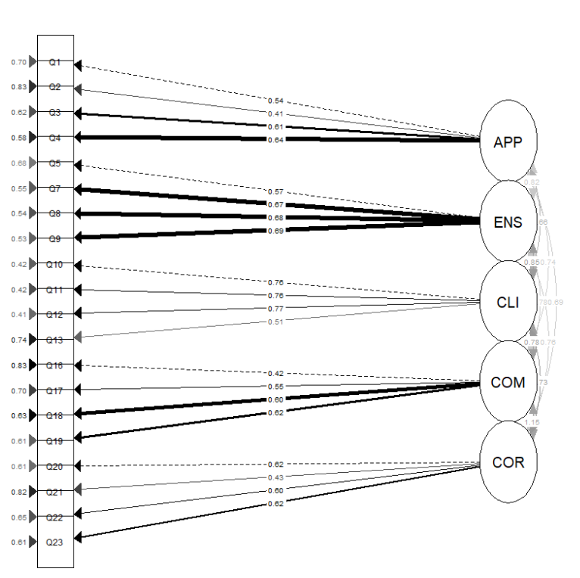

Figure 2: Measurement model for the lesson quality section. Note: APP - Learning Objectives, ENS - Teaching and Classroom Management, CLI - Teaching Climate, COM - Cognitive-Motor Activation, and COR - Cognitive and Reflective Activation.

16

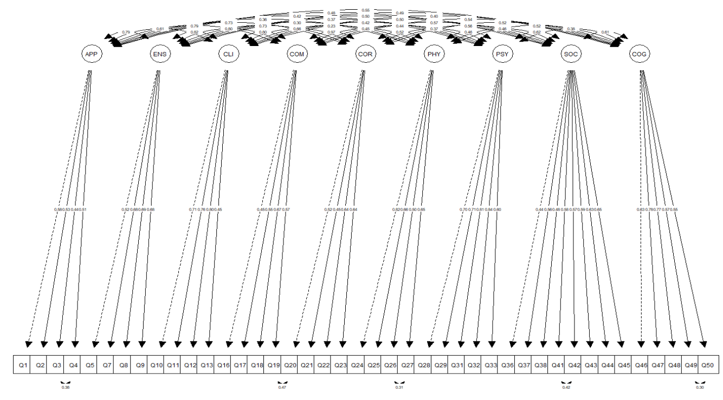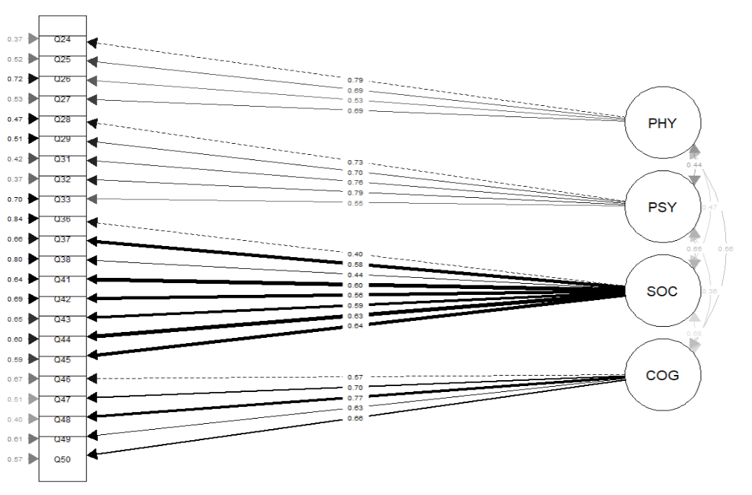

Figure 4: Measurement model for the physical literacy component. Note: PHY - Physical dimension, PSY -Psychological dimension, SOC - Sociological dimension, COG - Cognitive dimension.

Figure 6: Measurement model for all factors. Note: APP - learning object, ENS - classroom management, CLI - conducive teaching climate, COM - cognitive-motor activation, COR - cognitive and reflexive activation, PHY - Physical, PSY - Psychological, SOC - Social, and COG - Cognitive.

17

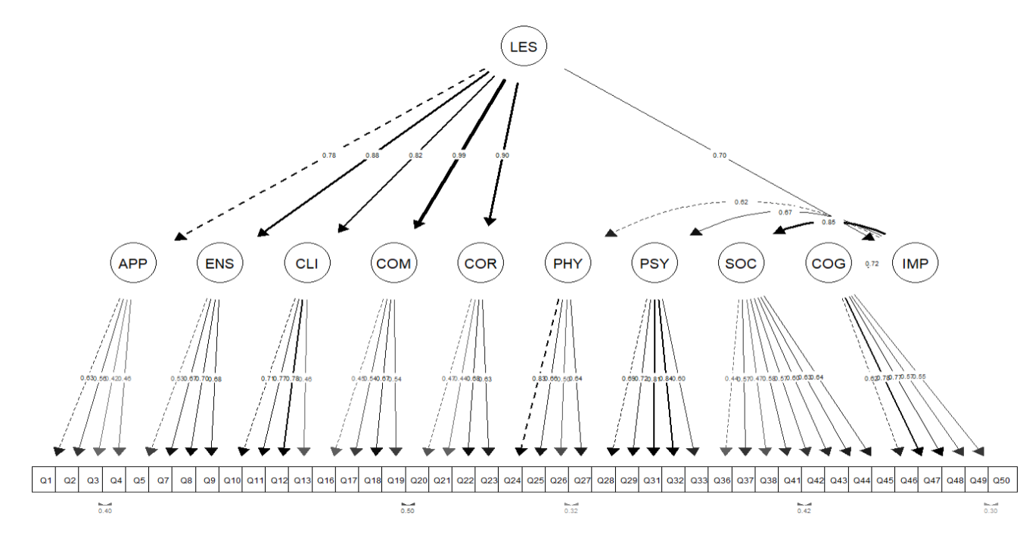

Figure 7: Measurement model for the quality of a lesson. Note: APP - learning object, ENS - teaching and class management, CLI - conducive teaching climate, COM - cognitive-motor activation, COR - cognitive and reflexive activation, PHY - Physical, PSY - Psychological, SOC - Social, COG - Cognitive, LES - Lesson, IMP - Impact.

18