Reporting:
The second goal of this project is to provide parents with the ability to monitor and derive reports on their child's Internet access. We looked at incorporating BASE (Basic Analysis and Security Engine) into Kindsicher to render this functionality. BASE is based of the ACID (Analysis Console for Intrusion Databases) project and provides a web-based front-end to query and analyze alerts generated by the SNORT IDS system.

We first define a rule within SNORT to capture all HTTP traffic originating from the home network.
alert tcp any any <> any 80 (msg:"HTTP Alert")
This causes SNORT to log all HTTP requests from any source IP and port to any destination IP and port 80 (indicating HTTP) to a MySQL database. BASE then reads the alert information from this database and displays it in a web-browser. (Figure R1)

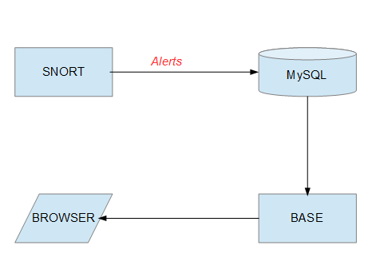
Figure R1 – BASE Data Flow

To access base you need to open a browser window and type in “<base server name>/base” in the URL field. Figure R2 shows the BASE home page presented to an user on logging into BASE.

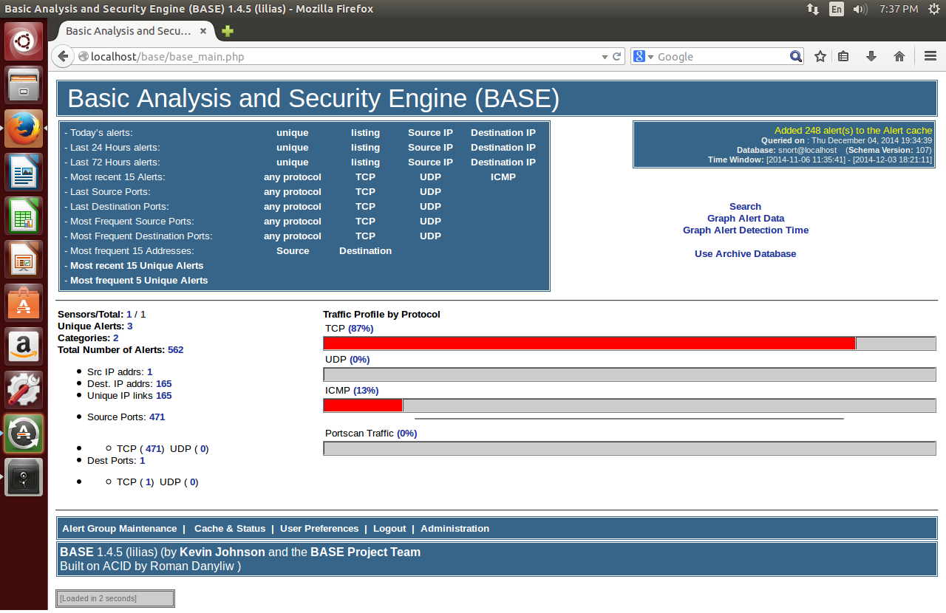
Figure R2 BASE Home Page

BASE displays network traffic profile by protocol and also different counts such as the number of destination IP addresses accessed from the network, the number of source (home network in this case) IP addresses the requests originated from, number of source ports etc.

For this project we were particularly interested in destination IP addresses. On clicking on the count of destination IP addresses shown in Figure R2, BASE displays a list of all the IP addresses accessed from the home network (Figure R3), along with other associated information such as the number of times the IP was accessed and the number of source addresses that accessed it.

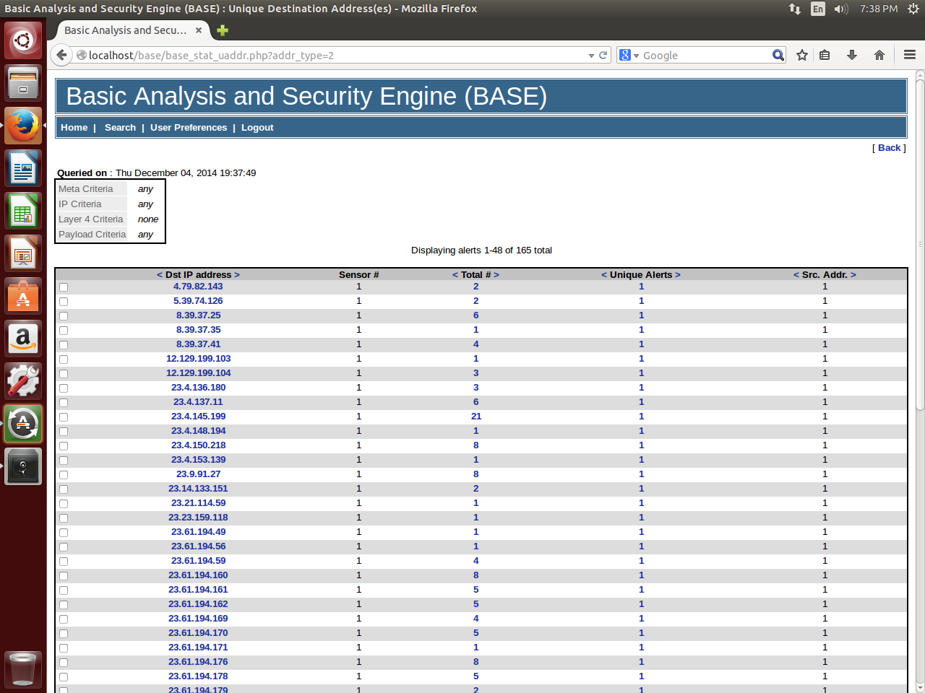
Figure R3 – List of destination IPs accessed from the network

BASE also provides several canned reports to graphically represent network data. Figure R4 shows an example of report selection and parameter specification.

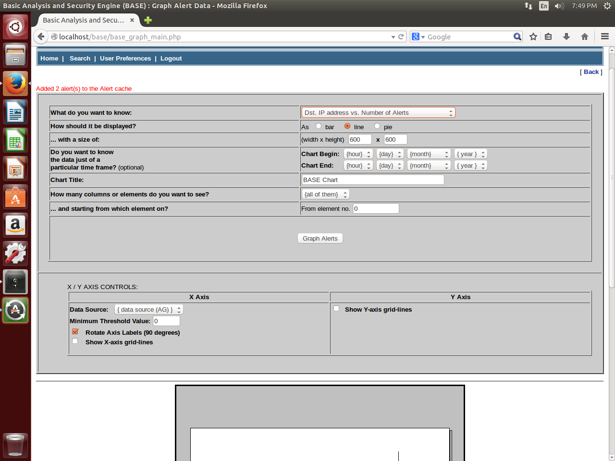
Figure R4 – BASE report selection and initiation

Based on our study of BASE we came up with the following conclusions.

Advantages of BASE:
- It is built to work in conjunction with SNORT.
- It provides a simple web-interface for users to view and analyze network traffic.
- It comes with several in-built reports to help in the analysis.

Disadvantages of BASE:
- It deals with only IP addresses and does not display the corresponding domain names. IP addresses are not intuitive to users and this raises a real concern given the fact that our target users are parents who are not necessarily tech-savvy.
- It also displays only the number of times a site has been accessed and gives no other information like the date and time of access.
- The in-built reports do not support any correlation of which source IP(s) accessed which destination IP(s), reducing a parent's understanding of their child's Internet access.

Although BASE does provide an avenue for uses to view and analyze web access, we could say it only partially meets the reporting goals for Kindsicher because of these disadvantages. This is further detailed in the Future Work/Improvements section.

