XAI: Model-agnostic Methods
Exercise 5 - Partial Dependence Plot (PDP)
Sergio Domínguez and Claudia Schuller

Introduction
This report applies model-agnostic explainability methods based on Partial Dependence Plots (PDP). PDPs are used to analyse the average marginal effect of a feature on the prediction of a trained model, while the rest of the variables are averaged over the dataset.
Two regression problems are studied. First, a Random Forest model is trained to predict the number of bike rentals using temporal and weather-related variables. Secondly, another Random Forest model is trained to predict house prices using structural characteristics of each house.
The objective is not only to obtain predictions, but also to interpret what the model has learned from the data and whether the relationships between the variables and the target values are reasonable.

Methodology
The analysis was carried out in R using the packages randomForest, pdp, ggplot2 and dplyr. The complete code is contained in the XAI3.Rmd file. The plots included in this report correspond to the outputs we obtained from that R Markdown analysis.
For the bike rental problem, the variable days_since_2011 was created from the original date column. The Random Forest model was trained using days_since_2011, temp, hum and windspeed as predictors of cnt.
For the two-dimensional PDP, we used a random sample of 500 observations before generating the partial dependence surface, as required in the exercise due to the computational size of the process.
For the house price problem, we trained the Random Forest model with bedrooms, bathrooms, sqft_living, sqft_lot, floors and yr_built. A random sample of 500 observations was also used when generating the house PDPs.
The code also uses set.seed(123), which makes the sampling and model generation more reproducible.

1. One-dimensional Partial Dependence Plot
The one-dimensional PDPs allow us to analyse how each explanatory variable influences the predicted number of bike rentals while keeping the rest of the variables averaged.
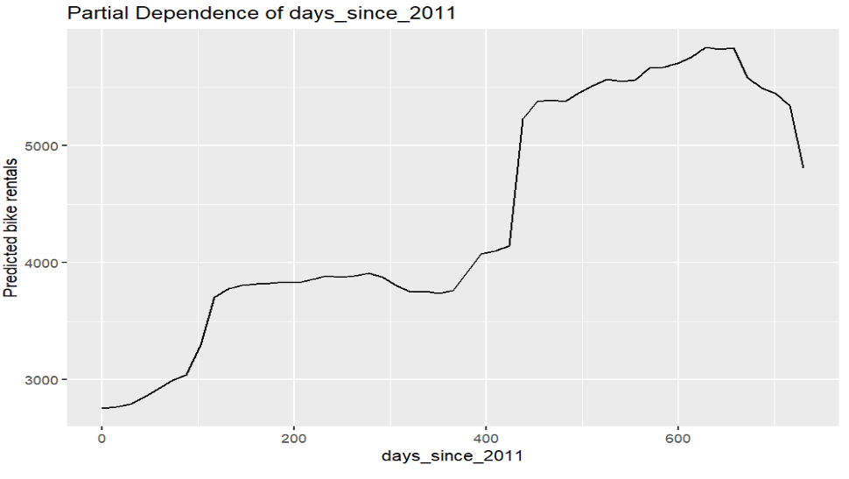
Figure 1. Partial dependence of days since 2011.
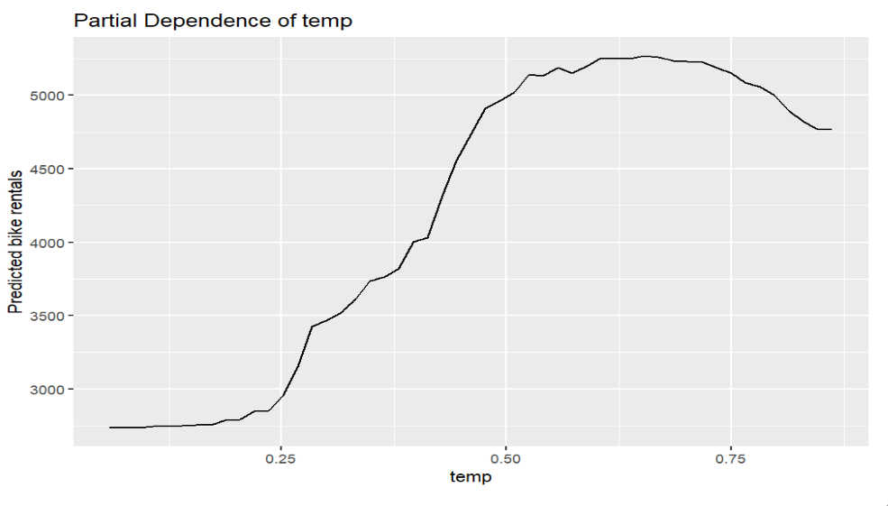
Figure 2. Partial dependence of temperature.
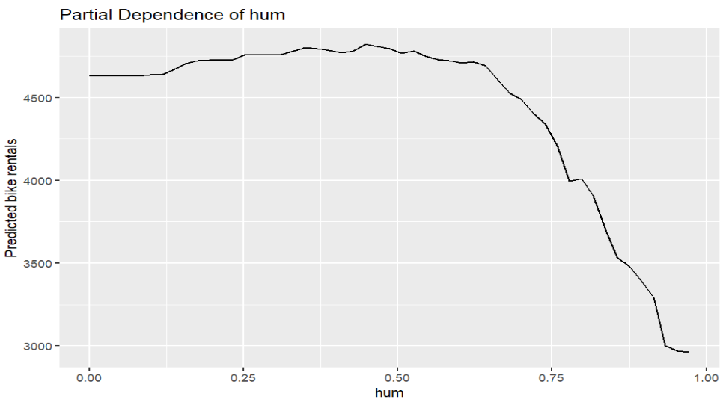
Figure 3. Partial dependence of humidity.
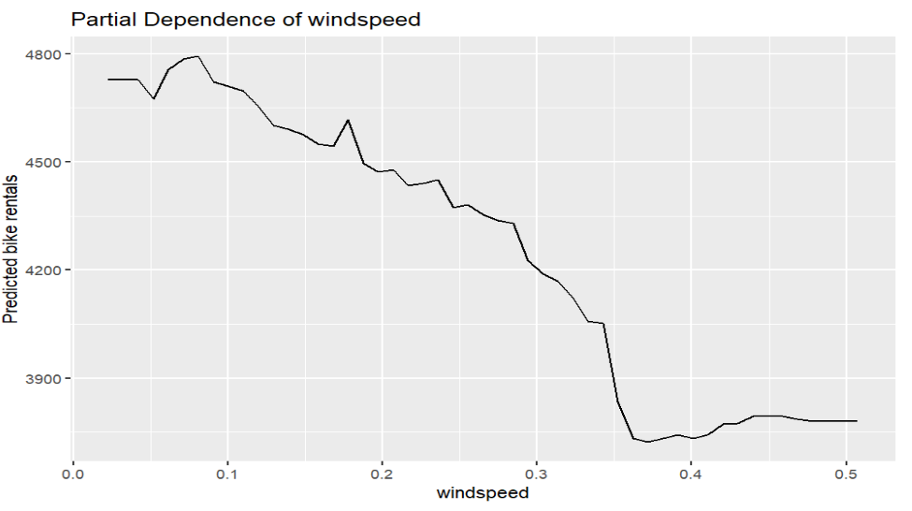
Figure 4. Partial dependence of wind speed.

Interpretation
The plot for days_since_2011 shows a clear increasing trend. At the beginning of the period, the predicted number of rentals is around 2,700-3,000, while later in the series it rises above 5,000. This indicates that the bike sharing system became progressively more popular over time. The model captures a strong temporal trend, with a particularly sharp increase after approximately day 430.
The partial dependence plot for temperature shows a non-linear relationship. When temperature is low, predicted rentals are also low. As temperature increases, the predicted number of bike rentals rises strongly, reaching its highest values at moderate to high temperatures. However, after the peak, very high temperature values produce a slight decline. This suggests that there is an optimal temperature range for bike usage, while extreme heat can discourage users.
Humidity has a clearly negative effect at high values. For low and medium humidity levels, the predicted rentals remain relatively high and stable, but after approximately 0.65-0.70 the curve starts to decline. At very high humidity values, the predicted rentals fall sharply. This indicates that humid weather conditions reduce the attractiveness of bike usage.
Wind speed also presents a negative effect. The curve decreases as windspeed increases, especially after values around 0.30-0.35. Although the effect is noticeable, it is less dominant than the effects of temperature and humidity. Wind speed can therefore be interpreted as a secondary weather factor in the model.
Overall, the Random Forest model learns realistic relationships: bike demand increases with time and comfortable temperatures, but decreases when humidity or wind speed become high.

2. Bidimensional Partial Dependence Plot
The bidimensional PDP analyses the joint effect of temperature and humidity on the predicted number of bike rentals. This allows us to observe an interaction between both weather variables that cannot be fully understood from the one-dimensional plots alone.
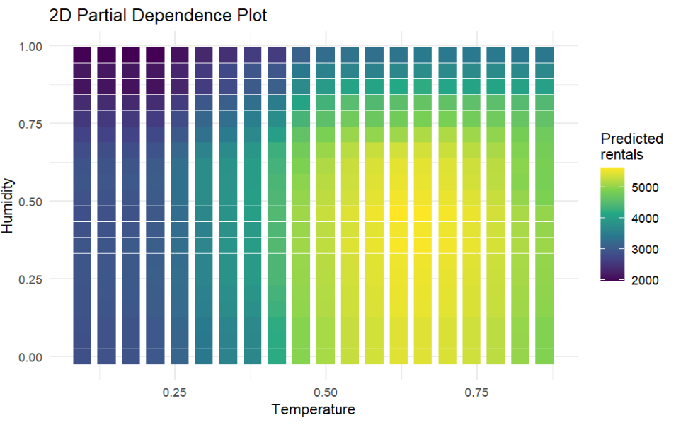
Figure 5. Two-dimensional partial dependence plot for temperature and humidity.

Interpretation
The plot shows that predicted bike rentals are low when temperature is low, almost independently of humidity. As temperature increases, the predicted number of rentals rises noticeably, which confirms the positive effect of warmer weather observed in the one-dimensional PDP.
The highest predicted bike counts are reached at moderate to high temperatures combined with low or medium humidity. In the plot, these areas correspond to the brightest regions, where predictions exceed approximately 5,000 rentals.
However, the positive effect of temperature is reduced when humidity becomes very high. Even at favourable temperatures, high humidity lowers the predicted number of rentals. Therefore, warm and dry or moderately humid days are more favourable for bike usage than warm but very humid days.
The 2D PDP confirms that temperature and humidity interact in the model. Temperature is beneficial up to a certain range, but this benefit is weakened under uncomfortable humidity conditions.

3. PDP to explain the price of a house
The same PDP methodology was applied to the house price dataset. The Random Forest model predicts price using bedrooms, bathrooms, sqft_living, sqft_lot, floors and yr_built. The variables interpreted in this section are bedrooms, bathrooms, sqft_living and floors.
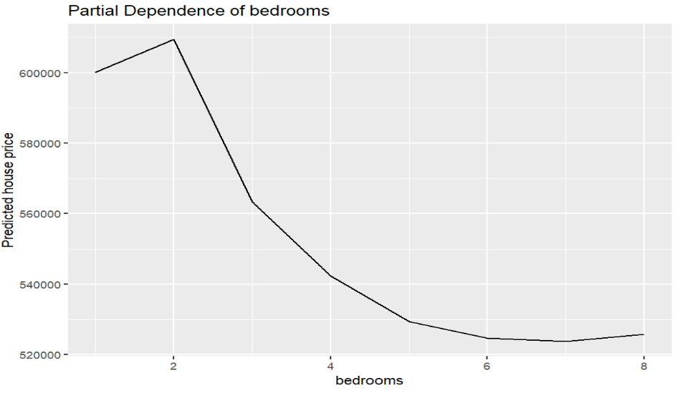
Figure 6. Partial dependence of bedrooms.
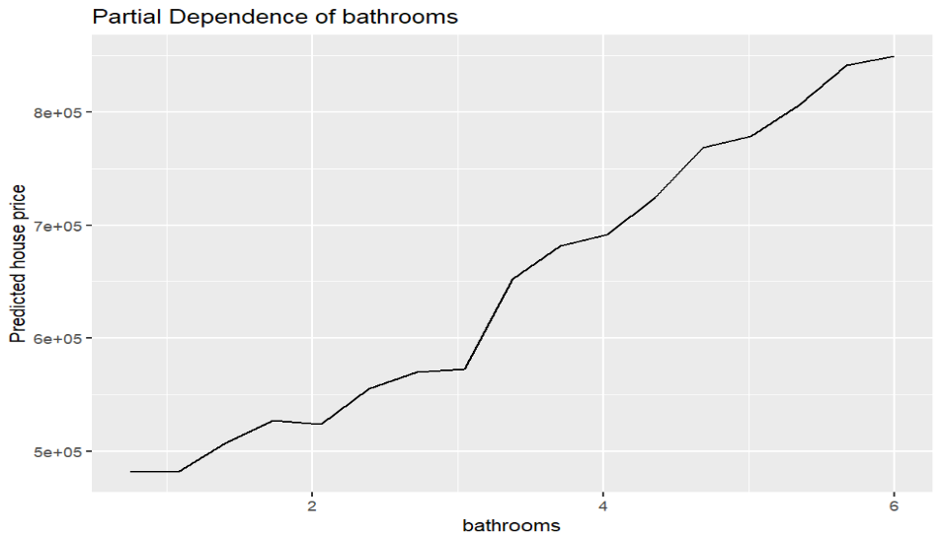
Figure 7. Partial dependence of bathrooms.
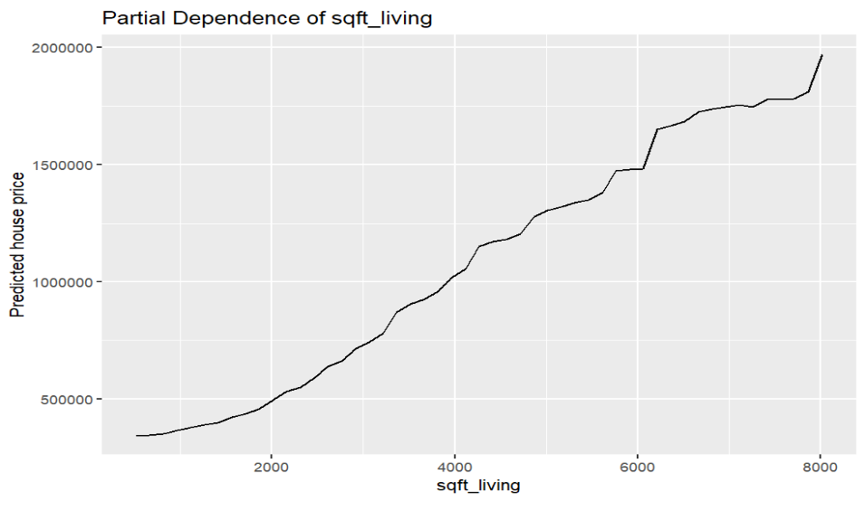
Figure 8. Partial dependence of living area.
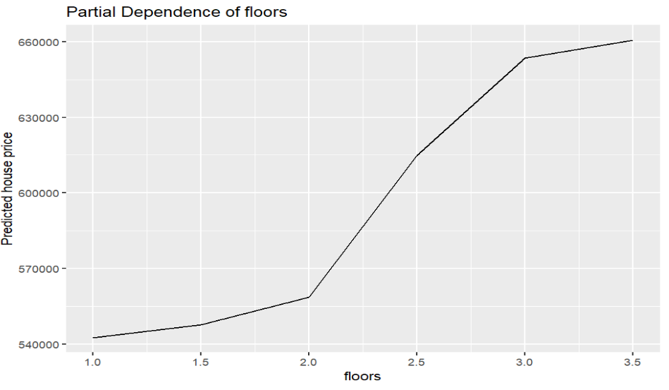
Figure 9. Partial dependence of floors.

Interpretation
The PDP for bedrooms shows a non-linear relationship. The predicted price increases slightly from one to two bedrooms, reaching its highest value around two bedrooms. From that point onwards, adding more bedrooms leads to a decrease in the predicted price. This suggests that a high number of bedrooms is not necessarily associated with more expensive houses once the other variables are averaged. It may reflect older constructions, less efficient layouts or properties with smaller rooms.
The PDP for bathrooms shows a strong positive influence. As the number of bathrooms increases, the predicted house price rises steadily. The increase becomes especially visible from around three bathrooms onwards. This is intuitive because more bathrooms are usually associated with larger, more comfortable and higher-quality houses.
The PDP for sqft_living shows the strongest effect among the analysed variables. The predicted price increases sharply as the living area grows, moving from values below 500,000 dollars for small houses to close to two million dollars for very large houses. This indicates that usable interior space is one of the main drivers of house price in the model.
The PDP for floors shows a positive but more moderate effect. Houses with more floors tend to have higher predicted prices, especially when moving from two to three floors. After that, the curve becomes flatter, suggesting that the number of floors adds value but its effect is smaller than the effect of living area or bathrooms.
In summary, the model assigns the strongest positive effect to sqft_living, followed by bathrooms. Floors have a secondary positive effect, while bedrooms show a more complex relationship that becomes negative after two bedrooms.

Conclusion
The PDP analysis provides a clear interpretation of the Random Forest models. In the bike rental problem, the model learns that demand increases over time and is strongly affected by weather conditions. Comfortable temperatures increase the number of rentals, while high humidity and high wind speed reduce demand.
The two-dimensional PDP confirms that temperature and humidity interact: warm days produce high rental predictions mainly when humidity is not too high. This interaction supports the idea that weather comfort is more important than temperature alone.
In the house price problem, the model identifies living area as the most influential factor, followed by bathrooms. The number of floors has a moderate positive effect, while bedrooms present a non-linear relationship in which more bedrooms do not always imply a higher price.
Overall, the use of PDPs makes the Random Forest predictions more interpretable and helps connect the model behaviour with realistic explanations of bike rental demand and house pricing.

