1. Quirk Creek - Watershed Assessment Report

Carl Schwarz

2017-05-04

Table of Contents

Background 1

Watershed Assessments 1

How is this information used? 3

Results 3

BKTR 4

BLTR 6

BLBK 9

CTTR 12

Summary 15

References 16

# Background

The content of this document is not relevant. It is just used as a style for the main documents.

Set the Style of TOC header to NORMAL..

# Watershed Assessments

Alberta Environment and Parks monitor fish in flowing waters using standardized electrofishing and habitat surveys techniques. Surveys often occur during the summer when river and stream flows are lower to allow for safe working conditions and high visibility of observed fish. Although information is collected from all species, assessments often focus on species such as Westslope Cutthroat Trout (*Oncorhynchus clarkii lewisi*), Bull Trout (*Salvelinus confluentus*), Arctic Grayling (*Thymallus arcticus*), Athabasca Rainbow Trout (*Oncorhynchus mykiss*), and Mountain Whitefish (*Prosopium williamsoni*).

Watersheds are defined by the Hydrologic Unit Code (HUC) 10 watershed boundary, as identified by the HUC Watersheds of Alberta system of classification system (reference? AB or USGS?). Within the study area, **999999999** potential sampling locations were randomly chosen using ArcGIS (ESRI, 2013) and R (R Core Team, 2015) using generalized random tessellation stratified (GRTS) sampling (Stevens and Olsen, 2004; Reilly, 2016). Sites were further removed from consideration if they were observed or strongly suspected to be dry or if there were access limitations that prevented crews from reaching the sites. In total, 8 sites were sampled in the Quirk Creek watershed as shown on the Figure 1.

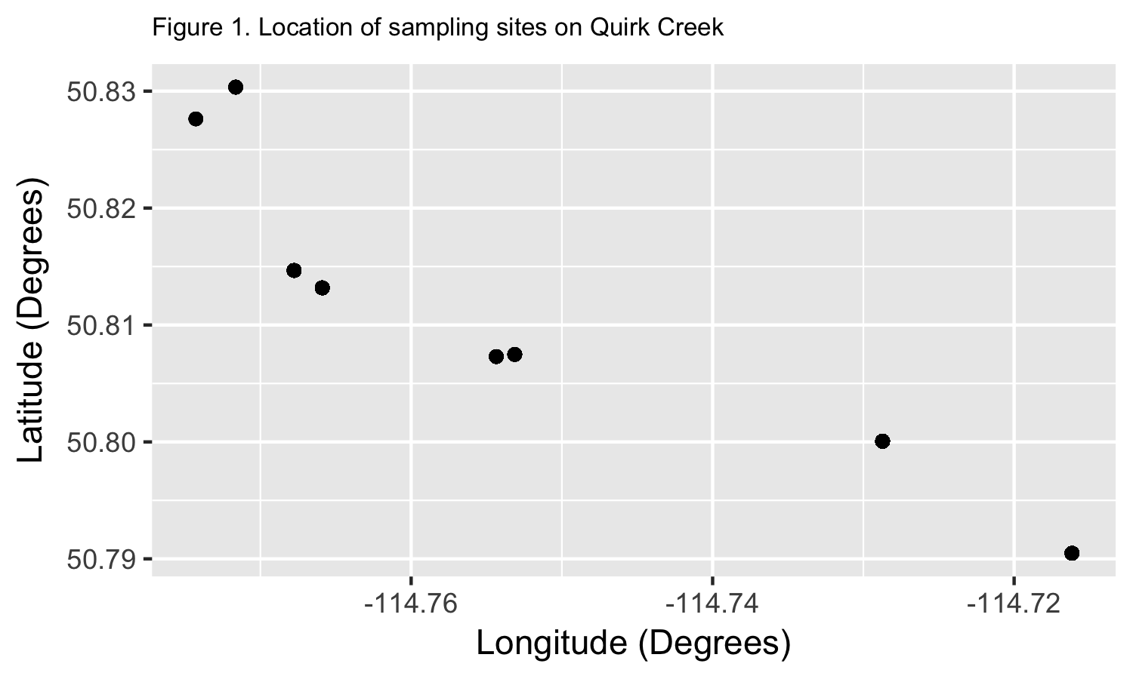

The set of unique TTM co-ordinates for the plot above are:

## TTM.Easting TTM.Northing Longitude Latitude  
## 516486.5 5626823 -114.7659 50.81318  
## 515890.8 5628428 -114.7743 50.82763  
## 517387.6 5626193 -114.7531 50.80748  
## 517301.5 5626173 -114.7544 50.80730  
## 516353.9 5626988 -114.7678 50.81466  
## 519109.2 5625374 -114.7287 50.80006  
## 516076.1 5628730 -114.7716 50.83034  
## 519998.2 5624313 -114.7162 50.79048

Fish sampling protocols followed existing flowing water fish survey standards.Specifically, we used backpack or boat electrofishing to capture fish in wadeable streams and rivers respectively. Sampling effort was recorded and fish were measured. If required, fin clips were taken for genetic analyses.

## How is this information used?

Catch rates (i.e., backpack electrofishing: number of fish per 300 meters, boat electrofishing: number of fish per 1 km) of fish species are an index of the populations' abundance, with higher catch rates meaning there are more fish in a stream or river. The sizes and age of fish also tell us if problems with overharvest (e.g. too few fish living to old age) or habitat (e.g., poor spawning success) are a concern. Biologists use this information, as well as a variety of data on water quality, access, development, and habitat threats as part of Alberta’s Fish Sustainability Index (FSI) and evaluation of species recovery work.

# Results

## BKTR

The mean fork length and size range for this species on a yearly basis are summarized in Table 2 and plotted in Figure 2.

Table 2. Summary statistics on fork length for BKTR captured in Quirk Creek

|  |  |  |  |  |
| --- | --- | --- | --- | --- |
| Year | n | Mean fork length mm | Min fork length mm | Max fork length mm |
| 1987 | 61 | 205 | 104 | 327 |
| 2000 | 30 | 184 | 78 | 235 |
| 2006 | 1046 | 126 | 41 | 287 |
| 2007 | 624 | 122 | 38 | 305 |
| 2008 | 375 | 126 | 47 | 249 |
| 2009 | 94 | 116 | 45 | 263 |
| 2010 | 228 | 131 | 39 | 310 |
| 2011 | 219 | 122 | 37 | 300 |
| 2012 | 125 | 118 | 37 | 281 |
| 2013 | 110 | 125 | 46 | 313 |

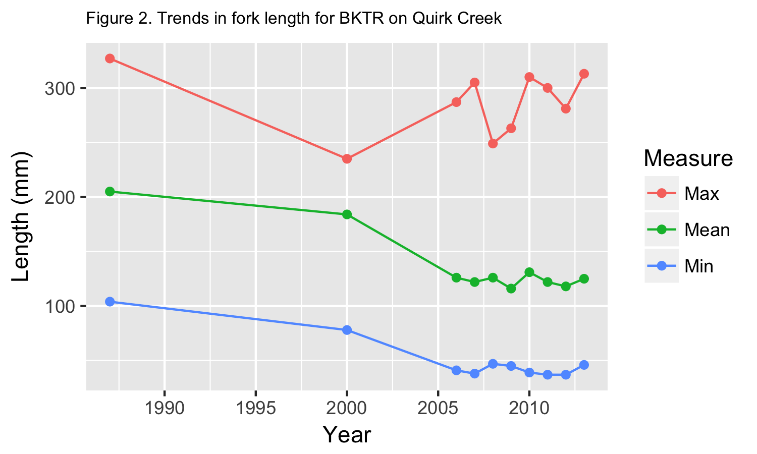

The length distribution over all years is shown in Figure 3. Black vertical line indicates estimated length at 50% maturity (**999999999999** mm Fork Length). {Not yet shown --How is this known from the data? }

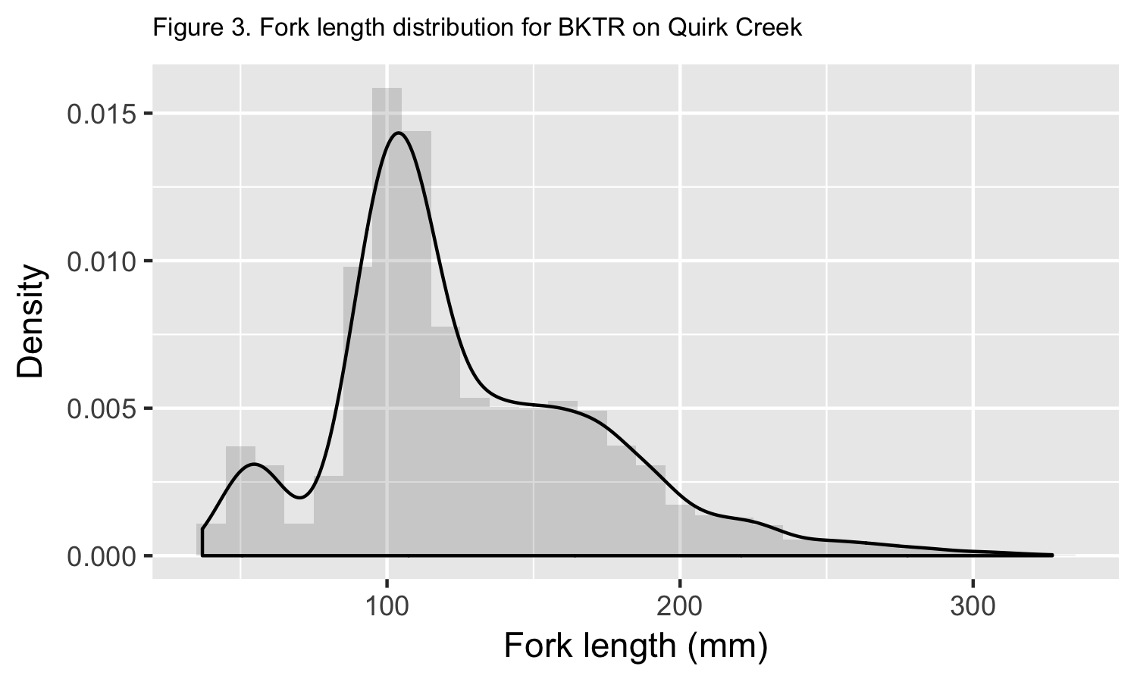

A plot of the CPUE over time is shown in Figure 4.

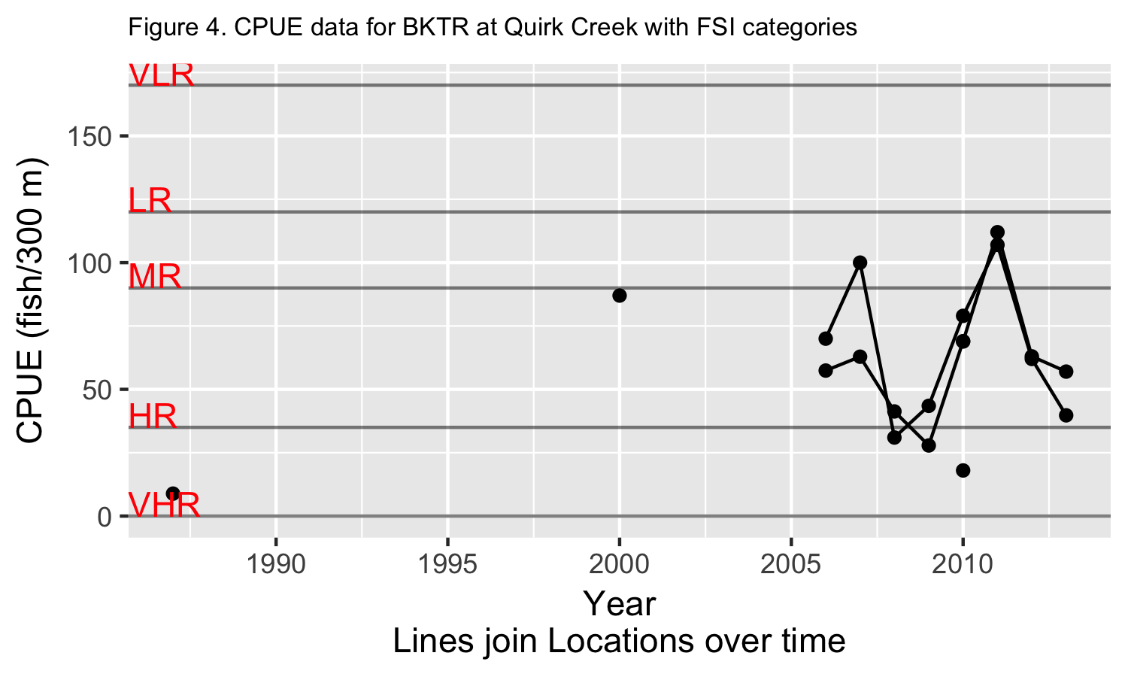

The Bayesian analysis on trend found that the median CPUE was changing at 0.79% (SD 8.18%) per year and the posterior probability that the slope is positive is 0.56.

Plots of the posterior distribution of the trend line for the median and the FSI Category membership are shown in Figure 5 and Figure 6.

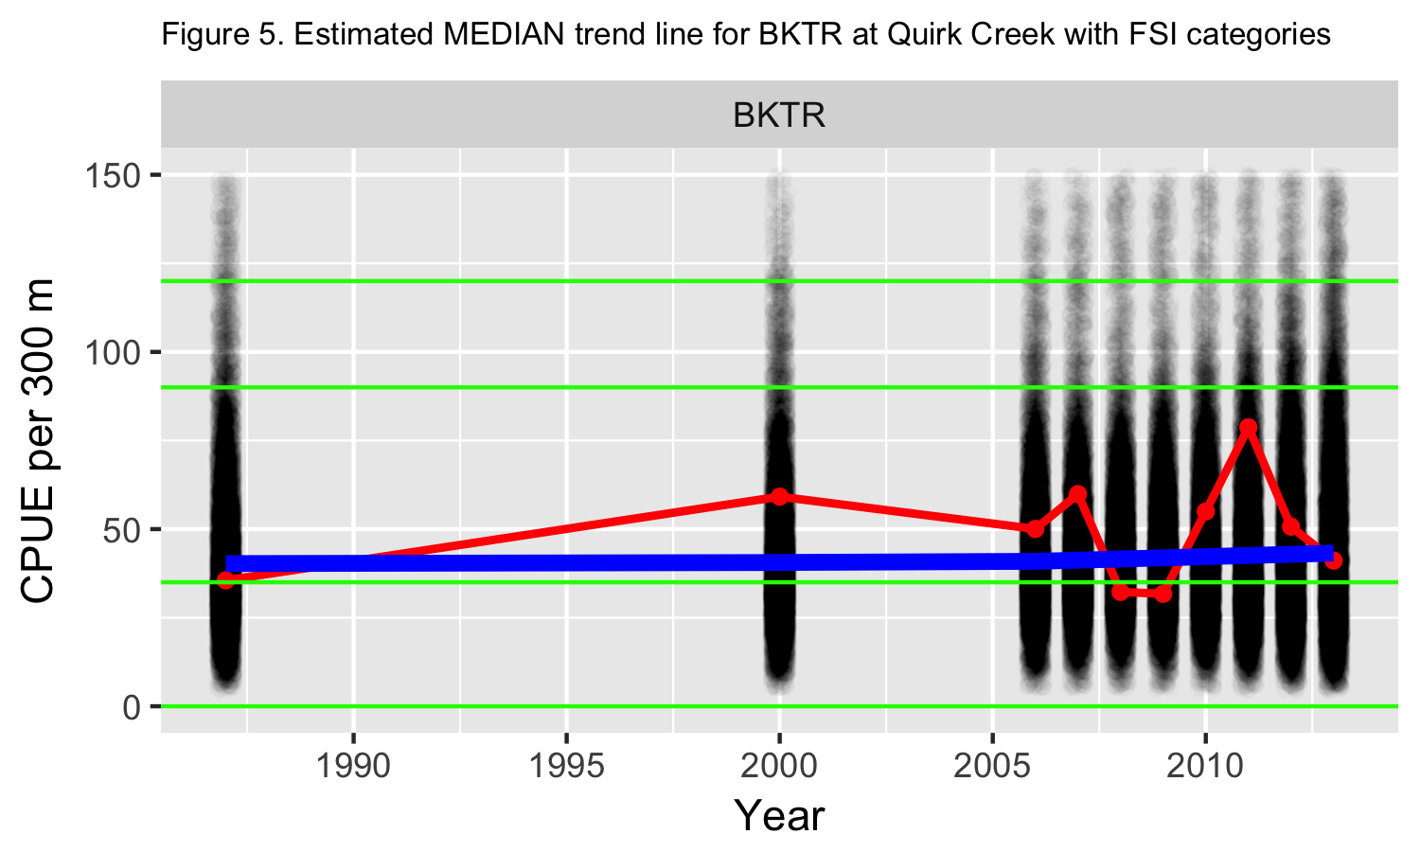

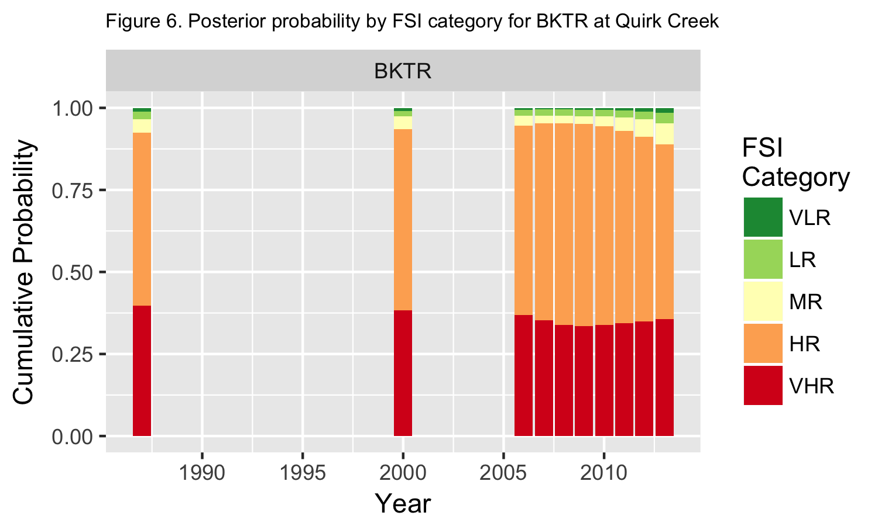

## BLTR

The mean fork length and size range for this species on a yearly basis are summarized in Table 3 and plotted in Figure 7.

Table 3. Summary statistics on fork length for BLTR captured in Quirk Creek

|  |  |  |  |  |
| --- | --- | --- | --- | --- |
| Year | n | Mean fork length mm | Min fork length mm | Max fork length mm |
| 1987 | 18 | 181 | 99 | 248 |
| 2000 | 1 | NA | NA | NA |
| 2006 | 75 | 204 | 136 | 273 |
| 2007 | 81 | 177 | 97 | 298 |
| 2008 | 31 | 202 | 134 | 277 |
| 2009 | 2 | 131 | 130 | 132 |
| 2010 | 4 | 189 | 154 | 231 |
| 2011 | 5 | 193 | 115 | 294 |
| 2012 | 17 | 139 | 103 | 259 |
| 2013 | 12 | 216 | 90 | 495 |

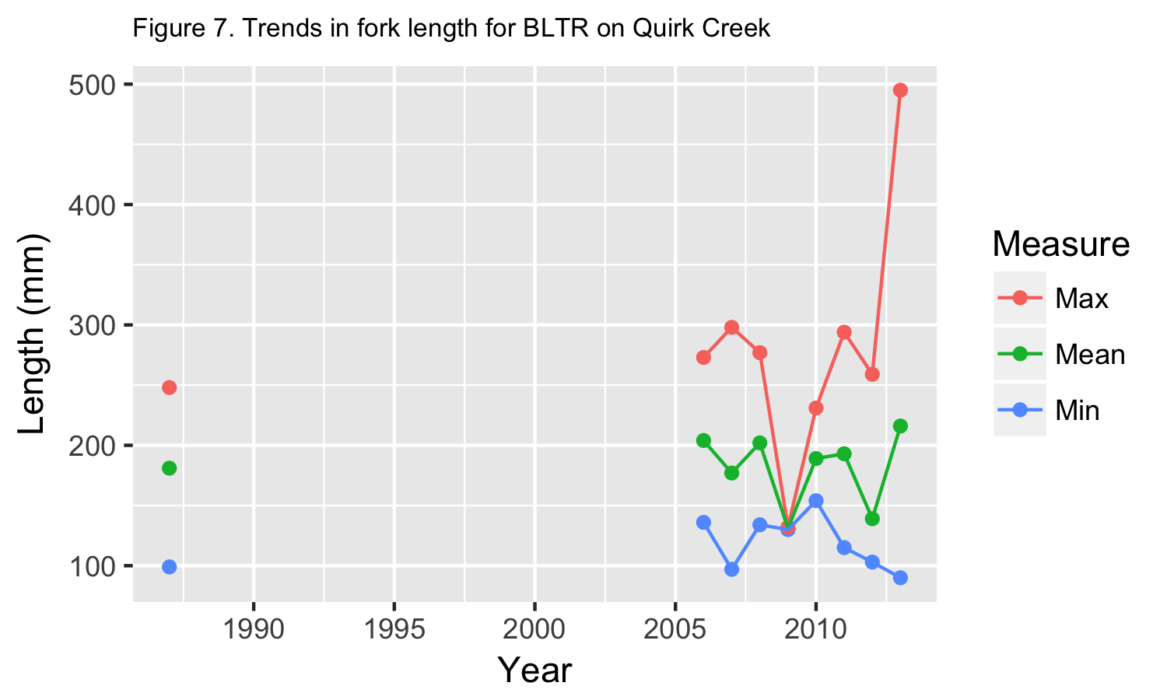

The length distribution over all years is shown in Figure 8. Black vertical line indicates estimated length at 50% maturity (**999999999999** mm Fork Length). {Not yet shown --How is this known from the data? }

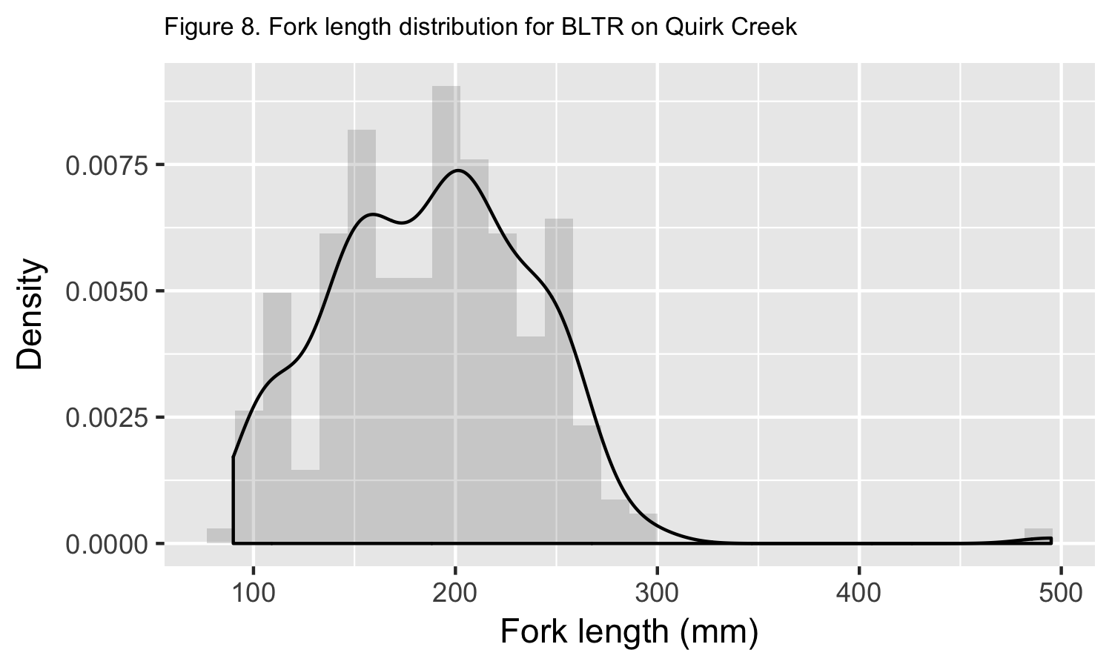

A plot of the CPUE over time is shown in Figure 9.

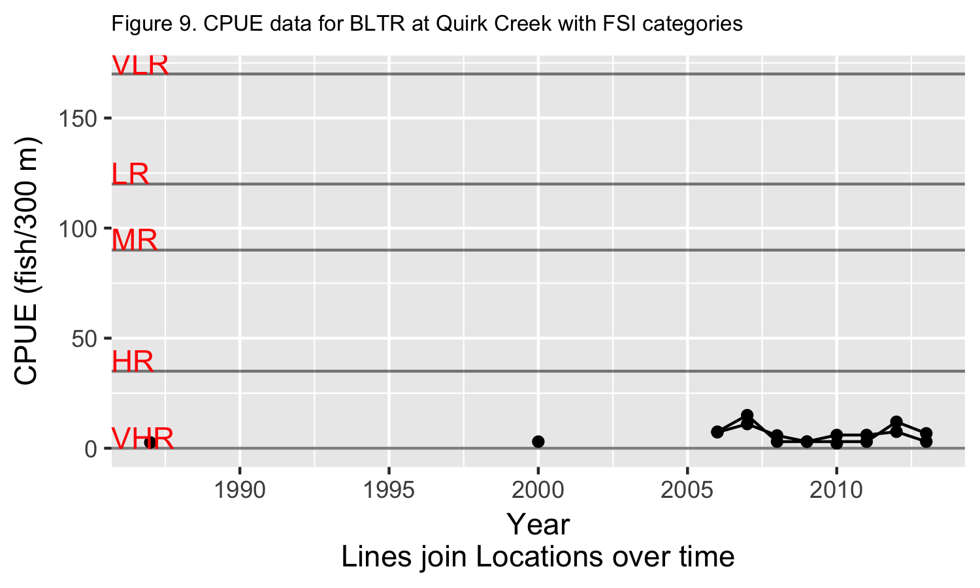

The Bayesian analysis on trend found that the median CPUE was changing at 1.05% (SD 8.90%) per year and the posterior probability that the slope is positive is 0.54.

Plots of the posterior distribution of the trend line for the median and the FSI Category membership are shown in Figure 10 and Figure 11.

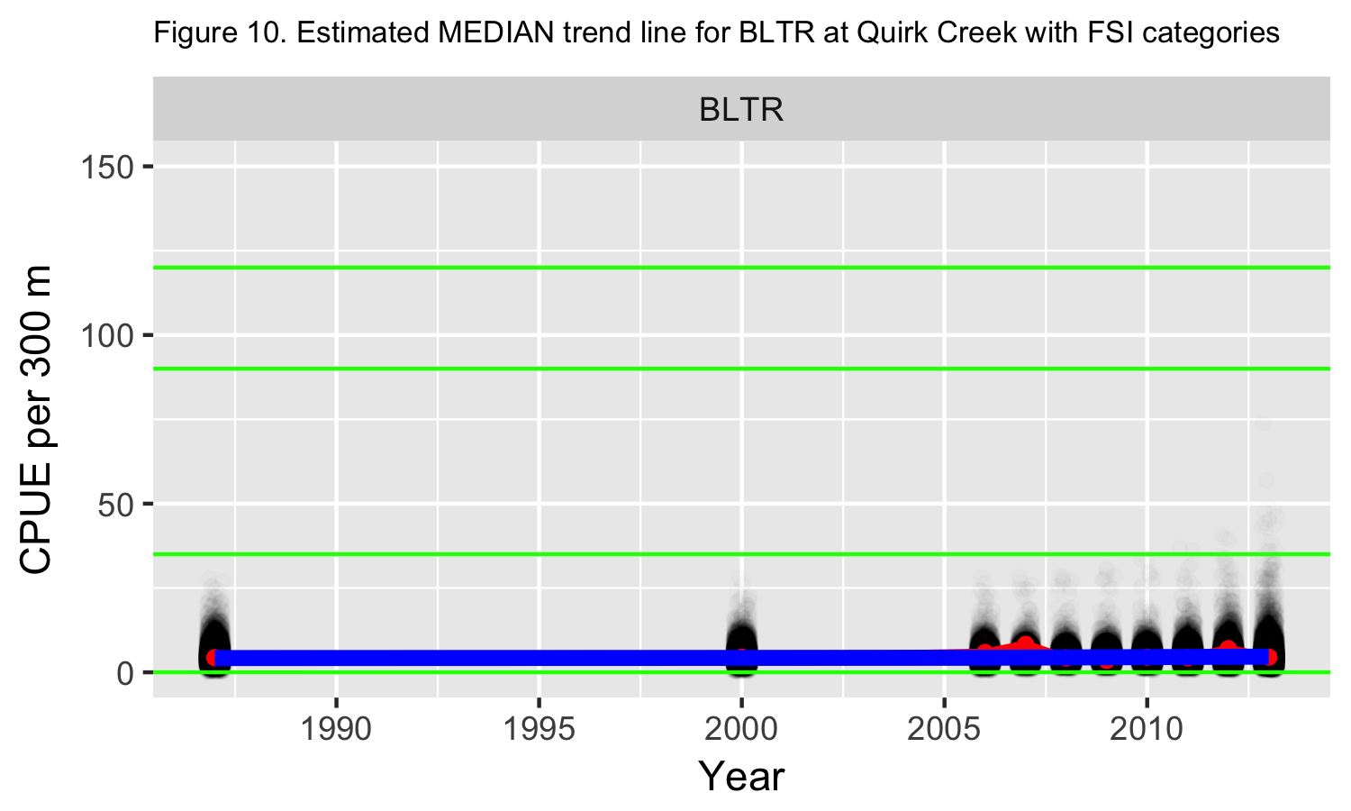

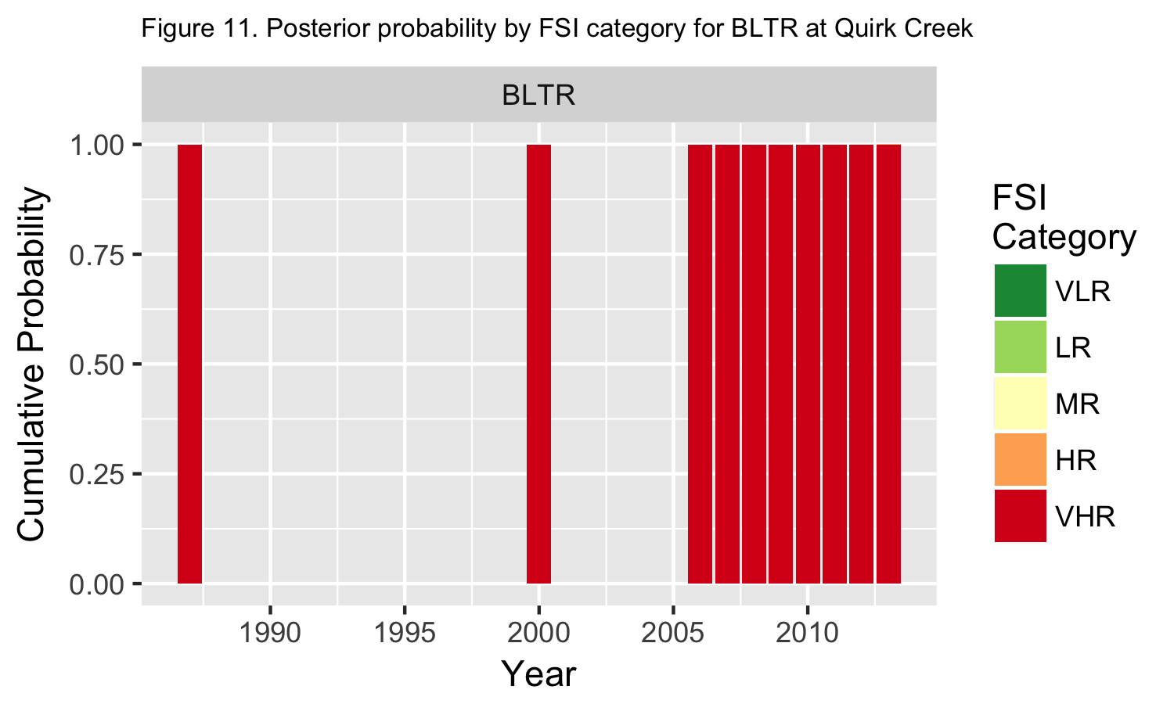

## BLBK

The mean fork length and size range for this species on a yearly basis are summarized in Table 4 and plotted in Figure 12.

Table 4. Summary statistics on fork length for BLBK captured in Quirk Creek

|  |  |  |  |  |
| --- | --- | --- | --- | --- |
| Year | n | Mean fork length mm | Min fork length mm | Max fork length mm |
| 2000 | 4 | 228 | 206 | 247 |
| 2006 | 103 | 127 | 82 | 312 |
| 2007 | 23 | 171 | 105 | 249 |
| 2008 | 2 | 236 | 226 | 246 |
| 2011 | 2 | 96 | 90 | 101 |
| 2013 | 4 | 156 | 136 | 181 |

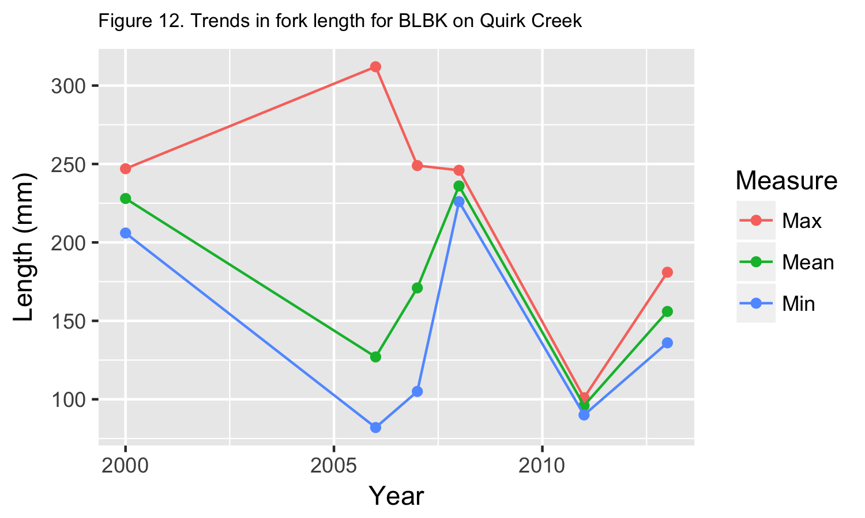

The length distribution over all years is shown in Figure 13. Black vertical line indicates estimated length at 50% maturity (**999999999999** mm Fork Length). {Not yet shown --How is this known from the data? }

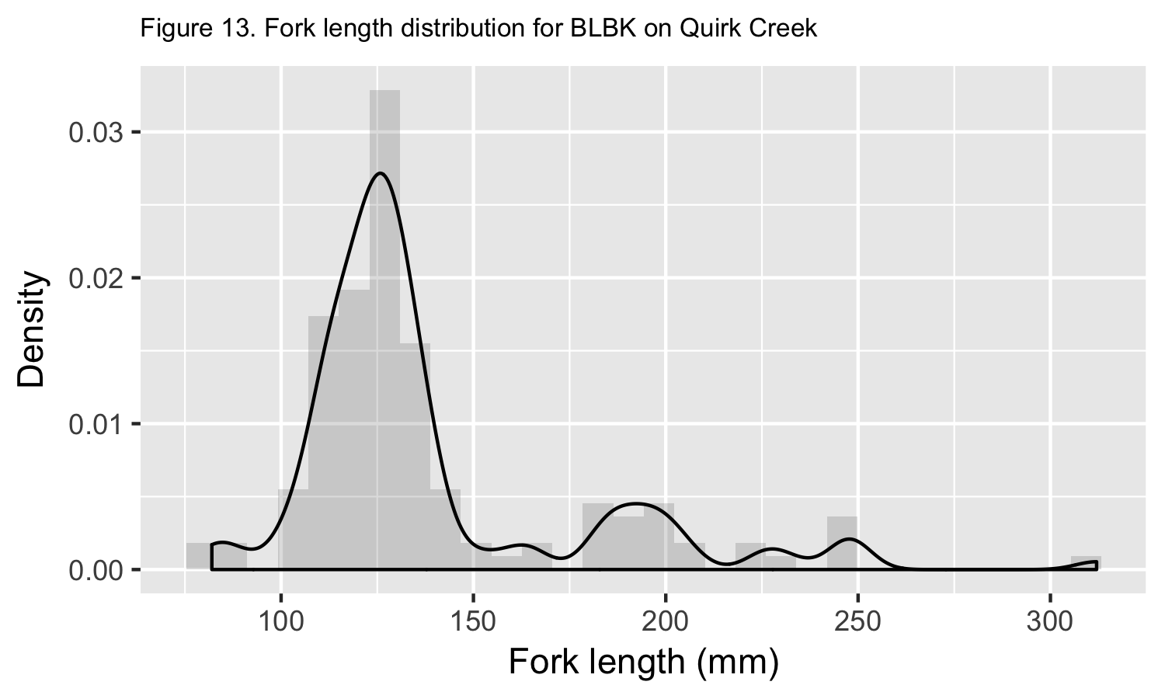

A plot of the CPUE over time is shown in Figure 14.

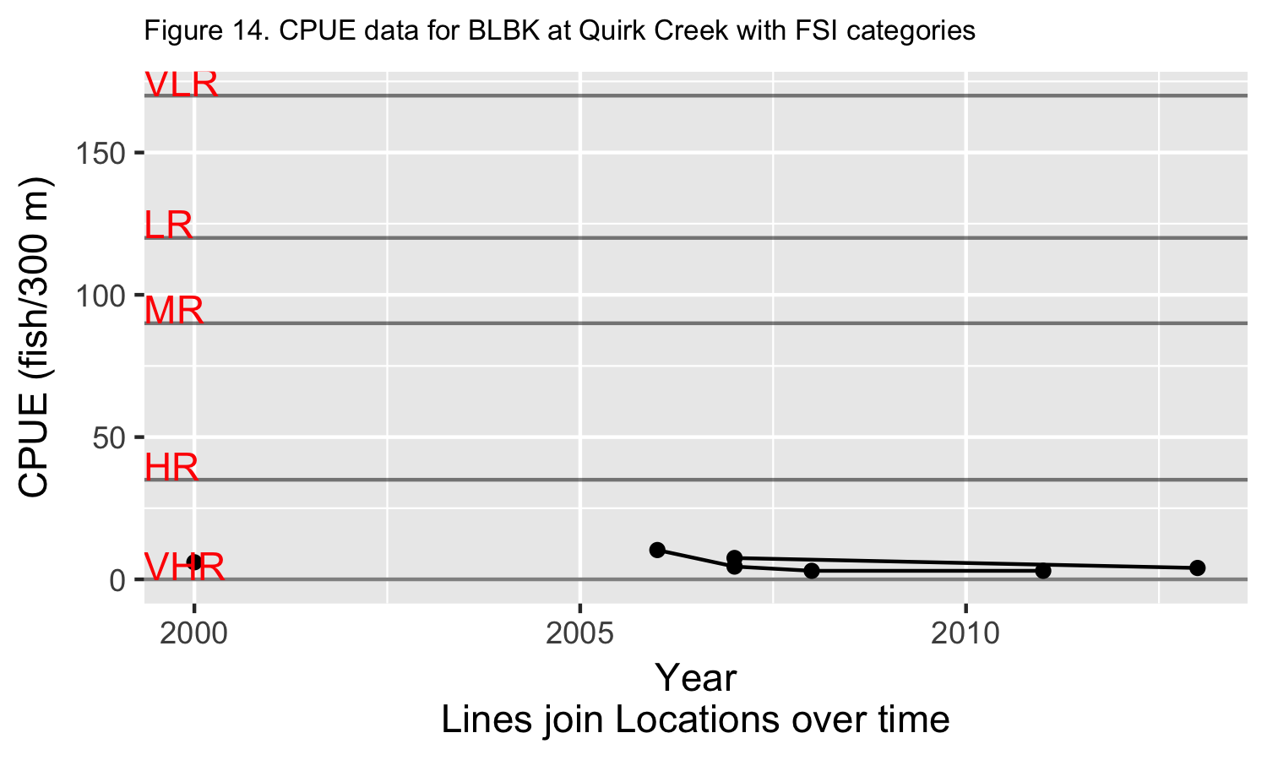

The Bayesian analysis on trend found that the median CPUE was changing at -21.52% (SD 18.77%) per year and the posterior probability that the slope is positive is 0.10.

Plots of the posterior distribution of the trend line for the median and the FSI Category membership are shown in Figure 15 and Figure 16.

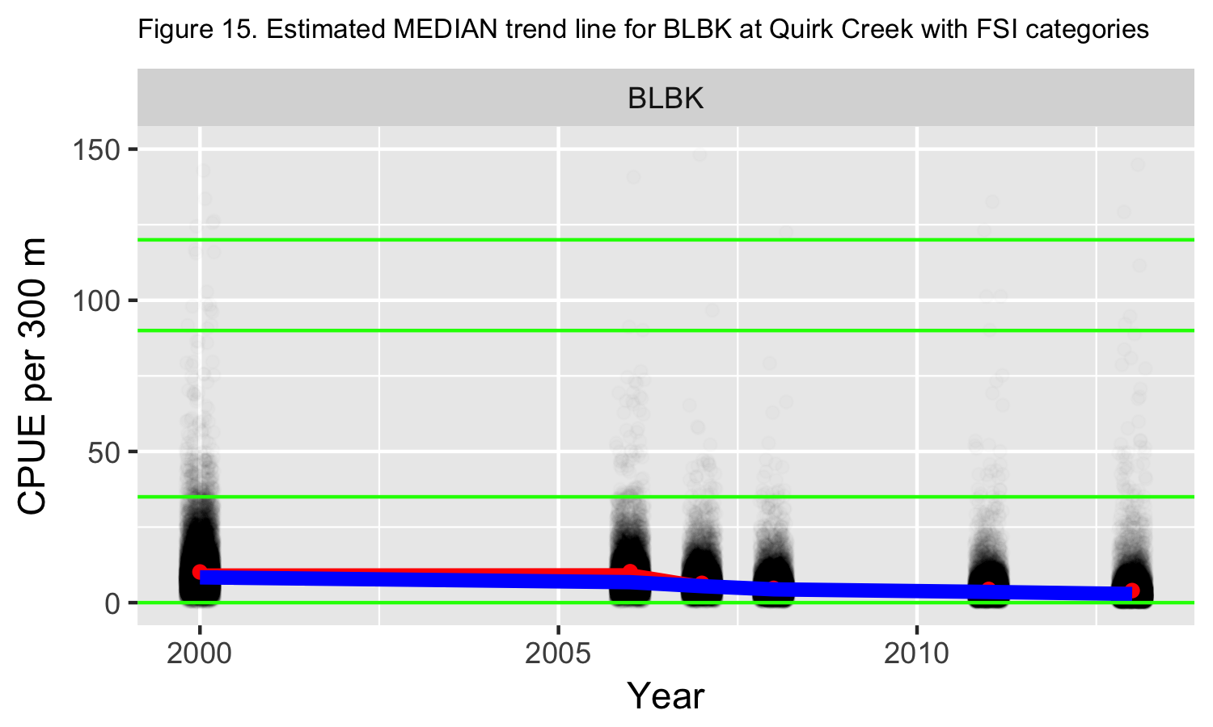

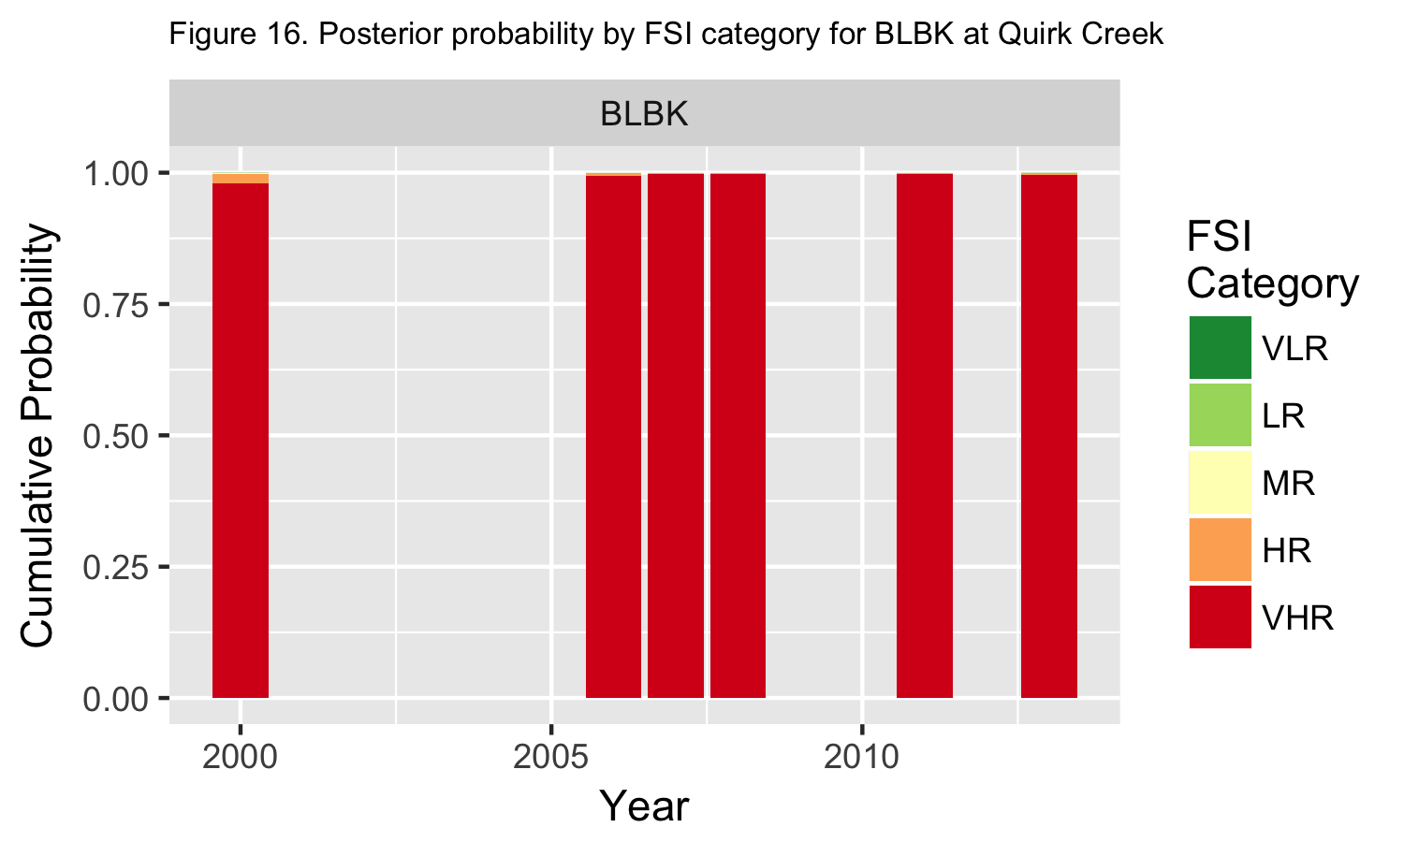

## CTTR

The mean fork length and size range for this species on a yearly basis are summarized in Table 5 and plotted in Figure 17.

Table 5. Summary statistics on fork length for CTTR captured in Quirk Creek

|  |  |  |  |  |
| --- | --- | --- | --- | --- |
| Year | n | Mean fork length mm | Min fork length mm | Max fork length mm |
| 1987 | 117 | 159 | 75 | 292 |
| 1988 | 7 | 215 | 145 | 278 |
| 2000 | 3 | 153 | 110 | 196 |
| 2006 | 418 | 167 | 28 | 390 |
| 2007 | 371 | 122 | 26 | 395 |
| 2008 | 335 | 130 | 30 | 401 |
| 2009 | 161 | 99 | 30 | 378 |
| 2010 | 157 | 115 | 31 | 320 |
| 2011 | 220 | 119 | 23 | 356 |
| 2012 | 107 | 101 | 22 | 351 |
| 2013 | 76 | 134 | 30 | 373 |

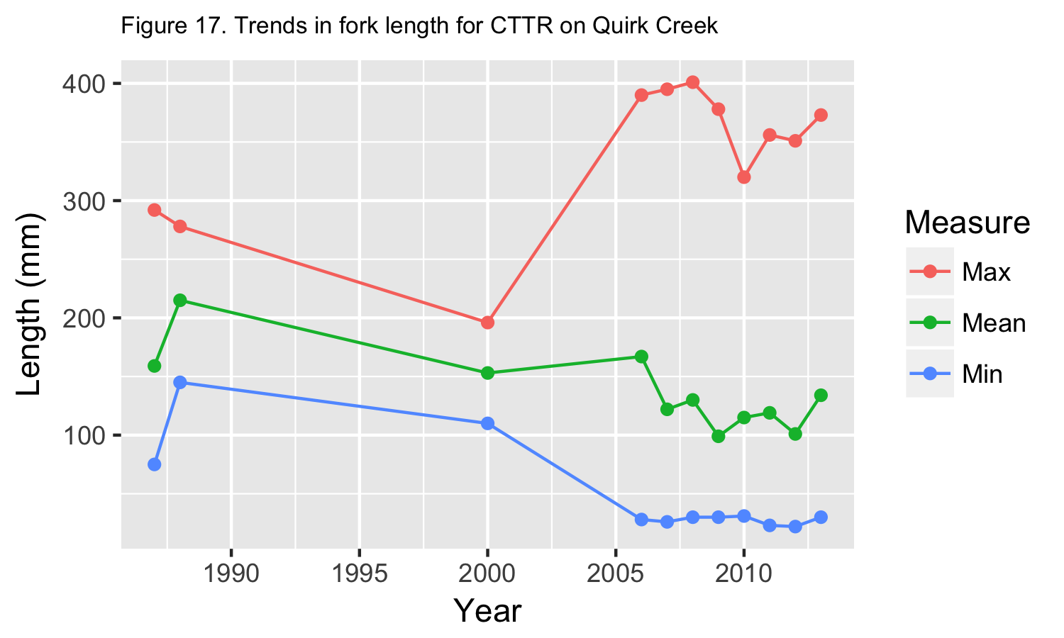

The length distribution over all years is shown in Figure 18. Black vertical line indicates estimated length at 50% maturity (**999999999999** mm Fork Length). {Not yet shown --How is this known from the data? }

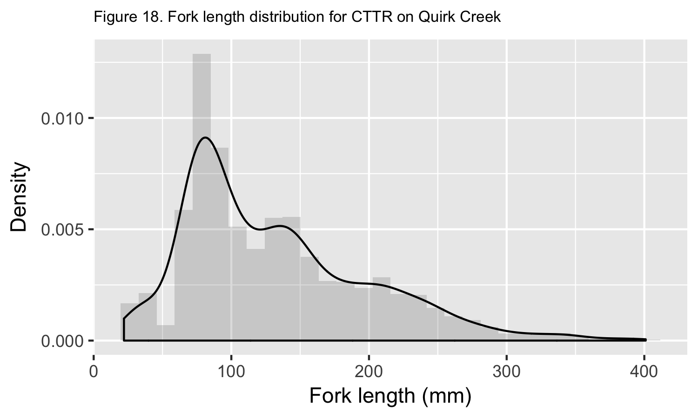

A plot of the CPUE over time is shown in Figure 19.

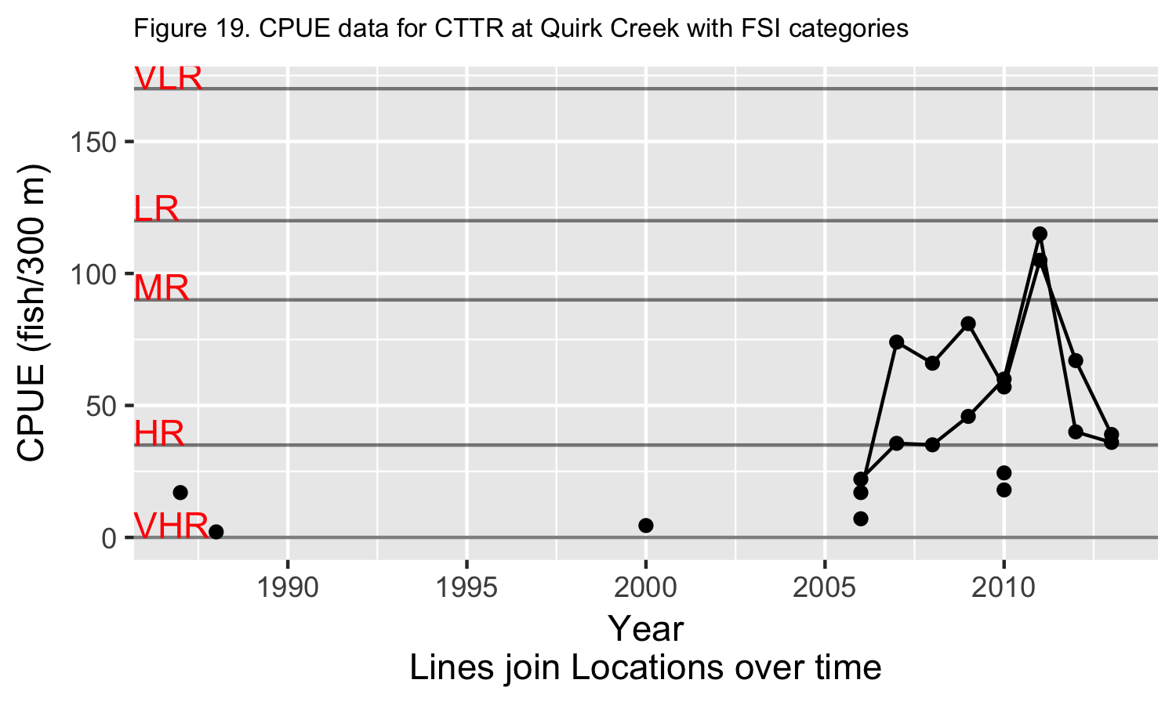

The Bayesian analysis on trend found that the median CPUE was changing at 14.47% (SD 8.95%) per year and the posterior probability that the slope is positive is 0.96.

Plots of the posterior distribution of the trend line for the median and the FSI Category membership are shown in Figure 20 and Figure 21.

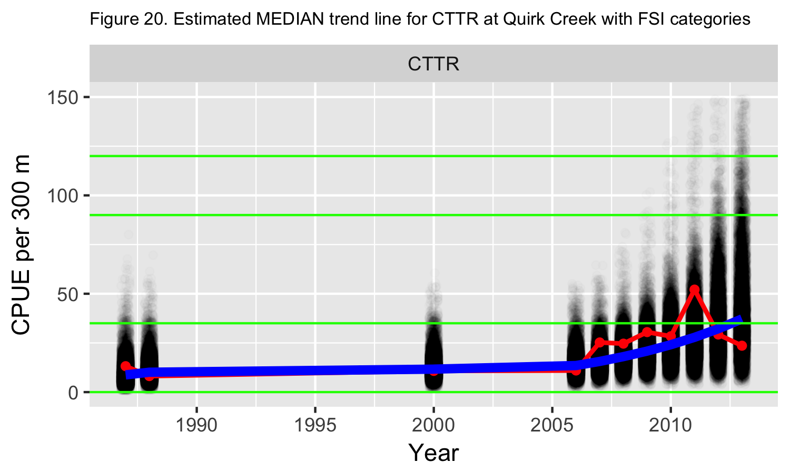

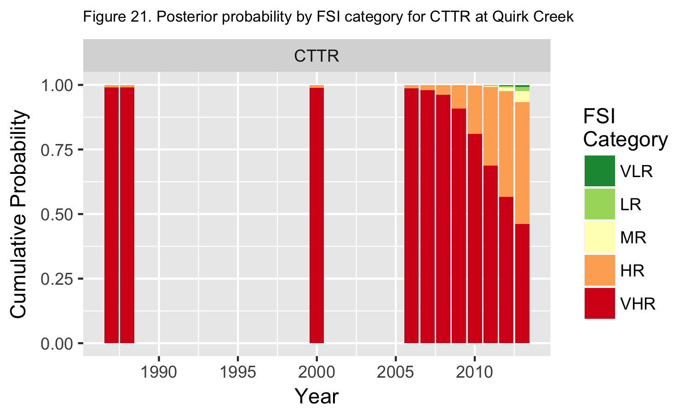

# Summary

**Describe where fish are found in the watershed (general statement for all game fish species) For each game species interpret the catch rate and size distribution. What does this mean for the population? Did any environmental factors potentially influence assessment e.g. flood? What kind of conservation actions need to be taken?**

# References

Alberta Biodiversity Monitoring Institute and Alberta Sustainable Resource Development (ABMI and ASRD). 2014.

Fish Survey Methods for Rivers: ABMI and ASRD Collaboration. Written by Jim Schiek and edited by M.G. Sullivan. Prepared for Alberta Biodiversity Monitoring Institute andAlberta Sustainable Resource Development. 20 pp.

Alberta Fisheries Management Branch. 2013. Standard for sampling of small streams in Alberta. Alberta Environment and Sustainable Resource Development, Fisheries Management Standards Committee. 19 pp.

Environmental Systems Research Institute (ESRI). 2013. ArcGIS Desktop: Version 10.2. Redlands , CA: Environmental Systems Research Institute.

R Core Team. 2015. R: A language and environment for statistical computing. R Foundation forStatistical Computing, Vienna, Austria. URL [(http://www.R-project.org/](http://www.R-project.org/).

Mackay, W.C., G.R. Ash, H.J. Norris. 1990. Fish ageing methods for Alberta. R.L. & L. Environmental Services Ltd. In assoc. with Alberta Fish and Wildlife Division and University of Alberta, Edmonton. 113 pp.

Microsoft Corporation. 2010. Microsoft Excel, version 14.0.7145.5000.  
Part of Microsoft Office Professional Plus 2010. Redmond Washington.

Reilly, J. 2016. GRTS: User friendly method for busy biologists. Alberta Environment and Parks. 4 pp.

Schwarz, C.J. 2017. Bayesian classification into the Alberta FWIS Categories. Unpublished report.

Statistical Analysis Software (SAS) Institute Inc. 2016. JMP Statistical Discovery, version 13.0.0. SAS Campus Drive, Cary, North Carolina 27513, USA.

Slipke, J.W. 2010. Fishery Analyses and Modeling Simulator (FAMS). Version 1.0.

Alberta Sustainable Resource Development (ASRD). 2008. Electrofishing Certification and Safety Standard. Alberta Sustainable Resource Development, Fish and Wildlife Division. Edmonton, AB. 76 pp.

Stevens, D.L., A.R. Olsen. 2004. Spatially balanced sampling of natural resources. Journal of the American Statistical Association 99(465):262-278.

Watkins, O.B., S.C. Spencer. 2009. Collection, preparation and ageing of walleye otoliths. Alberta Sustainable Resource Development, Fish and Wildlife Division. Spruce Grove, AB. 26 pp.