**Power analysis for** **Evaluating the effectiveness of intensive OHV reclamation activities to recover native trout along the East Slopes of Alberta, Canada.**

2018-05-25

# Introduction

This report is a power analysis for a proposed restoration actions to recover native trout along the east slopes of Alberta, Canada.

The basic design is explained in Reilly (2018) . Briefly, there are three watersheds where restoration actions will take place – Clearwater, Athabasca/North Saskatchewan, Falls Creek.. In the Clearwater watershed, restoration actions will take place on the Rocky stream, with three control streams (Cutoff, Limestone, and Elk). In the Athabasca/North Saskatchewan watershed, restoration actions will take place in the Mackenzie stream, with two control streams (Moon and Thistle). The Falls Creek restoration has no specified control streams.

The target increase of interest is a 2x increase in the mean CUE between the pre- and post-restoration periods.

Several levels of analysis will be performed.

Because the Falls Creek does not have any control streams, only a before/after comparsion will be possible.

A BACI analysis will be performed to measure the impact of restoration in the Clearwater and Athabasca/NS watershed on the catch per unit effort (CUE, fish/300 m) based on 1-pass electrofishing at randomly selected sites within each stream as described elsewhere.

Finally, all watershed will be combined into a super-BACI design.

# Data sources.

The FWMIS was queried for historical data on the 8 streams from 2010 onwards. A site on a stream was defined as the combination of latitude and longitude present in the file. The data file for Thistle Stream did not have any co-ordinate information. For this stream, the geographic co-ordinates as found on Wikipedia were “jittered” to produce 8 unique locations corresponding to the “site” label on file. A plot of the sites measured is found in Figure 1. There appears to be few (if any sites) that are repeatedly measured over time.

A common problem with databases such as FWMIS is dealing with sites where NO fish are captured. The FWMIS system inserts “dummy” records corresponding sites where no fish are capture. These sites have been included in Figure 1.

Only information from electofishing surveys conducted in June to October was retained. A summary of the number of sites measured in each stream is found in Table 1. Notice that Fall Stream was only measured in one year (2017) at two sites.

Information on CUE for BLTR, BKTR, and RNTR was retained. Only BLTR was captured at Thistle Creek.

Fish were divided in mature and immature age classes. The dividing point for BLTR was 150 mm. Insert dividing line here for other species.

Because the distance surveyed at each site-year possibly changed over the year, CUE for both age classes was standardized to a fish/300 m basis. A plot of the raw CUE is found in Figure 2. and on the logarithmic[1] scale in Figure 3. The mean CUE is shown in Figure 4.

The power to detect changes depends on several sources of variation.

* Year-to-Year (process variation) – year-specific effects may force the CUE to be higher or lower than the trend line
* Stream-to-Stream – different streams have different productivity
* Stream-Year – different streams may change in response to year specific factors in different ways
* Residual (Site) – different sites have different CUE on the same stream in the same year.

Because no site was measured on the same stream in different years, it is not possible know if there are local site effects as well.

These variance components were estimated using a mixed-linear model

where the *Year* term represents any trend over time; the *YearC* represents the random year-specific effects (categorical effect of year); the *Stream(R)* represents the random effect of the stream (productivity differences); the *Year:Stream(R)* represents the stream-year interaction; and the residual (site) effects is implicit. Because Fall Creek was only measured on one year, only residual (site-to-site) variation can be estimated. Estimates of the variance components is presented in Table 2.

There is no evidence of year-specific effects (process error) and site-to-site variation is fairly similar except for Fall Creek (mature).

# Estimates of Before/After power

The Fall Creek watershed has no control streams and so only a before/after analysis can be done for this watershed. Unfortunately, there is only 1 year of historical data available for this creek, and so the year-to-year variation (process error) cannot be estimated, but based on results from the other watershed (Table 2), it will be assumed that the process error is also small.

A before/after power analysis was computed using the following attributes:

* Alpha level. This is set to 0.05
* Effect size. The target effect size is a 2x increase in CUE. This corresponds to a log(2)=0.69 change on the logarithmic scale.
* Number of years stream is measured before restoration actions. We investigated 2:5 years of “before” data for this stream
* Number of years this stream is measured after restoration actions. We investigated 1, 2, 3, 4, 5, 7, 10, and 15 years of “after” data.
* Number of sites measured in each stream-year. We investigated 5, 10, 15, or 20 sites/year.

The variance components (Table 2) were used to estimate the (one sided) power of a Before/After design based on all combinations of the above and power plots are shown in Figure 5 for BLTR.

Generally speaking, the power to detect a before/after change was high for mature fish with even a small number of sites sampled/year and 10 sites/year are needed for detecting a similar change for immature fish.

# Estimates of BACI power

There are many parts of a BACI design that can be manipulated to affect the power of the design to detect an effect:

* Alpha level. This is set to 0.05
* Effect size. The target effect size is a 2x increase in CUE. This corresponds to a log(2)=0.69 change on the logarithmic scale.
* Number of years each stream is measured before restoration actions. We investigated 2:5 years of “before” data for each stream
* Number of years each stream is measured after restoration actions. We investigated 1, 2, 3, 4, 5, 7, 10, and 15 years of “after” data.
* Number of control streams. This is set to 2 for the Athabasca/NS watershed and 3 for the Clearwater watershed. A value of 2 was arbitrarily chosen for the Fall creak watershed.
* Number of treatment streams. There is 1 treatment stream in each watershed.
* Number of sites measured in each stream-year. We investigated 5, 10, 15, or 20 sites/year.

The variance components (Table 2) were used to estimate the (one sided) power of BACI design based on all combinations of the above and power plots are shown in Figure 6 for BLTR.

Not unexpectedly, power tends to increase with more sites measured/year, and more years of “after” measurements. Power also tends to increase with more “before” measurements, but the effect is not that large.

Power is generally poor for the immature fish in the Athabasca/NS watershed because of the presence of a large stream:year interaction (Table 2 and Figure 4). This interaction term is of the limiting factor in BACI designs and implies that the streams behave differently over time.

Generally speaking 10 sites/stream measured for 4 years after restoration should have adequate power to detect these large scale response to restoration.

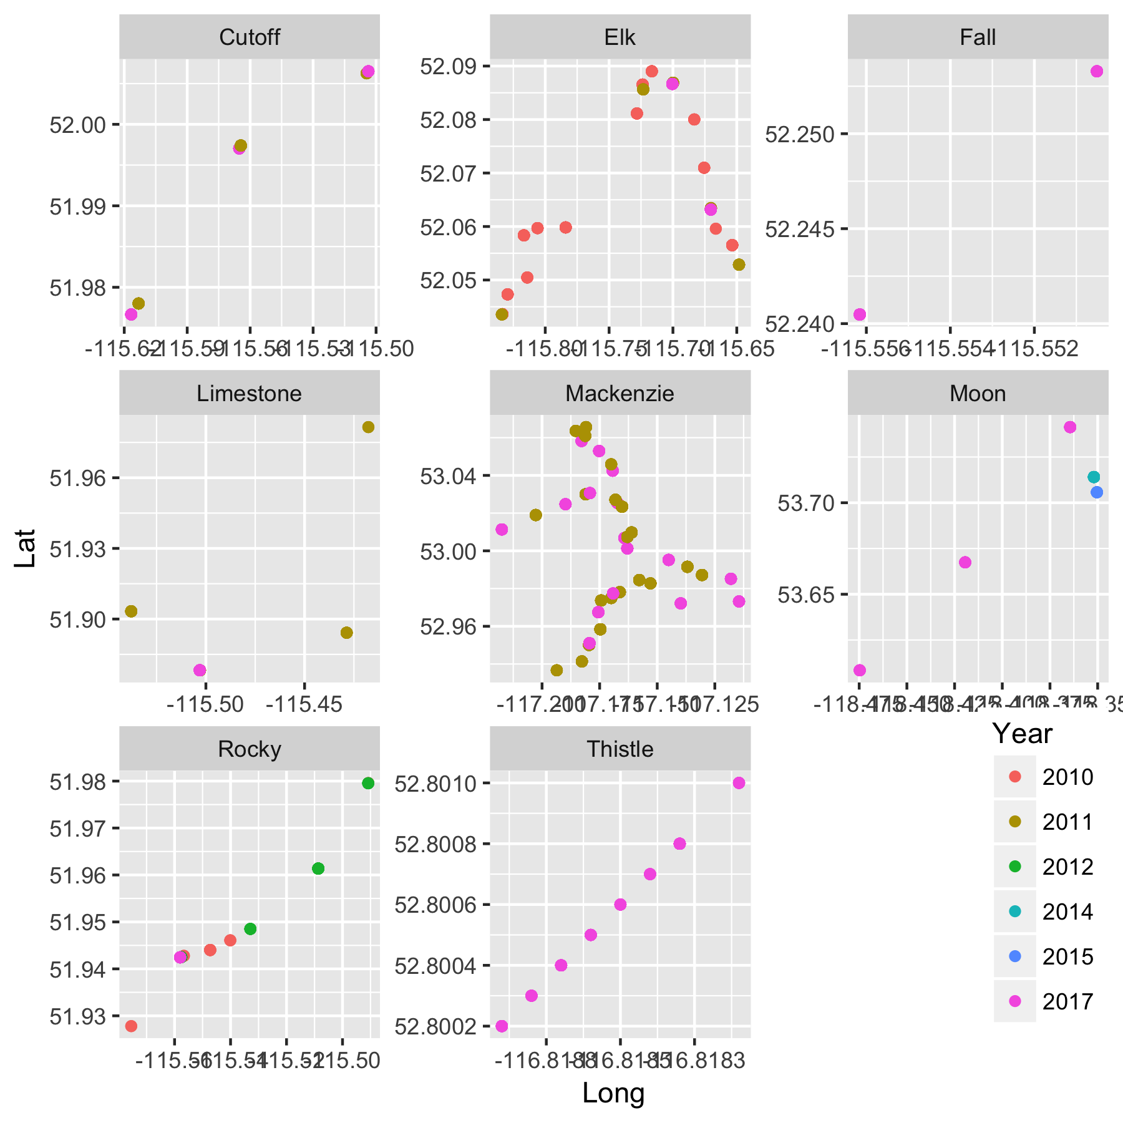

Figure 1. Locations of sites measured at streams in historical data. The data file for Thistle Stream did not have any co-ordinate information. For this stream, the geographic co-ordinates as found on Wikipedia were “jittered” to produce 8 unique locations corresponding to the “site” label on file and so the co-ordinates of sites on Thistle are arbitrary. A common problem with databases such as FWMIS is dealing with sites where NO fish are captured. The FWMIS system inserts “dummy” records corresponding sites where no fish are capture. These sites have been included in Figure 1.

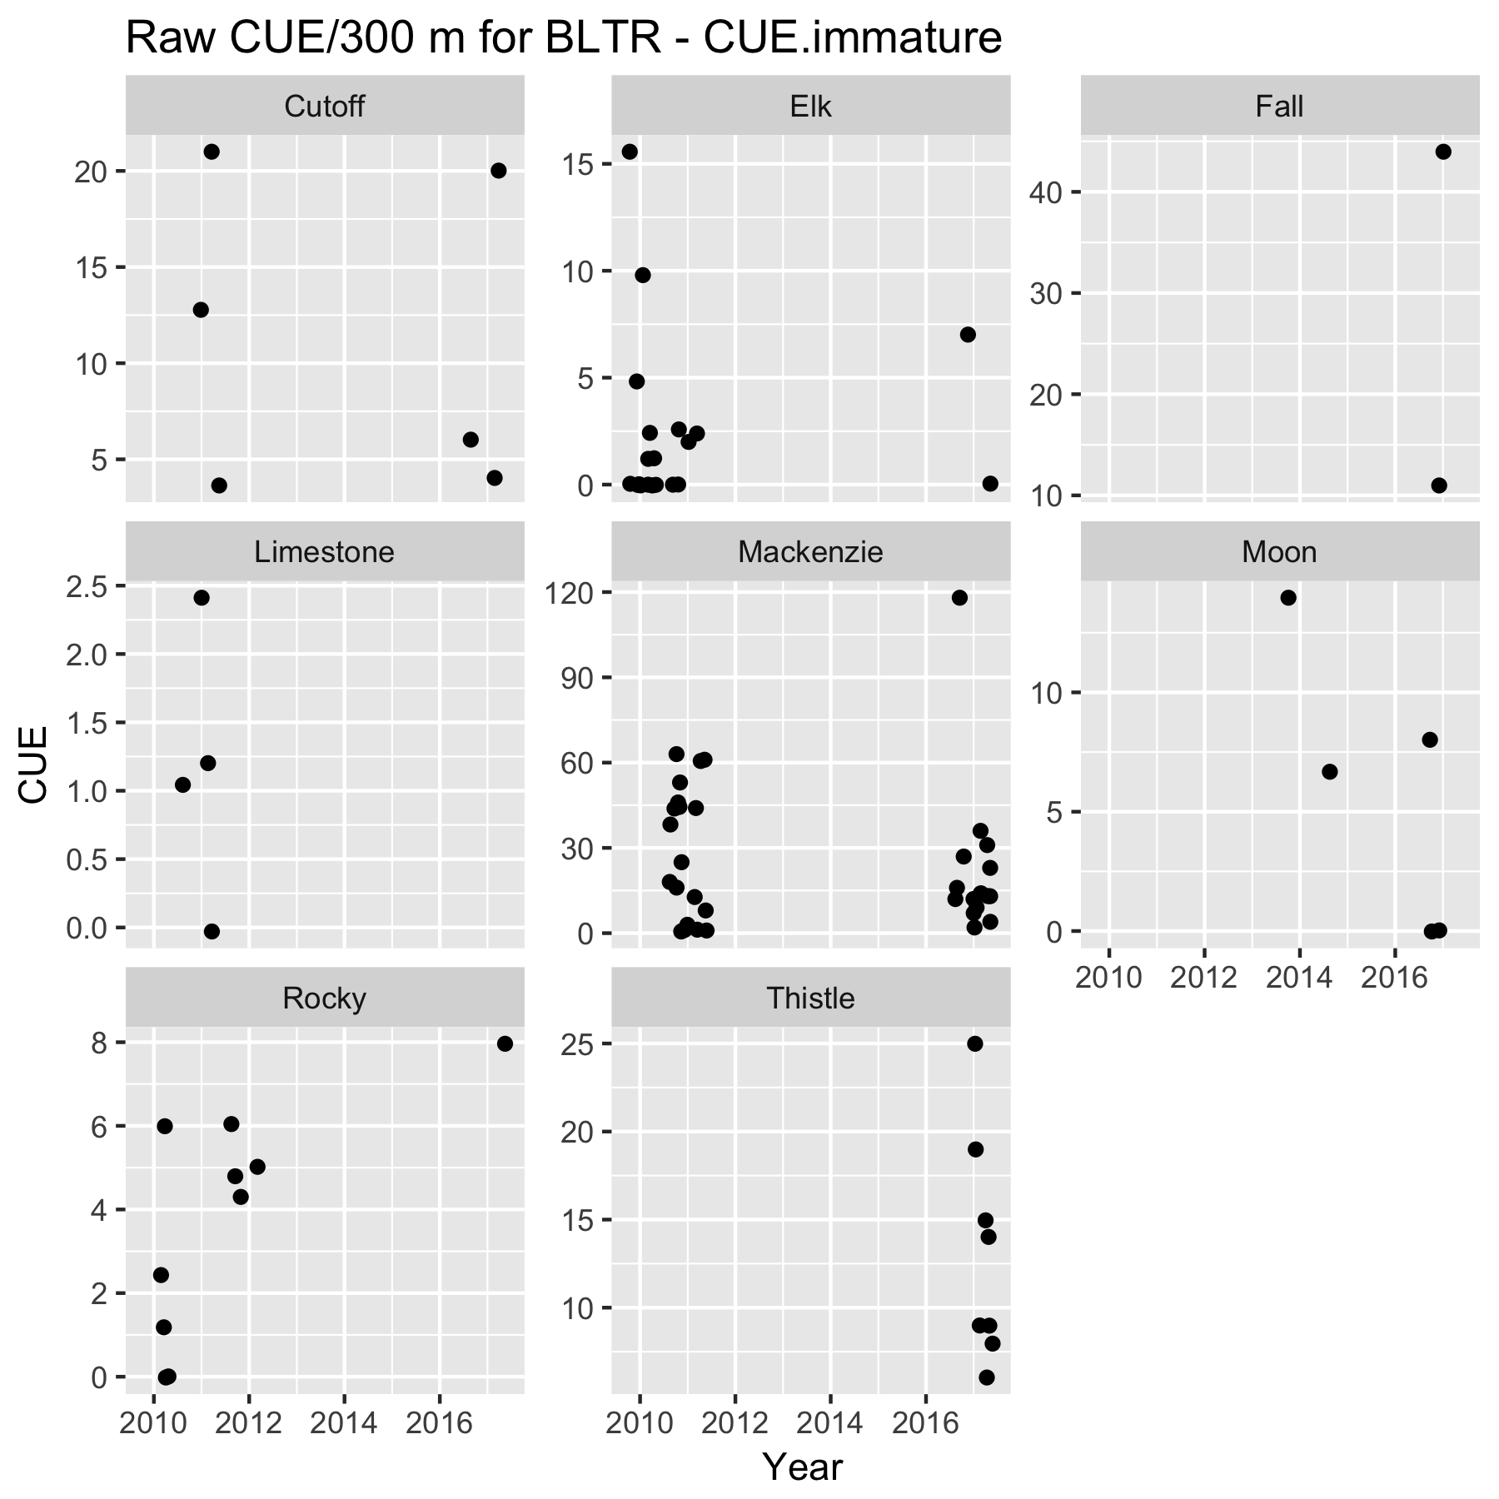

Figure 2a. Raw CUE (fish/300 m) for BLTR for each stream. Points jittered within years to prevent overplotting.

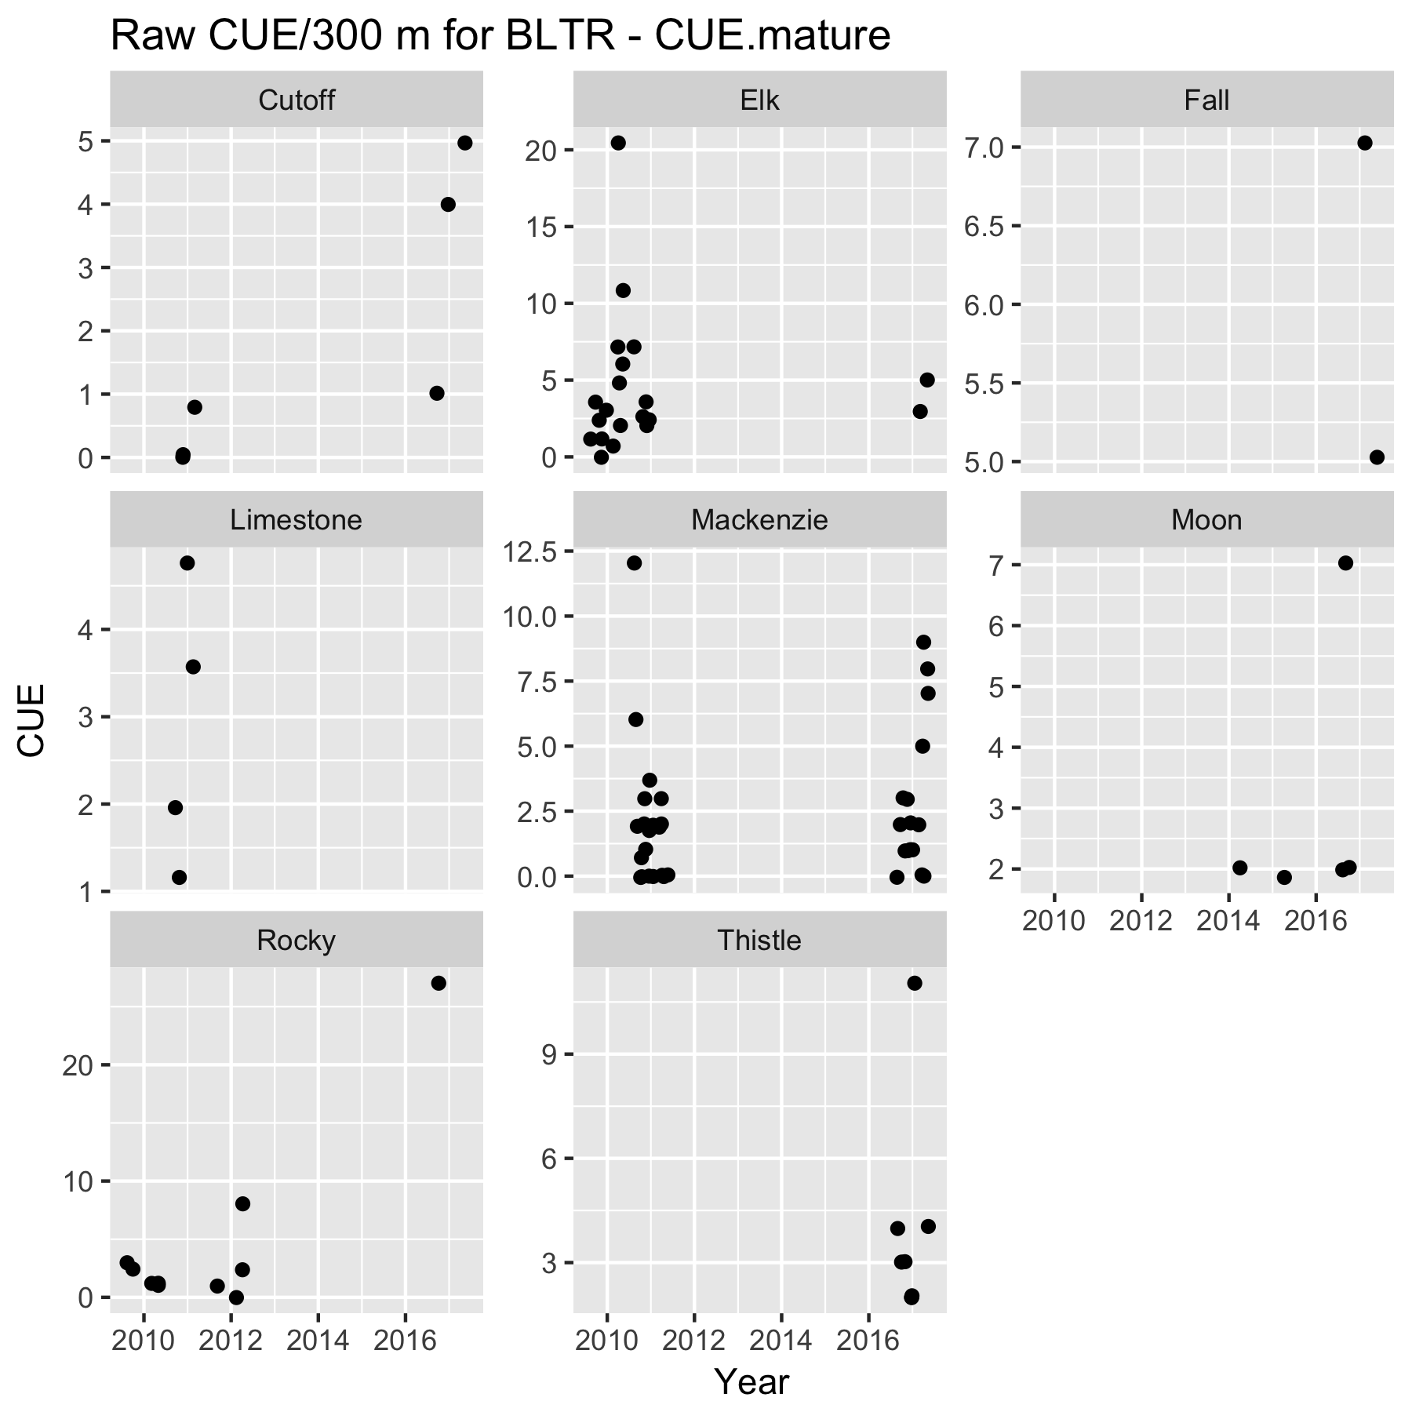

Figure 2b. Raw CUE (fish/300 m) for BLTR for each stream. Points jittered within years to prevent overplotting.

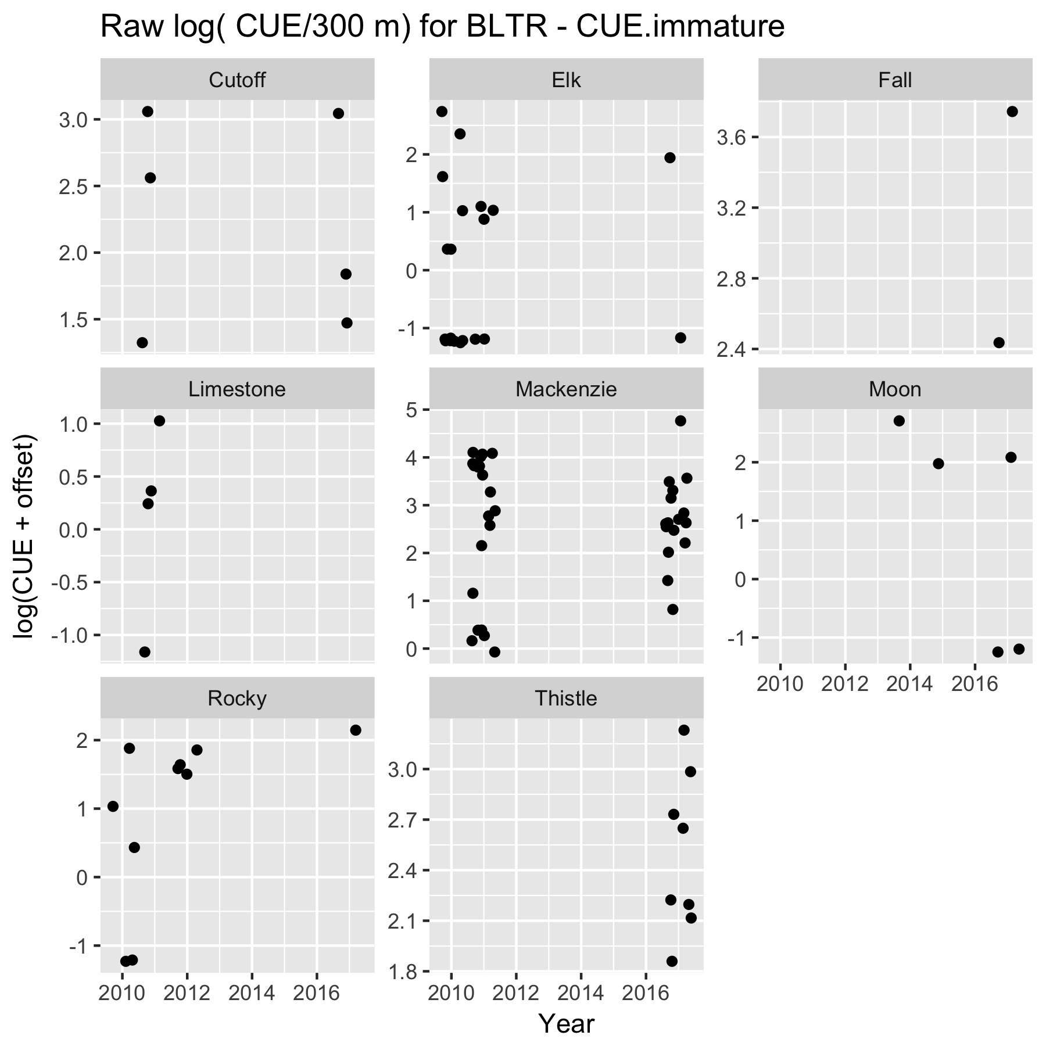

Figure 2a. Log( CUE (fish/300 m)) for BLTR for each stream. Points jittered within years to prevent overplotting.

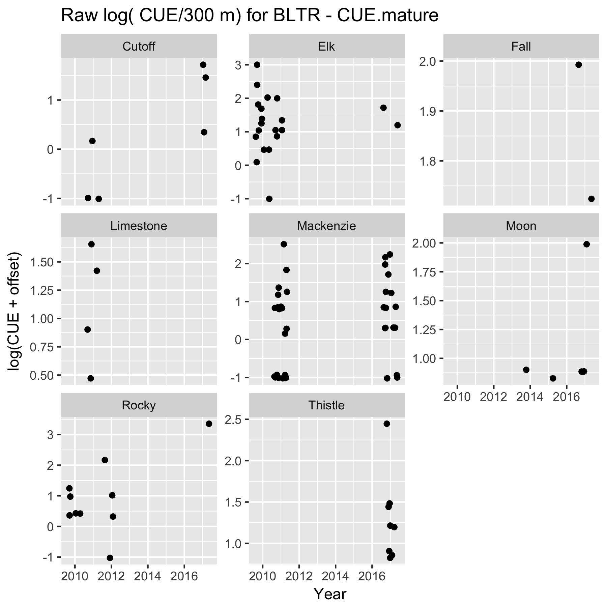

Figure 3b. Log( CUE (fish/300 m)) for BLTR for each stream. Points jittered within years to prevent overplotting.

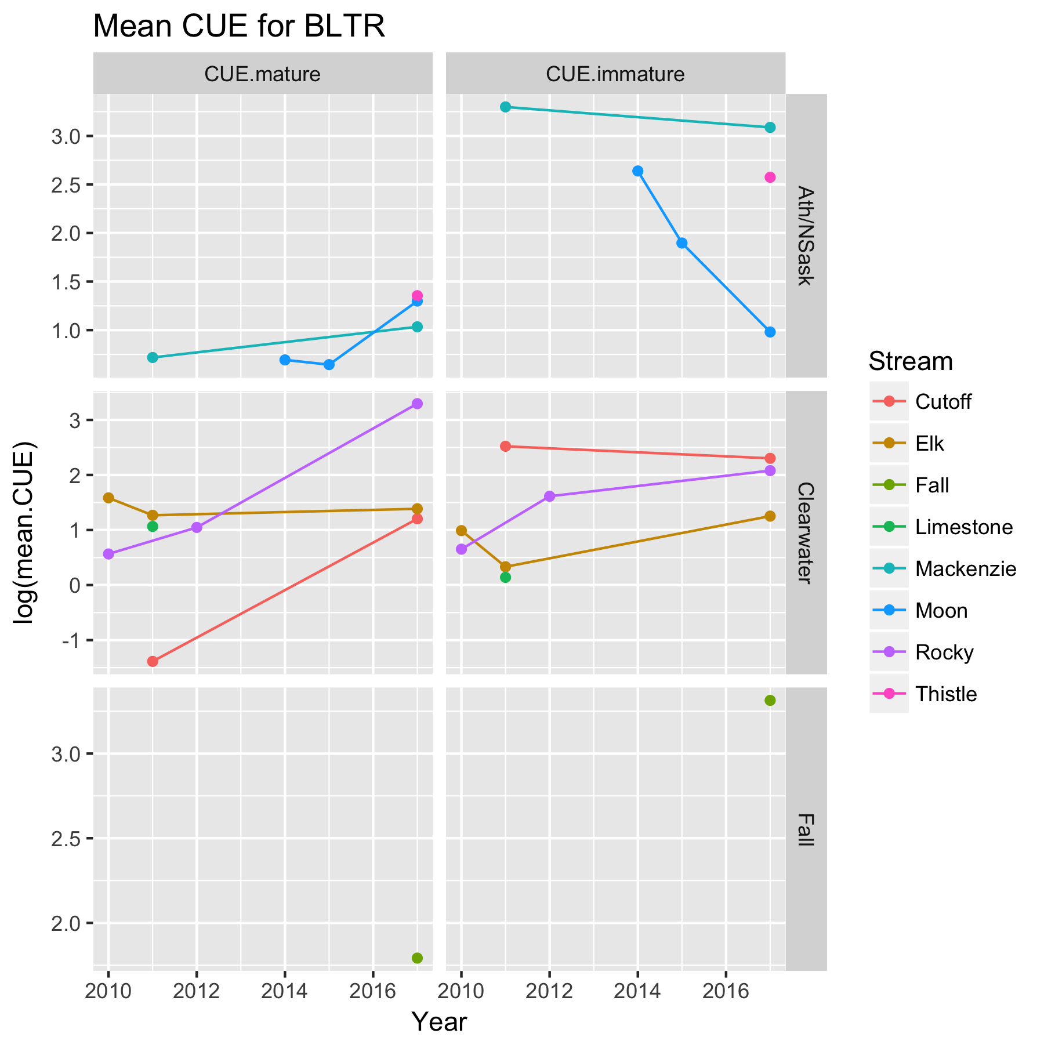

Figure 4. Mean log( CUE (fish/300 m)) for BLTR for each stream.

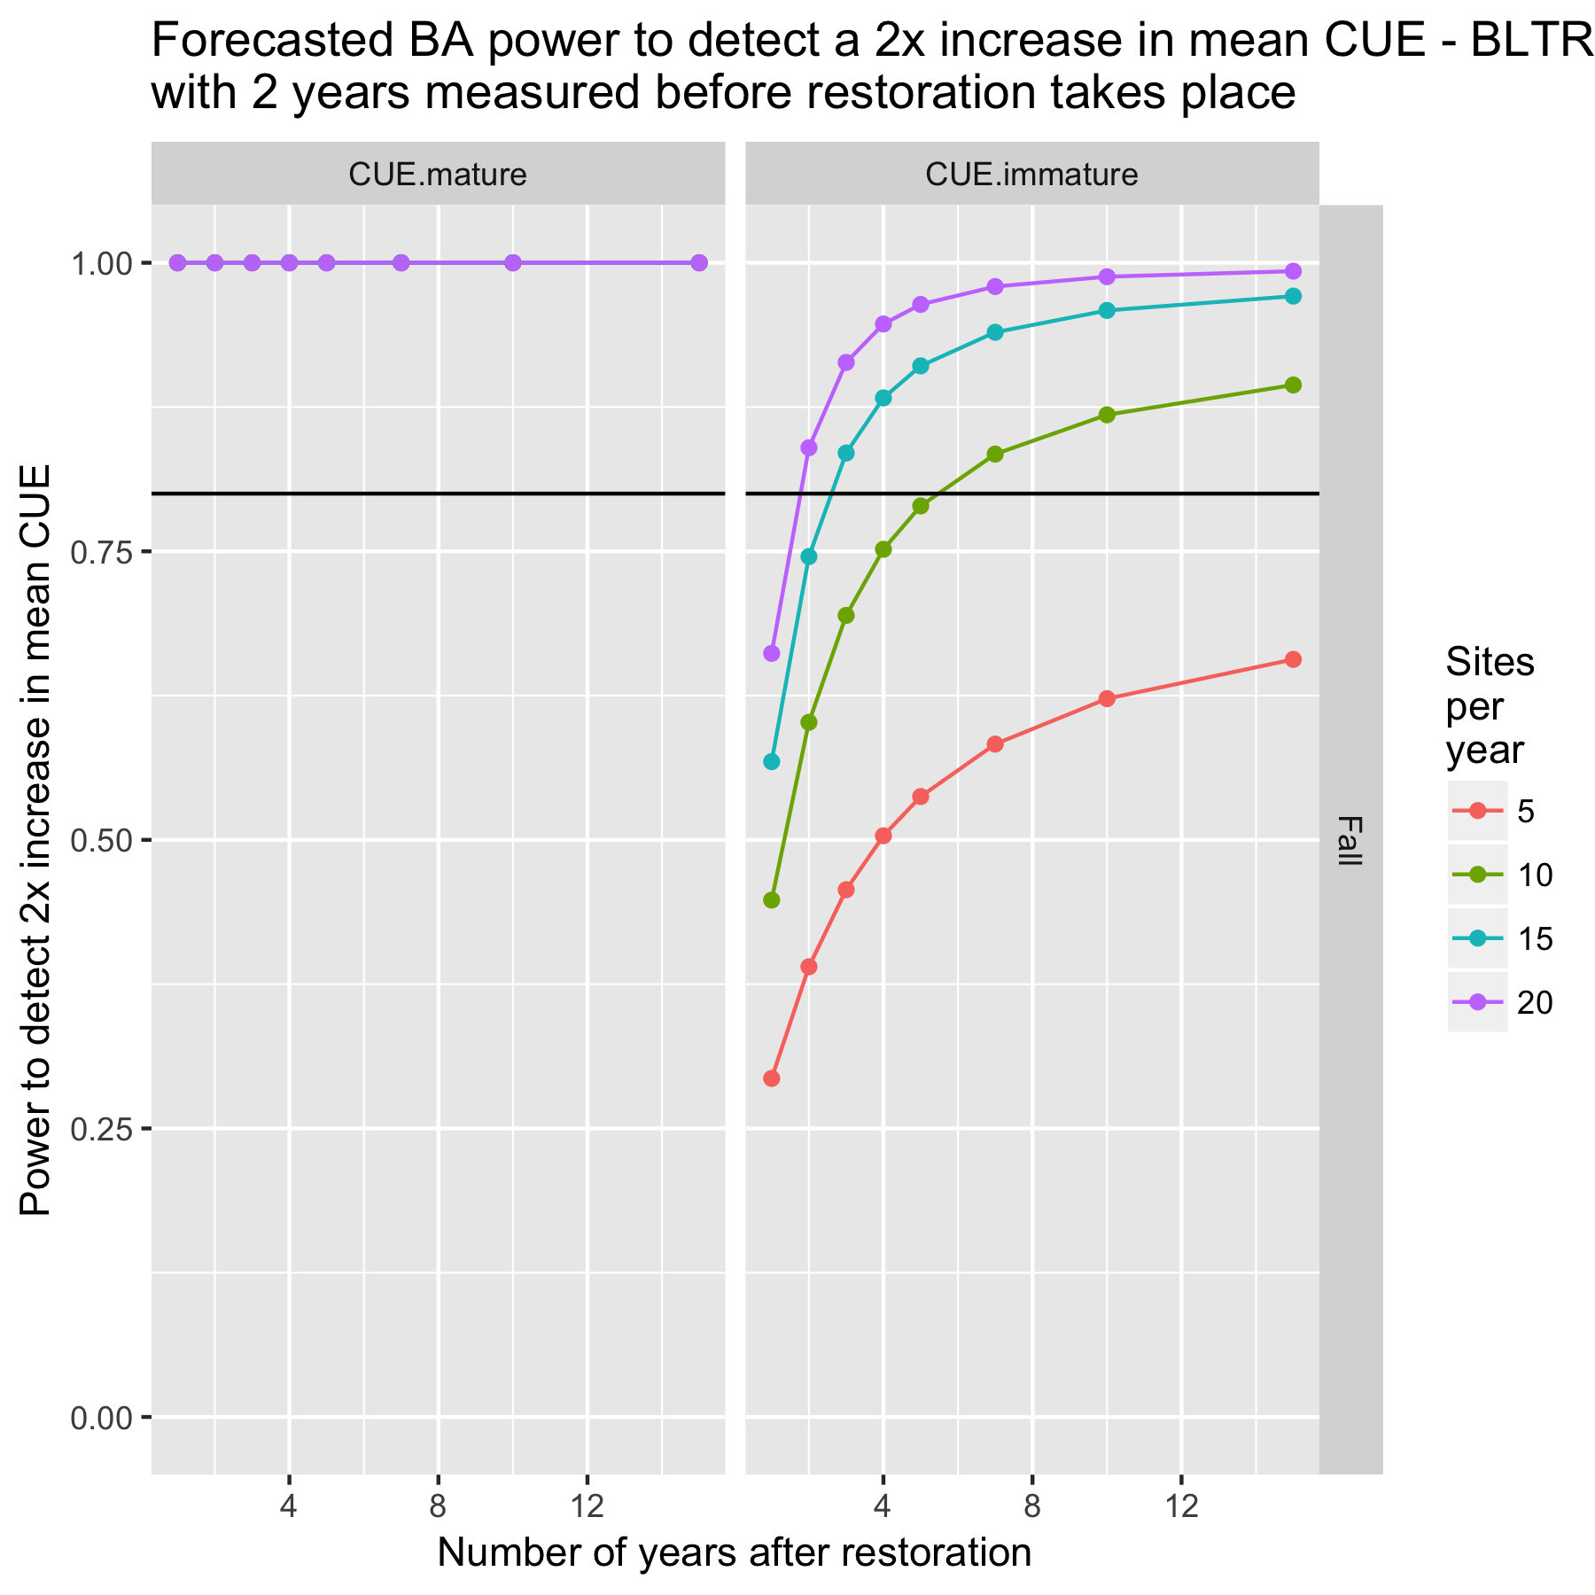

Figure 5a. Estimated power to detect a 2x change in mean(log(CUE)) with a before/after design for Fall Creek with 2 years of before measurements.

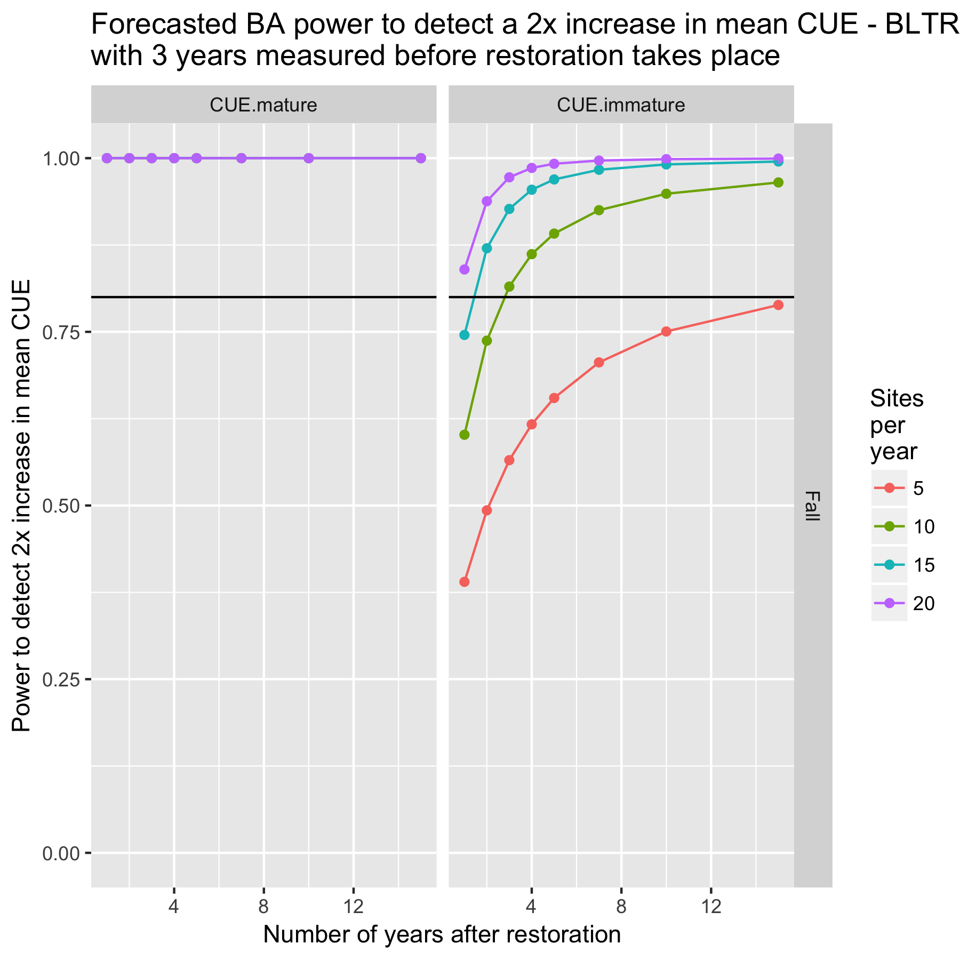

Figure 5b. Estimated power to detect a 2x change in mean(log(CUE)) with a before/after design for Fall Creek with 3 years of before measurements.

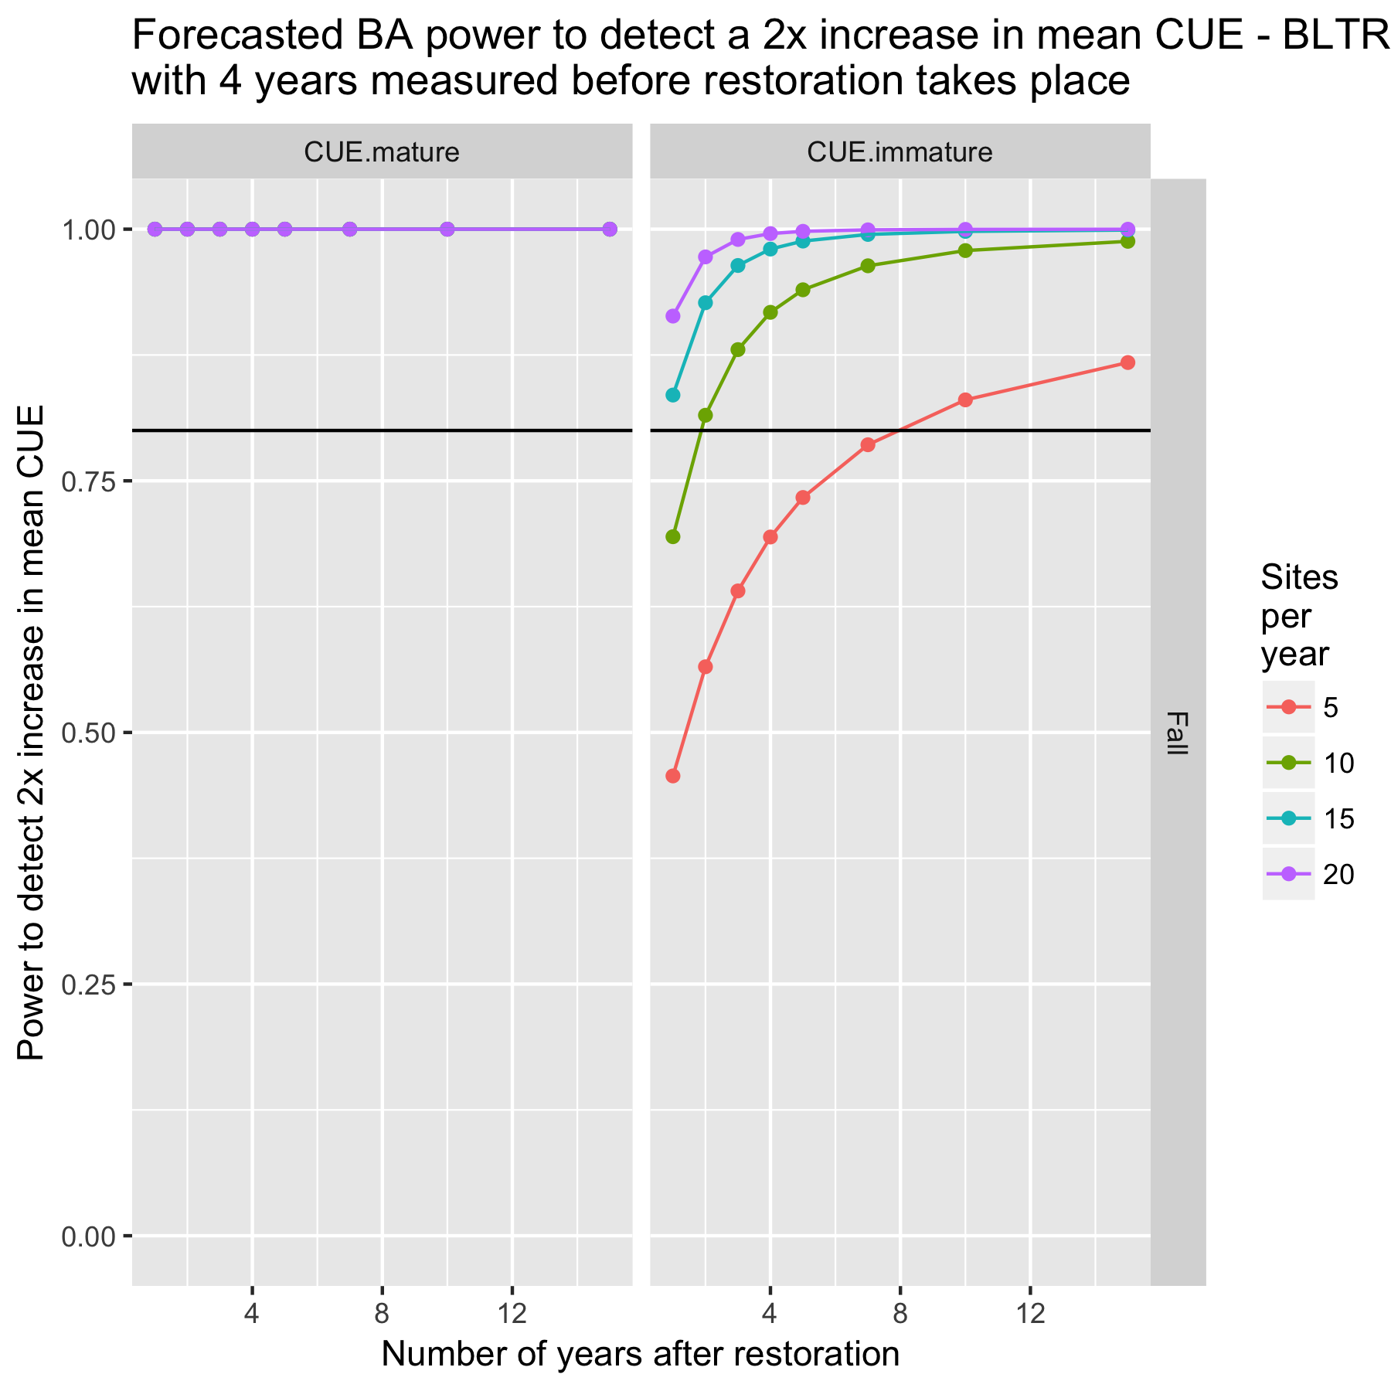

Figure 5c. Estimated power to detect a 2x change in mean(log(CUE)) with a before/after design for Fall Creek with 4 years of before measurements.

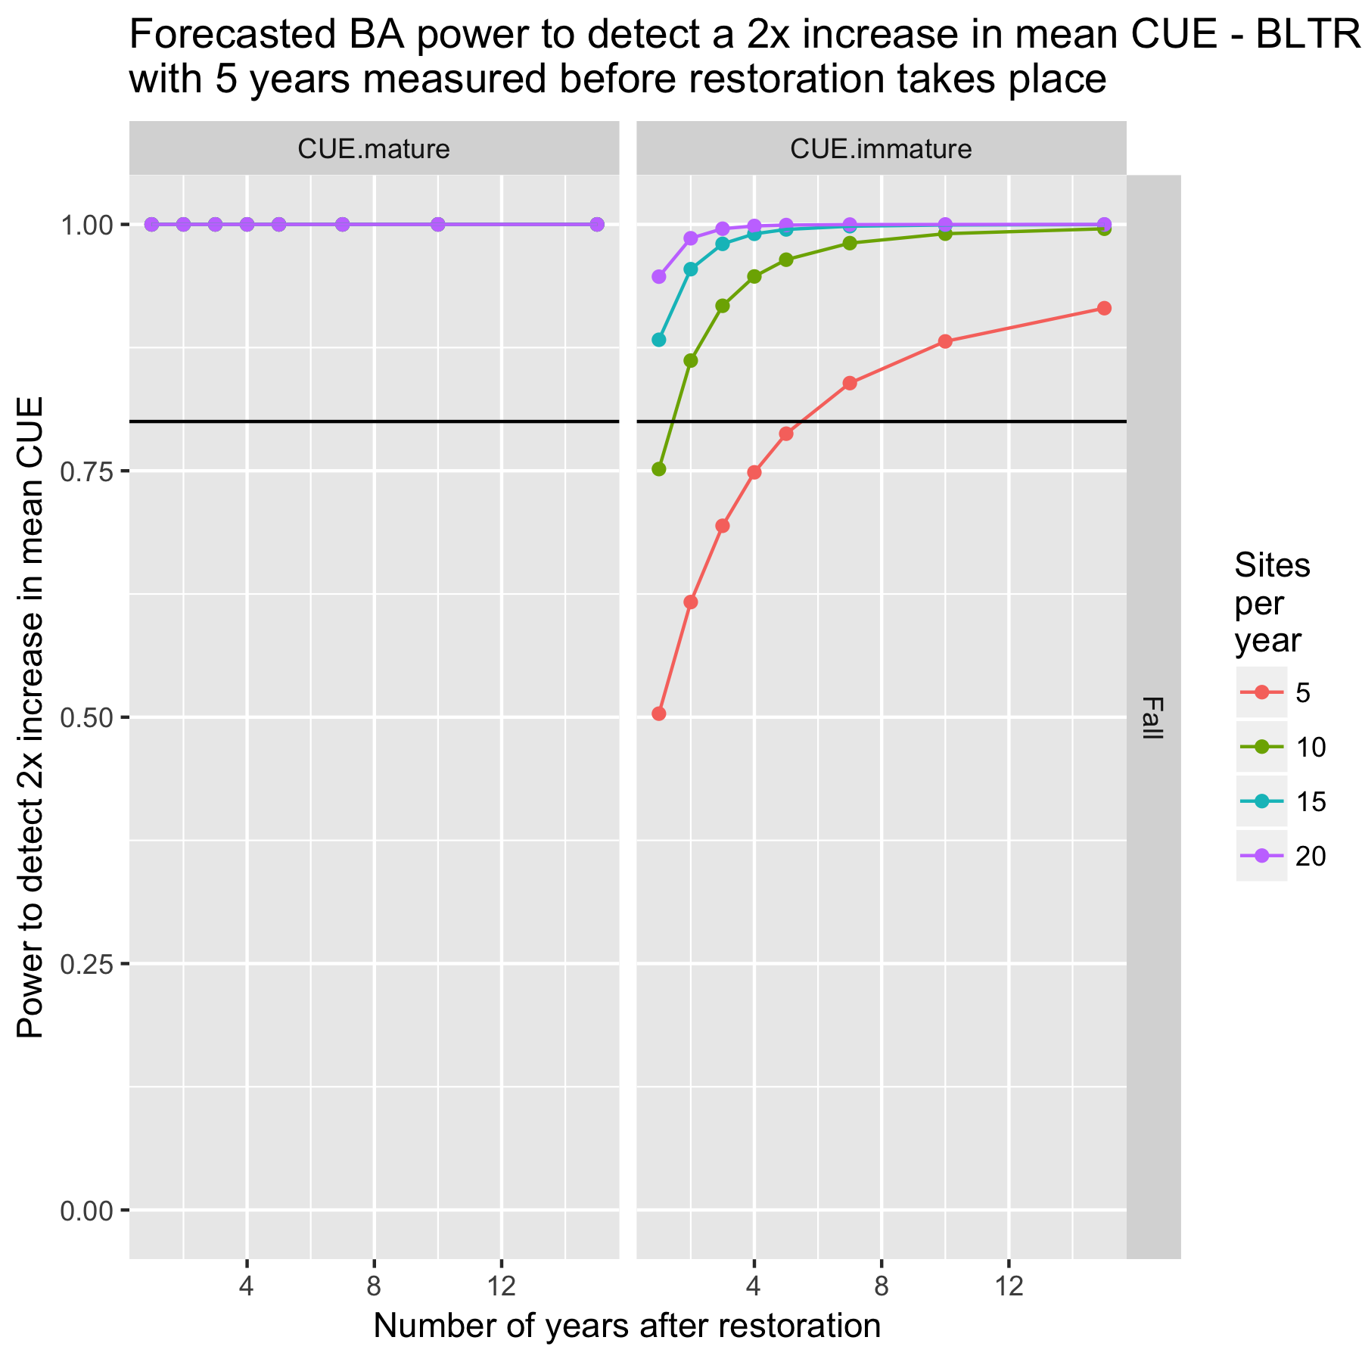

Figure 5a. Estimated power to detect a 2x change in mean(log(CUE)) with a before/after design for Fall Creek with 5 years of before measurements.

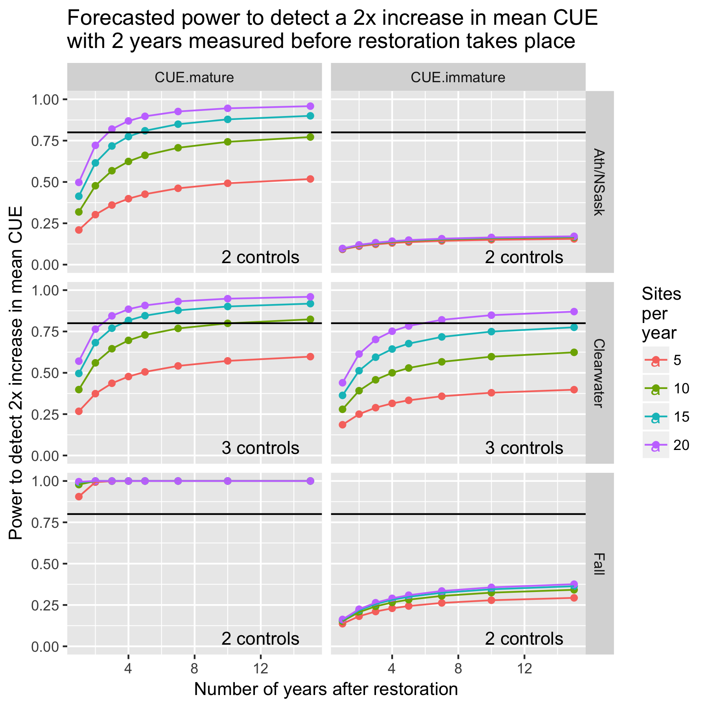

Figure 6a. Power plot for BLTR with 2 years of “before” measurements.

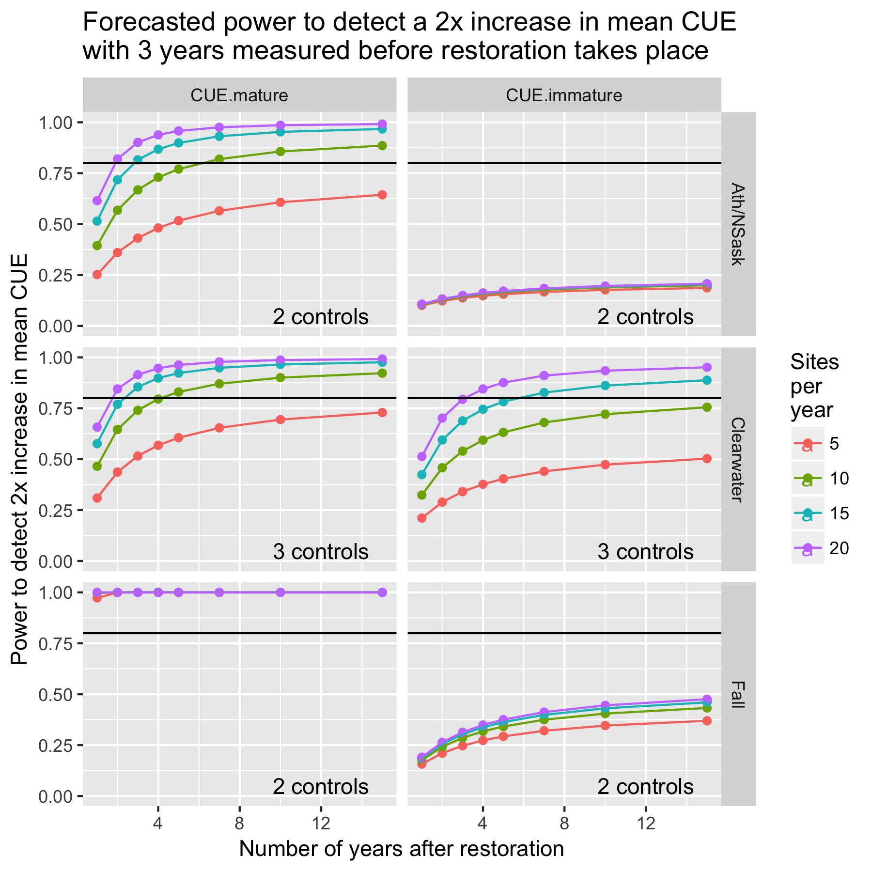

Figure 6b. Power plot for BLTR with 3 years of “before” measurements.

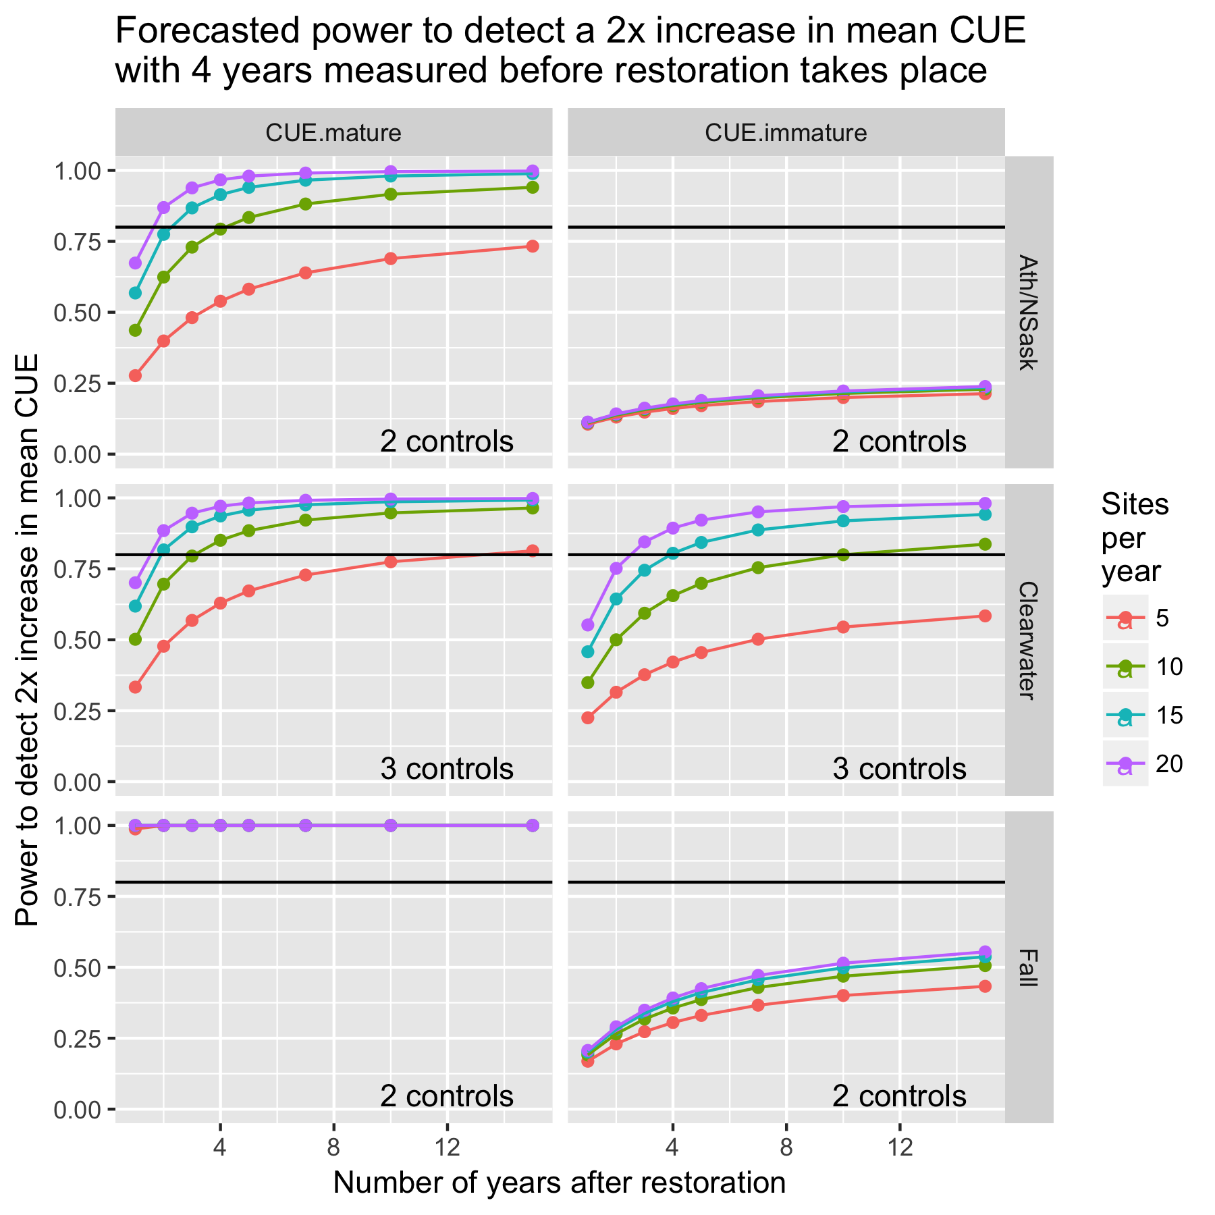

Figure 6c. Power plot for BLTR with 4 years of “before” measurements.

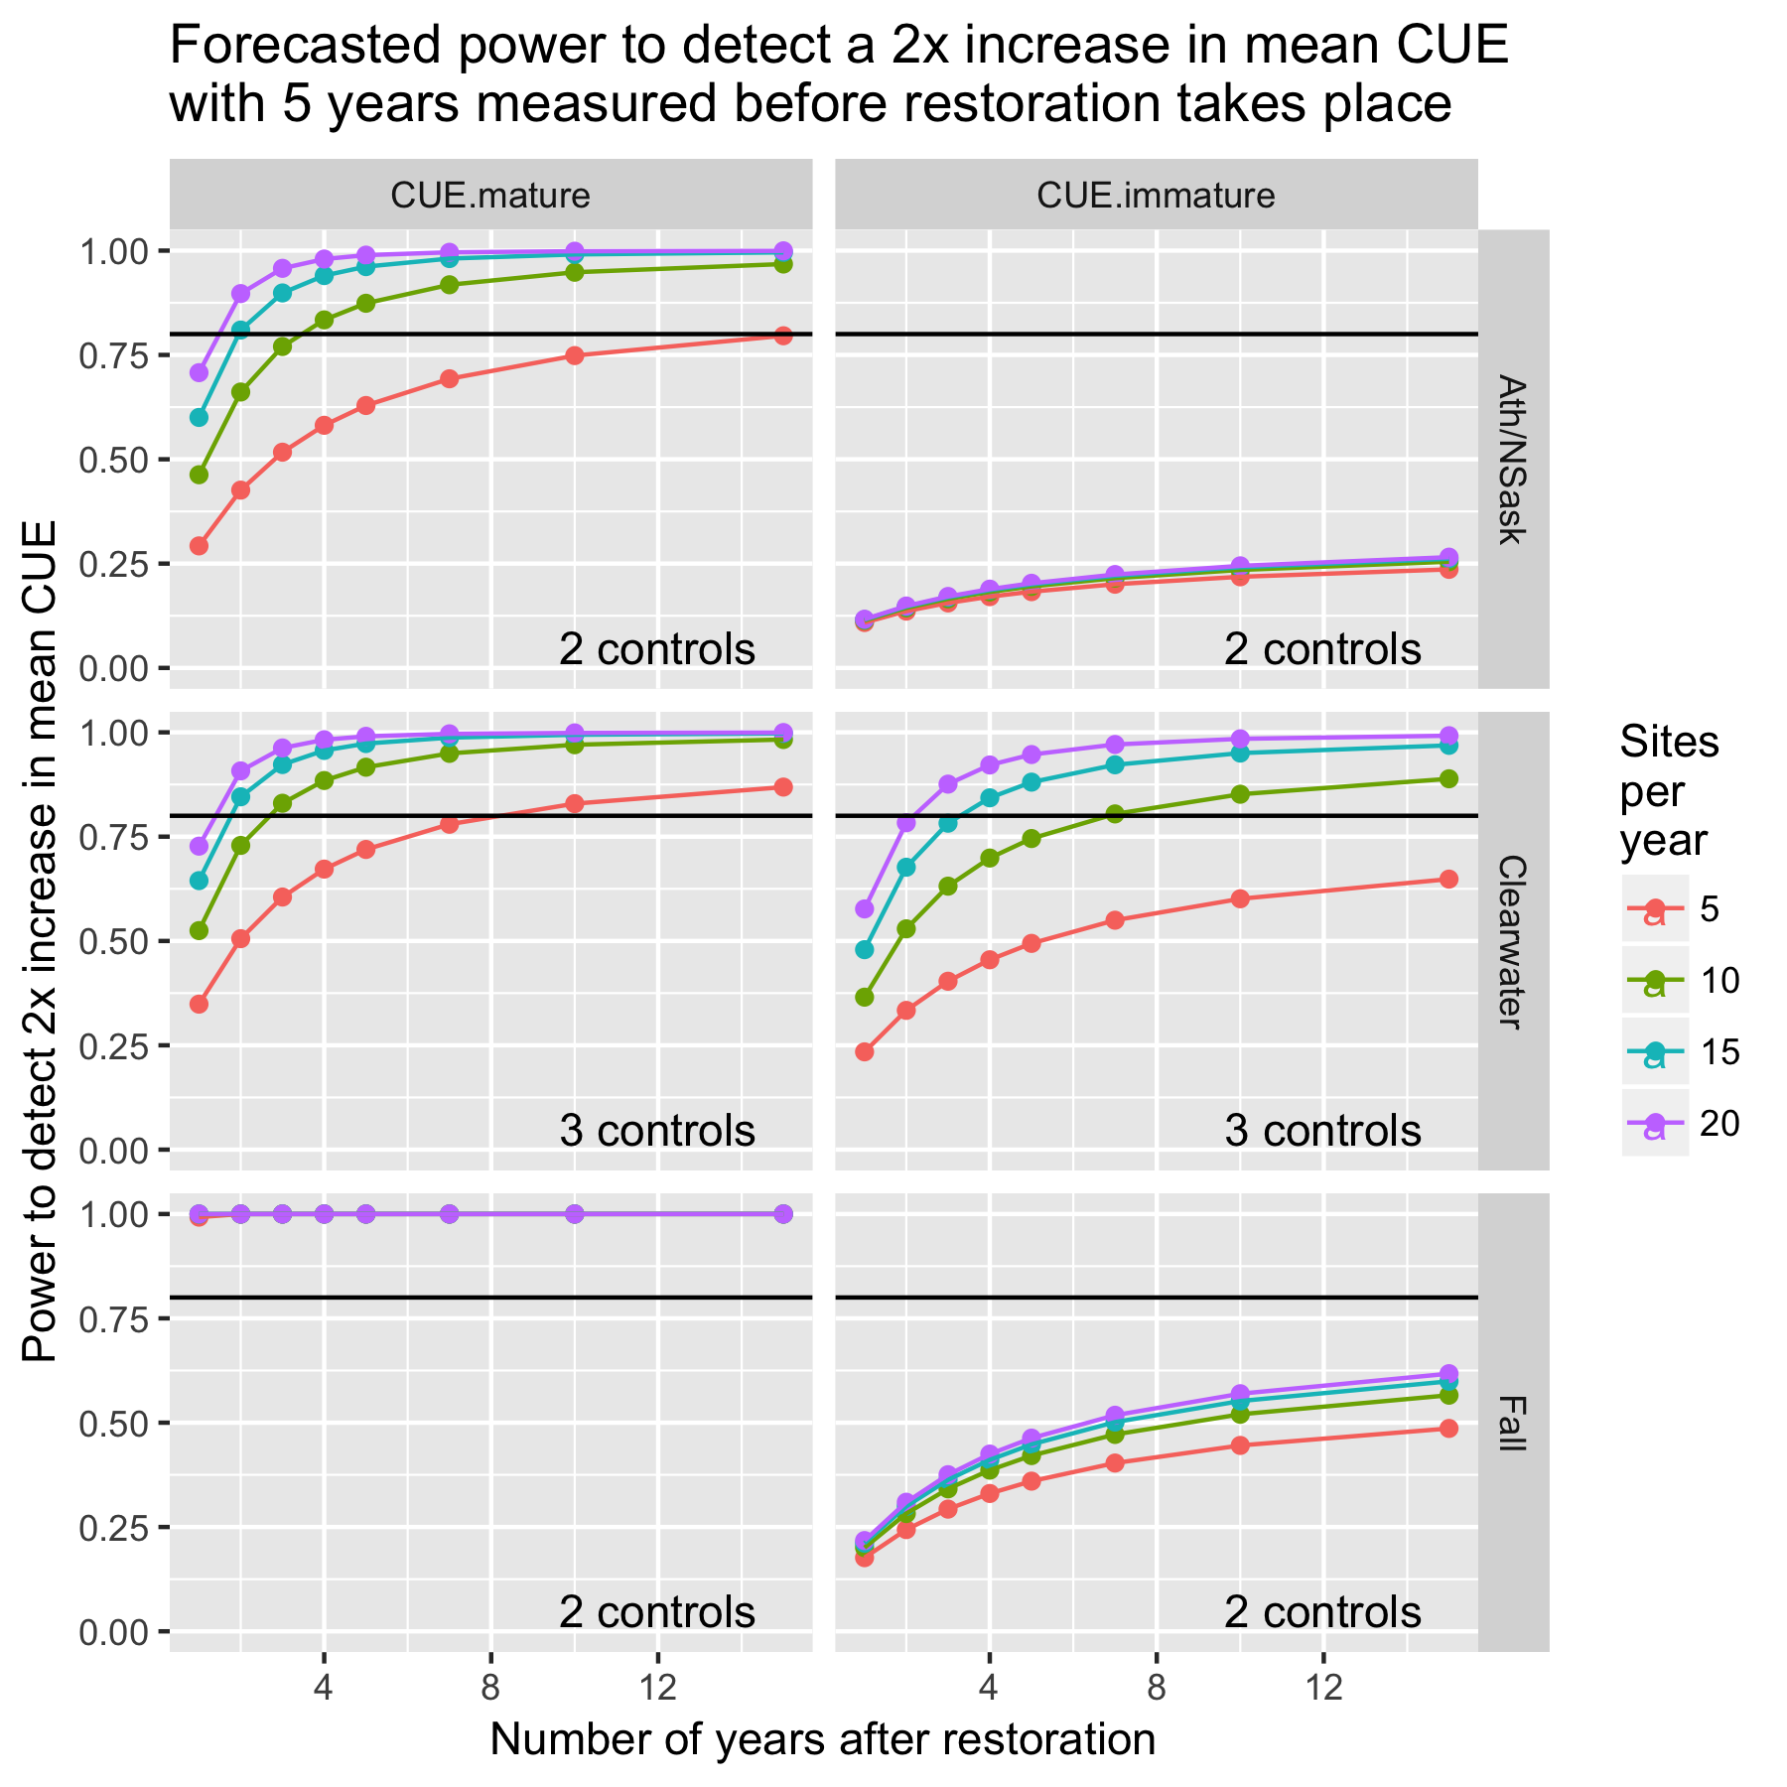

Figure 6d. Power plot for BLTR with 5 years of “before” measurements.

|  |  |  |  |  |  |  |  |  |  |  |
| --- | --- | --- | --- | --- | --- | --- | --- | --- | --- | --- |
| Table 1. Number of sites measured on each stream from historical data | | | | | | | | | | |
|  | Year/Month | | | | | | | | | |
| Stream/Watrershed | 2010  06 | 2010  07 | 2011  06 | 2011  07 | 2011  08 | 2012  06 | 2014  08 | 2015  07 | 2017  07 | 2017  08 |
| Mackenzie.Ath/NSask |  |  |  |  | 21 |  |  |  |  | 16 |
| Moon.Ath/NSask |  |  |  |  |  |  | 2 | 1 | 2 | 2 |
| Thistle.Ath/NSask |  |  |  |  |  |  |  |  |  | 8 |
| Cutoff.Clearwater |  |  | 4 |  |  |  |  |  |  | 3 |
| Elk.Clearwater |  | 17 |  |  | 5 |  |  |  |  | 2 |
| Limestone.Clearwater |  |  |  | 2 | 3 |  |  |  |  | 1 |
| Rocky.Clearwater | 12 |  |  |  |  | 5 |  |  |  | 1 |
| Fall.Fall |  |  |  |  |  |  |  |  | 2 |  |

|  |  |  |  |  |  |  |
| --- | --- | --- | --- | --- | --- | --- |
| Table 2. Estimates of variance components (standard deviations) from a mixed linear model. | | | | | | |
| Watershed | Species | AgeClass | sd.Year | sd.Stream | sd.StreamYear | sd.Resid |
| Ath/NSask | BLTR | CUE.mature | 0.000 | 0.182 | 0.000 | 0.973 |
| Clearwater | BLTR | CUE.mature | 0.000 | 0.547 | 0.119 | 0.890 |
| Fall1 | BLTR | CUE.mature | NA | NA | NA | 0.224 |
|  |  |  |  |  |  |  |
| Ath/NSask | BLTR | CUE.immature | 0.000 | 0.000 | 1.019 | 1.246 |
| Clearwater | BLTR | CUE.immature | 0.000 | 0.667 | 0.000 | 1.268 |
| Fall1 | BLTR | CUE.immature | NA | NA | NA | 0.966 |

1 Because Fall Creek was only measured on one year, only residual (site-to-site) variation can be estimated

1. Unless otherwise specified, logarithms are taken on the nature scale, i.e. ln() scale.