**Power analysis for** **evaluating the effectiveness of intensive OHV reclamation activities to recover native trout along the East Slopes of Alberta, Canada.**

2018-08-10

Changes from previous edition

* Fixed Figures 2 and 3 to avoid vertical jittering
* Updated Figure 07 for trend with 50%/100% per year scenarios
* Added power for combined analysis over all watersheds with and without noise in the effect size across watersheds (BACI Bayesian power analysis)

# Introduction

This report is a power analysis for a proposed restoration actions to recover native trout along the east slopes of Alberta, Canada.

The basic design is explained in Reilly (2018) . Briefly, there are three watersheds where restoration actions will take place – Clearwater, Athabasca/North Saskatchewan, Ram River. In the Clearwater watershed, restoration actions will take place on the Rocky stream, with three control streams (Cutoff, Limestone, and Elk). In the Athabasca/North Saskatchewan watershed, restoration actions will take place in the Mackenzie stream, with two control streams (Moon and Thistle). The Falls Creek restoration in the Ram River watershed has no specified control streams. The target increase of interest is a 2x increase in the mean CUE between the pre- and post-restoration periods.

Several levels of analysis will be performed.

Because the Ram River watershed does not have any control streams, only a before/after comparison will be possible.

A BACI analysis will be performed to measure the impact of restoration in the Clearwater and Athabasca/NS watershed on the catch per unit effort (CUE, fish/300 m) based on 1-pass electrofishing at randomly selected sites within each stream as described elsewhere.

Finally, all watersheds will be combined into a super-BACI design.

# Data sources.

The FWMIS was queried for historical data on the 8 streams from 2008 onwards. A site on a stream was defined as the combination of latitude and longitude present in the file or computed from the UTM co-ordinates in the file. A plot of the sites measured is found in Figure 1. Only one site on the Moon stream was repeatedly measured in multiple years (two years).

A common problem with databases such as FWMIS is dealing with sites where NO fish are captured. The FWMIS system inserts “dummy” records corresponding sites where no fish are capture. These sites have been included in Figure 1.

Only information from electofishing surveys conducted in June to October was retained. A summary of the number of sites measured in each stream is found in Table 1. Notice that Fall Stream was only measured in one year (2017) at two sites. One site from Moon Creek in 2014 was discarded because no information was available on effort (either distance or time) because of equipment failures.

Information on species BLTR, BKTR, and RNTR was retained.

Fish were divided in mature and immature age classes for BLTR and RNTR. The dividing point for BLTR was 150 mm; the dividing point for RNTR was 142 mm. Because of BKTR catch is sparse, no division into age classes was performed.

Because the distance surveyed at each site-year possibly changed over the year, CUE for both age classes was standardized to a fish/300 m basis. A plot of the raw CUE is found in Figure 2 and on the logarithmic[1] scale in Figure 3. The mean CUE is shown in Figure 4.

The power to detect changes depends on several sources of variation.

* Year-to-Year (process variation) – year-specific effects may force the CUE to be higher or lower than the trend line
* Stream-to-Stream – different streams have different productivity
* Stream-Year – different streams may change in response to year specific factors in different ways
* Residual (Site) – different sites have different CUE on the same stream in the same year.

Because no site was measured on the same stream in different years, it is not possible know if there are local site effects as well.

These variance components were estimated using a mixed-linear model

where the *Year* term represents any trend over time; the *YearC* represents the random year-specific effects (categorical effect of year); the *Stream(R)* represents the random effect of the stream (productivity differences); the *Year:Stream(R)* represents the stream-year interaction; and the residual (site) effects is implicit. Because Fall Creek was only measured on one year, only residual (site-to-site) variation can be estimated. Estimates of the variance components are presented in Table 2.

There is no evidence of year-specific effects (process error) and site-to-site variation is fairly similar except for Fall Creek (mature). Rather surprisingly, process error (year-to-year variation) is often estimated at zero – this may simply be an artefact of a small number of years of sampling with high variability in CUE within each year that makes process error difficult to detect.

# Estimates of Before/After power

The Ram watershed has no control streams and so only a before/after analysis can be done for this watershed.

A before/after power analysis was computed using the following attributes:

* Alpha level. This is set to 0.05, 0.10, and 0.15
* Effect size. The target effect size is a 2x increase in CUE. This corresponds to a log(2)=0.69 change on the logarithmic scale.
* Number of years stream is measured before restoration actions. We investigated 3, 4 or 5 years of “before” data for this stream
* Number of years this stream is measured after restoration actions. We investigated 1, 2, 3, 4, 5, 7, 10, and 15 years of “after” data.
* Number of sites measured in each stream-year. We investigated 5, 10, 15, or 20 sites/year.

The variance components (Table 2) were used to estimate the (one sided) power of a Before/After design based on all combinations of the above and power plots are shown in Figure 5.

Generally speaking, the power to detect a before/after change was high for mature fish with even a small number of sites sampled/year and 10 sites/year are needed for detecting a similar change for immature fish.

# Estimates of BACI power for individual watersheds

There are many parts of a BACI design that can be manipulated to affect the power of the design to detect an effect:

* Alpha level. This is set to 0.05. 0.10, and 0.15.
* Effect size. The target effect size is a 2x or 3x increase in CUE. This corresponds to a log(2)=0.69 or log(3)=1.09 change on the logarithmic scale.
* Number of years each stream is measured before restoration actions. We investigated 2:5 years of “before” data for each stream
* Number of years each stream is measured after restoration actions. We investigated 1, 2, 3, 4, 5, 7, 10, and 15 years of “after” data.
* Number of control streams. This is set to 2 for the Athabasca/NS watershed and 3 for the Clearwater watershed. A value of 2 was arbitrarily chosen for the Ram River watershed.
* Number of treatment streams. There is 1 treatment stream in each watershed.
* Number of sites measured in each stream-year. We investigated 5, 10, 15, or 20 sites/year.

The variance components (Table 2) were used to estimate the (one sided) power of BACI design based on all combinations of the above and power plots are shown in Figure 6.

Not unexpectedly, power tends to increase with more sites measured/year, and more years of “after” measurements. Power also tends to increase with more “before” measurements, but the effect is not that large.

Power is generally poor for the immature fish in the Athabasca/NS watershed because of the presence of a large stream:year interaction (Table 2 and Figure 4). This interaction term is of the limiting factor in BACI designs and implies that the streams behave differently over time.

It is not necessary that control streams have the same behaviour over time in a BACI design. The control streams are used to establish the changes in the mean due to temporal changes. So the year effects could be different in control and treatment streams (e.g. controls streams could increase in CUE in a particular year while the treatment streams declines) which is measured by the stream:year interaction. The implication is that you will need more years before and after treatment to establish the mean levels sufficiently well to detect an effect that is not attributable to simple temporal change.

Generally speaking 10 sites/stream measured for 4 years after restoration should have adequate power to detect these large scale response to restoration.

# Estimates of trend power for individual watersheds.

BACI designs are best for detecting sharp, large and permanent increases in the mean after an intervention. But in some cases, increases are more gradual and cumulative. In these cases, a trend analysis (regression analysis over time) is more of interest.

A power analysis to detect long term trends was conducted using

* Alpha level. This is set to 0.05. 0.10, and 0.15.
* Effect size. Ongoing, cumulative increases in mean CUE of 2% to 10%/year and 50%/year and 100%/year.
* Number of years each stream is measured after restoration actions. We investigated power for 5 to 20 years after restoration.
* Number of sites measured in each stream-year. We investigated 5, 10, 15, or 20 sites/year.

The variance components (Table 2) were used to estimate the (one sided) power to detect trends based on all combinations of the above and power plots are shown in Figure 7.

Not unexpectedly, power tends to increase with more sites measured/year if process variation is low, and more years of measurements after restoration.

Power is generally poor for small trends. This is not unexpected given that the BACI analysis was looking for 2x or 3x increases in CUE over short periods.

Power is generally higher for BKTR and in the Athabasca/North Saskatchewan watershed because there appears to be less variability (Table 2). Power is general poor for RNTR because of very high process and site-to-site variation.

.

# Estimates of BACI power combining watersheds

Section 4 of this report examined the power to detect effects for each individual watershed. But similar management actions will be taken in the multiple watersheds and so the power to detect management actions when “pooling” over watersheds is also conducted.

If the effect of the management action was “identical” across watersheds, the power analysis is easy to conduct – simply combine all of the streams (treatment and control) over all watersheds and conduct a standard BACI power analysis. For example, the three watersheds had 2/3/2 streams for controls and 1/1/1 for treatment respectively, so a power analysis would be conducted exactly the same way as in Section 4 but with 7 and 3 streams for control and treatment.

However, it is unlikely that the effect of the management action will be identical across watersheds. For example, while the average effect of the management action may be to increase CUE by a factor of 100% (on average), the actual effects in the three individual watersheds may increase by 70%, 100%, and 130% respectively (for an average increase of 100%) but with “noise” (variability) in the response. The amount of noise in the response can be measured by the standard deviation of the BACI effect size on the log() scale[2]. For example, a noise of 0.25 would imply that the effect size could vary by ±0.50 (two standard deviations) or from 0.50x of the average effect size to 1.50 of the average effect size. A noise of 0.50, would imply that the effect size could vary by ±1.00 (two standard deviations) or from close to no effect to 2x the average effect. We have no prior information the range of effect sizes, but based on past experience, a noise of 0.25 is likely a reasonable case, and a noise of 0.50 is a worst case scenario.

We conducted a power analysis under noise values of 0.00 (same effect size in all watersheds), 0.25 (a foreseeable case), and 0.50 (a worse case scenario) and the results are presented in Figure 8. Notice that RNTR is present only in a single watershed, and so this section is not applicable for this species. If is not necessary for all the watersheds to be monitored simultaneously – if watersheds have different starting years, they are treated as if the start years have been aligned.[3]

In cases where the noise is 0.00, i.e. all watershed have the same effect of restoration actions, power is very high for BKTR (needing only 5 sites/stream/year measured) and for BLTR if 10+ sites/stream/year are measured) with only a small number of “pre-impact” years measured and for a 2x+ effect size. As you increase the number of years measured prior to restoration, power improves.

In cases where the noise is 0.25, power is reduced, because the noise in the effect size over watersheds obscures the average effect. However, power is still acceptable if additional years pre-impact are measured or for larger effect sizes or for increase alpha level.

In cases where the noise is 0.50, power is poor with smaller effect sizes or smaller number of “pre-impact” years measured. In these cases, you are better off to analyze each watershed separately so that much larger effect sizes in some watersheds are detected.

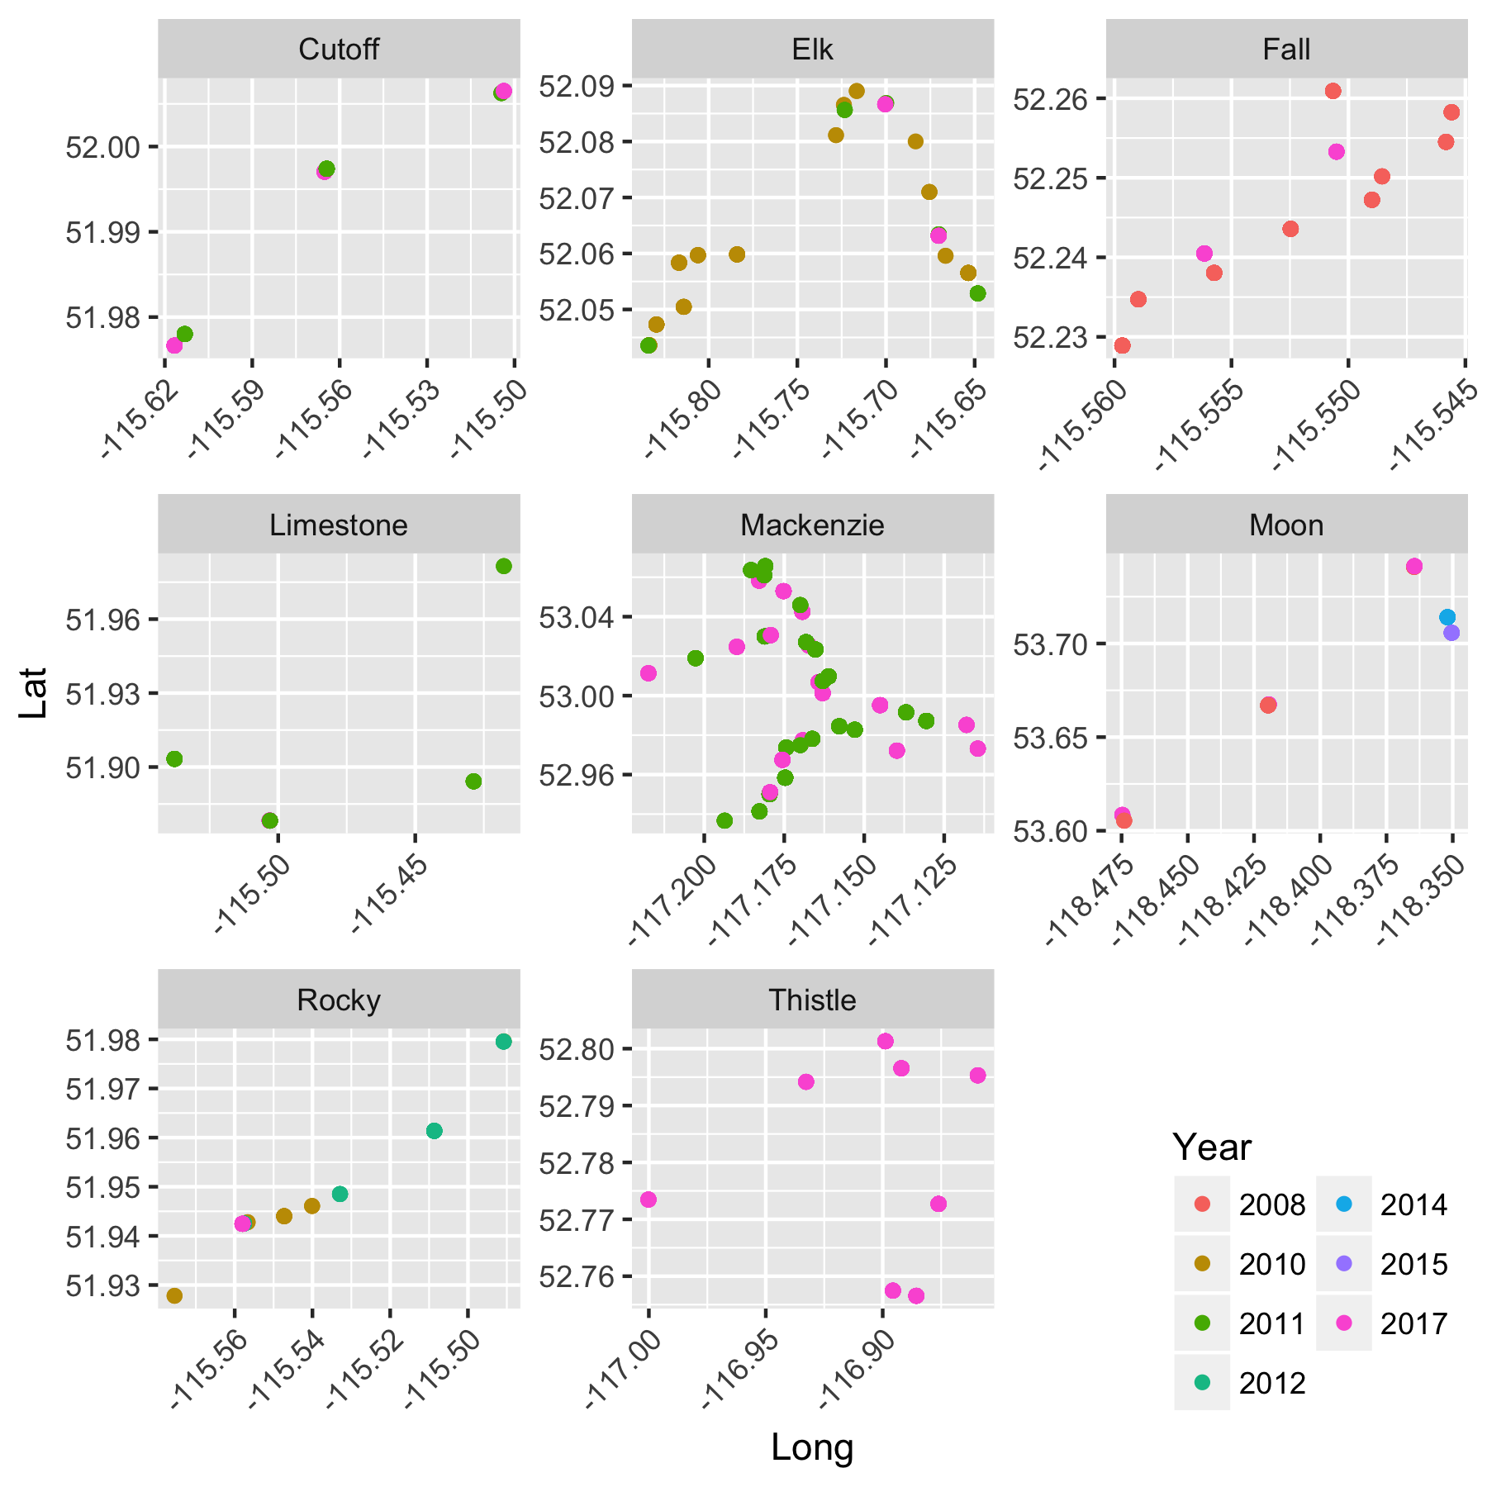

Figure 1. Locations of sites measured at streams in historical data. A common problem with databases such as FWMIS is dealing with sites where NO fish are captured. The FWMIS system inserts “dummy” records corresponding sites where no fish are captured. These sites have been included in Figure 1.

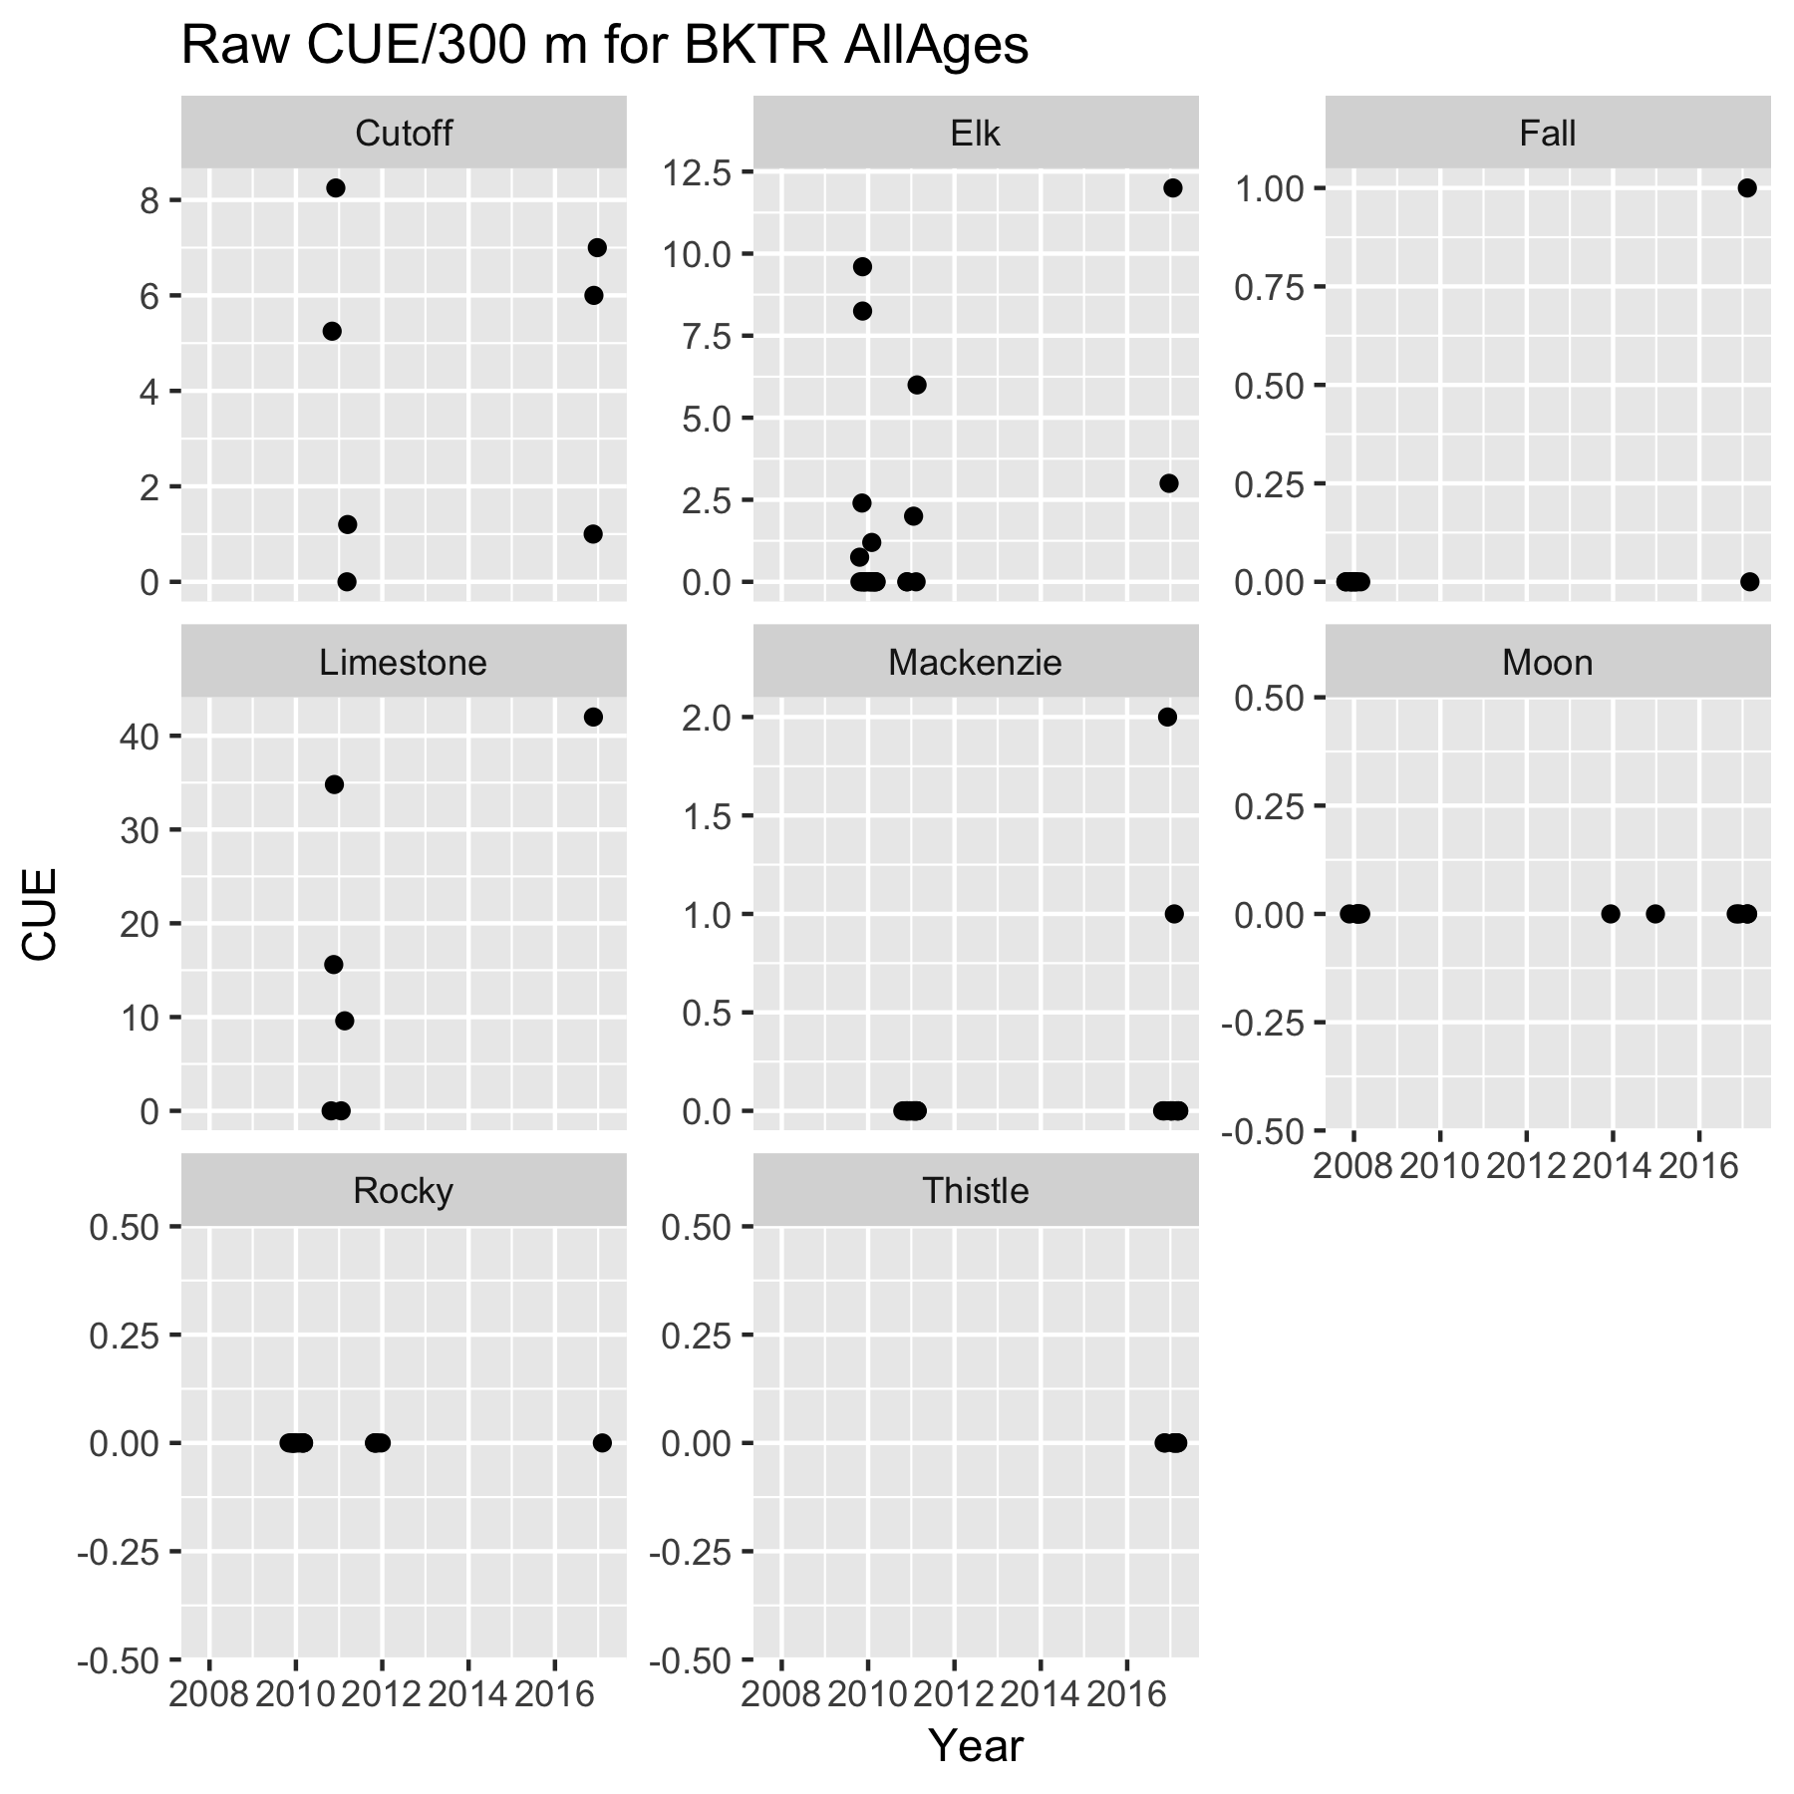

Figure 2a. Raw CUE (fish/300 m) for BKTR for each stream. Points jittered within years to prevent overplotting. Because of sparse data, BKTR was not divided into age classes.

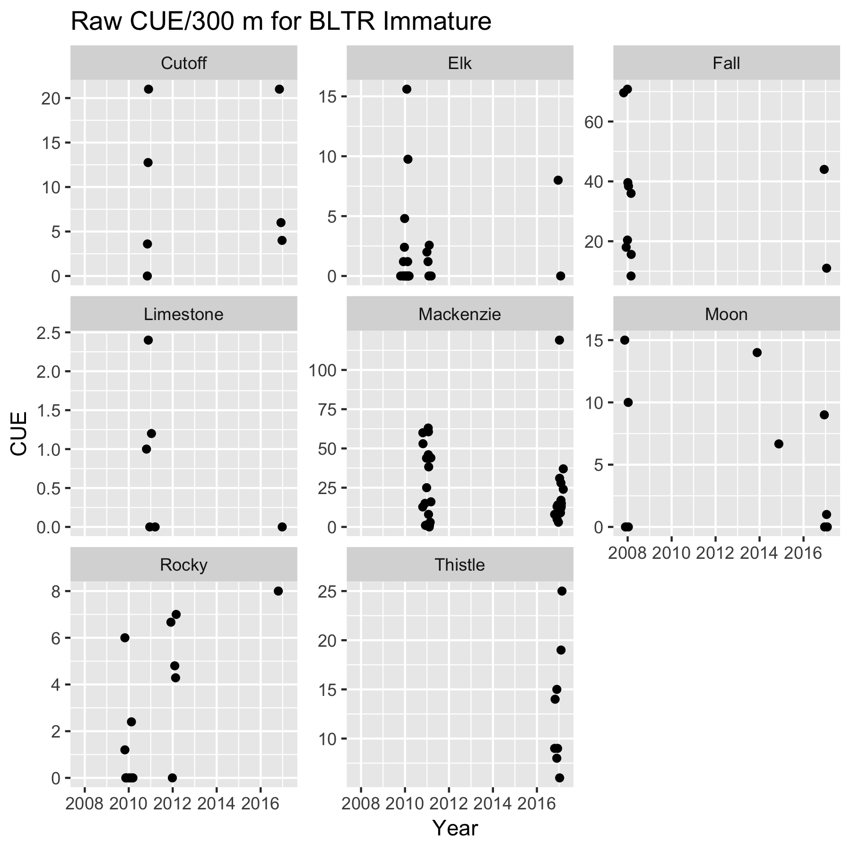

Figure 2b. Raw CUE (fish/300 m) for immature BLTR for each stream. Points jittered within years to prevent overplotting.

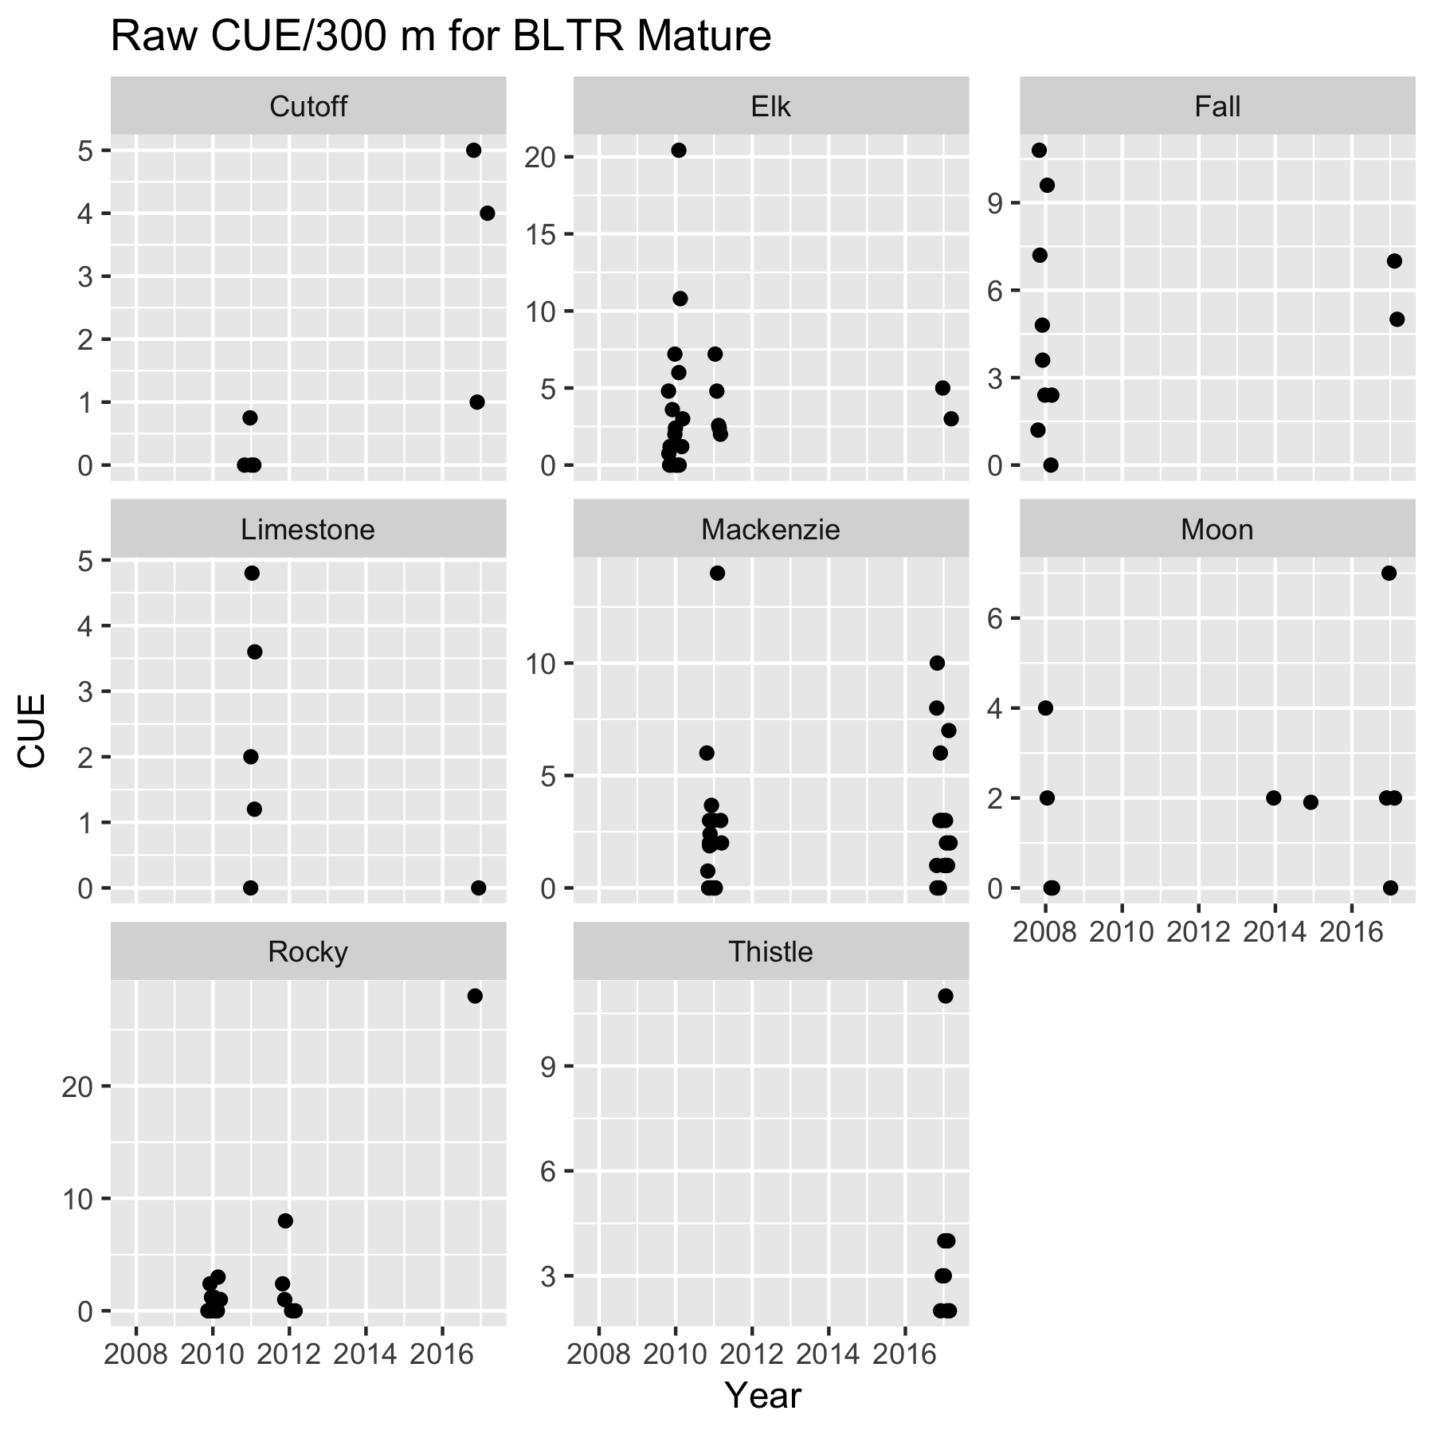

Figure 2c. Raw CUE (fish/300 m) for mature BLTR for each stream. Points jittered within years to prevent overplotting.

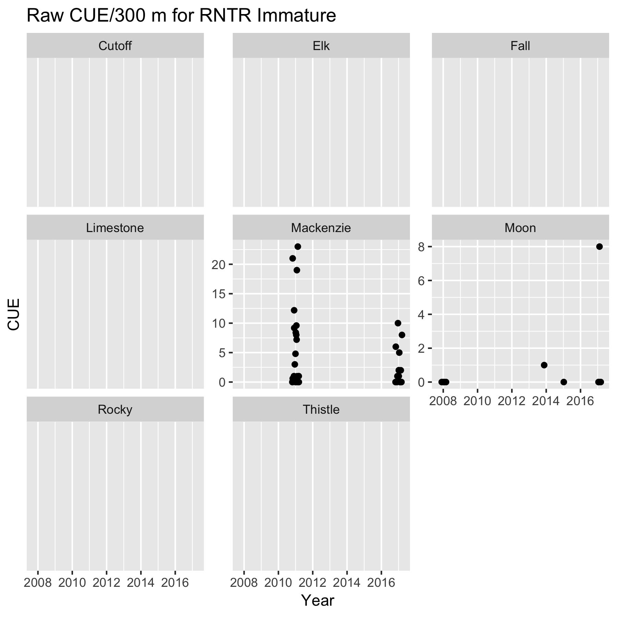

Figure 2d. Raw CUE (fish/300 m) for immature RNTR for each stream. Points jittered within years to prevent overplotting. RNTR is only present in two streams in the Athabaska/North Saskatchewan River watershed.

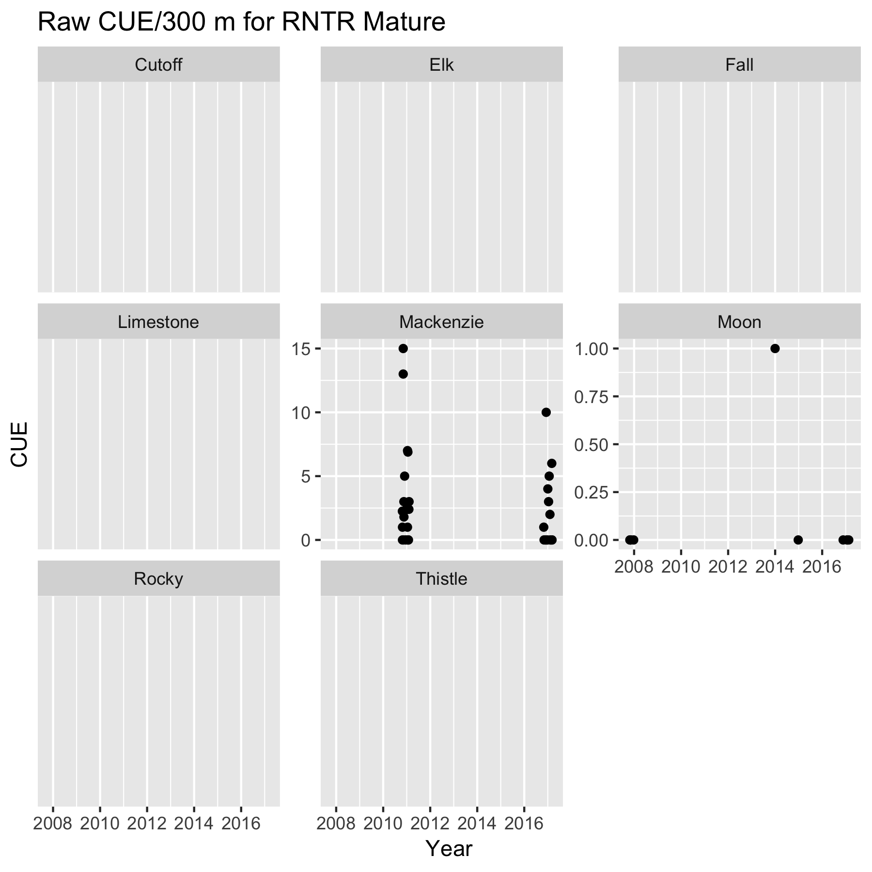

Figure 2e. Raw CUE (fish/300 m) for mature RNTR for each stream. Points jittered within years to prevent overplotting. RNTR is only present in two streams in the Athabaska/North Saskatchewan River watershed.

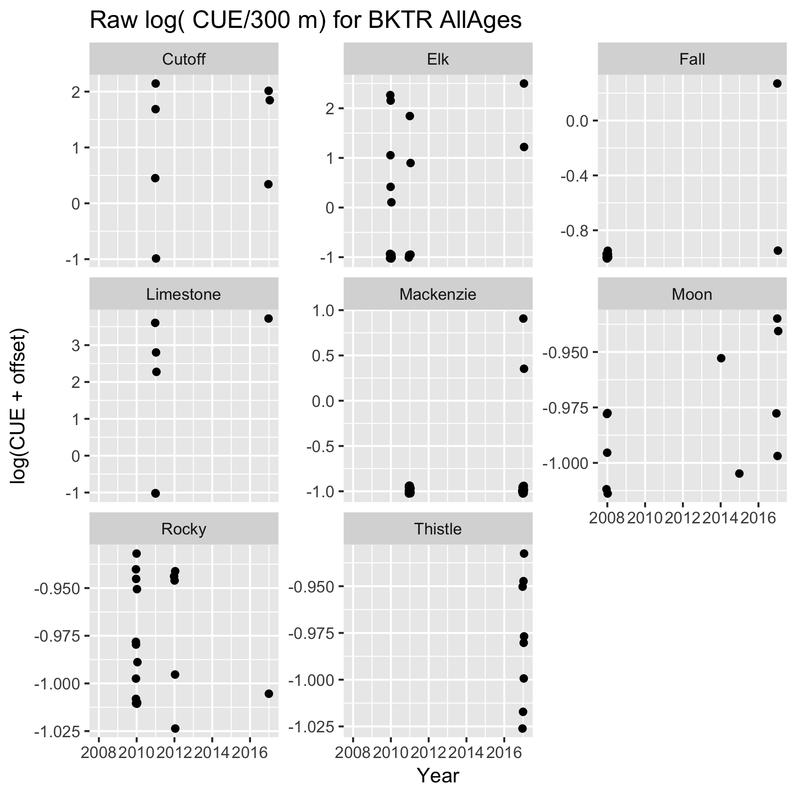

Figure 3a. Log CUE (fish/300 m) for BKTR for each stream. Points jittered within years to prevent overplotting. Because of sparse data, BKTR was not divided into age classes.

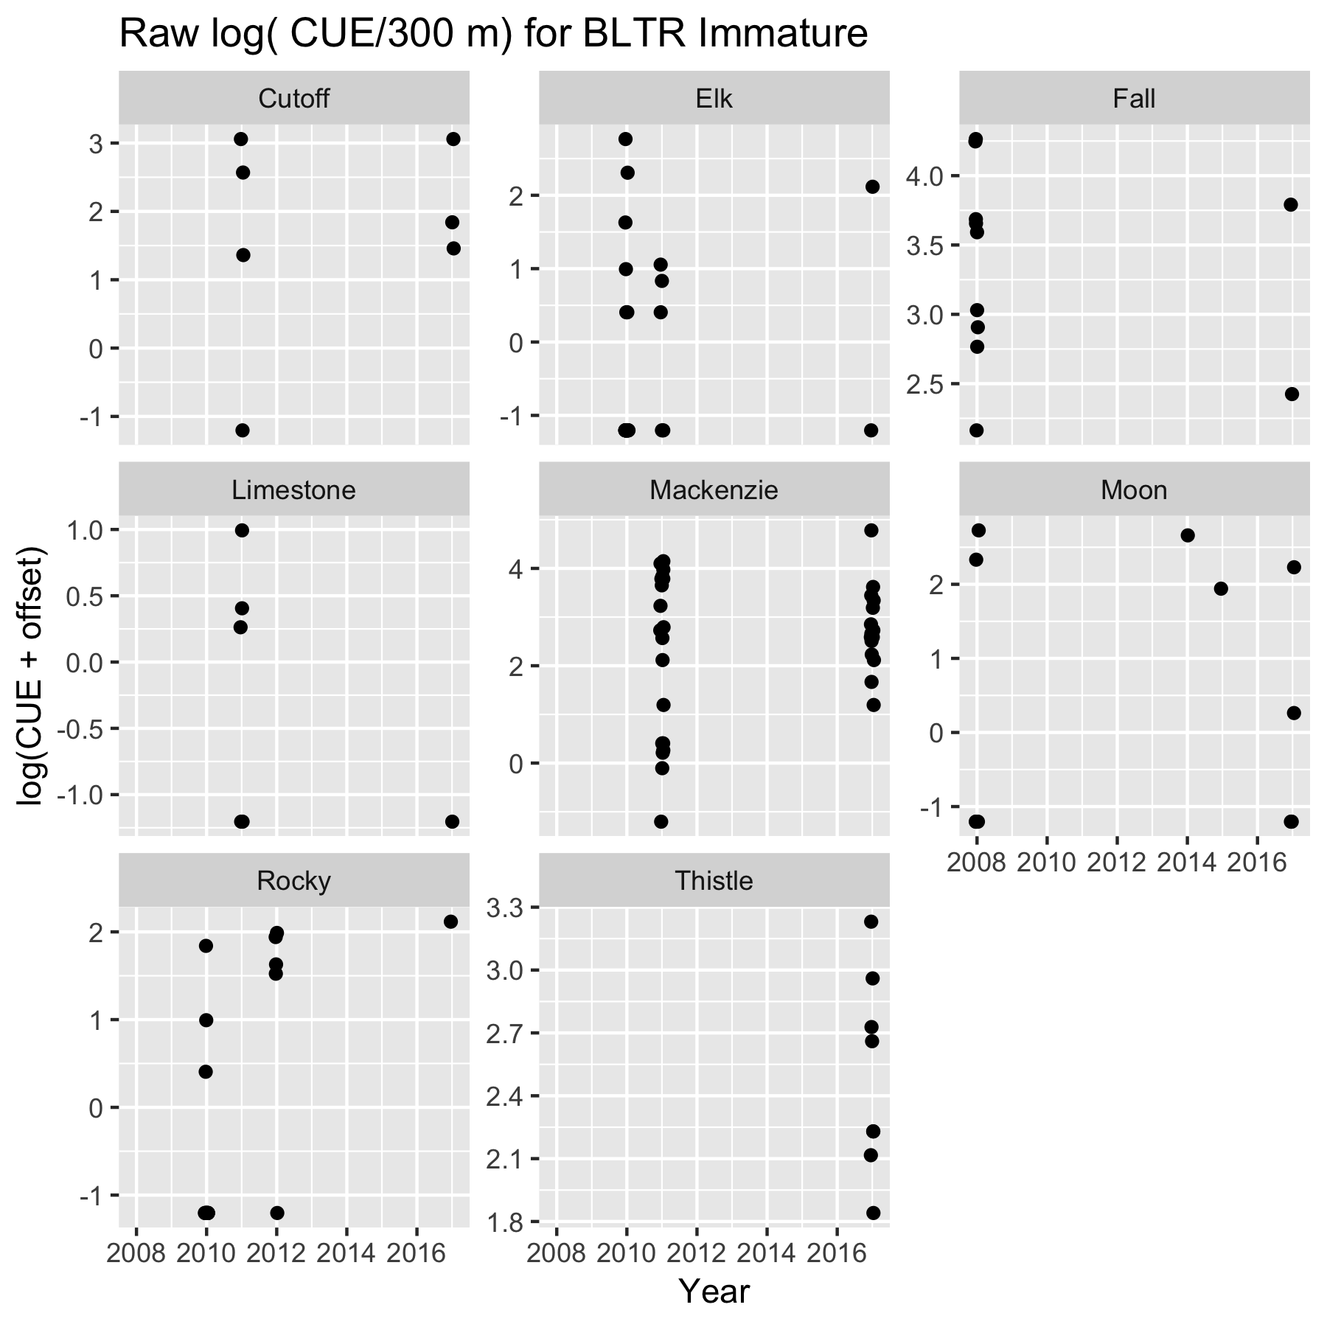

Figure 3b. Log( CUE (fish/300 m)) for immature BLTR for each stream. Points jittered within years to prevent overplotting.

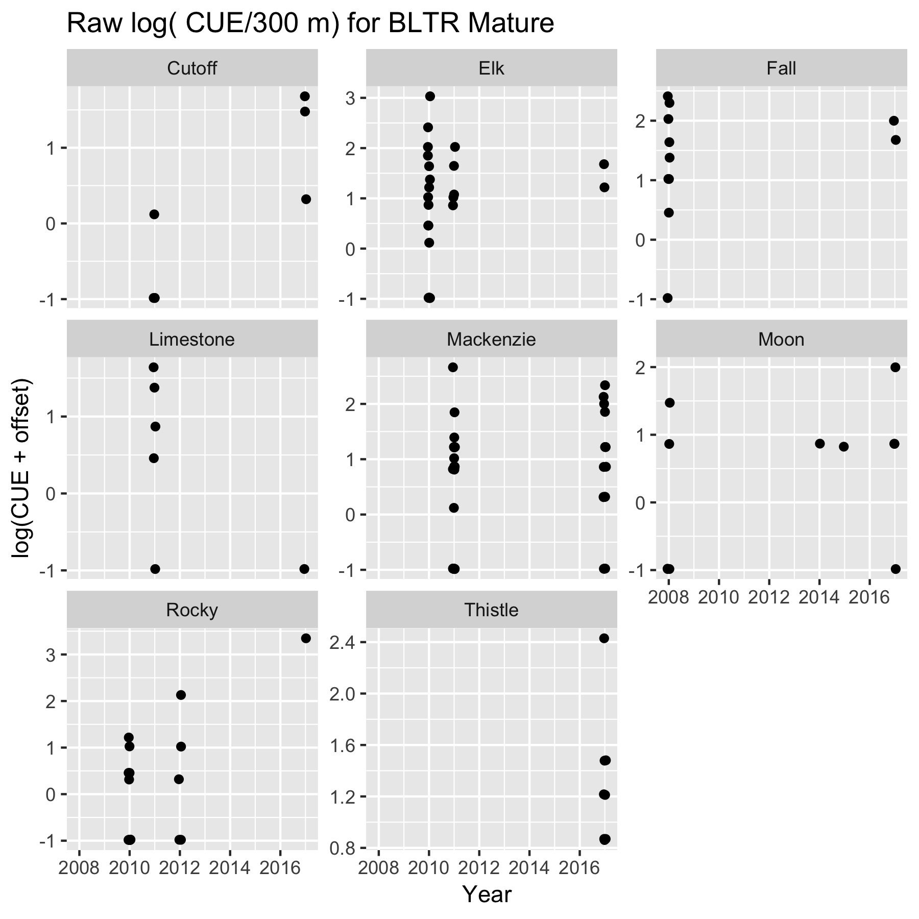

Figure 3c. Log( CUE (fish/300 m)) for mature BLTR for each stream. Points jittered within years to prevent overplotting.

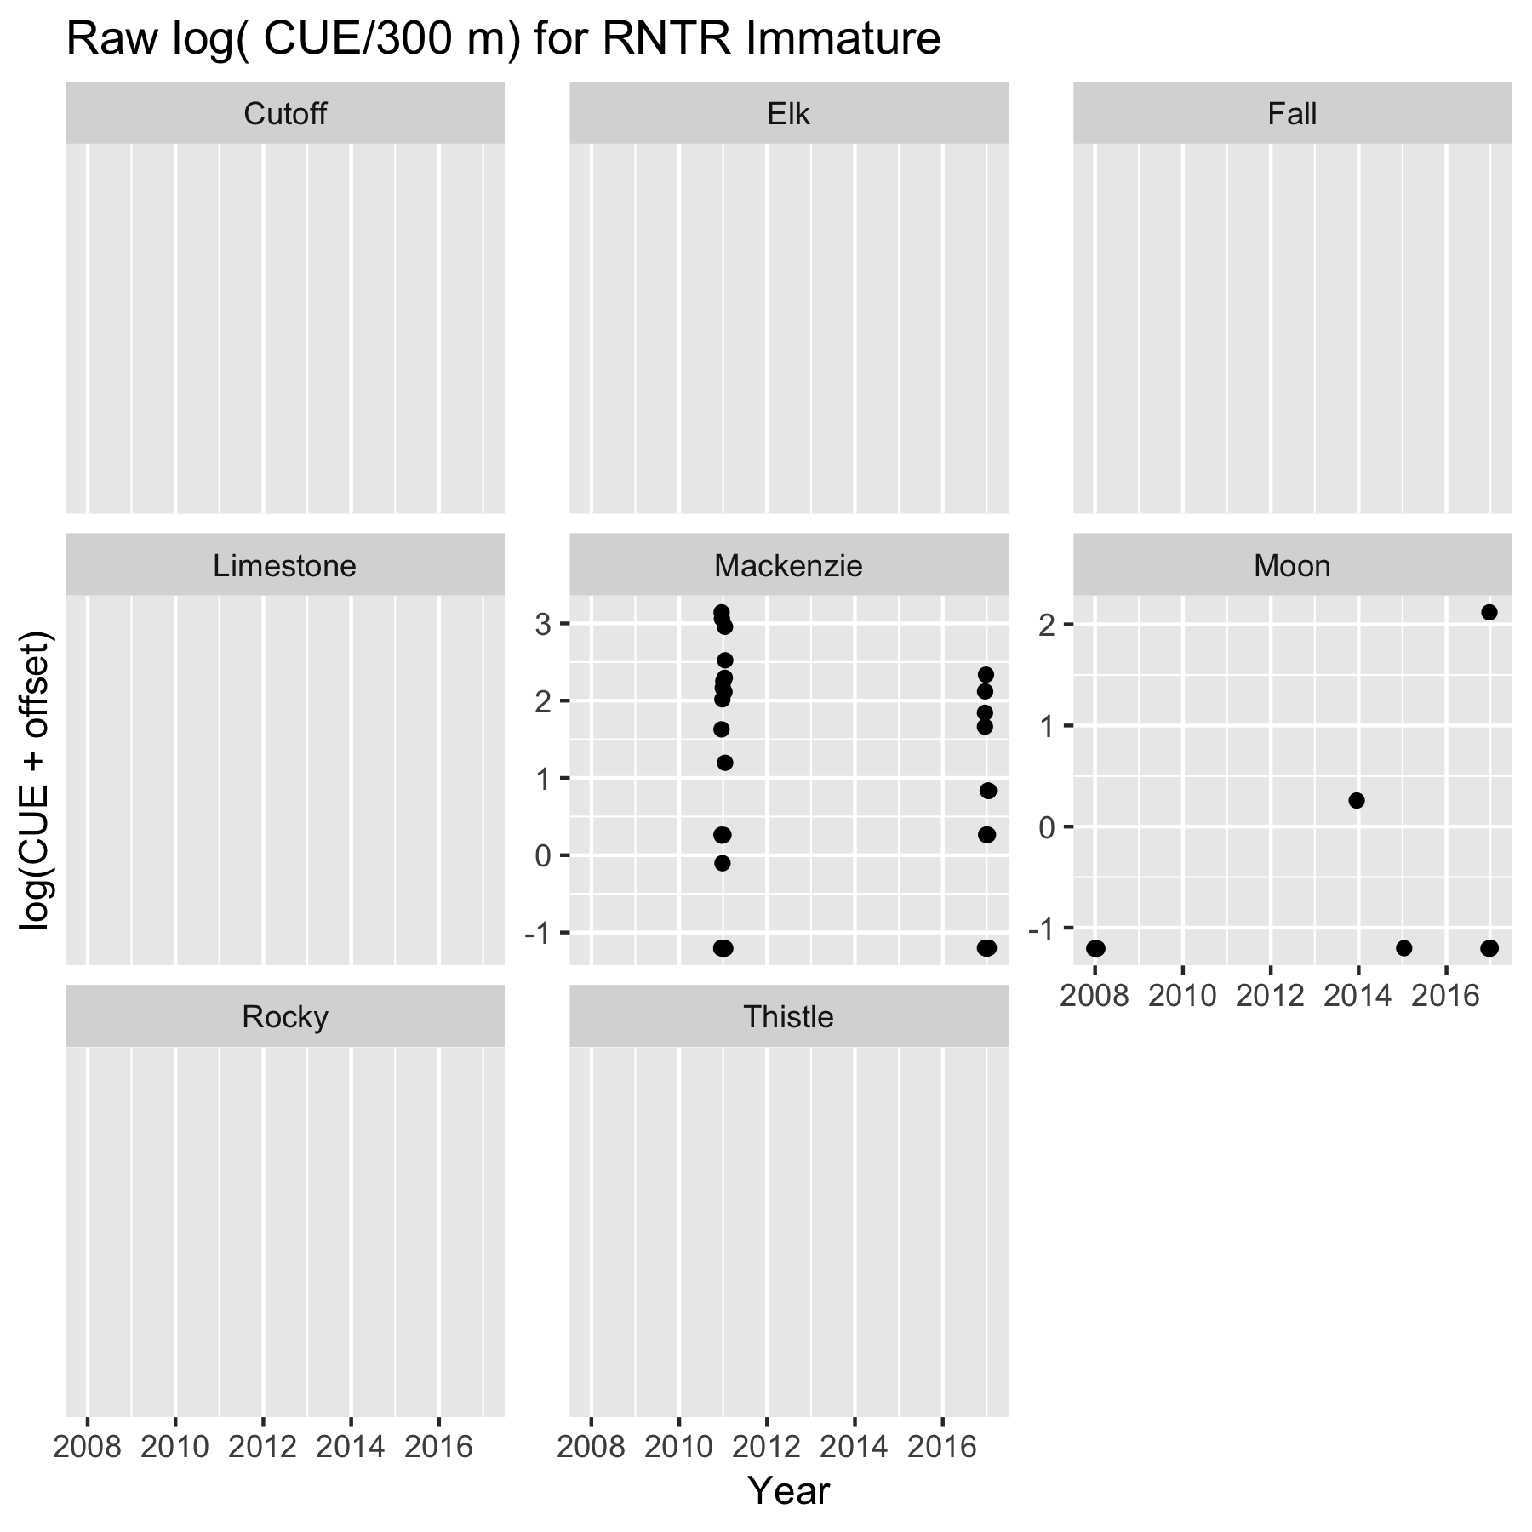

Figure 3d. Log( CUE (fish/300 m)) for immature RNTR for each stream. Points jittered within years to prevent overplotting. RNTR is only present in two streams in the Athabaska/North Saskatchewan River watershed.

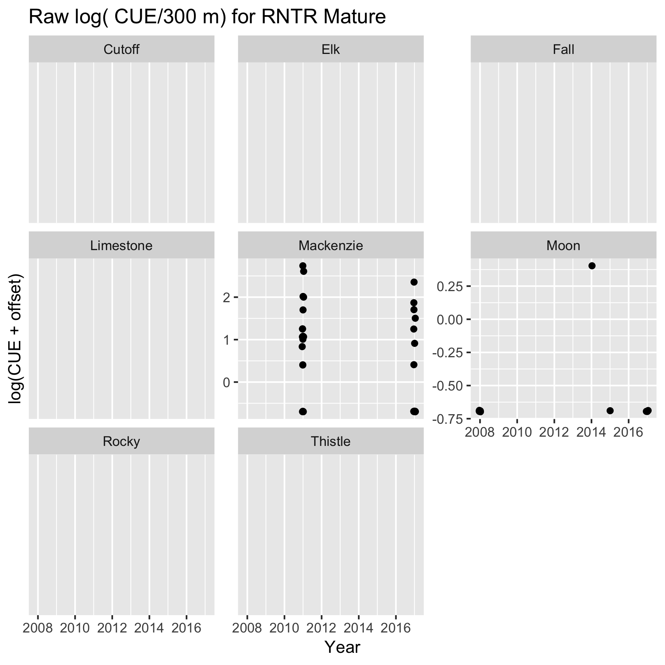

Figure 3e. Log( CUE (fish/300 m)) for mature RNTR for each stream. Points jittered within years to prevent overplotting. RNTR is only present in two streams in the Athabaska/North Saskatchewan River watershed.

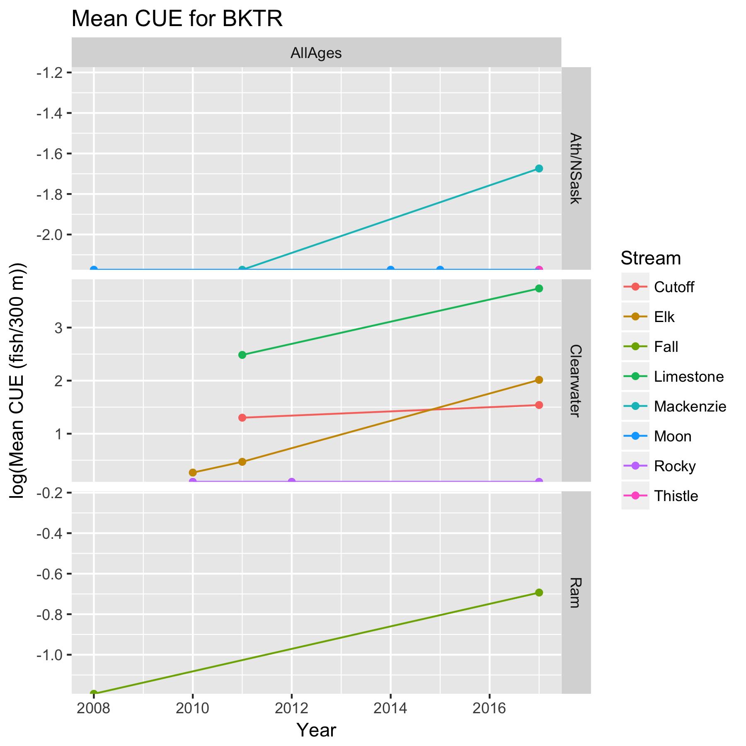

Figure 4a. Mean log( CUE (fish/300 m)) for BKTR for each stream. Because of sparse data, the fish were not divided by age classes.

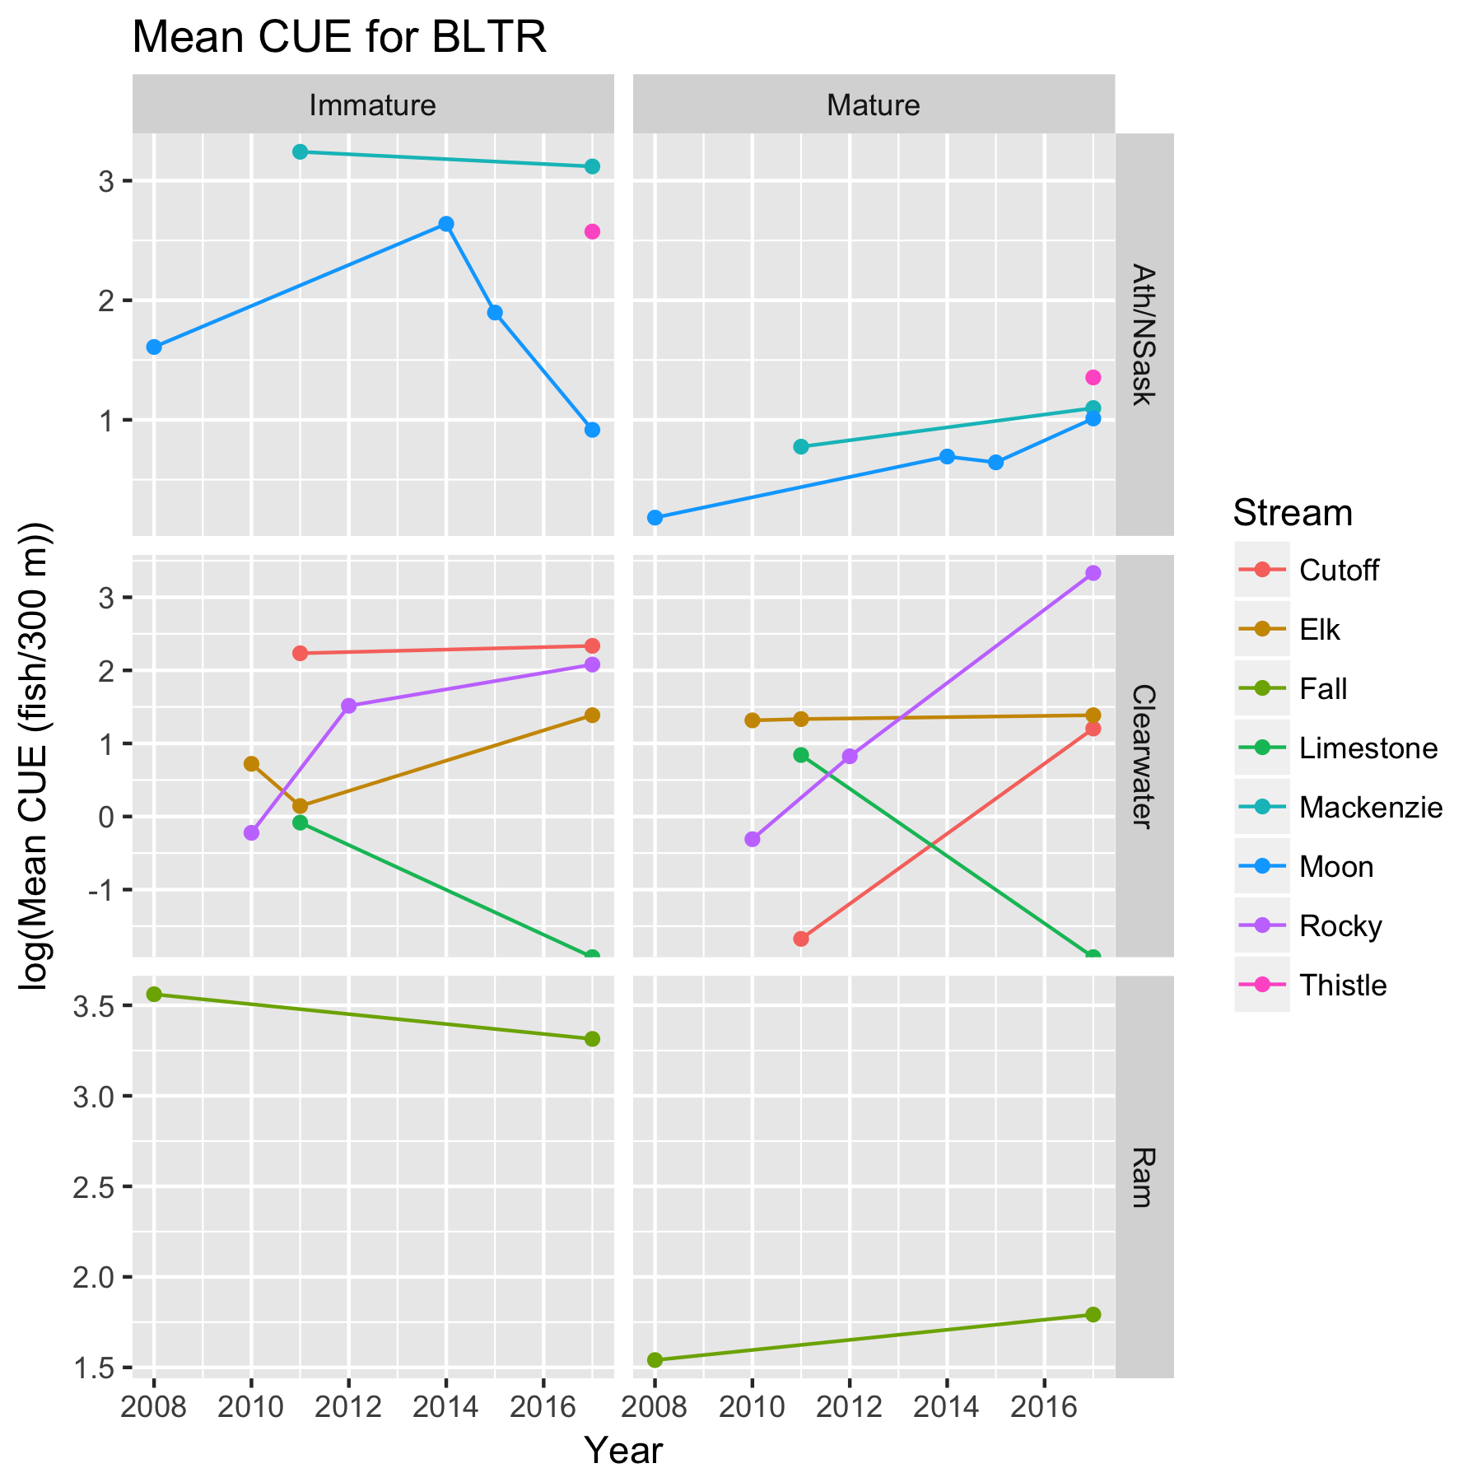

Figure 4b. Mean log( CUE (fish/300 m)) for BLTR for each stream.

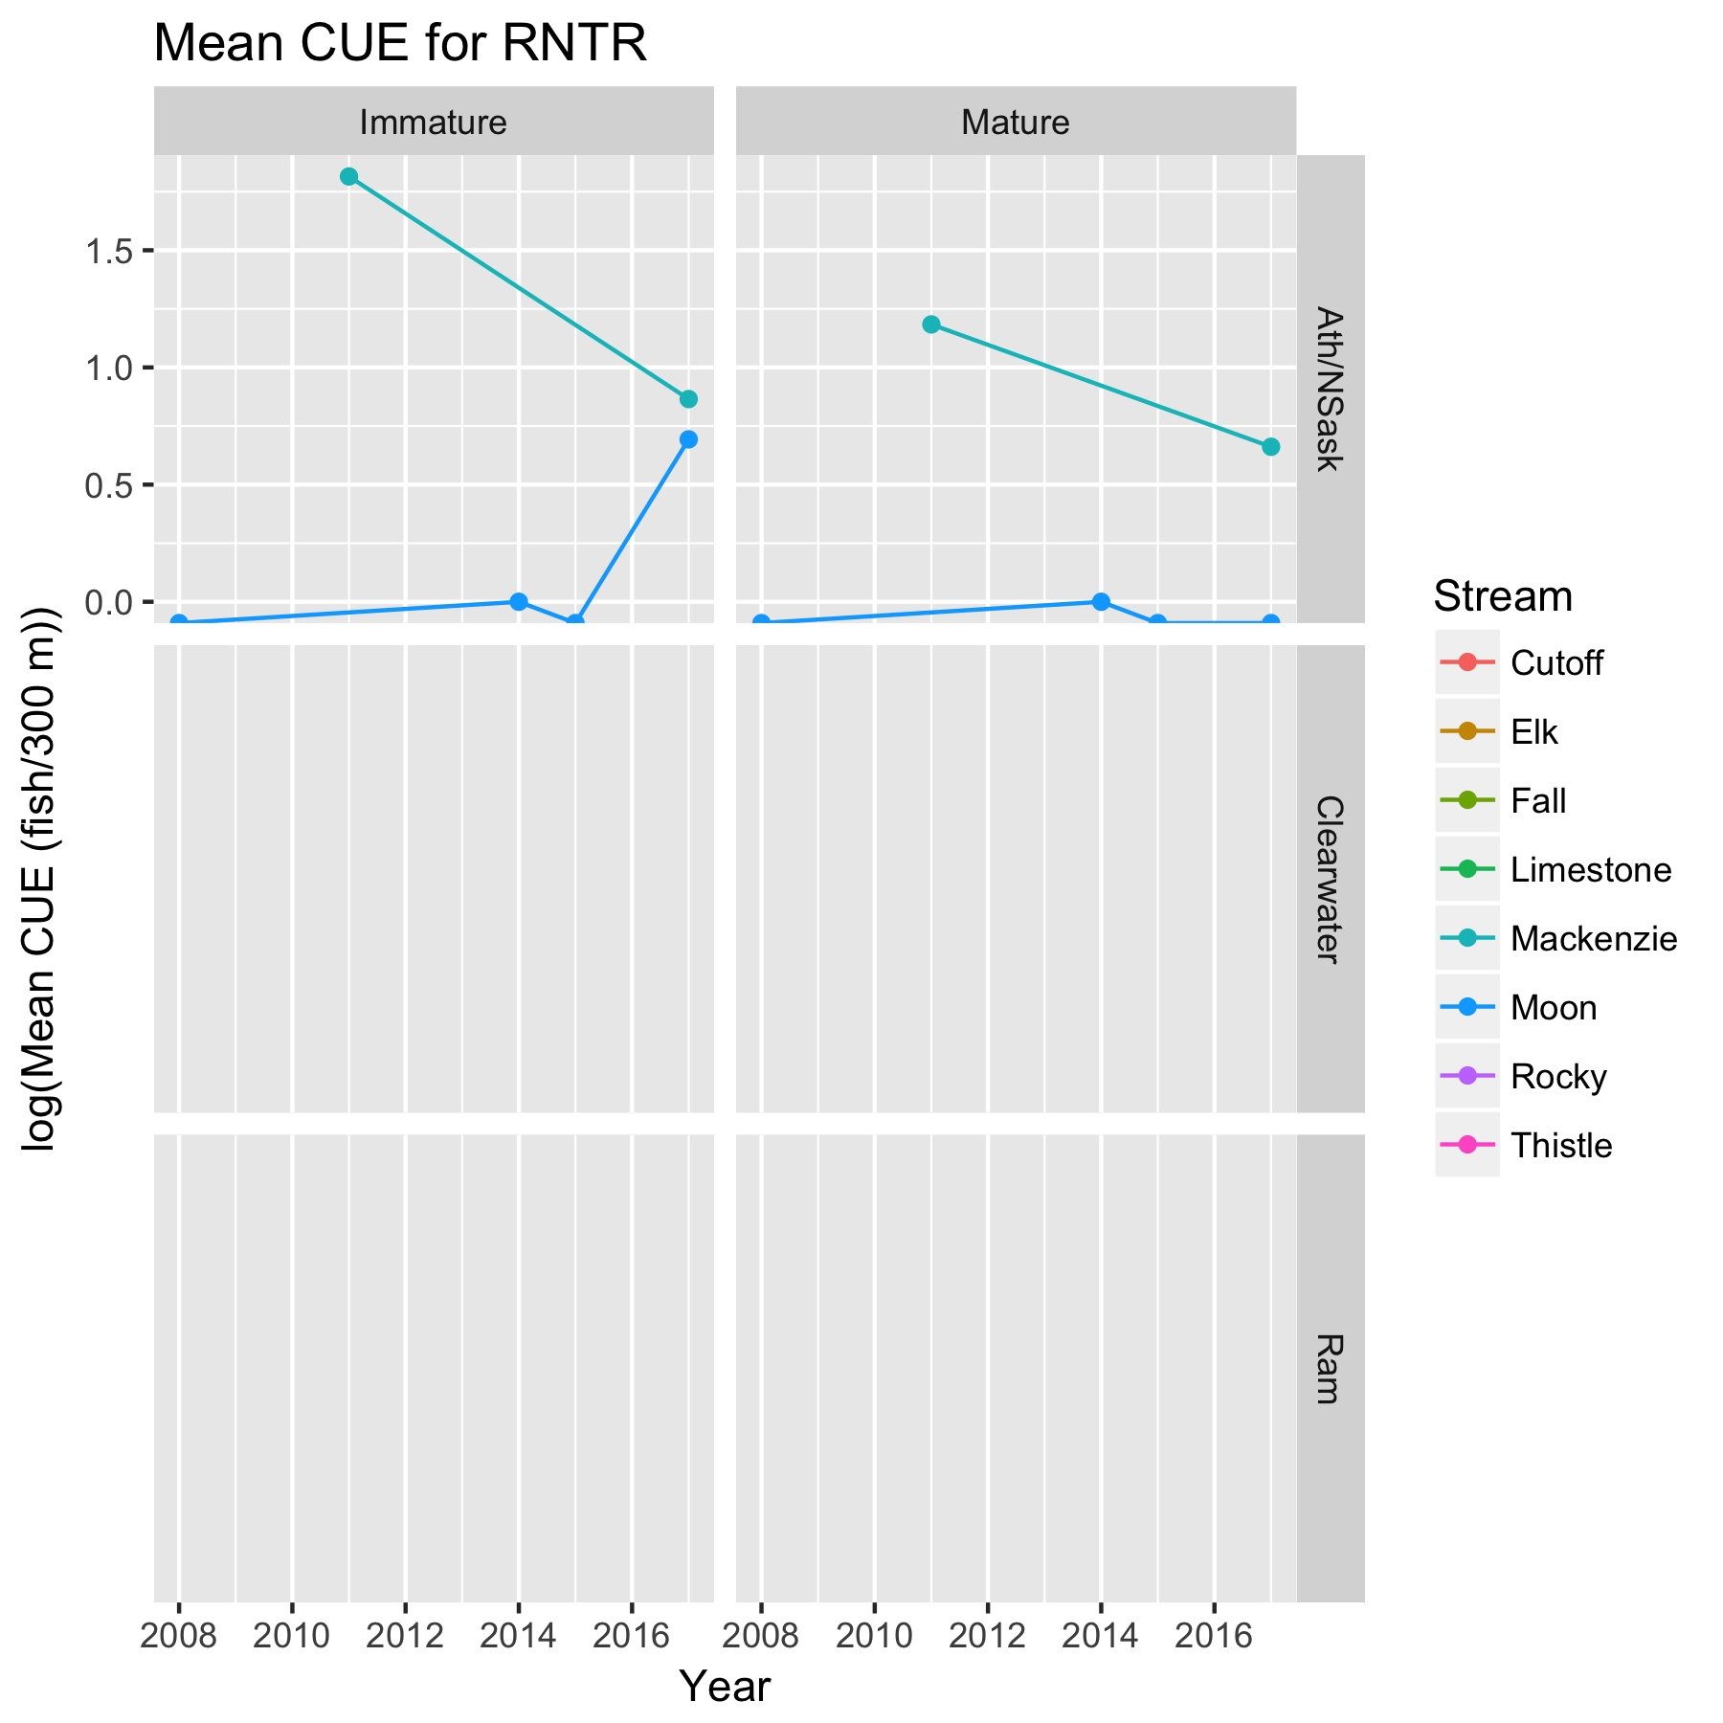

Figure 4c. Mean log( CUE (fish/300 m)) for RNTR for each stream. RNTR is only present in two streams in the Athabaska/North Saskatchewan River watershed.

Figure 5. Estimated power to detect a 2x change using a before/after design for Fall Creek. Please refer to the separate pdf file.

Figure 6. Power plots in a BACI design. Please refer to the separate pdf file.

Figure 7. Power plots for detecting trends. Please refer to the separate pdf file.

Figure 8. Power plots in a BACI design combining results over all watersheds with different levels of noise in the effect size. Notice that RNTR is present only in a single watershed, and so does not appear in the plots.

|  |  |  |  |  |  |  |  |  |  |  |  |  |  |
| --- | --- | --- | --- | --- | --- | --- | --- | --- | --- | --- | --- | --- | --- |
| Table 1. Number of sites measured on each stream from historical data | | | | | | | | | | | | | |
|  | Year/Month | | | | | | | | | | | | |
| Stream/Waterrshed | 2008  07 | 2008  08 | 2010  06 | 2010  07 | 2011  06 | 2011  07 | 2011  08 | 2012  06 | 2014  08 | 2015  07 | 2017  07 | 2017  08 |
| Mackenzie.Ath/NSask |  |  |  |  |  |  | 21 |  |  |  |  | 16 |
| Moon.Ath/NSask | 4 | 1 |  |  |  |  |  |  | 2 | 1 | 2 | 2 |
| Thistle.Ath/NSask |  |  |  |  |  |  |  |  |  |  |  | 8 |
| Cutoff.Clearwater |  |  |  |  | 4 |  |  |  |  |  |  | 3 |
| Elk.Clearwater |  |  |  | 17 |  |  | 5 |  |  |  |  | 2 |
| Limestone.Clearwater |  |  |  |  |  | 2 | 3 |  |  |  |  | 1 |
| Rocky.Clearwater |  |  | 12 |  |  |  |  | 5 |  |  |  | 1 |
| Fall.Ram | 9 |  |  |  |  |  |  |  |  |  | 2 |  |

|  |  |  |  |  |  |  |  |
| --- | --- | --- | --- | --- | --- | --- | --- |
| Table 2. Estimates of variance components (standard deviations) from a mixed linear model. | | | | | | | |
| Watershed | Species | AgeClass | sd.Year | sd.Stream | sd.StreamYear | sd.Resid |
| Ath/NSask | BKTR | AllAges | 0.000 | 0.000 | 0.037 | 0.296 |
| Clearwater | BKTR | AllAges | 0.000 | 0.982 | 0.000 | 1.099 |
| Ram | BKTR | AllAges | 0.427 | NA | NA | 0.306 |
|  |  |  |  |  |  |  |
| Ath/NSask | BLTR | Immature | 0.000 | 0.981 | 0.000 | 1.418 |
| Clearwater | BLTR | Immature | 0.431 | 0.505 | 0.139 | 1.328 |
| Ram | BLTR | Immature | 0.000 | NA | NA | 0.707 |
|  |  |  |  |  |  |  |
| Ath/NSask | BLTR | Mature | 0.000 | 0.000 | 0.000 | 1.043 |
| Clearwater | BLTR | Mature | 0.000 | 0.287 | 0.505 | 1.102 |
| Ram | BLTR | Mature | 0.000 | NA | NA | 0.978 |
|  |  |  |  |  |  |  |
| Ath/NSask | RNTR | Immature | 0.694 | 0.559 | 0.000 | 1.426 |
| Ath/NSask | RNTR | Mature | 0.298 | 0.709 | 0.000 | 1.023 |

1 Because the Ram watershed only has a single stream (Fall Creek) is it not possible to estimate the stream-to-stream variation or the steam-year interaction variance component.

1. Unless otherwise specified, logarithms are taken on the nature scale, i.e. ln() scale.
2. The actual analysis of such a “pooled” design would be easiest done using a Bayesian BACI analysis to allow for variability in the effect size among the multiple watesheds.
3. In the actual analysis, the model does not do this alignment because you want to estimate common year effects corresponding to actual calendar years. However, for purposes of the power analysis the start years have been aligned.