SampleScript.r

cschwarz

Tue Jan 22 19:22:40 2019

# This will be used as an example of creating a notebook in HTML, DOC, or PDF formats.  
  
# See   
# http://rmarkdown.rstudio.com/articles_report_from_r_script.html   
# for more informaton  
  
  
  
  
options(useFancyQuotes=FALSE) # renders summary output corrects  
#source("schwarz.functions.r")  
source('http://www.stat.sfu.ca/~cschwarz/Stat-650/Notes/MyPrograms/schwarz.functions.r')

# This script will read in the cereal data set,   
# do a simple listing,  
# fit a regression line,   
# draw a scatter plot and add the line to the plot  
# do a single factor crd anova  
# get the compact letter display  
# make some plots  
  
  
# load required libraries  
library(ggplot2)  
library(emmeans)  
library(readxl)  
  
# Read in the cereal data from a csv file  
cereal <- read.csv('cereal.csv',   
 header=TRUE, as.is=TRUE, strip.white=TRUE)  
  
  
# Define new variables and factors (for categorical variables). CHeck the structure of the data frame  
cereal$shelfF <- factor(cereal$shelf)  
cereal$Calories.fr.Protein <- cereal$protein * 4;  
  
str(cereal)

## 'data.frame': 77 obs. of 17 variables:  
## $ name : chr "100%_Bran" "100%_Natural_Bran" "All-Bran" "All-Bran_with_Extra_Fiber" ...  
## $ mfr : chr "N" "Q" "K" "K" ...  
## $ type : chr "C" "C" "C" "C" ...  
## $ calories : int 60 110 80 50 110 110 110 140 90 90 ...  
## $ protein : int 4 3 4 4 2 2 2 3 2 3 ...  
## $ fat : int 1 5 1 0 2 2 0 2 1 0 ...  
## $ sodium : int 130 15 260 140 200 180 125 210 200 210 ...  
## $ fiber : num 10 2 9 14 1 1.5 1 2 4 5 ...  
## $ carbo : num 5 8 7 8 14 10.5 11 18 15 13 ...  
## $ sugars : int 6 8 5 0 8 10 14 8 6 5 ...  
## $ shelf : int 3 3 3 3 3 1 2 3 1 3 ...  
## $ potass : int 280 135 320 330 NA 70 30 100 125 190 ...  
## $ vitamins : int 25 0 25 25 25 25 25 25 25 25 ...  
## $ weight : num 1 1 1 1 1 1 1 1.33 1 1 ...  
## $ cups : num 0.331 NA 0.33 0.5 0.75 0.75 1 0.75 0.67 0.67 ...  
## $ shelfF : Factor w/ 3 levels "1","2","3": 3 3 3 3 3 1 2 3 1 3 ...  
## $ Calories.fr.Protein: num 16 12 16 16 8 8 8 12 8 12 ...

# List the first few records  
cereal[1:5,]

## name mfr type calories protein fat sodium fiber  
## 1 100%_Bran N C 60 4 1 130 10  
## 2 100%_Natural_Bran Q C 110 3 5 15 2  
## 3 All-Bran K C 80 4 1 260 9  
## 4 All-Bran_with_Extra_Fiber K C 50 4 0 140 14  
## 5 Almond_Delight R C 110 2 2 200 1  
## carbo sugars shelf potass vitamins weight cups shelfF  
## 1 5 6 3 280 25 1 0.331 3  
## 2 8 8 3 135 0 1 NA 3  
## 3 7 5 3 320 25 1 0.330 3  
## 4 8 0 3 330 25 1 0.500 3  
## 5 14 8 3 NA 25 1 0.750 3  
## Calories.fr.Protein  
## 1 16  
## 2 12  
## 3 16  
## 4 16  
## 5 8

# List some variables  
cereal$calories

## [1] 60 110 80 50 110 110 110 140 90 90 120 110 130 100 110 110 110  
## [18] 100 110 110 100 100 90 100 100 110 90 120 130 100 100 100 100 110  
## [35] 110 130 110 120 100 140 100 100 110 110 150 150 160 90 120 140 90  
## [52] 130 130 90 40 50 100 90 120 90 90 110 100 80 80 90 110 100  
## [69] 80 100 150 110 100 110 100 90 110

cereal[,"calories"]

## [1] 60 110 80 50 110 110 110 140 90 90 120 110 130 100 110 110 110  
## [18] 100 110 110 100 100 90 100 100 110 90 120 130 100 100 100 100 110  
## [35] 110 130 110 120 100 140 100 100 110 110 150 150 160 90 120 140 90  
## [52] 130 130 90 40 50 100 90 120 90 90 110 100 80 80 90 110 100  
## [69] 80 100 150 110 100 110 100 90 110

cereal$fat

## [1] 1 5 1 0 2 2 0 2 1 0 2 2 3 2 1 0 0 0 1 3 0 0 1 0 1 0 0 2 0 1 0 1 1 0 3  
## [36] 2 1 0 1 1 1 2 1 1 3 3 2 1 1 2 0 2 1 0 0 0 1 2 1 2 0 0 0 0 0 0 1 0 0 1  
## [71] 1 1 1 1 1 1 1

cereal[1:5,c("name","fat","calories")]

## name fat calories  
## 1 100%_Bran 1 60  
## 2 100%_Natural_Bran 5 110  
## 3 All-Bran 1 80  
## 4 All-Bran_with_Extra_Fiber 0 50  
## 5 Almond_Delight 2 110

# Make a basic scatter plot  
plotbasic <- ggplot(data=cereal, aes(x=fat, y=calories))+  
 ggtitle("Calories vs Fat in cereals")+  
 xlab("Grams of Fat")+ylab("Calories/serving")+  
 geom_point()  
plotbasic

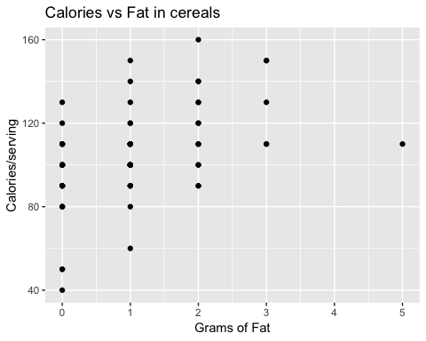

plotbasic2 <- ggplot(data=cereal, aes(x=fat, y=calories))+  
 ggtitle("Calories vs Fat in cereals")+  
 xlab("Grams of Fat")+ylab("Calories/serving")+  
 geom_jitter()  
plotbasic2

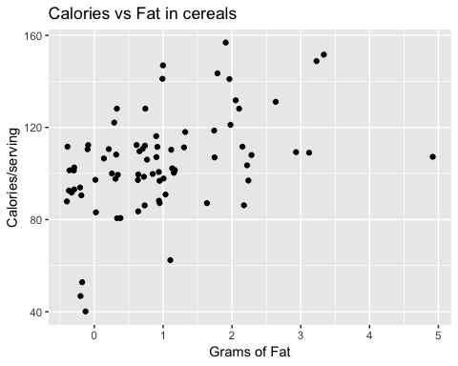

# Same plot in base R graphics (ugh) Try to avoid using Base R graphics  
plot(jitter(cereal$fat), jitter(cereal$calories),  
 main="Plot of calories vs. grams of fat",  
 xlab="Grams of fat", ylab='Calories/servince')

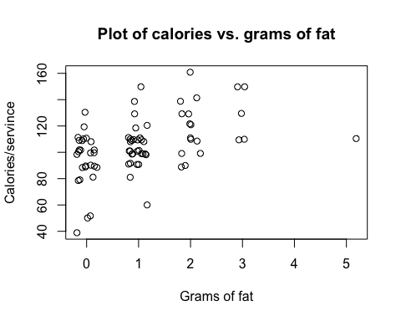

# Fit a regression between calories and grams of fat  
fit.calories.fat <- lm( calories ~ fat, data=cereal)  
summary(fit.calories.fat)

##   
## Call:  
## lm(formula = calories ~ fat, data = cereal)  
##   
## Residuals:  
## Min 1Q Median 3Q Max   
## -55.132 -5.132 4.868 14.868 45.256   
##   
## Coefficients:  
## Estimate Std. Error t value Pr(>|t|)   
## (Intercept) 95.132 3.141 30.285 < 2e-16 ***  
## fat 9.806 2.207 4.443 3.01e-05 ***  
## ---  
## Signif. codes: 0 '***' 0.001 '**' 0.01 '*' 0.05 '.' 0.1 ' ' 1  
##   
## Residual standard error: 19.36 on 75 degrees of freedom  
## Multiple R-squared: 0.2084, Adjusted R-squared: 0.1978   
## F-statistic: 19.74 on 1 and 75 DF, p-value: 3.009e-05

anova(fit.calories.fat) # careful Type I SS

## Analysis of Variance Table  
##   
## Response: calories  
## Df Sum Sq Mean Sq F value Pr(>F)   
## fat 1 7402.9 7402.9 19.743 3.009e-05 ***  
## Residuals 75 28121.8 375.0   
## ---  
## Signif. codes: 0 '***' 0.001 '**' 0.01 '*' 0.05 '.' 0.1 ' ' 1

coef(fit.calories.fat)

## (Intercept) fat   
## 95.131579 9.806005

sqrt(diag(vcov(fit.calories.fat))) # extract the SE

## (Intercept) fat   
## 3.141224 2.206897

confint(fit.calories.fat) # confidence intervals on parameters

## 2.5 % 97.5 %  
## (Intercept) 88.873939 101.38922  
## fat 5.409642 14.20237

names(summary(fit.calories.fat))

## [1] "call" "terms" "residuals" "coefficients"   
## [5] "aliased" "sigma" "df" "r.squared"   
## [9] "adj.r.squared" "fstatistic" "cov.unscaled"

summary(fit.calories.fat)$r.squared

## [1] 0.2083875

summary(fit.calories.fat)$sigma

## [1] 19.36381

class(fit.calories.fat)

## [1] "lm"

methods(class=class(fit.calories.fat))

## [1] add1 alias anova case.names   
## [5] coerce confint cooks.distance deviance   
## [9] dfbeta dfbetas drop1 dummy.coef   
## [13] effects emm_basis extractAIC family   
## [17] formula fortify hatvalues influence   
## [21] initialize kappa labels logLik   
## [25] model.frame model.matrix nobs plot   
## [29] predict print proj qr   
## [33] recover_data residuals rstandard rstudent   
## [37] show simulate slotsFromS3 summary   
## [41] variable.names vcov   
## see '?methods' for accessing help and source code

# Add the fitted line to the scatter plot; and save  
plotline <- plotbasic2 +  
 geom_abline(intercept=coef(fit.calories.fat)[1],  
 slope =coef(fit.calories.fat)[2])  
plotline

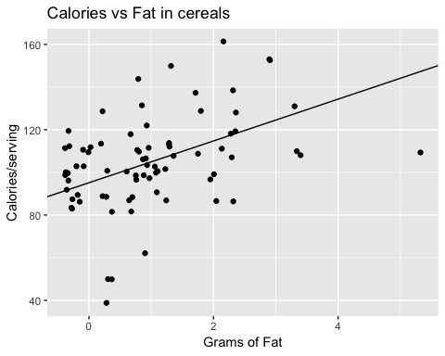

# Or, if you don't want' to do the actual fit, use ggplot directly  
plot.calories.fat <- ggplot(data=cereal, aes(x=fat, y=calories)) +  
 geom_jitter(shape=1) + # Use hollow circles  
 geom_smooth(method=lm, # Add linear regression line  
 se=FALSE) # Don't add shaded confidence region  
plot.calories.fat

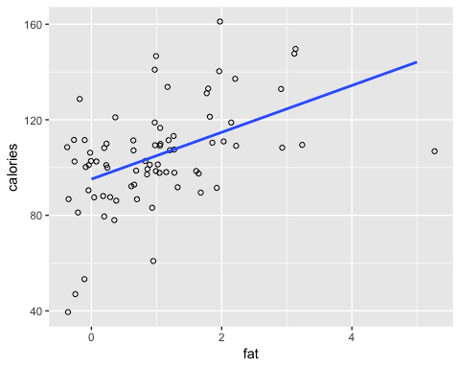

# Make a nicer scatter plot and add the fitted line in base R graphics. Ugh. Not recommended to use Base R graphics  
png("cal-vs-fat3-base.png")  
plot(jitter(cereal$fat), jitter(cereal$calories),  
 main="Plot of calories vs. grams of fat",  
 xlab="Grams of fat", ylab='Calories/servince')  
abline(fit.calories.fat)  
dev.off()

## quartz_off_screen   
## 2

# Do a simple single factor ANOVA  
# Is the mean number of calories the same for all shelves  
# Need to use a FACTOR variable for the categorical variable  
fit.sugars.shelf <- lm( sugars ~ shelfF, data=cereal)  
anova(fit.sugars.shelf)

## Analysis of Variance Table  
##   
## Response: sugars  
## Df Sum Sq Mean Sq F value Pr(>F)   
## shelfF 2 220.23 110.117 6.6013 0.002316 **  
## Residuals 73 1217.71 16.681   
## ---  
## Signif. codes: 0 '***' 0.001 '**' 0.01 '*' 0.05 '.' 0.1 ' ' 1

# Estimate the marginal means along with confidence limits and Tukey multiple comparison.  
fit.sugars.shelf.lsmo <- emmeans::emmeans(fit.sugars.shelf, ~shelfF)  
fit.sugars.shelf.cld <- CLD(fit.sugars.shelf.lsmo, adjust='tukey')  
fit.sugars.shelf.cld

## shelfF emmean SE df lower.CL upper.CL .group  
## 1 5.105263 0.9369889 73 2.815493 7.395034 1   
## 3 6.527778 0.6807066 73 4.864298 8.191257 1   
## 2 9.619048 0.8912542 73 7.441041 11.797054 2   
##   
## Confidence level used: 0.95   
## Conf-level adjustment: sidak method for 3 estimates   
## P value adjustment: tukey method for comparing a family of 3 estimates   
## significance level used: alpha = 0.05

cld.plot <- sf.cld.plot.bar(fit.sugars.shelf.cld, "shelfF", order=FALSE)  
cld.plot

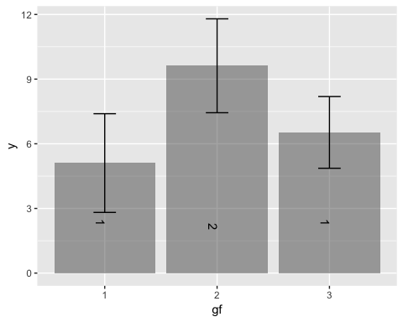

# Estimate the pairwise differences  
pairs(fit.sugars.shelf.lsmo)

## contrast estimate SE df t.ratio p.value  
## 1 - 2 -4.513784 1.293168 73 -3.490 0.0023  
## 1 - 3 -1.422515 1.158149 73 -1.228 0.4405  
## 2 - 3 3.091270 1.121470 73 2.756 0.0199  
##   
## P value adjustment: tukey method for comparing a family of 3 estimates