1. A simple analysis of the cereal dataset for G

Carl Schwarz

2019-10-30

Table of Contents

# Introduction

What is the relationship between the calories in a serving of breakfast cereal and the grams of fat.

# Material and Methods

A sample of 22 cereals were sampled from a local grocery store from this manufacturer and the nutritional information (e.g. number of grams of fat, protein, carbohydrates, etc.) and the number of calories per serving was extracted. The display shelf on which the cereal was stored was also recorded.

A simple linear regression was used to estimate the relationship between calories and fat.

All computations were performed using R version 3.6.0 (2019-04-26).

# Results

The data was screened for outliers and no unusal points were located.

This table summarizes the calories per serving by shelf number. shelf shelfc 1 2 3 High 0 0 9 Low 6 0 0 Middle 0 7 0

Summary statistics on calories per serving

|  |  |  |  |  |  |
| --- | --- | --- | --- | --- | --- |
| Shelf | n | Mean calories per serving | Min calories per serving | Max calories per serving | SD calories per serving |
| Low | 6 | 103.3 | 90 | 110 | 10.3 |
| Middle | 7 | 110 | 100 | 130 | 10 |
| High | 9 | 112.2 | 90 | 150 | 22.2 |

This figure shows a graphical display of the calories per serving vs. the amount of fat in a serving.

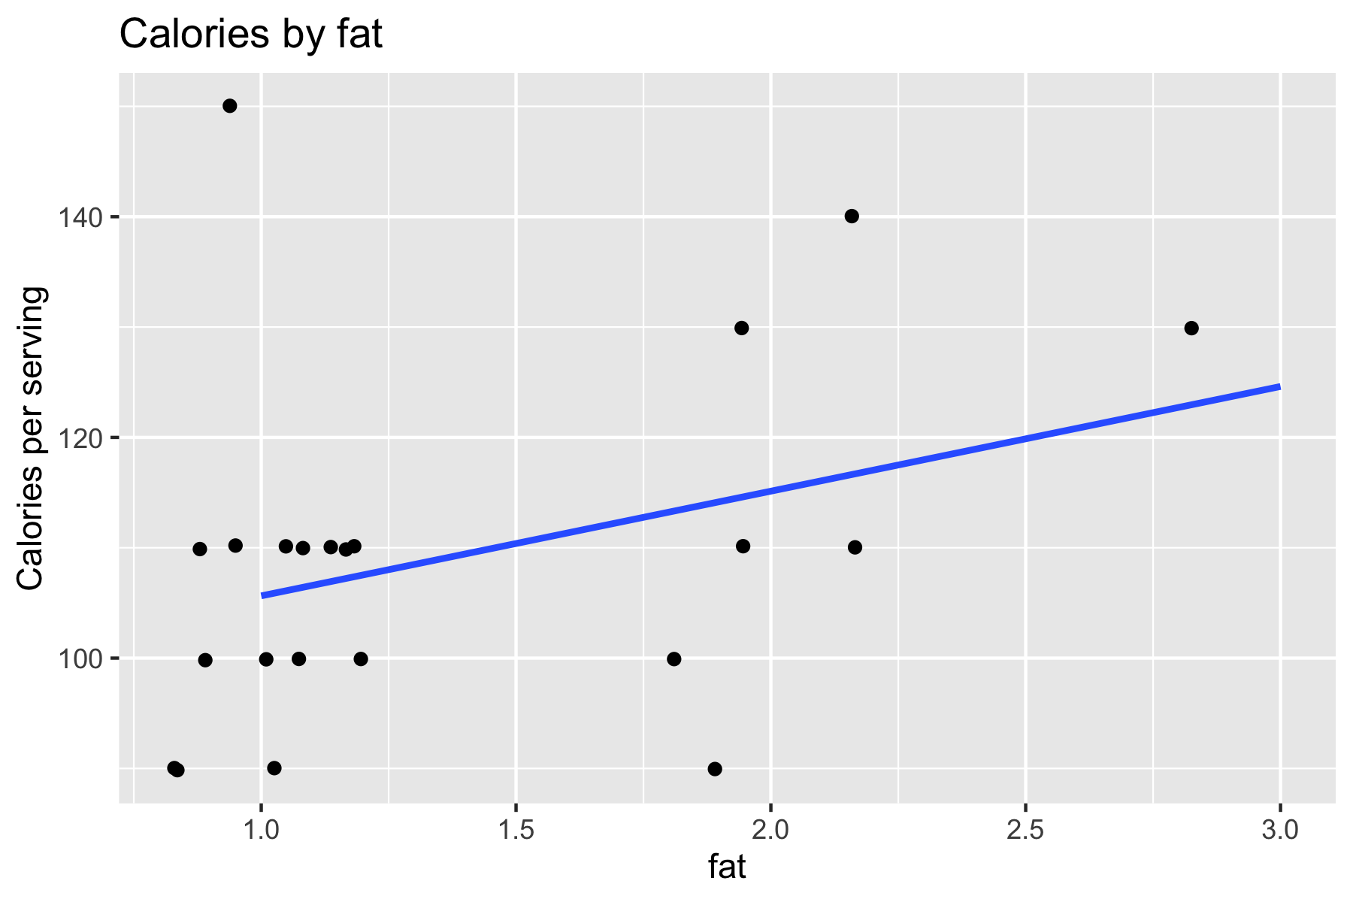

There was no evidence of a relationship between the calories per serving and the amount of fat (p=0.11656). The estimated slope was 9.49 (SE 5.78).

# Summary

We found no evidence that the mean number of calories varied with the amount of fat in a serving of cereal.