1. A simple analysis of the cereal dataset

Carl Schwarz

2018-06-18

Table of Contents

# Introduction

What is the relationship between the calories in a serving of breakfast cereal and the placement of the cereal on the shelf in the supermarket?

# Material and Methods

A sample of 77 cereals were sampled from a local grocery store and the nutritional information (e.g. number of grams of fat, protein, carbohydrates, etc.) and the number of calories per serving was extracted. The display shelf on which the cereal was stored was also recorded.

A single-factor Completely Randomized Design (CRD) analysis of variance was used to compare the mean number of calories of cereals from each display shelf. This was followed by a Tukey multiple comparison procedure to investigate among which shelves the mean may differ.

All computations were performed using R version 3.5.0 (2018-04-23).

# Results

The data was screened for outliers and no unusal points were located.

This table summarizes the calories per serving by shelf number. shelf shelfc 1 2 3 High 0 0 36 Low 20 0 0 Middle 0 21 0

Summary statistics on calories per serving

|  |  |  |  |  |  |
| --- | --- | --- | --- | --- | --- |
| Shelf | n | Mean calories per serving | Min calories per serving | Max calories per serving | SD calories per serving |
| Low | 20 | 100.5 | 80 | 120 | 11.5 |
| Middle | 21 | 107.6 | 80 | 130 | 12.2 |
| High | 36 | 106.1 | 40 | 160 | 29 |

This figure shows a graphical display of the calories per serving

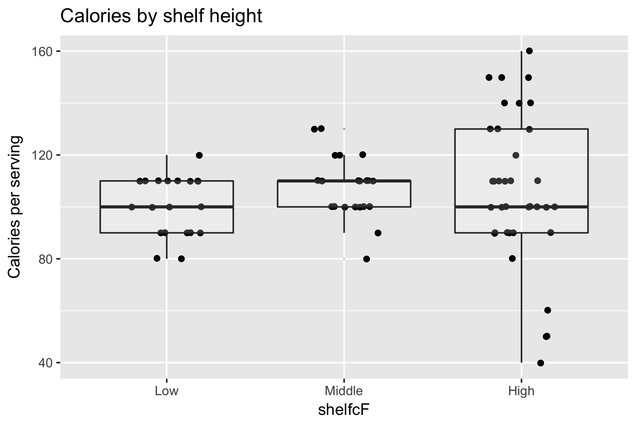

There was no evidence (p=0.54) of a difference in the mean calories per serving among the shelf height. But there was evidence of a difference in the mean grams of sugar per serving among the shelf height (p=0). A bar graph of the mean grams per serving is shown below. There was no evidence that the mean amount of sugar per serving varied between the *Low* and *High* shelves, but there was evidence that the mean of both shelves differed from that on the *Middle* shelf.

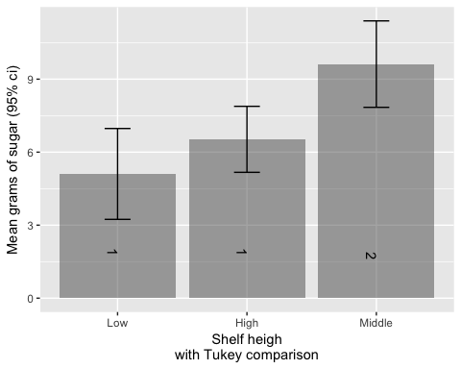

# Summary

We found no evidence that the mean number of calories varied among shelve heights, but there was evidence the the mean amount of sugars did.