***COMPUTER SCIENCE PROJECT***

***2022 – 2023***

***TOPIC:***

RAILWAY ENQUIRY CUM RESERVATION SYSTEM

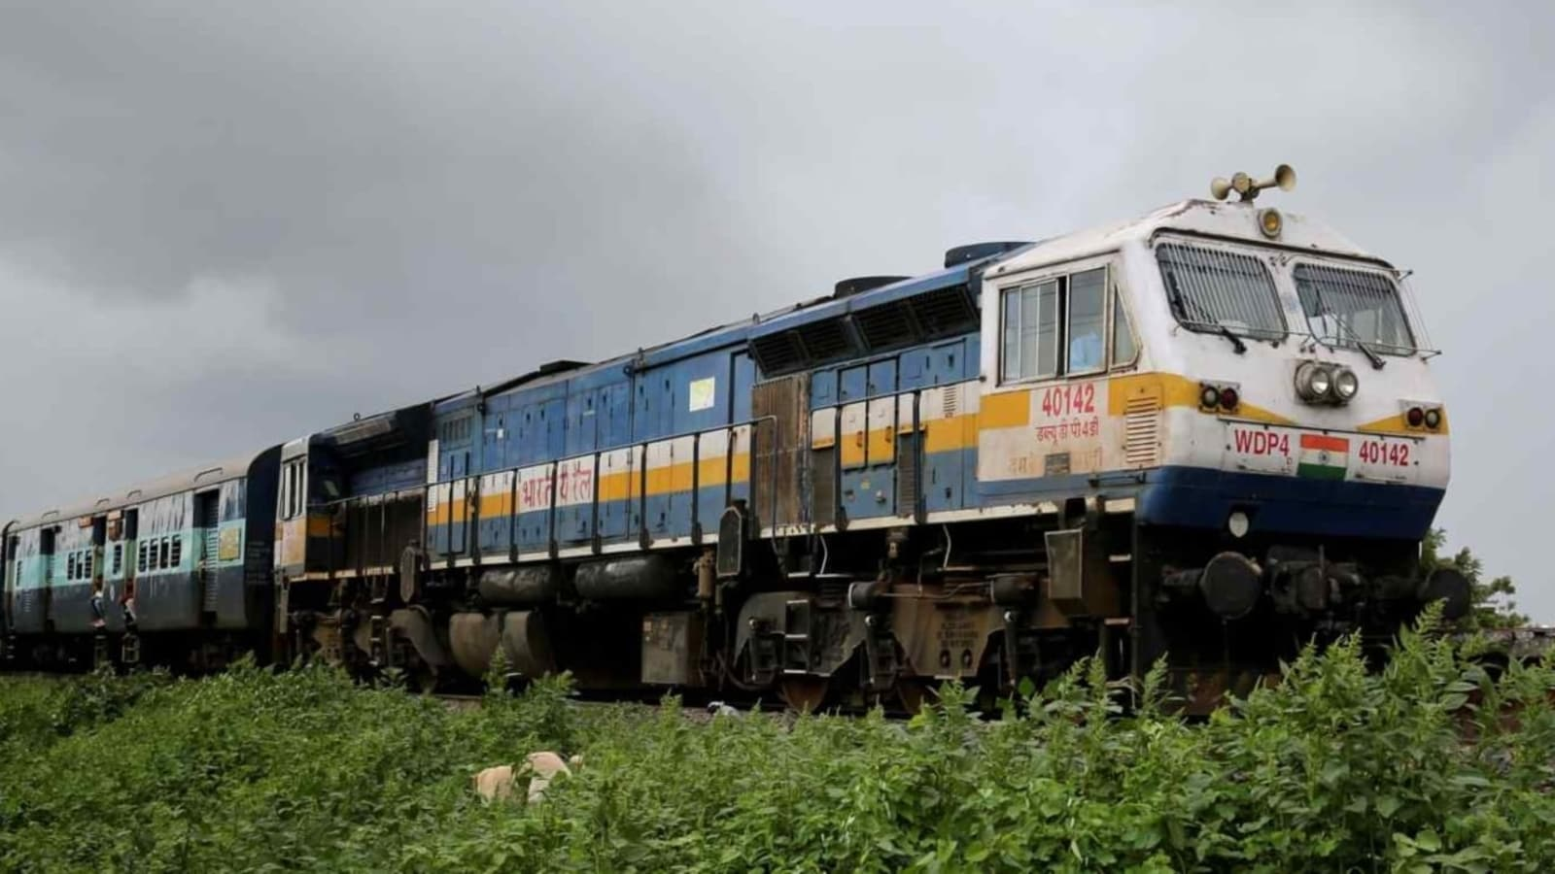

|  |  |  |  |  |  |  |  |
| --- | --- | --- | --- | --- | --- | --- | --- |
|  |  |  |  |  |  |  |  |

Register Number

**Bonafide Certificate**

Certified to be the bonafide record of work done by Master………….……………………………of …………… during the year 20.... - 20….

Dated……………… P.G.T in…………………

Chennai

Submitted for All India Senior Secondary Practical Examination held in……………………………………...…. at…………………………., Chennai.

Dated…………………

Examiner

Seal

**ACKNOWLEDGEMENT**

I wish to express my deep gratitude and sincere thanks to my computer science subject teacher Mrs. Hemalatha ma’am, my principal Mrs. Chitra Raghavan ma’am and our computer science lab attenders Mr. Karthik Saran and Mrs. Bhanu without whom this project would have not been completed.

***CONTENTS***

* Abstract
* Objective Program
* Description
* System Requirements
* Files Required
* Program Code
* Output
* System Implementation
* Conclusion
* Bibliography

***ABSTRACT***

The purpose of the project is to computerize the requirement

of the **RAILWAY ENQUIRY AND RESERVATION SYSTEM** to add a train, assign seats, add train route, reservation chart, delete a train in admin mode and booking a ticket, pnr enquiry, booking history in user mode. The software saves multiple train records and gives option for every kind of modification needed. It helps us to know all information about the trains, like the travelling duration, arrival and departures from stations, all the tickets booked in the past history, and many more.

***OBJECTIVE***

The objective of railway enquiry cum reservation system is to allow both the administrator and the user to add a few details and book ticket, etc. All the details of admin mode and user mode are stored in mysql database and text files. It also facilitates keeping all the records of trains, such as their arrival time, departure time, passenger details, reservation status, etc. So, all the information about a train will be available in a few seconds.

Overall, it will make Train Information Management an easier job for the administrator and booking easier for a user of any need and urgency.

***DESCRIPTION***

System comprises of two modes with their attributes as follows:

**Major Functions of Admin Mode:**

* **Add a Train**: Create a train with the details such as train number, train name, etc.
* **Assigning Seats**: Assigning seats to the train which the admin wants to for each category like Sleeper, General, etc.
* **Adding Train Route**: Adding a station in the route for halt in which the train is going.
* **Reservation Chart**: Getting the info of how many seats books in each category and the details of the passengers, etc.
* **Delete a train**: Deleting a train which of no use for any passenger.

**Major Functions of User Mode:**

* **Booking a Ticket:** Booking a ticket entering the boarding station and departing station and passenger details.
* **PNR Enquiry:** Get the status of the ticket which you booked using the unique pnr code given to you while booking.
* **Cancel Ticket:** Cancel your ticket at any moment when you feel it is unnecessary for you to travel.
* **Booking History:** Get the entire booking history of all the tickets purchased/booked.

***SYSTEM REQUIREMENTS***

# Hardware required:

1. A laptop/computer with O.S

windows 10/windows 11

1. CPU – 64 BITS
2. Minimum RAM- 4GB

# Software required:

1. Python 3.10/3.11 version
2. Tkinter (GUI)
3. MySQL Server and Database
4. OS Module
5. Datetime Module
6. Calendar Module

***FILES REQUIRED***

1. sqlconnect.py: Enter the password of the server and database name to be used.
2. database.py: Run the code once to create a database and required tables.
3. bg.png: For a good background image.
4. functions.py: The source code.
5. main.py: The file which has to be run for the output.
6. code.pdf: PDF file containing station name and code for entries in places required in admin and user mode.
7. readme.txt: Some general cautions and intimations from coder which is must to read before execution of the source code.

***FLOW CHART OF THE PROGRAM PROCESS***

***FRONT END – Python***

Python is a high-level, general-purpose, and very Popular programming language. Basically, it was designed with an emphasis on code readability, and programmers can express their concepts in fewer lines of code. We can also use Python with SQL. Here, we will learn how to connect SQL with Python using the ‘MySQL Connector Python ‘module. The diagram given below illustrates how a connection request is sent to MySQL connector Python, how it gets accepted from the database and how the cursor is executed with result data.

The Tkinter tutorial introduces you to the exciting world of GUI programming in Python.

Tkinter is pronounced as tea-kay-inter. Tkinter is the Python interface to Tk, which is the GUI toolkit for Tcl/Tk.

Tcl (pronounced as tickle) is a scripting language often used in testing, prototyping, and GUI development. Tk is an open-source, cross-platform widget toolkit used by many different programming languages to build GUI programs.

Python implements the Tkinter as a module. Tkinter is a wrapper of C extensions that use Tcl/Tk libraries.

Tkinter allows you to develop desktop applications. It’s a very good tool for GUI programming in Python.

***BACK END – MYSQL and TEXT FILES***

MySQL is the de-facto standard database system for websites with HUGE volumes of both data and end-users (like Facebook, Twitter and Wikipedia). Another great thing about MySQL is that it can be scaled down to support embedded database applications.

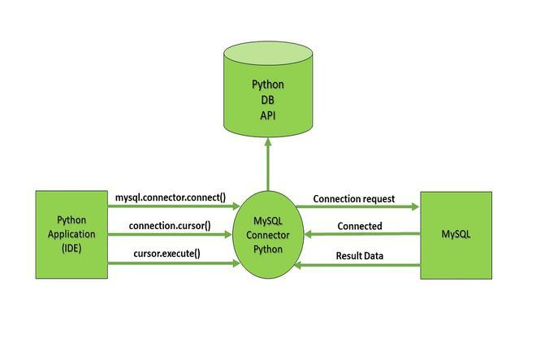

There are two kinds of memory in a computer i.e., Primary and Secondary memory every file that you saved or anyone saved is on secondary memory cause any data in primary memory is deleted when the computer is powered off. So, when you need to change any text file or just to work with them in python you need to load that file into primary memory. Python interacts with files loaded in primary memory or main memory through “file handlers” (This is how your operating system gives access to python to interact with the file you opened by searching the file in its memory if found it returns a file handler and then you can work with the files).

***SAMPLE OUTPUT***

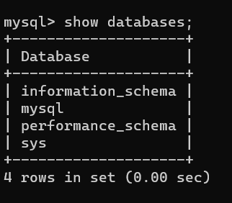

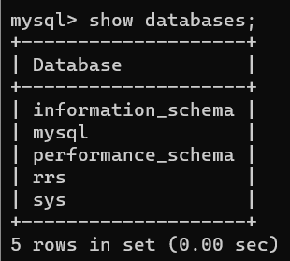

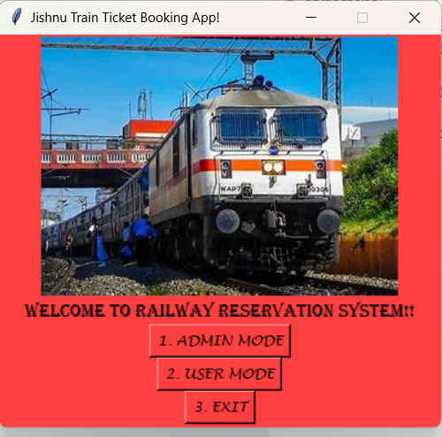

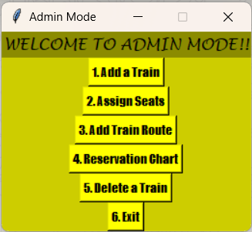

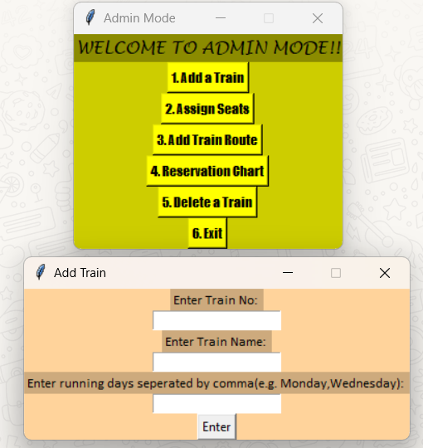

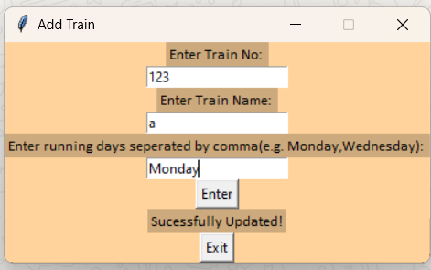

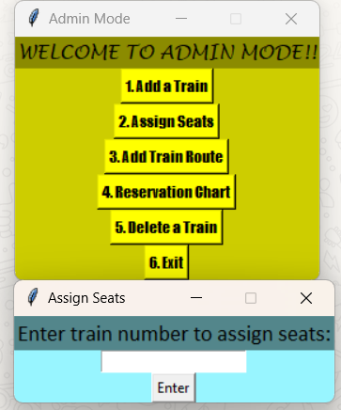

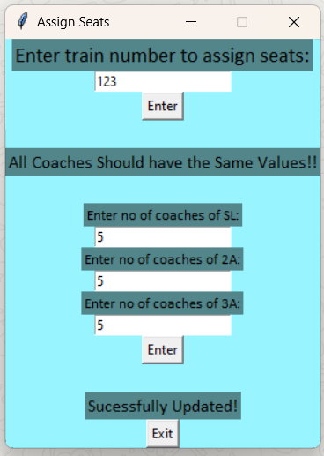

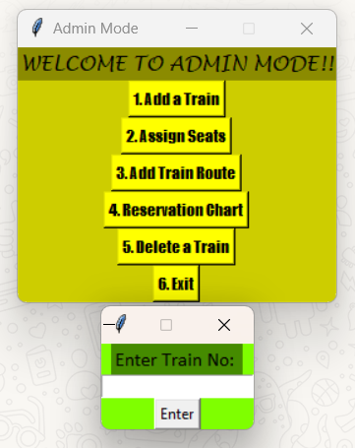

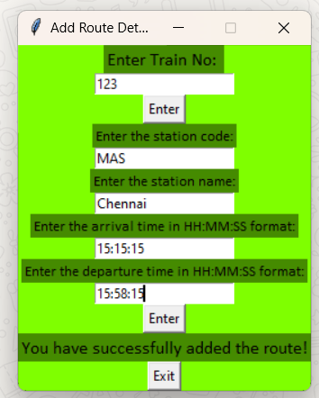

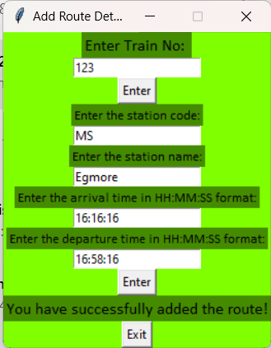

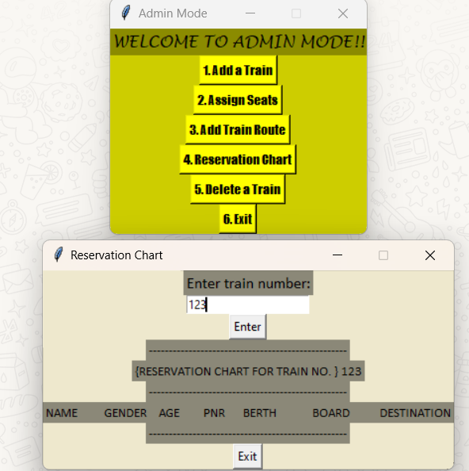

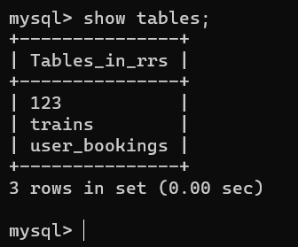

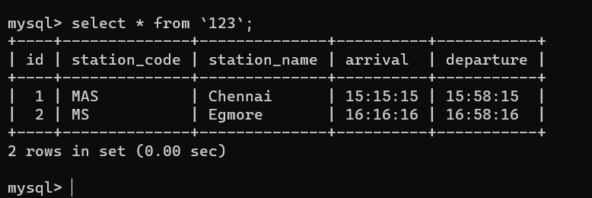

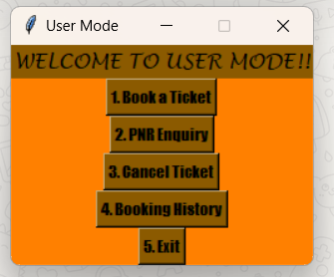

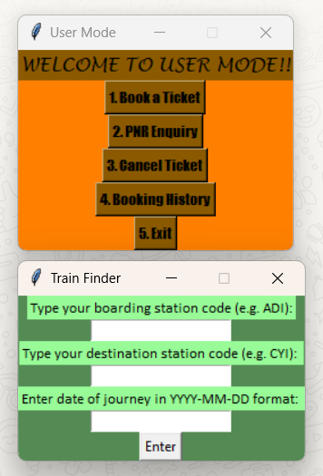

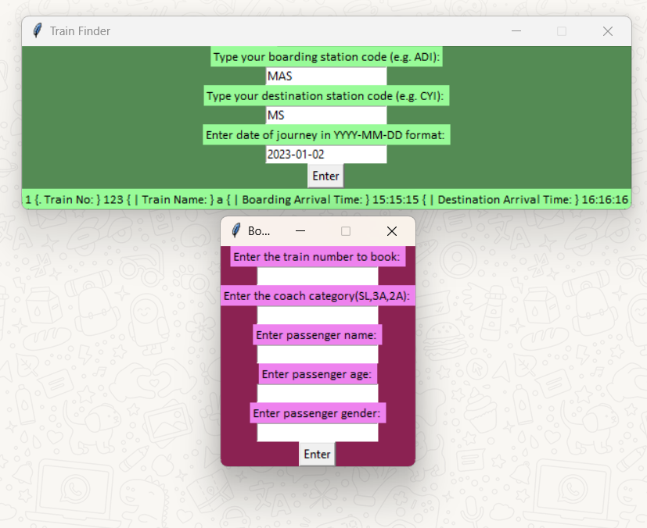

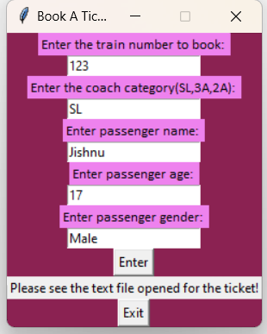

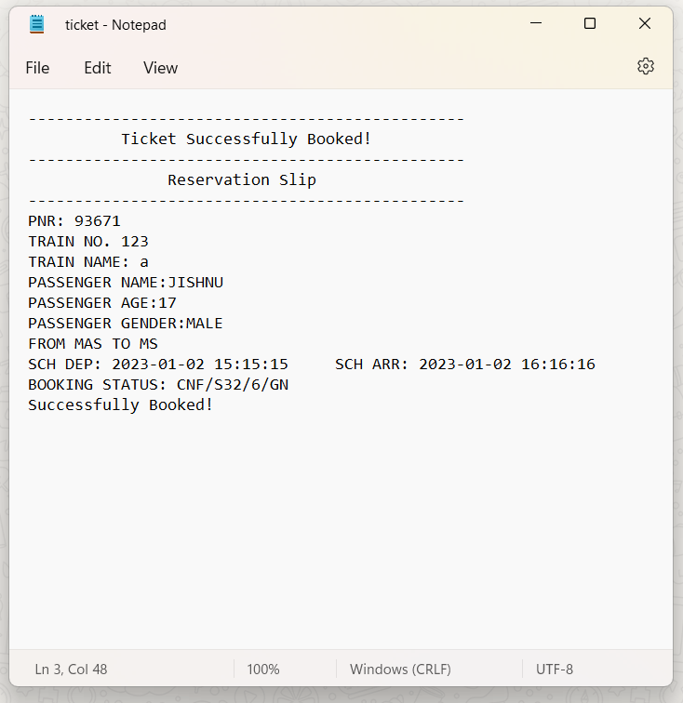

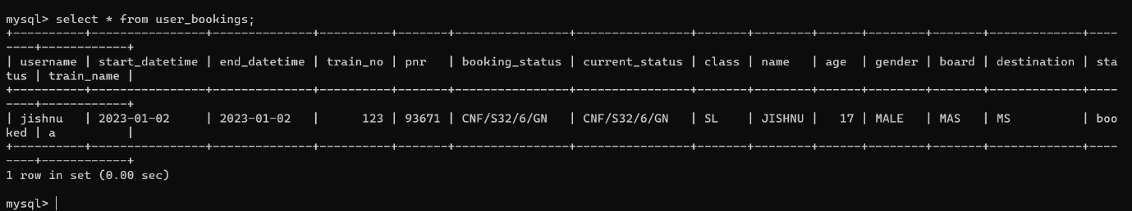

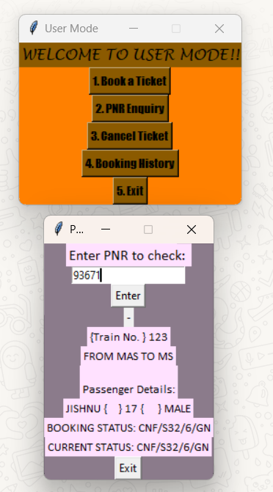

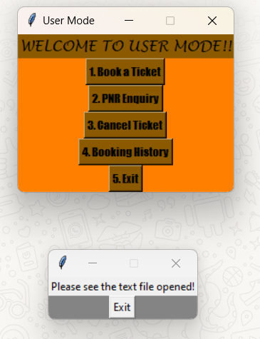

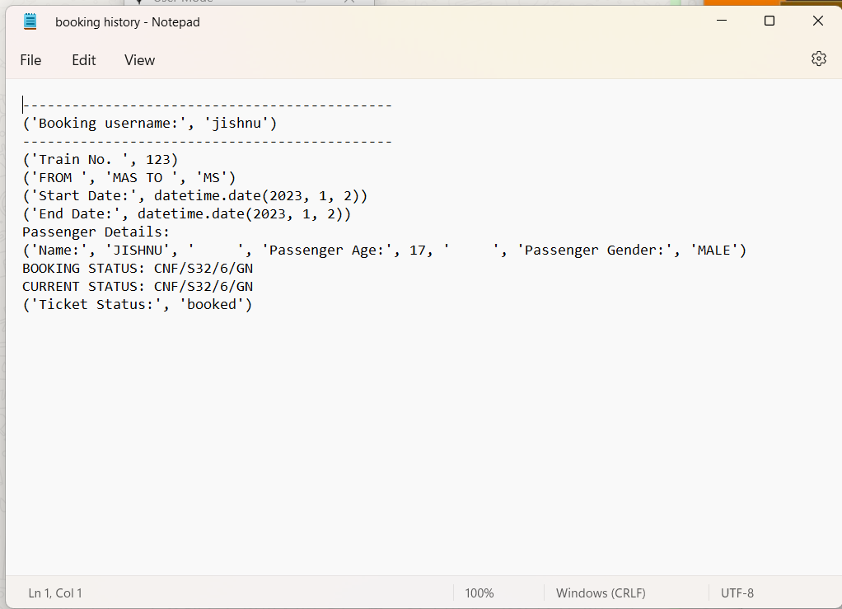

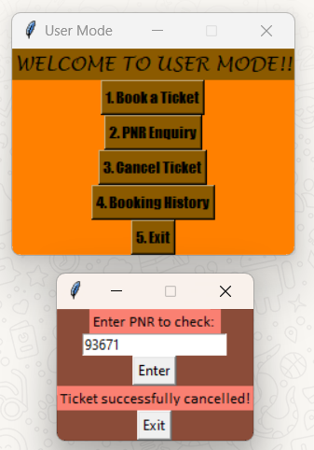

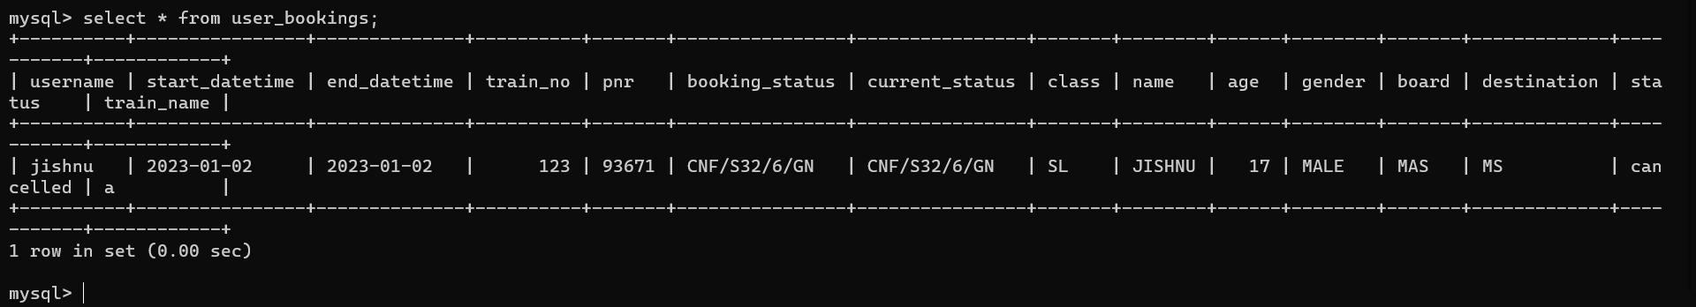

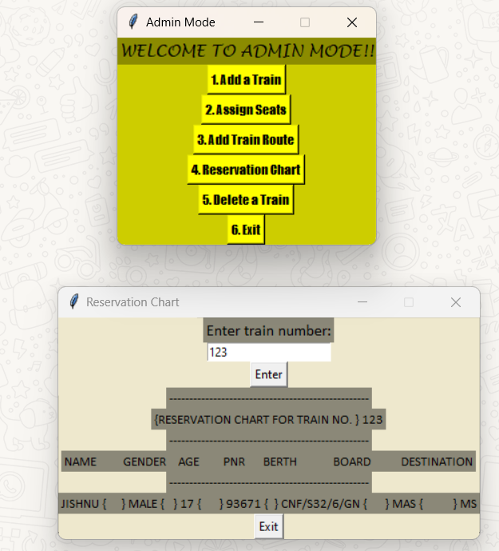



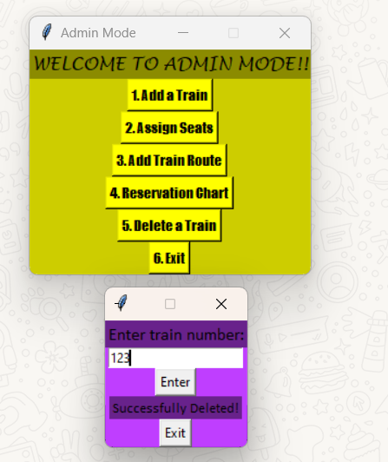

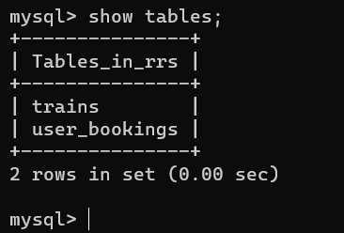

***SYSTEM IMPLEMENTATION***

* Viewing, Updating, Searching, Booking and Deleting introduced in this program can be used for any other program which requires the same functions.
* It can help offices to store important details of trains very easily as this code is User Friendly and a bit less complicated Program when compared to others.

***CONCLUSION***

Enquiry cum Reservation System can be used by railway institutions to maintain their record of train easily. Achieving this objective is difficult using the manual system as the information is scattered, can be redundant, and collecting relevant information may be very time consuming. All these problems are solved by this project. This system helps in maintaining the information of trains of the organization. It can be easily accessed by any higher authority who has been given access by the admin and kept safe for a longer period of time without any change from the user.

***BIBLIOGRAPHY***

1. Computer Science – CBSE Class 11th & 12th textbook.
2. Geeksforgeeks.org
3. Wikipedia.com

***THANK YOU***