

Functional Safety Concept Lane Assistance

**Document Version: 1.0**

**Template Version 1.0, Released on 2017-06-21**



# Document history

|  |  |  |  |
| --- | --- | --- | --- |
| Date | Version | Editor | Description |
| 2018-06-04 | v0.9 | Csathó, Csaba | First draft |
| 2018-06-19 | v1.0 | Csathó, Csaba | Final version |
|  |  |  |  |
|  |  |  |  |

# Table of Contents

Contents

Document history 2

Table of Contents 2

Purpose of the Functional Safety Concept 3

Inputs to the Functional Safety Concept 3

Safety goals from the Hazard Analysis and Risk Assessment 3

Preliminary Architecture 3

Description of architecture elements 4

Functional Safety Concept 4

Functional Safety Analysis 5

Functional Safety Requirements 6

Refinement of the System Architecture 7

Allocation of Functional Safety Requirements to Architecture Elements 7

Warning and Degradation Concept 8

# Purpose of the Functional Safety Concept

A functional safety concept produces functional safety requirements from the general functional safety goals. These requirements are allocated to different parts of the item architecture. From the result of the functional safety concept technical safety requirements can be derived in the following step – the technical safety concept. Instructions regarding the validation and verification of the requirements are also provided.

# Inputs to the Functional Safety Concept

## Safety goals from the Hazard Analysis and Risk Assessment

|  |  |
| --- | --- |
| ID | Safety Goal |
| **Safety_Goal_01** | The oscillating steering torque from the LDW function shall be limited. |
| **Safety_Goal_02** | LKA function shall be time limited and the additional steering torque shall end after a given time interval thus the driver cannot use the system for autonomous driving. |
| **Safety_Goal_03** | The LKA function has to be deactivated if the camera sensor is unable to detect lanes correctly. |
| **Safety_Goal_04** | The LDW function has to be deactivated if the camera sensor is unable to detect lanes correctly. |

## Preliminary Architecture

*The interaction between the three subsystems:*

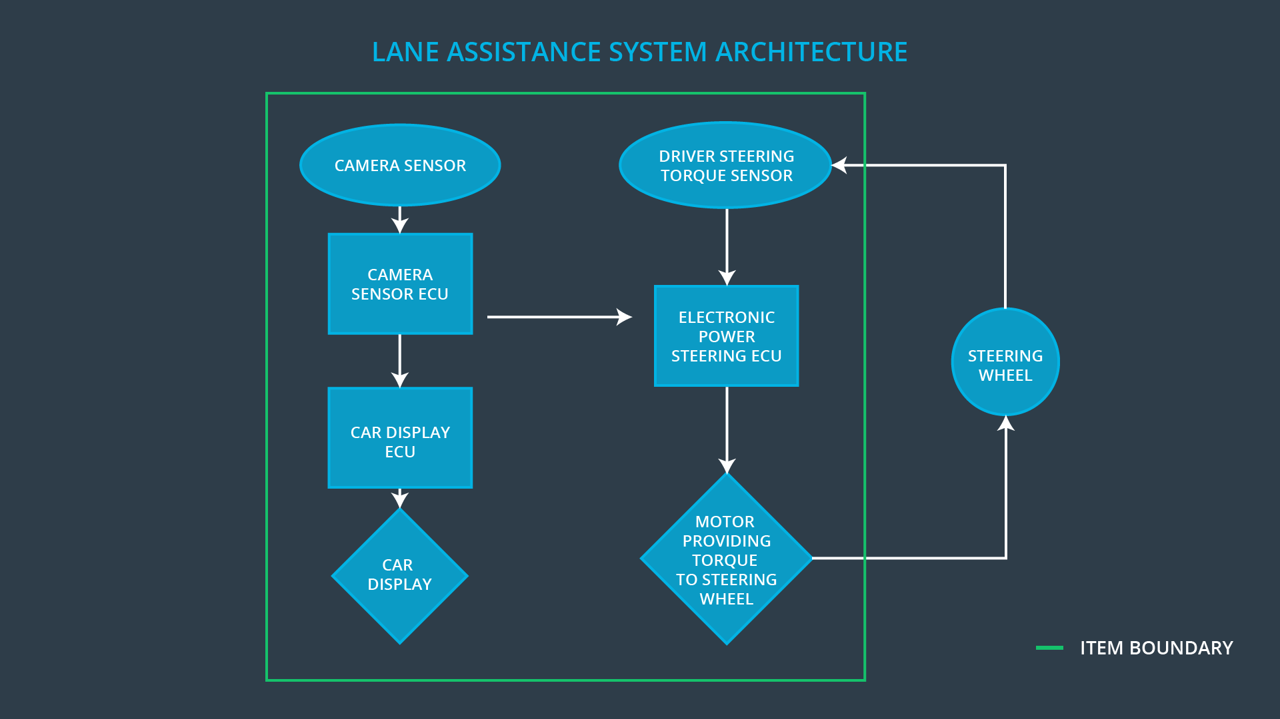

### Description of architecture elements

|  |  |
| --- | --- |
| Element | Description |
| **Camera Sensor** | Optical sensor for observing lane lines. |
| **Camera Sensor ECU** | Processes image data from above and detects lane line positions and issues a torque request to the Electronic Power Steering ECU. |
| **Car Display** | Vehicle dashboard that provides feedback of the car’s status to the driver (e.g. displaying warnings sings of the LKA/LDW). |
| **Car Display ECU** | Handles warning signals that come from the Camera Sensor ECU and Electronic Power Steering ECU. |
| **Driver Steering Torque Sensor** | Measures the torque applied to the steering wheel by  the driver. |
| **Electronic Power Steering ECU** | Combines the value from above and the torque requested by the by the LKA/LDW and sends the calculated torque value request to the Motor actuator. |
| **Motor** | Receives the request from above and applies it to steering wheel |

# Functional Safety Concept

The functional safety concept consists of:

* Functional safety analysis
* Functional safety requirements
* Functional safety architecture
* Warning and degradation concept

## Functional Safety Analysis

|  |  |  |  |
| --- | --- | --- | --- |
| Malfunction ID | Main Function of the Item Related to Safety Goal Violations | Guidewords (NO, WRONG, EARLY, LATE, MORE, LESS) | Resulting Malfunction |
| **Malfunction_01** | The LDW function shall apply an oscillating steering torque to provide the driver a haptic feedback | MORE – very high torque amplitude (above limit) | Driver loses control of the vehicle. may result in collision. |
| **Malfunction_02** | The LDW function shall apply an oscillating steering torque to provide the driver a haptic feedback | MORE – very high torque frequency (above limit) | Driver loses control of the vehicle. may result in collision. |
| **Malfunction_03** | The LKA function shall apply the steering torque when active in order to stay in ego lane | NO – no time limitation | LKA is not intended to be used for autonomous driving; may result in collision. |
| **Malfunction_04** | The LKA function shall be deactivated when the camera becomes unreliable. | WRONG – unreliable detection | The camera sensor is unable to detect lanes correctly, thus provides incorrect results. |
| **Malfunction_05** | The LDW function shall be deactivated when the camera becomes unreliable. | WRONG – unreliable detection | The camera sensor is unable to detect lanes correctly, thus provides incorrect results. |

## Functional Safety Requirements

*Lane Departure Warning (LDW) Requirements*

|  |  |  |  |  |
| --- | --- | --- | --- | --- |
| F/S ID | Functional Safety Requirement | ASIL | Fault Tolerant Time Intv. | Safe State |
| **Requirement 01-01** | The lane keeping item shall ensure that the lane departure oscillating torque amplitude is below Max_Torque_Amplitude | C | 50 ms | limit torque amplitude |
| **Requirement 01-02** | The lane keeping item shall ensure that the lane departure oscillating torque frequency is below Max_Torque_Frequency | C | 50 ms | limit torque frequency |
| **Requirement 01-03** | If the camera sensor becomes unreliable the LDW system shall be deactivated. | C | 25 ms | turn off the complete LDW functionality |

*Lane Departure Warning (LDW) Verification and Validation Acceptance Criteria*

|  |  |  |
| --- | --- | --- |
| F/S ID | Validation Acceptance  Criteria and Method | Verification Acceptance  Criteria and Method |
| **Requirement 01-01** | Testing how drivers handle different torque amplitudes to prove that the right value was selected. | Verifying whether the system limits torque amplitude when an intentionally wrong value was issued. |
| **Requirement 01-02** | Testing how drivers handle different torque frequencies to prove that the right value was selected. | Verifying whether the system limits torque frequency when an intentionally wrong value was issued. |
| **Requirement 01-03** | Testing various situations when the camera sensor may get occluded. | Verifying whether the system turns off in these scenarios. |

*Lane Keeping Assistance (LKA) Requirements*

|  |  |  |  |  |
| --- | --- | --- | --- | --- |
| F/S ID | Functional Safety Requirement | ASIL | Fault Tolerant Time Intv. | Safe State |
| **Requirement 02-01** | The item shall ensure that the LKA applies the torque for only Max_Duration timespan. | B | 500 ms | does not apply any torque |
| **Requirement 02-02** | If the camera sensor becomes unreliable the LKA system shall be deactivated. | C | 25 ms | turn off the complete LKA functionality |

*Lane Keeping Assistance (LKA) Verification and Validation Acceptance Criteria*

|  |  |  |
| --- | --- | --- |
| F/S ID | Validation Acceptance  Criteria and Method | Verification Acceptance  Criteria and Method |
| **Requirement 02-01** | Testing whether the Max_Duration selected really did deter drivers from taking their hands off the steering wheel. | Verifying that the LKA does not apply any torque if the time exceeds Max_Duration. |
| **Requirement 02-02** | Testing various situations when the camera sensor may get occluded. | Verifying whether the system turns off in these scenarios. |

## Refinement of the System Architecture

*System Diagram after Adding Extra Safety Elements*

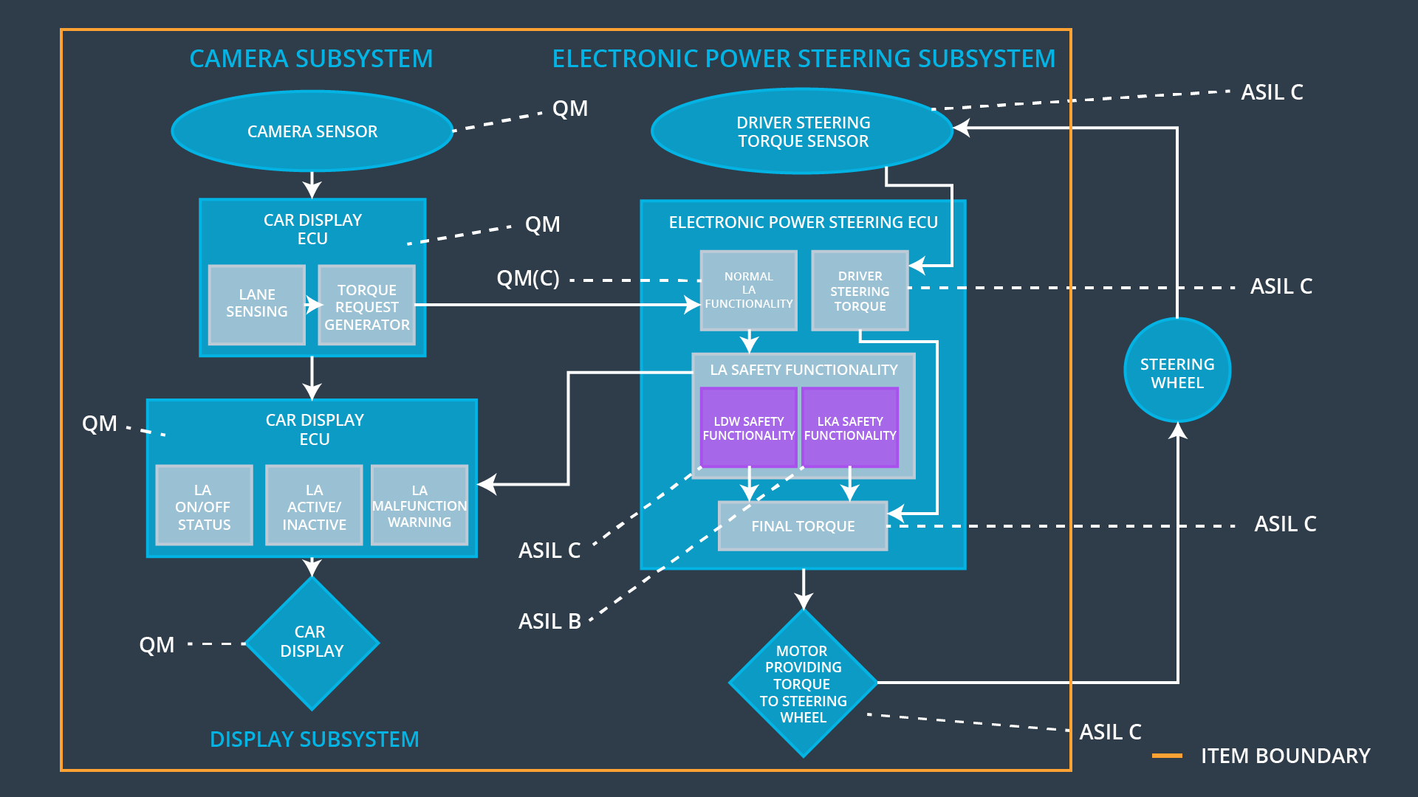

## Allocation of Functional Safety Requirements to Architecture Elements

|  |  |  |  |  |
| --- | --- | --- | --- | --- |
| F/S ID | Functional Safety Requirement | Electronic Power Steering ECU | Camera ECU | Car Display ECU |
| **Requirement 01-01** | The lane keeping item shall ensure that the lane departure oscillating torque amplitude is below Max_Torque_Amplitude | X | **—** | **—** |
| **Requirement 01-02** | The lane keeping item shall ensure that the lane departure oscillating torque frequency is below Max_Torque_Frequency | X | **—** | **—** |
| **Requirement 01-03** | If the camera sensor becomes unreliable the LDW system shall be deactivated. | X | **—** | **—** |
| **Requirement 02-01** | The item shall ensure that the LKA applies the torque for only Max_Duration timespan. | X | **—** | **—** |
| **Requirement 02-02** | If the camera sensor becomes unreliable the LKA system shall be deactivated. | X | **—** | **—** |

## Warning and Degradation Concept

|  |  |  |  |  |
| --- | --- | --- | --- | --- |
| ID | Degradation Mode | Trigger for Degradation Mode | Safe State invoked? | Driver Warning |
| **WDC-01** | Turn off LDW functionality | Malfunction_01 Malfunction_02 Malfunction_05 | yes | “LDW Malfunction” sign shows on the Car Display |
| **WDC-02** | Turn off LKA functionality | Malfunction_03 Malfunction_04 | yes | “LKA Malfunction” sign shows on the Car Display |