

Technical Safety Concept Lane Assistance

**Document Version: 1.0**

**Template Version 1.0, Released on 2017-06-21**



# Document history

|  |  |  |  |
| --- | --- | --- | --- |
| Date | Version | Editor | Description |
| 2018-06-04 | v0.9 | Csathó, Csaba | First draft |
| 2018-06-21 | v1.0 | Csathó, Csaba | Final version |
|  |  |  |  |
|  |  |  |  |

# Table of Contents

Contents

Document history 2

Table of Contents 2

Purpose of the Technical Safety Concept 2

Inputs to the Technical Safety Concept 3

Functional Safety Requirements 3

Refined System Architecture from Functional Safety Concept 3

Functional overview of architecture elements 4

Technical Safety Concept 5

Technical Safety Requirements 5

Refinement of the System Architecture 8

Allocation of Technical Safety Requirements to Architecture Elements 8

Warning and Degradation Concept 8

# Purpose of the Technical Safety Concept

The purpose of the technical safety concept is to refine the functional safety requirements documented in the functional safety concept into technical safety requirements. New requirements are defined and assigned to the given parts of the system architecture.

# Inputs to the Technical Safety Concept

## Functional Safety Requirements

|  |  |  |  |  |
| --- | --- | --- | --- | --- |
| F/S ID | Functional Safety Requirement | ASIL | Fault Tolerant Time Intv. | Safe State |
| **Requirement 01-01** | The lane keeping item shall ensure that the lane departure oscillating torque amplitude is below Max_Torque_Amplitude | C | 50 ms | limit torque amplitude |
| **Requirement 01-02** | The lane keeping item shall ensure that the lane departure oscillating torque frequency is below Max_Torque_Frequency | C | 50 ms | limit torque frequency |
| **Requirement 01-03** | If the camera sensor becomes unreliable the LDW system shall be deactivated. | C | 25 ms | turn off the complete LDW functionality |
| **Requirement 02-01** | The item shall ensure that the LKA applies the torque for only Max_Duration timespan. | B | 500 ms | does not apply any torque |
| **Requirement 02-02** | If the camera sensor becomes unreliable the LKA system shall be deactivated. | C | 25 ms | turn off the complete LKA functionality |

## Refined System Architecture from Functional Safety Concept

*System Diagram after Adding Extra Safety Elements*

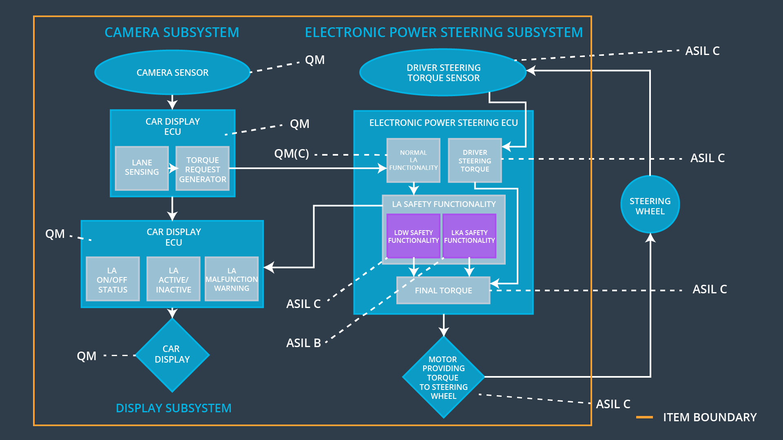

### Functional overview of architecture elements

|  |  |
| --- | --- |
| Element | Description |
| **Camera Sensor** | Optical sensor for observing lane lines. |
| **Camera Sensor ECU – Lane Sensing** | Processes image data from above and detects lane line positions. |
| **Camera Sensor ECU – Torque request generator** | Issues a torque request to the Electronic Power Steering ECU based on the information above. |
| **Car Display** | Vehicle dashboard that provides feedback of the car’s status to the driver (e.g. displaying warnings sings of the LKA/LDW). |
| **Car Display ECU – Lane Assistance On/Off Status** | Indicates the On/Off status of the Lane Assistance functionality. |
| **Car Display ECU – Lane Assistance Active/Inactive** | Indicates the Active/Inactive state of the Lane Assistance functionality. |
| **Car Display ECU – Lane Assistance malfunction warning** | Indicates warnings or fault of the Lane Assistance functionality. |
| **Driver Steering Torque Sensor** | Measures the torque applied to the steering wheel by the driver. |
| **Electronic Power Steering (EPS) ECU – Driver Steering Torque** | Software module processing the driver’s torque request coming from the steering wheel |
| **EPS ECU – Normal Lane Assistance Functionality** | Receives torque request from Camera Sensor ECU and forwards them to the Safety Lane Assistance Functionality. |
| **EPS ECU – Lane Departure Warning Safety Functionality** | Software module that is making sure that the torque amplitude is below Max_Torque_Amplitude and torque frequency is below Max_Torque_Frequency. |
| **EPS ECU – Lane Keeping Assistant Safety Functionality** | Software module that is making sure that the LKA functionality is not activate more than Max_duration time. |
| **EPS ECU – Final Torque** | A software value of the final torque which should be output to the EPS Motor based on both the Lane Assistance Function and the driver steering torque. |
| **Motor** | Receives the request from above and applies it to steering wheel. |

# Technical Safety Concept

## Technical Safety Requirements

*Lane Departure Warning (LDW) Requirements*

Functional Safety Requirements 01-01/02/03 with its associated system elements

(derived in the functional safety concept)

|  |  |  |  |  |
| --- | --- | --- | --- | --- |
| F/S ID | Functional Safety Requirement | Electronic Power Steering ECU | Camera ECU | Car Display ECU |
| **Requirement 01-01** | The lane keeping item shall ensure that the lane departure oscillating torque amplitude is below Max_Torque_Amplitude | X | **—** | **—** |
| **Requirement 01-02** | The lane keeping item shall ensure that the lane departure oscillating torque frequency is below Max_Torque_Frequency | X | **—** | **—** |
| **Requirement 01-03** | If the camera sensor becomes unreliable the LDW system shall be deactivated. | X | **—** | **—** |

Technical Safety Requirements related to Functional Safety Requirement **01-01/02/03** are …

|  |  |  |  |  |
| --- | --- | --- | --- | --- |
| T/S ID | Functional Safety Requirement | ASIL | F/Tol. Time Intv. | Safe State |
| **Requirement 01-01-01** | The *LDW safety component* shall ensure that the amplitude of the LDW_Torque_Request sent to the *Final Electronic Powersteering Torque Component* is below Max_Torque_Amplitude. | C | 50 ms | LDW torque is set to zero |
| **Requirement 01-02-01** | The *LDW safety component* shall ensure that the frequency of the LDW_Torque_Request sent to the *Final Electronic Powersteering Torque Component* is below Max_Torque_Frequency. | C | 50 ms | LDW torque is set to zero |
| **Requirement 01-03-01** | The *LDW safety component* shall ensure that the LDW_Torque_Request-s received from the Camera ECU are valid – that is, the camera is not malfunctioning or occluded. | C | 25 ms | LDW torque is set to zero |
| **Requirement 01-01-02 01-02-02 01-03-02** | If and when the LDW is deactivated, the *LDW Safety Component* software module shall send a signal to the Car Display ECU to show a warning signal. | C | 50 ms | LDW torque is set to zero |
| **Requirement 01-01-03 01-02-03 01-03-03** | When a failure is detected by the LDW function, it shall deactivate the LDW feature and the LDW_Torque_Request shall be set to zero. | C | 50 ms | LDW torque is set to zero |
| **Requirement 01-01-04 01-02-04 01-03-04** | The validity and integrity of the data transmission for LDW_Torque_Request signal shall be ensured. | C | 50 ms | LDW torque is set to zero |
| **Requirement 01-01-05 01-02-05 01-03-05** | Memory test shall be conducted at startup of the EPS ECU in order to rule out any faults in the memory module. | A | Ignition cycle timespan | LDW torque is set to zero |

*Lane Keeping Assistance (LKA) Requirements:*

Functional Safety Requirements 02-01/02 with its associated system elements

(derived in the functional safety concept)

|  |  |  |  |  |
| --- | --- | --- | --- | --- |
| F/S ID | Functional Safety Requirement | Electronic Power Steering ECU | Camera ECU | Car Display ECU |
| **Requirement 02-01** | The item shall ensure that the LKA applies the torque for only Max_Duration timespan. | X | **—** | **—** |
| **Requirement 02-02** | If the camera sensor becomes unreliable the LKA system shall be deactivated. | X | **—** | **—** |

Technical Safety Requirements related to Functional Safety Requirement **02-01/02** are …

|  |  |  |  |  |
| --- | --- | --- | --- | --- |
| T/S ID | Functional Safety Requirement | ASIL | F/Tol. Time Intv. | Safe State |
| **Requirement 02-01-01** | The *LKA safety component* shall ensure that the duration of the active LKA torque is applied for less than Max_Duration. | B | 500 ms | LKA torque is set to zero |
| **Requirement 02-02-01** | The *LKA safety component* shall ensure that the LKA_Torque_Request-s received from the Camera ECU are valid – that is, the camera is not malfunctioning or occluded. | C | 25 ms | LKA torque is set to zero |
| **Requirement 02-01-02 02-02-02** | If and when the LKA is deactivated, the *LKA Safety Component* software module shall send a signal to the Car Display ECU to show a warning signal. | B | 500 ms | LKA torque is set to zero |
| **Requirement 02-01-03 02-02-03** | When a failure is detected by the LKA function, it shall deactivate the LKA feature and the LKA_Torque_Request shall be set to zero. | B | 500 ms | LKA torque is set to zero |
| **Requirement 02-01-04 02-02-04** | The validity and integrity of the data transmission for LKA_Torque_Request signal shall be ensured. | B | 500 ms | LKA torque is set to zero |
| **Requirement 02-01-05 02-02-05** | Memory test shall be conducted at startup of the EPS ECU in order to rule out any faults in the memory module. | A | Ignition cycle timespan | LKA torque is set to zero |

## Refinement of the System Architecture

*Refined System Architecture*

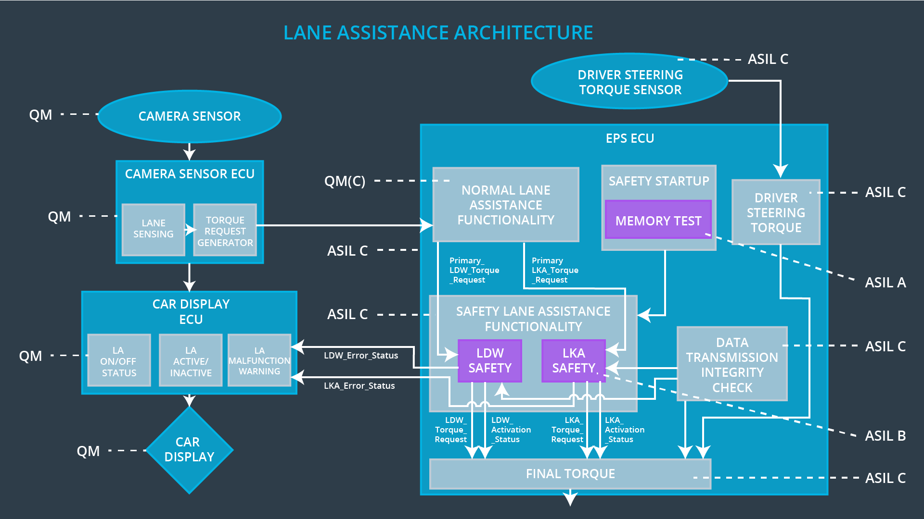

## Allocation of Technical Safety Requirements to Architecture Elements

All technical safety requirements were allocated to the EPS ECU. For the particular allocation within the EPS ECU compare the Technical Requirement tables above.

## Warning and Degradation Concept

|  |  |  |  |  |
| --- | --- | --- | --- | --- |
| ID | Degradation Mode | Trigger for Degradation Mode | Safe State invoked? | Driver Warning |
| **WDC-01** | Turn off LDW functionality | Malfunction_01 Malfunction_02 Malfunction_05 | yes | “LDW Malfunction” sign shows on the Car Display |
| **WDC-02** | Turn off LKA functionality | Malfunction_03 Malfunction_04 | yes | “LKA Malfunction” sign shows on the Car Display |