**Battle Zone**

**PA11**

**By: Kurt Andersen – CS 480**

**Connor Scully-Allison - CS 680**

**Hannah Munoz – CS 480**

**Sections:**

Overview

Dependency

User Manual

Build Instructions

Keyboard Inputs

Game Controls

Camera Controls

Shader Controls

Figures

Technical Manual

Issues

Things We Would Have Done Differently

Changes

**Overview:**

**Dependency Instructions:**

* For both of the operating systems to run this project installation of these three programs are required [GLEW](http://glew.sourceforge.net/), [GLM](http://glm.g-truc.net/0.9.7/index.html), and [SDL2](<https://wiki.libsdl.org/Tutorials>).
* This project uses OpenGL 3.3. Some computers, such as virtual machines in the ECC, cannot run this version. In in order to run OpenGL 2.7 follow the instructions at [Using OpenGL 2.7]( <https://github.com/HPC-Vis/computer-graphics/wiki/Using-OpenGL-2.7>)
* This project uses Assimp 3.2. Instructions for downloading and running Assimp can be found at [Main Downloads](http://www.assimp.org/main_downloads.html)
* This project uses ImagicMagick 6.8.9-9. Instructions for downloading and running ImageMagick can be found at [Install Source] (<http://www.imagemagick.org/script/install-> source.php)
* This project uses Bullet 2.86. Instructions for downloading and running Bullet can be found at [Releases](<https://github.com/bulletphysics/bullet3/releases>)

**Battle Zone**

**Technical Manual**

**By: Kurt Andersen**

**Connor Scully-Allison**

**Hannah Munoz**

**Issues:**

When continuously rotating the camera, the tank increases in speed due to the increased application of torque to the object. Also, the camera begins to veer away from the center of the tank while rotating, but snaps back to its correct position once the tank stops rotating.

A issue that we would like to address and figure out for the future is to properly map textures in blender. While in Blender the textures seem to be mapping appropriately, but then when we load it into OpenGL, it seems to have a mind of its own. We would like to figure out why this keeps happening with our textures in OpenGL.

Sometimes when the game loads, the frame rate does not run well due to collision of the random objects being spawned. We could solve this issue by gathering all of the locations of the random objects, but we did not have time to do this for this project.

**What would we have done differently?**

Our biggest issue when designing the project was coming up with a simple way to rotate the tanks around an axis when the ‘a’ or ‘d’ key were pressed. This required conversion between Euler angles and quaternions. After brushing up on our trigonometry we were able to solve this problem, but then we need the tank to know which direction was the new forward. While the solution did not end up being difficult to implement, the process that went into calculating the angles took us a bit of time. We should have considered how to rotate objects before we begun the project.

As for some changes, we would like to make the tank body two seperate models like a modern tank, rather than the tanks we use which are designed after the Trade Federation tanks from Star Wars. We would also like to learn to animate so objects when they move, i.e. if we had a full tank body, animate the tank treads, or have some sort of hit animation on a tank when the bullet hits an enemy.

We would also like to have implemented mouse movement for aiming. We kept it on a 2D field for aiming right now for simplicities sake and time constraints. If we were given more time, we would like to add up, down, left, right aiming all with just the mouse.

We would like to add a more intelligent AI for the computer tanks so they can drive around better rather than in just linear lines.

**Battle Zone**

**User Manual**

**By:Kurt Andersen**

**Connor Scully-Allison**

**Hannah Munoz**

**Build Instuctions:**

To run Battle Zone, ensure that you are in the proper build directory [PA11/build] and compile the code as follows.

cd build

cmake ..

make

To begin playing Battle Zone, enter the following command:

./ BattleZone

**ATTENTION:**

If the frames are not running at a normal speed, please stop the game and restart. Sorry for the inconvenience.

A new window should appear with the game ready to play. The score will be displayed in the terminal once the game has ended and the user has run out of lives.

If you make a top 10 score you will be prompted to input your initials at the end of the game in the terminal.

**Game Instructions**:

Drive around the arena and find enemy tanks. Shoot the enemy tanks to increase your score. Run over health packs to increase the total allotted time to play the game. The time initially gives the user 60 seconds to get as high of a score as possible. Each health pack will increase the total time by 5 seconds. Score is only increased if you shoot another tank. Enemy tanks will take damage if you run into them, but your score will not be increased. If the round bounces off an enemy tank you did not penetrate their armor. Please be patient for your tank crew to reload their round.

**Keyboard Inputs**:

*Game Controls:*

W : Forwards

A : Left

S: Backwards

D: Right

P: Phong Shader

G: Gourand Shader

Spacebar: Shoot

Esc – Quits the game.

*Shader Controls:*

*Numpad:*

'+' - increase ambient lighting.

'-' - decrease ambient lighting.

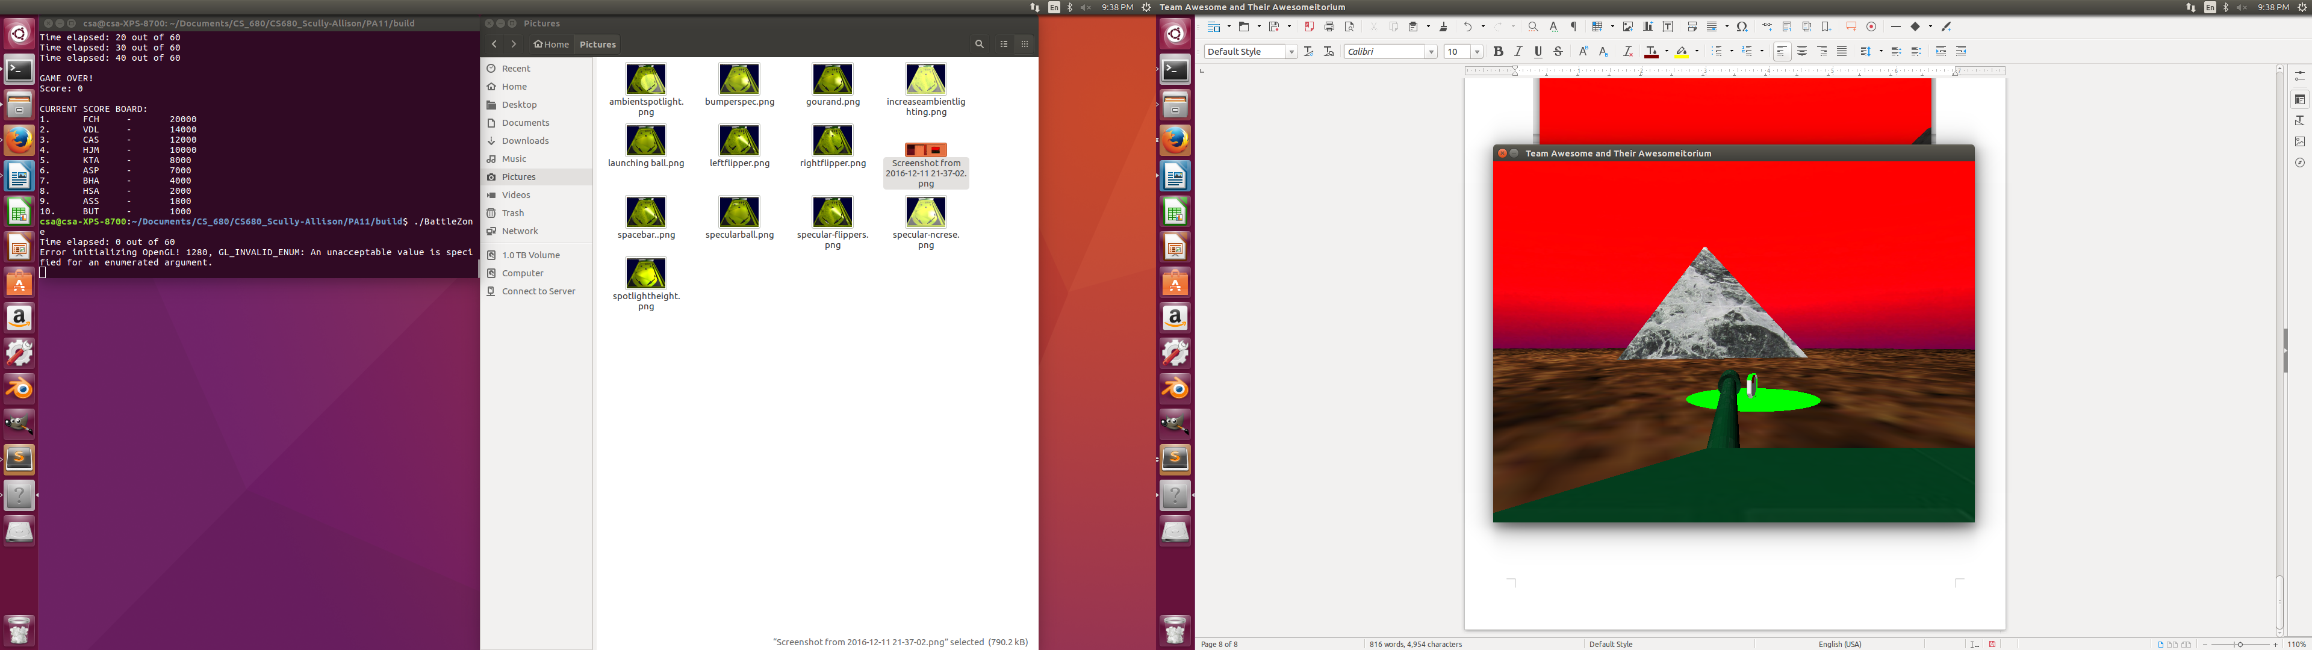**Figures:**

