The goals of the power quality meeter are outlined bellow:

- Cheap enough for large scale deployment.
- Easy to install and safe operate.
- Providing high resolution/accuracy measurements. (16/24 bit resolution and more then 50 samples per grid cycle)
- On board processing capability and local storage.
- Inter-device synchronization capability.
- Easy extendibility and open source design.

Our evaluation of the off-the-shelf power quality meters presented no candidates for our project. Available devices from the equipment manufactures such as Agilent and Tektronix are too expensive for wide deployment and will often require a licensed electrician to install.
Academic project such as FNET and PQUBE have developed their own power monitoring units for large scale monitoring. Both of these projects, while providing excellent analytics and monitoring capability are not developed with the crowd-sourcing mind set. The access to the raw data is limited, and the designs for the devices are released under restricted license, or not released at all.
Our prototype PQM design titled OHM1 aims to achieve all of our design goals. The block diagram of OHM1 is shown below.
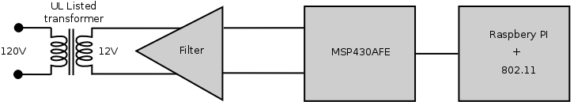
In order to make our device safe to operate, it is galvanically isolated from the power grid via a UL listed wall plug transformer. This transformer is used both for powering the meter and monitoring the power grid. The output of the transformer's secondary windings is passed through a low-pass filter shown in the figure below:
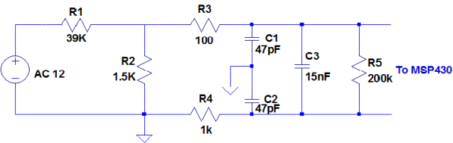
This filter is responsible for scaling down the voltage to the analog-to-digital converter(ADC) range, as well as filtering out frequencies above 1Mhz. Furthermore this filter protects the sensitive inputs of the ADC.

The output of the filter is digitized using an ADC on msp430afe microcontroller. This innovative microcontroller is specifically targeted at the smart grid monitoring, and metering. By combining the analog front-end, a 24bit SAR ADC capable of sampling at 4kHz, and a 16bit MCU into a single integrated circuit we were able to significantly reduce our bill of materials.
In order for our sensor network to scale, a significant amount of processing needs to be performed on the device itself. This includes power quality event detection, as well as buffering of historic data leading up to the event. Furthermore event data needs to be uploaded to the cloud for further analysis. In order to speed up the development Raspberry Pi single board computer is selected as the main processing unit. The msp430 sends the digitized samples to the Raspberry Pi via the SPI protocol. Data is compared to the expected waveform, if the deviation is significant an event containing the raw data is send to the cloud via a USB 802.11 adapter.

