Chapter 1

Introduction

1.1 The Price of Paradise Tax

This year I am going to graduate with a B.S. degree in Computer Science from the University of Hawai‘i (UH). Like many other computer science graduates at UH, I am faced with a difficult question: do I want to stay here in the beautiful islands of Hawai‘i or move to the U.S. Mainland? On one hand, I enjoy living in Hawai‘i where year-round warm weather allows me to go to the beach, participate in my favorite ocean sports, or have local-style barbecues with friends and family in the backyard anytime of the year. On the other hand, there are fewer career opportunities for software engineers in Hawai‘i, salaries tend to be low and the cost of living is high. On the Mainland, career opportunities are plenty, salaries tend to be high, and cost of living is in most cases lower. But there, I have no friends, no family and no tropical weather.
This financial and professional disadvantage of living in Hawai‘i compared to the Mainland is historically known as “Paradise Tax”, and because of it, many graduating computer science students and engineers from UH choose to move to the Mainland where they expect to have more successful careers. For many young “Hawaiians” this choice means leaving friends and family behind – a tough compromise that has created many homesick “Hawaiians” on the Mainland.

1.2 Providing Entrepreneurship Education

The Paradise Tax is a Catch-22 situation. The best graduates with technical degrees flee due to lack of career opportunities, which leaves Hawai‘i with few really good software developers and engineers. As a result, the high technology businesses that are needed to create the career opportunities find it difficult to get started, due to the lack of good software developers and engineers. In other words, there is no demand for high tech people, because there is no supply, and there is no supply, because there is no demand.
To fight this Catch-22 situation we need to encourage the local high tech industry from within, so the situation can be reversed. Back in 1959 when Hawai‘i became a state, tourism exploded because advancement in technology brought jetliners, which enabled millions of people from all over the world spend their vacation in Waikiki. Today, another change in technology has brought high-speed networks, which enables people in Hawai‘i to communicate with people around the world in a matter of milliseconds. This gives Hawai‘i the technical opportunity needed to initiate another major industry in addition to tourism, namely a high technology industry.
Given this technical opportunity, the people of Hawai‘i need to put their efforts into encouraging a new industry. Consider, for example, how people like Webley Edwards, who launched the radio program, Hawaii Calls, which was broadcast to the Mainland, Canada and Australia, put efforts into developing the tourism industry fifty years ago.
High quality education and research, and a legislature that supports the development of the industry, are fundamental aspects of the efforts needed to grow Hawai‘i’s high tech industry. Hence, it is encouraging to see that the Department of Information and Computer Sciences has the highest departmental enrollment in degree programs at UH, and for the second year in a row, a high technology bill that makes it attractive to start a high tech business was passed by the legislature. However, without the entrepreneurial expertise required to convert good local high tech potential into good local high tech businesses, the industry cannot thrive, and our graduates will continue to seek mainland careers. Therefore, teaching our students how to start and manage high tech businesses is another key aspect of initiating the industry.
Professor Philip Johnson in the Department of Information and Computer Sciences (ICS) has realized the importance of providing high tech entrepreneurship education at our university. Additionally, Johnson anticipated that entrepreneurship education is most effective when taught in an interdisciplinary environment, where computer science students, engineers and business students together learn how to start high tech businesses in Hawai‘i successfully. Johnson has devoted his ICS 691 class the last two years to teach entrepreneurship that specifically focuses on starting local high tech businesses, and he actively encourages interdisciplinary enrollment. Johnson’s classes, Software-based Business in Hawaii: Facts, Fantasies, and Lessons Learned (Spring 1999) and Internet Entrepreneurship: Theory and Practice (Spring 2000), were both very successful. The objective of the former class was to provide students with insight into the issues in starting and growing a software-based company in Hawai‘i. The later class emphasized Internet businesses, and a practical element to provide hands-on experience was added through use of an Internet Entrepreneurship simulation application called Virtual Commerce (VCommerce). VCommerce was designed and developed at the Collaborative Software Development Lab (CSDL) by Johnson and myself.

1.3 VCommerce: Hands-on Internet Entrepreneurship

Motivated by the need to teach students how to start high tech companies in Hawai‘i, VCommerce was developed to give students hands-on practice with aspects of the business startup process. VCommerce provides a simulated environment in which students can start (virtual) Internet businesses, and it is designed for integration in entrepreneurship courses with emphasis on high tech startups. Students are divided in groups to form VCommerce companies, and each group goes through a process where they identify their own Internet business idea, conduct market and competitor research, write a simple business plan and implement a company web site. These company web sites are uploaded to the VCommerce Server, where VCommerce consumers have access to them. The consumers are people (not from the class) that have been invited to participate, and they are given an amount of (virtual) cash and stock options to use in the environment. The following is a sequence of screens from the VCommerce consumer interface.

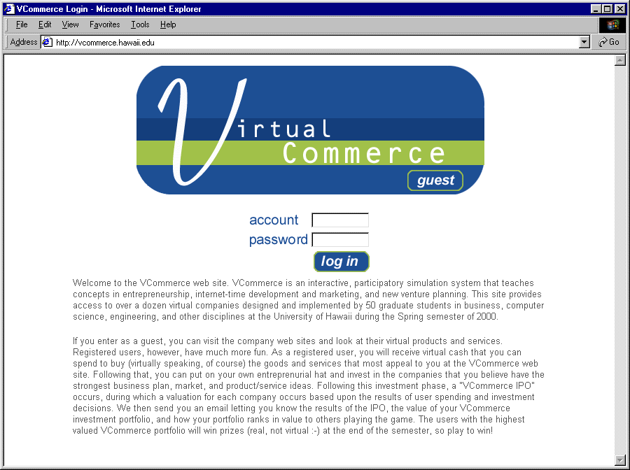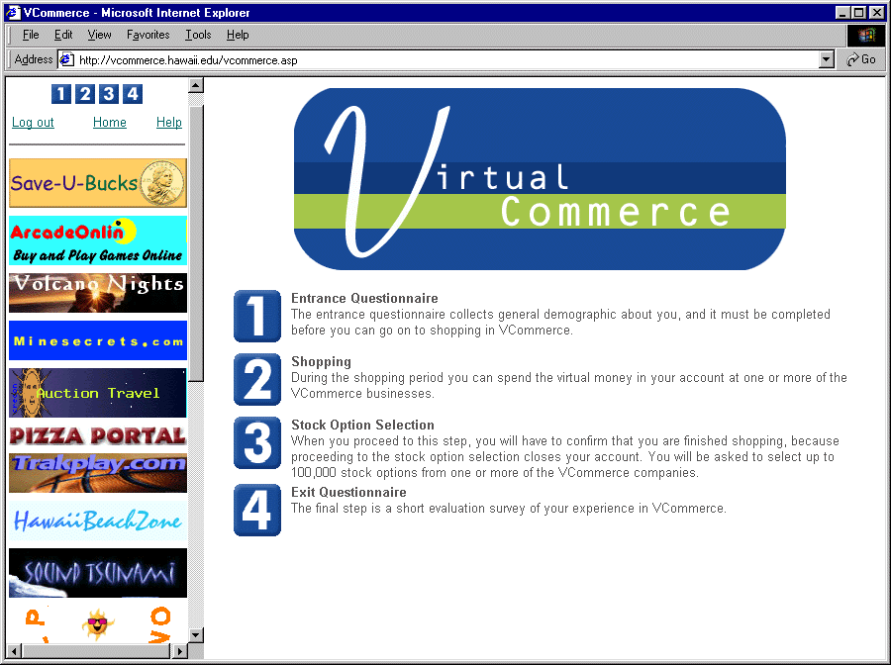
Figure 1.1: VCommerce login page. Figure 1.2: VCommerce home page.

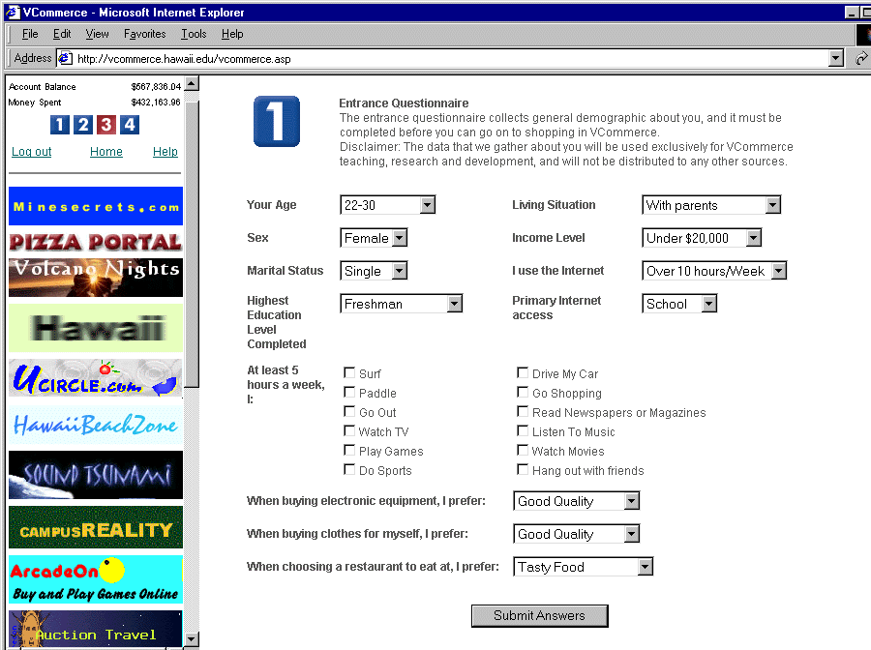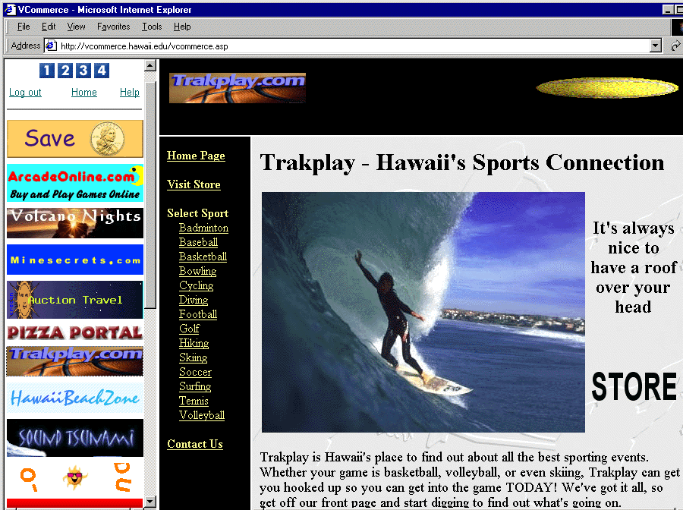
Figure 1.3: VCommerce entrance questionnaire. Figure 1.4: VCommerce company web site (Trakplay).

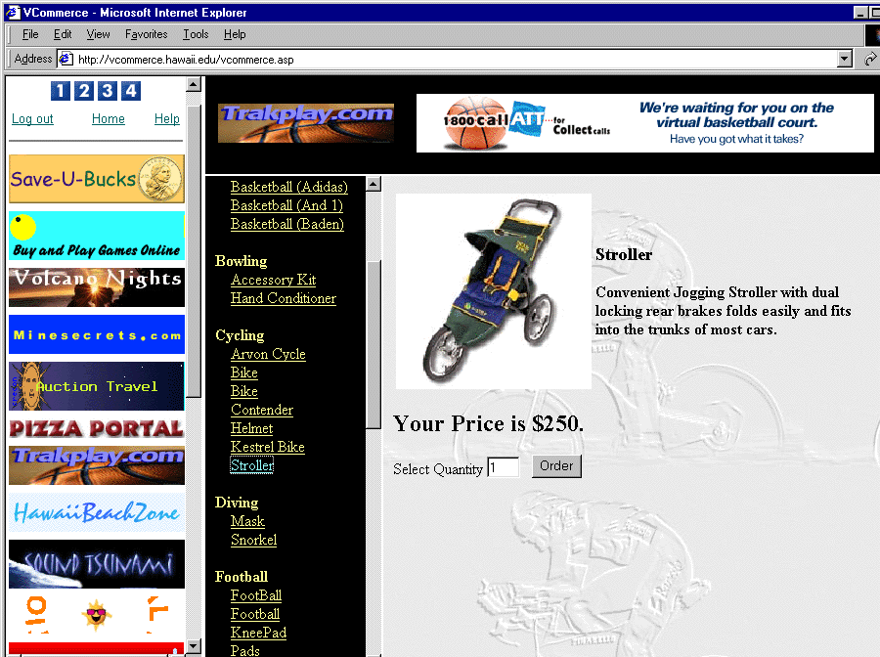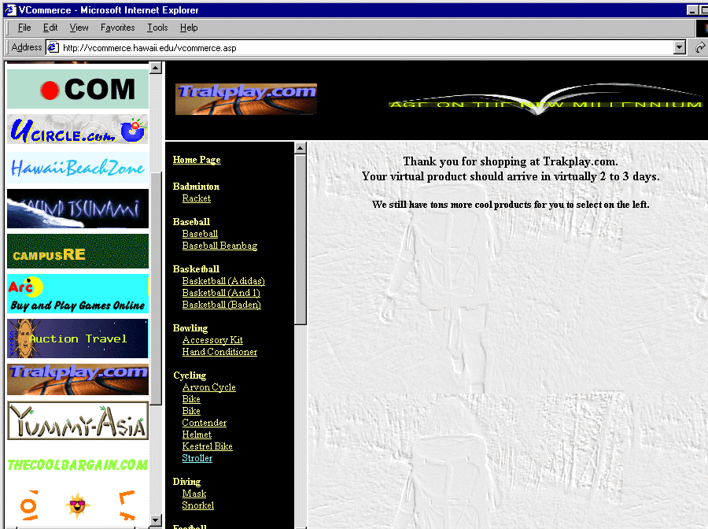
Figure 1.5. Figure 1.6.

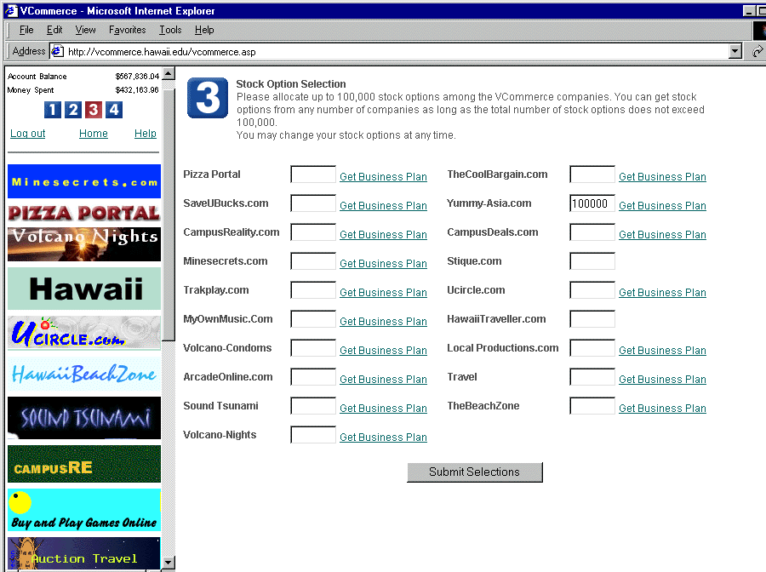
Figure 1.7: VCommerce stock option acquisition page. Figure 1.8: VCommerce Business Plan (Local Productions).

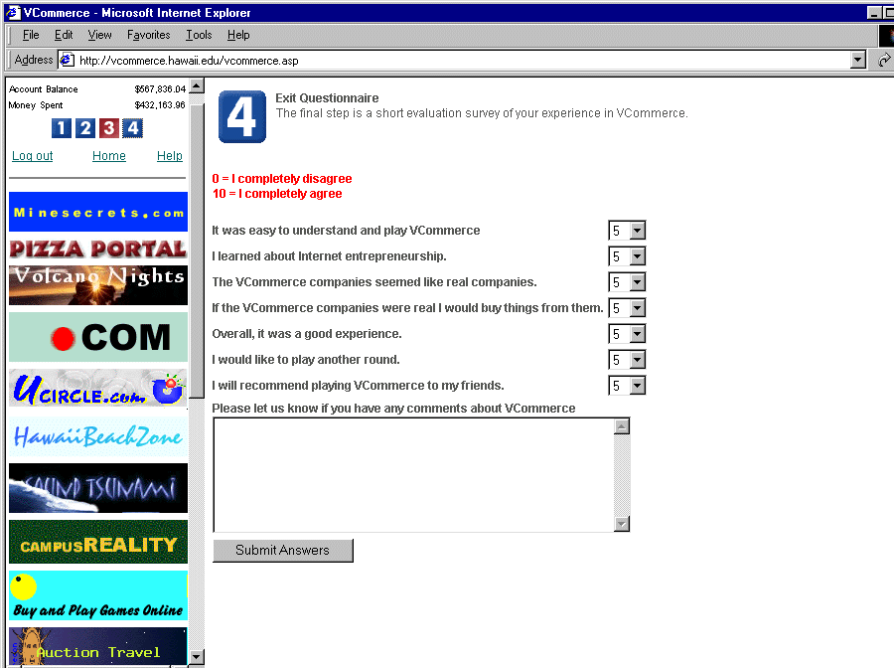
Figure 1.9: VCommerce exit questionnaire.

The process, from coming up with an Internet business idea to launching a company web site, is referred to as a VCommerce business cycle. Based on my case study in ICS 691 (Spring 2000), presented in Chapter 4 and 5, it seems that two business cycles are appropriate for a regular semester.
The VCommerce consumers have access to the web sites for approximately one week after the company sites have been launched. During each day of this consumer test phase, two e-mails are generated. A company report e-mail is sent to the class (fig. 1.10). It contains statistics about page hits, purchase transactions and stock allocation, which enable students to monitor the success of their business. A consumer e-mail (fig. 1.11), which provides current account information, is sent to participating consumers. This e-mail also contains short advertisement messages, which companies can optionally submit to the VCommerce system on the day before the e-mail is sent out. After the consumer access phase, and before the next business cycle begins, a VCommerce debrief is held to discuss the lessons learned from the cycle and the consumer test phase, and a “VCommerce IPO” occurs, where a final evaluation of each company occurs based upon the overall statistics.
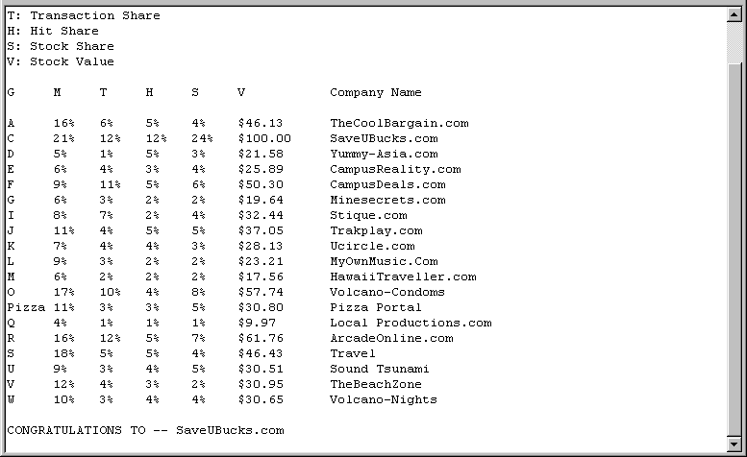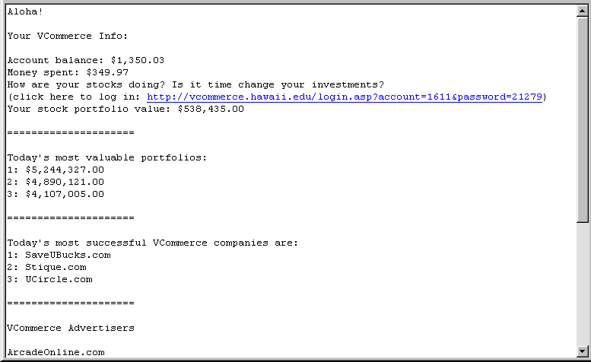
Figure 1.10: VCommerce company report e-mail Figure 1.11: VCommerce consumer e-mail

1.4 Thesis Statements

The philosophy behind VCommerce is “learning by doing”. In other words, that hands-on practice with is an effective way to learn a new skill. The hypotheses of this research are:

- Integrating VCommerce in entrepreneurship courses with emphasis on the Internet substantially improves students’ knowledge of the process involved with starting an Internet company, and it makes them more aware of their interest in Internet Entrepreneurship as a career path.

- Integrating VCommerce in a course with an interdisciplinary mix of business and computer science students makes the company startup exercise seem close to real-world entrepreneurship experiences.

1.5 Evaluation of VCommerce

To evaluate these hypotheses, I performed a case study in ICS 691: Internet Entrepreneurship: Theory and Practice (Spring 2000), where VCommerce was deployed for the first time. There were 55 students enrolled in this graduate level course. The lectures were broadcast live via the Hawai‘i Interactive Television System (HITS), which enables students to participate from remote classrooms. There was one student at University of Hawai‘i at Hilo, three students at Maui Community College, and two students at Leeward Community College. The broadcasts were recorded on videotapes, which are part of the research data. Other data includes the VCommerce system database, where simulation data is stored, my own observations of the students, and student feedback. The feedback comes from a survey conducted by University Connections towards the end of the semester, and from fourteen post-semester interviews that I conducted.

1.6 Results

The results of the ICS 691 case study show that students were very engaged and enthusiastic about the class. They believed they learned valuable lessons about project management and web site implementation. Steps were even taken to move from the virtual to the real world: several students registered their VCommerce company domain names, a VCommerce business plan received an Aspect Technology grant, and a company went out to seek venture capital.
The University Connection survey shows that the class was very effective in teaching entrepreneurship concepts, and a large majority thought the overall quality of the course was outstanding.
The post-semester interviews show that the students’ knowledge and interest in Internet entrepreneurship increased from taking the class, and that they were appreciative of the lessons learned about the topic, project management, and web site implementation from the hands-on experience VCommerce provided. They especially felt that having an interdisciplinary company resulted in a very real and believable project management experience.

1.7 Conclusions

The case study results indicate that VCommerce indeed improves students’ knowledge of Internet entrepreneurship, and makes them more aware of their interest in the field. The results also indicate that an interdisciplinary class profile enhance the effect of VCommerce in terms of providing a believable Internet company startup experience. Finally, the VCommerce experience has inspired students into direct entrepreneurial actions such as seeking venture capital, getting involved with local Internet start-up companies, and proposing VCommerce business plans to be implemented.

1.8 Overview of this Document

Chapter Two is an overview of related work. I describe three other business simulation applications such as Venture Out! from Harvard University. I also present examples of entrepreneurship courses at three major universities in the United States.
Chapter Three describes the design and implementation of the VCommerce process and the VCommerce simulation system.
Chapter Four describes the case study of VCommerce in ICS 691: Internet Entrepreneurship: Theory and Practice, taught by Professor Philip Johnson in the spring semester 2000.
Chapter Five presents the results of the ICS 691 case study.
Chapter Six presents the conclusions and contributions of this research, and I discuss future directions and enhancements for VCommerce. I also briefly describe the current use of VCommerce at Michigan State University.

Chapter 2

Related Work

There are at least two areas of work that relate to this research: entrepreneurship education and business gaming simulations designed for entrepreneurship education. This chapter presents examples of entrepreneurship education at three major universities in the United States, and three entrepreneurship simulation games, which appear to be the most dominant on the market. The chapter also discusses how VCommerce is different from existing simulation games, and why the VCommerce approach may be a more effective way of teaching entrepreneurship.

- Entrepreneurship Education

Entrepreneurship education at colleges and universities in the Unites States is an endeavor that began just forty years ago. Since then courses have rapidly grown in number. In 1970 there were sixteen universities that offered entrepreneurship courses, and in 1995 that number had grown to four hundred [1]. Most entrepreneurship courses are offered in the School of Business, and some schools even have a Center for Entrepreneurship, which is dedicated to teaching students how to initiate new ventures. The University of Hawai‘i’s School of Business has recently received a $1.1 million donation to create a Center for Entrepreneurship, which is good news for the Hawai‘i high technology industry [2].
This section presents examples of entrepreneurship courses at three other universities: Massachusetts Institute of Technology (MIT), Stanford University and Harvard University.

  - MIT

At MIT there is an entrepreneurship center with the mission to train and develop leaders who will make high tech ventures successful. To accomplish their mission, they offer educational programs to encourage and teach entrepreneurship for all MIT students. They have a policy that allows students to take any class regardless of major, assuming appropriate prerequisites, which means that science and engineering students have great opportunities to learn about entrepreneurship. In the fall semester 2000 the following six entrepreneurship courses are offered at MIT [3].

- #15.390 New Enterprises
- #15.397 Global Entrepreneurship Lab
- #15.399 Entrepreneurship Lab
- #15.835 Entrepreneurial Marketing
- #15.836 Proseminar New Product Development
- #15.968 Business Plans that Raise Money

The courses, New Enterprises and Entrepreneur Lab, which seem to emphasize the process of starting up a business are presented in detail in the following two sections.

    - 15.390 New Enterprises

The MIT course description for New Enterprises includes the following:

This class guides students through the steps required to start a new company, with focus on emerging technology. We begin by examining the business idea which forms the basis of the company and then we develop that idea through marketing, finance, organization, implementation, and funding. Students will devise and write a business plan for a company that they plan to have at a $50 Million market capitalization minimum within three years of launch. We also will use cases and real companies and bring entrepreneurs to class who have faced each of these business problems.

This course is the most popular entrepreneurship course at MIT in terms of enrollment. In the 1997-98 academic year, 270 students took this class. The following are some of the lecture topic from the fall 2000 syllabus [4]:

- Opportunity Evaluation
- Opportunities on the Internet
- Investment Decision Making
- Writing Business Plans
- Lessons from Past Entrepreneurs
- The CEO
- Lessons from Customer Feedback

Throughout the course students complete several written assignments, which are not only part of the business plan, but also the final project of the class. A final exam tests the student’s ability to spontaneously write a business plan.

    - 15.399 Entrepreneurship Lab

The MIT course description for Entrepreneurship Lab includes the following:

Teams of science, engineering, and management students participate actively one day a week on-site with the top management of high tech start-ups in order to gain hands-on experience in starting and running a new venture. Student projects focus on one urgent aspect of the start-up such as marketing plans, competitor analysis, financing, business plan writing, web/IT strategy, etc.

This course had 138 students enrolled in the 1997-98 academic year, which is the second largest enrollment after New Enterprises. According to the online syllabus for fall 2000, students are divided into groups of two to four persons during the first two sessions. Each group is then matched to an internship with one of 64 start-up companies most of which are Internet related. As entrepreneur interns, students work closely with the CEO one day a week on some aspect of the start-up process. In addition to the internship days, the class meets about ten times during the semester, where course-related subjects are discussed, and teams make brief presentations about individual company situations [5].

  - Stanford University

The Stanford School of Business has seventeen entrepreneurship courses listed online [6]. In addition, the Stanford School of Engineering has an entrepreneurship center called Stanford Technology Ventures Program (STVP), which consists of a series of courses, conferences, internships, web sites and research activities designed to promote entrepreneurship education for science and engineering students [7].
STVP sponsors ten entrepreneurship classes. I chose to examine at Industrial Engineering 273: Technology Venture Formation. The objective of this class is to develop entrepreneurial skills for the successful formation and initial growth of technology companies. The course focuses on how technology ventures are started, and attempts to identify the basic decisions an entrepreneur faces, including research and development, market analysis, financing and management. Students in the course are required to write a technology related business plan and make a corresponding oral presentation. The instruction methods consist of lectures, case discussions and guest presentations. Some of the lecture topics are listed below.

- Introduction to Business Plans
- Putting a Team Together
- Marketing
- Business Models
- Financial Models
- Venture Law

  - Harvard University

The Harvard Business School offers eight entrepreneurship courses. One of these courses, Starting New Ventures, focuses on the development of the skills and knowledge required to design and launch a new venture [8]. The course is structured in three modules:

- Students are introduced to design parameters and development of conceptual foundation for business planing.
- Students work on cases and notes that address technical issues such as organizational structure, financial modeling, and ownership and control in new ventures.
- Students learn about micro-level decisions involved in taking a good idea to business reality. The process of creating the working plan and engaging the resources necessary to launch the business is emphasized.

A course project requires student teams to write a business plan with sufficient detail to show how the new idea can be brought to market, and a strategic vision that will attract resources needed for launching and growing the venture. According to the Fall 1999 syllabus, the lectures include some of the following topics:

- Evaluating the Opportunity
- Business Planning
- Venture Capital
- Organizational Management
- Ownership and Control

  - Summary

The entrepreneurship courses presented above, with the exception of MIT’s Entrepreneurship Lab, seem to represent a standard approach to teaching new venture formation. The common aspects are:

- Students write a business plan.
- Lectures cover topics such as business opportunity, business models, business planning, marketing, venture capital and management.
- Students study cases of successful venture formations.
- Interaction with entrepreneurs -- typically through guest lectures.

The MIT Entrepreneurship Lab seems to be one of its kind. I was only able to find one similar course, namely NBA 530: Entrepreneurship Lab at Cornell University [9]. However, this course is more like a regular internship, because there are no lectures. Another difference is that the enrollment is restricted to MBA, whereas MIT’s Entrepreneurship Lab is open to all students at the university.
None of the available course information indicated that the courses use any kind of entrepreneurship simulation games.
The difference between the standard approach to teaching entrepreneurship and the VCommerce approach is that instead of studying cases of existing venture formations, students create their own (virtual) ventures to learn lessons through experience.
Another difference is the business plan requirements. Typically, the completion of business plan is considered a large course project, and students are required to write a very detailed and thorough plan. In VCommerce, the business plan requirements are lowered in order to give students the time and opportunity to execute the business plans.
Finally, VCommerce is designed for interdisciplinary enrollment where business and computer science students work together. In most entrepreneurship classes, enrollment is restricted to business majors or there are a number of business course prerequisites [1].

- Existing Simulation Games for Entrepreneurship Education

There is a wealth of business simulation games on the market that focuses on teaching various areas of business such as marketing, financing, management, organizational behavior, economics and entrepreneurship. I focused my research on entrepreneurship simulation games, of which there are also several on the market. Based on the prominence of the game, I chose three applications to study: TRECS, Venture Out! and Threshold Solo/Team Entrepreneur.

  - TRECS

Teaching Realistic Electronic Commerce Solutions (TRECS) is a business simulation developed at Deakin University (Australia) in which university students and business professionals can learn about potentials of eCommerce. Participants adopt the role of a company within a manufacturing supply chain and use eCommerce technologies such as electronic data interchange (EDI) to trade with one another. Although educators using TRECS can design the simulation to work for their preferred supply chain, a kitchen appliance manufacturing supply chain is the default, and it is also the most extensively used [10].
Each student takes a role of one company within the supply chain. In the kitchen appliance simulation the following company types exist:

- Retailers who sell kitchen appliances such as toasters, fry pans and kettles.
- Kitchen appliance manufactures who make appliances and sell them to retailers.
- Metal and plastic component manufacturers who make components from raw material and sell them to kitchen appliance manufacturers.

The student operated companies in the supply chain trade with each other by using eCommerce, and since there are several organizations of the same type, they also compete with each other. The purpose of the simulation is aimed at teaching students the use of eCommerce between organizations such as EDI, email and the Internet. In any TRECS supply chain there are five general types of companies that are simulated:

- A bank, which handles all electronic funds transfers
- A warehouse, which a student organization uses to arrange the manufacturing of their products
- A freight forwarder, which handles all product transfers between organizations
- An ultimate supplier to the TRECS supply chain, which manufactures, for example, might purchase raw materials for building components
- An ultimate customer to the TRECS supply chain that orders products from retailers of end-products and therefore dictates ultimate customer demand for all products in the supply chain.

The most recent version TRECS is web-TRECS, which – as its name implies – is a web-application that students can access through the Internet. The application is integrated in classes that teach eCommerce in a similar way to VCommerce. In one semester the simulation in executed two times. Before the business cycles there is a briefing session where students learn the fundamentals of the simulation, and after each cycle there is a debriefing session where the business simulation experiences are discussed. Below are some screens from web-TRECS [10].

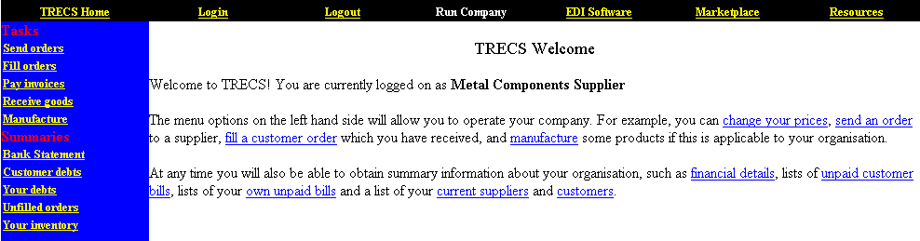
Figure 2.1: Web-TRECS Student login welcome screen.
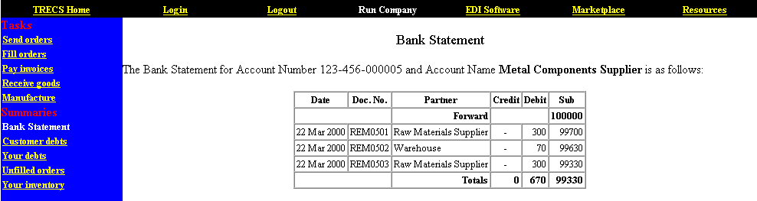
Figure 2.2: Web-TRECS company bank statement page.

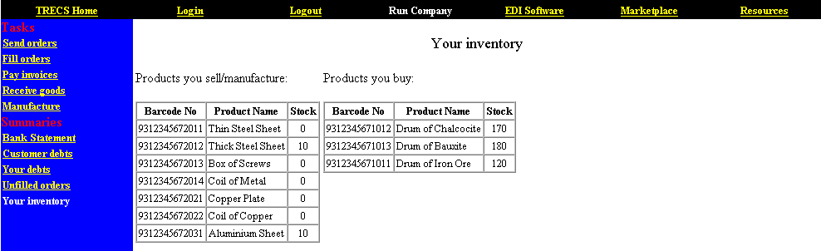
Figure 2.3: Web-TRECS company inventory page.

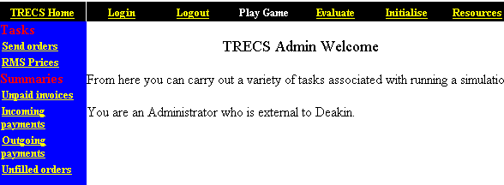
Figure 2.4: Web-TRECS administrator login welcome page.

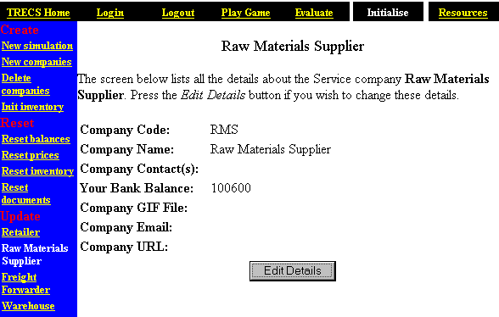
Figure 2.5: Web-TRECS company administration page.
I am not impressed with the TRECS user interface, because it is not interactive and intuitive to use. It seems oriented towards submitting numbers such as order quantities, which have been researched and decided upon by students off-screen. The interface is just a medium for submitting numbers to the TRECS simulation system, as opposed to be an interactive game with defined steps to complete.

  - Venture Out!

Venture Out! is a business simulation game from Harvard Business School designed for entrepreneurs who are in the early stages of starting a business. The game, which only supports individual use, let the player adopt the role of the CEO of a virtual company called RadioPhone. As the CEO the student is responsible for leading the enterprise from its inception through its growth. The simulation provides an opportunity to make complex strategic and operating decisions in a way that simulates the real world. The application also includes tools and resources for building the start-up such as guidelines for creating a business plan; financial forecasting tools; legal, tax and financing primers; templates for evaluating and selecting new hires; guidelines for managing growth and harvesting; financing sources, business information sources and suggested books and articles [11].
I have a copy of Venture Out! and I am extremely impressed with the user interface, which is very intuitive to use. The application also includes a large amount of useful entrepreneurship related educational material, such as a business plan example from PricewaterhouseCoopers. However, the simulation itself it not that realistic, because it is fairly easy to figure out by trial and error what will lead to successful growth and what will make you go bankrupt. The fact that Venture Out! can only be used individually makes it unsuitable for use in a class setting.

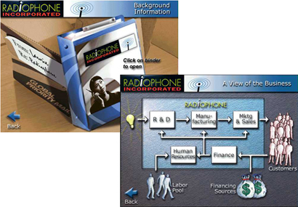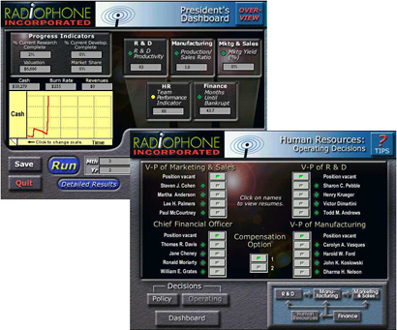
Figure 2.6: Venture Out! Information, President’s Dashboard and Human Resources.

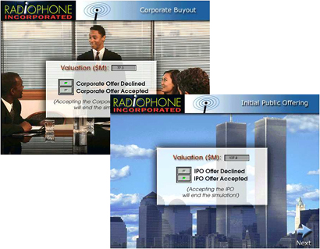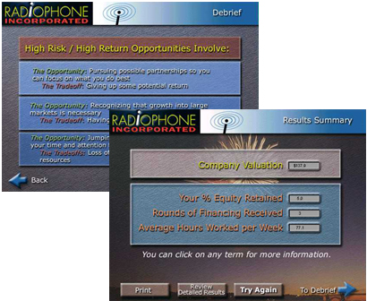
Figure 2.7: Venture Out! Corporate Buyout, IPO, Debrief and Summary.

  - Threshold Solo/Team Entrepreneur

Threshold Entrepreneur is a Windows-based simulation from Prentice Hall that allows students to launch, manage and operate their own small business enterprise, while facing computer-initiated situations. Student teams can either compete individually against computer-managed companies (Solo), or against other student-managed companies (Team). In either case the simulation provides students with an opportunity to apply their knowledge of entrepreneurship to the process of managing a start-up business in a simulated environment. Participants act as chief executives of a small company that sells two plastic molded products, Product 1 and Product 2, and they make decisions regarding marketing, manufacturing, and financing [12].
I obtained a demo version of the Threshold Solo Entrepreneur application. The application consists of windows in which you can “make decisions” by entering numbers in the Decisions windows (fig. 2.8). Reports and statements are automatically generated in Reports and Info windows (fig. 2.9 and 2.10) when the industry is “processed”, and the simulation proceeds to a new quarter.

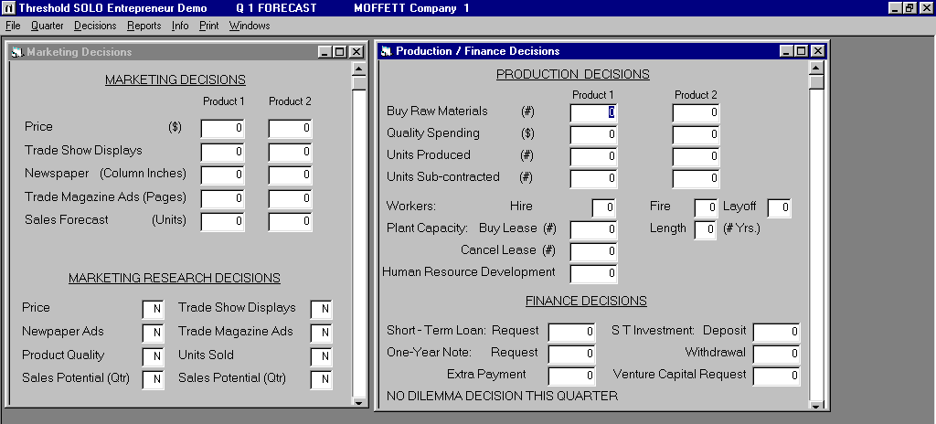
Figure 2.8: Threshold SOLO Entrepreneur Demo: Decision windows.

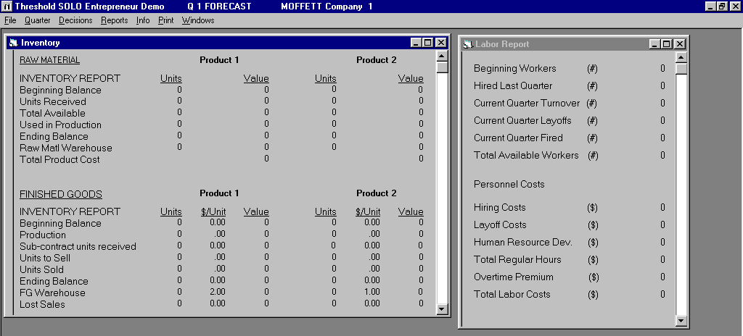
Figure 2.9: Threshold SOLO Entrepreneur Demo: Inventory and Labor Report windows.

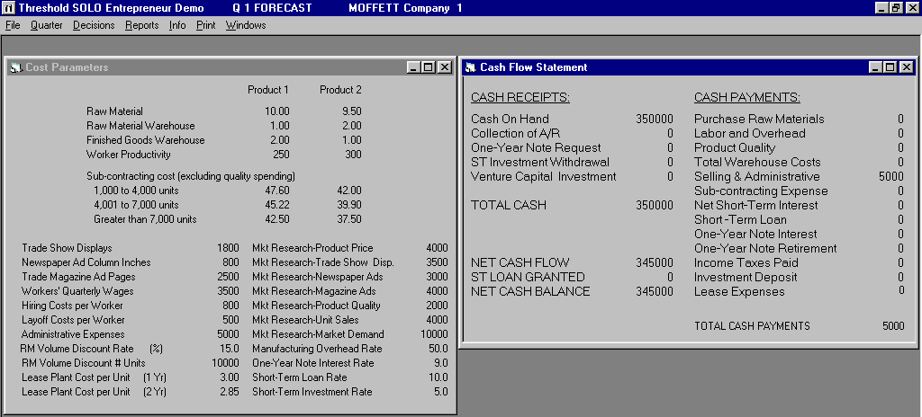
Figure 2.10: Threshold SOLO Entrepreneur Demo: Cost Parameters and Cash Flow Statement windows.

The application seems similar to TRECS in that it is not interactive nor intuitive to use. It also, is just an interface to submit pre-determined numbers, which represent decisions. Threshold Entrepreneur is even less interesting than TRECS, because the business type is generic. That is, instead of having defined businesses and products, such as a plastic component supplier in TRECS, Threshold Entrepreneur uses two generic products, namely Product 1 and Product 2.

- The VCommerce Advantage

VCommerce is similar to the applications mentioned above in the sense that they share the same goal, that is, to teach entrepreneurship concepts by using a business simulation game. However, VCommerce is significantly different in terms of the simulation method and the aspect of entrepreneurship that students practice.
In VCommerce students identify their own business opportunities within the domain of Internet businesses. The instructor may narrow down the domain by specifying a specific target market such as college students, which is the case in the case study presented in Chapter 4. In every other entrepreneurship simulation game I was able to find, including those presented above, the business opportunity was already defined (e.g. the RadioPhone in Venture Out!), and they all involved product manufacturing. Hence, those simulations are more focused on managing and amplifying the business opportunity, than going through the initial process of forming the idea and managing a team of people to implement the idea.
In VCommerce students also implement their business idea in terms of a functional company web site where consumers can buy their products and services.
I believe that allowing students to work with their own business ideas makes the simulation more effective, because students will naturally be more interested in their own ideas. Some students might have businesses ideas with real potential, and they can use VCommerce to practice the implementation of their idea. A predefined business idea does not have the same potential to be translated into a real-world business by the students.
Another VCommerce advantage is that the company web sites are actually used by real people. Having real people play virtual consumers does not necessarily give VCommerce entrepreneurs a realistic idea about how successful their companies would be in the real world. However, it does give them a good idea of how functional their sites are, and how popular they are in relation to competing VCommerce companies. Simulated consumer behavior would not be very effective in VCommerce, because computers today are not intelligent enough to look at a web page design and evaluate how visually pleasing it is, and how easy it is to navigate. The importance of web site usability is a very important lesson to learn for prospective Internet entrepreneurs, because even the best Internet business idea could fail if its user interface is difficult to use.
A substantial difference between VCommerce and the applications presented above is the aspect of entrepreneurship that the students practice. In TRECS, Venture Out!, and Threshold Entrepreneur, students work with predefined businesses where there is only one task, that is, to make decisions such as how much money to spend on predefined materials and employees. These financial decisions affect the companies’ successes, and hence the students’ successes. This approach does not easily translate to real-world business startup. In VCommerce student actually go through the process of implementing a web site for their company, which gives students web programming experience, and an actual “product”. Students can therefore refer to the site in their resumes, and if they at some point implement a real Internet business, they can incorporate some of the basic ideas used in the sites. Perhaps most importantly, the VCommerce experience can serve as a catalyst to the entrepreneurial spirit.

Chapter 3

VCommerce Design and Implementation

VCommerce is an educational process for learning aspects of Internet entrepreneurship. Students enrolled in a course that use VCommerce, are given the opportunity to identify and implement virtual Internet businesses of their own choice. These businesses are launched in the VCommerce Simulation System, a web application, which provides a simulated e-commerce environment, where people outside the class are invited to use the businesses as virtual consumers.
Students using VCommerce are introduced to some of the processes and challenges involved with starting up an Internet company. In particular, they gain hands-on experience with business innovation, business planning, web development, and project management. In this chapter, I describe the design and implementation of the VCommerce process and the VCommerce Simulation System.

3.1 VCommerce Process
VCommerce is designed for integration in courses that teach Internet entrepreneurship as a practical element of the course. The following is a diagram of the VCommerce process and its participants.

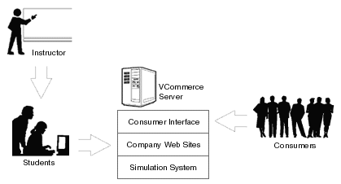
Figure 3.1: VCommerce Process

An instructor who uses VCommerce gives lectures that relate to entrepreneurship, and in particular that emphasize the process of starting up an Internet business. Although it is not necessary, the instructor should consider having one or two lectures about web programming early in the course.
Students in the class are divided into small teams, which should be interdisciplinary if possible. The teams represent VCommerce companies that go through the process of starting virtual Internet businesses. This process, which requires student teams to identify a business opportunity, conduct market research and implement a company web site on the VCommerce Server, is called a VCommerce Business Cycle, and it is presented in detail in section 3.2.
When the VCommerce companies have launched their web sites on the VCommerce Server, virtual consumers (people outside the class who are invited to participate) will be able to access the world of VCommerce companies through an online consumer interface for approximately one week. The consumers can spend their virtual money (made available to their accounts) on the products and/or services the companies offer from their web sites. Consumers can also acquire a certain number of stock options from any combination of companies.
Inviting outside people to participate in the VCommerce consumer access phase can be accomplished by one (or a combination) of the following approaches:

- The instructor hands out VCommerce invitation cards (fig. 3.2) to 100-200 random students at the university.
- Students in class using VCommerce are given 5-10 invitation cards each to pass on to people of their own choice.

The advantage to the first approach is that the invited consumers are less likely to know the owners of the company. Consumers that know company owners are likely to behave in favor of the known company and not provide objective feedback. The advantage of the second approach is that it is less labor intensive for the instructor, and the consumer profile is likely to be broader.

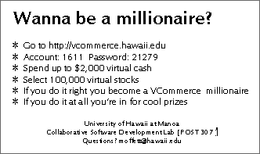
Figure 3.2: VCommerce invitation card front and back.

The VCommerce Simulation System tracks consumer behavior such as site usage, purchase transactions and stock option acquisitions. Once a day, during the consumer access phase, an email with statistics and current company valuations is generated and sent to the class. An email is also sent to participating consumers (fig. 3.15). This email contains a link for VCommerce access and current account information, such as money left and current stock portfolio value. The purpose of the e-mails is to incentivize students to maintain the company web sites, and for consumers to come back and adjust their stock option acquisitions to make their portfolios worth more. Following the consumer access phase, a “VCommerce IPO” occurs, during which a final valuation of each company occurs based upon the overall statistics.

  - VCommerce Consumer Interface

The VCommerce consumer interface enables (virtual) consumers to access the world VCommerce companies on the Internet. In this section I explain the interface by walking through a sequence of screen shots.

    - Logging In

When consumers enter the VCommerce URL, such as http://vcommerce.hawaii.edu, they arrive at the VCommerce login page (fig. 3.3) where they must enter an account number and a password. If it is the first time they log in, they will be prompted to enter their email address after logging in, otherwise they will proceed to the VCommerce home page.

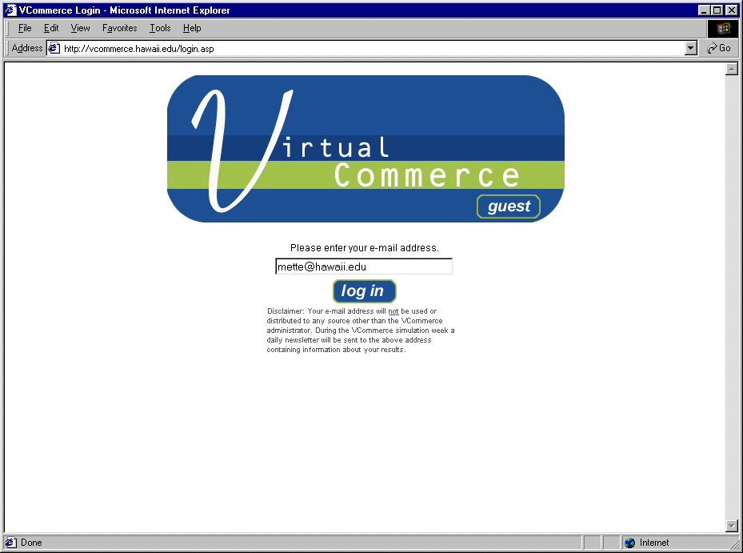
Figure 3.3: VCommerce login page. Figure 3.4: VCommerce email prompt.

    - Entrance Questionnaire

Upon logging in with a consumer account and password, the user arrives at the VCommerce home page (fig. 3.4). Here the four steps a consumer is expected to complete are explained. Step one is the entrance questionnaire, which asks the consumer to enter some demographic data about themselves.

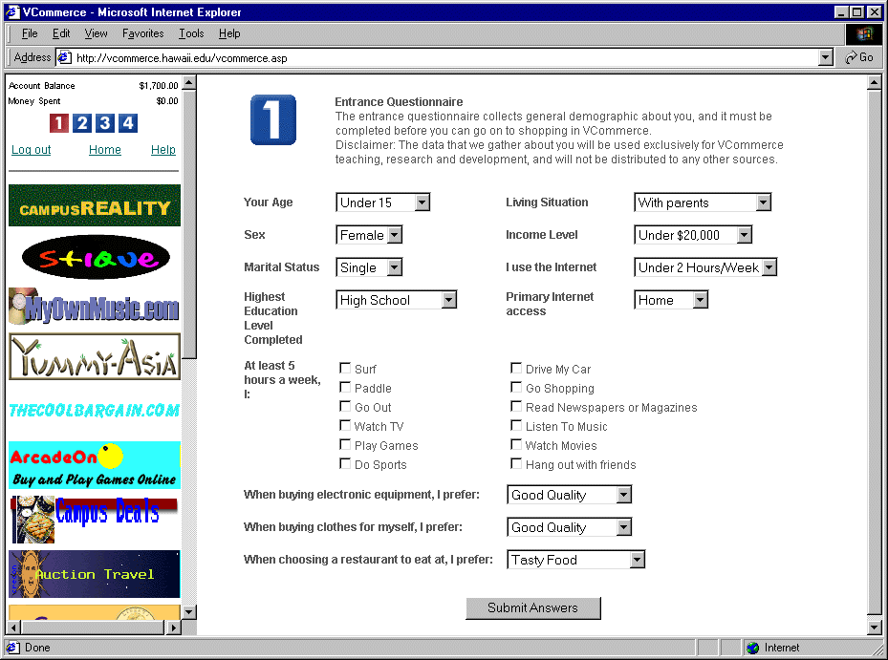
Figure 3.5: VCommerce home page. Figure 3.6: VCommerce entrance questionnaire.

    - Surfing the VCommerce Web

Step two is to “surf” the VCommerce web, and spend the (virtual) money in the account on products or services from the VCommerce companies. Although there is no mechanism to measure how realistically the consumers spend their money, they are encouraged to buy products that seem attractive to them. Therefore, it is not required to spend any money at all.
The left frame of the consumer interface, which is apparent all the time, provides current account balance, links to access each of the four steps, and banners ad from all companies, which link to the respective company sites. The banners are display in random order.
In the right frame the company sites are loaded by using the links in the left frame. The following sequence of screens demonstrates a user buying two products from two different companies.

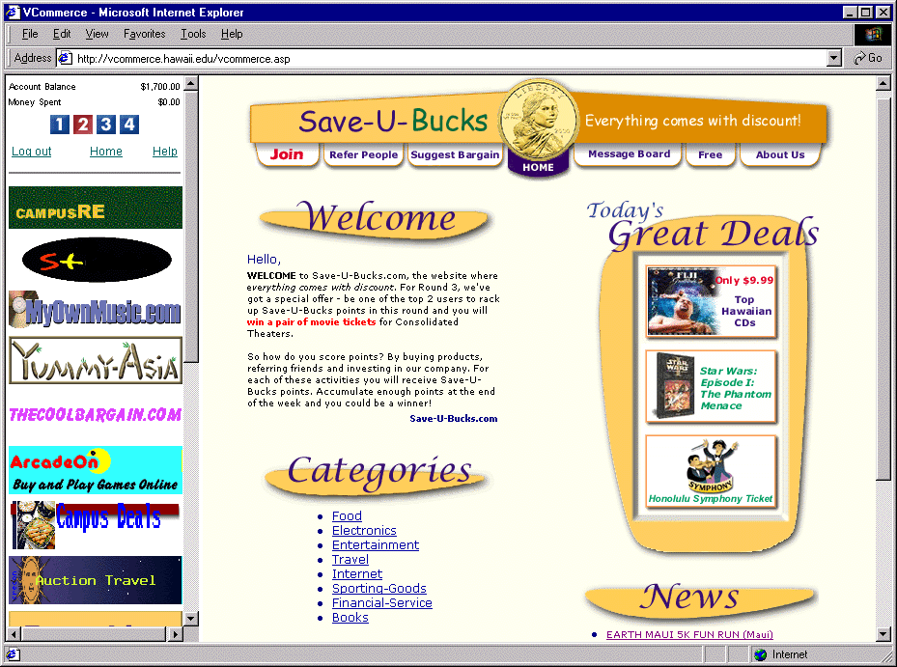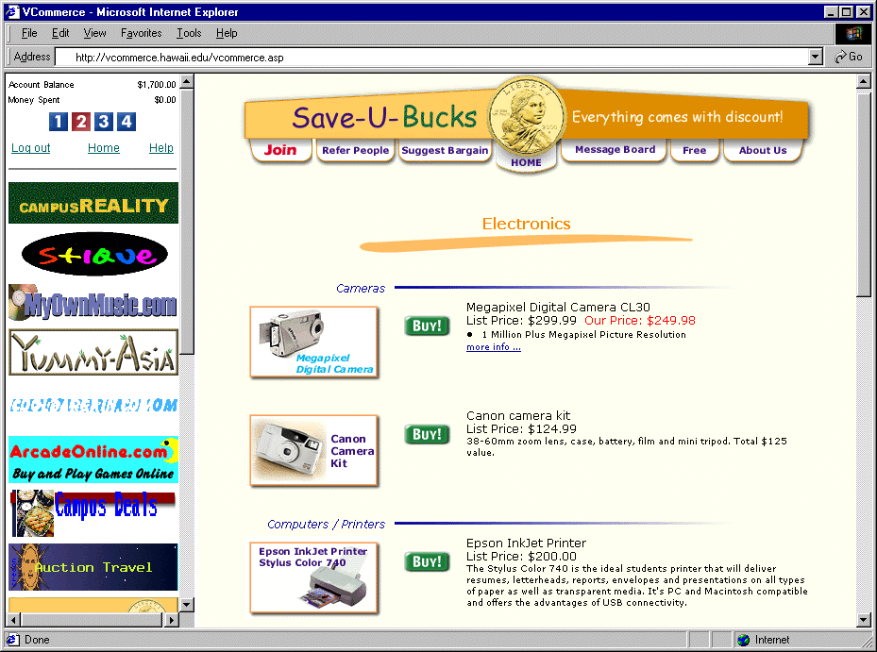
Figure 3.7: Save-U-Bucks home page Figure 3.8: Save-U-Bucks product listing for electronics.
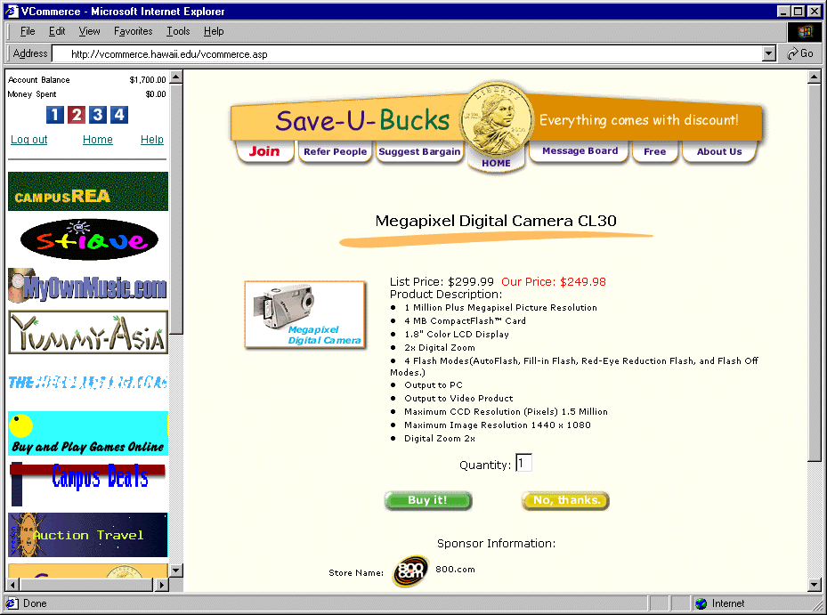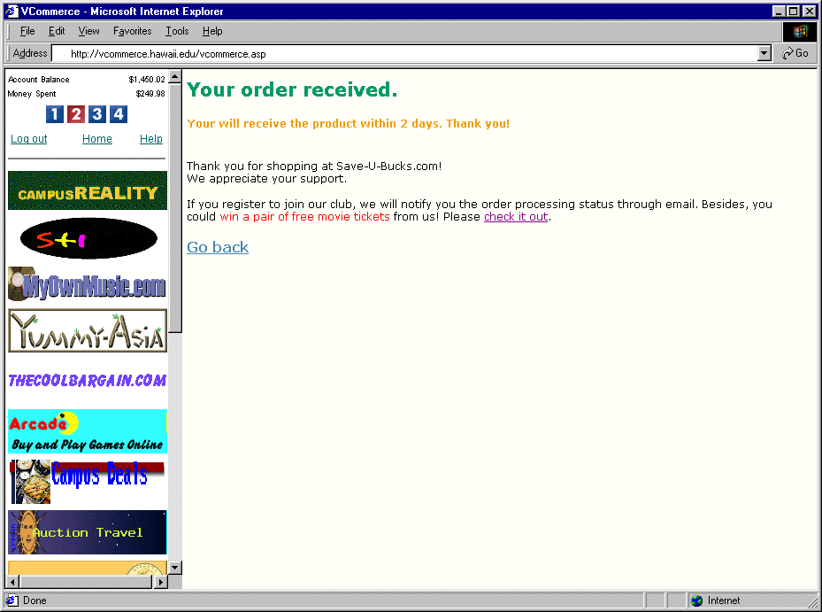
Figure 3.9: Save-U-Bucks product purchase page. Figure 3.10: Save-U-Bucks thank you page.

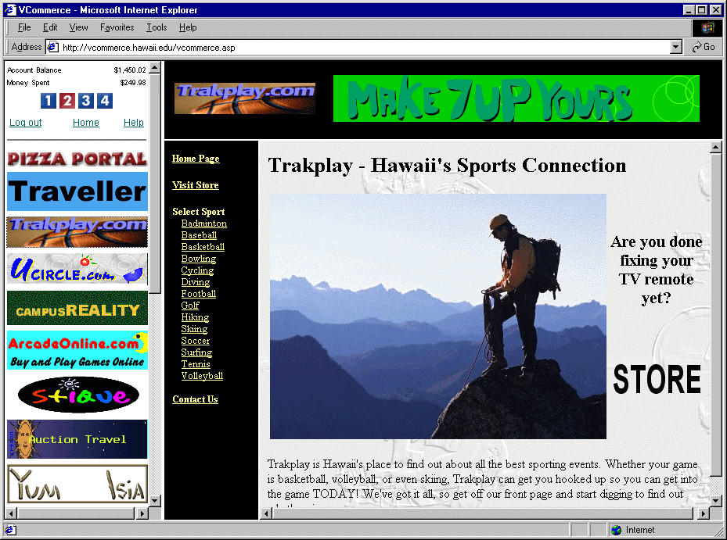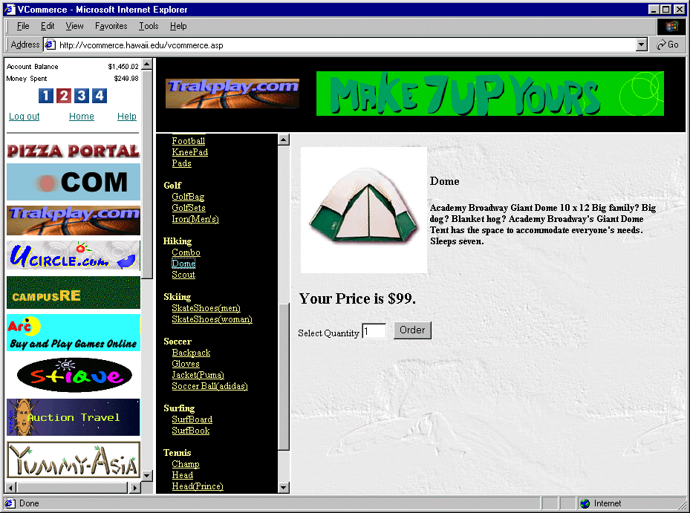
Figure 3.11: Trakplay home page. Figure 3.12: Trakplay product page (and listing).

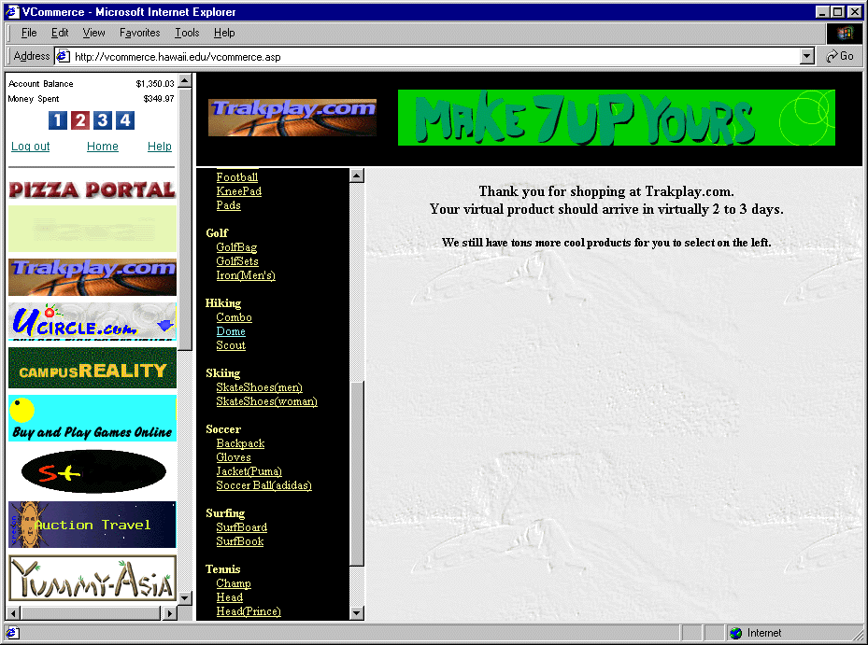
Figure 3.13: Trakplay thank you page.

    - Stock Option Acquisition

In step three, consumers can acquire a certain number of stock options from any combination of VCommerce companies (fig. 3.14). The values of the consumers' stock option portfolios are calculated once a day after the company valuations are calculated, and an e-mail is sent out to each participating consumer.
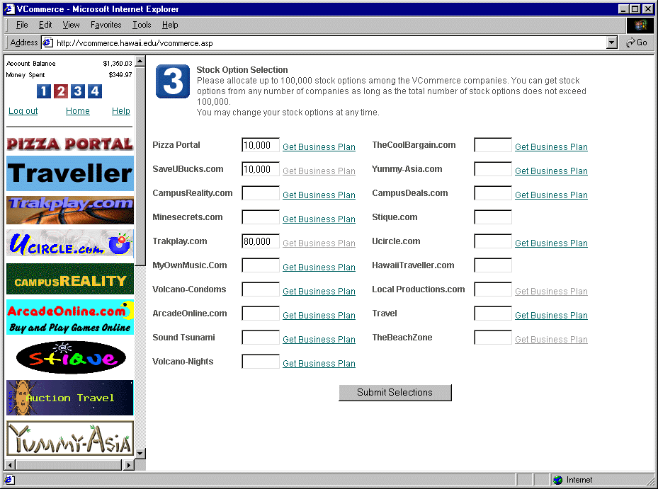
Figure 3.14: Stock option acquisition page. Figure 3.15: Consumer e-mail.

    - Exit Questionnaire

The fourth and final step asks the consumer to fill out an exit questionnaire (fig. 3.16). The purpose of the questionnaire is to evaluate the VCommerce consumer experience.

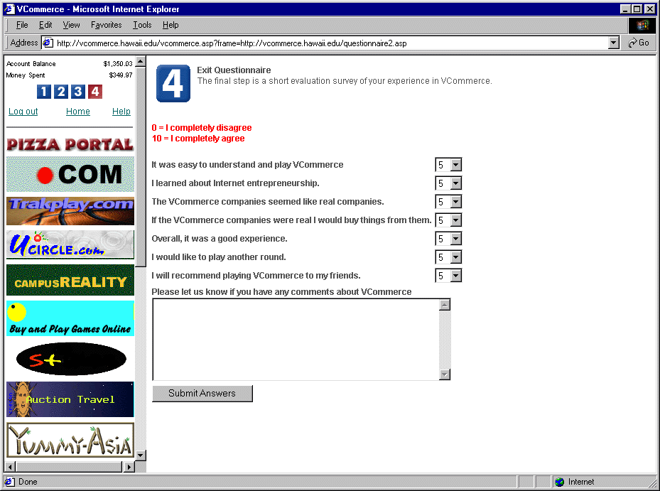
Figure 3.16: VCommerce Exit Questionnaire

  - VCommerce Business Cycles

A VCommerce business cycle consists of the following five phases: identifying an Internet business opportunity, business planning, web site development, consumer access phase and simulation debrief. Based on the case study results, presented in Chapter 5, it seems that two business cycles are appropriate for a regular semester. However, a third consumer access phase is useful to have to obtain additional feedback from consumer usage. In either case, more time should be allocated for the first cycle, because there is a steep learning curve.
In this section I describe each phase of the VCommerce business cycle.

    - Identify an Internet Business Opportunity

VCommerce entrepreneurs first identify an Internet business opportunity. The instructor may define the Internet business domain in terms of a specific target market, such as college students. This was the scenario in the case study presented in Chapter 4. Once settled on an idea, the entrepreneurs decide a name for their company, and begin developing their business plan.

    - Develop a Business Plan

A VCommerce business plan is a simplified version of a real-world business plan, from which students gain practice at developing the business plan fundamentals, such as business description, market research, financial plan, management plan and scalability. The business planning exercise also helps VCommerce entrepreneurs organize the process of designing their VCommerce business and evaluating its viability within a single business cycle.
A VCommerce business plan contains the following sections, each of which is one to two pages in length, for a total of 10-15 pages. See Appendix A for a VCommerce business plan example.

- Cover Sheet. A VCommerce cover sheet contains the business name and contact information for each entrepreneur.
- Executive summary. The executive summary is the most important part of the business plan, because it needs to sell the whole idea and how it will generate revenue in a one-page summary. Investors, who get numerous business plans, are likely not to read the entire business plan if the executive summary did not impress them. This section must sell the idea so well that investors want to look further into the document. The VCommerce executive summary contains a paragraph for the most fundamental components: business description, marketing plan, revenue model and management plan.
- Table of Contents.
- Description of business. A VCommerce business description provides a general explanation about the business idea. It also provides a more detailed description of the products and services that will be sold at the VCommerce store, and how they will benefit consumers.
- Industry analysis. The VCommerce industry analysis requires a study of market size, growth rate, competitor characteristics, relevant technology trends, entry and exit barriers, and other trends that may have an effect on the business.
- Customer analysis. The VCommerce customer analysis is a study of the anticipated customers and their behavior. It describes the target market profile; the market size, and the share the business is expected to draw. It also proposes consumer behavior; the products or services customers are going to buy, and how much will they buy.
- Competitor analysis. The VCommerce competitor analysis describes competing businesses both in the VCommerce world and the real world, and how the proposed business will do better than the competitors.
- Marketing strategy. The VCommerce marketing strategy contains a discussion of pricing strategy and promotion plan of the products or services the business sells.
- Management. The management section lists the entrepreneurs involved with the business: name, age and title, along with a paragraph that describes their background, skills, and responsibilities in the business. This section also identifies any skill deficiencies, and proposes how they will be corrected.
- Financial data. The financial data section contains a balance sheet that covers a seven month period of the initial startup with numbers for net sales, gross profit margin, cost of goods sold, net advertising revenue, expenses and the calculated net income or loss.
- Growth Potential. This section discusses in general terms the scalability and growth potential of the business idea in a real-world setting.

    - Implement a Web Site

Each company designs and implements a web site that puts the design goals of their business plan into practice. There are no minimum requirements or limitations about the number of pages in the web site, or how complex the site should be. It is up to the entrepreneurs in each company to develop a site they believe will attract their target market and successfully reach their business goals. There are however, a couple of functional requirements as described below:

- Every page in a company’s web site must be an Active Server Pages (ASP) page and include two VCommerce system files. One file ensures that the page is properly displayed in the VCommerce simulation system. The other file sets certain environment variables that are need for the simulation, and it tracks consumer usage of the page. The ASP technology is described in detail in section 3.5.3.

- Each company web site must contain a VCommerce store where consumers can purchase the company’s products and services, and each item in their store must use an HTML form that submits to a VCommerce system file that registers every purchase. A unique item ID, which is assigned when entrepreneurs submit their virtual products and services in the VCommerce system database using the VCommerce company interface (fig. 3.17), identifies each item in VCommerce.

- The company must create a banner ad (fig. 3.18) that is 180 pixels wide and 50 pixels high, and it must be GIF or JPG format. The banner ad is used as a link to access the company’s web site.

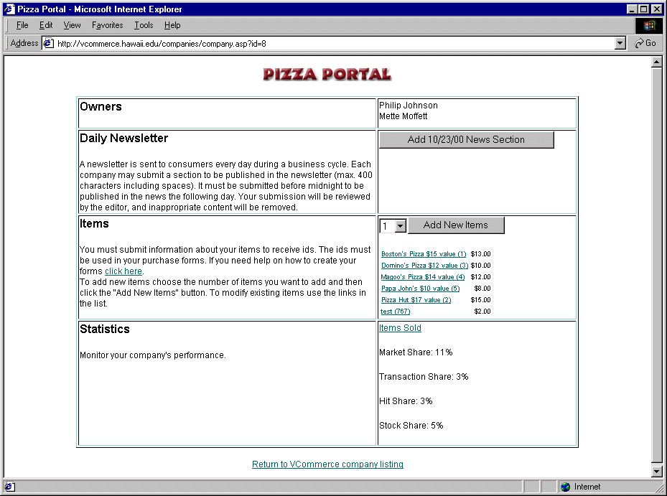
Figure 3.17: VCommerce company page (Pizza Portal) Figure 3.18: VCommerce banner ad (Volcano Nights)

All the VCommerce company web sites are stored on the VCommerce web server to which the entrepreneurs have been granted FTP access. A VCommerce company is granted read and write access to their own web site directory, and read access to all other VCommerce company directories. This open source approach enables students to learn ASP programming faster, and as a result the sites are of higher quality.
The sites are accessed through the VCommerce consumer interface, which links to each company site in a frame based layout. Consumer access is restricted to the people outside the class who have received an invitation with an account and password. A built in guest account allows anonymous users to take a look at the VCommerce consumer interface, but they are not able to purchase any items from the VCommerce company stores.
The instructor sets a deadline date for the company web sites to be implemented and tested. This date is also the beginning of the VCommerce consumer access phase.

    - VCommerce Consumer Access Phase

For a period of approximately one week, invited consumers can access the VCommerce companies via the online consumer interface (see section 3.2). A random amount of (virtual) money within a specified range (e.g. $1,500-$2,500) is assigned to each consumer account, and a certain number of stock options is available for acquisition.
During this phase, consumers are encouraged to come back and adjust their stock option acquisitions to make their portfolio worth as much as possible. This provides company owners an incentive to manage and update their site as the consumer access phase goes on. Companies are also able to submit a text advertisement in the daily consumer e-mail, which must be submitted by midnight on the day before the e-mail is generated.
An entrepreneur newsletter (fig. 3.19) contains a summary of the system statistics and the valuations of each company. The statistics include market share, page hit share, transaction share and stock share. The following algorithm calculates the companies’ stock value based on the statistics.

M: Market Share; P: Page Hit Share; T: Transaction Share; S: Stock Share.

Stock Value = 25*(M/max(M)) + 25*(P/max(P)) + 25*(T/max(T)) + 25*(S/max(S))

The company that has the highest value at the end of the simulation is considered the most successful VCommerce company.

Figure 3.19: VCommerce entrepreneur newsletter

    - VCommerce Simulation Debrief

After the consumer access phase and the VCommerce IPO, a debrief session is held in class where students share and discuss lessons learned for the simulation. The purpose of the debrief is for students to bear in mind the lessons learned, and then do things better in the following cycle, or in case of the last cycle, in real life.

  - An Example VCommerce Semester

Consider a hypothetical class with forty students: Fifteen students from the computer science or electrical engineering department, twenty from the business school, and five from other disciplines. The class is divided into twelve teams of three and one team of four. Each group has at least one student with programming experience and one from the School of Business. Assuming a class with this profile, a seventeen-week semester with VCommerce could be structured as follows.

Week | Lecture Topics | VCommerce Stages
1 | Internet business models  Market Research | Team formations (by instructor)
2 | Writing a Business Plan | Identify an Internet Business Opportunity and Conduct Market Research
3 | Web Design and Development  VCommerce Company Elevator Pitches | Business Planning  Web Site Design
4 | Network Backbones for Internet Businesses  Databases and application development for Internet Businesses  Outsourcing vs. In-house Development | Web Site Implementation
5 | Multimedia on the Web  VCommerce Company Web Site Presentations | Web Site Implementation
6 | Internet Advertising  Internet Consumer Behavior and Usability Testing | Web Site Implementation
7 | VCommerce IPO and Debrief Session  Guest Speaker | Consumer Access Phase #1
8 | Electronic Payment Systems  Security | Debrief  New Team formation (by students)
9 | Search Engines  VCommerce Company Elevator Pitches  Guest Speaker | Identify an Internet Business Opportunity and Conduct Market Research - or - Refine Existing Business Plan
10 | VCommerce Company Web Site Presentations  Guest Speaker | Write Business Plan and Design and Implement Web Site - or - Expand and improve existing company web site
11 | Intellectual Property and Software  Open Source Software | Implement or Improve Web Site
12 | VCommerce IPO and Debrief Session  Guest Speaker | Implement or Improve Web Site
13 | Privacy on the Internet  Legal Matters for Internet Businesses | Consumer Access Phase #2
14 | VCommerce Company Elevator Pitches  Venture Capital  Guest Speaker | Debrief
15 | VCommerce Company Web Site Presentations  Guest Speaker | Consumer Access Phase #3
16 | VCommerce Business Plan Competition | Consumer Access Phase #3
17 | VCommerce IPO, Debrief Session  Networking Party | Debrief

Table 3.1: VCommerce Semester Schedule Example

  - VCommerce Simulation System Implementation

The VCommerce Simulation System is an Active Server Pages (ASP) web application with an underlying Access database. The application contains three different interfaces, a sample company web site called Pizza Portal, and a number of underlying system files that store data needed for the simulation, which are outlined below.

- Consumer Interface (vcommerce.hawaii.edu): The central VCommerce web interface that provides consumer access to the VCommerce company web sites.

- Company Interface (vcommerce.hawaii.edu/companies): The VCommerce company interface provides each company with their own VCommerce company administration page where company owners maintain their product database, submit ads for the consumer newsletter and view current simulation statistics.

- Administrator Interface (vcommerce.hawaii.edu/admin): The VCommerce administrator interface provides the instructor with various system administration pages. The instructor can add, edit and delete new companies to the database, generate new consumer accounts and send out the consumer and entrepreneur newsletters.

- System files: A number of underlying system files are responsible for storage and retrieval of simulation data such as usage of the consumer interface, purchase transactions and company valuation calculations, and system control such as user authentication and access permissions.

- Pizza Portal: A sample VCommerce company gives students an idea of what they need to do in terms of implementing their company web site. The Pizza Portal source code is available for students to use as ASP programming reference.

The following sections present the VCommerce Simulation System hardware and software requirements, the system size and structure, and examples of Active Server Pages programming.

    - Hardware and Software Requirements

The VCommerce Server is an Intel platform with the following hardware and software specifications.

Hardware | Software
500 MHz Pentium II | Microsoft NT Server 4.0
128 MB RAM | Service Pack 6
12 GB Hard Drive | NT 4.0 Option Pack (Internet Information Server 4)
10/100 Base-T Network Connection | Access 97

Table 3.2: VCommerce Server Specifications

Built into the Internet Information Server (IIS) 4, Active Server is a server-side and script-based programming model that allows developers to create server and Web server applications (fig. 3.20).

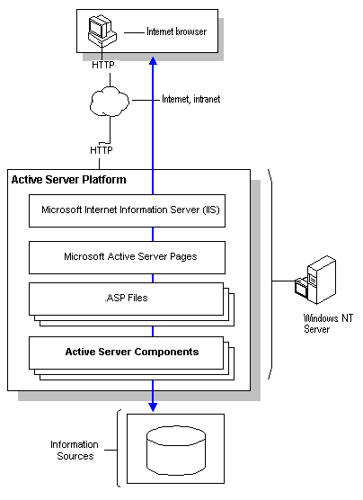
Figure 3.20: Active Server Platform

Active Server Pages (ASP) is an Internet Server Application Programming Interface (ISAPI), which is a Microsoft interface for writing in-process extensions to IIS. ASP programming is explained in section 3.5.3.

    - System Size and Structure

The VCommerce Simulation System consists of a hierarchy of ASP files and one ASA file. The ASA file is located at the application’s root directory and it can be seen by all ASP files in the application and can therefore be used to initialize global session and application variables. There are 78 files with a total of 3644 lines of ASP code, which consists of Visual Basic Script and HTML. The following table presents how the size and overall structure of the application.

vcommerce.hawaii.edu | Lines of Code | # Files | Description
/ | 1466 | 19 | The application’s root directory where the consumer interface is located.
/admin | 885 | 13 | The administration interface for instructors.
/companies | 828 | 9 | The administration interface for company owners.
/include | 76 | 3 | System files used for server-side include directives.
/images | 0 | 30 | Images used in application files
/Rx/pizza | 389 | 4 | Pizza Portal: A sample VCommerce company.
Total Lines of Code | 3644 | 78
Table 3.3a: VCommerce Simulation System Size and Structure

vcommerce.hawaii.edu | Size of files | # Files | Description
/Rx | 134 MB | 5154 | The company web sites are located in directories named Rx, where x is the business cycle number (e.g. R1). Within the Rx directory, each company has their own individual company directory, which are named A, B, C, etc. The size and number of files reflect the size of R1 and R2 after the Spring 2000 deployment of VCommerce (see Chapter 4).
Table 3.3b: VCommerce company directory size and structure

The underlying VCommerce Simulation System database is the key component of the system. Information about VCommerce companies, entrepreneurs, consumers, purchase transactions, stocks, user accounts and other simulation data is stored in this Access 97 database. The database is not located within the application structure, and it is accessed from the application files by using an ODBC Data Source Name (DSN). The database was 10 MB large after the spring semester 2000 deployment of VCommerce (see Chapter 4).

      - vcommerce.hawaii.edu

Sample Page | Filename  (lines of code) | Description
System file | global.asa  (11) | This system file contains global session and application variables.
 | default.asp  (73) | This page is loaded by default when vcommerce.hawaii.edu is accessed. It prompts the user to log in as a consumer or browse as a guest.
System file | login.asp  (80) | User authentication and session initialization process file.
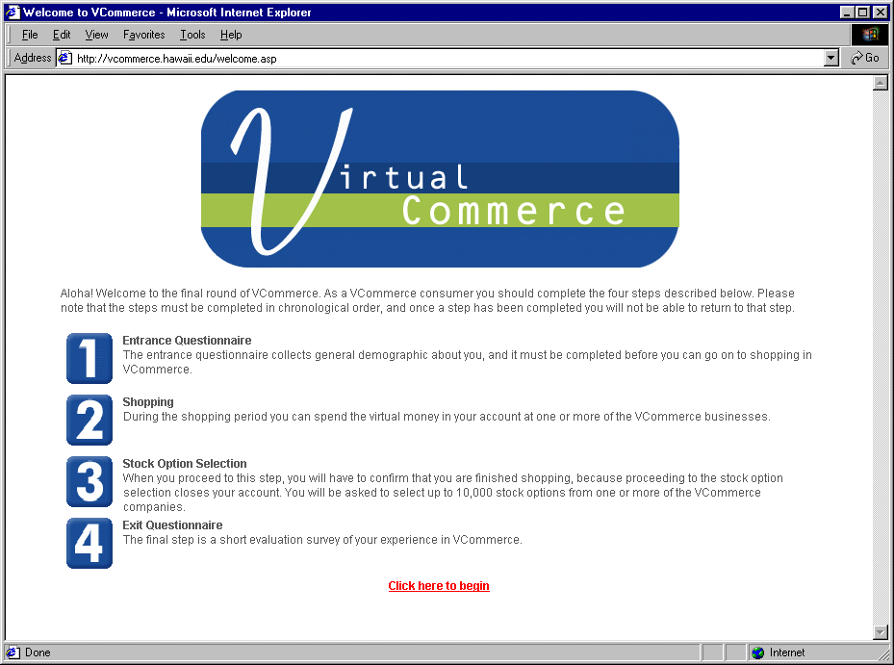 | welcome.asp  (53) | Upon logging in as a consumer a welcome page greets the consumer and explains the four steps consumers are asked to complete.
Frameset definition file. | vcommerce.asp  (46) | This page holds the frameset, which consists of two frames.
 | consumer_frame.asp  (192) | The consumer frame page is loaded in the left frame when a consumer has logged in. It contains VCommerce company banner ads and account balance information.
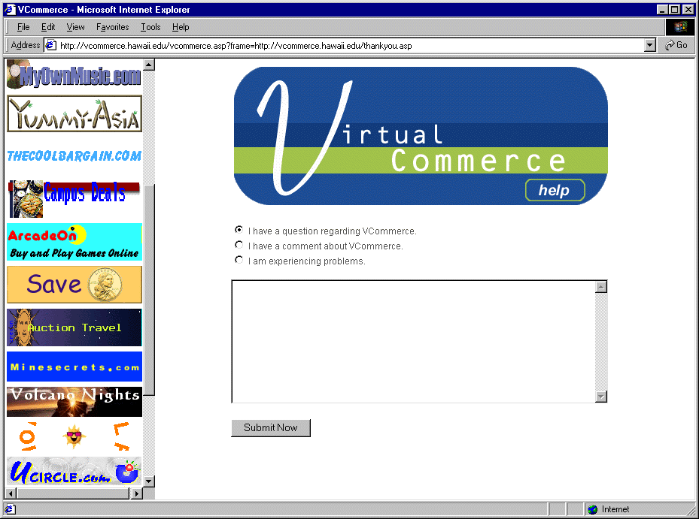 | entrepreneur_frame.asp  (51) | The entrepreneur frame page contains VCommerce company banner ads only.
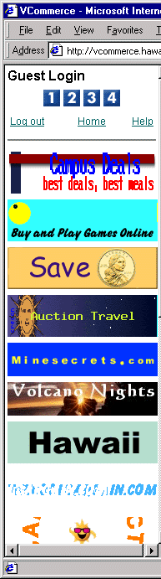 | guest_frame.asp  (129) | The guest frame page contains VCommerce company banner ads and it indicates at the top that the system is in guest mode.
 | home.asp  (46) | The home page is initially loaded in the right frame, and it contains an overview of the four consumer steps.
 | questionnaire1.asp  (159) | The entrance questionnaire page that consumers complete in step 1. The page contains a form, where they type in or select answers to the questions.
System file. | questionnaire1_submit.asp (37) | This file retrieves the submitted answers in the entrance questionnaire form, and stores them in the database.
System file. | purchase.asp  (124) | This file processes all purchase transactions in VCommerce. For every item a VCommerce company sells, there is a form that submits the item id and quantity to this file. The purchase file then stores a transaction receipt in the database.
 | stocks.asp  (103) | The stock option page contains a form with an input field for each company. A consumer can place up to a certain amount of stock options with one or more companies. The page also links to each company’s business plan.
System file. | stocks_submit.asp  (42) | This file retrieves the submitted numbers in the stock option form, and stores them in the database.
 | questionnaire2.asp  (198) | The exit questionnaire page that consumers complete in step 4. The page contains a form, where they type in or select answers to the questions.
System file. | questionnaire2_submit.asp (43) | This file retrieves the submitted answers in the entrance questionnaire form, and stores them in the database.
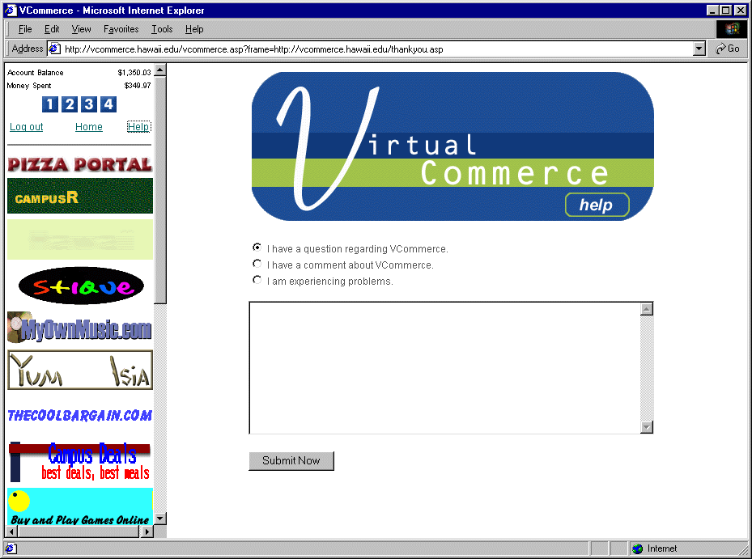 | help.asp  (60) | The help page contains a form in which users can write to the VCommerce director if the have a question, comment or bug report.
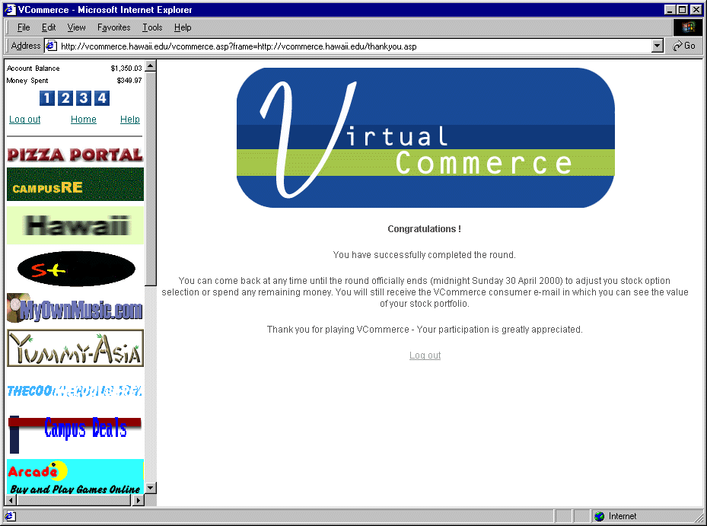 | thankyou.asp  (15) | When the consumer has completed all four steps, they are redirected to a thank you page.
System file. | logoff.asp  (4) | This file executes a log out script and redirects the user to default.asp

Table 3.4: VCommerce Consumer Interface Files

      - vcommerce.hawaii.edu/admin

The VCommerce administration interface for instructors, located at vcommerce.hawaii.edu/admin, can be used by the instructor to perform tasks such as adding new companies, editing existing companies and adding consumer accounts.
This interface is not complete in the sense that there are certain tasks such as adjusting the company valuation algorithm which currently is not supported through this admin interface. As a result the VCommerce System is dependent on someone who is capable of ASP programming. In Chapter Six I will discuss the administration component further as part of the future directions for my research.

Sample Page | Filename  (lines of code) | Description
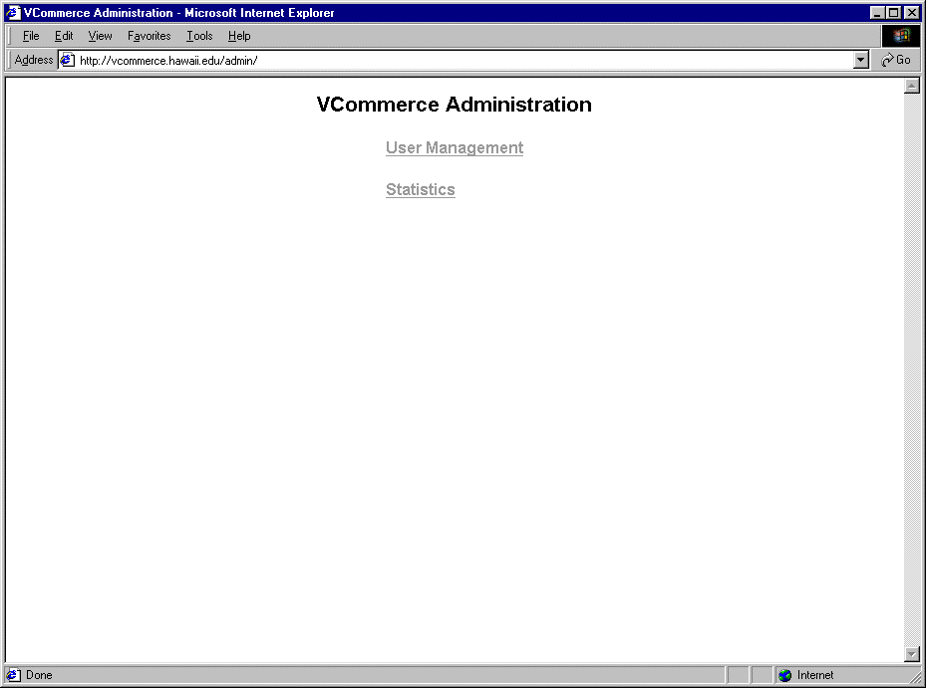 | default.asp  (16) | This page is loaded by default when vcommerce.hawaii.edu/admin is accessed. It provides access to user management and statistics pages.
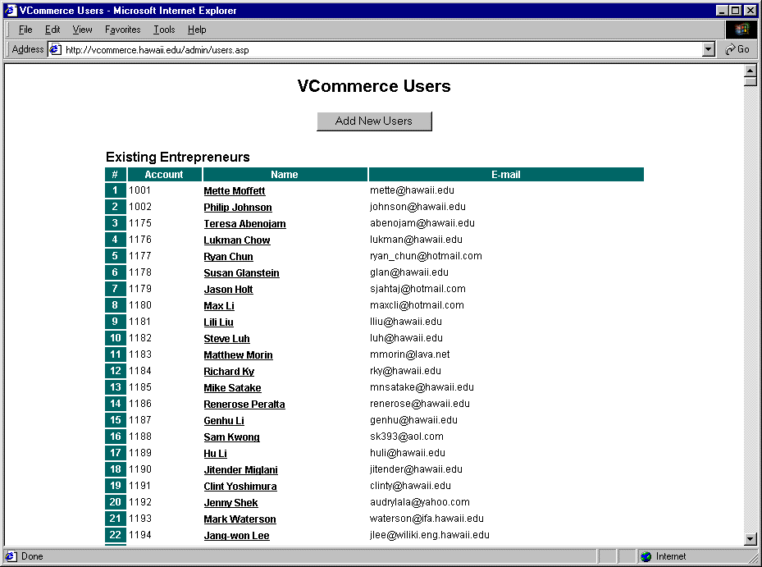 | users.asp  (74) | Listing of existing VCommerce users, that is, entrepreneurs and consumers.
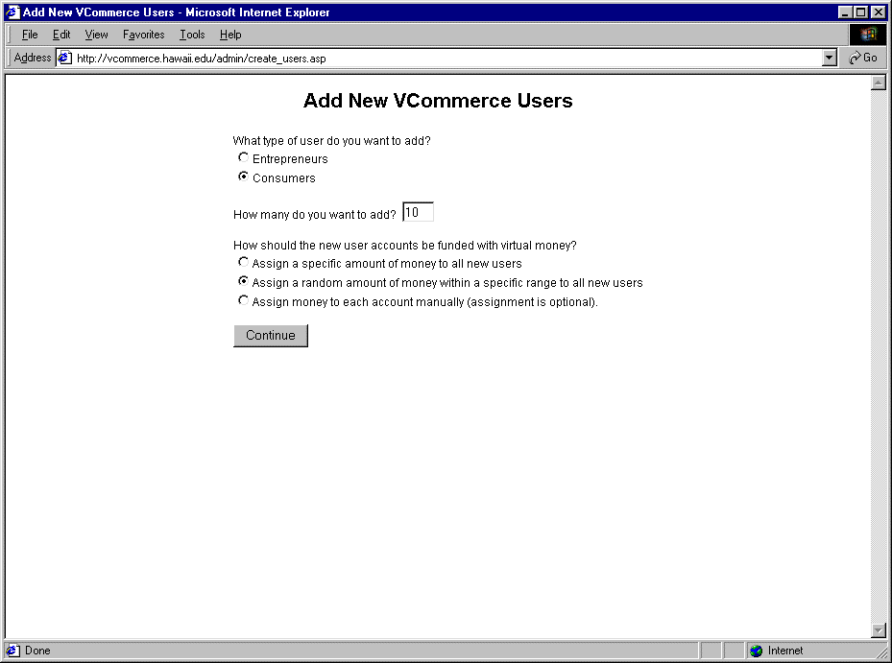  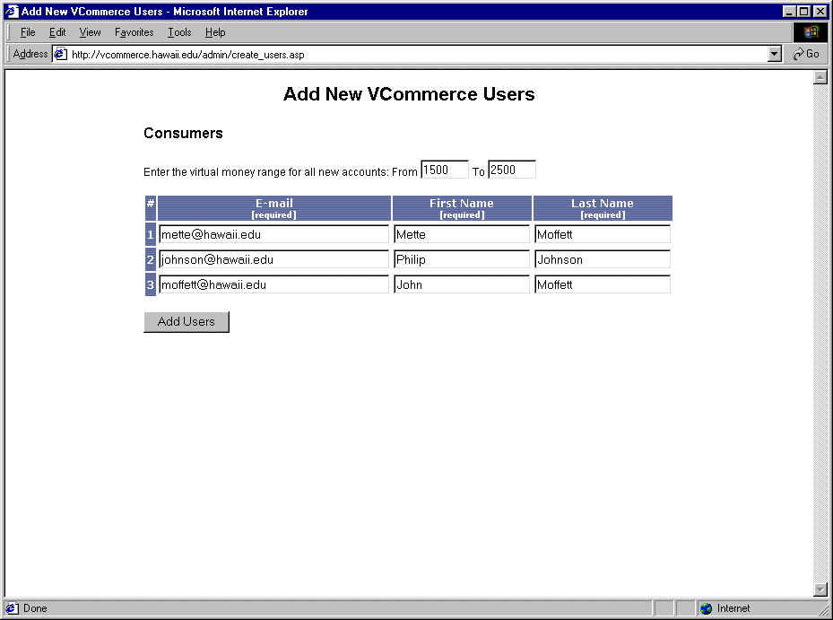 | create_users.asp  (114) | Create new users page. Initially the user will see a screen where (s)he can choose to create a consumer or entrepreneur accounts, and specify one of three methods to assigned money to the account.  - Assign a specific amount all new accounts.  - Assign a random amount that falls within a specific range.  - Assign money to each account manually.  Once the above choices are submitted the pages reloads with a form based upon the selections. The form requires a first name, last name and email address of the new user.
System file. | create_users_submit.asp  (90) | This file processes the create new users form when it is submitted, and stores the new users in the database.
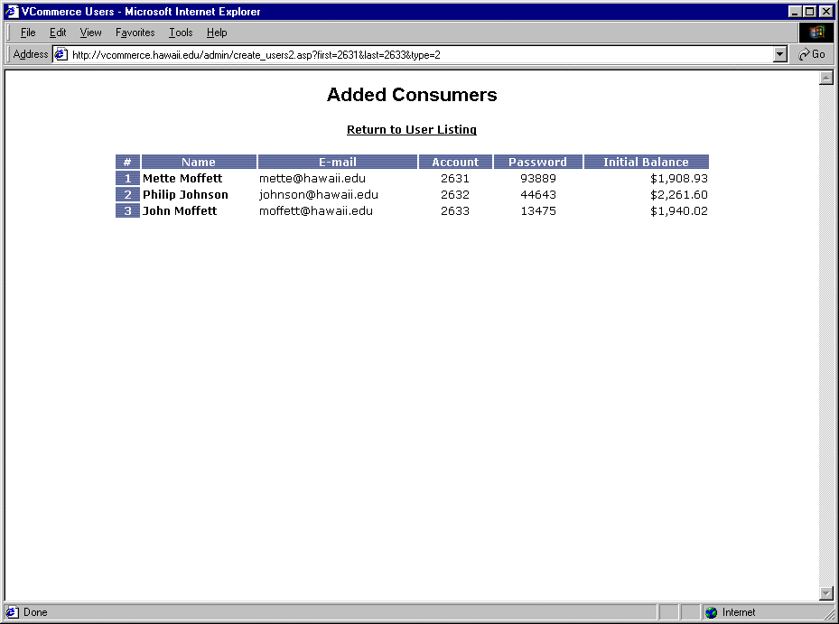 | create_users_confirm.asp (58) | This page confirms and displays the new user additions.
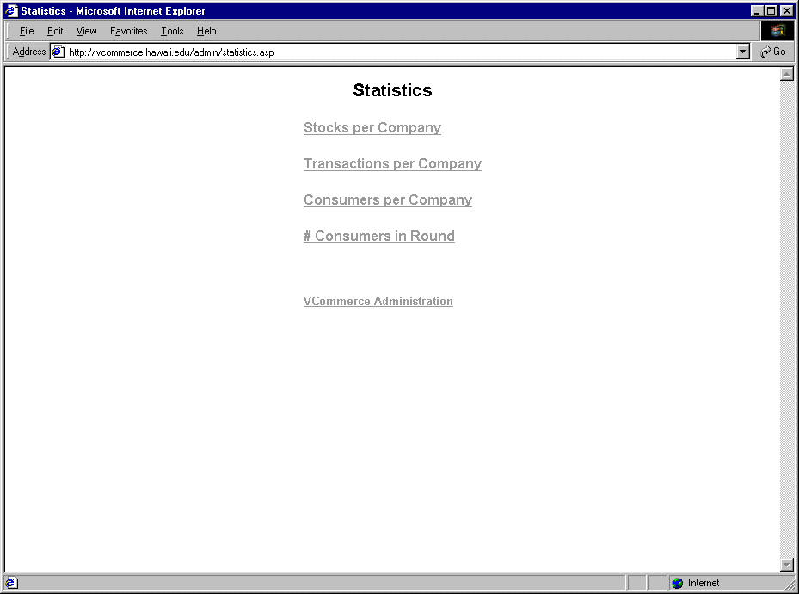 | statistics.asp  (29)  stocks.asp (34)  transactions.asp (34) customers.asp (36)  hits.asp (42) distinctconsumers.asp (27) | The statistics page provides access to pages where simple statistics are retrieved from the database. The statistics are:  - Acquired stocks for each company.  - Number of transactions per company.  - Number of customers per company.  - Number if page hits per company.  - Number of consumers participating.
System file. | entrepreneur_report.asp  (183) | This file generates the entrepreneur report. It can be run by requesting the file manually or by adding it to system scheduled tasks.
System file. | consumer_email.asp  (148) | This file generates the consumer e-mail. It can be run by requesting the file manually or by adding it to system scheduled tasks.

Table 3.5: VCommerce Administration Interface for Instructors Files

      - vcommerce.hawaii.edu/companies

The VCommerce administration interface for company owners, located at vcommerce.hawaii.edu/companies, provides access to current site statistics such as market share and transaction share. The company owners must use this interface to add products and services to the VCommerce Simulation System database. As an optional feature the company owners are also able to submit text advertisements to the consumer e-mails.

Sample Page | Filename  (lines of code) | Description
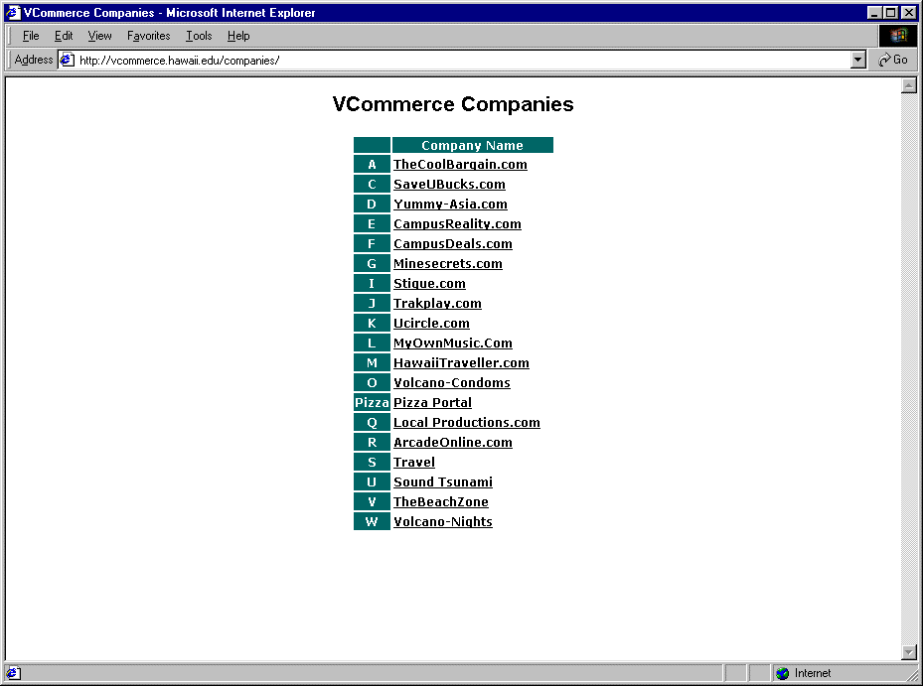 | default.asp  (32) | This page is loaded by default when vcommerce.hawaii.edu/admin is accessed. It provides access to user management and statistics pages.
 | company.asp  (181) | This is the individual company page. A company id is passed to the page, and based on that company information is dynamically retrieved.  Company owners can view their stock, hit, market and transaction shares here, add and edit their products in the VCommerce system database, and submit text advertisements to the consumer email.
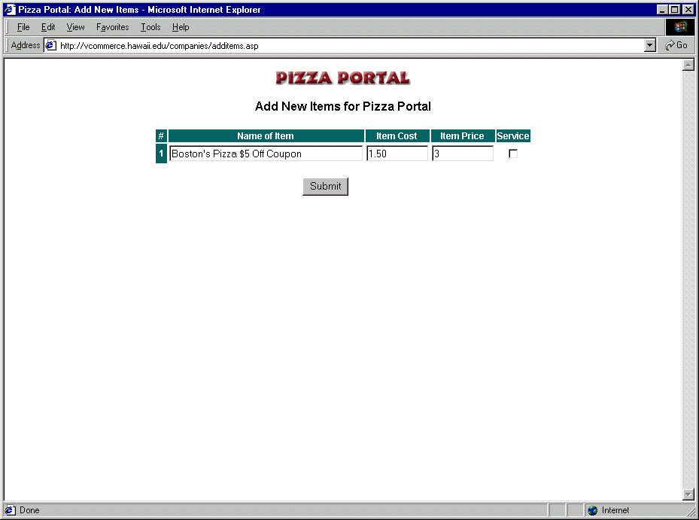 | additems.asp  (71) | Add new items page. Any number of items can be added through this page by selecting a number on the company page. Adding a new product or service to the system database requires a product name and a price. Item cost is optional, because it is not currently being used in the simulation.
System file. | additems_submit.asp  (78) | This system file processes the addition of new items to the system database when the form above is submitted.
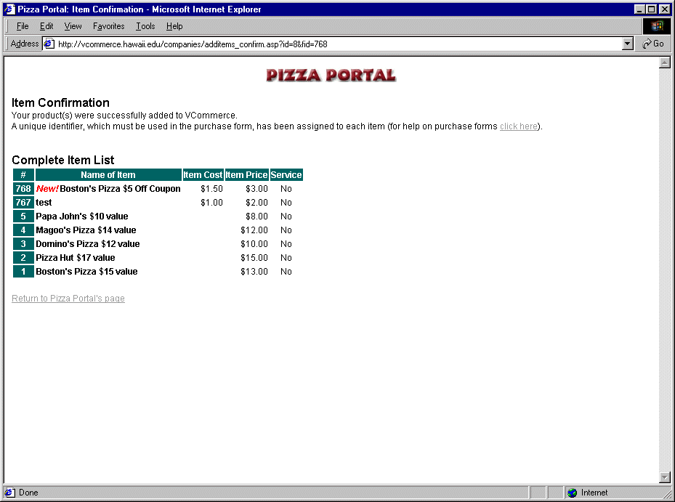 | additems_confirm.asp  (94) | This page confirms and displays the addition of news items.
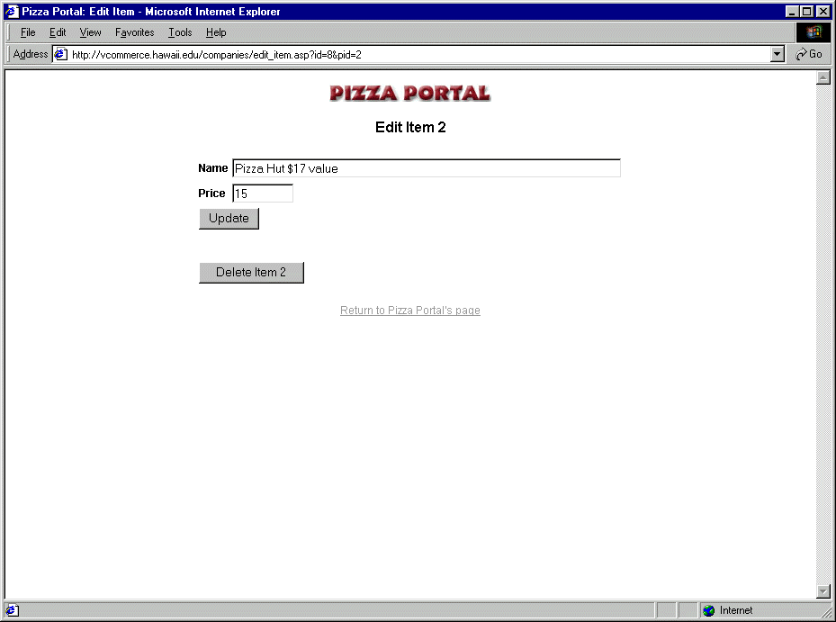 | edit_item.asp  (121) | At this page company owners are able to modify the name and the price of their items.
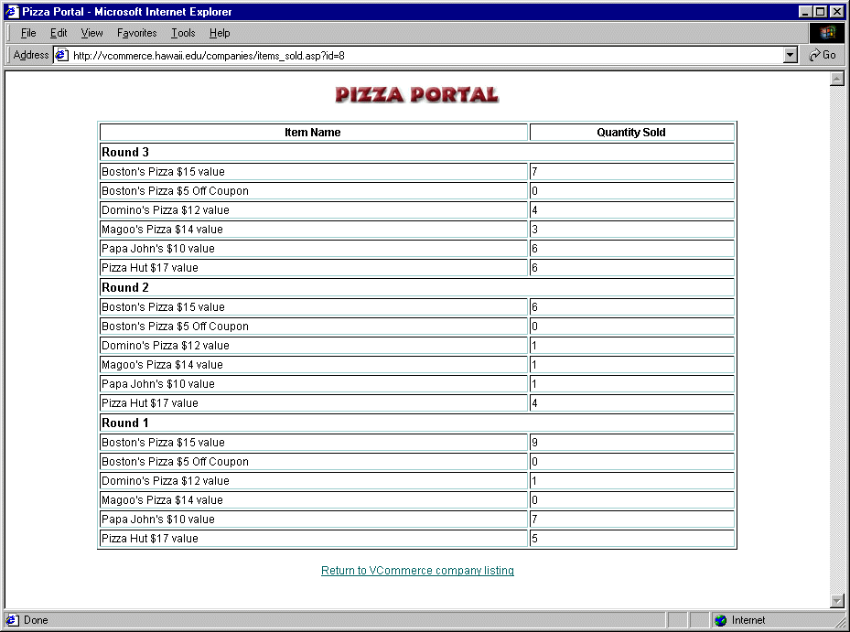 | items_sold.asp  (68) | This page shows how many times each item was purchased during each consumer access phase.
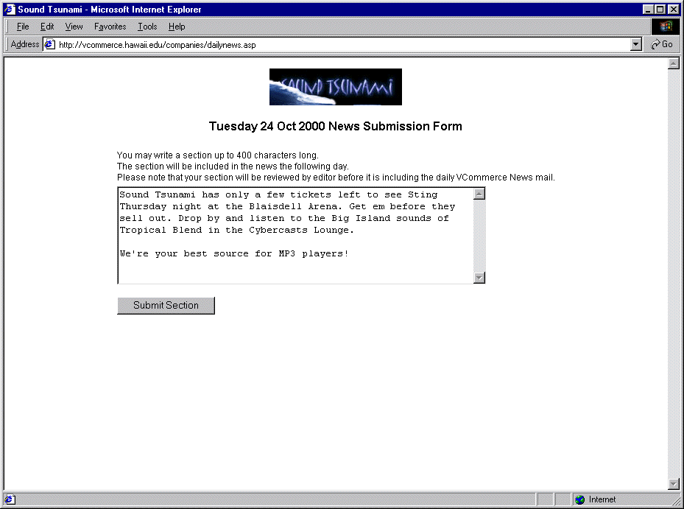 | dailynews.asp  (55) | At this page company owners can submit a text ad to go in the consumer email the following day.
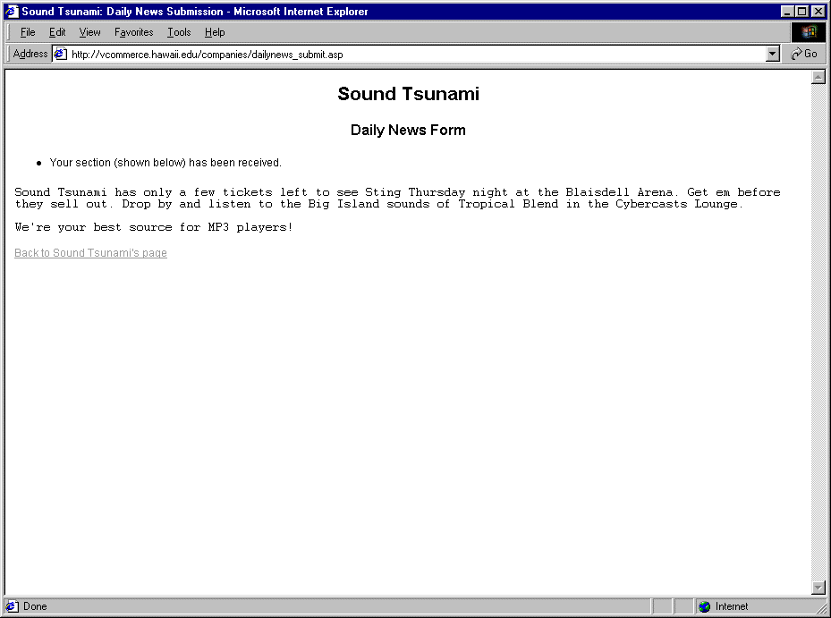 | dailynews_submit.asp  (128) | This page confirms the submission of a text ad for the consumer e-mail.

Table 3.6: VCommerce Administration Interface for Companies Files

      - vcommerce.hawaii.edu/include

There are three system files in the include directory, which are used as server-side include directives in a number of files. The include directives are useful for code that is reused in a number of places.

Filename  (lines of code) | Description
frame_script.html  (22) | This file contains a script, which ensures that the left frame with company banner ads is always displayed. It must be include in every company page that contains an HTML interface (except a frameset definition file).
include.asp  (23) | This file contains the consumer tracking mechanism, and it must be include
vars.inc  (31) | This file contains variables that are often used.

Table 3.7: VCommerce Server-side Include Directives

      - vcommerce.hawaii.edu/Rx/pizza

Pizza Portal is a sample VCommerce company web site, which students can use as a reference when they implement their own web sites. The site uses a simple database to display its products, and has a pizza directory feature, where users can find store locations and phone numbers, and check if they are currently open.

Sample Page | Filename  (lines of code) | Description
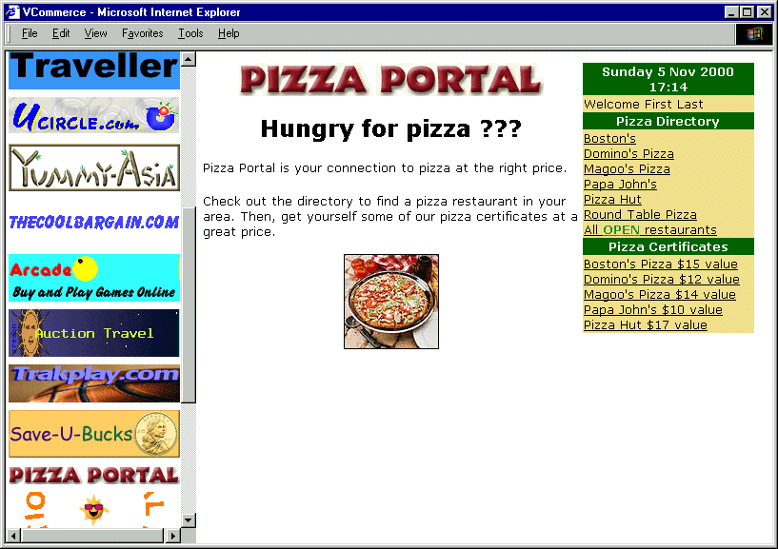 | default.asp  (88) | This page is loaded in the right frame when a consumer clicks on Pizza Portal’s banner in the left frame.
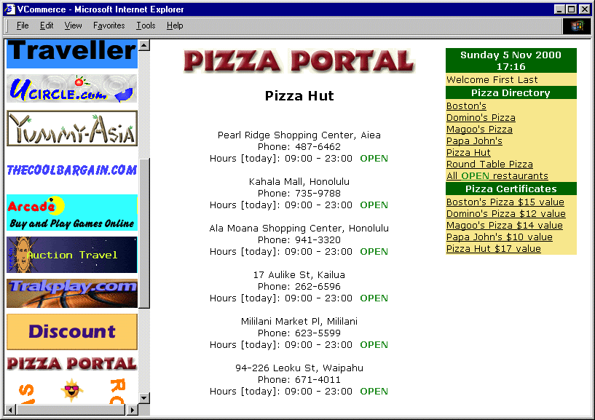 | store.asp  (117) | This page lists the locations and phone numbers of a store selected in the Pizza Directory, or all the stores, which are currently open.
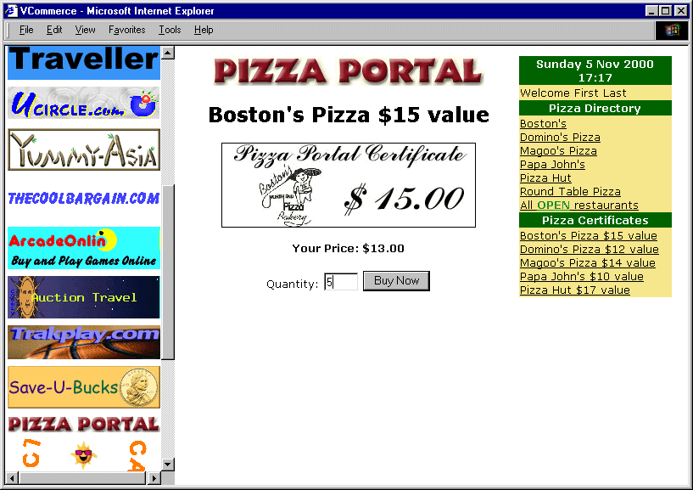 | product.asp  (100) | The product page allows users to purchase Pizza Portal’s products.
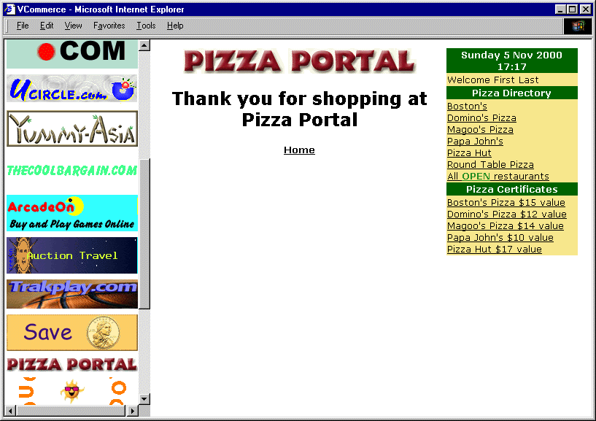 | thankyou.asp  (84) | This is the thank you page, which is displayed after a user have purchased a product from Pizza Portal.
Table 3.8: Pizza Portal Files.

      - System Database Design

The VCommerce system database is relational database designed and implemented with Microsoft Access 97. In this section I present the design of the database.

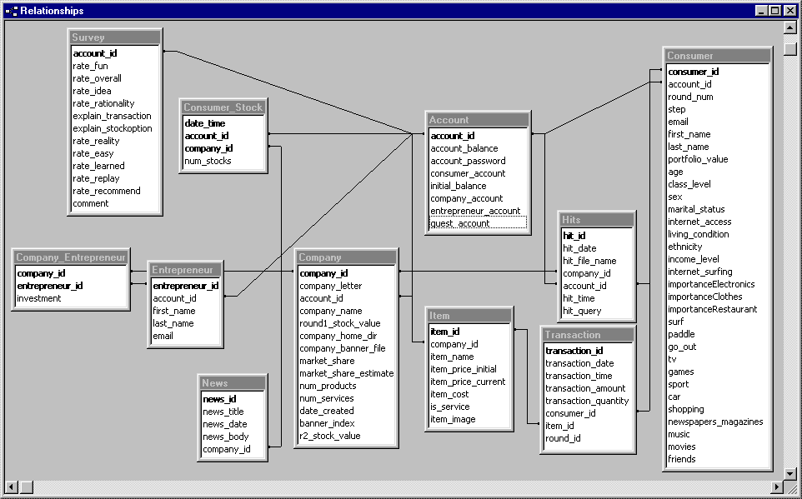
Figure 3.21: VCommerce System Database Diagram

Table | Description
Account | The Account entity is used for user accounts. Primary it has an account id and password, which is what is used for logging in at the VCommerce web site. It also keeps information about the account type and virtual cash balance.
Company | The Company entity represents a VCommerce company. The table stores information about the company that is used for the VCommerce simulation.
Company_Entrepreneur | The Company_Entrepreneur entity stores the relationships between a company and a number of entrepreneurs. An entrepreneur is associated with a company if s/he owns the company.
Consumer | The Consumer entity represents a VCommerce consumer. It stores the information users submit in the VCommerce simulation.
Consumer_Stock | The Consumer_Stock entity stores the relationships between a consumer and one or more companies that the consumer has selected stocks from during the VCommerce simulation.
Entrepreneur | The Entrepreneur entity represents a VCommerce entrepreneur. It stores the entrepreneur’s name and e-mail address.
Hits | The Hits entity represents page hits at the VCommerce company web sites. Each time a consumer requests a page from a VCommerce company web site, a hit is stored in this table. The hit is identified by the user’s account id, the company’s id and a timestamp.
Item | The Item entity represents a product or service a company sells in their VCommerce store. Each item is associated with the company id of the company that sells the product or service.
News | The News entity represents a news section from a company. A company’s news section is submitted in the consumer newsletter during the simulation on the day corresponding to the news date.
Survey | The Survey entity represents a set of survey answers from a consumer. These are the answer of the VCommerce exit questionnaire, which consumers’ are asked to complete in step 4 of the simulation.
Transaction | The Transaction entity represents a purchase transaction where a consumer buys an item from a VCommerce company store. It associates a consumer with an item, and stores additional information such as quantity and time of purchase.

Table 3.9: VCommerce System Database Table Descriptions

    - Active Server Pages (ASP) Programming

ASP is a language-neutral, compile-free scripting environment that is good for rapid web application development. By writing server-side scripts that are executed as extensions of IIS, ASP provides a medium for dynamic, data-driven web applications. The server-side scripts, which are embedded with HTML in .ASP files, can be written in a number of different scripting languages such as VBScript, JavaScript and Perl, and they allow you to connect to ActiveX server components without relying on external runtime engines. In the VCommerce web application I use a built-in ActiveX server component called Active Data Objects (ADO), which are capable of retrieving data from databases by executing SQL statements in the server-side scripts (fig. 3.24b). A server-side script is embedded by using a <% %> tag.
When a client requests an ASP page, the server-side scripts are interpreted and HTML is generated. Hence, the client receives HTML only (fig. 3.22b).
An ASP application is a collection of ASP files organized in a directory structure. The top directory is considered the root of the application and it contains a file named global.asa. This file is visible to the entire application, and it is a good place to store global variables. It is initiated when an ASP file somewhere within the application is accessed, and it keeps track of two states: application and session. The global session variables are ideal to store information about a user, and to initiate a connection to the database, which is likely to be used in every ASP file.

<html>
<head>
<title>The Time</title>
</head>
<body>
The time is now <%= Now %>
</body>
</html>

<html>
<head>
<title>The Time</title>
</head>
<body>
The time is now 10/21/00 8:21:16 AM
</body>
</html>

Figure 3.22a: ASP source code Figure 3.22b: Generated HTML sent to client.

The time is now 10/21/00 8:21:16 AM

Figure 3.22c: Client page

Since the number of users accessing the VCommerce Simulation System simultaneously is not likely to exceed fifty when running the simulation for just one class, I have not been concerned with load performance. However, it is likely that a VCommerce Server in future research will support multiple classes using the simulation, in which case performance tuning will be necessary.
An alternative to using ASP, which in some tests have shown better runtime performance for large number of requests is Java Server Pages (JSP), a relatively new technology developed by Sun, which is in many ways similar to ASP [13].

Chapter 4

Case Study: ICS 691

In the spring semester 2000, VCommerce was deployed for the first time when Professor Philip Johnson integrated the use of VCommerce in his class ICS 691 – Internet Entrepreneurship: Theory and Practice. I attended the class throughout the semester where I acted as VCommerce administrator and unofficial TA. This chapter describes the deployment of VCommerce in ICS 691, which serves as the case study for my thesis.

- Goals

To evaluate my research hypotheses that VCommerce substantially improves students’ knowledge of Internet entrepreneurship, and that it makes them more aware of their interest in Internet entrepreneurship careers, I designed a case around the deployment of VCommerce in ICS 691. The goal of the study was to answer the following research questions:

- Do students know the process of starting an Internet business after using VCommerce?
- Are students certain of the interest in Internet entrepreneurship after using VCommerce?
- Does an interdisciplinary class profile make the VCommerce experience a more real entrepreneurship experience?
- Do students want to become Internet entrepreneurs after using VCommerce?
- Does the VCommerce Simulation System provide a useful educational environment?

  - Method

The study was implemented in ICS 691 in the spring semester 2000 where VCommerce was deployed for the first time. The lectures took place on Fridays from 16:00 to 18:40, and it was broadcast via the Hawai‘i Interactive Television System (HITS), which allows students to participate from remote classrooms. There were 55 students enrolled from a wide variety of disciplines such as finance, marketing, computer science, engineering and political science, and there were six students participating remotely, namely one at University of Hawai‘i in Hilo, three at Maui Community College and two at Leeward Community College.
During this semester, which started January 14th 2000 and ended April 28th 2000, we had three VCommerce business cycles and a forth consumer access phase. Following are the class schedule and an outline of the student profile.

Date | Speaker | Topic
1/14 | Philip Johnson | Course Overview & Introduction to Business Plans
1/14 | Everyone | VCommerce company brainstorming
1/21 | Valerie Koenig | Online market research
1/21 | Walter Roth | Entrepreneur: hotU
1/28 | Mette Moffett | VCommerce hacking, Part I
1/28 | Student Group | Online business models
1/28 | Companies | Market research reports
2/4 | Mette Moffett | VCommerce hacking, Part II
2/4 | Student Group | Introduction to networks and the Internet
2/4 | Stuart Scott | Entrepreneur: (undisclosed startup)
2/11 | Student Group | Internet Databases
2/11 | Student Group | Multimedia on the web
2/11 | Companies | VCommerce site reports
2/11 | VCommerce Business Cycle 0 begins
2/18 | Student Group | Electronic Payment: Currency Models
2/18 | Student Group | Electronic Payment: Software Systems
2/18 | Companies | VCommerce site reports
2/25 | Student Group | Venture capital concepts
2/25 | Mette Moffett | VCommerce hacking, Part III
2/25 | Laurent Scallie | Entrepreneur: Atlantis Cyberspace
2/25 | VCommerce Business Cycle 1 begins
3/3 | Student Group | Search Engines
3/3 | John Chock & Randy Havre | Venture Capital in Hawaii
3/3 | Companies | VCommerce meetings
3/10 | Student Group | Security on the Internet
3/10 | Iris Okawa | Hawaii Technology Trade Association
3/10 | Companies | VCommerce meetings
3/17 | Student Group | Commerce bots
3/17 | Student Group | Internet Advertising
3/17 | Pete Martinez | Entrepreneur: Hawaii Internet Emporium
3/24 | Student Group | Open Source Software
3/24 | Student Group | Intellectual property and software
3/24 | Companies | VCommerce meetings
3/31 | Spring Break
4/7 | VCommerce Business Cycle 2 begins (4/3)
4/7 | Companies | VCommerce meetings
4/7 | David Talisman | Entrepreneur: Monster Software
4/14 | Companies | VCommerce meetings & business evaluations
4/21 | Holiday - Final VCommerce Consumer Access Phase begins( 4/17)
4/28 | Companies | Final Reports: Lessons learned from VCommerce

Table 4.1: ICS 691 Spring 2000 Schedule

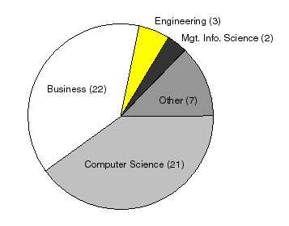
Figure 4.1: ICS 691 Student Profile

The people, who were invited to participate as consumers, were invited in part from ICS 101 classes and in part from handing out VCommerce cards. Therefore, the Internet business domain was defined in terms of the target market being college students.
The research data collected from this study includes my observations of the class throughout the semester, a mid-semester survey about the class, final presentations about lessons learned from VCommerce, and post-semester interviews. The following sections describe each data component.

    - Observations of the Class

By attending the lectures and acting as a teaching assistant, I was able to observe the students’ experience of the class, and see how the class developed as a result of using VCommerce. I held office hours where students could come by when they needed help with the web site development. I also extended my help via e-mail.
Because the lectures were broadcast via HITS and recorded on videotapes, I was also able to review all the lectures.
The VCommerce database contains valuable data about the company groups, such as product information and simulation data, which enables me to evaluate the respective efforts that were put into creating and maintaining the VCommerce businesses (see Appendix F and G).

    - University Connections Survey

The VCommerce project was supported by a grant from the University Connections at the University of Hawai‘i. Towards the end of the semester this office requested that students in ICS 691 completed a survey, which assessed the quality of the course, and how effective it was in teaching entrepreneurship concepts. I was granted permission to use the survey for my research after the semester had concluded (see Appendix B and C).

    - Lessons Learned

For the last class of the semester each company group prepared a presentation with the title Ten Things I Learned From ICS 691. These presentations present the students’ own evaluations of the class as a whole including the use of VCommerce. It also provides valuable feedback and ideas for improving future deployments (see Appendix H).

    - Post-semester Interviews

After the completion of ICS 691, I conducted fourteen post-semester interviews with students from the class to assess the effect of the class after its completion. These interviews provide insight to how VCommerce has affected students’ knowledge and interest in Internet Entrepreneurship, and how enthusiastic they are about the VCommerce (see Appendix D and E).
The interview consists of the following four parts:

- Background. Students’ experience with VCommerce is expected to vary depending on their backgrounds. For example, a business student might find it trivial to write the VCommerce business plan, but find the web development challenging.
- Knowledge of entrepreneurship before and after. This part of the interview is a quantitative assessment of how a student’s knowledge of Internet entrepreneurship has developed by taking ICS 691.
- Interest in entrepreneurship before and after. This part of the interview is a quantitative assessment of how a student’s interest in Internet entrepreneurship (i.e. starting or becoming involved in an Internet startup company) has developed as a result of ICS 691
- Overall effect of ICS 691 and VCommerce. This part of the interview is a qualitative assessment of the student’s ICS 691 and VCommerce experience.

  - Limitations

Given a limited amount time and resources to put towards this thesis, my research data is limited to the deployment of VCommerce in one course, namely ICS 691. As a result there are certain limitations to my case study, which I discuss below.

    - Control Over Subjects

There was no control over who enrolled in the class. If the case study shows an overwhelming increase in knowledge and interest in Internet entrepreneurship, it could theoretically be because all the enrolled students had an aptitude for the topic. Hence, we do not know if an increase of knowledge and interest is a result of the project, the student body, or a combination of these. Thus, we cannot predict with certainty that another class will show a similar increase in knowledge and interest.

    - Lack of Control Over Interdisciplinary Nature of Class

The evaluation of the interdisciplinary profile effect is limited, because I do not have a control group to compare with. Ideally, VCommerce should be deployed in an all business student class, and in an all computer science/engineer student class, to properly evaluate the effect of the interdisciplinary effect. The evaluation is based on the qualitative feedback provided by students who used VCommerce in an interdisciplinary class.

    - Incomplete Post-semester Data

The post-semester interviews, which make up a considerable part of my research has at least two limitations. First, the interviews were conducted with 14 out of 55 students, that is, about 25% of the class. Secondly, because I had a role in the class ad the “VCommerce mother” and TA, I developed a personal relationship with the students in the class. Therefore, it is likely that some of their answers were nicer than if a stranger had asked the same set of questions.

  - Summary

The evaluation of my thesis statements is based on the results of the ICS 691 case study described in this chapter. The research data consists of my own observations as TA and VCommerce administrator, video recordings of each lecture, an independent survey conducted by University Connections, and fourteen post-semester interviews conducted by myself. In the next chapter, I report on the results of this study.

Chapter 5

Results of Case Study

This chapter presents the results from the case study presented in Chapter 4. Section 5.1 describes my experiences and observations from the deployment of VCommerce in ICS 691. Section 5.2 presents the results from the independent student survey conducted by University Connections. Section 5.3 presents the quantitative observations and qualitative data obtained in my post-semester interviews. Finally, section 5.4 presents the results of the VCommerce Consumer Exit Questionnaires, which were completed by the “virtual” consumers during the consumer access phases.

- Observations of ICS 691

I was very involved with the ICS 691 class: I attended lectures throughout the semester, I gave two one-hour lectures about ASP and database programming, I assisted students in developing their VCommerce web sites by answering their questions via e-mail or at my office hours, and I acted as the VCommerce systems administrator and programmer. My involvement allowed me to closely monitor students’ experience with VCommerce.

  - Teaching Assistant Experience

I gave two one-hour lectures about ASP programming including database setup and programming on 28 January and 2 February, respectively. For reference purposes, VCommerce includes a very simple store called Pizza Portal, which consists of just four ASP files. In my lectures I went over the development of the Pizza Portal web site, which includes database setup, SQL queries, web interface programming and uploading the site to the VCommerce server. For homework after my first lecture, each VCommerce company used the Pizza Portal site skeleton to create their own site with a couple of visual changes that differentiated the site from the actual Pizza Portal site. After my second lecture, the students were equipped with the necessary knowledge to create their own database and VCommerce company web site.
The first set of VCommerce company web sites were completed on 14 February when we ran a test round of the VCommerce consumer access phase, which we called round zero. The consumers in round zero were the students themselves. That way, they were given a chance to test their sites, and experience what it is like to be a VCommerce consumer. In section 5.1.3, I present the lessons learned from round zero.
In the week prior to the round zero launch, company programmers were busy figuring out how to upload their web sites. Company groups without experienced HTML programmers were struggling to get their sites up and running. I received approximately fifty e-mails asking for my assistance. About half of the e-mails were administrative requests asking me to set up FTP accounts, clear account locks, create new VCommerce accounts and create data source names for their databases. The other half were specific programming questions. The most common programming problem was getting VCommerce system files integrated in their site. There are three files a company needs to use, namely include.asp (checks session state and stores a page hit), frame_script.html (checks required placement in the right frame), and purchase.asp (handles purchase transactions). The first two are included by using an include tag, and the latter is used for the action attribute of the purchase form. Although I did go through examples of how to integrate the system files, they did cause confusion with several programmers. It also seemed like some students thought they were required to have their own database since part of my second lecture went over how to set up a database for use in ASP. However, having a database other than the built-in VCommerce system database was not required.
These observations suggest that there is an initial need for detailed presentation of ASP programming, and that it is a challenge to learn even basic ASP in a matter of weeks. Therefore, more time should be allocated for the first cycle to compensate for the steep learning curve.

  - VCommerce System Data

The VCommerce Simulation System data from the deployment of VCommerce in ICS 691, which reveals the range of efforts companies put into building their VCommerce company sites, can be organized into the following six categories.

- ASP Code. The level of ASP programming ranged from having made minimal changes to the simple Pizza Portal site, to advanced backend system support applications for ease of management.
- User Interface Design. The efforts put towards site design ranged from inconsistent use of colors and very plain HTML, to beautiful designs and advanced use of HTML. Beyond this, a couple of sites added Flash to their sites.
- Companies. Twenty-three VCommerce companies were created during the semester. Seventeen companies in business cycle one, five in cycle two and one in cycle three (see Appendix F).
- Purchases. The total number of purchase transactions per company ranged from 37 to 325.
- Products and Services. The number of items sold at a VCommerce company ranged from 6 to 72 items (see Appendix G).
- Investments. The number of users that acquired stocks in a single company ranged from 11 to 75 users over the semester. The total number of stock options that were acquired from a company ranged from 41,450 to 1,754,935.

In the fourth and final consumer access phase, where the students handed out VCommerce cards to invite virtual consumers, it turned out that some students misused the cards to create successes for their own companies. I discovered the misuse because there were ranges of account numbers with a pattern matching how the cards were bundled together, each account had an invalid email address, the questionnaires had not been submitted, and all 10,000 stock options were acquired from the same company. This incidence shows that letting students hand out VCommerce invitations on their own, is not an ideal solution for inviting consumers to VCommerce.

  - “Lessons Learned from Round Zero” Data

In the February 18th lecture, following the end of round zero, students presented the lessons learned from round zero. This data can be organized in two categories, namely team management and web site programming.

- Team management
  - Need to communicate clearly within group and keep members informed.
  - Not all great ideas on paper are easy to implement and require compromises.
  - More members would be helpful.
  - Communication is really important.
  - Difficult to coordinate schedules with others.
  - Teamwork is very important.

- Web site development
  - Design sites from a user perspective and understand impacts of different browsers.
  - Steep learning curve on web page development. Start early.
  - Bugs and changes along the way are stressful.
  - Wished they could have used a stand-alone system or tool for building the web sites.
  - Having a web site that is simple to buy things from is key.
  - It is one thing to have a good idea. It is another thing to implement.

The points above show that students learned valuable lessons from the initial business cycle, which resemble the lessons any real-world Internet company might learn.

  - “Lessons Learned from ICS 691” Data

For the last lecture of the semester, April 28th, each VCommerce company group prepared a list of lessons learned from ICS 691 (see Appendix C). This section presents six points from the lists that were mentioned by nearly every group.

- Entrepreneurship. Students realized that being an Internet entrepreneur is a challenging and time consuming job, and to be successful you must have compassion and drive for your idea. One group mentions: “You must have passion and drive; entrepreneur life is not glamorous”, while another advices: “If you’re not having fun, you might as well get a real job”.

- Management. The most real aspect of the class for the students was practicing project and team management. Because the VCommerce business cycles required a combination of technical and business skills, success was dependent of how well the group’s interdisciplinary skill set was managed. Students learned the importance of teamwork, synergy among team members and good management. One student with over ten years of professional engineering project experience comments: “I think it was more real than you probably ever thought it would be”. Another group shares their experience: “We had different ideas, different personalities. We learned the art of compromising and listening; the vociferous person must listen, and the quiet person must talk”.

- Web Development. The students learned what it takes to set up an Internet business web site, and from hands-on experience, they learned many important lessons as a result of problems or lack of success. Below are some key points.
- “Maintaining and improving your web site is just as important as building the initial site”.
- “The more iterations the better. The first is definitely not the best”.
- “Planning the design is important at the beginning”.
- “Make everything as simple as possible, but not simpler”.

- Business Idea and Model. The importance of having a good business idea was obvious for the students, but they also learned the importance of creating a good business plan, which includes thorough research of the business idea and its potential for success, and deciding which business model to follow. One group asks: “Have you thought through the idea? Don’t wait to think about the next step until you have VC money”.

- Customers. An important thing the students learned, was the importance of the customer. These lessons were learned the hard way: through experience in the VCommerce consumer access phase. Below are some of their points.
- “Build a web site to attract customers, not yourself”.
- “Cut clicking steps to the point. Design to attract the target market”.
- “Understand your target market”.
- “Engage your customers; keep in touch, listen to them, build on feedback”.

- Internet Business. Students felt that they have been equipped with a broad knowledge about Internet business, and the basic skills needed to start their own Internet businesses. HTML, security, venture capital, business planning, and marketing are just a few of the skills mentioned. One group expresses with enthusiasm: “It’s independence day! VCommerce has equipped us with the basic skills we need to be Internet entrepreneurs, and it’s time to go out and apply it to the real world”. An MBA student says: “The start-to-IPO process was a reality check for me. What’s behind the scene, you don’t usually get from regular business classes”.

  - Results Beyond the Scope of the Class

Despite the virtual nature of the class, it did have some real-life effects, which suggests - along with the observations and feedback of the class – that ICS 691 and the deployment of VCommerce is a very effective way for teaching Internet entrepreneurship. Following is a list of such real effects that falls beyond the scope of the class.

- Registered domain names. There were three companies that registered their domain name.
- Garage.com submissions. Three groups submitted business plans to garage.com’s business plan competition.
- Aspect Technology Grants. Two of the four Aspect grants awarded this year came from this class. A couple of business students received a grant for their VCommerce business plan, and I received a grant for the VCommerce project.
- Venture Capital. One student has been in San Francisco seeking venture capital for a company that was deployed in VCommerce.
- Local Internet Start-ups. Two students joined local Internet start-up companies.

- University Connections Survey Results

VCommerce was made possible in part by a grant from University Connections. Therefore, University Connections sent a survey to the students towards the end of the semester to assess the impact of the project. Eight surveys were submitted, and after the end of the semester I was able to use these surveys for my research. All eight surveys were completed by graduate students, and this section presents their answers to the survey questions.

Question | Outstan-ding | Very Good | Average | Poor
Please rank the overall quality of this course. | 7 | 1 | 0 | 0

Table 5.1a: University Connections survey data: Overall quality of course answers.

Question | Highly effective | Effective | Neutral | Ineffec-tive
Please rate the overall effectiveness of guest speakers, business plan reviewers, and any other non-instructor participants in the course. | 7 | 1 | 0 | 0

Table 5.1b: University Connections survey data: Effectiveness of non-instructor participants answers.

Question | Much stronger | Somewhat stronger | About the same as before taking the course
As a result of taking this course, I believe my ability to start a successful business is... | 4 | 4 | 0

Table 5.1c: University Connections survey data: Ability to start successful business answers.

Question | Highly recommend it | Say it is somewhat helpful | Not recommend it
How would you refer this course to other people interested in entrepreneurship? | 8 | 0 | 0

Table 5.1d: University Connections survey data: How would you refer the course answers.

Question | Extremely Effective | Somewhat Effective | Not Effective
How effective was the course in helping you develop concepts for new businesses? | 5 | 3 | 0
How effective was the course in exposing you to useful business models and case studies? | 6 | 2 | 0
How effective was the course in increasing your understanding of how to conduct and/or use market research? | 4 | 4 | 0
How effective was the course in improving your ability to write effective business plans? | 6 | 2 | 0
How effective was the course in improving your ability to present business plans? | 4 | 4 | 0
How effective was the course in increasing your knowledge of Hawaii resources to help launch new businesses (e.g. capital, professional services, etc.)? | 8 | 0 | 0
How effective was the course in increasing your confidence to launch a new business? | 5 | 3 | 0
How effective was the course in introducing you to potential partners for launching a new business? | 4 | 3 | 1

Table 5.1e: University Connections survey data: Effectiveness of course answers.

The answers above clearly show the students felt the class was effective in many aspects of entrepreneurship, and in most cases a majority felt it was not only effective, but extremely effective. The overall quality of the course was clearly ranked as outstanding, and everybody would highly recommend the course to other people with an interest in entrepreneurship.

- Post-semester Interview Results

I conducted fourteen post-semester interviews with students from the class. This section presents their answers to the interview, which had three parts:

- Educational background, expertise and motivation for taking the class.
- Quantitative questions about their knowledge and interest in Internet entrepreneurship before and after the class.
- Qualitative questions about their experience of ICS 691 and VCommerce.

  - Interviewee Background and Motivation

The educational backgrounds of the interviewees are presented below. When the numbers add up to greater than fourteen, it is because several students has more than one area of expertise, and more than one motivation for taking the class.
Degrees sought | # Students
Masters Degree in Computer Science | 6
Masters Degree in Business Administration | 2
Masters Degree in Animal Science | 1
Ph.D. in Economics | 1
Ph.D. in Communication and Information Science | 1
Bachelor Degree in Computer Science | 1
None (UH faculty/staff) | 2

Table 5.2a: Post-semester interview data: Interviewees’ background: Education.

Skill and Expertise | # Students
Programming | 7
Engineering | 4
Management | 5
Finance | 2
Teaching | 2

Table 5.2b: Post-semester interview data: Interviewees’ background: Skills and expertise.

Motivation | # Students
Interest in entrepreneurship | 5
Wants financial independence | 2
Interest in web development | 3
Syllabus sounded interesting | 3
Interest in electronic commerce | 2

Table 5.2c: Post-semester interview data: Interviewees’ background: Motivation for taking ICS 691.

  - Quantitative Data

I asked the interviewees to rank their knowledge of Internet entrepreneurship aspects before and after the class on a 0-10 scale, where 0 is knowing nothing about the subject, and 10 is having a complete understanding of the subject.

Knowledge of Topic Before and After | Before (avg) | After (avg) | Difference
Internet entrepreneurship in general | 3 | 8 | +5
Business plans | 3 | 7 | +4
Stocks | 4 | 6 | +2
Venture capital | 1 | 7 | +6
Internet business models | 3 | 8 | +5
Internet technology | 5 | 8 | +3

Table 5.3a: Post-semester interview data: Knowledge of Internet entrepreneurship topics before and after.

Next, I asked the interviewees to rank their interest in Internet entrepreneurship before and after the class on a 0-10 scale, where 0 is no interest, and 10 is extreme interest.
Interest in Topic Before and After | Before (avg) | After (avg) | Difference
Internet entrepreneurship in general  (not necessarily interested in becoming an entrepreneur) | 6 | 8 | +2
Starting your own Internet business | 3 | 8 | +5
Becoming partner/co-founder of Internet startup  (idea is not yours) | 4 | 8 | +4

Table 5.3b: Post-semester interview data: Interest in Internet entrepreneurship topics before and after.

Finally, I asked the interviewees to rank how effective the course was in helping them to find out whether or not they want to pursue a career as an Internet entrepreneur. A rank of 10 means that the students are absolutely certain that they will pursue a career in Internet entrepreneurship, or they are absolutely certain that they will not. A rank of 0 means that the course was not effective in helping the student, that is, they are uncertain of their career interest as an Internet entrepreneur. The average answer was 9.

Answers | # Students
10 - Extremely effective: As a result of the course I am absolutely certain. | 5
9 | 5
8 | 1
7 | 2
6 | 0
5 | 1
4 | 0
3 | 0
2 | 0
1 | 0
0 - Not effective: I still don’t know. | 0

Table 5.3c: Post-semester interview data: Effectiveness on career interest discrimination

The numbers presented above show dramatic and consistent increases in both knowledge and interest in Internet entrepreneurship, and the final ranks are all around eight (except knowledge of stocks), which speak of very high knowledge and interest in the subject. An average higher than eight could only be expected if the interviewees had real-world entrepreneurship experience. This suggests that the effect of this course is close to the highest possible in a classroom setting.
Knowledge about stocks has the lowest increase, and the lowest final rank. This result was anticipated because stocks were not emphasized in the course. This supports the validity of the data.
The effectiveness of the course in helping students to find out if they want to be Internet entrepreneurs or not, is also very high. Ten of fourteen interviewees ranked the effectiveness as nine or ten, which indicates they are very certain, if not completely certain, of what they want. This suggests that VCommerce is capable of breaking down barriers of intimidation for starting up a business, and it makes the reality of entrepreneurship so clear to students that they know exactly what kind of lifestyle it involves (prior to success).
  - Qualitative Data

In the last part of the interview, I asked the students to tell me how they experienced ICS 691 and VCommerce, and mention one or two things they thought made the class worthwhile. Finally, I asked if they would recommend the class to other people.
When talking about the VCommerce business cycles, students clearly felt it was an extremely valuable experience. They believed they learned a lot about various aspects of Internet entrepreneurship, and felt it gave them a very good idea of how to start a new Internet business.
Group and project management was especially valuable and a very real experience according to most interviewees. They felt it was very rewarding to merge different skills and personalities, to produce a VCommerce company in such limited time.
The interviews revealed that most groups allocated work according to skill to ensure the highest possible quality of work given the short amount of time. That is, the business student would write the business plan, and computer science students would program. Although students did feel they learned a lot from the opposite disciplines, this behavior suggests that there should not be more than two business cycles in a regular semester. Ideally, there would be time for students to complete the tasks together, and thereby learn new skills. One cycle, however, would be too few, because students would then not be able to use the lessons learned to improve their business plans and web sites in a second round.
The consumer access phase where real people act as virtual consumers provided a good incentive to build a good-looking site. A computer-simulated consumer would not have been able to judge the aesthetic quality of the site. One student mentioned: “this was a real exam of your efforts”. Several groups also learned from this phase that listening to and knowing your target market is key to success. A suggestion for future classes is to capture more people from the target market to participate in the business simulation phase. Since students felt the consumer access phases were very valuable, a third consumers access phase would be good to have although there would ideally only be two full business cycles.
A couple of weaknesses about VCommerce were addressed in some of the interviews. One student felt that VCommerce is only suited for retail business models. Another person felt that as the owner of the idea in one round, she worked very long hours, while as a partner in a different company in another round, she barely did anything. This student suggests that every student should try their own idea at some point in the class. Lastly, one student’s response to the business plan writing experience, “You just write it up and submit it”, indicates that an incentive to write a good business plan is needed.
Of the aspects mentioned that made the course worthwhile, there were four things that were mentioned repeatedly.

Things that made the class worthwhile | # Students
The hands-on experience: going through the process of starting a business | 11
The guest speakers | 6
The mix of disciplines | 4
Learning ASP and related web development skills | 3

Table 5.4: Top four of the things that made the class worthwhile.

When asked if they would recommend the class to other people, everybody answered yes and most emphasized the answer with “definitely” or “absolutely”. Several interviewees were very enthusiastic about the course, and some of their comments are worth mentioning.

- UH staff with an MBA: “it’s as close to a real world situation as possible in a classroom setting”.

- Major, US Army: “I have always been interested in going into business of my own, but I had no idea of the process. VCommerce got me there”.

- Ph.D. student: “It is the only class at UH that I have taken so far where I learned something, I enjoyed it and it did not put me to sleep or was worn and tired dialog”.

- MBA student and financial analyst, Bank of Hawai‘i: “Having to develop an actual business plan and a functioning site. These were very practical assignments unlike most “academic” work I’ve had to do”.

The qualitative results presented in this section also indicate that the course was very effective, and that VCommerce in particular contributed to the effectiveness of the course. VCommerce was the number one thing that students thought made the class worthwhile, where guest speakers and the interdisciplinary mix of disciplines were number two and three, respectively.

- VCommerce Consumer Questionnaire Results

Step four of the VCommerce consumer access phase is the exit questionnaire, where the invited participants (not students in the class) are asked to rank a few aspects of the consumer experience on a 0-10 scale, where 0 is “ I completely disagree”, and 10 is “I completely agree”. Below I present the average rank of the 105 valid questionnaires that were submitted.

Question | Rank (avg)
It was easy to understand and play VCommerce | 7
I learned about Internet entrepreneurship | 5
The VCommerce companies seemed like real companies | 7
If the VCommerce companies were real, I would buy things from them | 7
Overall, it was a good experience | 8
I would like to play another round | 7
I will recommend playing VCommerce to my friends | 7

Table 5.5: VCommerce consumer exit questionnaire data.

The VCommerce consumer feedback indicates they had an overall good experience participating. Although it was not much of a learning experience, they would generally like to play another round and recommend playing to their friends.

Chapter 6

Conclusion

The goal of this thesis was to evaluate the effect of VCommerce on Internet entrepreneurship education. In this chapter, I summarize how this goal was achieved, present the research contributions, and discuss future directions. I also describe the current deployment of VCommerce at Michigan State University.

- Research Summary and Contributions

Inspired by the need to grow Hawai‘i’s high-technology industry and in partnership with Philip Johnson, I have developed the application, VCommerce, to enhance the effectiveness of entrepreneurship education at the University of Hawai‘i. VCommerce is designed to be an integral of entrepreneurship courses, which emphasize starting up Internet or other high technology businesses. The VCommerce Simulation System provides a virtual environment in which students can create virtual Internet companies, and thereby gain hands-on experiences such as identifying Internet business opportunities, writing business plans, managing interdisciplinary teams, and programming web applications. The instructor supports the VCommerce deployment with lecture topics such as Internet business models, business planning, and venture capital.
I deployed VCommerce in the Spring semester 2000 in ICS 691, Internet Entrepreneurship: Theory and Practice, where more than fifty students were enrolled. The deployment was a tremendous success, which is evident in Chapter 5, where I presented the case study results. On a personal note, I can say that I have never seen so much enthusiasm and interest in a course, as I saw in ICS 691.
I would like to think that VCommerce has and will continue to help students in Hawai‘i to learn about Internet entrepreneurship, and that VCommerce will encourage those who are highly interested in starting an Internet business to go for it. As a result, VCommerce will help grow Hawai’i’s high-tech industry to a level where our ICS graduates no longer seek mainland careers.

- VCommerce at Michigan State University

The effect of VCommerce on Internet entrepreneurship education is clear, and with the Internet becoming more and more integrated with peoples’ lives all around the world, Internet entrepreneurship education is of high interest. VCommerce has the potential of becoming a success at educational institutions worldwide and is already deployed at a second university.
This Fall 2000 semester VCommerce is deployed at Michigan State University in a graduate level accounting class taught by Dr. Brian Pentland. There are two sections with a total enrollment of 67 students from the MBA program, Accounting program and departments in the College of Engineering. Pentland has made some administrative enhancements to the system, but other than that it is the same implementation as in ICS 691. This semester, VCommerce will need to prove that it can be successful without the presence of Johnson and myself.
Pentland’s report after the conclusion of business cycle one includes the following points.

- Students created 13 VCommerce companies.
- It is not easy to get consumers to participate. An incentive such as “extra credit” for students is needed.
- Students divided the VCommerce tasks according to skills due to severe time pressure and high quality requirements (i.e. MBA students wrote the business plan while engineering students did the programming).
- Students have expressed desire for specific and detailed lectures about ASP programming.

The following figures are screen shots taken from VCommerce at Michigan State University (http://vcommerce.bus.msu.edu).

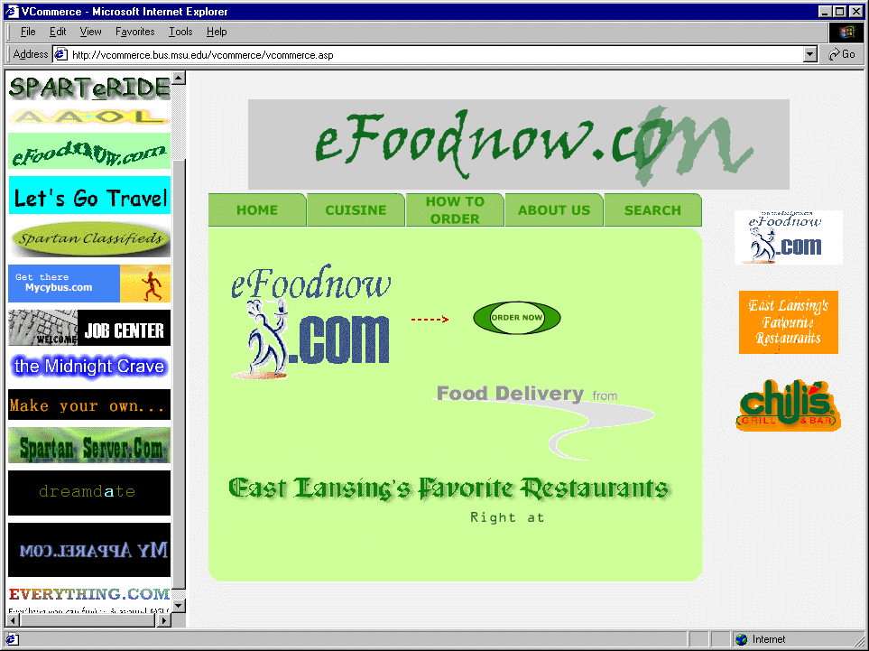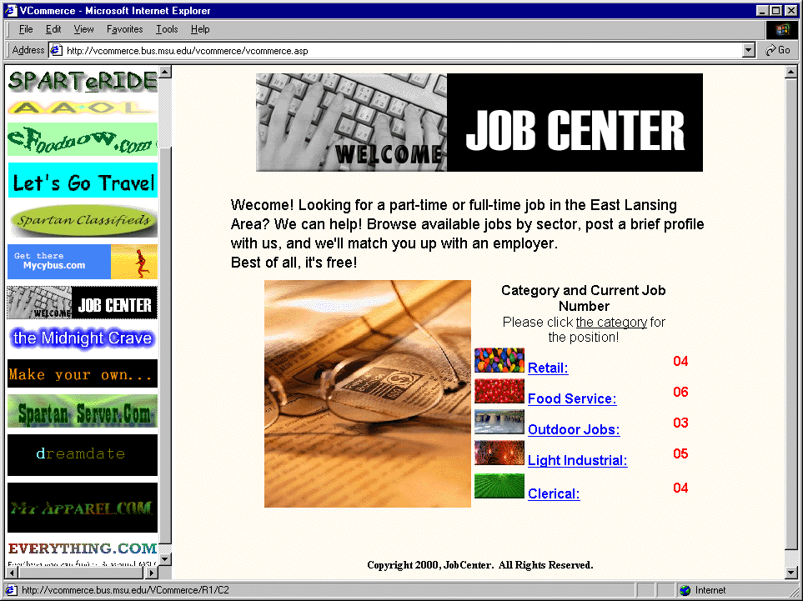
Figure 6.1: vcommerce.bus.msu.edu (eFoodnow.com). Figure 6.2: vcommerce.bus.msu.edu (Job Center).

- Future Directions

Based on student feedback and my own observations of the VCommerce deployment in ICS 691, I have ideas for fine-tuning the deployment and adjusting the VCommerce Simulation System. This section presents ideas for VCommerce’s future directions.

  - Adding a Business Plan Competition to the VCommerce Deployment

In one post-semester interview it was evident that the student thought the business plan was not important, because we did not critique the business plans and the ideas. Knowing that a solid business plan is essential if a company is going to raise venture capital, I think we need to provide an incentive for students to identify better business ideas and write business plans with a VC presentation in mind. Another student pointed out in another interview, that as the owner of the idea, you work a lot harder than in the case where the idea is someone else’s.
One possible way to address this issue is through a business plan competition in the class, where only the best ideas get virtual VC money to create a VCommerce company. Every student would be required to identify a business idea, and present an executive summary to the class. Because a complete business plan could easily take a whole semester to write, and because we want to create the VCommerce companies in the first or second week of the semester, students would only have to write the executive summary.
The students would vote for the best business ideas, and a limited number of companies win the right to become a VCommerce company based on these votes. The number of companies depends on the interdisciplinary profile. Ideally, each group should have a business student and a computer science student, who has experience writing business plans and programming, respectively. If the class is evenly split between business students and computer science students, I suggest the number of companies to be the number of students divided by three or four. Where groups larger than four could diminish the hands-on experience, groups smaller than three would most likely find the workload overwhelming, and the quality of the company could easily suffer. With three students in a group, everyone definitely has to work in order to make success happen, and it would be difficult for someone to hide from responsibilities.
The owner of an idea will automatically become the CEO, and receive credit for the success. Part of the voting process would require students to select primary and secondary companies that they would like to become co-founders of in case their idea does not make it. Because of the need to mix business and computer science students, they would only be allowed to select companies owned by students with the opposite background.

  - From Consumer Purchasing to Consumer Testing

The consumer access phase is clearly problematic in the sense that it is extremely difficult to incentivize the consumer participants to behave like real consumers. The statistics for hits and purchase transactions was therefore of limited value. However, having real people looking at the sites, gave the students an incentive to make their sites nice, which would not be the case of a computer simulated consumer phase, which we did consider. Therefore, there is no question that real users are here to stay, but we could change the way real users are applied to the simulation.
Being a co-founder and web developer of an Internet start-up company, I have learned the importance of user testing, and that your target market’s opinion is more important that your own when it comes to web site design and functionality. Therefore, one possible improvement is to change the “consumer shopping phase” to “user testing phase”. VCommerce participants would not enter VCommerce with virtual shopping in mind, but with testing and evaluation in mind. Instead of spending virtual money, users would be asked to rate the business idea, site design and site functionality. This data would be extremely useful for the companies.
Company owners themselves would be responsible for user recruiting by handing out VCommerce account cards as we did in ICS 691. Prior to the user recruiting, there should be a lecture about user testing, which would emphasize the importance of user testing, and that the most valuable feedback comes from users with complete objectivity. With that message in the company owners mind, the “cheating” problem is unlikely to occur. Students will most likely not go out and encourage their friends to rate their company high, because that would yield useless results.
This idea does take away some of the competitive spirit that occurred as a result of the simulation, but it is actually just shifted to the business plan competition, which is more realistic and less susceptible to cheating.

  - From ASP to WYSIWYG

There was clearly a learning curve for students to implement their web sites using ASP, because ASP requires one to hardcode HTML, and there were only a few students who knew HTML. With the limited time given to create the VCommerce companies, it would better if the sites do not have to consist of ASP pages. That way, students unfamiliar with HTML, can use WYSIWYG editors such as Microsoft FrontPage and Macromedia Dreamweaver.
Making use ASP pages optional would require a different mechanism to track page hits and user sessions. This is not a difficult change, because the web server log can be configured to store the information needed for tracking page hits as long as the web pages are on the same server, and user sessions will only be needed to track when the user interacts with VCommerce system pages when submitting ratings and evaluations, and those will of course will remain ASP pages.
  - Moving Away from Frames

An idea for adjusting the VCommerce environment is to make the central site more like a search engine site like Yahoo! where users can search and browse categories of interest, and where companies can display adds. When a user chose to visit a company, the company sites would be loaded in a new window over the central VCommerce site. This not only eliminates the problems that are involved with using frames, but it also gives the company site the entire window for their pages, which is more like a real world Internet company site. Another advantage to the adjustments suggested above is the fact that the VCommerce sites can more easily be moved to another web-server.

  - Improving the VCommerce Administration Interfaces

The biggest problem about VCommerce as it exists, is its dependence on a system administrator who knows ASP programming. The administrative tasks that are needed to set up and run VCommerce, are tasks such as adding and editing user accounts, adding and editing companies, generating statistics, compiling results, sending newsletters, and starting and ending business cycles. The VCommerce Administration interfaces for instructors and company owners are currently minimal due to the short implementation period. It would not be difficult to implement support for a range of administrative tasks such as those mentioned above. That way instructors and TAs can administrate VCommerce without knowledge of ASP.

  - From ASP to JSP

Right about the time when I had completed the implementation of VCommerce using ASP, Sun introduced JSP (Java Server Pages). I have recently researched the pros and cons of the two competing technologies, in an attempt to answer the question: which is better ASP or JSP. The conclusion I reached was: “it depends..." For a small web application with relatively low simultaneous usage, ASP is a better solutions because the learning curve and setup requirements is very small compared to JSP, and there is very little or no performance gain. However, for a web application that needs to be scalable and perform well with hundreds of simultaneous users, JSP is definitely the answer for several reasons:

- JSP is platform independent.
- JSP is very scalable
- JSP is free

If VCommerce is going to run from one server, that is, having other universities user a central VCommerce Server as opposed to running their own server, then VCommerce will need a platform with better performance than Internet Information Server and ASP, and JSP is an attractive alternative.

- Conclusions

At the end of the last ICS 691 lecture, Johnson concluded the semester by saying: “This is the most successful class I have ever taught”. This comment along with the ICS 691 student feedback presented in this thesis, and the practical results that came as a result of the class, clearly show that there is a tremendous student interest in the topic Internet Entrepreneurship, and that VCommerce is a very successful teaching tool to support entrepreneurial learning.
Part of the ICS 691 success is due to the fact that the enrollment was interdisciplinary. Business students and computer science students worked together building virtual Internet start-ups, just as they will, if they ever start Internet companies on their own. It seems very obvious that this approach is effective. However, interdisciplinary enrollment is not commonly seen in entrepreneurship classes due to restricted enrollment policies or prerequisites.
VCommerce provides an environment where students get hands-on experience building Internet businesses. There is currently no competing product on the market, which is similar to VCommerce. The closest competitors are simulations that focus on running predefined businesses, and where success is defined in terms of financial decisions. VCommerce lets students be creative by letting them identify their own Internet business ideas and implement them. Success is not measured in terms of expenditures and revenues, but in terms of how popular the site was with visiting consumers.
Probably the most significant aspect of VCommerce is the fact that students feel the exercise is very realistic, and as a result VCommerce becomes a catalyst the entrepreneurial spirit. As shown in Chapter 5, ICS 691 is one example of how VCommerce simulations can be used to transfer knowledge to actual applications.

Appendix A

Sample VCommerce Business Plan



Figure A.1 Pizza Portal Business Plan Cover

Appendix B

University Connections Survey

University Connections Entrepreneurship Course Student Survey

The entrepreneurship course you are taking was made possible in part by a grant from University Connections. In order to assess the impact of this new grant program and refine it for future years, please give us your feedback on this course by answering the following questions.

Course Title___________________________________________________________________________

1. What is your current student status?

- Undergraduate Student
Indicate degree sought:  Associate  Bachelors  Other_________________
Indicate major field of study:________________________________________

- Graduate student
Indicate degree sought:  Masters  Doctorate  Other__________________

Indicate major field of study:________________________________________

- Continuing Education student
- Other (please specify)_____________________________________

2. Please list any educational degrees or certificates you have already received

3. Please indicate your previous business experience upon entering this course
(Check all that apply)
- a. I have no formal business training or experience
- b. I have taken one or more post-secondary school business courses
- c. I have worked in business but not in a management capacity
 d. I have management experience with one or more businesses

4. Please rank the overall quality of this course
 a. Outstanding
 b. Very Good
 c. Average
 d. Poor

5. As a result of taking this course, I believe my ability to start a successful business is…
 a. Much stronger
 b. Somewhat stronger
 c. About the same as before taking the course

6. Please rate how effective the course was in each of the following areas
(use the following scale: 1 = Extremely effective; 2 = Somewhat effective;
3 = Not effective)

- Helping you develop concepts for new businesses (____)
- Exposing you to useful business models and case studies (____)
- Increasing your understanding of how to conduct and/or use market research (____)
- Improving your ability to write effective business plans (____)
- Improving your ability to present business plans (____)
- Increasing your knowledge of Hawaii resources to help launch new businesses (e.g. capital, professional services, etc.) (____)
- Increasing your confidence to launch a new business (____)
- Introducing you to potential partners for launching a new business (____)

7. Please rate the overall effectiveness of guest speakers, business plan reviewers, and any other non-instructor participants in the course:
 a. Highly Effective
 b. Effective
 c. Neutral - did not add or subtract significantly from course quality
 d. Ineffective

8. How would you refer this course to other people interested in entrepreneurship?
 a. I would highly recommend it
 b. I would say it is somewhat helpful
 c. I would not recommend it

Appendix C

Raw University Connections Survey Data

Student 1

1. What is your current student status?

- Undergraduate Student
Indicate degree sought:  Associate  Bachelors  Other_________________
Indicate major field of study:________________________________________

 Graduate student
Indicate degree sought:  Masters  Doctorate  Other__________________
Indicate major field of study: Business Administration

- Continuing Education student
- Other (please specify)_____________________________________

2. Please list any educational degrees or certificates you have already received
B.S. in Travel Industry Management; Associate degree in Liberal Arts

3. Please indicate your previous business experience upon entering this course
(Check all that apply)
- a. I have no formal business training or experience
 b. I have taken one or more post-secondary school business courses
 c. I have worked in business but not in a management capacity
 d. I have management experience with one or more businesses

4. Please rank the overall quality of this course
 a. Outstanding
 b. Very Good
 c. Average
 d. Poor

5. As a result of taking this course, I believe my ability to start a successful business is…
 a. Much stronger
 b. Somewhat stronger
 c. About the same as before taking the course

6. Please rate how effective the course was in each of the following areas
(use the following scale: 1 = Extremely effective; 2 = Somewhat effective;
3 = Not effective)

- Helping you develop concepts for new businesses (__2__)
- Exposing you to useful business models and case studies (__2__)
- Increasing your understanding of how to conduct and/or use market research (__2__)
- Improving your ability to write effective business plans (__1__)
- Improving your ability to present business plans (__2__)
- Increasing your knowledge of Hawaii resources to help launch new businesses (e.g. capital, professional services, etc.) (__1__)
- Increasing your confidence to launch a new business (__2__)
- Introducing you to potential partners for launching a new business (__2__)

7. Please rate the overall effectiveness of guest speakers, business plan reviewers, and any other non-instructor participants in the course:
 a. Highly Effective
 b. Effective
 c. Neutral - did not add or subtract significantly from course quality
 d. Ineffective

8. How would you refer this course to other people interested in entrepreneurship?
 a. I would highly recommend it
 b. I would say it is somewhat helpful
 c. I would not recommend it

Student 2

1. What is your current student status?

- Undergraduate Student
Indicate degree sought:  Associate  Bachelors  Other_________________
Indicate major field of study:________________________________________

X Graduate student
Indicate degree sought: X Masters  Doctorate  Other__________________
Indicate major field of study:________________________________________

- Continuing Education student
- Other (please specify)_____________________________________

2. Please list any educational degrees or certificates you have already received
BSEE

3. Please indicate your previous business experience upon entering this course
(Check all that apply)
X a. I have no formal business training or experience
- b. I have taken one or more post-secondary school business courses
- c. I have worked in business but not in a management capacity
 d. I have management experience with one or more businesses

4. Please rank the overall quality of this course
X a. Outstanding
 b. Very Good
 c. Average
 d. Poor

5. As a result of taking this course, I believe my ability to start a successful business is…
 a. Much stronger
X b. Somewhat stronger
 c. About the same as before taking the course

6. Please rate how effective the course was in each of the following areas
(use the following scale: 1 = Extremely effective; 2 = Somewhat effective;
3 = Not effective)

- Helping you develop concepts for new businesses (__2_)
- Exposing you to useful business models and case studies (__1_)
- Increasing your understanding of how to conduct and/or use market research (__1_)
- Improving your ability to write effective business plans (__1_)
- Improving your ability to present business plans (__1_)
- Increasing your knowledge of Hawaii resources to help launch new businesses (e.g. capital, professional services, etc.) (__1_)
- Increasing your confidence to launch a new business (_2__)
- Introducing you to potential partners for launching a new business (__3_)

7. Please rate the overall effectiveness of guest speakers, business plan reviewers, and any other non-instructor participants in the course:
X a. Highly Effective
 b. Effective
 c. Neutral - did not add or subtract significantly from course quality
 d. Ineffective

8. How would you refer this course to other people interested in entrepreneurship?
X a. I would highly recommend it
 b. I would say it is somewhat helpful
 c. I would not recommend it

Student 3

1. What is your current student status?

Graduate student Doctorate CIS

2. Please list any educational degrees or certificates you have already received
BA POLSCI, MSIS

3. Please indicate your previous business experience upon entering this course
United States Navy 18 years

4. Please rank the overall quality of this course
Outstanding

5. As a result of taking this course, I believe my ability to start a successful business is…
Much stronger

6. Please rate how effective the course was in each of the following areas
(use the following scale: 1 = Extremely effective; 2 = Somewhat effective;
3 = Not effective)

- Helping you develop concepts for new businesses (_1___)
- Exposing you to useful business models and case studies (_1___)
- Increasing your understanding of how to conduct and/or use market research (_2___)
- Improving your ability to write effective business plans (_1___)
- Improving your ability to present business plans (__2__)
- Increasing your knowledge of Hawaii resources to help launch new businesses (e.g. capital, professional services, etc.) (__1__)
- Increasing your confidence to launch a new business (__1__)
- Introducing you to potential partners for launching a new business (__1__)

7. Please rate the overall effectiveness of guest speakers, business plan reviewers, and any other non-instructor participants in the course:
Highly Effective. That was the best thing about this course. Phillip Johnson is the most outstanding instructor I have ever seen!! Have him teach more classes ASAP!!!

8. How would you refer this course to other people interested in entrepreneurship?
I would highly recommend it

Student 4

1. What is your current student status?

- Undergraduate Student
Indicate degree sought:  Associate  Bachelors  Other_________________
Indicate major field of study:________________________________________

- Graduate student (X)
Indicate degree sought: X  Masters  Doctorate  Other__________________
Indicate major field of study:________________________________________

- Continuing Education student
- Other (please specify)_____________________________________

2. Please list any educational degrees or certificates you have already received
MS, BS

3. Please indicate your previous business experience upon entering this course
(Check all that apply)
- a. I have no formal business training or experience
- b. I have taken one or more post-secondary school business courses
- c. I have worked in business but not in a management capacity
X d. I have management experience with one or more businesses

4. Please rank the overall quality of this course
X a. Outstanding
 b. Very Good
 c. Average
 d. Poor

5. As a result of taking this course, I believe my ability to start a successful business is…
X a. Much stronger
 b. Somewhat stronger
 c. About the same as before taking the course

6. Please rate how effective the course was in each of the following areas
(use the following scale: 1 = Extremely effective; 2 = Somewhat effective;
3 = Not effective)

- Helping you develop concepts for new businesses (_1__)
- Exposing you to useful business models and case studies (__1__)
- Increasing your understanding of how to conduct and/or use market research (_1___)
- Improving your ability to write effective business plans (__2__)
- Improving your ability to present business plans (_2__)
- Increasing your knowledge of Hawaii resources to help launch new businesses (e.g. capital, professional services, etc.) (__1__)
- Increasing your confidence to launch a new business (_1__)
- Introducing you to potential partners for launching a new business (__1__)

7. Please rate the overall effectiveness of guest speakers, business plan reviewers, and any other non-instructor participants in the course:
X a. Highly Effective
 b. Effective
 c. Neutral - did not add or subtract significantly from course quality
 d. Ineffective

8. How would you refer this course to other people interested in entrepreneurship?
X a. I would highly recommend it
 b. I would say it is somewhat helpful
 c. I would not recommend it

Student 5

1. What is your current student status?

- Undergraduate Student
Indicate degree sought:  Associate  Bachelors  Other_________________
Indicate major field of study:________________________________________

- X Graduate student
Indicate degree sought: X Masters  Doctorate  Other__________________
Indicate major field of study:________________________________________

- Continuing Education student
- Other (please specify)_____________________________________

2. Please list any educational degrees or certificates you have already received
BS, United States Military Academy, 1985

3. Please indicate your previous business experience upon entering this course
(Check all that apply)
- X a. I have no formal business training or experience
- b. I have taken one or more post-secondary school business courses
- c. I have worked in business but not in a management capacity
 d. I have management experience with one or more businesses

4. Please rank the overall quality of this course
 X a. Outstanding
 b. Very Good
 c. Average
 d. Poor

5. As a result of taking this course, I believe my ability to start a successful business is…
 X a. Much stronger
 b. Somewhat stronger
 c. About the same as before taking the course

6. Please rate how effective the course was in each of the following areas
(use the following scale: 1 = Extremely effective; 2 = Somewhat effective;
3 = Not effective)

- Helping you develop concepts for new businesses (__1__)
- Exposing you to useful business models and case studies (__1__)
- Increasing your understanding of how to conduct and/or use market research (_1___)
- Improving your ability to write effective business plans (_1___)
- Improving your ability to present business plans (__1__)
- Increasing your knowledge of Hawaii resources to help launch new businesses (e.g. capital, professional services, etc.) (_1___)
- Increasing your confidence to launch a new business (__1__)
- Introducing you to potential partners for launching a new business (__2__)

7. Please rate the overall effectiveness of guest speakers, business plan reviewers, and any other non-instructor participants in the course:
 X a. Highly Effective
 b. Effective
 c. Neutral - did not add or subtract significantly from course quality
 d. Ineffective

8. How would you refer this course to other people interested in entrepreneurship?
 X a. I have would highly recommended it
 b. I would say it is somewhat helpful
 c. I would not recommend it

Student 6

1. What is your current student status?

- Undergraduate Student
Indicate degree sought:  Associate  Bachelors  Other_________________
Indicate major field of study:________________________________________

- Graduate student
Indicate degree sought:  Masters  Doctorate  Other__________________
Indicate major field of study:____TIM Travel Industry Management

- Continuing Education student
- Other (please specify)_____________________________________

2. Please list any educational degrees or certificates you have already received
PAMI

3. Please indicate your previous business experience upon entering this course
(Check all that apply)
- a. I have no formal business training or experience
- b. I have taken one or more post-secondary school business courses
- c. I have worked in business but not in a management capacity
 d. I have management experience with one or more businesses

4. Please rank the overall quality of this course
 a. Outstanding
 b. Very Good
 c. Average
 d. Poor

5. As a result of taking this course, I believe my ability to start a successful business is…
 a. Much stronger
 b. Somewhat stronger
 c. About the same as before taking the course

6. Please rate how effective the course was in each of the following areas
(use the following scale: 1 = Extremely effective; 2 = Somewhat effective;
3 = Not effective)

- Helping you develop concepts for new businesses (__2__)
- Exposing you to useful business models and case studies (__2__)
- Increasing your understanding of how to conduct and/or use market research (_2___)
- Improving your ability to write effective business plans (__1__)
- Improving your ability to present business plans (__1__)
- Increasing your knowledge of Hawaii resources to help launch new businesses (e.g. capital, professional services, etc.) (__1__)
- Increasing your confidence to launch a new business (__1__)
- Introducing you to potential partners for launching a new business (__2__)

7. Please rate the overall effectiveness of guest speakers, business plan reviewers, and any other non-instructor participants in the course:
 a. Highly Effective
 b. Effective
 c. Neutral - did not add or subtract significantly from course quality
 d. Ineffective

8. How would you refer this course to other people interested in entrepreneurship?
 a. I would highly recommend it
 b. I would say it is somewhat helpful
 c. I would not recommend it

Student 7

1. What is your current student status?

- Undergraduate Student
Indicate degree sought:  Associate  Bachelors  Other_________________
Indicate major field of study:________________________________________

- Graduate student
Indicate degree sought:  Masters  Doctorate  Other__________________

Indicate major field of study:____ MBA Masters in Business Administration _______

- Continuing Education student
- Other (please specify)_____________________________________

2. Please list any educational degrees or certificates you have already received

3. Please indicate your previous business experience upon entering this course
(Check all that apply)
- a. I have no formal business training or experience
- b. I have taken one or more post-secondary school business courses
- c. I have worked in business but not in a management capacity
- d. I have management experience with one or more businesses

4. Please rank the overall quality of this course
- a. Outstanding
- b. Very Good
- c. Average
- d. Poor

5. As a result of taking this course, I believe my ability to start a successful business is…
- a. Much stronger
- b. Somewhat stronger
- c. About the same as before taking the course

6. Please rate how effective the course was in each of the following areas
(use the following scale: 1 = Extremely effective; 2 = Somewhat effective;
3 = Not effective)

- Helping you develop concepts for new businesses (__1__)
- Exposing you to useful business models and case studies (__1__)
- Increasing your understanding of how to conduct and/or use market research (__2__)
- Improving your ability to write effective business plans (__2__)
- Improving your ability to present business plans (__2__)
- Increasing your knowledge of Hawaii resources to help launch new businesses (e.g. capital, professional services, etc.) (__1__)
- Increasing your confidence to launch a new business (__2__)
- Introducing you to potential partners for launching a new business (__1__)

7. Please rate the overall effectiveness of guest speakers, business plan reviewers, and any other non-instructor participants in the course:
- a. Highly Effective
- b. Effective
- c. Neutral - did not add or subtract significantly from course quality
- d. Ineffective

8. How would you refer this course to other people interested in entrepreneurship?
- a. I would highly recommend it
- b. I would say it is somewhat helpful
- c. I would not recommend it

COMMENTS:

This course was very good and I would highly recommend it to others. Mr. Johnson and Mette especially put a lot of effort into this course and turned out very well. I hope that this class continues to be offered and that more like this will be available in the future. It was a real nice blend of the academic along with real world similarities.

Student 8

1. What is your current student status?

- Undergraduate Student
Indicate degree sought:  Associate  Bachelors  Other_________________
Indicate major field of study:________________________________________

- Graduate student
Indicate degree sought: X Masters  Doctorate  Other__________________
Indicate major field of study:_Library and Information Science__________________________

- Continuing Education student
- Other (please specify)_____________________________________

2. Please list any educational degrees or certificates you have already received
Bachelor of Arts, Business Administration

3. Please indicate your previous business experience upon entering this course
(Check all that apply)
- a. I have no formal business training or experience
- b. I have taken one or more post-secondary school business courses
- c. I have worked in business but not in a management capacity
X d. I have management experience with one or more businesses

4. Please rank the overall quality of this course
X a. Outstanding
 b. Very Good
 c. Average
 d. Poor

5. As a result of taking this course, I believe my ability to start a successful business is…
X a. Much stronger
 b. Somewhat stronger
 c. About the same as before taking the course

6. Please rate how effective the course was in each of the following areas
(use the following scale: 1 = Extremely effective; 2 = Somewhat effective;
3 = Not effective)

- Helping you develop concepts for new businesses (__1__)
- Exposing you to useful business models and case studies (_1___)
- Increasing your understanding of how to conduct and/or use market research (_1___)
- Improving your ability to write effective business plans (_1___)
- Improving your ability to present business plans (__1__)
- Increasing your knowledge of Hawaii resources to help launch new businesses (e.g. capital, professional services, etc.) (_1___)
- Increasing your confidence to launch a new business (_1___)
- Introducing you to potential partners for launching a new business (__1__)

7. Please rate the overall effectiveness of guest speakers, business plan reviewers, and any other non-instructor participants in the course:
X a. Highly Effective
 b. Effective
 c. Neutral - did not add or subtract significantly from course quality
 d. Ineffective

8. How would you refer this course to other people interested in entrepreneurship?
X a. I would highly recommend it
 b. I would say it is somewhat helpful
 c. I would not recommend it

Comments:
This course epitomizes the very reason I returned to graduate school. I was seeking a mental challenge and competitive skills. I now know how to create animated graphics, write a business plan, build e-commerce businesses, and conduct market research within the state of Hawaii. As a result of taking this course, I published an interview with one of the guest speakers; I helped draft a business plan for a legal software program, and I helped draft a proposal for a technology & tourism grant on the Big Island. A new goal is to soon join the Hawaii Technology Trade Association.

Dr. Johnson's vast knowledge and enthusiasm for entrepreneurialism is obvious. He motivated us by challenge, stimulation, feedback, and praise. He encouraged group interaction with our classmates. Teamwork is just one of the valuable lessons I've taken from this class and intend to apply in my entrepreneurial pursuits.

I hope that you'll expand the course offerings for entrepreneurial topics. I hope you'll continue to make them accessible to outer island students via HITs or the Internet.

Mahalo!

Appendix D

VCommerce Post-semester Interview

I used the following questions when I conducted the post-semester interviews. The questions, which are both quantitative and qualitative, fall into three sections, namely background information, knowledge and interest of Internet entrepreneurship, and ICS 691 and the VCommerce experience.

VCommerce Post-semester Interview

The purpose of this interview is to assess the effect of ICS691: Internet Entrepreneurship: Theory and Practice and the deployment of VCommerce in this class.

ICS 691 Student: Date:

Background

- Education (earned degree(s), current program/major)?
Answer:

- Type(s) of job experience, if any (e.g. programming, management, etc)?
Answer:

- Area(s) of expertise, if any?
Answer:

- Motivation for taking ICS 691?
Answer:

Knowledge of Internet entrepreneurship: before and after the class

- Rate your knowledge of Internet entrepreneurship in general (startup process, stocks, raising venture capital, business plan, marketing, Internet technologies) before and after taking ICS 691:
Scale: 0 = Knew nothing about the topic. 10 = Fully understood the topic.

Before: After:

- Rate your ability to write a business plan before and after taking ICS 691:
Scale: 0 = Never written a business plan. 10 = Very experienced writing business plans.

Before: After:

- Rate your knowledge of stocks before and after taking ICS 691:
Scale: 0 = Knew nothing about stocks. 10 = Knew everything about stocks.

Before: After:

- Rate your knowledge of how to raise venture capital before and after taking ICS 691:
Scale: 0 = Knew nothing about raising venture capital. 10 = Knew everything about raising venture capital.

Before: After:

- Rate your knowledge of Internet business models before and after taking ICS 691:
Scale: 0 = Knew nothing about Internet business models. 10 = Knew everything about Internet business models.

Before: After:

- Rate your knowledge Internet technologies (HTML, ASP, web-servers, databases, graphics, flash) before and after taking ICS 691:
Scale: 0 = Knew nothing about Internet technologies. 10 = Knew everything about Internet technologies.

Before: After:

Interest in entrepreneurship: before and after

- Rate your curiosity about Internet entrepreneurship before and after taking ICS 691:
Scale: 0 = Did not care about Internet entrepreneurship. 10 = Very interested in Internet entrepreneurship.

Before: After:

- Rate your interest in starting your own Internet business before and after taking ICS 691:
Scale: 0 = Never going to start my own Internet business. 10 = Definitely going to start my own Internet business.

Before: After:

- Rate your interest in becoming a co-founder or partner of an Internet business, where the idea is not yours, and you do not invest any money, before and after taking ICS 691.
Scale: 0 = I would never become a co-founder or partner. 10 = I would definitely become a co-founder or partner given the opportunity.

Before: After:

VCommerce - hands-on experience with Internet entrepreneurship

- How did the VCommerce business cycles contribute to your understanding and interest of Internet entrepreneurship?

Explain:

- How did you experience phase 1: coming up with a business idea?

Explain:

- How did you experience phase 2: writing the business plan?

Explain:

- How did you experience phase 3: developing the VCommerce web site?

Explain:

- How did you experience phase 4: customer simulation?

Explain:

Effect of the interdisciplinary profile

1. How did you experience the interdisciplinary profile of the class?

Explain:

2. How did your group manage and make use of the skill set each person came with?

Explain:

The overall effect of the ICS 691 class:

- Rate the overall effect of ICS 691:
Scale: 0 = I still don’t know if Internet entrepreneurship is something for me or not. 10 = I now know that Internet entrepreneurship is definitely something for me or not? (Underline “for me” or “not” depending on which it is)

Answer:

- Mention two things that made the class worthwhile, if any.

#1:

#2:

- If ICS 691: Internet Entrepreneurship: Theory and Practice is taught again would you recommend it to other people:
1 = definitely not. 2 = I don’t think so. 3 = I think so. 4 = definitely.

Answer:

Appendix E

Raw Post-semester Interview Data

I taped the post-semester interviews while conducting them, and transcribed them afterwards. The following tables consist of the raw data after transcribing all the interviews.

Questions | Answers
Background | - ICS major, undergrad  - Technical: programming, web app dev, graphics
Motivation | - Wants to be rich and popular
Knowledge 1 | 3 – 8 (+5)
Knowledge 2 | 0 – 5 (+5)
Knowledge 3 | 4 – 6 (+2)
Knowledge 4 | 2 – 7 (+5)
Knowledge 5 | 4 – 8 (+5)
Knowledge 6 | 7 – 8 (+1)
Interest 1 | 8 – 8 (0)
Interest 2 | 8 – 10 (+2)
Interest 3 | 5 – 9 (+4)
VCommerce 1 | Helped understanding of how a internet company works in the real world though practical parts: really had to create the web site, dealt with real customers. “Did things that real companies do”
VCommerce 2a | First round: had no say because team members already had an idea.  Second round with a new team: really liked to come up with an idea and be innovative
VCommerce 2b | R1: business team members did it, only looked at it  R2: another team member did it, he did programming.  Note: Felt that the bizplan was not important at all. “you just write it up and submit it”, because there were no consequence to a bad bizplan, as opposed to a bad web site. Agrees to my suggestion that bizplans should be evaluated and money should be given accordingly.
VCommerce 2c | Did the programming and learned a lot.
VCommerce 2d
Interdisciplinary 1 | One of favorite classes because there was people from different disciplines. When you are only taking classes in your dept. you are surrounded by people with similar visions and perspective, whereas this class exposed you to people with different sets of eyes. Enjoys running in to people across campus from the class (mentioned student from agriculture).
Interdisciplinary 2 | They split up work according to skill and did not take advantage of cross-training opportunity.  Noticed that business students in his groups did not learn programming, relied solely on ICS students.
Overall 1 | 9 (for)
Overall 2 | #1 the experience; learning the process of starting an e-commerce company; learning what entrepreneur is about;  #2 the interaction with other disciplines; ages; levels of profession
Overall 3 | 4 - Definitely. “Absolutely”.

Table E.1: Answers to post-semester interview (student 1)

Questions | Answers
Background | - BA MIS UW Seattle, currently working on MBA  - Technical: programming
Motivation | - Interested in ICS program, and this class sounded interesting: simulation
Knowledge 1 | 5-8 (+3)
Knowledge 2 | 8-9 (+1)
Knowledge 3 | 9-9 (0)
Knowledge 4 | 2-8 (+6)
Knowledge 5 | 7-9 (2)
Knowledge 6 | 10-10 (0)
Interest 1 | 6-7 (+1)
Interest 2 | 8-8 (0)
Interest 3 | 5-6 (+1)
VCommerce 1 | Helped to be in there actually doing it.
VCommerce 2a | Hardest part. It’s useful having to think it out. Disadvantage: the application is only suited for retail, and a lot of good web sites are not retail sites.
VCommerce 2b | “A pain”. It was worthwhile to do, and the template was good.
VCommerce 2c | Did do any programming, despite he works with ASP for a living. Duy wanted to learn ASP, so Ryan just helped out a bit with graphics. Very real because there was pressure to integrate a lot in a very short time.
VCommerce 2d | Rounds should’ve been spaced out; have less; last should’ve been longer. Round zero was good to have. Daily reports and stock values was good.
Interdisciplinary 1 | Group was pretty well mixed. It seemed real in the sense that technical people were dependent and could make use of business students to write business plans, and the other way around for programming tasks.
Interdisciplinary 2 | They spilt up the work according to interest and what they wanted to do -- not based on skills/ability. Duy wanted to program, Ester was interested in programming and picked up a bit, but mainly she took care of marketing, Ryan was the “check and balance”.
Overall 1 | 7 (for)
Overall 2 | #1 The mix of disciplines (“cross-disciplanary; that was key; #1 thing”)  #2 Guest speakers
Overall 3 | 4 - Definitely. “Yeah, totally”.

Table E.2: Answers to post-semester interview (student 2)

Questions | Answers
Background | - College: physics emphasis, current: MS ICS  - Major in Army, simulation officer, management experience
Motivation | - to learn how to do stuff on the web
Knowledge 1 | 1 – 8 (+7)
Knowledge 2 | 1 – 8 (+7)
Knowledge 3 | 1 – 6 (+5)
Knowledge 4 | 0 – 8 (+8)
Knowledge 5 | 1 – 9 (+8)
Knowledge 6 | 0 – 9 (+9)
Interest 1 | 6 – 9 (+3)
Interest 2 | 1 – 9 (+8)
Interest 3 | 1 – 10 (+9)
VCommerce 1 | Always interested in going into business on his own, but had no idea of the process. VCommerce got him there; to understand the business and technical process of starting a business.
VCommerce 2a | R1: liked the process of innovation, but the didn’t like the idea the company came up with – real management conflicts. But, acted as a team player: 3 members, 3 ideas -> real world decision making process.
VCommerce 2b | Delegated part of the business plan, shared the work, learned from business person
VCommerce 2c | New to programming, learned a lot from the web programming. Learning from the open source environment was a great help to get things done in a limited amount of time.
VCommerce 2d | “The simulation was fabulous”, cool for company owners and for shopping participants. Daily reports were good; valuation of companies where interesting; provided incentive.
Interdisciplinary 1 | It was good, because when you go into business you need expertise in a lot of areas, and this class introduced you how to work with two sets of expertise: the business perspective and a technical perspecive
Interdisciplinary 2 | The took advantage of cross-training opportunity: Each group member wrote a portion of the business plan. Steve (MBA) wrote some HTML. Good opportunity.
Overall 1 | 10 (for)
Overall 2 | #1 The hands-on practice – doing a web site, writing a business plan, dealing with real consumers for real  #2 Working in interdisciplinary teams, and more than one: group presentations and company groups
Overall 3 | 4 - Definitely . “I already have”.

Table E.3: Answers to post-semester interview (student 3)

Questions | Answers
Background | - Earned: BS computer science. Currently: MS ICS  - technical: programming and computer systems
Motivation | - wants to make good money; read course description in fall 99 while in India and thought it sounded amazing
Knowledge 1 | 0 – 7 (+7)
Knowledge 2 | 0 – 6 (+6)
Knowledge 3 | 3 – 6 (+3)
Knowledge 4 | 0 – 7 (+7)
Knowledge 5 | 2 – 6 (+4)
Knowledge 6 | 3 – 7 (+4)
Interest 1 | 8 – 10 (+2)
Interest 2 | 8 – 10 (+2)
Interest 3 | 6 – 8 (+2)
VCommerce 1 | Contributed a lot, learned many aspects of starting a business
VCommerce 2a | Tough, have to think a lot and do a lot of research, and sometime you find that your idea has already been done.
VCommerce 2b | R1: with business people; didn’t learn anything  R2: alone; learn a lot, challenging
VCommerce 2c | Learned a lot: it seemed easy, but realized how much work it was
VCommerce 2d | Most exciting part: competitive spirit, went in and tried to improve the site to attract customers.
Interdisciplinary 1 | This was the greatest thing. If it had been a pure cs plan, we couldn’t have learned from business students how to write business plans, and they couldn’t have created the web-sites.
Interdisciplinary 2 | R1: Teammates just wanted to split the work to get the work done the easiest way possible. They were not interested in the technical, and didn’t share the business plan writing aspect very much.  R2: alone
Overall 1 | 10 (for)
Overall 2 | #1 the opportunity to work with students from other disciplines and the opportunity to work with business innovation and planning, inspired Jitender to form a group to write a business plan to garage.com  #2 there was so much good learning in the course
Overall 3 | 4 - Definitely

Table E.4: Answers to post-semester interview (student 4)

Questions | Answers
Background | - Earned: Ph.D. Political Science, Certificate in International Entrepreneurship  - Teaching political science (professor at UH). Political science, political economy expertise
Motivation | - Interest in entrepreneurship, would like to teach entrepreneurship
Knowledge 1 | 4 – 8 (+4)
Knowledge 2 | 3 – 7 (+3)
Knowledge 3 | 5 – 6 (+1)
Knowledge 4 | 2 – 5 (+3)
Knowledge 5 | 2 – 9 (+7)
Knowledge 6 | 0 – 4 (+4)
Interest 1 | 2 – 10 (+8)
Interest 2 | 2 – 8 (+8)
Interest 3 | 0 – 3 (+4)
VCommerce 1 | Contributed very much to interest. Techofobia. Learned not to be afraid of technology. Thought Internet Entrepreneurship wasn’t tangible, now she isn’t intimidated anymore.
VCommerce 2a | Not very difficult, but it matters who’s idea it is. R1: it was her idea, and she experience that she did most of the work and her teammates weren’t committed. R2/3: she felt that she didn’t do much because it wasn’t her idea. Suggests that in the future, every person in the class must try his/her idea.
VCommerce 2b | It was difficult because she had never done it before, but she learned a lot.
VCommerce 2c | Programming was also difficult, but some ICS students taught her some HTML.
VCommerce 2d | Good idea, but participant should be rewarded or thanked for participating
Interdisciplinary 1 | Learned very much from students from other disciplines.
Interdisciplinary 2 | Had good experience with group, learned from each other, and cross-trained.
Overall 1 | 10 (for)
Overall 2 | #1 the whole topic itself, because it is a bridge between academics and the real world  #2 guest speakers
Overall 3 | 4 - Definitely. “This class should be taught in every department”, “everyone, I ask all my students to take it”.

Table E.5: Answers to post-semester interview (student 5)

Questions | Answers
Background | - Earned: BS EE. Currently: MS ICS.  - Work as EE. Programming experience.
Motivation | - To explorer the differences/similarities between doing a project of that type with a business motivation to the project he is used to do. No wishes to become a Internet entrepreneur
Knowledge 1 | 6 – 8 (+2)
Knowledge 2 | 3 – 7 (+4)
Knowledge 3 | 6 – 7 (+1)
Knowledge 4 | 5 – 8 (+3)
Knowledge 5 | 4 – 7 (+3)
Knowledge 6 | 8 – 9 (+1)
Interest 1 | 6 – 3 (-3)
Interest 2 | 6 – 6 (0)
Interest 3 | 5 – 7 (+2)
VCommerce 1 | Student was in Philip’s other class. The simulation made a huge difference, and answered a lot of questions about entrepreneurship through the VCommerce project. It was more real than he ever thought it would be. Has full time job, and this project had the exact same aspects: group work, ideas, management. So for someone w/o 10-15 years of experience, this is a tremendous opportunity.
VCommerce 2a | It was unrealistic that you had to find a product that matches a market, as opposed to find a market that matches your idea. Thought that most of the ideas that came up in class were pretty realistic.
VCommerce 2b | Depends how seriously you took it. There should have been feedback, and bad business plans should have been dropped.
VCommerce 2c | There were two programmers. That got split up between the two. Other student (business) didn’t get very involved. Would have been nice to have a more diverse set of sample.
VCommerce 2d | Interesting. Useful and realistic to see the use. Fun to monitor the stock prices although it was not realistic.
Interdisciplinary 1 | For it in all respects (Student was on Maui). Without the project would not have worked as well because there would not have been any reality checks when having to work across disciplines.
Interdisciplinary 2 | Wanted to get involved in all areas, but it was difficult to cross-train due time pressure
Overall 1 | 5 (not for)
Overall 2 | #1 remarkably good to experience the micro management of the company groups  #2 learning ASP, HTML and database programming
Overall 3 | 4 - Definitely

Table E.6: Answers to post-semester interview (student 6)

Questions | Answers
Background | - Earned: MBA  - UH Staff, Management experience.
Motivation | - Sounded interesting, the fact that we would do a real life project as opposed to studying it
Knowledge 1 | 5 – 8 (+3)
Knowledge 2 | 9 – 9 (0)
Knowledge 3 | 5 – 6 (+1)
Knowledge 4 | 0 – 8 (+8)
Knowledge 5 | 1 – 7 (+6)
Knowledge 6 | 7 – 8 (+1)
Interest 1 | 9 – 9 (0)
Interest 2 | 8 – 9 (+1)
Interest 3 | 8 – 9 (+1)
VCommerce 1 | Definitely improved knowledge and sparked interested
VCommerce 2a | No problem
VCommerce 2b | Split the work according to skill
VCommerce 2c | Student in group taught all of the group members
VCommerce 2d | Very good. Learned that you have to listen to the target market, and not your own taste. Felt that they didn’t have enough of the target market to test the idea.
Interdisciplinary 1 | Great.
Interdisciplinary 2 | Definitely took advantage of cross-training opportunity, but due to time pressure they all worked at what they were best at.
Overall 1 | 10 (for) as close to real world situation as possible is a classroom setting
Overall 2 | #1 just doing the businesses made it worthwhile  #2
Overall 3 | 4 - Definitely

Table E.7: Answers to post-semester interview (student 7)

Questions | Answers
Background | - Currently ICS graduate student. Biosystems Engineering, programming
Motivation | - Get knowledge about business because technical and business merge in the real world
Knowledge 1 | 2-8 (+6)
Knowledge 2 | 1-6 (+5)
Knowledge 3 | 3-5 (+2)
Knowledge 4 | 0-6 (+6)
Knowledge 5 | 3-8 (+5)
Knowledge 6 | 4-8 (+4)
Interest 1 | 4-7 (+3)
Interest 2 | 1-7 (+6)
Interest 3 | 3-10 (+7)
VCommerce 1 | Yes, a great and real experience -- good to work as a technical person with business students because that will happen in a real world job as well.
VCommerce 2a | Hard. Wanted to choose a good idea, because they wanted to be successful.
VCommerce 2b | There were two business student who wrote the business plan. Reviewed the plan but didn’t actually write it.
VCommerce 2c | Did all the programming, which seemed like real world experience.
VCommerce 2d | Important. Have real people to look and use the sites provides an incentive to make it work and make it interesting.
Interdisciplinary 1 | Really good. Usually classes are pure ICS students. Learned a lot from business students.
Interdisciplinary 2 | Definitely learned from each other. Split work according to skill, but reviewed and evaluated each others work and suggested changed.
Overall 1 | 9
Overall 2 | #1 Creating businesses – hands on experience  #2 Guest spearkers
Overall 3 | 4 - Definitely

Table E.8: Answers to post-semester interview (student 8)

Questions | Answers
Background | - Ph.d. chem, MS ICS student, teaching chemistry, Java programming
Motivation | - Learn about business aspect of starting a software company
Knowledge 1 | 2-8 (+6)
Knowledge 2 | 3-6 (+3)
Knowledge 3 | 2-4 (+2)
Knowledge 4 | 0-7 (+7)
Knowledge 5 | 5-7 (+2)
Knowledge 6 | 8-9 (+1)
Interest 1 | 5-5 (0)
Interest 2 | 5-10 (+5)
Interest 3 | 2-7 (+5)
VCommerce 1 | It’s a really really good experience for everyone in the class who wanted to learn about starting up a internet business.
VCommerce 2a | Not so hard, but too bad that it was limited to retail
VCommerce 2b | Other people in the group wrote the business plan, but he did read it and learn about it.
VCommerce 2c | Knew some ASP in advance, so it wasn’t too hard. Some time pressure. Learned more about ASP.
VCommerce 2d | A good simulation. It was not real in terms of consumer behavior but it was a good to have the site evaluated by human eyes.
Interdisciplinary 1 | Good – learned from each other
Interdisciplinary 2 | Cross-trained
Overall 1 | 7
Overall 2 | #1 guest speakers  #2 experiencing real project management
Overall 3 | 4 - Definitely

Table E.9: Answers to post-semester interview (student 9)

Questions | Answers
Background | - Current: ph.d. cis, EE, nuclear power
Motivation | - Opportunity to learn about electronic commerce
Knowledge 1 | 2-5 (+3)
Knowledge 2 | 0-7 (+7)
Knowledge 3 | 5-5 (+0)
Knowledge 4 | 0-5 (+5)
Knowledge 5 | 0-6 (+6)
Knowledge 6 | 5-9 (+4)
Interest 1 | 9-10 (+1)
Interest 2 | 10-10 (+0)
Interest 3 | 0-0 (+0)
VCommerce 1 | Real life environment
VCommerce 2a | Involved thought for a unique idea
VCommerce 2b | Important and learned how to do one.
VCommerce 2c | That was fun
VCommerce 2d | Too much cheating, but again real life huh?
Interdisciplinary 1
Interdisciplinary 2 | 2 people deserted and did nothing to help us in the first cycle and nothing prevented them from not getting an A
Overall 1 | 10
Overall 2 | #1 Guest lectures were fascinating. It is the only class at UH that I have taken so far where I learned something, I enjoyed it and it did not put me to sleep or was worn and tired dialog.  #2 Web design of your own personnel site without stopping student creativity.
Overall 3 | 4 - Definitely

Table E.10: Answers to post-semester interview (student 10)

Questions | Answers
Background | - Current: ICS MS. BS, MS Mechanical Engineering, programming, game development manager
Motivation | - To learn about Internet business and related technology
Knowledge 1 | 1-8 (+7)
Knowledge 2 | 0-4 (+4)
Knowledge 3 | 3-7 (+4)
Knowledge 4 | 1-6 (+5)
Knowledge 5 | 2-7 (+5)
Knowledge 6 | 3-7 (+4)
Interest 1 | 3-7 (+4)
Interest 2 | 3-5 (+2)
Interest 3 | 4-6 (+2)
VCommerce 1 | Though the cycles were simplified model of starting a new company, it gave me introductory idea on starting new Internet business.
VCommerce 2a | I think this was the most difficult part among the cycles. It’s still difficult for me to find a successful Internet business models now.
VCommerce 2b | This was a totally new experience for me. I didn’t have any chance to write a business plan. I am still not sure whether I can write a business plan or not. But, I learned what is the business plan and how it is composed of.
VCommerce 2c | I was not able to implement everything I wanted on our web site in this cycle. It was little bit difficult for me to learn and implement something together, but it definitely was fun. I think I learned a lot after finishing the course. I found that the knowledge I learned in this course is helping me a lot when I started to learn about JSP
VCommerce 2d | I think we need to develop this cycle more. To be frankly, this cycle was not very interesting to me. It was little difficult for me to find a compelling reason to buy a product I don’t want.
Interdisciplinary 1 | I didn’t have any chance to learn about business plan or management in my previous engineering discipline. I saw lots of engineers start their own business but fail due to bad business models or management problems. This course at least gave me some directions regarding what to learn about running the business.
Interdisciplinary 2 | Our group had three members, two from business school and one from engineering school. We tried to make most of each member’s skill. I was a technical staff and wrote the most of the web site. The other students contacted other companies, collected necessary information, and wrote business models.
Overall 1 | 8 (for me)
Overall 2 | #1: Learning valuable knowledge about Internet technology.  #2: Team working experience.
Overall 3 | 4 - Definitely

Table E.11: Answers to post-semester interview (student 11)

Questions | Answers
Background | - MS ANSC, current: MS ICS, management experience, animal science
Motivation | - Good topics and useful skills
Knowledge 1 | 1-7 (+6)
Knowledge 2 | 0-6 (+6)
Knowledge 3 | 0-5 (+5)
Knowledge 4 | 0-7 (+7)
Knowledge 5 | 1-8 (+7)
Knowledge 6 | 1-8 (+7)
Interest 1 | 0-9 (+9)
Interest 2 | 0-8 (+8)
Interest 3 | 0-10 (+10)
VCommerce 1 | As the more functions/services were required to increase by the instructor; as the other groups became more competitive; I have to work harder and get more involved.
VCommerce 2a | Real life experience, demanding
VCommerce 2b | Trying to make money out of our business
VCommerce 2c | Very exiting to make a single small progress
VCommerce 2d | That’s the real exam for the effort
Interdisciplinary 1 | Good
Interdisciplinary 2 | Involve and emphases
Overall 1 | 9
Overall 2 | #1: ASP skill  #2: wonderful instructor and TA
Overall 3 | 4 - Definitely

Table E.1: Answers to post-semester interview (student 1)

Questions | Answers
Background | - Current: MBA, BS economics, English. Financial analyst, risk management and profitability reporting.
Motivation | - Desire to learn more about Internet and entrepreneurship, with an eye toward forming or joining a young technology company.
Knowledge 1 | 3-8 (+5)
Knowledge 2 | 2-8 (+6)
Knowledge 3 | 7-7 (+0)
Knowledge 4 | 3-9 (+6)
Knowledge 5 | 2-9 (+7)
Knowledge 6 | 1-6 (+5)
Interest 1 | 7-9 (+2)
Interest 2 | 7-8 (+1)
Interest 3 | 7-10 (+3)
VCommerce 1 | The first cycle was the most useful. A huge amount of work had to be done in a short amount of time, which felt as though it simulated at least some of the stresses and issues that actual Internet startups go through.
VCommerce 2a | How did I experience? We sat down and discussed different ideas and came up with one we thought would be fun, appropriate for our target audience, and would be successful within the parameters of VCommerce.
VCommerce 2b | We divided up the work into sections and each did research on our components.
VCommerce 2c | Due to the time constraints at least in the first round we left the development of the site up to the most experienced person.
VCommerce 2d | It was interesting to receive daily reports on the customer visits to our site.
Interdisciplinary 1 | It was very effective to have a class mixed between people with different training and backgrounds.
Interdisciplinary 2 | We allocated the work to those people with the most experience in that area to ensure we could deliver as high a quality product as we could in a short period of time.
Overall 1 | 9
Overall 2 | #1: Guest speakers who created startups themselves and Venture Capitalists.  #2: Having to develop an actual business plan and a functioning site. These were very practical assignments unlike most “academic” work I’ve had to do.
Overall 3 | 4 - Definitely

Table E.1: Answers to post-semester interview (student 1)

Questions | Answers
Background | - Current: PhD candidate, Economics. Management and Finance expertise.
Motivation | - Desire to learn more about ASP and website design.
Knowledge 1 | 4-7 (+3)
Knowledge 2 | 0-8 (+8)
Knowledge 3 | 7-8 (+1)
Knowledge 4 | 7-8 (+1)
Knowledge 5 | 6-9 (+3)
Knowledge 6 | 5-8 (+3)
Interest 1 | 5-8 (+3)
Interest 2 | 6-7 (+1)
Interest 3 | 4-7 (+3)
VCommerce 1 | VCommerce industry changed dramatically.
VCommerce 2a | Be careful with your daily life and using new technology to improve the standard of living.
VCommerce 2b | Learned the importance of more research work.
VCommerce 2c | Learned some website design skill and computer languages
VCommerce 2d | Learned you need to do a good job on customer service.
Interdisciplinary 1 | Learned from each other. Since everyone has comparative advantage in some aspect.
Interdisciplinary 2 | Helped each other, communicated with each other/keep in touch.
Overall 1 | 9
Overall 2 | #1: Friendly teaching and learning environment  #2: A lot of new information and computer knowledge.
Overall 3 | 4 - Definitely

Table E.14: Answers to post-semester interview (student 14)

Appendix F

VCommerce Company List

Below is a list of the twenty-four VCommerce companies created in ICS 691.

Date Created | Company Name
1/4/00 | Pizza Portal
2/4/00 | MyOwnMusic.Com
2/4/00 | TheCoolBargain.com
2/4/00 | All A Papers
2/4/00 | SaveUBucks.com
2/4/00 | Yummy-Asia.com
2/4/00 | CampusReality.com
2/4/00 | CampusDeals.com
2/4/00 | Minesecrets.com
2/4/00 | EasyA.com
2/4/00 | Stique.com
2/4/00 | Ucircle.com
2/4/00 | HawaiiTraveller.com
2/4/00 | Event Horizon
2/4/00 | Volcano-Condoms
2/4/00 | CollegeSounds.com
2/4/00 | Local Productions.com
2/4/00 | Trakplay.com
3/12/00 | ArcadeOnline.com
3/12/00 | Travel
3/12/00 | FreezFrame
3/12/00 | Sound Tsunami
3/12/00 | TheBeachZone
3/30/00 | Volcano-Nights

Table F.1: VCommerce Company List

Appendix G

VCommerce Company Item List

Each VCommerce company added their product or service items in the VCommerce system database. The following table shows the items each VCommerce company in ICS 691 submitted to the database in the course of the semester.

Company | Item Name
All A Papers (10) | ics111  ics211  eng251  eng100  eng250  ics691-2  eng200  ics101  eng101  ics212
ArcadeOnline.com (51) | DC Crazy  Playstation2 System  Nintendo 64 System  Black Jack  DC NBA 2K  DC Sword  DC Dead  P Smackdown  GB Card  Playstation System  Dreamcast  P Chrono  P2 Eternal  Tic-Tac-Toe  P2 Ridge  GB Zelda  P2 Kressen  DC Rayman2  N Donkey  N Mario  Video Poker  Game Boy System  GB Bionic  GB Golf  GB Mario Bro.  Centipede  P2 Dead or Alive  P Triple  GB Pinball  GB Silver  P Vagrant  GB SW Racer  P2 Drum  D Chu Chu  D M vs. C  D Tomb  D Worms  P2 Type S  P2 EX3  P NBA  P2 Tekken  D RE  P2 IQ  N Stadium  GB Yellow  P GT  GB Blue  N Tony  P Syphon  P Fear  N Wrestle
CampusDeals.com (27) | Linguine with Pork& Garden  Lentil Stew  Brown Rice with Asparagus & Egg  Porkchop in Garlic Sauce  Greek Pasta  eCurrency: a comparative study  Paper 1  Business on Line  Paper 2  Jamacan Chicken  Overnight Tuna Casserole  Asian Pasta  Party Pasta Salad  Brocolli Shrimp Fetucini  Beef Stir Fry  Paper 3  Bowtie Pasta  Red & Green Pepper Steak  Easy Coastal Paella  Vegetable Lasagna  Chicken Chilli Pasta  Spicy Eggplant Sauce  Southwest Lasagna  Seafood Paella  Baked Rockfish Veracruz  Pasta Seafood Salad  Paprika Beef
CampusReality.com (25) | ics111  Book contact info  CD contact info  surf gear contact info  SurfBoard  ics212  ics321  ics311  ics101  Surfgear ads Info  ics211  English100  ics101  ics691-2  Egnlish200  English250  Book Ads Information  ics691-1  English101  Enlish251  ics421  CD Ads Information  ics451  Course evaluation info  English200
CollegeSounds.com (31) | CD - Missing Dave (local artist)  College Sounds Logo T-shirt  College Sounds Logo Long Sleeve T-shirt  CD Carrying Case with Logo (holds 24)  CD Carrying Case with Logo (holds 50)  College Sounds Bumper Stickers (3 pack)  Mug - Coffee Mug  Mug - Beer Mugs (pair)  CD - Throwback Products (local artist)  Poster - Jimmy Hendrix  CD - Sunburn (local artist)  Cap - Black Cap  Video - The Doors Live  Book - Nirvana Teen Spirit  Poster - Madonna  Poster - David Bowie  Poster - Rolling Stones #2  Poster - Rolling Stones #1  Book - Madonna Sex  Book - Annie Leibovits (Photographs)  College Sounds Logo Tank Top  Cap - Green Cap  Video - The Rose with Bette Midler  Cap - Cream & Black Cap  Poster - Bruce Springstein  College Sounds Logo Mouse Pad  CD - Blue Earth (local artist)  CD - Palolo Jones (local artist)  Book - Rolling Stones (The Photographs)  Maui Jim Sun Glasses  Membership to College Sounds (1 year)
EasyA.com (14) | Calculus Study Guide  GMAT Study Guide  Calculus Tutoring Service  LSAT Study Guide  Biology Tutoring Service  Biology Study Guide  GMAT Tutoring Service  Chemistry Tutoring Service  Chemistry Study Guide  LSAT Tutoring Service  Physics Study Guide  Physics Tutoring Service  GRE Tutoring Service  GRE Study Guide
Event Horizon (10) | concert  secondary membership  Sugar Ray  concert  concert  concert  concert  311  Membership  concert
HawaiiTraveller.com (38) | KonaKBH  MauiMI  HiloWV  KauaiAKL  KonaRKR  KauaiOKB  ASPP9  ASPP12  KonaAKB  OahuACR  KonaARS  OahuHWB  OahuWP  OahuP  OahuOH  MauiRL  MauiKS  MauiMC  MauiMCFI  HiloHN  ASPP3  ASPP4  ASPP1  ASPP10  ASPP6  ASPP5  KonaKK  HiloHBH  ASPP2  OahuQK  KauaiKS  KauaiKCB  MauiMB  KauaiAWP  HiloHH  ASPP8  ASPP7  ASPP11
Local Productions.com (8) | Pearl Harbor movie  Contest  digital_movie  digital_photos  King Kam movie  Waikiki movie  Actor/Actress Application  Movie merchandise
Minesecrets.com (31) | Sony VPC - G250 Digital Camera  Harry Potter  Poster: Beach at Sainte Adresse 1867  Poster: Birds on a Beach  Poster: Artist's garden at Giverny  Poster: Barques a Argenteuil  The Clubtrain Manifesto  Who Moved My Cheese?  Sony PCG- Z505 HE 450 Mhz Slim Notebooke  Sony PCV - R545 DS 600 Mhz  Sena Pen  Casio QV-8000SX Digital Camera  CD - Sounds from a Secret Garden  HTP-55 Dolby Pro-Logic Home System  RCA RT2300 Home Theater System  CD - On How Life Is by Macy Gray  Diamond RIO500 MP3 Player  Palm Organizers Binders & Case  Retro 51 Tornado Rollerball Pen  Quad-Point Pen  Sony PCV - R547 DS 600 Mhz  Sensa Pencil  Sony PCG - F490 650 Mhz All in one F  Sony NW-M57 Memory Stick Walkman  Sony PCG - XG18 VIAO XG Notebook  The Mysteries Within  CD - White Stones by Secret Garden  Sony PCG - F480 600 Mhz All in one F  CD - Supernatural by Santana  Palm Organizer  Sony PCV - R549 DS 750 Mhz
MyOwnMusic.Com (19) | Ticket - Hapa  Ticket - Keali'I Reichel - Blisdell Conc  KoAloha Ukulele  Paniolo Ukulele  Ticket - Ka'au Crater Boys - Stockton CA  Ticket - Brothers Cazimero - Waikiki HI  Ticket - Makaha Sons - Aloha Stadium  Customized CD  Ticket - Ho'okena - Honolulu HI  Hall of Fame  Ticket - Baba B  Ticket - Brothers Cazimero - Kahului HI  Hawaiian CD  Ukulele - XLarge  Ticket - Kapena  Ticket - Kau Crater Boys  Ukulele - small  Ukulele - Medium  Ukulele - Large
Pizza Portal (6) | Pizza Hut $17 value  Boston's Pizza $15 value  Domino's Pizza $12 value  Magoo's Pizza $14 value  Papa John's $10 value  Boston's Pizza $5 Off Coupon
SaveUBucks.com (50) | Skydive Tandem  CHINA DISCOVERY  Inline Skates - Men's  Men's Golf Set  Holst - The Planets - CD  Honolulu Symphony Tickets  FNB College Plus  CD - Britney Spears: Baby One More Time  SPAIN - CAMINO DE SANTIAGO  Golf For Dummies  Memoirs of a Geisha  EZ CD CREATOR CD DELUXE V4.0  Desktop PC Quantex M600t SD  ALASKA ADVENTURE CRUISE  Shogun  Soundtrack CD: Romeo Must Die  CPK Gift Certificate  Sugar Ray CD  Eyes Wide Shut - DVD  test  Inline Skates - Women's  Kauai - Kayaking/hiking/snorkeling  Japanese for Busy People  UH Cap  Canon color bubblejet printer  Epson InkJet Printer  FRONTPAGE 2000  Megapixel Digital Camera CL30  Camelback hydration pack  Duke: The Life of Duke Kahanamoku  Notebook Computer Quantex T-1330 SD  Video Tape: Star Wars - Episode I  Desktop PC Quantex M466c SD  Whale Watch Cruise 2 for 1 Ticket  Santana CD - Supernatural  Photography Outdoors  Legends of Ukulele  Diamond Head Grill Gift Certificate  History of Japanese Art  Canon camera kit  Playstation 2  Eagle Creek Bullfrog  Secrets of the Samurai  Pizza Hut $5 Gift Certificate  Barnes & Noble $10 Gift Certificate  3Com Palm 80300U Palm III Personal  Hawaiian CD  CIRCUITCITY $20 Gift Certificate  ESPN: The Magazine  Surfing
Sound Tsunami (22) | Concert Tickets - 311  T-Shirt (Sound Tsunami)  Music Video - Bush  Concert Tickets - Sting  Fiji Concert Ticket  CD Case  Mr. Yuck tunes  Fiji Concert Ticket  7 Degrees North  Sunburn CD  Bruddah Kuz CD  Tropical Blend tunes  Portable MP3 Player  Music Video - Sublime  Tropical Blend CD  Concert Footage - Creed  Membership to Sound Tsunami (1 year)  Concert Tickets - Sugar Ray  Concert Tickets - Rail  Technical Difficulties CD  Concert Tickets - Poifest  Concert Footage - Phish
Stique.com (17) | Nokia 61xx Seal  Nokia 5190 Seal  Ericsson 237/3xx Seal  Motorola StarTac Seal  Nokia 6190 Seal  Audiovox MVX 405 Seal  Nokia 5120 Seal  Nokia 8860 Seal  Motorola ST7760 Seal  Nextel i1000 Seal  Nextel i500 Seal  Audiovox PCX3500 Seal  Ericsson KF688 Seal  Ericsson KF788 Seal  Nextel i600 Seal  Nokia 6120 Seal  Nokia 51xx Seal
TheBeachZone (30) | book - the soul of surfing  surfboard3  surfboard2  surfing hawaii - book  book - The book of waves  surfboard1  book - stoked : history of surfing  book - surfing high waves with ease  book - longboarder's startup  suit3  surfboard4  painting2  book - North shore chronicles  Adult full suit - wet-clothes  earring4  Speed Shape Surfboard  painting1  painting3  earring1  earring2  earring3  shirt2  shirt1  book - the next wave  surfboard5  surfboard6  surfboard7  surfboard8  suit2  book - surfing : ancient history
TheCoolBargain.com (72) | PaperPort 6100 scanner  Gap Pants for Women  Crochet Camisole top  10 Speed Bike  Binoculars  Aser Computer  Body Board  Lap Top Drawer  Beginning Java 2  The FJC Swing Tutorial  Palm Pilot VX  Book Case  Monitor Arms  Computer Desk2  dark oak desk  Glare Filter for Computer  Steel Fruit Holder  Gap Long Khaki Pants  Tommy Jeans vest  BR Gray Shorts  Building Dynamic HTML GUIs  Franklin Electronic Rolodex  Palm Pilot IIIc  Canon BJC-210 printer  Fruit print blouse  Futon  Rose Candles  Stool  Active Server Pages 3.0 from Scratch  Magazine Basket  Active Server Pages 3.0  Beginning Active Server Pages  Tommy Jeans shorts  Esprit handbag  Blue Checkered Dress  Computer Desk1  Cross Stitch Top  DC Plus Camera  Digital Camera1  Digital Camera2  Embroidered Pants  Gap Khaki Shorts  Gap Three Quarter Shorts  Moped  Copy Holder  Votive Candles  Sega Genesis System  Coleman Sleeping Bag  Matrix  Gen-X Snowboard  Coleman Convection Heater  Bollinger's Spindle Set  Sharp UX-300 fax machine  NSync  Striped Sweater  Marc Anthony  Super Godzilla  Wall Paper Pants  Gap Capri  Telescope  Packard Bell Computer  Patched Jeans  Light Lime Top  Crimson-Batik Separates  More Jumping JavaScript  Acid Jazz  Laundry Basket  Return of the Jedi  Wide Cuff Stretch Shirt  Celine Dion  Dynamic HTML Unleashed  Vince Gill
Trakplay.com (47) | Baseball Beanbag  Hand Conditioner  Accessory Kit  Racket  Basketball (And 1)  Basketball (Baden)  Champ  GolfBag  Iron  Contender  Stroller  Bike  Head  Bowling Skimmer  Volleyball  Volleyball2  mask  mask  Football  Baseball  Defender Mask  Bike  Football  Bicycle Helmet  Bike  Combo  Curve Ball Pitching Machine  Racket  Head2  Bike  Scout  Dome  Basketball (Adidas)  Dunlop Racket  PrinceBag  Shoes2  Jacket  Soccer Ball  Surfbook  Surfboard  Shoes  Backpack  GolfSets  KneePad  Snorkel  Pads  Gloves
HawaiiTraveller.com (69) | Oahu hotel only - luxury  C2  Las Vegas Hotel/air - Upscale  C8  Oahu hotel only - economy  cl  C7  Oahu hotel only - upscale  D8  C1  C3  C4  C5  Islands Hotel/air Economy  C6  Kauai complete - luxury  Las Vegas Air only - Luxury  New York Package  Las Vegas Complete - Upscale  Florida hotel/air - economy  Oahu complete - luxury  Kauai air only - economy  Kauai air only - upscale  Kauai air only - luxury  Kauai hotel/air - economy  Kauai hotel/air - upscale  Kauai hotel/air - Luxury  California Complete Upscale  New York Complete - Luxury  California Complete Economy  Kauai complete - upscale  New York Hotel/air only - Luxury  New York Hotel/air - Upscale  New York Hotel/air- Economy  New York air only - Luxury  New York air only - Upscale  New York air only - Economy  Florida Complete - Upscale  Florida Hotel/air - Luxury  Florida hotel/air - upscale  Oahu complete - upscale  Kauai complete - economy  Las Vegas Air only - Upscale  D1  D2  D3  D4  D5  D6  D8  Oahu complete - economy  Florida Complete - Luxury  D7  California air only - economy  California Complete Luxury  Las Vegas Air only - Economy  C9  Las Vegas Hotel/air - Economy  Las Vegas Hotel/air - luxury  Las Vegas Complete - Economy  New York Complete - Upscale  Las Vegas Complete - Luxury  New York Complete - Economy  California air only - upscale  California air only - luxury  California hotel/air economy  California hotel/air upscale  California Hotel/air Luxury  Florida Complete - Economy
Ucircle.com (24) | Planner  Pad purse  3 pack of Trustex grape Flavored Condom  Backpack  MP3 Player  Phonecard  Calculator  KOTEXR Thin Super Maxi pads  Pad purse  Home Access HIV Test_  Tam purse  Tam carrier  3 pack of Trustex VinallaFlavored Condom  KOTEXR thick pads  Minidisk  KOTEXR SECURITYR tampons  CD Player  KOTEXR Ultra Thin Overnight Pads  Large Tam carrier  Walkman  3 pack of Trustex Banana Flavored Condom  3 pack of Trustex Chocol.Flavored Condom  3 pack of Trustex straby Flavored Condom  NovofemTM disposable douche
Volcano-Condoms (29) | Romantic Weekend  Trojan Extra Strength Lub Latex-12  AstroGlide (2.35 ounce)-1  Trojan Assorted Pack Lub Latex-12  Trojan Ribbed Lub-3  Reality Female Condom-6  LifeStyles Standard Lub Latex-12  Trojan Shared Sensation Lubricated-12  30-min Express Delivery  Trojan Ribbed Lub-12  Trojan Enz Lub Latex-12  Trojan Magnum Spermicide/Lub Latex-12  Seduction Kit  Durex Enhanced Pleasure Lub-12  Trojan Naturalamb Natural Skin-12  LifeStyles Ultra Sensitive Regular 36  Avanti Super Tin - 6 pack  Durex Enhanced Pleasure Lub-3  Trojan Ribbed w/Lub 36  Trojan Enz w/Sp and Lub 40  AstroGlide (5 ounce)-1  Trojan Ultra Pleasure w/Sp and Lub 36  Standard Shipping  Durex Enhanced Pleasure w/Lub 24  Durex Colors and Scents - 12 pack  LifeStyles Ultra Sensitive w/Sp 36  Deluxe Seduction Kit  LifeStyles Studded Lub Latex-12  Avanti Super Thin - 3 pack
Volcano-Nights (14) | Learn Massage in a Weekend Book  Seduction Kit  Pain Eraser Family Massage Tools  Nirvana Massage Oil  The Best Places to Kiss in Hawaii  Godiva Chocolates  Godiva Chocolates Easter Basket  Massage Oil  Aromatherapy Candle  Unscented Candle  "1001 Ways to be Romantic" Book  Seasons of George Winston CD  Lava Interlude  Scented Candle
Yummy-Asia.com (6) | Shrimp with Cashews  Yummy-Asia Meal Plan II  Yummy-Asia Luxury Plan  DimSumPackage  GongBao Chichen  Yummy-Asia Meal Plan I

Table G.1: VCommerce Company Item List

Appendix H

Lessons Learned From ICS 691

In the final class of the semester, each VCommerce company in ICS 691 presented a list of lessons learned from ICS 691, which are listed below.

Coolbargains.com

- Data management and data analysis to readjust business strategy
- Maintaining and improving web site is just as important as building the initial site
- Communication
- Ability to look at e-commerce world from a entrepreneur’s perspective, not only from a consumer’s perspective
- Take better advantage of the cross-training opportunity
- Being e-commerce entrepreneur, build a web-site to attract customers, not yourself

Stique/Ucircle

- Learn how to write a business plan for online business
- Ideas of opportunities on Internet
- Internet business models
- Entrepreneurial spirit
- Getting practical skills: html, design
- Learning entrepreneurial skills
- Internet issues from all presentations
- Meeting people from other disciplines
- Project and group management
- Felt need for more HTML hands-on before start
- Reduce to two cycles, and spread out more

Trakplay

- Improve skills: both business and technical, combine two areas to e-commerce
- Teamwork: cooperation with each other in groups, take advantage of interdisciplines
- A variety of skills are essential: technical, artistic, business
- Importance of iteration: the more iterations the better, first is definitely not the best
- Importance of specialization: higher efficiency need to be somewhat cross-functional
- Being an “entreponewer”: lots of work, requires a healthy ego to handle the rejection, and understanding, supportive significant other.
- Having the right attitude, willingness to learn, diligence
- What resources are needed: talent foremost, pay and retain good employees, how to spot, good people can make things happen overnight, good management skills.
- Where the big opportunities are. The innovative application of IT. Not just adding a web page with slight modifications of existing business models.
- Success is measured in different ways

Sound Tsunami

- Importance of a solid business plan
- Emphasis on customer value
- Explore new areas
- Observing and heeding feedback – listen to your customers
- Selection of team/partners
Note: One person got a new job with an Internet startup, and another got two job interviews out of people who went to their VCommerce company site.

HawaiiTraveller.com

- Confidence of our self and vision into future
- Know how to use resources
- How to finance business
- How to manage HR – combine skill to make one goal
- How to harmonize with other people
- Technical issues: online business models, payment systems
- Learned security issues, and intellectual property
- Web programming – have become very interested from class
- Importance of business model
- Team work and project management
- Sense of community business opportunities

Hawaii Beach Zone

- Business perspective
- Learned business models, venture capital
- A good business plan is essential
- Good management is essential
- Must know technology well
- Is going to become an entrepreneur
- Appreciate Johnson’s effort to encourage business in Hawai‘i
- “Silicon Valley can come to Mānoa Valley”

Yummy Asia

- Business issues: b2b or b2c, have to be conscious about market and demand
- Marketing issues: cut clicking steps to the point, design to attract the target market
- Computer issues: planning design is important at the beginning, stick to one tool and be proficient about it, appreciation of graphics design
- Ethics issues: trustworthiness, respect, responsibility, caring, justice and fairness, civic virtue and citizenships law

Campus Deals

- Mission impossible: challenging to complete business plan and web site dev in two weeks
- Must know rules of starting e-businesses, how to do market research, how to best approach vcs
- Must know methods to start e-businesses: payment methods, intellectual property rights, etc.
- Get into action: look ahead of competitors and recognize the opportunities and challenges
- Good team with skills, good network connections, good quality products that address the needs of your target market
- Must be flexible, learn to adopt to changes in environment, remain competitive but be on the look out for possible cooperation strategies.
- Be patient, keep the faith, do give up, you can make it
- Independence day: VCommerce has equipped us with the basic skills we need to be internet entrepreneurs, and it’s time to go out and apply it to the real world.
- Show me the money, follow your dreams
- Life is beautiful, we need to learn and relearn in the Internet world because life there is so fast paced.

My Own Music

- Much more realistic than ever thought is would be. Being able to prioritize and manage your time and product development and real jobs
- Understanding your target market
- You can’t do it all not even ten percent of it
- Be on-target, success being at the right time, right product
- Be flexible to continue success
- Focus on end result
- Easy to use is key
- Competitive pricing and market research is essential
- Be innovative constantly

Campus Reality

Tech Top Five
- Marketing principles
- Business plan skills
- Venture capital, what they look for and how to approach them
- Products and consumers; must look at business from consumer’s view
- Real-world projects and homework

Biz-kid Top Five
- HTML and ASP skills (where to borrow good HTML, ASP)
- Banner design, GIFs, multimedia
- New business models
- E-payments and e-marketing
- Start-to-IPO process “reality check” / behind the scenes don’t usually get from regular business classes.
Note: received Aspect grant for VCommerce business plan

Auction travel

- Spirit of entrepreneurship; must have passion and drive, entrepreneur life is not glamerous
- Value of team work: different ideas, personality; learn art of compromise and listening, voice needs to listen, quiet need to talk – balance
- Dummy guide of online business issues: search engines, e-currency, security, database, web design, asp, etc.
- Importance of business models; has to fit target market.
- You have to take risks, if you fail do it again.

Minesecrets.com

- Team work – especially from interdisciplinary mix of students, interact, specialize in a field
- Importance of a good business idea and business plan
- Importance of a good management team
- Raising venture capital
- Follow-up operation control
- Effective online marketing – the need to attract customers
- Get help from experts
- Importance of establish a good business network
- Learn from your competitors
- Keep working hard don’t fall behind

Local Productions

- Believe in your dream
- You gotta love what you wanna do – compassion
- Start today!
- Learn to cope with changes
- Good leadership – vision and guidance
- Commitment of each member
- Team work
- Must have a diversity of talents and way of thinking
- You must be creative in web site dev and in generating the biz idea and generating revenue.
- You have to be ready for success – have you thought through the idea to go by when you ge. Don’t wait to think about next step until you have VC money
- Must be motivated
- Realize that it isn’t simple
- Would like: more emphasis on business side
- Your dream won’t come true if you don’t make it happen today.
Note: CEO is in San Francisco to raise money from VC for first round of financing

Volcano Condoms/Volcano Nights

- Effective to have mix of business and computer science students
- Important to have a good name for the business
- Learn a lot from market research and writing the business plan
- Learned how big a resource of the Internet
- Learned from each other by being from different disciplines
- Learning to work in different teams
- Learning what’s involved with entrepreneurship
- The conveniences and great to use and learn HITS
- Learning that conflicts of interest can cause problems

Save-U-Bucks

- Test, test, test, test, small bugs = big problems, shoddy code turns users off
- Image is almost everything, your idea is only as good as its packaging, be professional
- Build your site from front to back, use templates when possible, let laziness be your guide
- Cultivate your team, synergy between team members are KEY in a start-up
- Engage your customers; keep in touch, listen to them, build on feedback.
- Game is not that different from real world
- Lots of competitors; distinguish by having good customer service
- In life as well as in business, make everything as simple as possible, but not simpler
- If you’re not having fun, you might as well get a real job

ArcadeOnline.com

- Team work
- Communication
- ASP/HTML – business apps
- Business aspects of eCommerce (business plan)
- Graphics
- Website development
- Pressures of operating eBusiness (Group member’s comment: “it’s definitely not for me – I would be smoking two packs a day”)
- Common goal
- Need for dependable people on your development team

Philip

  - Most successful class ever taught
  - Two of four Aspect grants this year went to students in the class.
  - Three VCommerce business plans were submitted to garage.com’s national business plan competition.
  - Three VCommerce domain names were bought.

Bibliography

[1] Mark P. Rice, Jerome T. Mahone, and Terri Standish-Kuon. Introducing Engineering And Science Students To Entrepreneurship: Models And Influential Factors At Six American Universities. Center for Technological Entrepreneurship, Rensselaer Polytechnic Institute, June 1998.
[2] College of Business Administration News. University of Hawai‘i. <http://www.cba.hawaii.edu/news/weinman.asp>.
[3] MIT Entrepreneurship Center. MIT. <http://entrepreneurship.mit.edu>.
[4] 15.390 New Enterprises, Fall 2000. MIT. <http://web.mit.edu/course/15/
15.fall2000/15.390a/attach/15390a.pdf>.
[5] 15.399 Entrepreneurship Lab, Fall 2000. MIT. <http://ecenter.mit.edu/elab/>.
[6] Entrepreneurship at Stanford. Stanford University. <http://www.stanford.edu/
group/eship/>.
[7] Stanford Technology Ventures Program. Stanford University. <http://www.stanford.edu/
group/stvp/>.
[8] Starting New Ventures, Fall 1999. Harvard University. <http://www.entrepreneurship.
hbs.edu/NewVentures.htm>.
[9] Entrepreneurship Lab. Cornell University. <http://epe.cornell.edu/courses/
nba530.htm>.
[10] TRECS. Deakin University, Australia. <http://www.detc.deakin.edu.au/trecs/>.
[11] Venture Out! CD-ROM. Harvard Business School Publishing. 1999.
[12] Threshold Entrepreneur. Prentice-Hall. <http://ajax.prenhall.com/
divisions/BP/app/threshold/html/entrepreneur/entrepreneur.html>.
[13] ASP vs JSP Test Page. <http://www.geocities.com/gslender/>.

By “Hawaiian” I refer to people who feel Hawai‘i is their home.
I define a valid survey to be one that does not have all 5-rank answers or all 0-rank answers. All 0-rank answers most likely means the survey was not submitted at all, and all 5-rank answers most likely means the user submitted the form with default values without actually reading the questions.

