Lessons learned from VCommerce:
A virtual environment for interdisciplinary learning about software entrepreneurship
Philip Johnson
University of Hawaii
Mette Moffett
HotU, Inc.
Brian Pentland
Michigan State University

Introduction
The precipitous rise of the "New Economy" during the late 1990’s created a cornucopia of opportunities for software-based startups and high tech professionals. The ready availability of capital allowed entrepreneurs, many newly graduated from college, to create well-financed businesses based upon a rough business plan and a small team of collaborators. Universities responded to the New Economy with courses and programs on entrepreneurship, and a renewed emphasis on interdisciplinary studies. New programs involving "information technology alliances" or "schools of information" were created to bring together students from related disciplines such as business, engineering, and computer science. A typical outcome of these programs was to provide students with hands-on experience working with people from other disciplines, giving them better preparation for the inherently interdisciplinary environment of a high technology business. Industry leaders also recognized the need for such interdisciplinary learning, and programs such as Trilogy University arose to provide new hires with exposure to such concepts.
Does the "fall" of the New Economy during the past year signal the end of these educational initiatives and/or their irrelevance to the "next" economy? We believe not; indeed, we believe that the fall of the New Economy means these programs are needed more than ever. Successful new venture creation, and even the continued survival and growth of extant high tech businesses will now depend more than ever on professionals with sophisticated skills who operate well in an interdisciplinary setting. Such sophistication requires depth, or a substantial expertise in one or a few areas, along with breadth, or a working knowledge of the range of business and technical areas addressed by the organization. Finally, and most importantly, the sophisticated high tech professional knows how to collaborate, or bring that depth and breadth to the organizational table and combine it with the differing skills of others to produce an efficient and productive team.
Providing interdisciplinary education that creates real opportunities for students to grow in depth, breadth, and collaboration is very challenging. Because students necessarily come to such courses with uneven backgrounds, the easiest curriculum to design is a kind of "survey" course with superficial exposure to a diversity of topics, resulting in a "watering down" to the "lowest common denominator" background of all of the students. Such curricula may slightly increase breadth, but at the expense of depth and ability to practice collaboration in a sophisticated manner with counterparts from other disciplines.
This paper presents the lessons learned so far from our efforts to create interdisciplinary high technology education that supports the growth of depth, breadth, and collaboration among students with a variety of backgrounds. It also presents VCommerce, a simulation game that provides the framework in which this learning takes place. VCommerce creates a novel blend of virtual and real-world activities that helps students build depth in their chosen specialty, while also acquiring breadth in other disciplines. Finally, student feedback from the VCommerce experience indicates that they grew in their sophistication about how to effectively collaborate in cross-disciplinary teams. We hope that these experiences and lessons learned will help other researchers and educators, both in academia and industry, to accelerate the development of successful, productive interdisciplinary teams for software development organizations.
VCommerce in a nutshell
VCommerce, on the surface, is a simulation game about the process of new venture creation. We divide the class into a dozen or more interdisciplinary groups of three to four students. Each group must develop an idea for a business involving one or more products or services for the college student market. They design the marketing, financial, and organizational structure of their new venture in a VCommerce business plan. They next build a web site for their venture using Active Server Pages technology with certain software "hooks" that allows them to be deployed within the VCommerce Simulation Engine.
The VCommerce Simulation Engine is designed to create a self-contained "economic virtual reality" (although, as we shall later discuss, the boundary between real and virtual turned out to be more permeable than we expected). The simulation engine creates a framework in which a set of "players" from outside the classroom population can obtain virtual money with which to "buy" any of the products or services within the simulation. In addition to spending their virtual money on the goods and services that are most appealing to them, each player can "invest" in one or more companies based upon their evaluation of the company’s web site as well as their business plan, which is made available online through the VCommerce Simulation Engine.
At the end of the day (literally), the simulation engine combines a variety of process data including the relative frequency of transactions, page hits, and sales volume to generate an "IPO" share price for each company. These share prices (which can range from $1.00 to $100.00 per share depending upon the success of the company) give each player's stock portfolio a total value. The simulation then emails the aggregate portfolio value (but not the share value of individual companies) to each player, along with their current ranking among all of the players in the simulation. Since a simulation round lasts for seven days, players can reenter the simulation and adjust their stock allocations (and buy more goods and services from their favorite companies) in hopes of increasing their portfolio value (the share price for each company is recomputed each day). The player with the highest portfolio at the end of the seven days is declared the VCommerce champion for that round.
The simulation provides the students with a way to evaluate the comparative strengths and weaknesses of their new venture through interaction with the players, or "consumer/investors". More importantly, since we run two or three simulations during the semester, students can use the results from each simulation to refine and improve their business and/or website for the next round. Indeed, in some cases, students decide to abandon their current business idea (and/or current group members) to work on a more promising venture for a later round.
The simulation engine allows "guest" logins, which enable visitors to view the company websites but not receive virtual money to spend (or allow stock purchase). To view the company websites at the University of Hawaii, login as a guest at http://vcommerce.hawaii.edu/. For those at Michigan State University, login as a guest at http://vcommerce.bus.msu.edu/.
Documentation on VCommerce includes an Entrepreneur User Guide [1], a VCommerce Administrators Guide [2], a sample VCommerce business plan for "Pizza Portal" [3], and a bachelor's honor's thesis [4]. The source code for the system is available under the terms of the GNU public license. The current implementation runs on Windows/NT and IIS using Microsoft Access 2000. Figures 1-5 provide snapshots of selected screens from VCommerce.
A unique approach to interdisciplinary entreprenurial education
VCommerce is one among many simulation systems available. This section briefly discusses three representative systems and then discusses the unique combination of design features in VCommerce.
TRECS [5] (Teaching Realistic Electronic Commerce Solustions) from Deakin University simulates the supply chain process. Participants adopt the role of a company within a manufacturing supply chain and use eCommerce technologies such as electronic data interchange (EDI) to trade with one another. Although educators using TRECS can design the simulation to work for their preferred supply chain, a kitchen appliance manufacturing supply chain is the default, and it is also the most extensively used. Each student takes the role of a entire company in the supply chain, such as a retailer, manufacturer, or component vendor, and the simulation involves the buying and selling of material through the supply chain and the setting of prices to maximize profit of individual companies. TRECS provides students with experience in technologies such as EDI.
Venture Out! [6] from Harvard Business School simulates the decision making process of entrepreneurs who are in the early stages of starting a business. The game, which only supports individual use, lets the player adopt the role of the CEO of a virtual company called RadioPhone. In the simulation, the student makes strategic and operational decisions concerning the hiring of various simulated staff, the allocation of resources between research and manufacturing, and the maintenance of cash reserves through loans, equity stakes, or sales. Based upon these decisions, the simulation computes the cash reserves, sales volume, and profits of the company. The game is provided on a multimedia CD-ROM and also includes includes tools and resources for building a new start-up including guidelines for creating a business plan; financial forecasting tools; legal, tax and financing primers; templates for evaluating and selecting new hires; guidelines for managing growth and harvesting; financing sources, business information sources and suggested books and articles.
Threshold Entrepreneur [7] is a Windows-based simulation from Prentice Hall that allows students to launch, manage and operate their own small business enterprise, while facing computer-initiated situations. Student teams can either compete individually against computer-managed companies (Solo), or against other student-managed companies (Team). Participants act as chief executives of a small company that sells two plastic molded products, Product 1 and Product 2, and they make decisions regarding marketing, manufacturing, and financing. In the simulation, students make decisions concerning marketing (such as how many trade show displays to buy), production (such as how many workers to hire, fire, or layoff), and finances (how much debt to incur), and the simulation then computes sales, cash on hand, inventory, and so forth.
In contrast, the following features of VCommerce combine to enable interdisciplinary teams of computer science and business students to grow in depth, breadth, and collaboration:
- VCommerce requires group work. The combined responsibilities of developing a business plan, performing market research, and implementing a functional website tend to necessitate group work, at least for the first round of the simulation. To create a successful business, students must be able to work effectively together.
- VCommerce does not presuppose a specific product or service. Instead, student groups must come up with their own ideas for virtual goods or service. Because we typically draw our players from college classrooms, we suggest to the groups that the most successful companies will probably provide a product or service of interest to the college student market. Definition of a promising product or service requires the groups to develop their market research and analysis skills in a realistic setting: VCommerce groups often perform market surveys on campus to assess their ideas.
- VCommerce requires the design and implementation of a functioning e-commerce web site. Actual software development is a fundamental part of the VCommerce experience. To be successful, the student groups must learn how to design web pages, interact with a database, gather metrics, obtain usability feedback from customers, and evolve their site over time.
- VCommerce groups get “real” feedback on their efforts from dozens to hundreds of players. It is hard to overemphasize the impact that the knowledge of real usage has upon the student groups. Although the “money” is simulated, the satistfaction of providing an interesting product or service within a well functioning web site is very real, as is the embarrassment of public scrutiny of a “lame” or broken site. Real user feedback provides an important incentive for groups to work together and produces real world anxieties and issues.

Lessons learned
We used VCommerce during Spring, 2000 at the University of Hawaii and Fall, 2000 at Michigan State University. In both cases, the course attracted an interdisciplinary mix of students from both business and computer science (or engineering) departments. For the University of Hawaii course, we had 50 students in one section, divided relatively equally between business and computer science students. For the Michigan State University course, we had MsuStudentTotal students in two sections, with MsuBusinessTotal from business and MsuComputerScienceTotal from computer science. Both courses were able to attract several hundred players over the course of the semester to participate in the VCommerce simulation rounds. More details on the syllabus and structure of each course are available at their respective websites, http://csdl.ics.hawaii.edu/~johnson/691s00/ and MsuWebSiteURL.
Our experiences suggest to us that VCommerce supports a rich educational environment, one that requires an interdisciplinary set of skills in order to succeed, and one that challenges each student’s background in new ways. Our experiences also suggest that simply deciding to use VCommerce does not automatically guarantee such an educational experience. The following lessons learned illustrate some of the strengths and weaknesses of this approach to interdisciplinary learning.
- VCommerce facilitates a more sophisticated understanding of “technical management”. In many cases, students from a business background entered the course with the idea that their “management” contribution to the team consisted of “telling the programmers what to do”. This, of course, didn’t work very well: the computer science students felt that the business students didn’t have sufficient understanding of technical issues to unilaterally make decisions. By the end of the semester, the successful teams had developed through experience a much more sophisticated understanding of the way in which business and technical talents combine to create a productive development team. Those with business talents brought market and financial issues to the table, those with technical talents brought implementation and usability issues to the table, and from this combination of data the team as a whole converged on a decision.
- VCommerce provides a rich environment for learning-by-example. One of our fears during the design of the course was that we had unrealistic expectations with respect to the ability of the students to produce functional e-commerce web sites by mid-semester when the first simulation round would occur. We did not presume that students had any background in Active Server Pages or web page graphic design, and we worried that the learning curve would be too steep. We discovered that, although the learning curve was indeed quite steep, the learning environment turned out to be much richer than we anticipated. VCommerce requires students to upload their web site files to an internal subdirectory within the VCommerce Simulation Engine. At the beginning of the semester, we create a subdirectory for each student team, and provide them with an account and password for FTP access to that subdirectory. Almost as an afterthought, we also decided to provide every student team with read (but not write) access to every other team’s subdirectory so they could see how other teams implement the features in their web site. The effect of this was quite interesting. Student groups began to monitor each other’s web sites for interesting features, and as soon as one team figured out a new web site design element (such as animated gifs, or Flash, or dynamic HTML), other teams would download the source and adapt it to their own sites. Conversely, students having problems implementing a certain feature, such as a database access, could peruse other sites for functional related code and use that to help them in debugging. It’s important to note how the interplay of requirements for success in VCommerce kept this access to other student work from devolving into “cheating”. Since the success of student groups ultimately depended upon creating an interesting and novel web site for players, they couldn’t simply copy code. Instead, they needed to use the code implemented by others as a basis for implementing an better version for their own web site.
- VCommerce reflects the current accelerated pace of software-based product development and deployment. Like any simulation, VCommerce sacrificed verisimilitude to real software-based startups along many dimensions. However, student feedback at the University of Hawaii indicated a strong appreciation for the way in which VCommerce required them to enter “crunch mode” in order to deliver the product (including both the web site and the business plan) to the players by a deadline.
- Blending real and virtual in VCommerce has unpredictable side-effects. In VCommerce, some things are simulated, such as the money spent by players, and other things are abstracted away altogether, such as the legal processes necessary to incorporate the business. However, some things are very real, such as the presence of live players, and the web sites which actually exist on the Internet, and the need to develop feasible potential products and services in order to succeed in the game. This blending of real and virtual led to some surprising incidents. First, during the University of Hawaii semester, one of the instructors was passing through the Campus Center on February 14 where a health fair was in progress. To his surprise, he saw a booth set up by the members of VolcanoCondoms.com dispensing information and pointers to their website to interested students. Second, another UH VCommerce team decided to give away a free t-shirt as an incentive for students to visit their site. However, they found it difficult to get players to differentiate between the “real” t-shirt give-away from the remaining “virtual” products and services on their site. Finally, at MSU, one student group decided to implement a virtual “portal” with links inside to real web sites. During a preliminary round, a player queued up orders for $150 of compact discs from cdnow.com before the instructor discovered the issue and made the site post a prominent announcement that the VCommerce virtual money would not work at real sites like cdnow.
- VCommerce favors a relatively balanced interdisciplinary mix of students. At the University of Hawaii, we had an almost exactly equal number of students from business and computer science backgrounds in the course. This meant that the strengths and weaknesses of the class with respect to management and technical areas was relatively balanced, and that the teams could be constructed with relatively equal strengths and weaknesses. At Michigan State University, most students were from business backgrounds and a minority of students came from computer science (or engineering). This had a number of negative effects on the course. Brian, please describe here. As a result of our experiences, we believe that the interdisciplinary learning objectives of VCommerce are best achieved if the class is relatively balanced with respect to business and technical backgrounds.
- Player involvement is key to success, but is challenging to obtain and sustain. As should be clear, VCommerce depends upon the participation of players to succeed. During the two semesters that we used VCommerce, player participation in a simulation round varied from as little as a few dozen players to over four hundred. We also tried a variety of approaches to soliciting player involvement. One approach was to ask instructors in other courses to provide extra credit to their students if they agreed to play VCommerce, and another was to ask each student in the course to give out 30 VCommerce playing cards (each with a unique username and password, see Figure 5) to their friends and neighbors. From these experiences, we discovered that the quality of feedback to the student groups was directly related to the both the population of players and the quality of their interest. The data from four hundred players included over 20,000 page hits and enabled some students to do some interesting market analyses not possible with a few dozen students. We also had the unfortunate experience of one student group “hacking the game” by not distributing the VCommerce playing cards and instead logging in to all of the accounts themselves and using the virtual cash to buy products from their own company.

Future directions
The VCommerce system is available without charge to other institutions under the GNU public license, and we look forward to the development of a growing body of knowledge about the approach and its strengths and weaknesses. The system is relatively easy to extend, and there are several enhancements that we believe might further improve the educational experience. First, in the current system, the business plan developed by the students is only “loosely” integrated into the simulation, in that players can look at the business plan in order to evaluate the strengths and weaknesses of the business, but are not required to do so. An interesting extension would be to require each business plan to make projections about the success of the business during the simulation round, and then have the simulation engine compare these projected values to the business’ actual results when calculating share values during the IPO. This would make the development of the business plan more tightly coupled to the outcome of the simulation. Second, the system is well suited to an “Application Service Provider” model, where a centralized location provides the engine to any institution wishing to use VCommerce. This architecture would create interesting new possibilities, such as inter-University VCommerce competitions, and the ability to draw the population of players from a much wider pool.
References
[1] VCommerce Entrepreneur User Guide, Philip M. Johnson, Department of Information and Computer Sciences, University of Hawaii, Honolulu, Hawaii 96822, Number ICS-TR-00-07, January, 2000. <http://csdl.ics.hawaii.edu/techreports/00-07/00-07.pdf>
[2] VCommerce Administrator Guide, Mette L. Moffett and Brian Pentland and Philip M. Johnson, Department of Information and Computer Sciences, University of Hawaii, Honolulu, Hawaii 96822, Number ICS-TR-00-13, January, 2001. <http://csdl.ics.hawaii.edu/techreports/00-13/00-13.pdf>
[3] VCommerce Example Business Plan: Pizza Portal, Philip M. Johnson, Department of Information and Computer Sciences, University of Hawaii, Honolulu, Hawaii 96822, Number ICS-TR-00-08, January, 2000. <http://csdl.ics.hawaii.edu/techreports/00-08/00-08.pdf>
[4] The Design, Development, and Evaluation of VCommerce: A Virtual Environment to Support Entrepreneurial Learning, Mette L. Moffett, Department of Information and Computer Sciences, University of Hawaii, Honolulu, Hawaii 96822, Number ICS-TR-00-11, December, 2000. <http://csdl.ics.hawaii.edu/techreports/00-11/00-11.pdf>
[5] TRECS. Deakin University, Australia. <http://www.detc.deakin.edu.au/trecs/>.
[6] Venture Out! CD-ROM. Harvard Business School Publishing. 1999. <http://www.hbsp.harvard.edu/products/interactive/ventour/>
[7] Threshold Entrepreneur. Prentice-Hall. <http://ajax.prenhall.com/divisions/BP/app/threshold/html/entrepreneur/entrepreneur.html>.
Figures

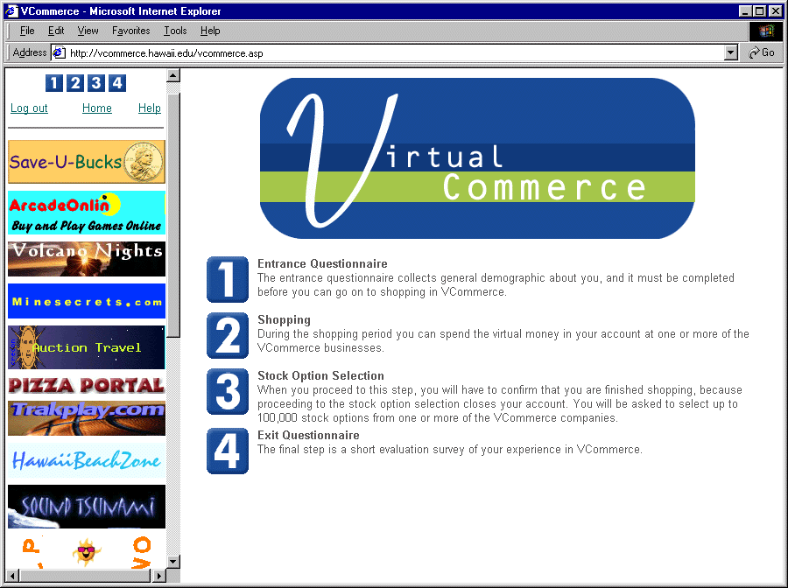
Figure 1: VCommerce Home Page, showing the list of student companies in the left frame and instructions in the center frame.

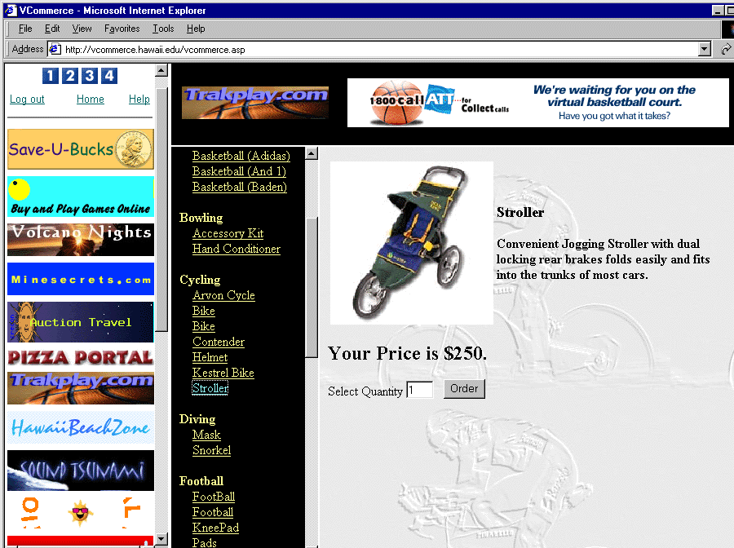
Figure 2: A merchandise page within one student company called “Trakplay.com”

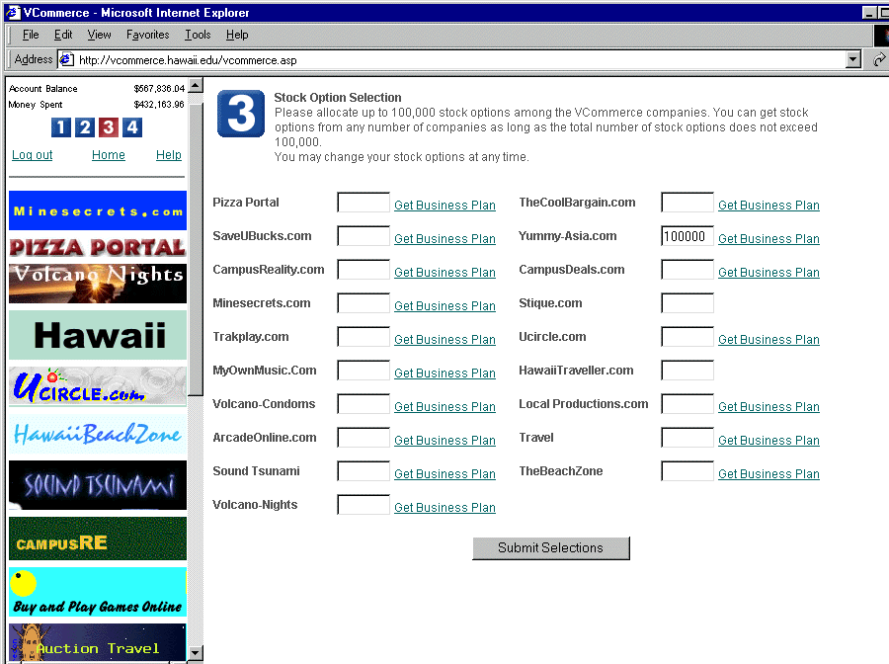
Figure 3: The stock acquisition page, where players can decide which companies to invest in.

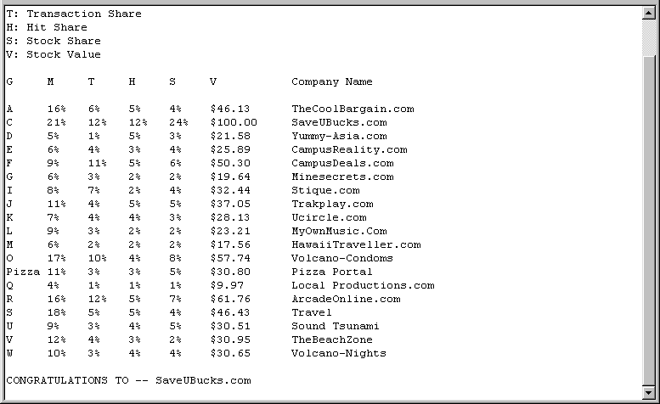
Figure 4: The VCommerce daily email to companies indicating their performance.
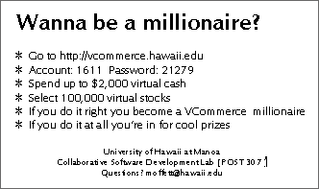
Figure 5: The VCommerce Player Cards

