Lessons learned from VCommerce:
A virtual environment for interdisciplinary learning about software entrepreneurship
Philip M. Johnson
Department of Information and Computer Sciences
University of Hawaii
Honolulu, HI
johnson@hawaii.edu
Mette L. Moffett
hotU inc.
Honolulu, HI
mette@hotu.com
Brian T. Pentland
Eli Broad Graduate School of Management
Michigan State University
East Lansing, Michigan
pentlan2@msu.edu

Introduction
Technical people know the tension created by accelerated development cycles coupled with expanded feature sets. Likewise, managers have all experienced the frustration of proposing a critical competitive feature and having the technical staff stare in stunned silence. New features are easy to imagine, but not always easy to implement by next Friday. Over the last few years, as companies strive to compete on “internet time,” the conflicting pressures of deadlines and fancy new features has risen to new heights. While the dot-bombs have come and gone, the reality of market-driven competition is certainly here to stay. The ability to make clever trade-offs between business objectives and technical possibilities is an important skill for managers and technical people alike.
The question is; how can we reproduce the reality of market-driven software development in a classroom setting? We have good methods for helping students build technical skills, and we can acquaint students with concepts from marketing, business strategy and management. But how can we put these elements together into a learning experience?
In response to this problem, we developed the Virtual Commerce (VCommerce) simulation environment. VCommerce provides a framework within which students can develop internet-based businesses, but unlike most entrepreneurship simulation games, the objective of VCommerce is not to maximize profits. The environment, which is designed for use in interdisciplinary classroom settings, provides an opportunity for students with different backgrounds to build (virtual) businesses together – from the conception of an idea, to the launch of a functioning business website. Elements of VCommerce, such as (a) an open-ended business model and product; (b) significant technical depth; (c) external players; and (d) severe time constraints, combine to create a surprisingly realistic and effective learning experience for students in both computer science and management. Whether they are planning on becoming entrepreneurs or not, the challenge of launching a VCommerce business provides an extremely engaging, motivating scenario for most students.
This paper presents the lessons learned so far from our use of VCommerce. The VCommerce simulation framework creates a novel blend of virtual and real-world activities that help students build depth in their chosen specialty, while also acquiring breadth in other disciplines. Student feedback from the VCommerce experience indicates that they grew in their sophistication about how to effectively collaborate in cross-disciplinary teams. We hope that this freely available technology in conjunction with our experiences and lessons learned will help other researchers and educators, both in academia and industry, to accelerate the development of successful, productive interdisciplinary teams for software development organizations.
VCommerce in a nutshell
VCommerce, on the surface, is a simulation game about the process of new venture creation. We divide our class into a dozen or more interdisciplinary groups of three to four students, where each group develops a business idea involving one or more products or services for the college student market. Next, they design the marketing, financial, and organizational structure of their new venture in a VCommerce business plan, and they implement a business website using Active Server Pages technology with certain software "hooks" that allows them to be deployed within the VCommerce Simulation Engine.
The VCommerce Simulation Engine is designed to create a self-contained "economic virtual reality" (although, as we shall later discuss, the boundary between real and virtual turned out to be more permeable than we expected). The simulation engine creates an environment in which a set of "players" from outside the classroom population can obtain virtual money with which to "buy" any of the products or services within the simulation. In addition to spending their virtual money on the goods and services that are most appealing to them, each player can "invest" in one or more companies based upon their evaluation of the company’s website as well as their business plan, which is made available through the VCommerce Simulation Engine.
At the end of the day (literally), the simulation engine combines a variety of process data including the relative frequency of transactions, page hits, and sales volume to generate an "IPO" share price for each company. These share prices, which can range from $1.00 to $100.00 per share depending upon the success of the company, give each player's stock portfolio a total value. The simulation engine then emails the aggregate portfolio value (but not the share value of individual companies) to each player, along with their current ranking among all of the players in the simulation. The ranking system provides an incentive for players to reenter the simulation, which runs for seven days. They can adjust their investments (and buy more goods and services from their favorite companies) in hopes of increasing their portfolio value (the share price for each company is recomputed each day). The player with the highest portfolio at the end of the seven days is declared the VCommerce champion for that round.
While the simulation does declare a winner of the round among the players, there is no winner declared among the companies per se. Although the owners of the company with the highest share price feel a certain sense of accomplishment and pride, victory goes to all the teams that learn valuable lessons about balancing business objectives with technical feasibility, and as such, full credit is given to all those who complete their business plans and website implementations by the simulation launch date.
The simulation provides students with a way to evaluate the comparative strengths and weaknesses of their new venture through interaction with the players, or "consumer/investors". More importantly, since we run two or three simulations during the semester, students can use the results from each simulation to refine and improve their business and/or website for the next round. Indeed, in some cases, students decide to abandon their business idea (and even group members) to work on a more promising venture.
The simulation engine allows "guest" logins, which enable visitors to view the company websites but not to make purchases or investments. To view the company websites at the University of Hawaii, login as a guest at http://vcommerce.hawaii.edu/, and for those at Michigan State University, login as a guest at http://vcommerce.bus.msu.edu/.
Documentation on VCommerce includes an Entrepreneur User Guide [1], a VCommerce Administrators’ Guide [2], a sample VCommerce business plan for "Pizza Portal" [3], and a bachelor's honors thesis [4]. The current implementation runs on a Windows NT Server with Internet Information Server and Microsoft Access. The VCommerce source code is available under the terms of the GNU public license. Figures 1-5 provide snapshots of selected screens from VCommerce.
A unique approach to entrepreneurship education
VCommerce is one among several entrepreneurship simulation systems available. This section briefly describes three representative systems and then discusses the unique features of the VCommerce design.
TRECS [5] (Teaching Realistic Electronic Commerce Solutions) from Deakin University simulates a kitchen appliance manufacturing supply chain, where students adopt the role of a company within the chain, such as a retailer, manufacturer, or component vendor. The simulation, which students access via a web interface, involves buying and selling material through the supply chain, and setting prices to maximize the profit of individual companies. Although the simulated manufacturing supply chain is not required to produce kitchen appliances, it is the default and the most commonly used chain.
Venture Out! [6] from Harvard Business School simulates a CEO’s decision-making process in the early stages of starting a virtual company called RadioPhone. The simulation, which only supports individual use, lets the user make strategic and operational decisions concerning hiring, allocation of resources between research, development, manufacturing and marketing, and the maintenance of cash reserves through loans, equity stakes, or sales. Based upon these decisions, the simulation computes the cash reserves, sales volume, and profits of the company. The game is provided on a multimedia CD-ROM, which also includes tools and resources for building a new start-up, such as business plan guidelines; financial forecasting tools; templates for evaluating and selecting new hires; guidelines for managing growth; and suggested books and articles.
Threshold Entrepreneur [7] from Prentice Hall is a Windows-based simulation application, where teams of students run a small company that sells two arbitrary products, Product 1 and Product 2. The teams either compete against each other (Team version), or against simulated companies (Solo version). In either case, the students act as chief executives, and they make decisions about financing, manufacturing and marketing, while facing computer-initiated situations.
In contrast, we designed VCommerce to enable interdisciplinary teams of computer science and business students to actively experience the trade-offs between business objectives and technical possibilities through the following features:
VCommerce begins with the conception a new business idea. Student groups must come up with their own ideas for virtual goods or services. Definition of a promising product or service requires the groups to develop their market research and analysis skills in a realistic setting. Because they know that the shoppers will come from the local campus population, VCommerce groups often perform market surveys on campus to assess their ideas. Because the business model is open ended, is very easy to imagine features that are difficult to implement.
VCommerce requires the design and implementation of a functioning website. Actual software development is a fundamental part of the VCommerce experience. To be successful, the student groups must learn how to implement web pages that interact with a product database, gather metrics, obtain usability feedback from customers, and evolve their site over time. The tension between desirable and feasible features very quickly surfaces in this situation – a phenomenon, which (unfortunately) is well known by many software-based companies today.
VCommerce groups get “real” feedback on their efforts from dozens to hundreds of players. It is hard to overemphasize the impact that the anticipation (and eventual reality) of real usage has upon the student groups. Although the “money” is simulated, the satisfaction of providing an interesting product or service within a well functioning web site is very real, as is the embarrassment of public scrutiny of a “lame” or broken site. Real user feedback provides an important incentive for groups to work together and produces real world anxieties and issues, including competition among the teams.
VCommerce requires groups to work effectively under pressure. The combined responsibilities of developing a business plan, performing market research, and implementing a functional website require effective group work. To create a successful business, students must be able to define an attractive, competitive, and feasible business idea and implement it within a matter of weeks. It does no good to imagine a great business model if it cannot be implemented, or to implement a fancy website if it does not attract customers.

Lessons learned
We used VCommerce in graduate courses at the University of Hawaii and Michigan State University during the spring and fall semesters of 2000, respectively. In both cases, the course attracted an interdisciplinary mix of students from both business and computer science (or engineering) departments. For the University of Hawaii course, we had 55 students in one section, divided relatively equally between business and computer science students. For the Michigan State University course, we had 67 students in two sections, with 53 from business and 14 from computer science or engineering. Both courses were able to attract several hundred players over the course of the semester to participate in the VCommerce simulation rounds. More details on the syllabus and structure of each course are available at their respective websites, http://csdl.ics.hawaii.edu/~johnson/691s00/ and http://misweb.bus.msu.edu/acc890F00/.
Our experiences suggest that VCommerce supports a rich educational environment, one that requires an interdisciplinary set of skills in order to succeed, and one that challenges each student’s background in new ways. Our experiences also suggest that simply deciding to use VCommerce does not automatically guarantee such an educational experience. The following lessons learned illustrate some of the strengths and weaknesses of the VCommerce approach to interdisciplinary learning.
- VCommerce facilitates a more sophisticated understanding of “technical management”. In many cases, students from a business background enter the course with the idea that their “management” contribution to the team consists of “telling the programmers what to do”. For example, the business students might “storyboard” a web site (“click on this, and it bring up a another window with an animated image…”). While interesting, some of these ideas vastly exceed the time or technical resources of their team. By the end of the semester, the successful teams develop through experience a much more sophisticated understanding of the way in which business and technical talents combine to create a productive development team. Those with business talents bring market and financial issues to the table, those with technical talents bring implementation and usability issues to the table, and from this combination of data the team as a whole converges on a decision.
- VCommerce provides a rich environment for learning-by-example. One of our fears during the design of the course was that we had unrealistic expectations with respect to the ability of the students to produce functional e-commerce web sites by mid-semester when the first simulation round would occur. We did not presume that students had any background in Active Server Pages or web page graphic design, and we worried that the learning curve would be too steep. We discovered that, although the learning curve was indeed quite steep, the learning environment turned out to be much richer than we anticipated. VCommerce requires students to upload their web site files to an internal subdirectory within the VCommerce Simulation Engine. At the beginning of the semester, we create a subdirectory for each student team, and provide them with an account and password for FTP access to that subdirectory. Almost as an afterthought, we also decided to provide every student team with read (but not write) access to every other team’s subdirectory so they could see how other teams implement the features in their web site. The effect of this was quite interesting during the UH course. Student groups began to monitor each other’s web sites for interesting features, and as soon as one team figured out a new web site design element (such as animated gifs, or Flash, or dynamic HTML), other teams would download the source and adapt it to their own sites. Conversely, students having problems implementing a certain feature, such as a database access, could peruse other sites for functional related code and use that to help them in debugging. It’s important to note how the interplay of requirements for success in VCommerce kept this access to other student work from devolving into “cheating”. Since the success of student groups ultimately depended upon creating an interesting and novel web site for players, they couldn’t simply copy code. Instead, they needed to use the code implemented by others as a basis for implementing a better version for their own web site.
- VCommerce reflects the current accelerated pace of software-based product development and deployment. Like any simulation, VCommerce sacrifices verisimilitude to real software-based startups along many dimensions. However, student feedback at the University of Hawaii indicates a strong appreciation for the way in which VCommerce requires them to enter “crunch mode” in order to deliver the product (both business plan and website) to the players by a deadline.
- Blending real and virtual in VCommerce has unpredictable side effects. In VCommerce, some things are simulated, such as the money spent by players, while other things are abstracted away altogether, such as the legal processes necessary to incorporate a business. However, some things are very real, such as the presence of live players, websites that actually exist on the Internet, and the need to develop feasible potential products or services in order to succeed in the game. This blending of real and virtual led to some surprising incidents. First, during the University of Hawaii semester, one of the instructors was passing through the Campus Center on February 14 where a health fair was in progress. To his surprise, he saw a booth set up by the members of VolcanoCondoms.com dispensing information and pointers to their website to interested students. Second, another University of Hawaii company were advertising free t-shirts at their website to attract customers. However, they found it difficult to get players to differentiate between the “real” t-shirt give-away from the remaining “virtual” products and services on their site. Finally, at MSU, one student group decided to implement a virtual “portal” with links inside to real web sites. The transition between the “virtual” and the “real” world was sufficiently seamless that one player placed orders for $172 at cdnow.com. When the instructor discovered the issue, he asked the site to post a prominent announcement that the VCommerce virtual money would not work at real sites like cdnow.
- VCommerce favors a relatively balanced interdisciplinary mix of students. At the University of Hawaii, we had an almost exactly equal number of students from business and computer science backgrounds in the course. This meant that the strengths and weaknesses of the class with respect to management and technical areas were relatively balanced, and that the teams could be constructed with relatively equal strengths and weaknesses. At Michigan State University, most students were from business backgrounds and a minority of students came from computer science (or engineering). This had a number of negative effects on the course. In particular, the time pressure to create a working website quickly encouraged the more technical students to commandeer the web development work, thereby leaving their teammates with no input into the process. As a result of our experiences, we believe that the interdisciplinary learning objectives of VCommerce are best achieved if the class is relatively balanced with respect to business and technical backgrounds.
- External player involvement is critical, but is challenging to obtain and sustain. As should be clear, VCommerce depends upon the participation of players to succeed. During the two semesters we used VCommerce, player participation in a simulation round varied from as little as a few dozen players to over four hundred. We tried a variety of approaches to soliciting player involvement. The most effective approach was to ask instructors in other courses to provide extra credit to their students if they played VCommerce. At MSU, this resulted in over four hundred players. Another approach was to ask each student in the course to give out ten VCommerce playing cards (each with a unique account number and password, see Figure 5) to their friends. The least effective approach was to simply invite players (e.g., with advertising or in-class announcements). At MSU, this resulted in only 3-4% participation, versus nearly 80% when extra credit was offered.
Future directions
The VCommerce system is available without charge to other institutions under the GNU public license, and we look forward to the development of a growing body of knowledge about the approach and its strengths and weaknesses. The system is relatively easy to extend, and there are several enhancements that we believe might further improve the educational experience. First, in the current system, the business plan developed by the students is only “loosely” integrated into the simulation, in that players can look at the business plan in order to evaluate the strengths and weaknesses of the business, but are not required to do so. An interesting extension would be to require each business plan to make projections about the success of the business during the simulation round, and then have the simulation engine compare these projected values to the business’ actual results when calculating its share values. This would make the development of the business plan more tightly coupled to the outcome of the simulation. Second, the system is well suited to an “Application Service Provider” model, where a centralized location provides the engine to any institution wishing to use VCommerce. This architecture would create interesting new possibilities, such as inter-University VCommerce competitions, and the ability to draw the population of players from a much wider pool.
References
[1] VCommerce Entrepreneur User Guide, Philip M. Johnson, Department of Information and Computer Sciences, University of Hawaii, Honolulu, Hawaii 96822, Number ICS-TR-00-07, January, 2000. <http://csdl.ics.hawaii.edu/techreports/00-07/00-07.pdf>
[2] VCommerce Administrator Guide, Mette L. Moffett and Brian Pentland and Philip M. Johnson, Department of Information and Computer Sciences, University of Hawaii, Honolulu, Hawaii 96822, Number ICS-TR-00-13, January, 2001. <http://csdl.ics.hawaii.edu/techreports/00-13/00-13.pdf>
[3] VCommerce Example Business Plan: Pizza Portal, Philip M. Johnson, Department of Information and Computer Sciences, University of Hawaii, Honolulu, Hawaii 96822, Number ICS-TR-00-08, January, 2000. <http://csdl.ics.hawaii.edu/techreports/00-08/00-08.pdf>
[4] The Design, Development, and Evaluation of VCommerce: A Virtual Environment to Support Entrepreneurial Learning, Mette L. Moffett, Department of Information and Computer Sciences, University of Hawaii, Honolulu, Hawaii 96822, Number ICS-TR-00-11, December, 2000. <http://csdl.ics.hawaii.edu/techreports/00-11/00-11.pdf>
[5] TRECS. Deakin University, Australia. <http://www.detc.deakin.edu.au/trecs/>.
[6] Venture Out! CD-ROM. Harvard Business School Publishing. 1999. <http://www.hbsp.harvard.edu/products/interactive/ventour/>
[7] Threshold Entrepreneur. Prentice-Hall. <http://ajax.prenhall.com/divisions/BP/app/threshold/html/entrepreneur/entrepreneur.html>.
Figures

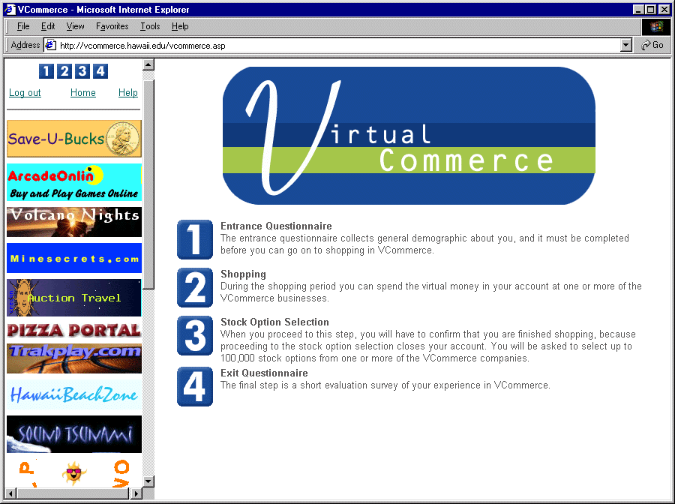
Figure 1: VCommerce Home Page, showing the list of student companies in the left frame and instructions in the center frame.

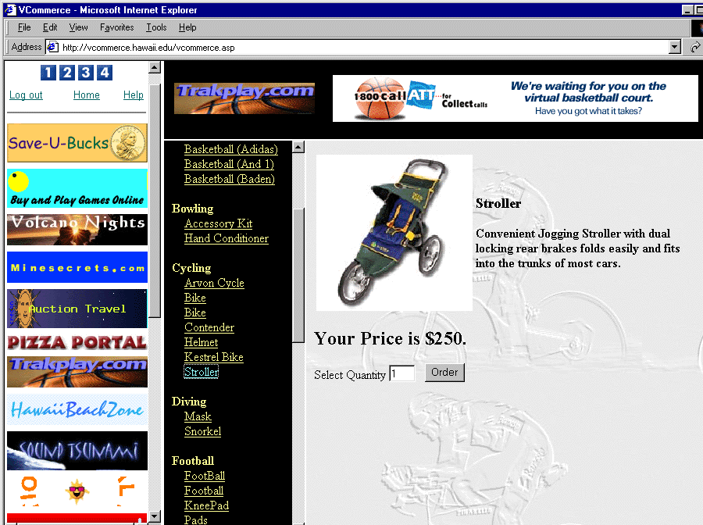
Figure 2: A merchandise page within one student company called “Trakplay.com”

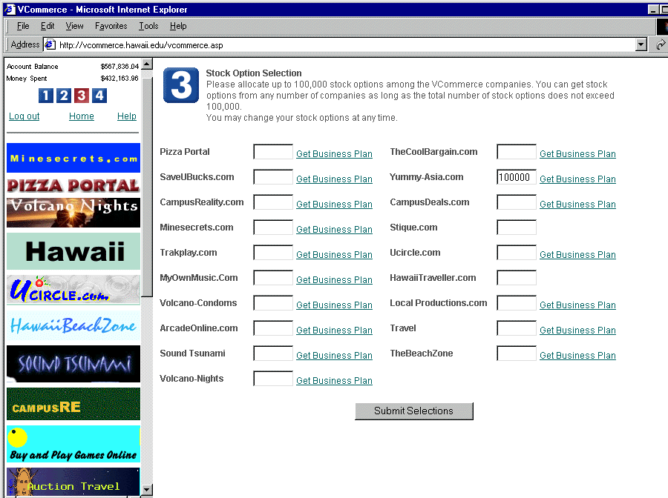
Figure 3: The stock acquisition page, where players can decide which companies to invest in.

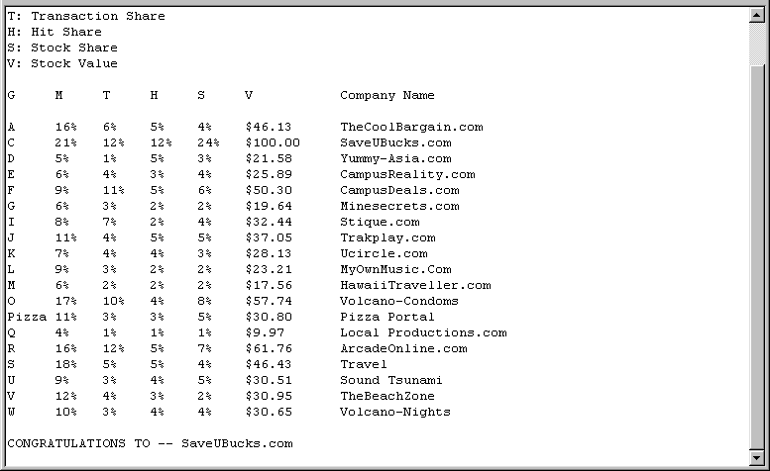
Figure 4: The VCommerce daily email to companies indicating their performance.

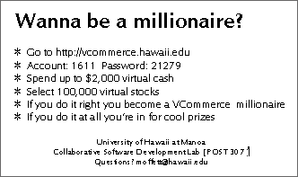
Figure 5: The VCommerce Player Cards

