Team Name:
3A – Hawai’i

Business Name:
Virtual Mall Management Software (VMMS), Inc.

Team Members:
Joy M. Agustin
William M. Albritton
Nolan Y. Kido
Executive Summary

Virtual Mall: An e-commerce marketplace, which aggregates marketing, sales, and administration functions for small merchants.
Virtual Malls spent $20 billion last year creating and maintaining their online marketplaces. This figure is expected to increase 68% in the next four years. Nearly all of that money is spent on software. That software infrastructure is currently constructed on an individual basis. Every virtual mall has to create and maintain proprietary software packages for their very similar services.
Virtual Mall Management Software (VMMS) has already created a prototype virtual mall management software package. Our software is comprehensive and customizable. Virtual malls will purchase our software and use it to create, manage, alter, and market their e-marketplaces. Merchants who sign on with those virtual malls will also be able to benefit from a user-friendly interface and any-time access to their information.
Although several companies sell software that can be used to create the different software components of a virtual mall, no companies are selling all components as one complete package. In addition to combining these components, our product will also offer integrated shipping and financial components, so that merchants that have little computer knowledge or business experience can easily join the virtual mall.
From a virtual mall’s perspective, possible competitors are content management system (CMS) providers. They provide servicing for web pages and backend database services of virtual malls. With CMS providers, the virtual mall company is responsible for updating all web content. Our software reduces the burden on those companies by allowing the individual merchants to update the information themselves.
Virtual mall companies will be able to purchase our software for a fraction of the cost of developing a proprietary system from scratch. They would also have drastically lower ongoing expenses, as our software package is easier to manage than proprietary systems. For the average virtual mall, one dedicated software engineer will be able to manage our system compared with 3-4 for proprietary systems.
Since we are one of the few companies to offer this particular product, we expect significant market penetration in the first 24 months. 24 months is also the time frame it would take a competitor to develop a similar product. Because of a one-year graduate research project already completed by VMMS founders, our time-to-market can be as fast as nine months with adequate funding.
Once the software is developed, VMMS would be able to generate significant revenue from sales of the software while incurring little or no marginal costs. Virtual mall clients will hire VMMS to install and maintain the software package. We will also offer technical support to merchants and customers of the virtual mall, eliminating the need for the malls to retain technical support and software staff. The final phase of our company’s development would be consulting with individual groups of merchants interested in starting virtual malls. This would open international opportunities for VMMS.
VMMS’ software package can be easily localized for any country’s market. With our software, merchants in countries such as Vietnam and China would be able to aggregate their products and services into one virtual mall company. VMMS will allow small, local vendors in third-world nations to sell their products to the global marketplace. Our company will gain additional revenue not only from selling the software to these entrepreneurial consortiums, but also by providing consulting, maintenance, and support services to these international customers.
Although it is unlikely—given the size of the market— that major companies would invest the resources necessary to compete directly with VMMS, there is always the risk that another start-up would develop competing software. Because of the time required to research and develop software, our company will have a two-year advantage on any possible competitor.
Software development time may also be subject to unexpected delays. Due to the size and complexity of the project, maximum delay time will not exceed three months. Therefore, even in the worst-case scenario, VMMS will have a beta version complete within 1 year. Given the pre-programming research required, no competitor will be able to complete a similar product within 18 months of the release of our software beta.
Exit strategy for VMMS investors would most likely be acquisition by a larger software company. Given the size of the virtual mall software niche, it would be more efficient for large software companies to purchase VMMS than create a competing product. Obvious candidates include SMC Technologies, Commerce1, and Bigstep.com. Alternative exit strategies include an initial public offering, acquisition by virtual mall company, or leveraged buy-out by employees financed by ongoing cash flows.
Depending on exit method, investments in VMMS can be liquidated within 5 years.
The ideal personnel structure of VMMS would be 4 software engineers, 1 financial manager, 1 sales/marketing professional, and 1 support person. Additional software engineers would not decrease the software development time and personnel would be hired in phases. VMMS will need a CEO to handle strategic planning and coordinate exit strategy. CEO position would be filled by a representative of our major investor.
Initial investment of $250,000 would be sufficient to cover 12 months of development time. Upon completion of beta version of software, an additional $250,000 will be needed to cover first year of sales/marketing and final software design. VMMS should be cash flow positive within 24 months and profitable within 3 years. See appendix.
Of the investment capital required, founders would be willing to contribute virtually all their existing assets. In addition to this $30,000, founders would be willing to co-sign for any loans VMMS may be able to get from banks or other sources.
Given sufficient investment, founders would be willing to give up 60% of ownership. Due the high-risk/high-reward nature of VMMS, all employees would be given ownership to encourage loyalty and limit the need for cash outlays in the form of higher salaries. Investors would be given board seats proportionate to their ownership.
Virtual Mall Management Software, Inc.

Virtual Mall: An e-commerce marketplace, which aggregates marketing, sales, and administration functions for small merchants.
Last year virtual malls spent $20 billion towards creating and maintaining their online marketplaces. Within the next four years this figure is expected to increase 68% [1]. Nearly all of that money is spent on software infrastructures which are currently constructed on an individual basis. Every virtual mall has to create and maintain proprietary software packages for their very similar services. Virtual Mall Management Software (VMMS) would be used by a virtual mall to improve their backend services – receiving product information from their merchants, sending ordering information to their merchants, allowing the customer access to tracking information, and giving the merchants up-to-the-minute information on product sales.

Vision

The Internet appears to offer a perfect solution for local, geographically isolated businesses that want to expand their market. Instead of limiting the business to the local populace, the World Wide Web gives global access to all companies that have made the transition online. Ideally, the Internet offers vast, untapped markets, lowers the costs of reaching these markets, and frees businesses from geographical constraints. An interesting example can be found in Peru. In 1991, journalist Jorge Soriano founded the Peruvian Scientific Network (RCP), which was the first privately funded electronic communications net independent in South America. Because only 2 per cent of Peru’s 24 million people own a computer, RCP gradually built numerous public Internet booths in poor rural areas. In an isolated farming village near Chincheros, the RCP, along with local nongovernmental organizations and the Agriculture Ministry, set up an Internet connection for the village in 1996. Once the connection was complete, the village leaders arranged for their produce to be sold in New York by using an international export company. Before the Internet, the village’s income was US $300 a month. In 1998, it was up to $1,500 a month [2].
Other examples of using the Internet to overcome geographic isolation and access beneficial information can be found all over the world. In Sri Lanka, farmers have increased their income by roughly 50 percent. By using the Internet to access product prices in Colombo, they were able to negotiate better rates with brokers. In Papua New Guinea, village elders put their storm forecasts, which are created from observations of physical changes in plants and animals, on the Internet to warn the rest of the island’s population. In Africa, the Internet allows farmers to be more aware of the state of crops in different regions. [3]. They are able to reduce the risk of famine by possibly sending more food to those regions. In the United States, a doctor in Boston guided a sailor on a solo voyage to operate on his arm using email on an emergency solar-powered satellite communication system [4].
What kind of customer base do businesses potentially have on the Internet? Although many surveys differ in the exact number of users on the Internet, all surveys have a common ground – that worldwide Internet users are increasing at a dramatic rate. The following statistics show the number of people going online around the world.
On the global level, 30 percent of online shoppers were from outside North America for the year 2000. This number is expected to grow to 60 percent by the year 2003, according to the International Data Corporation (IDC). In Europe, the compound annual growth rate of e-commerce is estimated to be 138 percent. In Asia and the Pacific region, the number of Internet users is expected to grow from 21 million to 81 million users from 1998 to 2003. According to Forrester Research, Inc, online users in South America will grow from 4.1 million to 26.6 million users from the year 1999 to 2002 [6]. Internet users in Africa are estimated to be at 4 million in 2001 [7]. According to the Computer Industry Almanac Inc, the United States had 33 percent of the worldwide Internet users at the end of the year 2000. Worldwide Internet users have grown from 200 million in 1998 to 400 million in 2000. Asia, Latin America and Eastern Europe are responsible for the majority of the Internet user growth [8].
VMMS will help virtual malls by reducing spending and increasing efficiency by giving them a backend system that can allow the small vendors, who might not have the technical know-how to make their own web pages, to sell their products on the virtual mall’s web page and automatically take orders that are sent by customers of the virtual mall. Furthermore, our product will also give the merchants constantly updated on the current number of products being sold, allowing them to make daily changes in their product prices to adjust to demand. Customers will also have access to shipping information about their order. Not only will our product make money for ourselves, but it will also help other businesses in three ways. First, using our product will empower individuals and businesses in 3rd world countries to come together as one virtual mall so they can sell their goods online on the worldwide marketplace. Secondly, our product will help small business or individuals to sell their products over the Internet cheaper and easier. Thirdly, our product will help the virtual malls already on the Internet to have less overhead and send orders more efficiently.

Product

Currently, most virtual malls function as an aggregation of virtual stores. An example is Yahoo! Stores. Vendors can register with Yahoo and pay a monthly fee as well as a fee that is a percentage of their sales. In turn, Yahoo hosts their website. Yahoo also serves as a gathering point on the web for customers, who can select different types of goods, which will lead them to links to the stores that are set up with Yahoo. Customers order and do business with the different merchants individually. Merchants, in turn, must keep up with the orders, pricing, banking, and shipping by themselves. A calculation of total sales and an analysis and breakdown of what is being sold, or what is the most popular product being sold, must also be done by the individual vendor. See Figure 1 of the Appendix for a diagram of the virtual mall aggregation model.
Virtual Mall Management Software (VMMS) will be the backend of a virtual mall. What does this mean? First of all, our software is to be used by a virtual mall with a different model. Instead of giving the responsibility of making a website to the merchants, the virtual mall has its own website, which sells the products of all the merchants. From the customer’s point of view, they are dealing with one large store, instead of many small stores. Instead of filling out numerous online order forms from many virtual stores, they only have to fill out one order form from the virtual mall. (This is similar to Amazon.com’s virtual mall structure, except, with our software, the virtual mall does not have to do warehousing – instead the orders are sent automatically to the individual merchants.) In the case where the virtual mall has runs its own website, the physical company that created the virtual mall must warehouse all its goods – thus creating extra work and overhead for the virtual mall. The backend system in this case would consists of keeping track of what is in the warehouse, ordering more of a certain product once it gets low, etc. This is the case with Amazon.com. (See figure 2 in the Appendix.) With our new backend system, this strain on the virtual mall would be taken over by the individual merchant companies. (See figure 3 in the Appendix.) When a customer orders something from the virtual mall’s website, our software will handle order processing by sending the order automatically to the merchant company via email. To complete the order fulfillment, the merchant will print out a shipping label provided at an attachment in the email. A shipping provider will come to pick up the package. Because of this label, the customer will be able to track the status of the shipping over the web from the virtual mall’s website.
In addition to taking away the need for warehousing and providing a convenient shipping service, our software will also connect to a financial institution. The financial institution will be a fourth party to the merchants, virtual mall, and shipping providers, and will distribute the money on a daily basis to the three partners. This will be an advantage for the small vendors, who typically have to wait two months or more, while the larger company “floats” their money. The financial component to our software will also give the merchants a daily analysis of the product sales on the virtual mall’s website.
Finally, the most important part of our software is that the merchants do not have to have extensive technical knowledge to sell their goods over the Internet. All they need is an email account to receive the orders, a web browser to log into the VMMS’s interface. (See figure 4 in the Appendix.) Instead of designing a web page and having to figure out web hosting and other technical issues, the merchant can simply fill in a few text boxes for the name, description, price, and other product information. They can upload photographs of their product as well. Once they do this, a web page on the virtual mall’s website will be automatically generated. Once the virtual mall has set up a website, neither the virtual mall nor the merchants have to do any web page maintenance, since our software takes care of this.
Although several companies sell software that can be used to create the different software components of a virtual mall, no companies are selling all components as one complete package. In addition to combining these components, our product will also offer integrated shipping and financial components, so that merchants that have little computer knowledge or business experience can easily join the virtual mall.
With regards to pricing, we have three editions – demo, entrepreneur, and enterprise. The demo will be only partially-functional for a maximum of 30 days. This version will only allow five products to be sold via a single merchant account. Another edition is the entrepreneur edition. This will sell for around $350. It will include a user-friendly interface to the database, and order notifications without shipping label attachments. This version is for individuals or groups up to 10 individuals who want to sell a few items on the web. Finally, the enterprise edition will sell for $5000. This version will include complete order fulfillment functionality for an unlimited number of merchants.
All of our software will be licensed under the GNU General Public Licensing [9].

Marketing
Open Source is one of our strategies for marketing. We have found a couple of important advantages to participating in Open Source. The main advantage is increased code reliability. Since our source code would be accessible to the public, bugs can be found and fixed by other programmers without adding them to our payroll. On the other hand, an advantage for our customers is that other programmers would also be able to implement additional features to our software. However, from the investor’s standpoint, any person who gets our software for “free” is money that our company lost. So we have decided to compromise. We will not participate in Open Source with the first two most recent versions of our software. Instead, the first two most recent versions will be 30-day demos. Since we plan to add significant features with each new version, any version previous to those two will be Open Source. Programmers can find the bugs and add additional features. Furthermore, companies or individuals who cannot afford our newest release can download the older versions for free. We believe that this is beneficial to us because we would be able to charge them for various support services. If they are satisfied with our older product(s) and start to generate profits, they can later upgrade to our newest edition.
Because our product will be marketed to organizations that are interested in creating a virtual mall, as opposed to small merchants who want to sell products in one, our marketing will be targeted at two specific groups: companies that already operate online virtual malls and organizations (or groups of merchants) that are likely to start one in the future.
The first group consists of medium-to-large size companies such as Yahoo! Stores and Bigstep.com. These companies are using proprietary software products of varying complexity in running their online operations. This is the natural target market for our product as these companies would benefit from a customizable interface, personalized customer support, and out-of-the-box functionality. The marketing for this group would demonstrate the lower support and development costs and easier-to-use interface (for the small merchants who list products on their sites).
The second group consists of smaller organizations or groups of merchants (possibly in foreign and undeveloped countries) who are looking to expand their economic opportunities by selling products through the Internet. These organizations simply would not have the ability to create a virtual mall without our product. Easy setup, simple administration, and lower on-going costs would be the main benefits of our product for this group.
After 6 months of developing we will start marketing our product to the two groups mentioned above. We will begin locally by reserving booths in local trade shows like ITEC [10] for the first group and the Made in Hawaii Festival [11] for the second group. After the first year, we plan to attend at least one international trade show per quarter like Internet World [12]. During this time, we will also be pushing to have our software on the shelves of retail stores like CompUSA, OfficeMax, etc.

Sales

Due to the nature of our product, there are two primary ways that it could be sold: downloaded and purchased through a website or from a computer store such as CompUSA. Both options will be available, and our research indicates that more sophisticated buyers tend to purchase large-ticket items such as VMMS software’s product from an Internet site or due to a sales call from a software vendor. Smaller companies and less-sophisticated buyers tend to prefer purchasing items from a physical store and prefer to receive a physical box with paper documentation.
Targeting physical computer stores with our product would most likely involve deep wholesaler discounts due to the expensive and niche nature of our product. However, as there is currently no out-of-the-box competitor, research indicates that major chain stores would be willing to carry our product.
Targeting Internet distribution would be the job of our full-time sales staff. By conducting in-person sales calls by appointment of existing virtual malls, our staff could effectively target larger merchants and provide a hands-on demonstration of the product’s effectiveness. Although the small price of our product relative to marketing and sales costs make it unlikely that in-person sales would be effective long-term, in the short-run research indicates that this would be the most effective way to get the initial clients whose names we could then use in advertising and targeted marketing programs.

Competition

From a virtual mall’s perspective, possible competitors are content management system (CMS) providers. They provide servicing for web pages and backend database services of virtual malls. With CMS providers, the virtual mall company is responsible for updating all web content. Our software reduces the burden on those companies by allowing the individual merchants to update the information themselves.
Virtual mall companies will be able to purchase our software for a fraction of the cost of developing a proprietary system from scratch. They would also have drastically lower ongoing expenses, as our software package is easier to manage than proprietary systems. For the average virtual mall, one dedicated software engineer will be able to manage our system compared with 3-4 for proprietary systems.
Since we are one of the few companies to offer this particular product, we expect significant market penetration in the first 24 months. 24 months is also the time frame it would take a competitor to develop a similar product. Because of a one-year graduate research project already completed by VMMS founders, our time-to-market can be as fast as nine months with adequate funding.
Since our product focuses on a niche market, we do not expect large companies such as Microsoft to compete with us. The profits that they make are simply too small for them to bother. As for small companies or a computer programmer in a garage, it is easier to simply buy our product, than to spend the resources on creating a new, similar product from scratch.

Expansion

Once the software is developed, VMMS would be able to generate significant revenue from sales of the software while incurring little or no marginal costs. Virtual mall clients will hire VMMS to install and maintain the software package. We will also offer technical support to merchants and customers of the virtual mall, eliminating the need for the malls to retain technical support and software staff. The final phase of our company’s development would be consulting with individual groups of merchants interested in starting virtual malls. This would open international opportunities for VMMS.
VMMS’ software package can be easily localized for any country’s market. With our software, merchants in countries such as Vietnam and China would be able to aggregate their products and services into one virtual mall company. VMMS will allow small, local vendors in third-world nations to sell their products to the global marketplace. Our company will gain additional revenue not only from selling the software to these entrepreneurial consortiums, but also by providing consulting, maintenance, and support services to these international customers.

Risks

Although it is unlikely - given the size of the market - that major companies would invest the resources necessary to compete directly with VMMS, there is always the risk that another start-up would develop competing software. Because of the time required to research and develop software, our company will have a two-year advantage on any possible competitor.
Software development time may also be subject to unexpected delays. Due to the size and complexity of the project, maximum delay time will not exceed three months. Therefore, even in the worst-case scenario, VMMS will have a beta version complete within 1 year. Given the pre-programming research required, no competitor will be able to complete a similar product within 18 months of the release of our software beta.

Exit Strategy

Exit strategy for VMMS investors would most likely be acquisition by a larger software company. Given the size of the virtual mall software niche, it would be more efficient for large software companies to purchase VMMS than create a competing product. Obvious suitors include SMC Technologies, Commerce1, and Bigstep.com.
Depending on exit method, investments in VMMS can be liquidated within 5 years.

Personnel

The ideal personnel structure of VMMS would be 1 CEO, 1 CFO, 4 software engineers, 3 sales/marketing professionals, and 1 support person. Additional software engineers would not decrease the software development time and personnel could be hired in phases.

- Chief Executive Officer: Confidential
The position of VMMS CEO would be filled be an individual who is currently employed as an executive at a small software design firm. This individual possesses a bachelor’s degree in business administration from the University of Hawaii and an MBA from USC. This individual has been employed at two small software-related companies for the past four years.

- Team Leader / Project Manager: William Albritton
Instructor at the University of Hawaii at Manoa Department of Information and Computer Science. Former member of CSDL (Collaborative Software Development Laboratory) research team on VMMS software design and implementation. Co-author of technical report “Vendor Relationship Management: Re-engineering the business process through B2B infrastructure to accelerate the growth of small businesses in geographically isolated areas”. Four years of software programming experience with one year in ASP pages and Access database design.

- Team Leader: Joy Agustin
Graduate student at the University of Hawaii at Manoa Department of Information and Computer Science. Current member of CSDL research team investigating software engineering practices. Former member of CSDL research team on VMMS software design and implementation. Co-author of technical report “Vendor Relationship Management: Re-engineering the business process through B2B infrastructure to accelerate the growth of small businesses in geographically isolated areas”. Four years of software programming experience with one year in ASP pages and Access database design.

- Chief Financial Officer: Nolan Kido
Managing member of West Oahu Financial Group LLC. Former commercial banking officer at large commercial bank and former investment advisor at national brokerage company. Holds a bachelor’s degree in business administration from the University of Hawaii at Manoa.

Financing

Initial investment of $400,000 would be sufficient to cover 12 months of development time. Upon completion of beta version of software, an additional $400,000 will be needed to cover first year of sales/marketing and final software design. VMMS should be cash flow positive within 36 months and profitable before 48 months. See appendix.
Of the investment capital required, founders would be willing to contribute virtually all their existing assets. In addition to this $30,000, founders would be willing to co-sign for any loans VMMS may be able to get from banks or other sources. Although this figure represents less than 4% of the total investment required in VMMS, it represents more than 90% of the founder’s combined assets. As such, it serves to demonstrate the founders’ level of commitment to the success of VMMS.
Given sufficient investment, founders would be willing to give up 60% of ownership over the two investment phases. The initial investor will receive a non-dilative 40% ownership in VMMS. Once a beta version is completed, the company should be valued at a point that a non-dilative 20% ownership stake would be given to the second-round investor. Due the high-risk/high-reward nature of VMMS, all employees would be given ownership through the form of restrictive options or warrants to encourage loyalty and limit the need for cash outlays in the form of higher salaries. Investors would be given board seats proportionate to their ownership.

Appendix

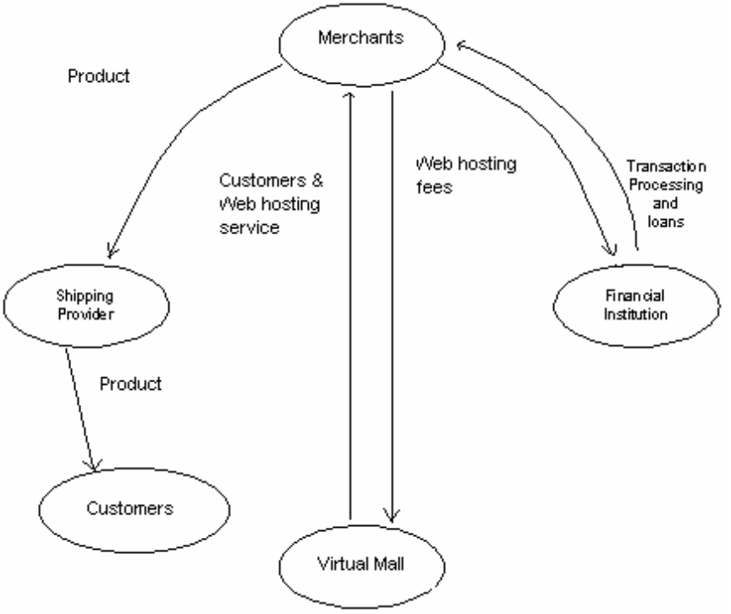

Figure 1. Virtual Mall Aggregation Model

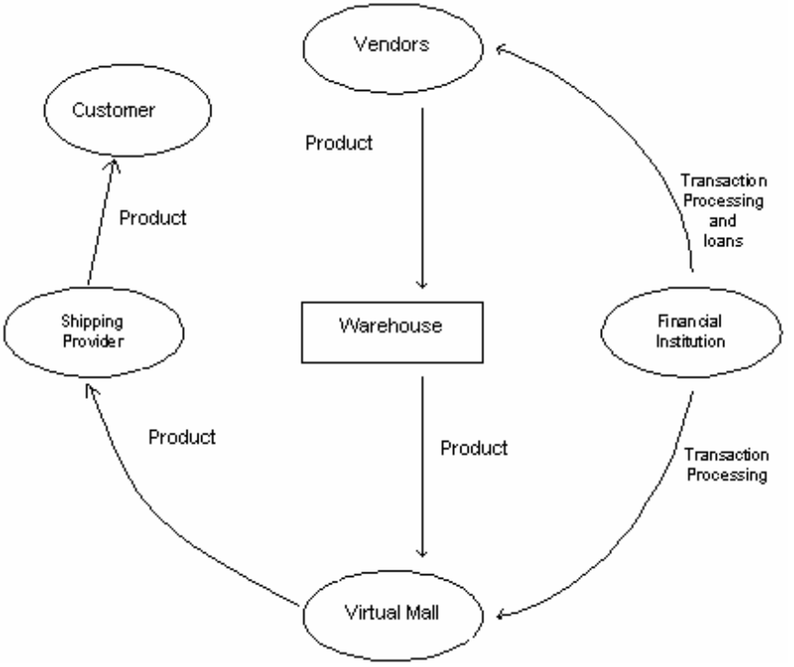

Figure 2. Virtual Mall Single Web Site Model

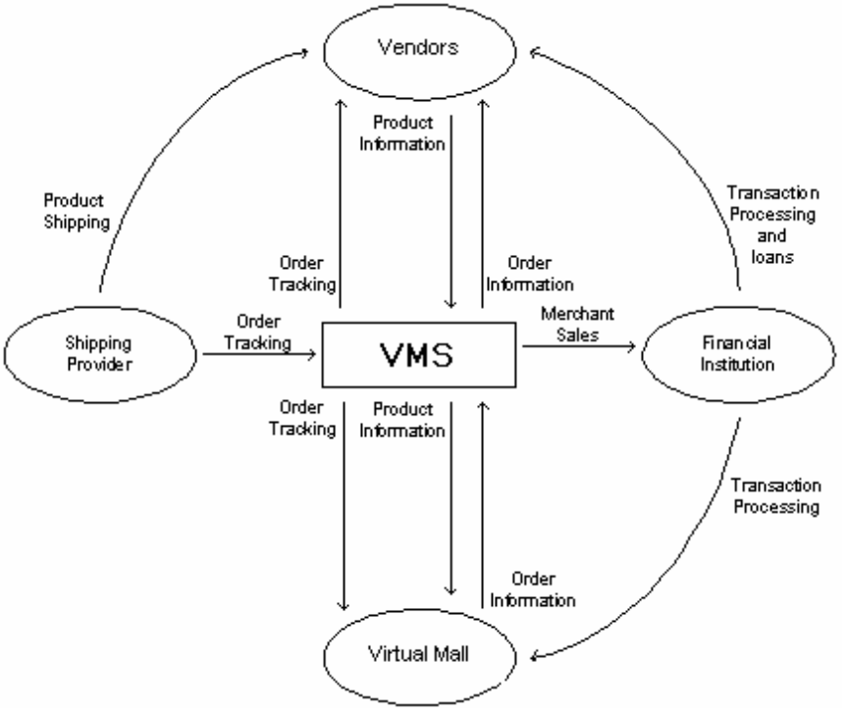

Figure 3. Virtual Mall Management Software (VMMS) Model

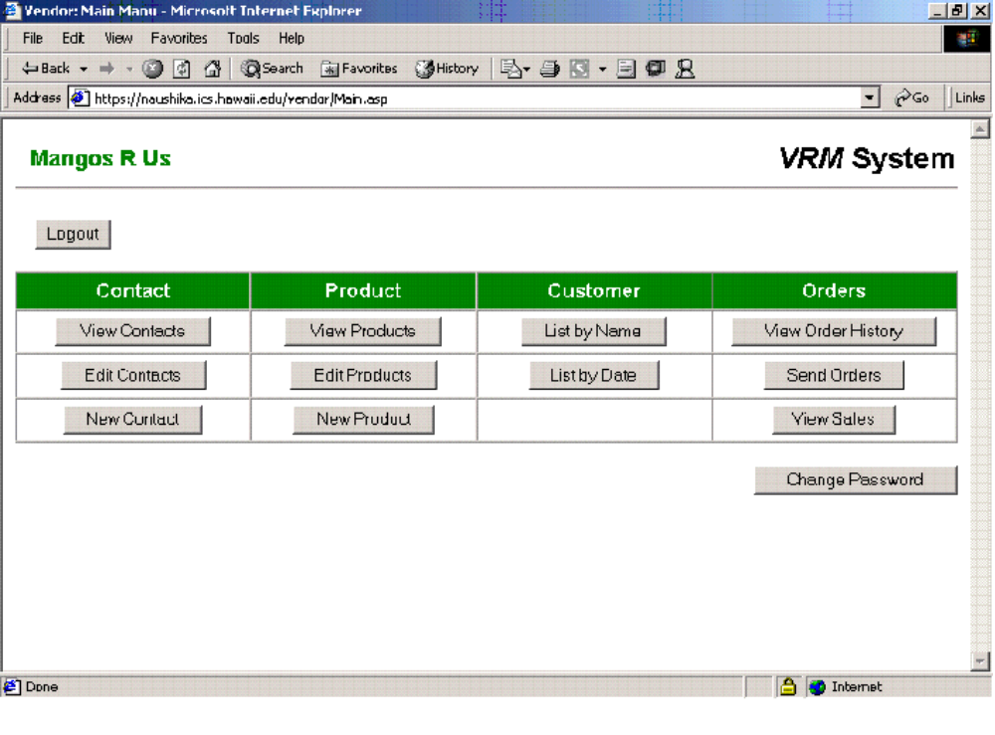

Figure 4. Example Merchant Interface

VMS, Inc. Cash Flow Forecast - Three Years (Quarterly)
 |  | Year 1 |  |  |  | Year 2 |  |  |  | Year 3
 | Qtr 1 | Qtr 2 | Qtr 3 | Qtr 4 | Qtr 1 | Qtr 2 | Qtr 3 | Qtr 4 | Qtr 1 | Qtr 2 | Qtr 3 | Qtr 4 | Totals
Receipts
Software sales | 0 | 0 | 0 | 10,000 | 14,000 | 20,000 | 40,000 | 80,000 | 120,000 | 160,000 | 240,000 | 300,000 | 984,000
Consulting fees | 0 | 0 | 0 | 5,000 | 6,000 | 12,000 | 18,000 | 28,000 | 40,000 | 80,000 | 160,000 | 240,000 | 589,000
Support services | 0 | 0 | 0 | 2,500 | 5,000 | 10,000 | 12,000 | 16,000 | 30,000 | 50,000 | 75,000 | 100,000 | 300,500
Investor equity inflow | 400,000 | 0 | 0 | 0 | 400,000 | 0 | 0 | 0 | 0 | 0 | 0 | 0 | 800,000
Founder equity inflow | 30,000 | 0 | 0 | 0 | 0 | 0 | 0 | 0 | 0 | 0 | 0 | 0 | 30,000
Total Receipts | 430,000 | 0 | 0 | 17,500 | 425,000 | 42,000 | 70,000 | 124,000 | 190,000 | 290,000 | 475,000 | 640,000 | 2,703,500
Payments
Salaries and wages | 60,000 | 60,000 | 60,000 | 85,000 | 85,000 | 85,000 | 100,000 | 100,000 | 100,000 | 100,000 | 125,000 | 125,000 | 1,085,000
Rent | 3,000 | 3,000 | 3,000 | 3,000 | 3,000 | 3,000 | 3,000 | 3,000 | 5,000 | 5,000 | 5,000 | 5,000 | 44,000
Utiltities | 600 | 600 | 600 | 600 | 600 | 600 | 600 | 600 | 1,000 | 1,000 | 1,000 | 1,000 | 8,800
Office supplies | 2,000 | 1,200 | 1,200 | 1,200 | 800 | 800 | 800 | 800 | 800 | 800 | 800 | 800 | 12,000
Advertising/Marketing | 0 | 0 | 8,000 | 15,000 | 10,000 | 14,000 | 18,000 | 20,000 | 30,000 | 40,000 | 50,000 | 75,000 | 280,000
Professional fees | 2,000 | 2,500 | 2,000 | 1,500 | 600 | 600 | 600 | 600 | 600 | 600 | 600 | 600 | 12,800
Miscellaneous | 600 | 600 | 600 | 600 | 600 | 600 | 600 | 600 | 600 | 600 | 600 | 600 | 7,200
Capital Equipment | 35,000 | 0 | 0 | 10,000 | 0 | 0 | 0 | 0 | 60,000 | 0 | 0 | 0 | 105,000
Furniture | 5,000 | 0 | 0 | 0 | 0 | 0 | 0 | 0 | 0 | 0 | 0 | 0 | 5,000
Internet Connections | 250 | 250 | 250 | 250 | 400 | 400 | 400 | 400 | 1,000 | 1,000 | 1,000 | 1,000 | 6,600
Total Payments | 108,450 | 68,150 | 75,650 | 117,150 | 101,000 | 105,000 | 124,000 | 126,000 | 199,000 | 149,000 | 184,000 | 209,000 | 1,566,400
Cashflow Surplus | 321,550 | -68,150 | -75,650 | -99,650 | 324,000 | -63,000 | -54,000 | -2,000 | -9,000 | 141,000 | 291,000 | 431,000 | 1,137,100
Opening Cash Balance | 0 | 321,550 | 253,400 | 177,750 | 78,100 | 402,100 | 339,100 | 285,100 | 283,100 | 274,100 | 415,100 | 706,100 | 0
Closing Cash Balance | 321,550 | 253,400 | 177,750 | 78,100 | 402,100 | 339,100 | 285,100 | 283,100 | 274,100 | 415,100 | 706,100 | 1,137,100 | 1,137,100

Bibliography
[1] Newman, M., (2000). Dotcom Inferno: Money to Burn, Business 2.0. Online at http://www.business2.com/articles/mag/0,1640,8599|2,FF.html.

[2] Batstone, D., (1999). Wiring the Pueblo, Business 2.0. Online at http://www.business2.com/articles/mag/0,1640,12658,FF.html.

[3] Schenker, J., (1999). A Wider Net: New technology could help narrow the information gap between the developed and developing worlds, Time.com. Vol154 (15). Online at http://www.time.com/time/magazine/printout/0,8816,32519,00.html.

[4] Irving, L., (1998). Forging A Connected Global Village, NTCA-World Bank's First International Conference on Rural Telecommunications, Washington, D.C. Online at http://www.ntia.doc.gov/ntiahome/speeches/ntca120198.htm.

[5] Steinfield, C.; Whitten, P. (1999). Community Level Socio-Economic Impacts of Electronic Commerce, Journal of Computer Mediated Communication, Vol. 5 (2). Online at http://www.ascusc.org/jcmc/vol5/issue2/steinfield.html.

[6] Bayles, D, (2001). E-commerce Logistics and Fulfillment: Delivering the Goods. Upper Saddle River, NJ: Prentice Hall PTR, pages 203-204.

[7] Jensen, M, (2001). The African Internet - A Status Report. Online at http://www3.wn.apc.org/africa/afstat.htm.

[8] Computer Industry Almanac Inc, (2001). U.S. has 33% Share of Internet Users Worldwide Year-end 2000 According to the Computer Industry Almanac. Online at http://www.c-i-a.com/200103iu.htm.

[9] Free Software Foundation, Inc.,(1991) GNU’s not Unix. Online at http://www.gnu.org/licenses/licenses.html.

[10] GoITEC.com Online at http://www.goitec.com/home/.

[11] Made In Hawaii Festival. Online at http://www.madeinHawaiifestival.com.

[12] Internet World. Online at http://www.internetworld.com/global_sites/asia.php.

