Internet entrepreneurship
Volume
3
VCommerce Simulation
Administrator
Guide
Table of Contents

Installation 1
Setting up the Server 1
Windows NT 4.0 Server 1
Getting the VCommerce distribution 1
Locating the files 2
Creating the DSN for your database 2
Setting up VCommerce in IIS 3
Configuring site properties 3
Configuring include files 4
Development site vs. production site 4
Student FTP sites 4
Bringing up the system 6
Setting up the VCommerce Database 6
Accounts 6
Entrepreneurs 7
Companies 7
Company-Entrepreneur 8
Consumers 8
Consumer Stock purchases 9
Tracking Hits 9
Transactions 10
News 10
Item 11
Running a round 12
Debug the businesses 12
Drum up consumers 12
Assign accounts 12
VCommerce file structure 14
Frequently asked questions 19

Chapter
1

Installation
Installing VCommerce involves the following steps: setting up an appropriate Windows server to run the system, locating the files appropriately, creating a datasource, bringing up IIS, configuring site properties, and setting include file properties. Each of these steps are briefly described next.

Setting up the Server
Our current experience running VCommerce is limited to Windows NT 4.0 server. This does not mean VCommerce cannot be run on other platforms, but we do not know what issues will arise. We do expect to port the University of Hawaii system to Windows/2000 during Spring semester, 2001, so we will know more at that time about the issues that arise on this platform. Please let us know if you have success (or failure) setting up VCommerce on other platforms.

Windows NT 4.0 Server
Configuring Windows NT 4.0 Server has two steps:
- Install the latest service pack for NT Server.
- Install NT Option pack 4.0, which includes IIS 4.

Getting the VCommerce distribution
The latest release of the VCommerce source code is available from http://csdl.ics.hawaii.edu/Tools/VCommerce/.

Locating the files
Once you’ve obtained the VCommerce source distribution, you need to unpack it.
The ASP files should be kept in the structure provided with VCommerce. The root directory can be place anywhere you wish. The spring 2000 deployment of VCommerce took up 150MB space including company web sites - just to give you an idea of the space requirement.
It is common practice to put web applications within the directory C:\inetpub\wwwroot. It's not a law, but it has one advantage in that directory permissions have been set for web application purposes.
The database should not be located with the web-site application, that is, within the ASP file directories. That way it could be downloaded. Thus, you should put it a directory that is not online. However, the permissions do need to be set so that internet users can read and update the database.

Creating the DSN for your database
DSNs are used in the ASP files to open databases. You can get by without it, but the code for doing so is not nearly as readable.
- Open the Control Panel (Start > Settings > Control Panel)
- Open ODBC Data Sources
- Select the System DSN tab
- Click Add...
- Select Microsoft Access Driver and Click Finish
- Enter the Data Source Name (DSN) - typically a string with no spaces.
- Click Select...
- Browse to your database file (.mdb), select it and click OK.
- Click OK twice to finish.
- Make sure to set the NT permissions on the file to allows Internet users to read and update the database. Right-button on the file, select properties, security, and then allow the Inet_guest change permission (RWXD).

NOTE: If students are creating their own databases (and they will probably want to), you will need to create DSNs for each of them. It’s not much work, but it’s a source of frustration and delay for some students. To avoid this problem, you can encourage students to use an ODBC connection string when they open their databases.

Setting up VCommerce in IIS
In this step you will configure IIS to serve the VCommerce ASP files.
- Open the Internet Service Manager (Programs > Windows NT 4.0 Option Pack > Internet Information Server > Internet Service Manager)
- Expand the Internet Information Server folder.
- Right-click on the icon with the machine's and click new > web site
- Type in a descriptive name for your site like VCommerce.
- Enter your machine's IP address and the port number you want to use (default is port 80).
- Browse to the root directory of the ASP application.
- Allow anonymous access.
- Set permissions to read, write and execute (RWX). Execute is necessary for ASP to work.
- Click Finish.
- Right-click and click Start to run the web site application. If there is an IP/Port conflict, you need to stop the conflicting site before you can start a new one.

Configuring site properties
- Open the Internet Service Manage as before
- Right-click the name of the VCommerce site and click Properties.

From the Properties window you can control all the web-site configurations. The most important settings (tabs) are:

- Web Site, where you can change name, IP and port number.
- Home Directory, where you can specify the location of the home directory and set permissions (RWX).
- Documents, where you can specify filenames that should be loaded by default in directories - default.asp should have the highest precedence.

Configuring include files
The files vars.inc and frame_script.html in the include directory have variables that are unique to your system. You need to modify several of these variables to conform to your system’s configuration.

Development site vs. production site
Students may find it useful to publish files to a “development site” while they are working and then publish their working business to a “production site”. These sites can be hosted on the same physical server, but they require parallel directory structures, FTP and web services. If you do want to have a separate production site, you can simply cut/paste the entire VCommerce directory structure and go through the basic setup procedure again. Make sure to edit the include files appropriately. The same DSN can be used for both the production and development sites, however, since the data will be the same in both cases. This greatly simplifies the administration of parallel sites.

Student FTP sites
A set of FTP sites must be created for the VCommerce teams. These are created under the pathname ../wwwroot/vcommerce/r1/… If so desired, permissions should be set to allow students to read from (but not write to) each others’ accounts.
NT accounts need to be created for each VCommerce team, as well. The default directory for each account should be the same as its FTP site. That way, when students connect, their FTP session is pointed at the correct directory on the server. Usernames and passwords need to be distributed for each team.
Hint: Make sure that these accounts do not have read/write access to any other directories on the server. Similarly, make sure that the Inet guest account is restricted. This is important because ASP scripts can access any part of the NT file system, not just the directories where the web user has connected.

Bringing up the system
Chapter
2
This chapter will describe the steps involved in readying the system for use by students. This includes creating passwords and accounts for FTP access by students, and creating consumer passwords and accounts.

Setting up the VCommerce Database
There are a number of tables in the VCommerce database. They are blank in the copy of the database that is included in the distribution kit, but it is a good idea to familiarize yourself with them.

Accounts
There are four kinds of accounts. The Account_ID is the number that consumers use to login to shop on VCommerce. Use 0/1 to designate types of accounts.
- Consumers. Nearly all accounts are consumer accounts.
- Entrepreneurs. One for each student enrolled in the course.
- Company. One for each company. These Ids also go into the company table.
- Guest. Only one is needed and it should already be set up in the distribution database
- bogus_account. If you want to remove data from your “entrepreneurs” during a regular VCommerce round, this flag provides an easy way to do so. All hits, transactions and stock options for accounts with bogus_account = 1 can be deleted before running the accounting data.

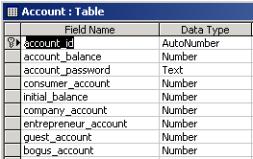

The initial balance is the amount of virtual cash that consumers start with.

Entrepreneurs
Each “entrepreneur” enrolled in the class gets a record in the “entrepreneur” table. The account_id links their name & email to the rest of the simulation. Create the accounts first, then assign them to the entrepreneurs.

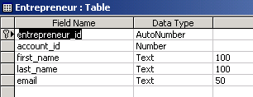

Companies
This table defines the name, home directory, and basic financial information for the companies. Most of these fields are computed by Vcommerce based on consumer activity, but several must be set up by the administrator. These include:
- Company letter (corresponds to the letter in the include vars)
- Company name
- Company home dir (the pathname for the FTP & web site for the company)
- company banner file (should be banner.gif or banner.jpg)
- in_business: must equal 1 or else they are “out of business”
- hit_count_adjustor: should equal 1 for most Vcommerce businesses. But if a site uses frames that load multiple files, this can artificially increase the page hits. Students will probably not catch on (or care), but if they do, this factor can be used to level the playing field. Set it equal to the number of panes in the frame.

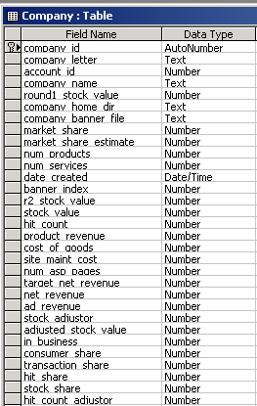

Company-Entrepreneur
This table implements a many-to-many relation between the entrepreneurs and the companies. This creates the possibility of entrepreneurs (students) being involved in more than one company. Realistic, but a grading nightmare!

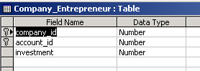

Consumers
This table contains fields for first/last name, but this information is not collected or used anymore. Email is the only identifier that links the actual person back to the game. The rest of the table is survey/demographics. These records are created when the person first logs on using a unique ID.
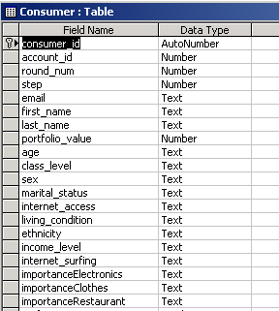

Consumer Stock purchases
There is one record created in this table for each stock that a consumer selects.
Make sure to delete all records in this table before each round.

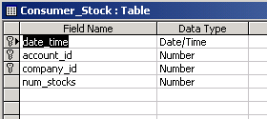

Tracking Hits

There is one record created in this table each time a consumer loads a page.
Make sure to delete all records in this table before each round. When linked to the consumer and company tables, this data can provide hours of wonderful homework analyzing consumer surfing patterns!

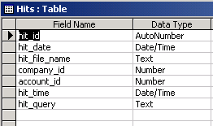

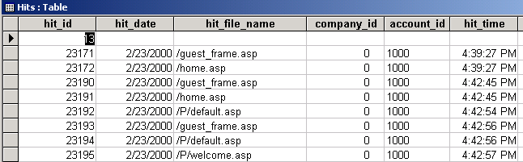

Transactions
There is one record created in this table each time a consumer executes a transaction using purchase.asp or broker.asp. Make sure to delete all records in this table before each round. This data can provide hours of wonderful homework analyzing consumer shopping patterns!

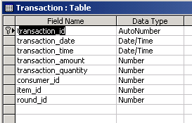

News
The news table is used to store advertisements that will be sent to consumers during a round. Since it is indexed by date, there is no need to worry about clearing it out.
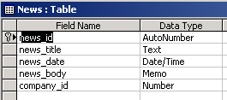

Item
The item table is used to store descriptions of the goods and services that Vcommerce businesses will sell. It is maintained by students (from the /companies page). The item_price_current field is used for pricing transactions. The item_cost is intended to reflect the cost of goods sold. You may want to encourage students to audit each others’ assumptions on the realism of these values, since unrealistically high or low values can undermine confidence and enthusiasm for the simulation.

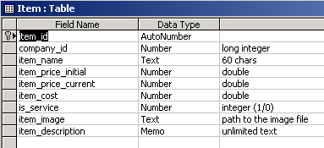

Running a round
Chapter
3
This chapter will describe the administrative activities involved in running a round of VCommerce. It will include the reports and emails that should be generated.

Debug the businesses
It is important to think of your VCommerce site as one large active server page application. When a consumer logs in, they can visit any/all of the businesses. It is important that the whole site, including all of the student businesses, function well together. Some typical problems:
- ASP & ODBC errors: banish them!
- Frame reloading needlessly: target = main
- Links to outside sites: discourage them
- Missing pages: report them
The most challenging programming task that students are required to do for their VCommerce business is building the purchase forms and making them submit properly to purchase.asp. It is a good idea to check at least one purchase form on each company site to make sure that students have understood how to make them work properly.

Drum up consumers
This is the number one risk factor. Ideally, you want at least 100 consumers. You can handle 500 or more on a modest NT server with no trouble. Extra credit assignments in large undergraduate marketing courses are one possibility.

Assign accounts
The current VCommerce implementation requires you to create records in the Account table in the database, which has at least the account number and password required to log in, and an amount of virtual cash. There are two ways of doing this.

- Use Admin Interface
From the Admin pages you can access the “Add New VCommerce Users”. This interface requires you to enter email, first name, and last name for each new user. It will then assign account numbers and passwords, and display them on a page that you can print out. This method is only good if you need to add a few users, and if you have the required information.

- Create VCommerce Invitation Cards
When you need to create hundreds of new accounts and invite users to participate, a faster way is to generate at text file with accounts and passwords, which then are merged with a Word document that has an invitation card template.
There is a file in the admin directory named add_accounts_fast.asp, which you can configure and run to create a text file on your hard drive with the number of accounts you need. In this case, users will be prompted to enter their email address at first login.

In the next VCommerce release, a signup mechanism will be added on the main interface to avoid the administrative hassles of having to distribute accounts.

VCommerce file structure
Chapter
4
This chapter overviews the files in the VCommerce distribution.

Directory | File (.asp by default) | Description
Root | consumer_frame | Used in the left frame when a consumer has logged in. Displays account balance information, links to the different steps and the banner links to the different companies.
Root | default | The default application file. Contains the login form.
Root | global | An application file where global application and session variables can be created.
Root | guest_frame | Same as consumer_frame, but without account information.
Root | help | Help page. Contains a form where users can contact the administrator with questions, comments and bug reports. The "To" e-mail address is a session variable set in global.asa.
Root | home | The home page in the main frame after login (or entering as a guest). Contains description of the consumer steps.
Root | login | Log in process
Root | logoff | Log off process
Root | purchase | Purchase process
Root | Broker.asp | Purchase, but with a percentage or flat fee. Allows consumers to purchase from each other, with appropriate ID.
Root | Questionnaire1 | Entrance questionnaire page
Root | Questionnaire1_submit | Entrance questionnaire processing
Root | Questionnaire2 | Exit questionnaire
Root | Questionnaire2_submit | Exit questionnaire processing
Root | stocks | Stock option selection page with links to business plans.
Root | stocks_submit | Stock option selection processing
Root | thankyou | "Thank you for participating" page. Displayed upon completion of step four.
Root | vcommerce | The page that contains the frameset: LEFT frame and MAIN frame.
Root | welcome | This page is shown immediately after logging in (does not apply to guest login). It contains a more personal greeting to the consumers along with descriptions of the consumer steps.
include | frame_script.html | This JavaScript should be included in all company pages. It checks if a file is loaded outside the frame, and if so, it pulls the file back into the main frame.
include | include | This file should be included in all company pages. It stores a hit in the database when a page is requested.
include | vars.ins | This file contains important system variables that are unique to each application - such as file paths.
companies | additems | Contains a form that company owners use to add product names and prices in the database.
companies | additems_confirm | Confirms and displays that new products have been added for a company. Assigned products ids are displayed for each product.
companies | additems_submit | add new items processing
companies | company.asp | Contains information and links unique to an individual company.
companies | dailynews | Contains a form where a 400 character add can be submitted to the daily newsletter.
companies | dailynews_submit | Daily news add processing
companies | default | The default page in the "companies" directory. Contains a list of all the companies and links to their individual company pages.
companies | edit_item | Company owners can change name and price of their products on this page. The edit item processing is also contained in this file.
companies | items_sold | A page that displays a company's products and the number of sold item sold in each round.
businessplans |  | Contains company business plans (companyletter.pdf or companyletter.doc).
admin | default | This page is loaded by default when vcommerce.hawaii.edu/admin is accessed. It provides access to user management and statistics pages.
admin | users | Listing of existing VCommerce users, that is, entrepreneurs and consumers.
admin | create_users | Create new users page. Initially the user will see a screen where (s)he can choose to create a consumer or entrepreneur accounts, and specify one of three methods to assigned money to the account.  - Assign a specific amount all new accounts.  - Assign a random amount that falls within a specific range.  - Assign money to each account manually.  Once the above choices are submitted the pages reloads with a form based upon the selections. The form requires a first name, last name and email address of the new user.
admin | create_users_submit | This file processes the create new users form when it is submitted, and stores the new users in the database.
admin | create_users_confirm | This page confirms and displays the new user additions.
admin | statistics  stocks.  transactions  customers  hits  distinctconsumers | The statistics page provides access to pages where simple statistics are retrieved from the database. The statistics are:  - Acquired stocks for each company.  - Number of transactions per company.  - Number of customers per company.  - Number if page hits per company.  - Number of consumers participating.
admin | entrepreneur_report | This file generates the entrepreneur report. It can be run by requesting the file manually or by adding it to system scheduled tasks.
admin | consumer_email | This file generates the consumer e-mail. It can be run by requesting the file manually or by adding it to system scheduled tasks.

Frequently asked questions
Chapter
5
This chapter contains answers to questions asked by new administrators of VCommerce.

