MAKAHIKI: AN OPEN SOURCE SERIOUS GAME FRAMEWORK FOR SUSTAINABILITY EDUCATION AND CONSERVATION
Yongwen Xu, Philip M. Johnson, George E. Lee, Carleton A. Moore, Robert S. Brewer
Collaborative Software Development Lab, University of Hawaii at Manoa, Honolulu, HI 96822 USA
{yxu, johnson, gelee, cmoore, rbrewer}@hawaii.edu

ABSTRACT
Sustainability education and conservation have become an international imperative due to the rising cost of energy, increasing scarcity of natural resource and irresponsible environmental practices. This paper presents Makahiki, an open source serious game framework for sustainability, which implements an extensible framework for different organizations to develop sustainability games. It provides a variety of built-in games and content focused on sustainability; game mechanics such as leaderboards, points, and badges; a variety of common services such as authentication, real-time game analytics and ability to deploy to the cloud, as well as a responsive user interface for both computer and mobile devices. The successful implementation of six sustainability educational games in different organizations provides evidence regarding the ability to customize the Makahiki framework successfully to different environments.

KEYWORDS

Sustainability Education, Serious Game, Gamification, Cloud
- INTRODUCTION
The rising cost, increasing scarcity, and environmental impact of fossil fuels as an energy source makes a transition to cleaner, renewable energy sources an international imperative. Moving away from petroleum is a technological, political, and social paradigm shift, requiring citizens to think differently about energy policies, methods of generation, and their own consumption than they have in the past. Unfortunately, unlike other civic and community issues, energy has been almost completely absent from the educational system. To give a sense for this invisibility, public schools in the United States generally teach about the structure and importance of our political system (via classes like “social studies”), nutrition and health (through “health”), and even sports (through “physical education”). But there is no tradition of teaching “energy” as a core subject area for an educated citizen, even though energy appears to be one of the most important emergent issues of the 21st century.
Another emergent issue is the explosive spread of game techniques, not only in its traditional form of entertainment, but across the entire cultural spectrum. The adoption of game techniques to non-traditional areas such as finance, sales, and education has become such a phenomenon that the Gartner Group included “Gamification” (Deterding 2011) on its Hype List.
This paper describes Makahiki, an open source serious game framework for sustainability education and conservation, in which we attempt to create synergy between these two emergent issues. The result of over three years of research and iterative development, Makahiki explores one section of the design space where virtual world game mechanics are employed to affect real world energy behaviors. The goal of the Makahiki project is to provide a framework for organizations to learn to not just affect energy behaviors during the course of the game, but to produce long lasting, sustained change in energy behaviors and outlooks by participants.
We initially used Makahiki to create an energy challenge called the Quest for the Kukui Cup (hereafter, the Kukui Cup) for approximately 1,000 first year students living in four residence hall towers at the University of Hawaii in 2011. During the three weeks of the competition, over 400 of the eligible students played the game, for a total of 850 game play hours. The game mechanics were designed to create a self-reinforcing virtuous circle between the real world and virtual world activities. The challenge was well received and has been repeated in academic years 2012 and 2013 at the University of Hawaii. In addition, Makahiki, as a serious game framework, has been used in several organizations including Hawaii Pacific University and the East West Center, an international education institute in Hawaii, to implement their own version of the Kukui Cup serious game.
In this paper, we detail the innovative features of Makahiki framework, along with our experiences using them to implement several serious games related to sustainability education and conservation in different organizations.
- RELATED WORK
Our research draws on previous work done in the areas of energy behavior research, energy competitions, gamification, and serious games.
To reduce energy consumption, providing energy feedback is a critical foundation. Darby's survey of energy consumption studies from the past three decades found that consumption in identical homes could differ in energy use by a factor of two or more depending on the behavior of the inhabitants (Darby 2006). Another survey of energy feedback conducted by Faruqui et al. found that residents that actively used the in-home displays with near-real-time feedback averaged a 7% reduction in energy usage (Faruqui 2009). Darby also points out that feedback alone is not always enough: other factors such as training could lead to higher rates of energy conservation (Darby 2000).
Energy competitions or challenges have been introduced to college dormitories and residential homes as ways to facilitate and incentivize energy reduction. Petersen et al. describe their experiences deploying a real-time feedback system in an Oberlin College dorm energy competition in 2005 that includes 22 dormitories over a 2-week period (Petersen 2007). Web pages were used to provide feedback to students. They found a 32% reduction in electricity use across all dormitories. The Building Dashboard (Lucid Design Group 2008), developed by Lucid Design Group, is used to support Oberlin's dorm energy competition, as well as the Campus Conservation Nationals, a nationwide electricity and water use reduction competition on college campuses (Lucid Design Group 2011). The Building Dashboard enables viewing, comparing and sharing building energy and water use information on the web in compelling visual interface, but the cost of the system creates the barrier for wider adoptions. In addition, the building dashboard solutions focus on providing energy information as a passive media. There is little interaction between participants and the system.
Games on the other hand, have been shown with great potential as successful interactive media that provide engaging interfaces in various serious contexts (McGonigal 2011, Reeves 2009). Priebatsch attempts to build a game layer on top of the world with his location-based service startup (Priebatsch 2010).
Reeves et al. described the design of Power House, an energy game that connects home smart meters to an online multiple player game with the goal to improve home energy behavior (Reeves 2011). In the game, the real world energy data are transformed into a “more palatable and relevant form of feedback”, and players may be incentivized by the in-game rewards to complete more energy-friendly real-world behaviors.
ROI Research and Recyclebank launched the Green Your Home Challenge as a case study of employing gamification techniques online to encourage residential green behavioral changes offline (Haiges 2011). Working with Google Analytics, the results show a 71% increase in unique visitors and 97% of participants surveyed said that the challenge increased their knowledge about how to help the environment.
The blending of real and virtual worlds has been explored in broader contexts. McGonigal designed the award winning serious Alternative Reality Game (ARG) “World Without Oil” (Electric Shadows 2010) and later “Evoke” (World Bank 2010) with the goal to empower people to come up with creative solutions to our most urgent real-world problems. ARGs have also been used to support learning. Connolly et al. discuss the development of an educational ARG to motivate secondary school students across Europe to learn foreign languages (Connolly 2009). The results of the pilot run of the game in 2009 indicated that 92% of students felt the game motivated students to learn a second language. One of problems the team identified is the limitation of Moodle platform the game is based on.
The report of the ARGOSI project provides insights to the use of ARGs in game based learning and the challenges in the field of higher education (Whitton 2009). The pilot was run at the University of Bolton with the aim to provide an engaging alternative to traditional methods of introducing students to university life. The overall up-take of the game was fairly low with only 23 active players out of 173 total. The project identifies a number of questions surrounding educational ARGs, such as motivation, relationship to curriculum, marketing and timing. The report suggests that a complete ARG model may not be appropriate for wholesale learning, but there is certainly potential in using game elements.
- Makahiki System Design
Makahiki is an open source “serious game framework for sustainability”. It provides a framework for creating serious games for the purpose of education and behavioral change regarding energy, water, food, and waste generation and use. Makahiki intends to create synergy between the need to create knowledge and engagement regarding energy and the ability of so-called “serious game” techniques and energy feedback to create participation and engagement.
Makahiki consists of a configurable game engine that can be customized to the needs of different organizations. It includes a library of pre-built game “widgets” that implement a variety of game mechanics. Using the widgets, an organization can create a custom energy challenge in which players can compete individually and/or in teams to earn the most points by reducing their energy consumption as well as by learning about energy concepts in general.
Figure 1 illustrates a home page of the system implemented by using the Makahiki framework.
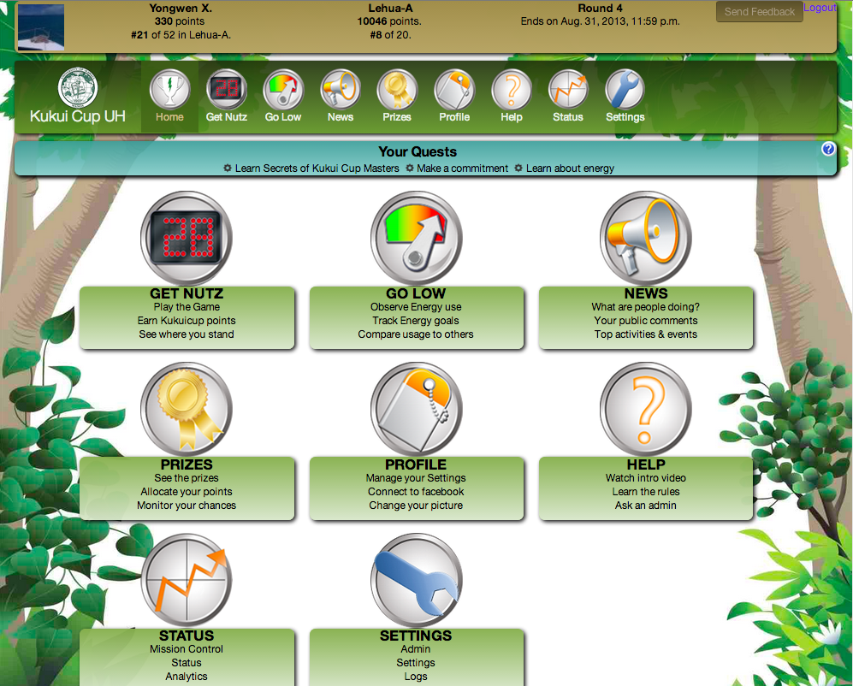

Figure 1. Makahiki home page

3.1 Architecture
Figure 2 illustrates the overall architecture of Makahiki.
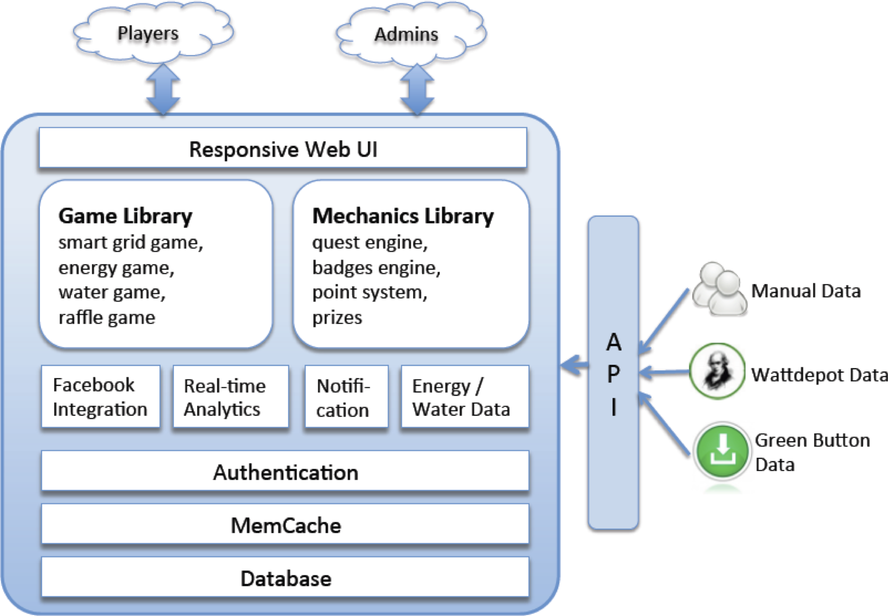

Figure 2. Architecture of Makahiki
The core component of Makahiki is a configurable game engine that can be customized to the needs of different organizations. It includes two libraries of games and game mechanics. These libraries consist of a set of pre-built “widgets”. By selecting and configuring these game and game mechanics widgets, an organization can create a customized serious game.
Makahiki interfaces with the outside environment in three different ways. First, the top side of the architecture diagram shows that Makahiki has two primary user interfaces: one for the players of the serious game, who directly interact with the game and game mechanics widgets; the other for the administrators of the system, who configure the system and monitor the real-time game analytics.
Second, the right side of the diagram illustrates that Makahiki must obtain real-world environmental data as the challenge progresses in order to provide feedback to users about the impact of their actions. In some cases, environmental data can be input automatically into the system through a combination of “smart” meters and additional services, such as WattDepot (Brewer 2011) for energy data collection, storage, and analysis). If that is not possible, then manual meters can be read by administrators on a regular (typically daily) basis and input into Makahiki using and administrator interface.
Third, the bottom side illustrates that Makahiki stores its data in a database repository (currently PostgreSQL). To reduce database access and improve performance, Makahiki provides support for caching (currently memcached).

3.2 A Library of Configurable Games and Mechanics
Makahiki builds in a set of configurable games and mechanics that can be turned on or off, or customized by the game designers to the needs of different organizations.

3.2.1 Energy and Water Game
A fundamental requirement for enabling more active participation in sustainability behavior is feedback regarding their resource such as energy and water usage. The Energy and Water game in Makahiki are implemented as the Daily Resource Goal Game. The Daily Energy Goal Game widget provides a way for players to see the outcome of the energy reduction behavior, and to make it a game by earning points from their behavior. By reducing their teams' daily energy consumption from a baseline by a set percentage, the players in the team will all earn the configured amount of points. Figure 3 illustrates this widget.
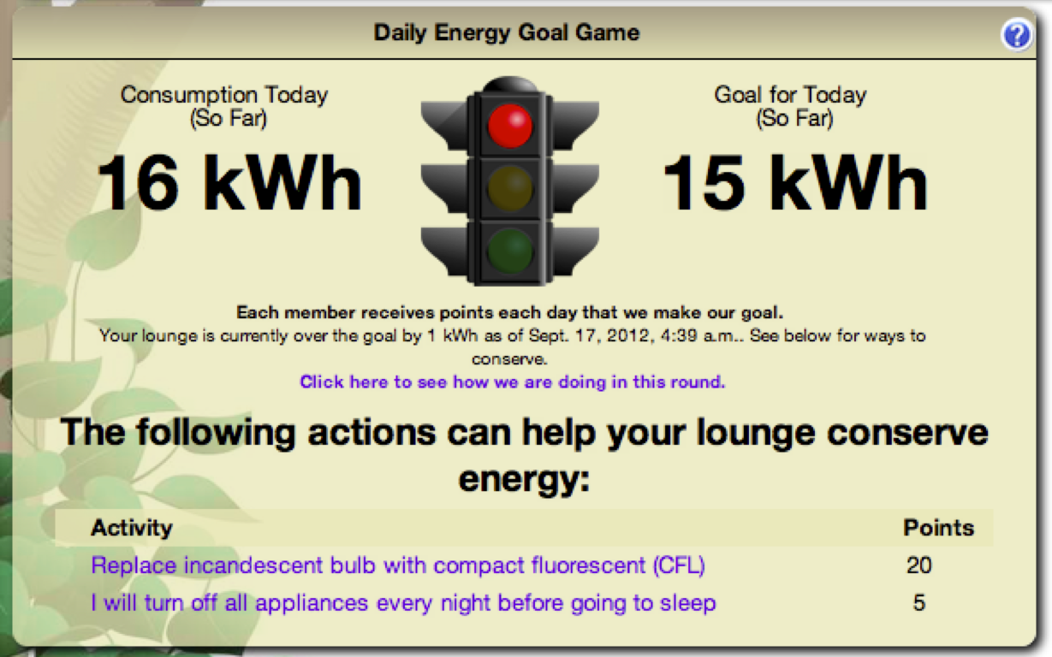 | 
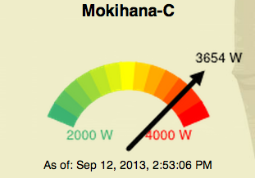
Figure 3. Daily Energy Goal Game Widget
This interface uses a stoplight metaphor to show at a glance whether or not the team is making the goal. In this case, the stoplight is green, indicating they are currently below the goal. We have found additional perspectives of the energy feedback to also be useful. One useful perspective to a team is a real time power meter visualization that shows the current power usage of a team. This visualization displays the real time power consumption which updates at a specified interval such as 10 seconds. Another useful perspective to a team is a historical, calendar-based visualization that shows the results of the energy goal game for each day of the current round.

3.2.2 Smart Grid Game
Smart Grid Game (SGG) is Makahiki's approach to support “gamified” delivery of educational experiences. Educational actions are organized into a grid of squares (hence the name “Smart Grid”) and organized by category columns and levels. Players use its grid interface to discover “actions” they can perform. Successful completion of an action earns the player a variable number of points depending upon the difficulty of the action, and can potentially “unlock” additional actions and higher levels in the SGG. Figure 4 shows a typical Smart Grid Game interface for players:
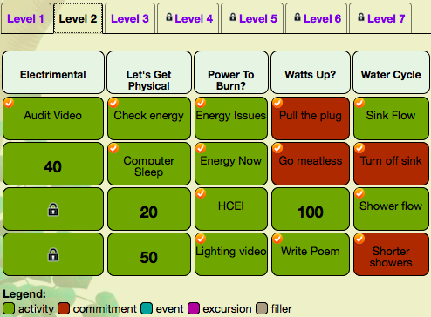

Figure 4. Smart Grid Game widget
To make your SGG more interesting to players, and more pedagogically sophisticated, Makahiki supports the definition of “path” through the educational content or actions. In most cases, when a new player sees the SGG for the first time, there should only be a few actions available to them‚ possibly only one. All of the rest should be locked. Makahiki provide a set of predicates that can be used to define the path. The predicates determine if an action or level is locked or unlocked for a player, which in term depends on the outcome of another action or multiple other actions.

3.2.3 Raffle Game
The Raffle Game widget provides a way to incentivize participation from all individuals, even those who are not in the running for a top prize. For every 25 points a player earns, they receive one virtual raffle ticket. Players can dynamically allocate their tickets to any raffle prizes they are interested in at any time, up to the end of the raffle. Figure 5 shows an example of the Raffle Game.
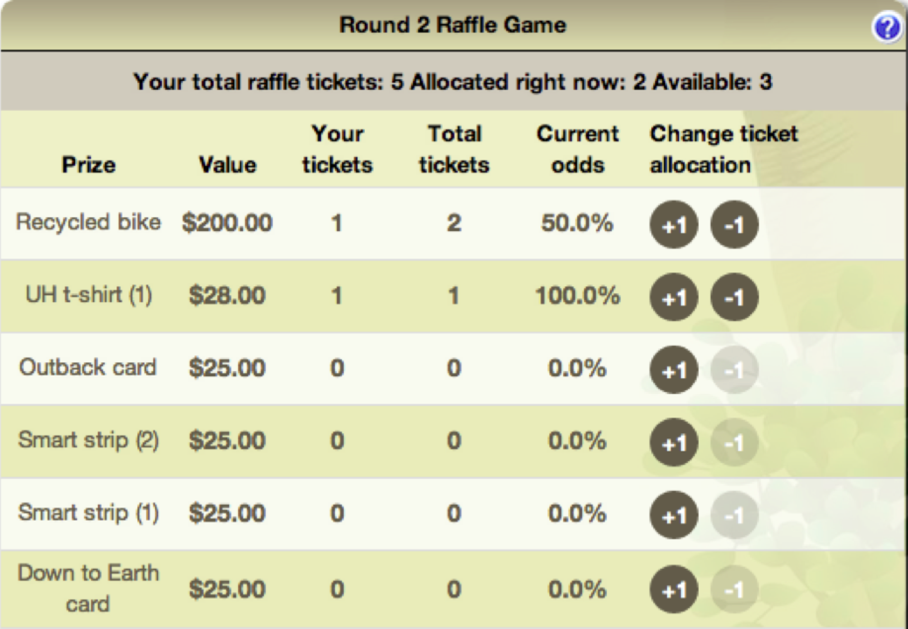

Figure 5. Raffle Game widget
Raffle tickets are independent from a player's score, and allocating a raffle ticket does not affect their rank. The system provides random selection of the winner of each raffle item at the end of a round.

3.2.4 Social and Referral Bonuses Game Mechanics
The Social and Referral Bonus widgets are the game mechanics that help encourage participation by providing additional points to players who participate in activities with other players, and facilitate the entry of new players into an energy challenge.
The social bonus is a configurable option when an action is created in the Smart Grid Game. Players earn extra points if they perform the action with another player. When a player submits a response for an action with a social bonus, the player can provide the email address of the person who jointly completed the action. Once the other player completes the action, the social bonus is awarded.
Players are led through a setup process when logging into Makahiki for the first time. One of the steps in this process is the referral bonus. If a player was referred by another player in the system, he can use this step to input their email address. Once the new player earns a certain number of points in the competition, both players are awarded a referral bonus of a configurable number of points.

3.3 Real-time Analytics
Makahiki is designed to support energy challenges involving hundreds or thousands of users lasting weeks or months. In these circumstances, effective use of the technology requires the ability to understand the state of the game, such as: Who is using it? What are they doing? What is the player response to activities, commitments, excursions, and events? Such state information is important for planning purposes, such as assessing the transportation needs for an upcoming excursion by seeing how many players signed up. It can also be used for making in-game changes to game design, such as changing the point values associated with activities to encourage or discourage participation. It can also help identify breakdowns in game play, such as significant numbers of unallocated raffle tickets indicating that users do not understand the nature of that game mechanic. To address these needs and others, Makahiki includes a variety of widgets that work together to provide high level overview of game play state to the administrators of a challenge.

3.4 Cloud deployment support
Another Makahiki feature is the ability to deploy to a cloud platform such as Heroku. Cloud computing has the advantage of simplifying IT administration by eliminating the need to acquire and maintain hardware and operating system software. This also can dramatically decrease the cost of deployment. Figure 6 shows a screen shot of the Dashboard showing the 2012 East West center Kukui challenge deployed in Heroku, one cloud platform provider, and the monthly cost for this deployment.


Figure 6. Heroku cloud deployment
- Experiences with Makahiki
We have used Makahiki to create six different energy and water serious game instances, all called “Kukui Cup” challenges. Three Kukui Cup Energy challenges were held at the University of Hawaii (UH) in 2011, 2012 and 2014 for over 1,000 first year students each year living in the residence halls. Hawaii Pacific University (HPU) held a Kukui Cup Energy challenge in 2012 and 2013 for about 200 students each year. An international organization called the East-West Center (EWC) held a Kukui Cup Energy and Water challenge for approximately 600 international residents living in their residence halls in 2012. Since the EWC residence halls did not have internet-enabled meters, resource consumption data had to be entered by the game managers manually.
The successful creation of these serious game challenges by three different organizations provides evidence that Makahiki can be successfully tailored to the needs of different organizations. First, UH and HPU used different metering infrastructure, and EWC collected their resource data manually. Second, while UH and HPU challenges involved only energy consumption data, the EWC challenge involved both energy and water consumption data. Third, the IT infrastructure at UH and HPU provided authentication services using CAS (Central Authentication Service) and LDAP, while EWC used the built-in Django authentication. Fourth, the user interface was customized to “brand” each challenge with the logo, thematic elements, and the education contents of the sponsoring organizations.
The evaluation of Makahiki includes both qualitative and quantitative sources of data regarding the system. Makahiki provides custom quantitative instrumentation that enables us to track when, where, and for how long each player accessed each page of the site. Unlike generic web server logs, we could track per-player application-specific behaviors. We also gathered qualitative data through a survey that players could complete as part of a Smart Grid Game activity during the final week of the competition. The survey asked participants to provide short answers to questions regarding the way the competition and website was designed. 41 players completed this survey.
In response to a survey question asking how the player might describe the Kukui Cup, 83% said “Fun”, 95% said “Educational”, while 7% said “Difficult” and 2.3% said “Boring”. In response to the question, “What was confusing in the website”, 46% of the players said “Nothing”, and 32% of the players also responded “Nothing” in response to the question, “What would you change about the website? When asked what they liked most about the website, 60% of the survey respondents said “ease of use”. Instrumentation also indicates that the game was generally easy to use. 73% of the 418 players never accessed the “Help” page, and only 5% of the players sent questions to the administrators. The data bear out the success of the raffle game. Players mentioned the raffle game repeatedly as the most interesting incentive in the game, and over half the students with at least 100 points participated in the Raffle.
To assess the effectiveness of the framework for designing games that improve player literacy in sustainability, we conducted two energy literacy surveys during the 2011 Kukui Cup Challenge at the University of Hawaii at Manoa. One survey was administrated before the challenge (pre-game) and one after (post-game). 24 players completed both surveys. Out of the total 19 energy literacy questions, the average number of questions answered correctly is 7.54 before the challenge, and 8.96 after the challenge. This result indicates an 18% improvement on the energy literacy. We also surveyed non-players as a control condition, and found that their literacy did not change, indicating that the improvement in player literacy was indeed due to the game.
To assess the effectiveness of the framework for designing games that produce positive change in sustainability behaviors, we recorded and analyzed energy consumption data before, during and after the challenge. Before the challenge, an energy usage baseline was established. During the challenge, compared to the baseline, 12 out of the total 20 teams reduced their energy consumption, with the highest reduction of 16.1%. However, 3 teams actually increased their energy consumption, with the highest increase of 11.7%. Overall, the average reduction of the 20 teams was low, approximately 2%.
We also assessed player engagement of the game. We calculated a variety of engagement metrics based on the analytics data collected by the Makahiki framework. The participation rate of this challenge is 37%, which is good compared to other sustainability challenges. Over the course of the challenge, an average player spent about 27.7 minutes per day on the website. One player spent 8.5 hours on one day. There were an average of 266 activity submissions and 208 social interactions between players per day. The average number of website errors per day was 0.6. The data indicates that Makahiki can be successful in achieving player engagement and literacy improvement, although the evidence of positive change in behavior is not significant.
- CONCLUSION
The Makahiki research presents an innovative information technology infrastructure that can support effective and efficient development of serious games for sustainability education and conservation that can be used by different organizations. Its tailorability and game analytics also provides a useful platform for research on gamification, sustainability education, and behavior change.
Our research suggests that several enhancements to the Makahiki framework would be useful. One is real-time player awareness. It is not possible currently in Makahiki to know who is currently “on line” and playing the game. Creating this awareness opens up new social gaming opportunities (performing tasks together), new opportunities for communication (chat windows), and potentially entirely new games (play “against” another online player).
Makahiki currently ships with over 100 possible “actions” already developed for the Smart Grid Game. However, the content is intimately tied to the Smart Grid Game implementation. An enhancement is to provide a “content management system” for “actions”, separating “content” from the “presentation”, thus new contents can be added and more games can be developed using this content library.
We are also exploring a future direction involving the development of a consortium of organizations in order to scale the use of the Makahiki framework in new settings. Moving outside of the context of either Hawaii or college-aged players will necessitate development of significant new forms of content, as well as new game mechanics.

ACKNOWLEDGEMENT
This research is supported in part by grant IIS-1017126 from the National Science Foundation; the HEI Charitable Foundation; Hawaii Electric Company; and the State of Hawaii Department of Business, Economic Development, and Tourism.

REFERENCES
Brewer, R.S. and Johnson, P.M. 2010. WattDepot: An open source software ecosystem for enterprise-scale energy data collection, storage, analysis, and visualization. Proceedings of the First International Conference on Smart Grid Communications.
Connolly,T. et al, 2009. Arguing for multilingual motivation in web 2.0: a games-based learning platform for language learning. European Conference on Games Based Learning.
Darby, S. 2000. Making it obvious: designing feedback into energy consumption. Proceedings of 2nd International Conference on Energy Efficiency in Household Appliances and Lighting.
Darby, S. 2006. The effectiveness of feedback on energy consumption. Technical report, Environmental Change Institute, University of Oxford.
Deterding, S. et al, 2011. From game design elements to gamefulness: Defining “gamification”. Proceedings of MindTrek.

Electric Shadows. 2010. World without oil, http://www.worldwithoutoil.org/metaabout.htm
Faruqui, A. et al, 2010. The impact of informational feedback on energy consumption–a survey of the experimental evidence. Energy, 35(4):1598–1608.
Haiges, H. 2011. Gaming for good. Technical report, ROI Research Inc.
Lucid Design Group. 2011. Campus conservation nationals, http://www.competetoreduce.org/, Lucid Design Group, Inc.
Lucid Design Group. 2008. Building Dashboard. http://www.luciddesigngroup.com/, Lucid Design Group, Inc.
McGonigal, J. 2011. Reality is broken: Why games make us better and how they can change the world. Penguin Press.
Petersen, J. E. et al, 2007. Dormitory residents reduce electricity consumption when exposed to real-time visual feedback and incentives. International Journal of Sustainability in Higher Education, 8(1):16–33.
Priebatsch, S. 2010. The game layer on top of the world. http://www.ted.com/talks/seth_priebatsch_the_game_layer_
on_top_of_the_ world.html, TED.
Reeves, B. et al, 2011. Leveraging the engagement of games to change energy behavior. Proceedings of the CHI 2011 Workshop on Gamification.
Reeves, B. and Read, J. 2009. Total engagement: using games and virtual worlds to change the way people work and businesses compete. Harvard Business School Press.
Whitton, N. 2009. Alternate reality games for orientation, socialisation and induction (ARGOSI). Technical report, JISC.
World Bank. 2010. Urgent evoke. http://www.urgentevoke.com/, World Bank Institute.

