Simulating Power Meters Using WattDepot
Robert S. Brewer, Philip M. Johnson
Collaborative Software Development Laboratory, Department of Information and Computer Sciences, University of Hawaii at Manoa, Honolulu, HI, rbrewer@lava.net

Summary
Competitions between dormitories to see which one can conserve the most energy have become a common occurrence on college campuses. Such a competition will take place at the University of Hawaii in the fall of 2010, with power meters recording data at 15-second intervals installed on each floor of two dormitories. The open source WattDepot system for collecting, storing and analyzing energy data was developed to support the upcoming competition. WattDepot has been designed to allow data collection from new devices, and diverse visualizations of the data. While the process of selecting, purchasing, and installing the meters is ongoing, an end-to-end simulation of dorm energy was developed to ensure the WattDepot software sensors would work with any meter. This simulated data source is allowing the development of the competition website months before real power data is available from the dorms.

Motivation
Energy conservation has been proposed as one way to deal with the coming global energy crisis. Previous research has demonstrated that direct energy usage feedback of leads to reductions of 5-15% in energy use, which has been confirmed in dorm competitions. Our research examines the sustainability of energy behavior changes through monitoring energy usage after a competition has ended, and how the energy literacy of participants might impact sustained energy conservation.
To support the dorm competition, we needed a system to collect energy data from meters on each floor of the dorms and visualize it in a variety of formats on the competition website. Systems exist for handling energy data on the individual home scale, such as the TED 5000, and on the utility scale, but we found no open system at a scale between those extremes.

Results
To support the dorm energy competition, we created WattDepot: a general-purpose system for dealing with energy data. WattDepot consists of software sensors that collect data from measurement devices, which is stored in a server repository, and queried by visualization clients as shown in Fig. 1. By using small software sensors to collect data from devices, WattDepot makes it easy to support diverse meters.
After researching power meters to use for the competition, we decided to focus on meters supporting the Modbus/TCP standard. Modbus/TCP is a low-level protocol where clients query registers on the remote meter over the Internet using TCP/IP. However, work on the competition website could not wait for the selection of a meter vendor, let alone their installation. Therefore, we decided to create simulations of both the potential meters being considered and the data they would be recording. Fig. 2 shows a diagram of the data flow in the simulated system. Each meter that supports Modbus records data such as instantaneous power and energy used in registers, and the locations are different for each manufacturer. The meter simulations respond to queries from WattDepot sensors for the appropriate registers. An embedded simulation of a dormitory floor generates the data that the meter simulations send. Once the data is in the WattDepot server, it can be displayed graphically by the competition website. The use of simulation allows testing of the entire system, including sensors for devices not yet purchased or installed.
Figures
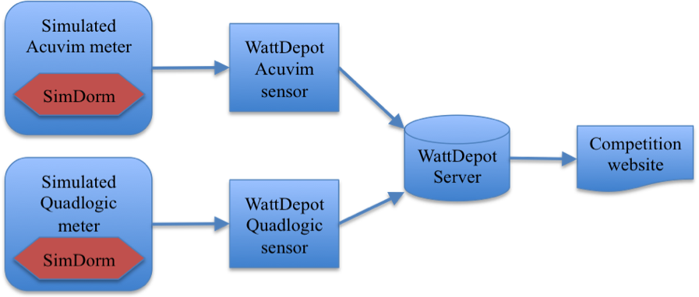
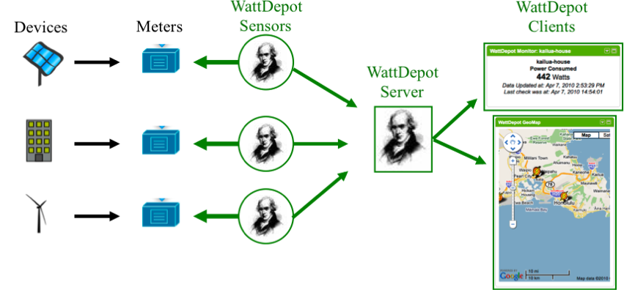
Fig. 1: The WattDepot architecture, showing sensors, server, and clients
Fig. 2: End-to-end testing using simulated meters generating simulated data

R. H. Socolow and S. W. Pacala, “A plan to keep carbon in check”, Scientific American, 295(3):50–57, Sep 2006.
S. Darby, “The effectiveness of feedback on energy consumption”, Technical report, Environmental Change Institute, University of Oxford, 2006.
J. E. Petersen, V. Shunturov, K. Janda, G. Platt, and K. Weinberger, “Dormitory residents reduce electricity consumption when exposed to real-time visual feedback and incentives”, International Journal of Sustainability in Higher Education, 8(1):16–33, 2007.

