Title of Your Contribution
Author A, Author B*,….Author N⁺
Department, Institution/Company, Town, State/Country, Email-Address
…
⁺Department, Institution/Company, Town, State/Country

Summary
Clearly state what is new in this first paragraph. The degree of novelty will be one of the major evaluation criteria in the review process. Relate your work to existing previous work in the field. This very first section should describe your major achievements and represent a summary and conclusions of your contribution in a nutshell. You must not submit work that has already been presented at a conference or has already been published elsewhere. Do not use more than 1000 characters (including spaces) in this section. IMPORTANT: This summary section contains the text that should also be pasted as summary text in the course of the online abstract submission via the Web-Interface. It should thus be self-contained as only this text is going to appear in the Book of Abstracts being distributed at the conference (if your submission is accepted). The two page abstract (i.e. this document) serves for the evaluation of your work in the review process.

Motivation
Here is some space to describe the Background of your work. Cite references using footnotes. You may refer to the Figures you provide on the second page to illustrate basic structures, device designs, etc. (see Fig. 1).

Results
It is mandatory to present sample results in your abstract. Illustrate your approach and latest results by referring to Figures on the second page (see Fig. 2 and Fig. 3). The second page should contain figures only! Do not refer to expected results but present specific existing results instead. Underline the presenting author and make sure that the email address of the contact author is provided (author A in this example). You will indicate the topic category for your submission during the web-based submission process. Used Fonts are “Arial 14pt bold” for Headings and “Times New Roman 11pt” for the text (10 pt for footnotes). If you don’t use this MS-Word template, please adhere to the style as closely as possible. Page dimensions correspond to “letter” size, i.e. 21.59 cm (width) by 27.94 cm (height), left and right margins are 2.54 cm each, top and bottom margins are 1.25 cm and 2.54 cm respectively. Please upload your abstract in PDF format via the conference submission website.
Figures
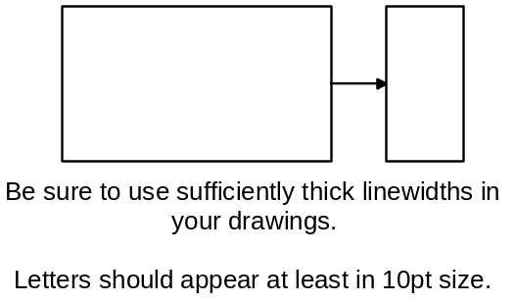
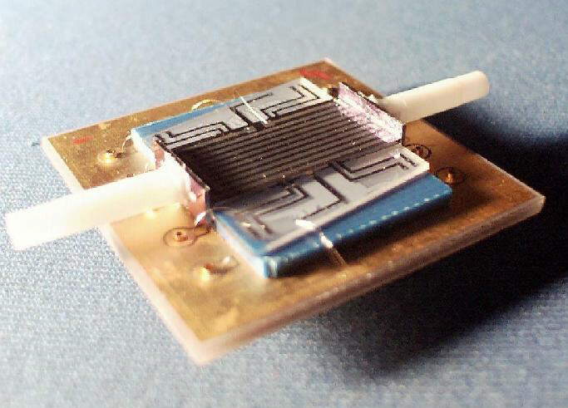
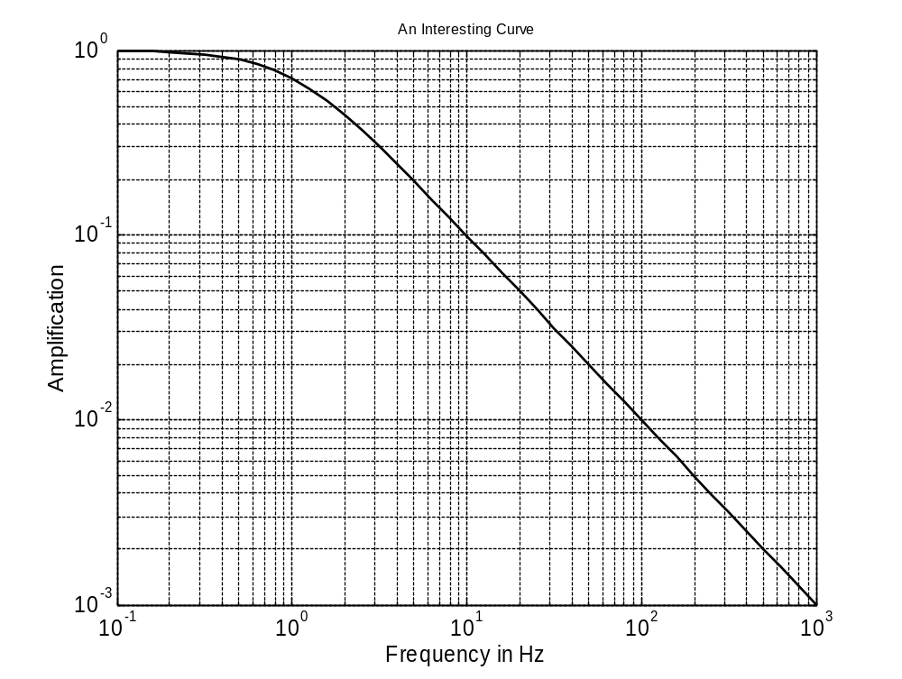
Fig. 1: Briefly describe figure contents, preferably self-explanatory.
Fig. 2: When using photos, make sure the resolution is sufficient.
Fig. 3: You may include up to six figures on the second page, a minimum of two is recommended.

J.R. Knoweverything, “Title of important work”, J. Appl. Phys., vol. 38, nr. 6, p. 33-44, 1999.

