Request to move the   
  
Ph.D. in Information and Computer Sciences,   
University of Hawaii at Manoa,   
  
From Provisional to Established Status   
  
Fall 2011

[http://www.ics.hawaii.edu/logo.jpg](http://www.ics.hawaii.edu/)

Table of Contents

Introduction 3

The importance of Computer Science 3

A brief history of the Department of Information and Computer Sciences 3

Assessment of program organization and objectives 4

Overview of Information and Computer Sciences 4

The Ph.D. in Computer Science 6

Demonstration of core competency 6

Coursework 7

The research portfolio 7

Proposal defense 7

Final defense 8

Assessment of student learning objectives 8

Description of learning objectives 8

Assessment of learning objectives 9

Assessment of program resources 9

Faculty resources 9

Research and teaching laboratory resources 11

Information technology and fiscal support resources 12

Department financial resources 12

Assessment of program efficiency 13

Resources required and generated by the ICS Ph.D. program 13

Efficiency with respect to cost and revenue data 14

Ph.D. head count trends 15

Student semester hours 15

Program cost per SSH 16

Comparison of Cost/SSH (B.A. ICS vs. B.S. EE) 17

Revenue 17

Assessment of program quality 18

Faculty research activities 18

Faculty productivity: external funding and refereed publications 22

Time to degree 22

Assessment of program objectives 23

ICS Mission 23

Alignment with the UH Manoa strategic plan 24

Alignment with the UH System strategic plan 24

Alignment with the State of Hawaii 24

Need Factors 25

National and International need factors 25

University need factors 25

Hawai‘i need factors 26

Appendix C: Head counts, student semester hours, and costs 27

This self-study report is organized according to the “Guidelines for Assessment of Provisional and Established Programs” E5.201.

# Introduction

## The importance of Computer Science

About one-third of the economic growth in the U.S. in the last decade has been in information and computing technology. While the Internet and the Web are perhaps the most visible aspects of this change, the revolution is pervasive, touching nearly every field and discipline, from computational techniques in the physical and biological sciences, to new interactive media in the fine arts. The impact of the digital and information revolution upon society is profound. The evolution of computing and information technology will continue to be a driving force behind the creation of new industries, careers, and academic disciplines. As a result, there is a genuine and increasing need for workers with an interdisciplinary background who understand the social and organizational uses of technology and who are literate and articulate. These workers require knowledge of computing systems, global communications networks, and interactive information resources. The requisite proficiencies go beyond being comfortable with computing tools. They require the ability to apply computational ways of thinking to design, to writing, to experimentation, to artistic expression, and to problem solving.

## A brief history of the Department of Information and Computer Sciences

The formative roots of the Department of Information and Computer Sciences (ICS) extend back to the late 1960's. At that time, UH began a project to provide radio-linked satellite computers to the existing University time-shared computing system. The purpose of this project, then known as the ALOHA system, was to make the full information processing capabilities of the central computing facility on the Manoa campus available to all operating units of UH on Oahu and the neighbor Islands. Norman Abramson, the principal designer of the ALOHAnet, whose principles formed the design philosophy of the Ethernet, became the first chair of a new interdisciplinary program that awarded a Master of Science (M.S.) degree in Information and Computer Sciences (the science of processing information by natural or artificial systems). This M.S. program was designed both for students interested in careers in information sciences and those who expected to use information sciences in another profession. Other professors in the initial Information Sciences program included W. Wesley Peterson (a winner of the Japan Prize for his work on error correcting codes), David Pager, (the inventor of an early parser for computer languages), Wilbert Gersch, and Art Lew.

During the early 1970's the Information Sciences program became the Department of Information and Computer Sciences. In the mid 1970’s, Professor Peterson, the ICS chair from 1973 until 1984, initiated an interdisciplinary program leading to B.S. degree in Computer Science. This program was designed to give students an understanding of computers, their operation, programming, and applications, and to provide the knowledge and skill needed for a career in the computer field. Special fields of emphasis for the B.S. degree are computer systems, data analysis, data processing systems, and scientific computation.

In 1986, the ICS Department joined with three other programs, the Department (now School) of Communication in the College of Social Sciences, the Department of Decision Sciences (now Information Technology Management) in the College of Business, and School of Library and Information Studies (now the Library and Information Science program) to provide an interdisciplinary Ph.D. degree in "Communication and Information Sciences" (CIS). In 1994, CIS became organizationally housed in the College of Natural Sciences. In 1995, the ICS Department moved from Keller Hall to the newly constructed Pacific Ocean Sciences and Technology (POST) building. In 1998, the B.A. in ICS and the Ph.D. in Computer Science were established.

In 1997, the School of Library and Information Studies (SLIS) merged with the ICS Department and changed its name to the Library and Information Science (LIS) Program. The LIS Program offered courses through the UH Manoa Outreach College as early as 1957. In 1965, the Graduate School of Library Studies (GSL) was formed. In 1987, the school recognized the rapidly changing world of libraries and information technologies and the role of information in society, by simultaneously changing its name to the School of Library and Information Studies and offering the Master's in Library and Information Studies degree, now the Master of Library and Information Science (MLISc) degree.

Since 2000, the ICS Department has grown substantially. By 2003, the six degree programs[1] associated with ICS at that time accounted for a total of 888 majors, making our Department larger than the entire College of Engineering and the largest Department in the University of Hawaii system. This explosive growth motivated a special legislative allocation specifically to ICS of $1M (which the UH administration made part of the ICS budget) in order to support its mission and students. During this past decade, we have used these additional resources to establish strong research and educational programs in areas including networking, human computer interaction, software engineering, high performance computing, bioinformatics, and information assurance.

Today, the Department continues to aggressively develop its role as a premier educational and research program in Information and Computer Science. The mission of the Department of Information and Computer Sciences (ICS) is to: (1) develop leading edge research that fuels economic and entrepreneurial advances, prepares information and technologically literate citizens, and drives technological improvements in curriculum and teaching and (2) provide professional education for students specializing in computer science and basic computer science education for all interested students.

# Assessment of program organization and objectives

Is the program organized to meet its objectives? (Discussion of curriculum, requirements, admissions, advising and counseling, and other aspects of the program, with reference to the objectives.)

## Overview of Information and Computer Sciences

The Department of Information and Computer Sciences is part of the College of Natural Sciences at the University of Hawaii at Manoa. The Information and Computer Sciences (ICS) Department is solely responsible for six academic degrees:

* Bachelor of Arts in Information and Computer Sciences (approved as provisional in 1998)
* Bachelor of Science in Computer Science (approved in 1974)
* Master of Science in Information and Computer Sciences (approved in 1965)
* Master of Science in Computer Science (approved 1974)
* Professional Master Degree Program in Library and Information Science (approved 1969)
* Ph.D. in Computer Science (approved as provisional in 1997)

The ICS Department participates in two other joint degree programs with other departments on campus:

* Bachelor of Science in Computer Engineering (approved as provisional in 2009)
* Ph.D. in Communication and Information Sciences, Interdisciplinary (approved in 1986)

Figure 1 below shows the enrollment numbers and graduation rates associated with each of these eight programs over the past five years.

Figure 1 shows that our department enjoys a strong and significant enrollment of over 450 declared majors during the past five years. Out of this pool of declared majors, we have graduated between 70 and 126 students per year. Dividing these two numbers provides a rough sense of the "throughput" of our department, which varies between 15% and 25%. We believe that our throughput is currently resource constrained, and that we could improve both the total number of ICS graduates per year as well as the number of semesters required to progress through our program with additional resources.

In addition to these eight majors, we also provide a minor in Computer Science for students who would like to develop a solid foundation in Computer Science in conjunction with their major degree program. Collaborations such as the minor in Computer Science and the two joint degree programs are vital for the department’s mission, for service to the students, as well as for campus collaboration and support. For example, the Bachelor of Science in Computer Engineering (BSCE), a joint initiative between ICS and the Department of Electrical Engineering was approved by the Board of Regents as a provisional program in November 2009. ICS provides the Discrete Math curriculum and up to 6 credits of technical electives towards the attainment of this degree.

  
Figure 1: Enrollment and graduation rates for all ICS degree programs

The ICS department also offers hundreds of seats each year to students looking to fulfill one or more of their general education and/or focus requirements through the ICS program. These course offerings are large and serve a diverse campus population. The department has also created Honors sections for select students in various disciplines. This illustrates the importance of the service courses offered by ICS to other departments.

## The Ph.D. in Computer Science

The Ph.D. is the highest degree awarded by universities in the United States and thus represents the pinnacle of academic achievement. The Ph.D. Program in Computer Science is designed for students who want to contribute to the study of the description and representation of information and the theory, design, analysis, implementation, and application of algorithmic processes that transform information.

ICS Ph.D. students receive advanced training in the scientific principles and technology required to develop and evaluate new computer systems and applications. We equip our students with the expertise necessary to independently perform state-of-the-art research, to formulate and develop creative solutions to novel and existing problems, and to intelligently manage the research of others. Our curriculum covers all major areas of Computer Science, with active research in areas including artificial intelligence, bioinformatics, human-computer interaction, software engineering, machine learning, high performance computing, digital democracy, computer vision, and computer systems.

An applicant may be admitted with a Bachelor’s degree or with an M.S. degree in Computer Science or a related field. If the applicant enters without the M.S., the applicant will earn the M.S. before proceeding to the “Ph.D. portion” of the program.

The ICS Ph.D. curriculum is designed to: (1) Certify the student’s core competency in Computer Science and address any deficiencies in this competency as efficiently as possible, so that the bulk of the student’s Ph.D. program is focused on research. (2) Prepare the student to do research through an apprenticeship with a faculty member, assessing readiness to do research with a research portfolio that is analogous to a professional tenure and promotion portfolio. We achieve these goals by guiding the students through a curriculum with the following components: (1) Demonstration of core competency; (2) Coursework (participation in ICS 690); (3) Preparation of a research portfolio; (4) Proposal defense; and (5) Final defense.

### Demonstration of core competency

The ICS Ph.D. student will demonstrate core competency in Computer Science by meeting the following two requirements:

1. Completion of a Master’s degree in Computer Science or a related field, where what counts as "related" is at the discretion of the graduate program chair, assisted by the admissions committee;
2. Successful completion of the comprehensive exam. The comprehensive exam covers core knowledge of Computer Science at a level that might be reasonably expected of a job interview with a Master’s degree. Students shall take the comprehensive exam at the end of the first semester of the Ph.D. portion of their studies. Student may attempt the comprehensive exam only twice and must pass this exam no later than the end of the first year of their Ph.D studies.

### Coursework

According to Graduate Division guidelines, coursework is optional for University of Hawai‘i Ph.D. programs. However, the ICS Ph.D. program requires all ICS Ph.D. students to attend and pass the seminar course ICS 690 each semester they are in the program. ICS 690 is a one credit seminar course that meets once a week and is directed by the Graduate Chair. It provides an opportunity for all ICS graduate students (both M.S. and Ph.D) to regularly discuss their research issues and problems and gain insight from presentations by other faculty members, other graduate students, and guest lectures by visiting academic and industry professionals.

### The research portfolio

By the end of the year following the passing of the comprehensive exam, the student must prepare and submit a research portfolio that includes the following:

1. A statement of purpose, which is a one to two page description of the student’s professional interests in research, teaching, service, and/or product development;
2. Evidence of core competency, as described above;
3. Evidence of scholarly ability, i.e. the ability to identify, critically analyze, and research a problem, and of written communication skills, in the form of two items authored by the student and reviewed by doctoral level scholars. The first item is a written literature review in the proposed area of study of 20-30 pages, following the graduate division dissertation format and reviewing at least 20 published works. The second item must be one of the following: a masters thesis by the student; a publication by the student in a reviewed conference or journal; or a technical report approved by at least two other faculty members.
4. (Optional) Other evidence of professional capacity, which might include a professional vita of employment, professional presentations, reviewing of papers for conferences and journals, competitive fellowships, patents, teaching, and service on committees or as graduate student representatives contribute to the candidacy decision. Letters of reference may also be included. Students should report all forms of research, teaching, and service to the community and to the discipline when preparing their portfolios.

The portfolio is approved by a two-thirds majority vote of a quorum of the ICS faculty (typically at a faculty meeting). The portfolio shall be distributed to the faculty in advance of the meeting at which it will be voted upon.

The graduate program chair shall designate one faculty to argue for the student’s case and one to argue against the student, who may both vote as they see fit. Faculty that have a conflict of interest with the student (e.g., advisor or co-advisor, co-author on research articles, direct supervisor) cannot serve in these capacities.

The portfolio must be approved before undertaking the Proposal Defense.

### Proposal defense

Before commencing the final dissertation research, the student shall give a public defense of his or her Ph.D. proposal. Students prepare a research proposal that includes a literature review in the chosen topic area (this usually is but is not required to be derived from the literature review from the portfolio) and a description of research topics to be investigated. This work should be done under the direction of an appropriate faculty adviser. Students must also form their dissertation committee prior to the proposal defense.

The defense includes both a presentation of the student’s research proposal and an oral examination covering their general preparation for the research involved, as specified in the General and Graduate Information Catalog.

It is generally advised that the proposal defense be scheduled for a time period of 3 hours.

Once the student passes the proposal defense, they then conduct their research and write a dissertation under the direction of their advisor and their dissertation committee.

### Final defense

The final defense is a public presentation of the student’s completed research and dissertation. The dissertation must be presented to and approved by a doctoral committee, as specified in the General and Graduate Information Catalog.

We believe that our five step process of demonstrating core competency, coursework, preparation of a research portfolio, proposal defense, and final defense, when combined with our graduate curriculum and research areas, creates an effective and efficient program for students who wish to contribute to the study of the description and representation of information and the theory, design, analysis, implementation, and application of algorithmic processes that transform information. Our program is thus organized in such a way as to meet its objectives.

# Assessment of student learning objectives

Is the Program meeting its learning objectives for students? (An assessment of the quality of student learning as indicated by systematic analysis of student performance with reference to standard expectations, surveys of student satisfaction with instructional aspects of the program, etc.)

## Description of learning objectives

We have defined nine student learning objectives for the ICS Ph.D. program, six of which are shared with our M.S. program plus an additional three learning objectives specific to the Ph.D. program.

The ICS M.S. graduate program provides courses for advanced education in Computer Science and affords opportunities to conduct research. Our objective is to help students achieve a high level of professional competence and lifelong learning, with the following Student Learning Objectives:

1. Master core Computer Science theoretical concepts, practices and technologies;
2. Identify, formulate and solve problems employing knowledge within the discipline;
3. Contribute effectively to collaborative team oriented activities;
4. Communicate effectively about Computer Science topics using appropriate media;
5. Demonstrate advanced knowledge in an area of specialization within the discipline;
6. Engage in significant research in their area of specialization within the discipline and/or in projects that respond to community and industry needs.

The ICS Ph.D. graduate program provides advanced, individualized training in research in Computer Science, preparing students for research careers in academia and industry. Beyond those for the M.S. program, the Ph.D. program involves the three following Student Learning Objectives:

1. Develop a research portfolio that demonstrates the capacity to carry out original research in the field;
2. Become an expert in the area of specialization including mastery of the relevant research skills and methods, develop a research vision, and formulate a research plan that will lead to novel scientific contributions;
3. Execute a research plan and demonstrate original contributions to the field, as shown through findings and/or publications, culminating in a Ph.D. dissertation and oral defense.

## Assessment of learning objectives

Our development of empirically based assessment procedures for these student learning objectives is ongoing. For example, we are planning an “exit interview” procedure in which we can gather data directly from each graduating student regarding their subjective view as to whether each of these student learning objectives were achieved. We also plan to classify each course in the curriculum according to the program SLOs that it covers, which would provide an additional level of 8 evidence regarding assessment and coverage by noting which courses the student took during their program.

Although development of assessment procedures is ongoing, we believe strongly that the basic structure of our program as described above ensures that successful graduates have satisfactorily achieved all of these learning objectives, as illustrated in Table 1.

Table 1: Ph.D. program components and satisfaction of student learning objectives

|  |  |
| --- | --- |
| **Ph.D. program component** | **Student Learning Objective(s)Addressed** |
| Demonstration of core competency | 1 |
| Participation in ICS 690 | 3, 4, |
| Preparation of a research portfolio | 2, 4, 5, 7, 8 |
| Proposal Defense | 1, 2, 4, 5, 6, 8 |
| Final Defense | 1, 2, 4, 5, 6, 8, 9 |

# Assessment of program resources

Are program resources adequate (Analysis of number and distribution faculty, faculty areas of expertise, budget and sources of funds, and facilities and equipment)

Due to the overlapping nature of our M.S. and Ph.D. degree programs, and the level of shared infrastructure between graduate and undergraduate programs, it is impossible to provide a precise accounting for the department resources dedicated solely to the Ph.D. degree program. In order to provide an appropriate perspective, this section presents the resources associated with the ICS Department as a whole, not just the resources associated with the Ph.D. program.

## Faculty resources

The ICS faculty is a diverse and well qualified group. A brief listing of our faculty and their areas of expertise follows.

#### Professors

* M. Crosby, Ph.D. (Chair)—human-computer interaction, augmented cognition, computer science education
* D. Chin, Ph.D.—artificial intelligence, natural language processing, user modeling
* P. Johnson, Ph.D. (Associate Chair)—renewable energy, software engineering
* D. Suthers, Ph.D.—human-computer interaction, computer-supported collaborative learning, technology for education, socio-technical networks and online communities

#### Associate Professors

* E. Biagioni, Ph.D.—networks, systems, languages
* K. Binsted, Ph.D.—artificial intelligence, human-computer interaction, cognitive science, natural language processing
* H. Casanova, Ph.D.—high performance computing, distributed systems
* G. Poisson, Ph.D.— bioinformatics, computational biology
* L. Quiroga, Ph.D. (ICS/LIS)—information retrieval, databases, library systems, website design
* N. Reed, Ph.D.—artificial intelligence, autonomous agents
* S. Robertson, Ph.D.—human-computer interaction, digital government and digital democracy
* J. Stelovsky, Dr.Tech.Sc.—computer-hypermedia, human-computer interaction
* S. Still, Ph.D.—bioinformatics/theoretical biology, information theory, machine learning
* K. Sugihara, Dr.Eng—algorithms, distributed computing, visual languages

#### Assistant Professors

* K. Baek, Ph.D.—computer vision, machine learning, bioinformatics
* R. Gazan, Ph.D. (ICS/LIS)—social aspects of information technology
* C. Ikehara, Ph.D.—biometrics and physiological sensors, adaptive human-computer interfaces
* L. Lim, Ph.D.—database systems
* J. Patriarche, Ph.D.—applications of computers to medicine

#### Assistant Specialists

* G. Lau—student advising, professional software engineering
* M. Ogawa, Ph.D.—multimedia course design

#### Emeritus Professors

* S. Itoga, Ph.D.—database systems, expert systems, logic programming
* D. Pager, Ph.D.—compiler theory, theory of computability, artificial intelligence

Two of the faculty above, Dr. Gazan and Dr. Quiroga, hold dual appointments and are assigned half load to ICS and LIS.

The Assistant Specialists hold substantial non-instructional duties. These duties include academic support by coordinating and assisting the Department Chair and Graduate Program Chairs in major initiatives such as distance education, student services, recruitment, financial aid, and placement services. The specialists also coordinate outreach programs and act as liaisons with other campus-wide committees, alumni groups and the community. One specialist manages the many sections of ICS 101 with the help of a large number of student assistants.

The average instructional workload for each faculty member is two courses per semester. Using the Teaching Equivalent Workload Spreadsheet adopted by the College of Natural Sciences, we estimate that our faculty averages 8.82 semester credit hours for coursework (including directed reading courses, thesis advising and guest lecturing) and another 2.10 semester credit hours for additional teaching, for a total of 10.92 semester credit hours. On February 18, 2011 a comprehensive ICS Department Workload Documentation Procedure[2] was approved by faculty.

In addition to teaching, faculty members are expected to participate with industry, agency and community groups. ICS has established relationships with a variety of local and national companies including: Alion Science, B.A.E, Booz Allen Hamilton, Camber, Central Intelligence Agency, DataHouse, Decision Research Corporation, FBI, High Technology Development Corporation, Hoana, Ikayzo, Infraguard, Orincon/Lockheed Martin, National Security Agency, Progeny Systems, Referentia, SAIC, TREK, and Oceanit. In addition, we are working with Information and Technology Services to establish internships within the UH Manoa environment.

## Research and teaching laboratory resources

In today's rapidly changing technology environment, ICS must constantly maintain and update its networking and data environment in order to provide up-to-date equipment for students and faculty. The department has developed a number of research labs to support both research and teaching. These include:

The Adaptive Multimodal Interaction (AMI) lab studies user behavior. Typical experiments collect eye movements, pressure grasping, and other physiological input to develop novel and effective interactive systems. Research in the AMI lab produces new design principles, user interfaces, multimedia interaction systems, and visualizations of complex information. The website of the AMI lab is at: http://www2.hawaii.edu/~amilab/.

The Bioinformatics (BIL) Lab pursues research in bioinformatics and metagenomics. For example, a recent project studied the diversity and ecology of marine RNA viruses. The website of BIL is at: http://navet.ics.hawaii.edu/~poisson/BiL/index.html

The Collaborative Software Development Lab (CSDL) has performed research and development in a variety of areas including renewable energy technology, software engineering, and computer supported cooperative work. A recent focus of CSDL is the Kukui Cup project, in which 1,000 first year students living on-campus participated in a three week energy challenge. The website of CSDL is at: http://csdl.ics.hawaii.edu/.

The Concurrency Research Group (CORG) performs research in parallel and distributed computing, computer system simulation, and high-performance computing. For example, CORG is part of an international research consortium developing SimGrid, a toolkit for simulation of distributed applications in heterogeneous distributed environments. The website of CORG is at: http://navet.ics.hawaii.edu/~casanova/corg/index.html

The Hawai’i Computer-Human Interaction (HI’CHI) lab focuses on understanding how people use information systems based on human performance data. Current research includes digital government applications and how people use the Internet including Facebook to make political decisions. The website of the HI'CHI lab is at: http://manoa.hawaii.edu/hichi/.

The Laboratory for Interactive Learning Technologies (LILT) partners with the Department of Education and other local educational agencies to support innovative uses of high technology in education. A recent project, Traces, will develop a theoretical foundation for analysis, a data model, and software tools to trace out the movements, confluences, and transformations of people and ideas in online social networks. The website of LILT is at: http://lilt.ics.hawaii.edu/.

The Machine Learning (ML) group pursues research and development in machine learning, robotics and computational neuroscience. A recent project involves the use of clustering methods to better understand whale songs. The website of the ML Group is at: http://www2.hawaii.edu/~sstill/MLL.html.

The Research Center for Information Assurance (RCIA) provides a learning laboratory and test bed for investigations and applications related to the generation, organization, access, preservation, and secure use of digital information. The website of RCIA is at: http://www2.hawaii.edu/~rcia/.

The research and teaching facilities occupied by the ICS Department are primarily located on the 3rd floor of the POST building. This includes office space for all the faculty and staff as well as a small conference meeting room.

## Information technology and fiscal support resources

In addition to the instructional staff, the department has two information technology (IT) specialists. They are responsible for system administration, networking, installation, maintenance of the department’s computer hardware and software infrastructure. The IT specialists also acquire software, hardware, and other products in response to instructional and research needs.

The department also has an administrative and fiscal support person that works with the Department Chair to develop and track an annual department budget with corresponding projections for all forms of revenues including general and extramural funds. This person also provides fiscal support to faculty for grant and contract proposals with funding agencies such as NSF, DARPA, NIH, etc. Timely fiscal status reports are required to meet the needs of the college, department, accreditation bodies and researchers. Prompt and accurate payments of obligations to vendors upon delivery of goods and services are another function of this staff person, as well as fiscal work related to curriculum and instructional needs of the department.

## Department financial resources

The last major influx of general funds occurred in 2001 when the Hawaii state legislature directed an allocation of $1M that became a permanent part of the ICS department’s budget. This major investment has enabled us to accomplish the following: 1) hire instructors to expand our lower division course offerings, 2) increase the number of teaching assistants assigned to high enrollment classes, and 3) purchase equipment to support these individuals and the computer labs servicing the students. In general, the funding allowed us to increase the number of sections of high-demand classes, improve the quality of education in each class, and reduce the dropout rate from its undergraduate programs. As a result, we have been able to improve the faculty-student ratio of our classes, provide additional course assistance, and provide additional computer laboratory facilities for student use. We believe the net result of this investment has been a significant improvement in the student experience and increased the retention of students in the ICS program.

The department receives an annual budget determined by the College of Natural Sciences. This budget supports operational costs such as:

* Software licensing fees Software purchases
* Lab teaching supplies Office supplies
* Delivery charges, postage, freight Equipment maintenance, service agreements
* Facilities repairs, maintenance, modifications Fees, subscriptions, dues
* Printing and publications: program brochures Recruiting: travel, per diem
* Telcom installation, fees, long distance Student help: office, graders
* Travel for department business Laboratory equipment
* Office equipment: computers, shredders Shop equipment: drills, cutters
* Teaching Supplies and Equipment Instructors

Finally, our Department financial resources are augmented significantly by extramural funding. As shown in Figure XX, ICS faculty have generated over $3M in extramural funding every year for the past four years. As the next section concludes, the ICS Ph.D. program is quite directly responsible for the existence and level of these financial resources.

# Assessment of program efficiency

Is the program efficient? (An assessment of productivity and cost/benefit considerations within the overall context of campus and University “mission” and planning priorities. Include quantitative measures comparing, for example, SSH/faculty, average class size, cost per SSH, cost per major with other programs in the college, on the campus and, as appropriate, similar programs to other UH campuses)

## Resources required and generated by the ICS Ph.D. program

To properly understand the efficiency of the ICS Ph.D. program, it is useful to better understand the impact of the program on Departmental resources. The last section overviewed the total resources available to the ICS Department. We now discuss the resources required for the Ph.D. program alone.

One reasonable way to estimate Ph.D. resource consumption is to calculate the percentage of our students who are in the Ph.D. program, and use that to estimate the resource requirements for the program. Figure 1 shows that out of the 464 declared majors in the ICS Department in Spring 2011, 20 of those were Ph.D. students, or roughly 4% of our student population. Thus, one might estimate that the ICS Ph.D. program consumes 4% of the total ICS Department resources.

The problem with this estimate is that the average ICS Ph.D. student requires far less resources than the average ICS undergraduate student or even M.S. student. While an undergraduate student typically takes 2-3 undergraduate ICS courses a semester for a total of 6 to 9 credit hours, a Ph.D. student is required to enroll in only 1 credit hour of ICS 690 seminar[3]. Furthermore, ICS undergraduate courses are much more resource intensive than graduate courses in general and the ICS 690 seminar in particular, as they meet more frequently, often involve TA resources, and may require lab sections. Thus, counting ICS Ph.D. students as equal to undergraduate ICS majors with respect to resource needs grossly overestimates resource requirements for the Ph.D. program.

To account for this differential resource requirement, one can make the very conservative assumption that the average undergraduate student requires only twice as many departmental resources as the average Ph.D. student, and that M.S. students require roughly the same amount of resources as Ph.D. students.[4] Applying this resource consumption differential, a better estimate of the percentage of total Departmental resources consumed by ICS Ph.D. students is 20/775, or 2.5%.

However, we believe that this revised estimate of 2.5% is still a gross exaggeration of the resource impact of the Ph.D. program, because it fails to take into account a unique property of the program: it is both a consumer *and a generator* of ICS Departmental resources. As is shown below in Figure XX, ICS Department faculty have generated over $3M per year in external funding over the past four years. The presence of the ICS Ph.D. program and the available of ICS Ph.D. students is critical to our success in achieving and maintaining these high rates of external funding. ICS Ph.D. students actively participate in the research funded by these grants, and they author or co-author publications that result from these grants. Their hard work, and the subsequent publications, create a track record that enables us to compete successfully for additional funding. All of the major grants in our department (i.e. over $100,000) have been impacted positively in one way or another by the ICS Ph.D. program and its students. In addition to this "first order" effect of the Ph.D. program on ICS Department resources, it also has a significant second-order effect: we are able to attract and retain higher quality and more productive faculty by virtue of the presence of a Ph.D. program in our department.

In conclusion, the ICS Ph.D. program is extremely "lightweight" in terms of resource consumption, with a reasonable estimate being 2-3% of overall department resources per year. On the other hand, the ICS Ph.D. program contributes significantly, if not fundamentally, to the demonstrated ability of ICS faculty to generate over $3M in departmental extramural funding resources per year. In light of these numbers, we do not feel it is at all unreasonable to claim that the ICS Ph.D. program actually generates more resources than it consumes per year: it is quite literally a "profit center" for the Department and the University.

## Efficiency with respect to cost and revenue data

This section presents a set of quantitative charts that reveal various aspects of the efficiency of the ICS Department. These charts are based upon the data collected for the administration cost and revenue spreadsheets in Appendix C, which are a required supplement to this document. We intend this section to serve as a useful narrative to the data presented in that Appendix by highlighting various data of interest.

## Ph.D. head count trends

We begin with a simple chart showing the enrollment of Ph.D. students from 1998 to 2010, taken from the data in Appendix C.

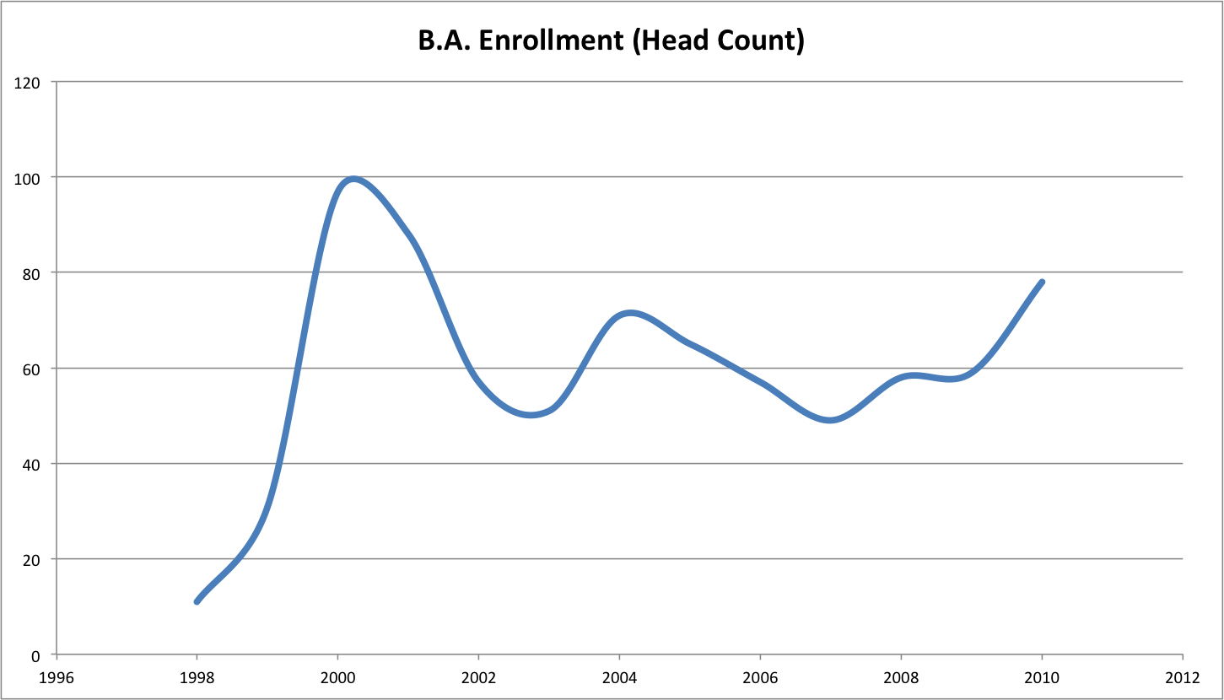  
Figure 3: B.A. Enrollment (Head Count)

Figure 3 reveals that B.A. enrollment skyrocketed in 2000 as part of the overall "dot com" explosion in our economy, and then decreased sharply in 2002 as part of the "dot bomb" economic correction. Fortunately, interest in computer science as a career has resumed in the past several years, and our enrollment has recovered to the point that only the years 2000-2001 showed higher numbers. The trend in recent years has resumed a positive, upward growth. Another factor affecting our enrollment numbers was our inability to continue employing adjunct faculty members due to budgetary constraints.

## Student semester hours

Appendix C also provides information on student semester hours, illustrated in the following chart:

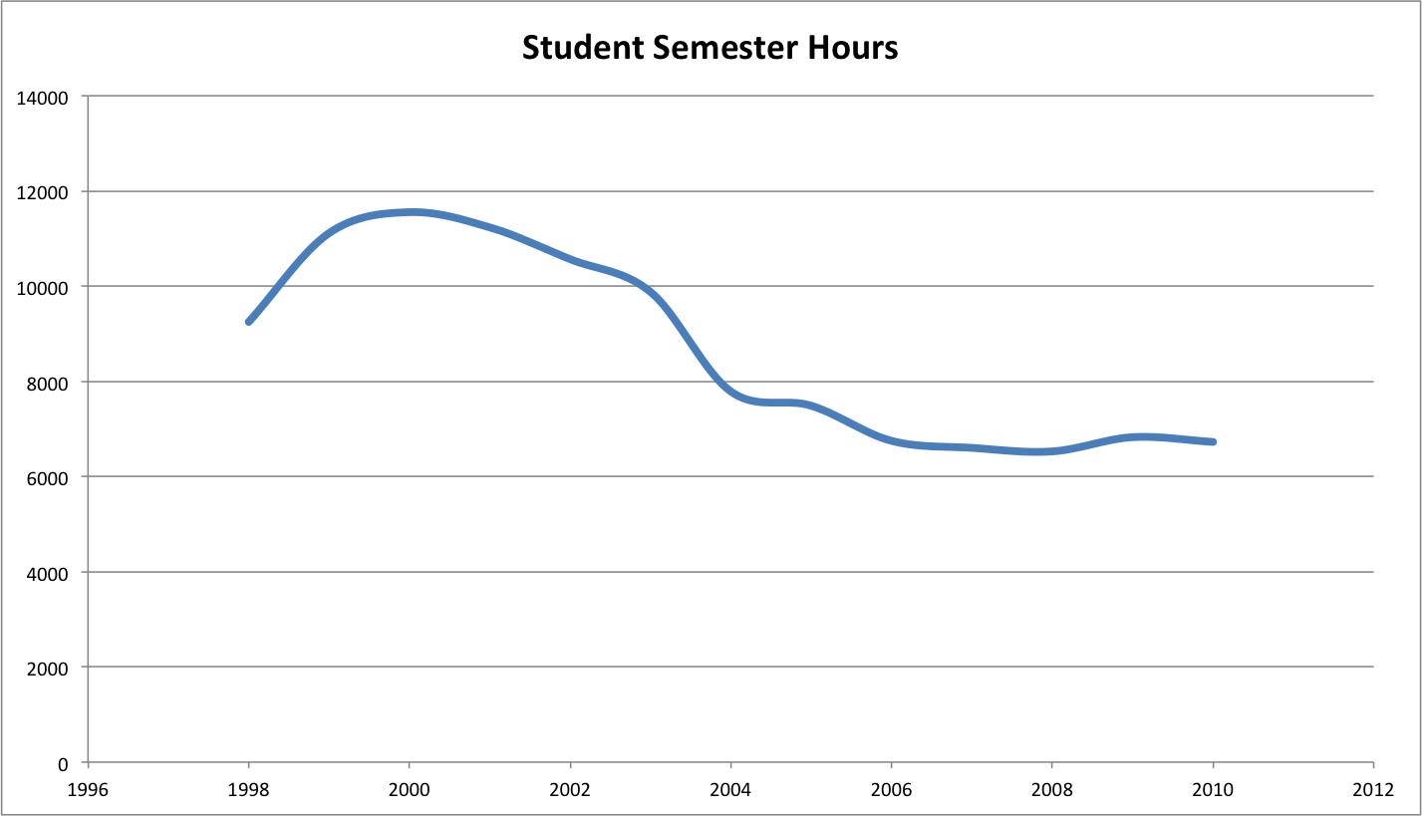  
Figure 4: Student semester hours in the B.A. program

Figure 4 shows the trend in student semester hours (SSH) to be flatter and less dramatic than the enrollment data presented above. In general, SSH reached a peak in 2000 along with the dot.com explosion, then dropped, and for the past several years has been in a relatively stable state. We believe that SSH tends to lag head count, as students can declare themselves in the B.A. program before taking a significant course load. Thus, we predict that SSH will increase in the coming years as a result of the last several years of growth in the program.

## Program cost per SSH

The next chart highlights the total program cost per SSH from Appendix C:

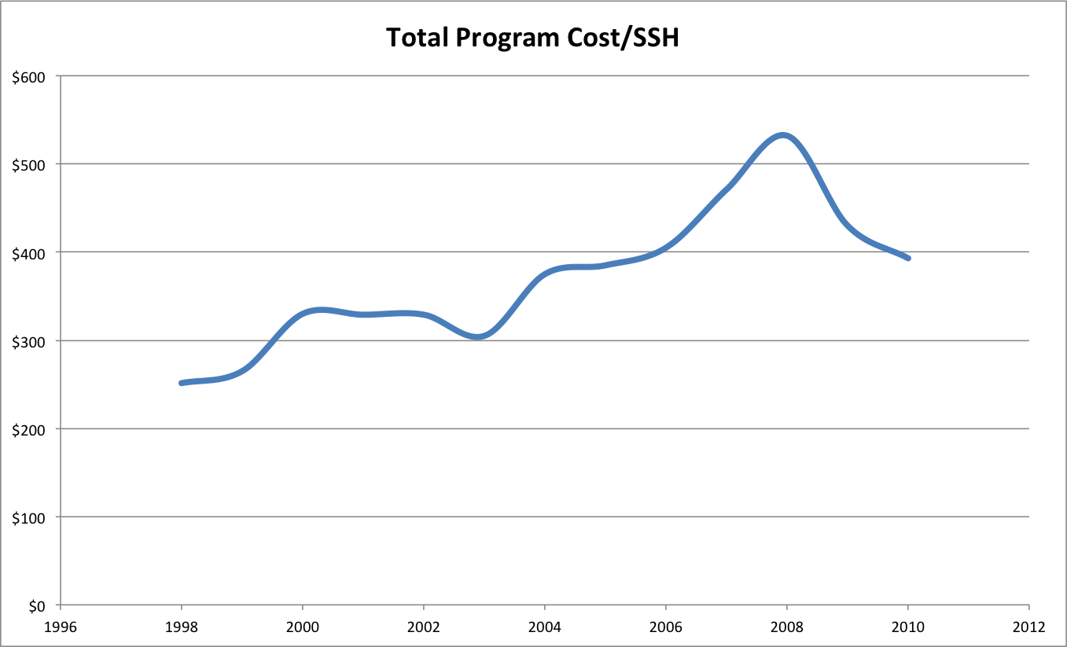  
Figure 5: Cost of B.A. program per student semester hour

Figure 5 reveals that program cost has risen over the past decade, but dropped in the last year. We believe that this reflects the gradual ramping up of services for our B.A. students as the program matured over the past decade. Although this trend is somewhat disconcerting, the next two charts provide some additional context that we believe puts this trend in a favorable light.

## Comparison of Cost/SSH (B.A. ICS vs. B.S. EE)

The following chart shows Cost/SSH for the B.A. as well as Cost/SSH for the B.S. degree in Electrical Engineering.

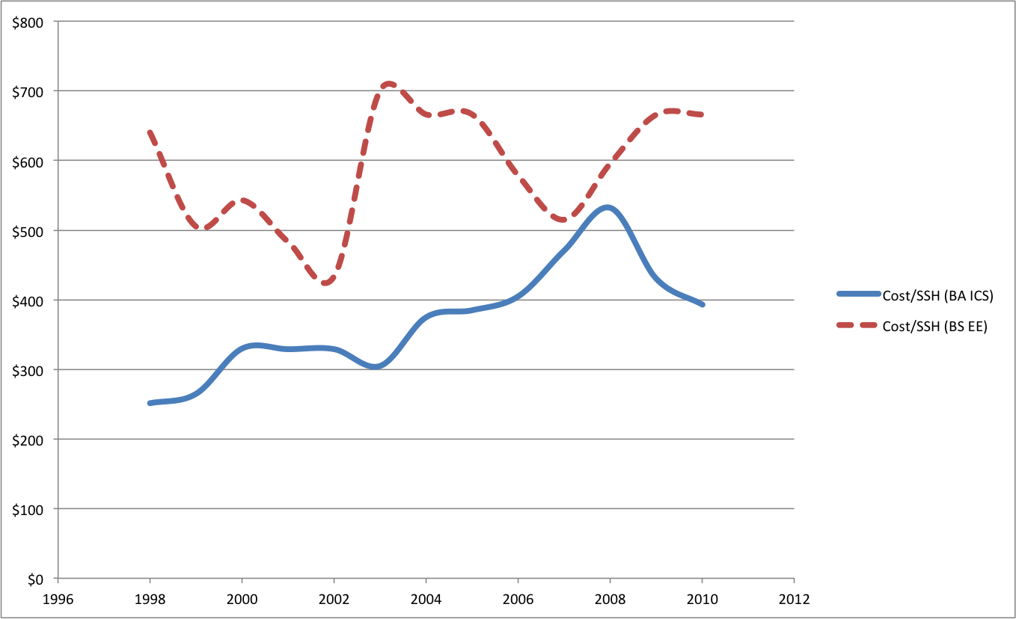

Figure 6: Comparison of B.A ICS vs. B.S. EE degree programs

Figure 6 shows that the Cost/SSH for the B.A. in ICS is consistently below the Cost/SSH for a comparable program (B.S. in Electrical Engineering). Thus, while our cost/SSH has increased, we are still a relatively "cheap" program compared to Electrical Engineering.

## Revenue

Our final excerpt from Appendix C illustrates revenue.

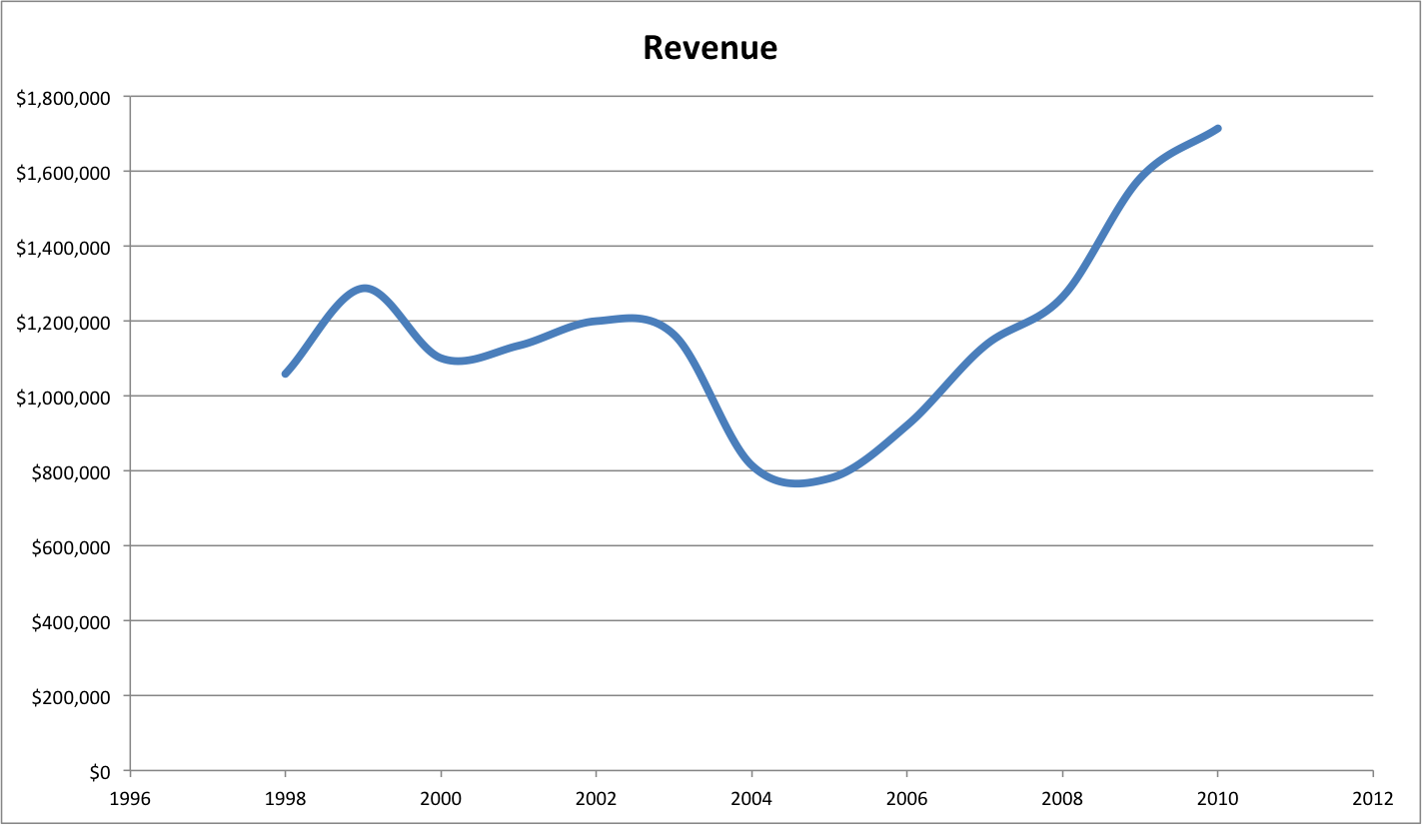  
Figure 7: Revenue from the B.A. program

Again, although our Cost/SSH has risen, Figure 7 shows that revenue has remained positive throughout the entire program, and more importantly that revenue has increased significantly during the past four years. Thus, although we are investing more in our students (in terms of Cost/SSH), the net result has been an increase in revenue for the program as a whole. We take this data to indicate that our program is a good investment, both for our students and for the University's bottom line.

.

# Assessment of program quality

(A qualitative assessment of the program in relation to competing demands for resources by new programs and continuing programs. Accreditation or other external evaluation, student performance [e.g., on external exams], satisfaction, placement and employer satisfaction, awards to faculty and students faculty publication record, evaluation of faculty…)

The ICS department has a national and international reputation and our faculty are regularly awarded grants, fellowships, awards, contracts and commissions. In prior sections of this document, we have presented evidence for the quality of our faculty. In the introduction, we noted that Wesley Peterson won the Japan Prize for his work on error correcting codes, and that Norman Abramson designed an early version of Ethernet. The next section presents a snapshot of recent ICS faculty activities as evidence of the quality of our work.

## Faculty research activities

#### Digital democracy

Professor Scott Robertson and his students have developed projects to understand the way participation in public debate and deliberation is influenced by emergent social media such as Facebook. The research includes user-centered design of enhancements to search engine tools, laboratory studies of how potential voters browse, and longitudinal studies through at least three election cycles. This research has been funded by multiple NSF grants totalling over $1.3M.

#### Artificial intelligence and medicine

Professor Julia Patriarche and her students have developed a system for the detection of change in serial magnetic resonance imaging studies of brain tumor patients. The system is a multi-level AI system, which demonstrates how such systems can augment patient care by performing routine tasks and thus elevating the role of the clinician to the more interesting and less routine parts of patient care. Dr. Patriarche's work has resulted in a diagnostic system that has been adopted as a standard part of patient care for brain tumor patients at the Mayo Clinic. This research has been funded by multiple grants from the National Institute of Health and has resulted in two patent applications.

#### Socio-technical network analysis

Professor Dan Suthers and his students are studying the new emergent forms of socio-technical systems enabled by modern communication and information technologies. A recent project called Traces provides a theoretical foundation for analysis, a data model, and software tools to trace out the movements, confluences, and transformations of people and ideas in online social networks. Professor Suther's recent research is funded by the National Science Foundation for approximately $400K.

#### Data management

Professor Lipyeow Lim and his students have developed efficient algorithms for  evaluating XPath queries on XML data that exploit the multi-core parallelism available in modern processors resulting in performance improvements of up to an order of magnitude. Other students have also designed query processing algorithms for mobile devices (eg. i-Phones, android phones) that optimize the energy efficiency in such devices in order to improve battery life. A recent project investigates using the streaming paradigm to forecast wind profiles for the purpose of wind energy monitoring and management. This project has been funded by an IBM innovation award.

#### Biometrics

Professors Martha Crosby and Curtis Ikehara have been applying biometrics to study cognitive overload in specific situations. In 2007, they received patent No. US 7,245,218 B2 for an “Input Devise to Continually Detect Biometrics.” This patent was granted for a method and system that uses surface finger pressures to identify the biometric characteristics of a user from a computer input device (such as a mouse).

#### User modeling

Professor David Chin and his students perform research to create models of user to improve information systems. A recent project involves a prototype agent-based simulation system that will allow analysis of the long-term effects of policy on culture, and to predict the effects of cultural change on the level of violence in various localities. The goal is to better predict which policy alternatives are likely to minimize long-term violence. Professor Chin's recent research has been funded by a variety of grants totaling over $1M.

#### Space exploration

Professor Kim Binsted manages a NASA-funded 4-month simulated space-exploration mission using an environment on the Big Island. Six crewmembers will live in a habitat for four months, while researchers study their diet, psychology, teamwork, etc. ICS graduate students will work on automated tools for data collection, as well as on advanced communication strategies for long-term space missions. In addition, Professors Binsted and Rich Gazan are applying computational methods to the search for life in the universe, funded by a 5-year, $8M NASA Astrobiology Institute grant. They work with a cross-disciplinary team at UH including researchers from Astronomy, SOEST, Physics and Chemistry, and NASA researchers nationwide, using information-theoretic clustering methods to relate the work of researchers in diverse fields, and to model the galactic habitable zone.

#### High performance computing

Professor Henri Casanova and his students have developed a novel method for sharing compute resources among competing users. This approach, called Dynamic Fractional Resource Scheduling, makes both theoretical and practical advances and outperforms state-of-the-art techniques by orders of magnitude. Among its benefits are a higher level of user satisfaction, a quantifiable and optimized measure of fairness among users, and enhanced resource economy both in terms of hardware and electrical power expense. This research has been funded by multiple grants from the National Science Foundation totaling over $500K.

#### Wireless networking and security

Professor Edo Biagioni and his students have developed a seamless voting system that lets voters vote from home, verify that their vote has been counted, yet remain anonymous. Another project involves a virtual machine system that detects attacks on the operating system. In embedded systems, a student designed a wireless system that can track buses, similar in function but different in technical details from the system that TheBus is currently using.

#### Studio-based learning

Professor Martha Crosby and her students perform research in studio-based learning, an innovative paradigm for science education that adapts concepts from architectural education including "design crits". Professor Crosby's recent research has been funded by multiple grants from the National Science Foundation totaling over $2M.

#### Broadening Participation in Computing (BPC)

Working with Chaminade University (CU) and the University of Hawai’i at Hilo (UHH), Professor Martha Crosby is part of a NSF Broadening Participation in Computing (BPC) alliance grant for planning and developing the infrastructure for serving higher education institutions in the Pacific region with significant Native Hawaiian (NH) and Pacific Island (PI) student populations. CU and UHH are two of the three NH-serving institutions in Hawai’i.

#### Collaborative Research in Computer Security Education

Since 2006, Professor Martha Crosby has collaborated with The George Washington University (GW), a DHS/NSA designated Center of Academic Excellence in Information Assurance Education and Research (CAE/IAE and CAE/IAE-R), in Project PISCES (Partnership in Securing Cyberspace through Education and Service) to expand computer security and information assurance (CSIA) education opportunities to potential successful CSIA applicants from ICS. In 2011 Professor Crosby built on this partnership and received a NSF Collaborative Research grant to make this educational perspective available to ICS students.

#### STEM education

Professors Violet Harada and Dan Suthers are principal investigators of the Hawai‘i Networked Learning Communities (HNLC) Initiative, which is a partnership of the Hawai‘i Department of Education and the University of Hawai‘i to improve science, mathematics and technology learning in K-12 rural schools. It directly supports the effort to form a seamless connection between UH and the State DOE. This initiative has been funded by grants from the Department of Education totaling over $1M.

#### Renewable energy and sustainability

Professor Philip Johnson and his students perform research on consumer-facing energy analysis and visualization that results in open source technology and empirical data to guide policy making. For example, they designed and implemented "The Quest for the Kukui Cup", an energy challenge for all 1,000 first year students living in the Hale Aloha residence halls. The project involves novel information technology, pedagogy, and game design techniques designed to raise student awareness of the energy challenges facing Hawaii, help them to learn how to use energy more efficiently, and connect them with organizations and curriculum if they decide to pursue energy studies at the University. Professor Johnson's recent research is funded by grants from the National Science Foundation totalling over $400K.

#### Bioinformatics

Professors Guylaine Poisson and Kyungim Baek are Director and Associate Director for the Bioinformatics cores of the COBRE Pacific Center for Emerging Infectious Diseases Research and the INBRE Hawaii State Research and Education Partnership programs. They work with their students on research projects that include metagenome analysis, prediction of phosphorylation sites in proteins, and population clustering using human SNPs (single nucleotide polymorphism) data. As Directors of the Bioinformatics cores, Professors Poisson and Baek manage research funds from multiple grants from the National Institute of Health totaling around $1.8M.

#### Computer vision

Professor Kyungim Baek and her students designed and implemented a traffic density estimator which provides traffic monitoring information by analyzing images from Hawaii state traffic cameras. Other students implemented a wrist pose estimator for robotic surgical instrument that helps human-robot interaction in a minimally invasive robotic surgery environment.

#### Software Visualization

Professor Jan Stelovsky and his students developed a visualization tool embedded within a popular software development environment. This tool allows a programmer to view algorithm execution in a textbook-like graphical fashion. When the resulting video is replayed, the programmer can switch between a variety of different visualizations. The tool was successfully used in introductory ICS courses to help students understand the behavior of typical algorithms.

#### Undergraduate education

Professor M.B. Ogawa supervises a variety of research projects related to undergraduate education. As one example, four undergraduate students were semi-finalists in the 2009 ImagiNations Competition sponsored by Walt Disney Corporation. These students designed a mobile device to enhance the experience of Walt Disney park goers with live data feeds to determine ride wait times, GPS mapping, and historical information about the park. This is part of an overall research program on student learning that has been funded by multiple grants totaling over $500K.

#### Human computer interaction

While the ICS faculty prides itself on providing a diversity of research interests and activities to its students and the community, the focus area of human computer interaction (HCI) encompasses such a substantial number of ICS faculty interests that it deserves special mention. Professors Scott Robertson, Martha Crosby, Dan Suthers, David Chin, Rich Gazan, Curtis Ikehara, Jan Stelovsky, and Philip Johnson have all published research in HCI related conferences and journals. When viewed in aggregate, HCI is an area in which the ICS faculty have achieved a special level of national and international recognition.

## Faculty productivity: external funding and refereed publications

Figure 2 provides a perspective on faculty productivity based upon the aggregate value of external funding that ICS faculty have been awarded as PIs or co-PIs, along with the number of refereed publications that ICS faculty have authored or co-authored.

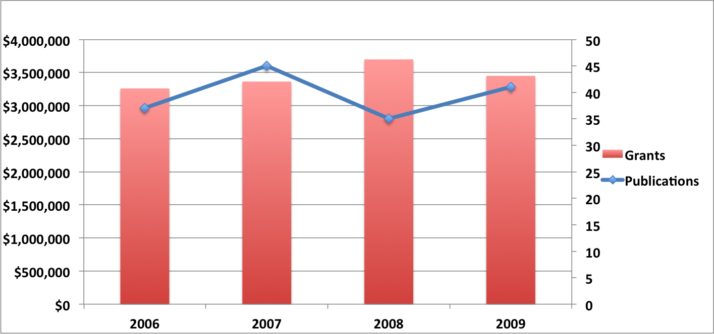  
Figure 2: External funding and refereed publications by ICS faculty

This is a snapshot of faculty activity for the years 2006 - 2009, and was generated through review of faculty curriculum vitae and online sources. The figure shows that aggregate external funding in which ICS faculty were directly involved varied between $3.2M and 3.7M during this four year period, and the number of refereed publications by ICS faculty varied between 35 and 45 per year.

## Time to degree

A different perspective on program “efficiency” for our Ph.D. program can be provided through time-to degree (TTD). While the TTD can be predicted fairly accurately for students in M.S. or undergraduate programs (depending on whether they are full-time students or whether they have full-time jobs), the same cannot be said of the TTD for a Ph.D. program. This is due to the original research component, whose duration depends both on the student and on the chosen area of research within Computer Science. Variations among students in terms of one year or more is thus common. Furthermore, some Ph.D. students are admitted in our program right after obtaining their B.S., while others come into the program with a M.S. in hand, which shortens their TTD by at least 1 year and typically 1.5 years if that degree is in Computer Science or a related field.

According to data collected by Graduate Division, the mean TTD in our Ph.D. program is 5.8 years, with a median of 6.0 years. We can attempt a comparison with national averages. The report *Time To Degree of U.S. Research Doctorate Recipients* available from the National Science Foundation (NSF) Web site 1 presents data specific to Computer Science programs for academic year 2003. It reports mean TTD between 8.3 and 15.1 years depending on student categories (Research Assistants, Teaching Assistants, supported by fellowships, unsupported). The registered-to-degree (RTD) metric is also reported, which accounts for time during which the student is actually registered in graduate school, and which ranges between 7.0 and 9.0 depending on the student category. These times are “since obtaining a Bachelor.” We can thus see that our program compares favorably to nationwide averages, even accounting for the fact that the Graduation Division data does not account for M.S. degrees obtained in other institutions. A recent report on nationwide doctorate recipients is also available from the NSF Web site 2. It presents data for the 2007-2008 academic year, but unfortunately does not present data specific to Computer Science programs. Instead is shows aggregate data for “Physical Sciences.” A median TTD of 6.7 years is reported, which seems to confirm the above observations regarding our program.

The conclusion is that our program allows students to graduate at the same or at a faster pace than the national average. While this is good news, we still see some students who graduate in more than 8 years and up to 9.5 years. To try to reduce the maximum time to graduation, in 2005 we redesigned our Ph.D. program. Like many high-profile programs nationwide (UC Berkeley, Univ. of Washington, UC San Diego, etc.) we did away with the traditional comprehensive exam that occurs after the second or third year of study. Instead, our comprehensive exam occurs early on with a subsequent “research portfolio” exam that ensures our students are actively engaged in the research process.

Through this process, we expect to maintain our relatively low average TTD but also to reduce our maximum TTD in the future. Our first graduate for the redesigned program successfully defended his dissertation in 2010. He graduated in 4 years (he already held a M.S. degree in Mathematics prior to applying to our program), has a very strong publication record, and has recently accepted a tenure-track position at a UK university.

# Assessment of program objectives

Are program objectives still appropriate functions of the college and University? (Relationship to University mission and development plans, E5.201 P 13 of 13 evidence of continuing need for the program, projections of employment opportunities for graduates, etc.)

## ICS Mission

The following section addresses how the mission statements for the Department of Information and Computer Sciences support the larger missions of the University of Hawaii at Manoa, the University of Hawaii system, the state of Hawaii, and the overall national picture.

The mission of the Department of Information and Computer Sciences is to nurture a world-class community of students and faculty dedicated to innovative scientific and information-related research and education for the benefit of the participants, Hawaii, the United States, and the world. A goal of the ICS program is to prepare students to be research and development leaders in computer science and computer technology. To this end, the program is a catalyst and a resource for shaping the future of the broad discipline of computer science. The faculty embraces the mutual interdependence of research and teaching to achieve excellence in both. As part of its mission the program brings the latest research findings into courses and actively involves students in research endeavors of the faculty. The program also provides leadership in the application of high technology to improve the educational experience.

## Alignment with the UH Manoa strategic plan

The final draft of Achieving Our Destiny, the University of Hawaii at Mānoa 2011–2015 Strategic Plan has been released, and central to the UHM mission statement is to "support innovations in education, health care, social development, culture and arts, earth, space, and ocean sciences, sustainable land management, and technological advancement." In its broad-based research, teaching and professional networks, the ICS department is a catalyst for innovation in each of these areas.

## Alignment with the UH System strategic plan

The University of Hawaii System strategic plan approved by the Board of Regents has the following goals for the system:

* Educational Effectiveness and Student Success
* A Learning, Research, and Service Network
* A Model Local, Regional, and Global University
* Investment in Faculty, Staff, Students, and Their Environment
* Resources and Stewardship

The ICS department’s mission statement closely aligns with the first goal of educational effectiveness and student success. Furthermore, the department helps to provide the university system with a strong learning, research, and service network.

## Alignment with the State of Hawaii

At the state level, Governor Neil Abercrombie’s Technology and Information platform states the need for human capital and education in the area of technology, specifically:

“The fuel of an innovation economy is our human capacity to learn and create. Everyone can contribute. Education at all levels is the fundamental investment we will make to improve our economy. Industry and public education must work very closely to support each other and ensure highly skilled employees are being prepared at the same rate that high skill jobs are being created.”

The need for education in technical fields is further underscored by Office of Department of Business, Economic Development and Tourism’s report on Hawaii’s Technology. This report includes a summary of employment trends, reproduced in Appendix D. Our degree programs directly address the highlighted occupations. Focusing on just these occupations, the Bureau is projecting an increase of more than 50% that would result in over 1.4 million new positions.

In a U.S. Department of Commerce, Office of Technology Policy report entitled “The Digital Workforce: Building Infotech Skills at the Speed of Innovation” (June 1999) Alan Greenspan said, “The rapid acceleration of computer and telecommunications technologies is a major reason for the appreciable increase in our productivity in this expansion, and is likely to continue to be a significant force in expanding standards of living into the twenty-first century.” This bodes well for the increasing use of information technology and for the strategic role that the ICS Department might play in delivering high-quality teaching and research at UHM.

# Need Factors

## National and International need factors

Computer Science is a fundamental discipline whose advances in research and development impact the lives of millions of people every day across the globe. In 2009, a panel of 8 experts from the Wharton School of Business (University of Pennsylvania) was asked to name the 20 biggest innovations of the last 30 years, with the results published in the New York Times in March of that year. Out of the 20 innovations, 9 are directly from the field of computer science (the Internet, person computers, email, the microprocessor, office software, open source software, e-commerce, media file compression, and social networking) and 5 of the remaining 11 are directly enabled by it.

Given this impressive coverage, it is not surprising that Computer Science Ph.D. programs are mainstays of virtually all first tier research universities worldwide. What makes Computer Science unique is its cross-cutting impact and relevance for other disciplines. Indeed, computers are use today not only in virtually all disciplines of science and engineering (where computer modeling and simulation are pervasive), but also in all the humanities (e.g., due to the use of large-scale and distributed digital databases), with direct involvement in fields as diverse as education (e.g., for internet collaboration technologies for learning) and even music (e.g., for computer-aided composition). Far from being straightforward applications of computers, many important developments in those fields require that Computer Science challenges be addressed through innovative research and development activities, such as those pursued by ICS Ph.D. students. Consequently, advances in computer science research are fundamental for furthering human knowledge and progress in general.

## University need factors

Since Computer Science’s relevance is pervasive across so many disciplines, our Ph.D. program is an invaluable resource for the university:

* ICS Ph.D. students are often engaged in collaborative projects between professors in ICS and in other departments. They are thus key contributors to the fostering of interdisciplinary research at UHM, which is highly strategic given the amount of federal funding available for such research.
* A significant fraction of our Ph.D. students are currently or were previously supported by Research Assistantships hosted in other departments. This is because many research projects require the type of expertise that only our students have through the training provided in our Ph.D. program. We regularly receive requests from Principal Investigators on campus asking us to advertise Research Assistantship opportunities to our graduate students. Thus, our Ph.D. students provide a unique and important research workforce for the university.
* Our graduate program offers courses that provide advanced training for graduate students outside of our programs. Every semester, such students take our graduate-level courses. For instance, Oceanography and Astronomy students have take our high-performance computing course, Biology students have taken our bioinformatics course, Educational Technology students have taken our Human-Computer Interaction courses.
* Almost 30% of our Ph.D. graduates to date have chosen to stay in the University of Hawai‘i system and contribute either to research and development activities or to information technology management.

## Hawai‘i need factors

Innovations in computing through Ph.D. research drive economic growth for the state of Hawai‘i. This growth occurs not just in the IT industry, but across the entire economy. A strong Computer Science Ph.D. program provides a nexus for this growth and the means to both build Hawai‘i’ capacity for technical innovation and to staff Hawai‘i’s research and development community. In the specific case of Hawai‘i, the benefit goes beyond economic growth to (much needed) economic diversification. Consequently, a strong ICS Ph.D. program can be a major contributor to growing a diversified economy in Hawai‘i.

The career paths of our Ph.D. graduates is a clear testimony of the dramatic impact that our students have on the state’s economy. Approximately 35% of our Ph.D. graduates so far have chosen to stay in Hawai‘i and work in local research and development organizations. The impact of these graduates is also felt at the level of the community. As just one example, many of our Ph.D. students are active contributors to TechHui, Hawai‘i’s premier social network for science, technology and new media.

Our Ph.D. program fulfills a clear local educational need. We have admitted many outstanding local students who were exposed to research during their undergraduate experience at the University of Hawai‘i, and although many alternatives were available to them, they chose our Ph.D. program based on their interactions with our faculty and the opportunities this degree would make available to them.

In summary, the national and international need for Computer Science Ph.D. graduates is currently strong and will only grow stronger in future. Regionally, the diversification of the Hawai‘i economy requires skilled, innovative thinking in high technology areas which Computer Science Ph.D. graduates are ideally suited to provide. Finally, the ICS Ph.D. program provides students who are in high demand and a valued resource to other departments.

We believe strongly that the ICS Ph.D. program satisfies university, state, national, and international need factors.

|  |
| --- |
|  |

# Appendix C: Head counts, student semester hours, and costs

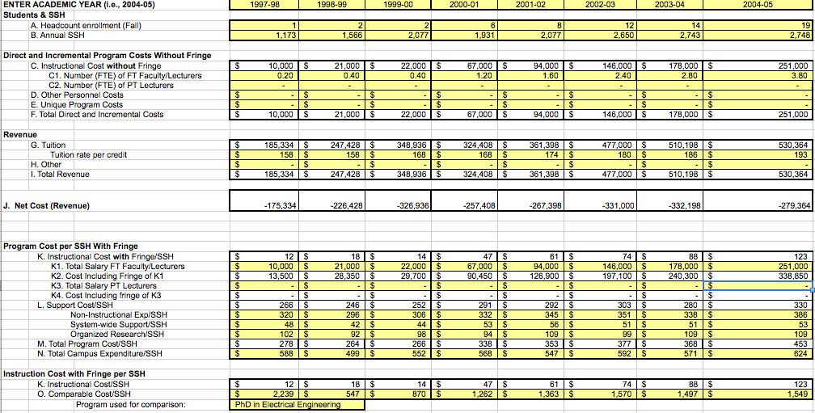  
Figure C.1: Costs & Revenues Spreadsheet, 1997 - 2005

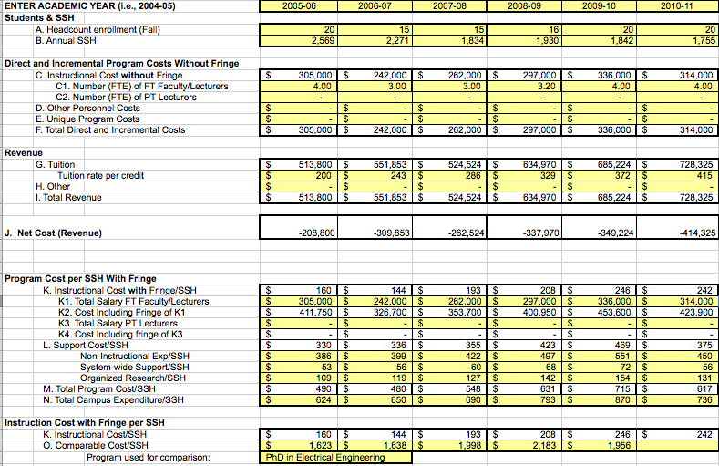  
Figure C.2: Costs & Revenues Spreadsheet, 2006 -2011

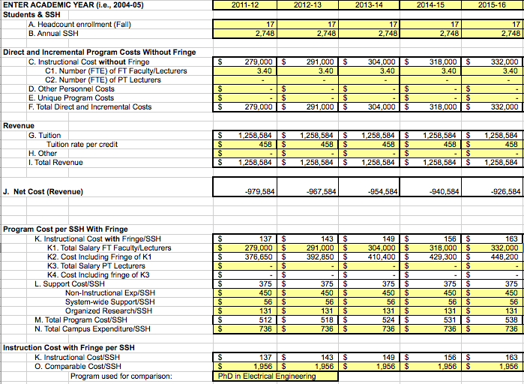  
Figure C.3: Costs and Revenues Spreadsheet, 2011 - 2016 (Projected)

1. B.S., M.S. and Ph.D. degrees in CS; B.A. in ICS, MLISc and Ph.D. in CIS.
2. http://goo.gl/IGRrr
3. In addition to the one required credit hour of ICS 690, ICS Ph.D. students often elect to enroll in additional credits of ICS 800, "Dissertation Research", in order to qualify for full-time student status for financial aid purposes. However, while ICS 800 does generate tuition revenue, it does not consume any Department resources.
4. In reality, M.S. students require significantly more resources than Ph.D. students since as they take 6-9 credit hours per semester, but this assumption simplifies the calculation.