Request to move the   
  
Bachelor of Arts in   
Information and Computer Sciences,   
University of Hawaii at Manoa,   
  
From Provisional to Established Status   
  
Fall 2011

[http://www.ics.hawaii.edu/logo.jpg](http://www.ics.hawaii.edu/)

Table of Contents

Introduction 3

The importance of Computer Science 3

A brief history of the Department of Information and Computer Sciences 3

Assessment of program organization and objectives 4

Overview of Information and Computer Sciences 4

The Bachelor of Arts in Information & Computer Sciences 6

Curriculum and individualized course plans 7

B.A focus areas: Bioinformatics & Information Assurance/Computer Security 8

Distance learning 9

Undergraduate mentoring and advising 10

Assessment of student learning objectives 10

Curriculum design and learning objectives 10

Infrastructure and learning objectives 11

End-of-semester evaluations and learning objectives 12

Social media and student assessment 12

Assessment of program resources 13

Faculty resources 13

Research and teaching laboratory resources 14

Information technology and fiscal support resources 16

Student advising and financial aid resources 16

Department financial resources 16

Assessment of program efficiency 17

B.A. head count trends 17

Student semester hours 19

Program cost per SSH 19

Comparison of Cost/SSH (B.A. ICS vs. B.S. EE) 20

Revenue 21

Graduation rates 21

Assessment of program quality 21

Faculty research activities 22

Faculty productivity: external funding and refereed publications 25

Curriculum quality 26

Initiatives related to student quality 27

Assessment of program objectives 29

ICS Mission 29

Alignment with the UH Manoa strategic plan 29

Alignment with the UH System strategic plan 29

Alignment with the State of Hawaii 29

Alignment with international needs 30

Appendix A: ICS course descriptions 31

Appendix B: B.A. curriculum plan/map 35

Appendix C: Head counts, student semester hours, and costs 36

Appendix D: Employment trends 38

Appendix E: Distance education courses and enrollments 39

Appendix F: Faculty extramural funding 40

Appendix G: Faculty publications 42

Appendix H: Assessing teamwork, communication, and critical review skills 43

Overview 43

Steps 43

Review Protocol 44

Rubric 44

This self-study report is organized according to the “Guidelines for Assessment of Provisional and Established Programs” E5.201.

# Introduction

## The importance of Computer Science

About one-third of the economic growth in the U.S. in the last decade has been in information and computing technology. While the Internet and the Web are perhaps the most visible aspects of this change, the revolution is pervasive, touching nearly every field and discipline, from computational techniques in the physical and biological sciences, to new interactive media in the fine arts. The impact of the digital and information revolution upon society is profound. The evolution of computing and information technology will continue to be a driving force behind the creation of new industries, careers, and academic disciplines. As a result, there is a genuine and increasing need for workers with an interdisciplinary background who understand the social and organizational uses of technology and who are literate and articulate. These workers require knowledge of computing systems, global communications networks, and interactive information resources. The requisite proficiencies go beyond being comfortable with computing tools. They require the ability to apply computational ways of thinking to design, to writing, to experimentation, to artistic expression, and to problem solving.

## A brief history of the Department of Information and Computer Sciences

The formative roots of the Department of Information and Computer Sciences (ICS) extend back to the late 1960's. At that time, UH began a project to provide radio-linked satellite computers to the existing University time-shared computing system. The purpose of this project, then known as the ALOHA system, was to make the full information processing capabilities of the central computing facility on the Manoa campus available to all operating units of UH on Oahu and the neighbor Islands. Norman Abramson, the principal designer of the ALOHAnet, whose principles formed the design philosophy of the Ethernet, became the first chair of a new interdisciplinary program that awarded a Master of Science (M.S.) degree in Information and Computer Sciences (the science of processing information by natural or artificial systems). This M.S. program was designed both for students interested in careers in information sciences and those who expected to use information sciences in another profession. Other professors in the initial Information Sciences program included W. Wesley Peterson (a winner of the Japan Prize for his work on error correcting codes), David Pager, (the inventor of an early parser for computer languages), Wilbert Gersch, and Art Lew.

During the early 1970's the Information Sciences program became the Department of Information and Computer Sciences. In the mid 1970’s, Professor Peterson, the ICS chair from 1973 until 1984, initiated an interdisciplinary program leading to B.S. degree in Computer Science. This program was designed to give students an understanding of computers, their operation, programming, and applications, and to provide the knowledge and skill needed for a career in the computer field. Special fields of emphasis for the B.S. degree are computer systems, data analysis, data processing systems, and scientific computation.

In 1986, the ICS Department joined with three other programs, the Department (now School) of Communication in the College of Social Sciences, the Department of Decision Sciences (now Information Technology Management) in the College of Business, and School of Library and Information Studies (now the Library and Information Science program) to provide an interdisciplinary Ph.D. degree in "Communication and Information Sciences" (CIS). In 1994, CIS became organizationally housed in the College of Natural Sciences. In 1995, the ICS Department moved from Keller Hall to the newly constructed Pacific Ocean Sciences and Technology (POST) building. In 1998, the B.A. in ICS and the Ph.D. in Computer Science were established.

In 1997, the School of Library and Information Studies (SLIS) merged with the ICS Department and changed its name to the Library and Information Science (LIS) Program. The LIS Program offered courses through the UH Manoa Outreach College as early as 1957. In 1965, the Graduate School of Library Studies (GSL) was formed. In 1987, the school recognized the rapidly changing world of libraries and information technologies and the role of information in society, by simultaneously changing its name to the School of Library and Information Studies and offering the Master's in Library and Information Studies degree, now the Master of Library and Information Science (MLISc) degree.

Since 2000, the ICS Department has grown substantially. By 2003, the six degree programs[1] associated with ICS at that time accounted for a total of 888 majors, making our Department larger than the entire College of Engineering and the largest Department in the University of Hawaii system. This explosive growth motivated a special legislative allocation specifically to ICS of $1M (which the UH administration made part of the ICS budget) in order to support its mission and students. During this past decade, we have used these additional resources to establish strong research and educational programs in areas including networking, human computer interaction, software engineering, high performance computing, bioinformatics, and information assurance.

Today, the Department continues to aggressively develop its role as a premier educational and research program in Information and Computer Science. The mission of the Department of Information and Computer Sciences (ICS) is to: (1) develop leading edge research that fuels economic and entrepreneurial advances, prepares information and technologically literate citizens, and drives technological improvements in curriculum and teaching and (2) provide professional education for students specializing in computer science and basic computer science education for all interested students.

# Assessment of program organization and objectives

Is the program organized to meet its objectives? (Discussion of curriculum, requirements, admissions, advising and counseling, and other aspects of the program, with reference to the objectives.)

## Overview of Information and Computer Sciences

The Department of Information and Computer Sciences is part of the College of Natural Sciences at the University of Hawaii at Manoa. The Information and Computer Sciences (ICS) Department is solely responsible for six academic degrees:

* Bachelor of Arts in Information and Computer Sciences (approved as provisional in 1998)
* Bachelor of Science in Computer Science (approved in 1974)
* Master of Science in Information and Computer Sciences (approved in 1965)
* Master of Science in Computer Science (approved 1974)
* Professional Master Degree Program in Library and Information Science (approved 1969)
* Ph.D. in Computer Science (approved as provisional in 1997)

The ICS Department participates in two other joint degree programs with other departments on campus:

* Bachelor of Science in Computer Engineering (approved as provisional in 2009)
* Ph.D. in Communication and Information Sciences, Interdisciplinary (approved in 1986)

Figure 1 below shows the enrollment numbers and graduation rates associated with each of these eight programs over the past five years, as reported from STAR.

Figure 1 shows that our department enjoys a strong and significant enrollment of over 470 declared majors during the past five years. Out of this pool of declared majors, we have graduated between 65 and 127 students per year. Dividing these two numbers provides a rough sense of the "throughput" of our department, which varies between 14% and 21%. We believe that our throughput is currently resource constrained, and that we could improve both the total number of ICS graduates per year as well as the number of semesters required to progress through our program with additional resources.

In addition to these eight majors, we also provide a minor in Computer Science for students who would like to develop a solid foundation in Computer Science in conjunction with their major degree program. Collaborations such as the minor in Computer Science and the two joint degree programs are vital for the department’s mission, for service to the students, as well as for campus collaboration and support. For example, the Bachelor of Science in Computer Engineering (BSCE), a joint initiative between ICS and the Department of Electrical Engineering was approved by the Board of Regents as a provisional program in November 2009. ICS provides the Discrete Math curriculum and up to 6 credits of technical electives towards the attainment of this degree.

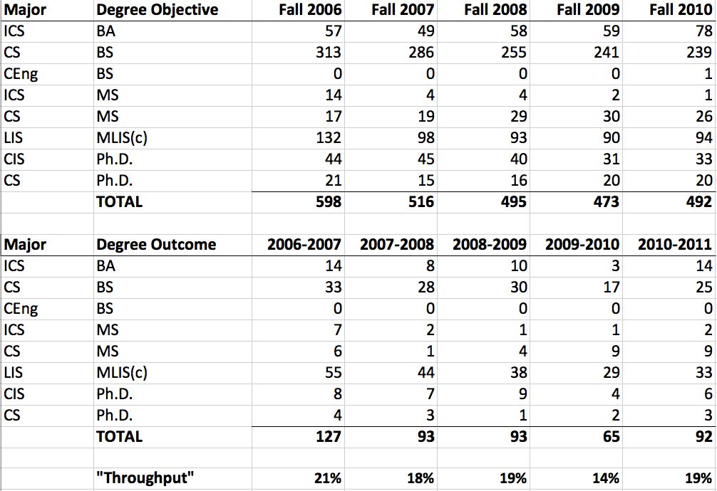  
Figure 1: Enrollment and graduation rates for all ICS degree programs

The ICS department also offers hundreds of seats each year to students looking to fulfill one or more of their general education and/or focus requirements through the ICS program. These course offerings are large and serve a diverse campus population. The department has also created Honors sections for select students in various disciplines. This illustrates the importance of the service courses offered by ICS to other departments.

Appendix A provides a complete listing of ICS undergraduate courses.

## The Bachelor of Arts in Information & Computer Sciences

The Bachelor of Arts degree program allows ICS students to combine computer science with other disciplines, giving them the opportunity to explore the ways computers, networks and mobile devices affect society. Our B.A. students can contribute to collaborative interdisciplinary teams and have the program flexibility to apply this knowledge to areas beyond traditional computer science programs.

The curriculum for a B.A. in ICS was developed by the ICS faculty in response to numerous student and industry requests for a flexible undergraduate major that would allow students to develop expertise in both computer science and other subject areas. We defined a program that blends the requirements of a strong computer science core with the flexibility of a liberal arts education. Students earning the B.A. degree in ICS will be particularly attractive to technical organizations that desire people with strong written and oral communication skills.

Upon completion of the B.A. program, student will be able to:

* Use current technical concepts and practices in software development, computer networking, databases, and web related technologies,
* Manage all aspects of solving computer-based problems involving requirements analysis, design, implementation, and project management,
* Participate in collaborative team oriented activities,
* Communicate effectively using modern technologies, using oral, written, and web media.

The B.A. in ICS degree is unique in its ability to allow students to combine Computer Science with another discipline. Many of the B.A. courses are also taken by students pursuing the B.S. in ICS, however the B.A. allows for more electives and customization. It is the careful selection of electives that allows students to customize their degree and their future job opportunities in such diverse areas as business information systems, educational development environments, and multimedia entertainment systems. An academic plan handout is available for students as an advising tool.

### Curriculum and individualized course plans

Students must complete the Bachelor of Arts General Education Core, which is described in the General and Graduate Information Catalog. For the major requirements, B.A. students must complete:

* Required courses: ICS 111/L, 141, 211, 212, 241, 311, 312, 313, 321
* Junior/senior electives: three ICS (or approved) 400-level courses, including at most three credits of ICS 499 and three credits of ICS 491.
* Area concentration electives: four upper division (300-level or above) courses in some area of concentration (e.g., art, business, music, education).

Appendix B presents a curriculum map or plan showing how students can progress through our B.A. curriculum and graduate in eight semesters.

Students seeking a B.A. must write a proposal, of one page or less, specifying the seven courses they will use for their ICS and area concentration electives. This course proposal must be approved by an ICS undergraduate advisor. The proposal must explain how these courses form a coherent plan of study combining computer science with another field. Some examples of recent proposals include:

I want to work in computer games programming, which requires art/drawing, computer graphics, and software engineering skills. ICS electives: ICS 481 Intro. to Computer Graphics, ICS 413 Software Engineering I, ICS 414 Software Engineering II. Area electives: ART 313 Advanced Drawing, ART 322 Advanced Color, ART 363 Design: Studio 2, ART 309 Image in Motion Studio II.

I want to do machine translation of Japanese and English, which requires artificial intelligence, cognitive science, and Japanese language skills. ICS electives: ICS 361 Artificial Intelligence I, ICS 461 Artificial Intelligence II, ICS 464 Introduction to Cognitive Science. Area electives: JPN 301 Third-Year Japanese, JPN 302 Third-Year Japanese, JPN 350 Intrduction to Japanese Linguistics, JPN 425 Japanese Translation.

I want to create web pages, which requires hypermedia, databases, and graphic design skills. ICS electives: ICS 465 Intro. to Hypermedia, ICS 665 User Interfaces & Hypermedia (3.0 GPA required), ICS 421 Database Systems. Area electives: ART 363 Design: Studio 2, ART 364 Design: Studio 3, ART 465 Design: Typography 3, ART 322 Advanced Color.

I want to use computers to predict the stock market, which requires statistics, databases, and business skills. ICS electives: ICS 442 Analytical Models & Methods, ICS 471 Probability, Statistics, & Queuing, ICS 421 Database Systems. Area electives: BUS 310 Statistical Analysis for Business Decisions, BUS 311 Information Systems for Global Business Environment, BUS 316 Quantitative Business & Economic Analysis, BEC 389 Applied Business Economics: Forecasting.

Since 2002, we have increased the number of advanced undergraduate level offerings focused on the B.A. options. Of course, these emerging topics are also of great interest for students pursuing the B.S. degree.

### B.A focus areas: Bioinformatics & Information Assurance/Computer Security

In addition to allowing students to build their own degree paths, we define two explicit B.A. degree focus areas: the Bioinformatics focus area and the Information Assurance and Computer Security focus area.

#### Focus area: Bioinformatics

Students seeking the B.A. in ICS with a Bioinformatics focus must also earn an appropriate Bioscience degree or a minor in Biology. The requirements include the following:

B.A. in ICS

* ICS 111, 141, 211, 212, 241, 311, 312, 313 and 321
* 3 courses (300-level or above) from the minor will double count (BIOL 375, BIOL 4xx, and the course in botany. Biochemistry microbiology, physiology and zoology).
* 4 ICS courses (300-level or above)
* Bioinformatics focus area (3 courses)

Minor in Biology

* BIOL 172 (Introduction to biology II)
* BIOL 265 (Ecology and evolutionary biology)
* BIOL 275(Cell and molecular biology)
* BIOL 375 (Concepts of genetics)
* Minimum of 3 credits in: BIOL 401 (molecular biotechnology), 402(Principles of biochemistry), 405(Biochemistry), 406/406L (Cellular biology), 407/407L(Molecular biology), 409(Biology seminar), 441 (Basic biochemistry) or 499 (Biological problem).
* BIOL 171 (Introductory biology), CHEM161 (General chemistry I), 162 (General chemistry II), 272, (Organic chemistry I), and 273 (Organic chemistry II) if you take BIOL 402, 405, 406, 407 or 441.
* Minimum of 3 credits: approved upper level botany, biochemistry, microbiology, physiology and/or zoology.

#### Focus area: Information Assurance and Computer Security

In response to emerging industry needs and student demand, we provide a focus area in Information Assurance and Computer Security. This curriculum was built through a team approach in June 2006 with the faculty of the ICS department and the Center for Information Assurance and Cybersecurity (CIAC) at the University of Washington. The Director of the CIAC teaches a series of information assurance classes for the ICS department including: ICS 425 (Computer Security and Ethics), ICS 426 (Computer System Security) and ICS 491 (Special Topics in Secure Development). Students who successfully complete this series earn a certificate from CIAC, an NSA/DHS Center of Academic Excellence in Information Assurance Education and Research. To date, we have graduated over 75 students who have earned this credential.

One outgrowth of the Information Assurance and Computer Security focus area is a student group called the “ICS Greyhats” that competes in regional and national collegiate cyberdefense competitions. In its first year, the Greyhats placed first in a virtual regional competition that included the University of Alaska Fairbanks and several colleges on the islands. In its second year, the ICS students placed second, losing to students from the Air Force Academy. Membership in the Greyhats is open to all ICS undergraduate students, though those in this focus area take a leadership role.

Part of the Greyhats mission is to reach out to local high schools that want to participate in similar exercises. The Greyhats have been enthusiastically embraced by our students, and the group also exposes local high school students to some of the opportunities available through the ICS department.

While the fraction of students in each focus area for the B.A. varies from year to year, an approximate current breakdwown is 41% in the Information Assurance focus area, 3% in the Bioinformatics focus area, and the remaining 56% in the general B.A. program. 10% of the students in the Information Assurance focus area participated in the ICS Greyhats.

### Distance learning

In 1998, the ICS Department received WASC approval for distance delivery of its bachelor and master programs and we remain committed to expanding access to the University through distance learning. We have focused on Asynchronous Learning Network (ALN) media for learning. ALN classes have no class meetings. Students learn the material “anytime, anywhere” by reading books, handouts, or Web pages and interacting with other students and the instructor via electronic media. Employing ALN enables us to provide educational offerings for the non-traditional student, the working professional and populations such as the military and neighbor island residents who cannot attend campus-based classes.

In 1999, while collaborating with the UH Manoa Outreach College, we secured a $405,000 grant from the Alfred P. Sloan Foundation to support this program. As a result of this initiative, ICS agreed to offer at least 2 ALN graduate courses each semester. The Outreach College has also marketed our online B.A. classes to students looking for non-traditional methods for completing their computer science degrees. The department offers expanded ALN and hybrid courses each fall, spring and summer semester. ICS distance education offerings are completely integrated into our curriculum as a primary goal of our ALN program is to provide additional access to our courses. Since ICS began offering online classes, we have steadily increased the number of students enrolling in ALN courses each academic year. Since 2004, we have offered an average of 4 classes per semester to an average of 28 students. Appendix E provides a breakdown of distance education classes and enrollments.

#### Distance education and system articulation

The ICS faculty work closely with their colleagues at the other system campuses to ensure articulation provides a clear path for students. In 2005 all campuses of the University of Hawaii system that offer ICS courses agreed to an ICS System Articulation Agreement which remains in place. Given the access to distance education opportunities, it is even more important that articulation be clearly aligned and communicated to students. Many of our colleagues teaching ICS in the system are products of the ICS graduate programs and we routinely include them in discussions concerning curriculum issues.

### Undergraduate mentoring and advising

Since 1998, the ICS department has employed an Educational Specialist to assist in all areas of student services, including recruitment, retention, placement, and outreach services. This position allows consolidation of the Department’s record keeping system for all undergraduate students and helps to manage basic intake services. As a result, the role of faculty advising in our department has moved from bookkeeping activities to mentoring and project supervision activities. The Educational Specialist holds a master’s degree from ICS and is well qualified to mentor ICS students. Because of previous experience advising UH-Manoa students, the specialist’s advice is useful for ICS students who are seeking a B.A. degree. Students interested in ICS are first referred to the Educational Specialist who provides consistent advising and serves as the department's contact with the Arts and Sciences Advising office. Students are immediately counseled on the differences between the B.A. degree in Information and Computer Sciences and the B.S. degree in Computer Science in order to plan a degree program that meets their career goals. Through these meetings we find that some students need additional advising and are counseled appropriately.

The department began a program of mandatory student advising in 2009 for students who were: 1) entering UH Manoa for the first time; 2) transferring into the program from another college or university, or 3) changing their major to a bachelor’s degree to either the B.S. in Computer Science or the B.A. in Information and Computer Science. Advising is implemented through individual appointments and several hundred individual advising sessions have been conducted since January 1, 2009 to the present. We plan to continue conducting individual advising appointments and also conduct group sessions with individual follow-up advising.

# Assessment of student learning objectives

Is the Program meeting its learning objectives for students? (An assessment of the quality of student learning as indicated by systematic analysis of student performance with reference to standard expectations, surveys of student satisfaction with instructional aspects of the program, etc.)

## Curriculum design and learning objectives

The curriculum of the ICS department is influenced by a variety of sources, including the Association of Computing Machinery (ACM) and by the Accreditation Board for Engineering and Technology (ABET).

As one of the oldest professional organizations for computer science, ACM has prepared recommendations[2] for computer science curriculum since the 1960's. Our Department is also guided by ABET curriculum and standards for applied science, computing, engineering, and technology.

In particular, we use ABET objectives as a basis for the development of the ICS curriculum and course syllabi. These 9 objectives include:

1. An ability to apply knowledge of computing and mathematics appropriate to the discipline.
2. An ability to analyze a problem, and identify and define the computing requirements appropriate to its solution.
3. An ability to design, implement, and evaluate a computer-based system, process, component, or program to meet desired needs.
4. An ability to function effectively on teams to accomplish a common goal.
5. An ability to use current techniques, skills, and tools necessary for computing practice.
6. An understanding of professional, ethical, legal, security and social issues and responsibilities
7. An ability to communicate effectively with a range of audiences.
8. An ability to analyze the local and global impact of computing on individuals, organizations, and society.
9. Recognition of the need for and an ability to engage in continuing professional development.

Appendix H presents assessment procedures we plan to introduce to directly assess the ability of our students to achieve these objectives. At the current time, however, we can state that our curriculum is designed to require all of our B.A. students to gain proficiency with all of these concepts in order to obtain their degree. As one example, all B.A. students are assessed with respect to their performance in a capstone experience, such as :

* Collaborative work on a software engineering project with a team of peers. A key objective is to learn how to plan, design, implement, and test an original software project.
* Development of an advanced programming project. This includes a proposed “original” programming exercise to meet goals set between the student and faculty mentor. In this situation, the student is expected to completely document the process of the project, including end-user meetings and training sessions.

Successful completion of either capstone experience verifies achievement of the first 7 objectives. Currently, courses such as ICS 314, ICS 414, and ICS 499 include a capstone experience. Achievement of the remaining learning objectives is accomplished through other courses, such as ICS 290 (Computer Science Careers: An Exploration of the Specialties of Computer Science) and ICS 390 (Computing Ethics for Lab Assistants).

## Infrastructure and learning objectives

ICS students must have access to modern computing infrastructure in order to gain the hands-on learning needed to obtain the learning objectives described above. Infrastructure such as lab space, hardware and software tools all play a role in delivering our academic curriculum. The ICS department has a governing structure that enables curriculum and infrastructure to be planned and developed in a coordinated way. The ICS department's curriculum committee considers all academic related recommendations for modification or addition of new curricula. The ICS Department's infrastructure committee recommends equipment expenditures based in part on assessment results. Throughout the year, these two committees meet monthly to examine the relationship between the assessment plan, the program objectives, and infrastructure requirements. These results are communicated to the department faculty each month and each semester the department holds a planning retreat to discuss overall recommendations.

## End-of-semester evaluations and learning objectives

Students have the opportunity to provide anonymous feedback on their courses and instructors every semester using either the eCAFE system or a departmental evaluation form. Data from these assessments are provided back to the instructor to inform their future teaching efforts. We have inquired about making this assessment data available as part of this document, and we are prohibited from doing so on a department-wide basis due to University privacy policies.

However, to provide a flavor of this assessment mechanism, we can provide access to data that is already public. ICS Professor Philip Johnson has made a practice of making public the (anonymous) responses to his software engineering course assessments for the past several years. These assessments are available at the eCafe website[3].

## Social media and student assessment

Since 2008, we have been making use of social media to obtain feedback from our students about our program. The social networking site TechHui[4] is designed to support the high technology community in Hawaii. We have created a forum there for ICS students, and as part of the software engineering curriculum, we ask that they join TechHui and use two specially created discussion lists to provide their personal perspective on both positive[5] and negative[6] aspects of the ICS program. Over 600 positive and negative experiences have been recorded so far, providing an informative perspective on what our department does well and the challenges we face.

While students have provided a wide variety of responses, some general themes have emerged. On the positive side, many students state that ICS provides:

* Modern software technology in its labs, and through programs such as MSDNAA, software at low cost to students for their educational use;
* High quality faculty and advisors who are committed to student education;
* Opportunities for students to engage in industry related projects, networking, and mentorship.

On the negative side, recurrent complaints include:

* The rigor of and time required to complete ICS project work;
* The high cost of text books;
* An insufficient number of "focus" courses (i.e. Ethics, Oral, and Writing Intensive focus areas)

# Assessment of program resources

Are program resources adequate (Analysis of number and distribution faculty, faculty areas of expertise, budget and sources of funds, and facilities and equipment)

Due to the overlapping nature of our B.A. and B.S. curriculum, and the fact that students can move between the B.A. and B.S. degree programs at unpredictable times, it is difficult to provide a precise accounting for the department resources dedicated only to the B.A. degree program. Instead, this section provides an overview of the total resources available in the ICS Department, followed by estimates of the proportion of resources allocated to the B.A. program.

## Faculty resources

The ICS faculty is a diverse and well qualified group. As indicated by responses in the TechHui forum discussed in the previous section, students recognize and value the strength and the quality of faculty in the department. A brief listing of our faculty and their areas of expertise follows.

#### Professors

* M. Crosby, Ph.D. (Chair)—human-computer interaction, augmented cognition, computer science education
* D. Chin, Ph.D.—artificial intelligence, natural language processing, user modeling
* P. Johnson, Ph.D. (Associate Chair)—renewable energy, software engineering
* D. Suthers, Ph.D.—human-computer interaction, computer-supported collaborative learning, technology for education, socio-technical networks and online communities

#### Associate Professors

* E. Biagioni, Ph.D.—networks, systems, languages
* K. Binsted, Ph.D.—artificial intelligence, human-computer interaction, cognitive science, natural language processing
* H. Casanova, Ph.D.—high performance computing, distributed systems
* G. Poisson, Ph.D.— bioinformatics, computational biology
* L. Quiroga, Ph.D. (ICS/LIS)—information retrieval, databases, library systems, website design
* N. Reed, Ph.D.—artificial intelligence, autonomous agents
* S. Robertson, Ph.D.—human-computer interaction, digital government and digital democracy
* J. Stelovsky, Dr.Tech.Sc.—computer-hypermedia, human-computer interaction
* S. Still, Ph.D.—statistical mechanics, information theory, machine learning, theoretical biology
* K. Sugihara, Dr.Eng—algorithms, distributed computing, visual languages

#### Assistant Professors

* K. Baek, Ph.D.—computer vision, machine learning, bioinformatics
* R. Gazan, Ph.D. (ICS/LIS)—social aspects of information technology
* C. Ikehara, Ph.D.—biometrics and physiological sensors, adaptive human-computer interfaces
* L. Lim, Ph.D.—database systems
* J. Patriarche, Ph.D.—applications of computers to medicine

#### Assistant Specialists

* G. Lau—student advising, professional software engineering
* M. Ogawa, Ph.D.—multimedia course design

#### Emeritus Professors

* S. Itoga, Ph.D.—database systems, expert systems, logic programming
* D. Pager, Ph.D.—compiler theory, theory of computability, artificial intelligence

Two of the faculty above, Dr. Gazan and Dr. Quiroga, hold dual appointments and are assigned half load to ICS and LIS.

The Assistant Specialists hold substantial non-instructional duties. These duties include academic support by coordinating and assisting the Department Chair and Graduate Program Chairs in major initiatives such as distance education, student services, recruitment, financial aid, and placement services. The specialists also coordinate outreach programs and act as liaisons with other campus-wide committees, alumni groups and the community. One specialist manages the many sections of ICS 101 with the help of a large number of student assistants.

The average instructional workload for each faculty member is two courses per semester. Using the Teaching Equivalent Workload Spreadsheet adopted by the College of Natural Sciences, we estimate that our faculty averages 8.82 semester credit hours for coursework (including directed reading courses, thesis advising and guest lecturing) and another 2.10 semester credit hours for additional teaching, for a total of 10.92 semester credit hours. On February 18, 2011 a comprehensive ICS Department Workload Documentation Procedure[7] was approved by faculty.

In addition to teaching, faculty members are expected to participate with industry, agency and community groups. ICS has established relationships with a variety of local and national companies including: Alion Science, B.A.E, Booz Allen Hamilton, Camber, Central Intelligence Agency, DataHouse, Decision Research Corporation, FBI, High Technology Development Corporation, Hoana, Ikayzo, Infraguard, Orincon/Lockheed Martin, National Security Agency, Progeny Systems, Referentia, SAIC, TREK, and Oceanit. In addition, we are working with Information and Technology Services to establish internships within the UH Manoa environment.

## Research and teaching laboratory resources

In today's rapidly changing technology environment, ICS must constantly maintain and update its networking and data environment in order to provide up-to-date equipment for students and faculty. The department has developed a number of research labs to support both research and teaching. These include:

The Adaptive Multimodal Interaction (AMI) lab studies user behavior. Typical experiments collect eye movements, pressure grasping, and other physiological input to develop novel and effective interactive systems. Research in the AMI lab produces new design principles, user interfaces, multimedia interaction systems, and visualizations of complex information. The website of the AMI lab is at: http://www2.hawaii.edu/~amilab/.

The Bioinformatics (BIL) Lab pursues research in bioinformatics and metagenomics. For example, a recent project studied the diversity and ecology of marine RNA viruses. The website of BIL is at: http://navet.ics.hawaii.edu/~poisson/BiL/index.html

The Collaborative Software Development Lab (CSDL) has performed research and development in a variety of areas including renewable energy technology, software engineering, and computer supported cooperative work. A recent focus of CSDL is the Kukui Cup project, in which 1,000 first year students living on-campus participate in a three week energy challenge. The website of CSDL is at: http://csdl.ics.hawaii.edu/.

The Concurrency Research Group (CORG) performs research in parallel and distributed computing, computer system simulation, and high-performance computing. For example, CORG is part of an international research consortium developing SimGrid, a toolkit for simulation of distributed applications in heterogeneous distributed environments. The website of CORG is at: http://navet.ics.hawaii.edu/~casanova/corg/index.html

The Hawai’i Computer-Human Interaction (HI’CHI) lab focuses on understanding how people use information systems based on human performance data. Current research includes digital government applications and how people use the Internet including Facebook to make political decisions. The website of the HI'CHI lab is at: http://manoa.hawaii.edu/hichi/.

The Laboratory for Interactive Learning Technologies (LILT) partners with the Department of Education and other local educational agencies to support innovative uses of high technology in education. A recent project, Traces, will develop a theoretical foundation for analysis, a data model, and software tools to trace out the movements, confluences, and transformations of people and ideas in online social networks. The website of LILT is at: http://lilt.ics.hawaii.edu/.

The Machine Learning (ML) group pursues research in machine learning, information theory, statistical mechanics, quantitative finance, robotics, time series analysis, and computational neuroscience. Ongoing projects focus on the theory of interactive learning, optimal predictive coding, the thermodynamics of systems driven far from thermodynamic equilibrium, energy efficient information processing in (silicon) neurons, novel approaches to robust clustering, the effects of regularization on portfolio optimization, the analysis of volcanic features on Io, the analysis of whale songs, document classification, and the development of games for the use in psychophysics research. The website of the ML Group is at: http://www2.hawaii.edu/~sstill/MLL.html.

The Research Center for Information Assurance (RCIA) provides a learning laboratory and test bed for investigations and applications related to the generation, organization, access, preservation, and secure use of digital information. The website of RCIA is at: http://www2.hawaii.edu/~rcia/.

The research and teaching facilities occupied by the ICS Department are primarily located on the 3rd floor of the POST building. This includes office space for all the faculty and staff as well as a small conference meeting room.

## Information technology and fiscal support resources

In addition to the instruction staff, the department has two information technology (IT) specialists. They are responsible for system administration, networking, installation, maintenance of the department’s computer hardware and software infrastructure. The IT specialists also acquire software, hardware, and other products in response to instructional and research needs.

The department also has an administrative and fiscal support person that works with the Department Chair to develop and track an annual department budget with corresponding projections for all forms of revenues including general and extramural funds. This person also provides fiscal support to faculty for grant and contract proposals with funding agencies such as NSF, DARPA, NIH, etc. Timely fiscal status reports are required to meet the needs of the college, department, accreditation bodies and researchers. Prompt and accurate payments of obligations to vendors upon delivery of goods and services are another function of this staff person, as well as fiscal work related to curriculum and instructional needs of the department.

## Student advising and financial aid resources

As our TechHui forum responses indicate above, ICS students view our department's advising as a significant strength. Providing focused academic advising helps free the faculty to engage in mentoring relationships with students. ICS students are also often employed by the department as student assistants, teaching assistants and research assistants. These activities provide students with both financial resources and real-world work experience. Through general funds and special funds, the department spends approximately $110,000 per year on student employment.

We recently received a $100,000 endowment for the cyber security program which will go directly to support students in the Bachelor of Arts program. The Fred and Annie Chan Scholarship is used to recruit ICS students and provides them with a full scholarship each year. Many other scholarships and tuition waivers are provided to students on an annual basis. The department also supports high school students in the 6th through 12th grade by providing financial awards to winners of science fair competitions.

We strive to provide internships and industry work experience to our students. They strengthen the relationship between the University and local industry and they provide students with valuable out-of-class experiences. Work experiences have included: web application development, usability assessments, software maintenance, XML programming, and penetration testing. Finally, institutes such as the National Survey of Student Engagement (NSSE) have found that students involved in industry and real-world related projects have higher rates of retention and success.

## Department financial resources

The last major influx of general funds occurred in 2001 when the Hawaii state legislature directed an allocation of $1M that became a permanent part of the ICS department’s budget. This major investment has enabled us to accomplish the following: 1) hire instructors to expand our lower division course offerings, 2) increase the number of teaching assistants assigned to high enrollment classes, and 3) purchase equipment to support these individuals and the computer labs servicing the students. In general, the funding allowed us to increase the number of sections of high-demand classes, improve the quality of education in each class, and reduce the dropout rate from its undergraduate programs. As a result, we have been able to improve the faculty-student ratio of our classes, provide additional course assistance, and provide additional computer laboratory facilities for student use. We believe the net result of this investment has been a significant improvement in the student experience and increased the retention of students in the ICS program.

The department receives an annual budget determined by the College of Natural Sciences. This budget supports operational costs such as:

* Software licensing fees Software purchases
* Lab teaching supplies Office supplies
* Delivery charges, postage, freight Equipment maintenance, service agreements
* Facilities repairs, maintenance, modifications Fees, subscriptions, dues
* Printing and publications: program brochures Recruiting: travel, per diem
* Telcom installation, fees, long distance Student help: office, graders
* Travel for department business Laboratory equipment
* Office equipment: computers, shredders Shop equipment: drills, cutters
* Teaching Supplies and Equipment Instructors

# Assessment of program efficiency

Is the program efficient? (An assessment of productivity and cost/benefit considerations within the overall context of campus and University “mission” and planning priorities. Include quantitative measures comparing, for example, SSH/faculty, average class size, cost per SSH, cost per major with other programs in the college, on the campus and, as appropriate, similar programs to other UH campuses)

This section presents a set of quantitative charts that reveal various aspects of the efficiency of the ICS Department. These charts are based upon the data collected for the administration cost and revenue spreadsheets in Appendix C, which are a required supplement to this document. We intend this section to serve as a useful narrative to the data presented in that Appendix by highlighting various data of interest.

## B.A. head count trends

We begin with a simple chart showing the enrollment of B.A. students from 1998 to 2010, taken from the data in Appendix C.

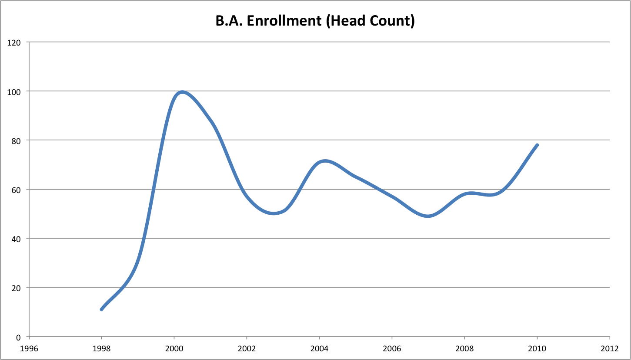  
Figure 2: B.A. Enrollment (Head Count)

Figure 2 reveals that B.A. enrollment skyrocketed in 2000 as part of the overall "dot com" explosion in our economy, and then decreased sharply in 2002 as part of the "dot bomb" economic correction. Fortunately, interest in computer science as a career has resumed in the past several years, and our enrollment has recovered to the point that only the years 2000-2001 showed higher numbers. The trend in recent years has resumed a positive, upward growth. Another factor affecting our enrollment numbers was our inability to continue employing adjunct faculty members due to budgetary constraints.

It is also useful to see B.A. enrollment as a percentage of overall enrollment, as illustrated in Figure 3:

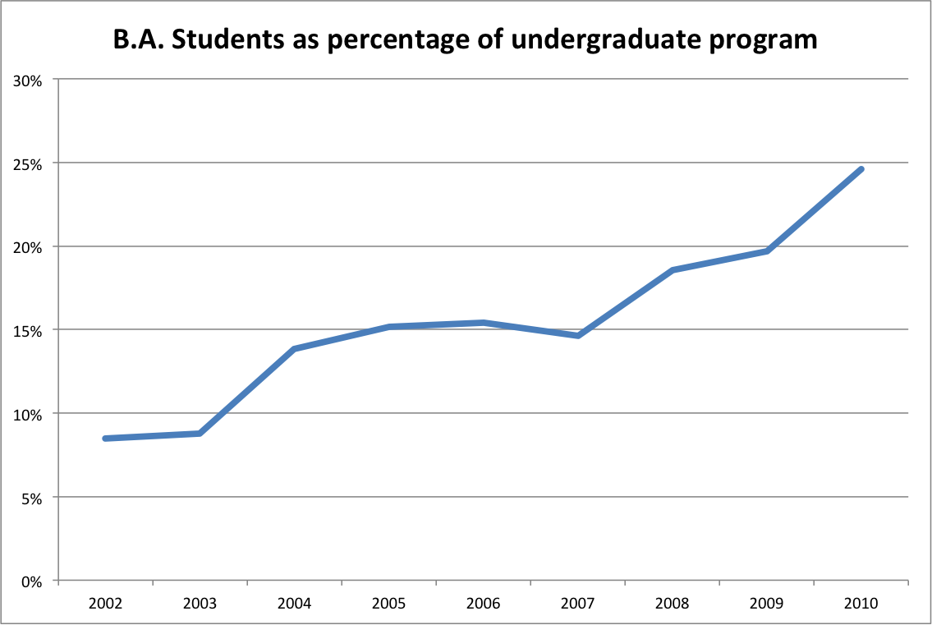  
Figure 3: Percentage enrollment in B.A. program over time

This chart shows that the percentage of our undergraduate students enrolled in the B.A. program has risen steadily over time, from 8% in 2002 to 25% in 2010. Similarly, the percentage of undergraduate ICS students that graduated with a B.A. degree rose from 18% in the 2002 to 39% in 2010.

## Student semester hours

Appendix C also provides information on student semester hours, illustrated in the following chart:

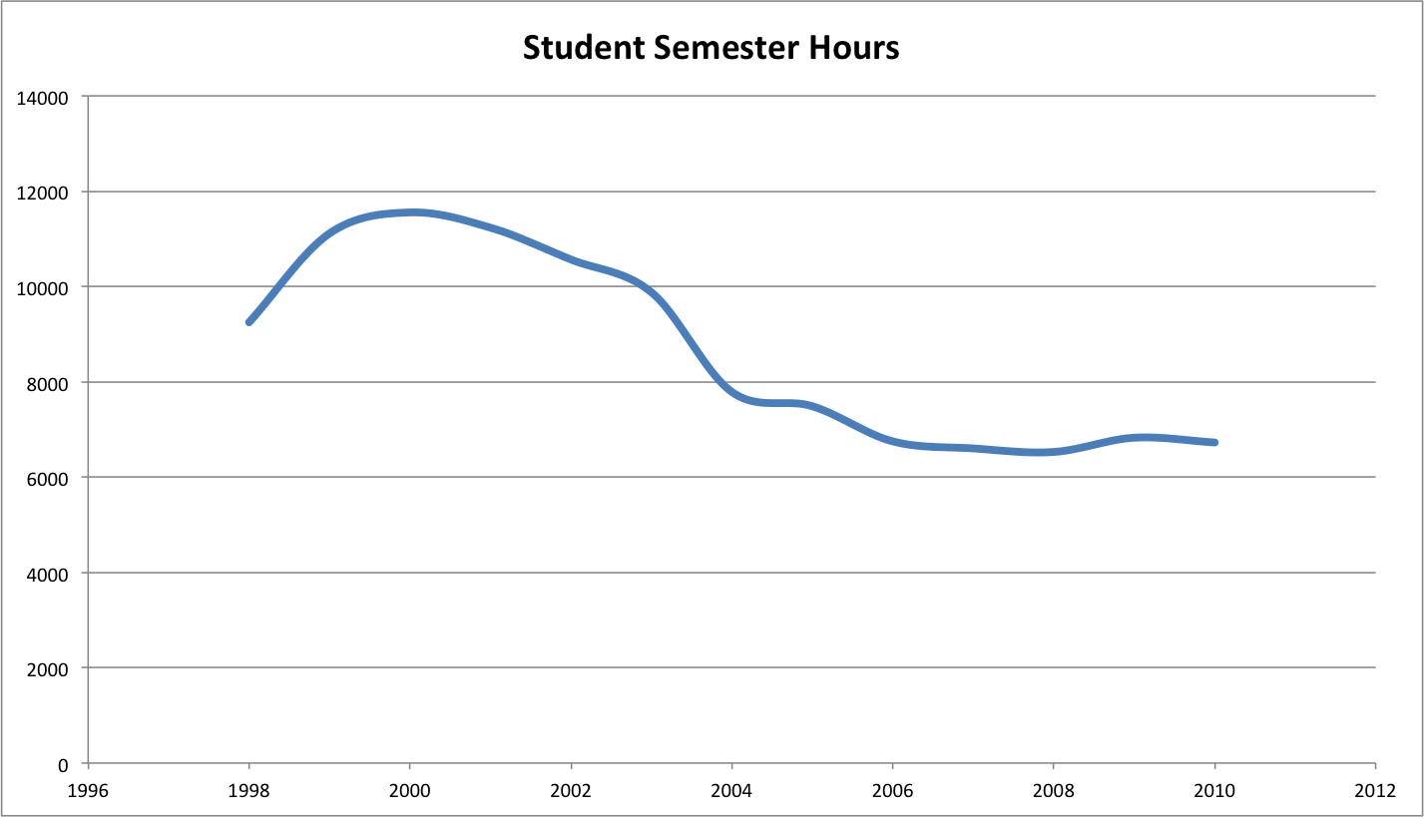  
Figure 4: Student semester hours in the B.A. program

Figure 4 shows the trend in student semester hours (SSH) to be flatter and less dramatic than the enrollment data presented above. In general, SSH reached a peak in 2000 along with the dot.com explosion, then dropped, and for the past several years has been in a relatively stable state. We believe that SSH tends to lag head count, as students can declare themselves in the B.A. program before taking a significant course load. Thus, we predict that SSH will increase in the coming years as a result of the last several years of growth in the program.

## Program cost per SSH

The next chart highlights the total program cost per SSH from Appendix C:

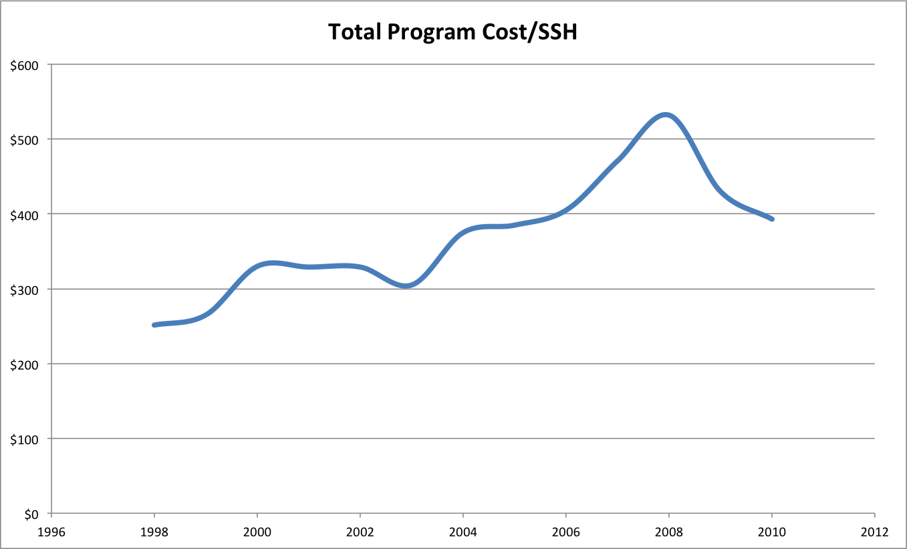  
Figure 5: Cost of B.A. program per student semester hour

Figure 5 reveals that program cost has risen over the past decade, but dropped in the last year. We believe that this reflects the gradual ramping up of services for our B.A. students as the program matured over the past decade. Although this trend is somewhat disconcerting, the next two charts provide some additional context that we believe puts this trend in a favorable light.

## Comparison of Cost/SSH (B.A. ICS vs. B.S. EE)

The following chart shows Cost/SSH for the B.A. as well as Cost/SSH for the B.S. degree in Electrical Engineering.

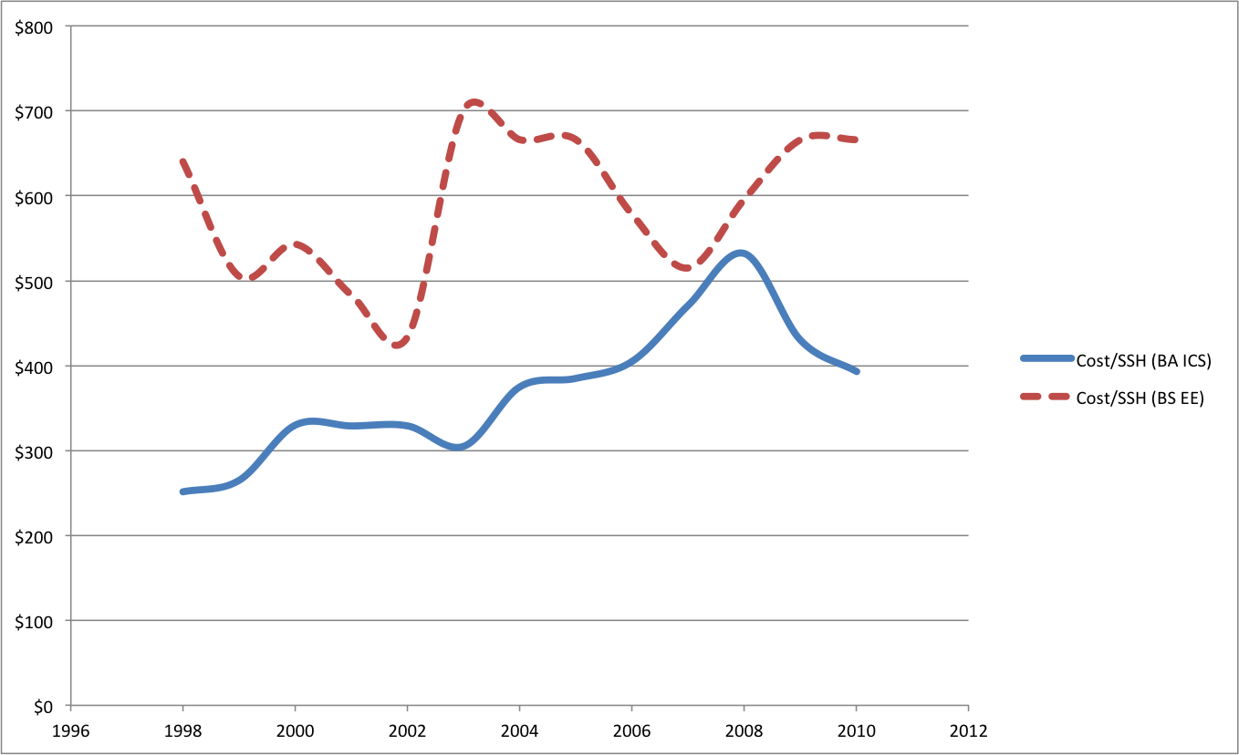

Figure 6: Comparison of B.A ICS vs. B.S. EE degree programs

Figure 6 shows that the Cost/SSH for the B.A. in ICS is consistently below the Cost/SSH for a comparable program (B.S. in Electrical Engineering). Thus, while our cost/SSH has increased, we are still a relatively "cheap" program compared to Electrical Engineering.

## Revenue

Our final excerpt from Appendix C illustrates revenue.

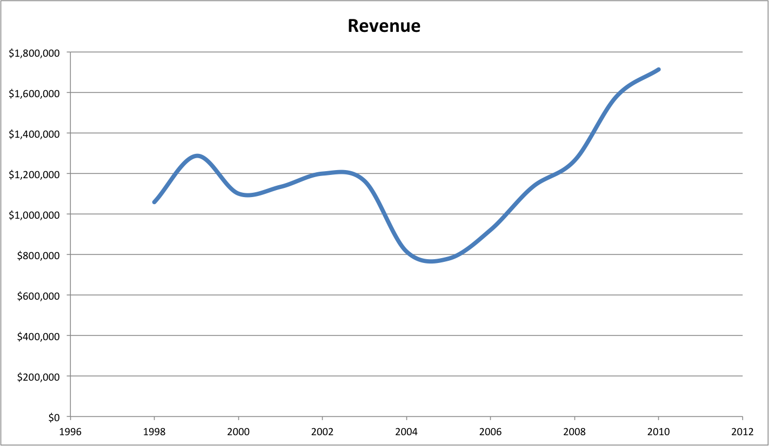  
Figure 7: Revenue from the B.A. program

Again, although our Cost/SSH has risen, Figure 8 shows that revenue has remained positive throughout the entire program, and more importantly that revenue has increased significantly during the past four years. Thus, although we are investing more in our students (in terms of Cost/SSH), the net result has been an increase in revenue for the program as a whole. We take this data to indicate that our program is a good investment, both for our students and for the University's bottom line.

## Graduation rates

Figure 1 (on page 5) shows the graduation rates for the B.A. program, which has hovered around one dozen per year for the past five years (with the exception of 2010, where only 4 B.A. degrees were awarded). The B.A. program accounts for roughly a quarter to a third of the undergraduate degrees awarded by our department. As is also noted in Figure 1, our overall "throughput" has varied between 15% and 25%. We believe that careful addition of resources could be used to improve the throughput rate.

# Assessment of program quality

(A qualitative assessment of the program in relation to competing demands for resources by new programs and continuing programs. Accreditation or other external evaluation, student performance [e.g., on external exams], satisfaction, placement and employer satisfaction, awards to faculty and students faculty publication record, evaluation of faculty…)

The ICS department has a national and international reputation and our faculty are regularly awarded grants, fellowships, awards, contracts and commissions. In prior sections of this document, we have presented evidence for the quality of our faculty. In the introduction, we noted that Wesley Peterson won the Japan Prize for his work on error correcting codes, and that Norman Abramson designed an early version of Ethernet. The next section presents a snapshot of recent ICS faculty activities as evidence of the quality of our work.

## Faculty research activities

#### Digital democracy

Professor Scott Robertson and his students have developed projects to understand the way participation in public debate and deliberation is influenced by emergent social media such as Facebook. The research includes user-centered design of enhancements to search engine tools, laboratory studies of how potential voters browse, and longitudinal studies through at least three election cycles. This research has been funded by multiple NSF grants totalling over $1.3M.

#### Artificial intelligence and medicine

Professor Julia Patriarche and her students have developed a system for the detection of change in serial magnetic resonance imaging studies of brain tumor patients. The system is a multi-level AI system, which demonstrates how such systems can augment patient care by performing routine tasks and thus elevating the role of the clinician to the more interesting and less routine parts of patient care. Dr. Patriarche's work has resulted in a diagnostic system that has been adopted as a standard part of patient care for brain tumor patients at the Mayo Clinic. This research has been funded by multiple grants from the National Institute of Health and has resulted in two patent applications.

#### Socio-technical network analysis

Professor Dan Suthers and his students are studying the new emergent forms of socio-technical systems enabled by modern communication and information technologies. A recent project called Traces provides a theoretical foundation for analysis, a data model, and software tools to trace out the movements, confluences, and transformations of people and ideas in online social networks. Professor Suther's recent research is funded by the National Science Foundation for approximately $400K.

#### Data management

Professor Lipyeow Lim and his students have developed efficient algorithms for  evaluating XPath queries on XML data that exploit the multi-core parallelism available in modern processors resulting in performance improvements of up to an order of magnitude. Other students have also designed query processing algorithms for mobile devices (eg. i-Phones, android phones) that optimize the energy efficiency in such devices in order to improve battery life. A recent project investigates using the streaming paradigm to forecast wind profiles for the purpose of wind energy monitoring and management. This project has been funded by an IBM innovation award.

#### Biometrics

Professors Martha Crosby and Curtis Ikehara have been applying biometrics to study cognitive overload in specific situations. In 2007, they received patent No. US 7,245,218 B2 for an “Input Devise to Continually Detect Biometrics.” This patent was granted for a method and system that uses surface finger pressures to identify the biometric characteristics of a user from a computer input device (such as a mouse).

#### User modeling

Professor David Chin and his students perform research to create models of user to improve information systems. A recent project involves a prototype agent-based simulation system that will allow analysis of the long-term effects of policy on culture, and to predict the effects of cultural change on the level of violence in various localities. The goal is to better predict which policy alternatives are likely to minimize long-term violence. Professor Chin's recent research has been funded by a variety of grants totaling over $1M.

#### Space exploration

Professor Kim Binsted manages a NASA-funded 4-month simulated space-exploration mission using an environment on the Big Island. Six crewmembers will live in a habitat for four months, while researchers study their diet, psychology, teamwork, etc. ICS graduate students will work on automated tools for data collection, as well as on advanced communication strategies for long-term space missions. In addition, Professors Binsted and Rich Gazan are applying computational methods to the search for life in the universe, funded by a 5-year, $8M NASA Astrobiology Institute grant. They work with a cross-disciplinary team at UH including researchers from Astronomy, SOEST, Physics and Chemistry, and NASA researchers nationwide, using information-theoretic clustering methods to relate the work of researchers in diverse fields, and to model the galactic habitable zone.

#### Quantitative Finance

Professor Susanne Still and her collaborators have argued that portfolio optimization must be regularized for large portfolios, such as those of banks and insurance companies. They have shown that regularization gets rid of an intrinsic instability that is otherwise present in portfolio optimization. They are studying the effects of regularization on investment strategies and on market dynamics, with the goal of finding mechanisms that could help prevent future crashes.

#### High performance computing

Professor Henri Casanova and his students have developed a novel method for sharing compute resources among competing users. This approach, called Dynamic Fractional Resource Scheduling, makes both theoretical and practical advances and outperforms state-of-the-art techniques by orders of magnitude. Among its benefits are a higher level of user satisfaction, a quantifiable and optimized measure of fairness among users, and enhanced resource economy both in terms of hardware and electrical power expense. This research has been funded by multiple grants from the National Science Foundation totaling over $500K.

#### Wireless networking and security

Professor Edo Biagioni and his students have developed a seamless voting system that lets voters vote from home, verify that their vote has been counted, yet remain anonymous. Another project involves a virtual machine system that detects attacks on the operating system. In embedded systems, a student designed a wireless system that can track buses, similar in function but different in technical details from the system that TheBus is currently using.

#### Studio-based learning

Professor Martha Crosby and her students perform research in studio-based learning, an innovative paradigm for science education that adapts concepts from architectural education including "design crits". Professor Crosby's recent research has been funded by multiple grants from the National Science Foundation totaling over $1M.

#### Broadening Participation in Computing (BPC)

Working with Chaminade University (CU) and the University of Hawai’i at Hilo (UHH), Professor Martha Crosby is part of a NSF Broadening Participation in Computing (BPC) alliance grant for planning and developing the infrastructure for serving higher education institutions in the Pacific region with significant Native Hawaiian (NH) and Pacific Island (PI) student populations. CU and UHH are two of the three NH-serving institutions in Hawai’i.

#### Collaborative Research in Computer Security Education

Since 2006, Professor Martha Crosby has collaborated with The George Washington University (GW), a DHS/NSA designated Center of Academic Excellence in Information Assurance Education and Research (CAE/IAE and CAE/IAE-R), in Project PISCES (Partnership in Securing Cyberspace through Education and Service) to expand computer security and information assurance (CSIA) education opportunities to potential successful CSIA applicants from ICS. In 2011 Professor Crosby built on this partnership and received a NSF Collaborative Research grant to make this educational perspective available to ICS students. This research has been funded by multiple grants from the National Science Foundation totaling over $6M.

#### STEM education

Professors Violet Harada and Dan Suthers are principal investigators of the Hawai‘i Networked Learning Communities (HNLC) Initiative, which is a partnership of the Hawai‘i Department of Education and the University of Hawai‘i to improve science, mathematics and technology learning in K-12 rural schools. It directly supports the effort to form a seamless connection between UH and the State DOE. This initiative has been funded by grants from the Department of Education totaling over $1M.

#### Renewable energy and sustainability

Professor Philip Johnson and his students perform research on consumer-facing energy analysis and visualization that results in open source technology and empirical data to guide policy making. For example, they designed and implemented "The Quest for the Kukui Cup", an energy challenge for all 1,000 first year students living in the Hale Aloha residence halls. The project involves novel information technology, pedagogy, and game design techniques designed to raise student awareness of the energy challenges facing Hawaii, help them to learn how to use energy more efficiently, and connect them with organizations and curriculum if they decide to pursue energy studies at the University. Professor Johnson's recent research is funded by grants from the National Science Foundation totalling over $400K.

#### Bioinformatics

Professors Guylaine Poisson and Kyungim Baek are Director and Associate Director for the Bioinformatics cores of the COBRE Pacific Center for Emerging Infectious Diseases Research and the INBRE Hawaii State Research and Education Partnership programs. They work with their students on research projects that include metagenome analysis, prediction of phosphorylation sites in proteins, and population clustering using human SNPs (single nucleotide polymorphism) data. As Directors of the Bioinformatics cores, Professors Poisson and Baek manage research funds from multiple grants from the National Institute of Health totaling around $1.8M.

#### Machine Learning

Professor Susanne Still has developed a new approach to interactive learning. Her theoretical work has spawned a number of applications in machine learning and robotics. Her students are using this approach to implement curiosity driven learning and exploration in robotics, to understand human learning and behavior in simplified scenarios, such as computer games, and for devising intelligent agents which are to be embedded into computer games. Professor Still and her collaborators have developed a novel robust clustering algorithm, and they have improved the state-of-the-art in cluster analysis methods. Her students are applying these methods to document classification, whale song analysis, and, in collaboration with researchers at NASA, to problems in geophysics and planetary sciences.

#### Computer vision

Professor Kyungim Baek and her students designed and implemented a traffic density estimator which provides traffic monitoring information by analyzing images from Hawaii state traffic cameras. Other students implemented a wrist pose estimator for robotic surgical instrument that helps human-robot interaction in a minimally invasive robotic surgery environment.

#### Software Visualization

Professor Jan Stelovsky and his students developed a visualization tool embedded within a popular software development environment. This tool allows a programmer to view algorithm execution in a textbook-like graphical fashion. When the resulting video is replayed, the programmer can switch between a variety of different visualizations. The tool was successfully used in introductory ICS courses to help students understand the behavior of typical algorithms.

#### Undergraduate education

Professor M.B. Ogawa supervises a variety of research projects related to undergraduate education. As one example, four undergraduate students were semi-finalists in the 2009 ImagiNations Competition sponsored by Walt Disney Corporation. These students designed a mobile device to enhance the experience of Walt Disney park goers with live data feeds to determine ride wait times, GPS mapping, and historical information about the park. This is part of an overall research program on student learning that has been funded by multiple grants totaling over $500K.

#### Human computer interaction

While the ICS faculty prides itself on providing a diversity of research interests and activities to its students and the community, the focus area of human computer interaction (HCI) encompasses such a substantial number of ICS faculty interests that it deserves special mention. Professors Scott Robertson, Martha Crosby, Dan Suthers, David Chin, Rich Gazan, Curtis Ikehara, Jan Stelovsky, and Philip Johnson have all published research in HCI related conferences and journals. When viewed in aggregate, HCI is an area in which the ICS faculty have achieved a special level of national and international recognition.

## Faculty productivity: external funding and refereed publications

Figure 8 provides a perspective on faculty productivity based upon the aggregate value of external funding that ICS faculty have been awarded as PIs or co-PIs, along with the number of refereed publications that ICS faculty have authored or co-authored.

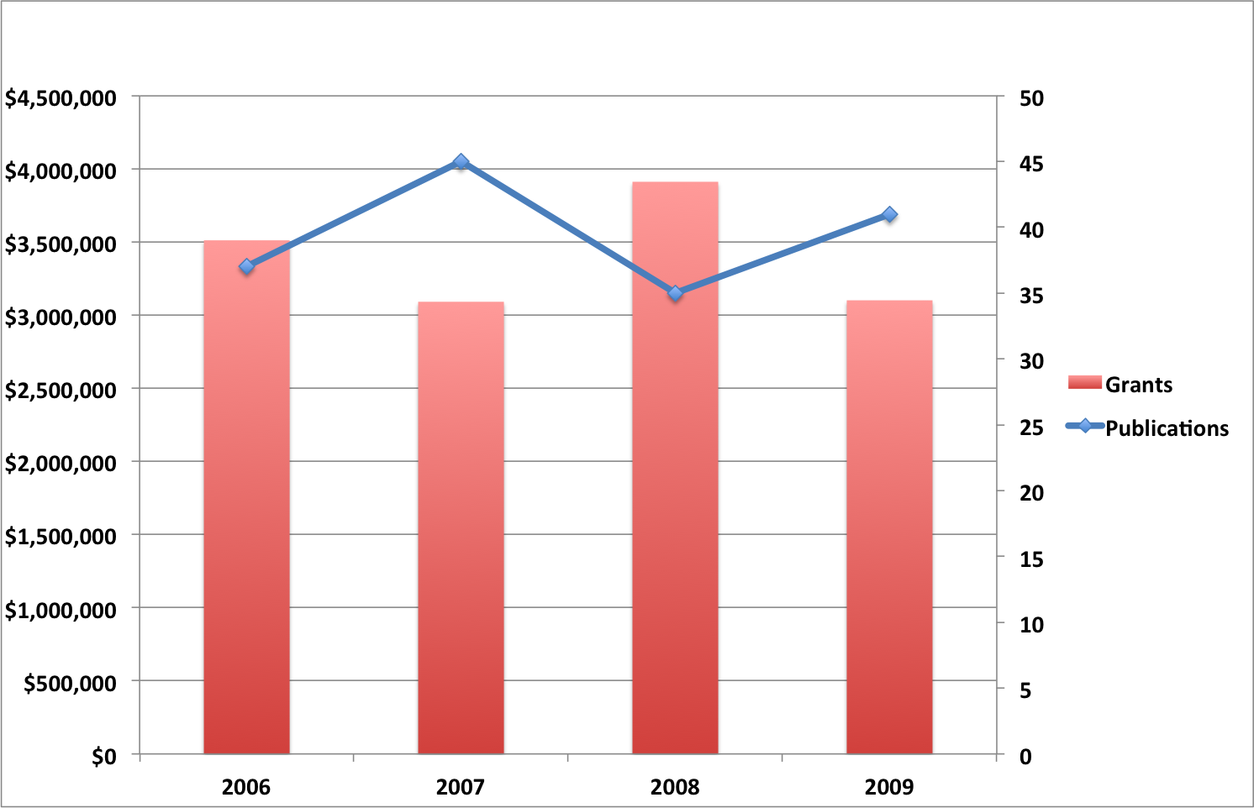  
Figure 8: External funding and refereed publications by ICS faculty

Figure 8 shows that aggregate external funding in which ICS faculty were directly involved varied between $3M and $4M during this four year period, and the number of refereed publications by ICS faculty varied between 35 and 45 per year.

For a listing of recent faculty extramural funding awards, please see Appendix F. For faculty publications, please see Appendix G.

## Curriculum quality

We now turn from our faculty to a discussion of the quality of our curriculum.

Encouraged by the provisional approval of a B.A. in Information and Computer Sciences, the approval of a Minor in Computer Science and WASC approval for distance delivery of its bachelor and master programs, we have introduced major curricular changes and articulation agreements with UH-Hilo, Maui College and the Community Colleges for most of our 100 and 200 level courses.

There has been considerable discussion regarding the need to provide increased access to “information technology” (IT), “computer science”, “programming” and other related general concepts. “The First Two” Project attempted to meet this need. Using funds from the state government, we established a learning and support environment to directly impact the first two years of course work in ICS. This includes ICS 111 and 211 (Introduction to Computer Science I & **II),** ICS 212 (Program Structure), ICS 141 & 241 (Discrete Mathematics I & II), and ICS 311 (Data Structures & Algorithms). Although the changes in these foundational ICS courses are incremental, it is a key part of a long term effort to revamp the upper division undergraduate courses to reflect the latest changes in the Association for Computing Machinery (ACM) 2008 computer science curriculum. The ultimate goal is to provide a significantly more supportive and successful environment for those students enrolled in ICS 111, ICS 211, ICS 212, ICS 141, ICS 241, and ICS 311. These courses represent the basic concepts and skills that frame computer science and “informatics”. They also provide opportunities for application of technology to other fields. The program does not differentiate between students in regular day, extended, summer, or ALN courses.

We have also been exploring different teaching methodologies that use active learning techniques. In 2007, we began testing how using a studio-based learning (SBL) methodology could improve learning outcomes in computer courses. This project was initially funded with a grant from NSF and was to addresses the dual challenge of retaining computer science students, and broadening access to computing education, by building a community of educators and researchers using a novel studio-based instructional model in introductory computing education courses. Adopted from architectural education, this instructional model emphasizes learning activities in which students (a) construct personally-meaningful representations of the algorithms and programming concepts under study, and then (b) present those representations to their instructors and peers for feedback and discussion within the context of so-called “design crits.”

We also teamed with George Washington University on Project PISCES (Partnership in Securing Cyberspace through Education and Service). This program provides opportunities for students with diverse backgrounds to become Computer Security and Information Assurance (CSIA) professionals and help protect the safety and security of our nation’s information infrastructure. It does this by combining scholarships, university courses in computer security and information assurance, internships, laboratories, and government service, and appropriate monitoring and evaluation for these students. A major new thrust of the project is to include students from the ICS department at the University of Hawaii at Manoa (UHM) to provide potential successful CSIA applicants.

## Initiatives related to student quality

Recently we have begun a series of initiatives to improve and award student quality. The following table describes some of our recent activities.

|  |  |  |
| --- | --- | --- |
|  | **Impact:** | **Project Description** |
| 1 | Incoming | ICS Science Fair Awards - Five $200 awards for a computer science project. One for the best project from each class level from 8th grade, freshman, sophomore, junior and senior. Status: Ongoing from 2009. |
| 2 | Incoming | Fred and Annie Chan Scholarship for incoming Freshmen. First, this requires organizing a publicity campaign to students, counselors and parents. Second, collection and organizations of applicants. Third, the assembly of a selection committee. Finally, implementation and follow-up with the recipient.  Status: Ongoing from 2008. |
| 3 | Incoming | ICS Minor promotion – This is a promotion to recruit more undergraduates to minor in ICS. It requires the printing and disbursement of over 500 flyers on the ICS minor program. Status: Ongoing from 2007. |
| 4 | Undergrad | ICS 290 - Computer Science Careers: An exploration of the specialties of computer science – Spring 2009. A class designed to provide students with information to help define and achieve their goals in computer science. Status: Ongoing from 2010. |
| 5 | Undergrad & Grad | W. Wesley and Hiromi Peterson Scholarship – To encourage research and scholarship among students. Status: Will start once funds become available. |
| 6 | Incoming, Undergrad & Grad | Bachelor’s packet, thanking graduates for selecting our department, informing them of alumni services and requesting that they send thank you notes to their high school mentors. The thank you notes increase awareness of the ICS program and will hopefully motivate more high school mentors to send their best students to our department. Status: Ongoing since 2008. |
| 7 | Undergrad | Promotion to encourage high end undergraduates to take graduate courses before graduating. This will provide high end students with a transcript that stands out and increase confidence in their academic ability. This requires organizing a publicity campaign to students. Status: Ongoing since Fall 2009. |
| 8 | Undergrad & Grad | ICS Software Engineering Competition for undergraduate students (where a graduate student may mentor undergraduates). First, this requires coordinating with the faculty on the notification and incentive systems to increase student participation. Second, conducting the competition and awarding of the winners. Status: Competition held Fall 2009. |
| 9 | Undergrad | Promoting the hiring of lower division CS students by commercial CS organizations as entry level help. This will provide students who cannot do CS work with the experience of working in a CS environment. Status: Started 2011. |
| 10 | Undergraduate & Graduate | Graduation and awards ceremony.  Status: Spring 2011 graduates completed |
| 11 | Undergraduate & Graduate | Short Skill Set Classes - Creating special non-credit classes to fill-out the specific skill sets requested by the local computer companies. Status: Organizing in progress – currently communicating with local companies. |
| 12 | Undergraduate | GRE Award – This award is encourages high performing undergraduate computer science majors to prepare for graduate school. A full-time undergraduate ICS student who takes the Graduate Record Exam (GRE) and scores above the 80% percentile for two categories can apply for a $200 award. A student can only receive this award once. Status: Organizing in progress. |
| 13 | Undergraduate | Help promote the department of Information and Computer Sciences at the university open house, high school counselors meeting, and high school events. Since 2007. |
| 14 | Undergrad & Grad | ICS 40th Alumni Lunch with alumni, faculty and their best students. Status: Completed 2008 |

The large number of local and mainland companies that recruit our graduates attests to the success of our academic programs. Federal agencies like the FBI and CIA also show a strong interest in our majors.

# Assessment of program objectives

Are program objectives still appropriate functions of the college and University? (Relationship to University mission and development plans, E5.201 P 13 of 13 evidence of continuing need for the program, projections of employment opportunities for graduates, etc.)

## ICS Mission

The following section addresses how the mission statements for the Department of Information and Computer Sciences support the larger missions of the University of Hawaii at Manoa, the University of Hawaii system, the state of Hawaii, and the overall national picture.

The mission of the Department of Information and Computer Sciences is to nurture a world-class community of students and faculty dedicated to innovative scientific and information-related research and education for the benefit of the participants, Hawaii, the United States, and the world. A goal of the ICS program is to prepare students to be research and development leaders in computer science and computer technology. To this end, the program is a catalyst and a resource for shaping the future of the broad discipline of computer science. The faculty embraces the mutual interdependence of research and teaching to achieve excellence in both. As part of its mission the program brings the latest research findings into courses and actively involves students in research endeavors of the faculty. The program also provides leadership in the application of high technology to improve the educational experience.

## Alignment with the UH Manoa strategic plan

The final draft of Achieving Our Destiny, the University of Hawaii at Mānoa 2011–2015 Strategic Plan has been released, and central to the UHM mission statement is to "support innovations in education, health care, social development, culture and arts, earth, space, and ocean sciences, sustainable land management, and technological advancement." In its broad-based research, teaching and professional networks, the ICS department is a catalyst for innovation in each of these areas.

## Alignment with the UH System strategic plan

The University of Hawaii System strategic plan approved by the Board of Regents has the following goals for the system:

* Educational Effectiveness and Student Success
* A Learning, Research, and Service Network
* A Model Local, Regional, and Global University
* Investment in Faculty, Staff, Students, and Their Environment
* Resources and Stewardship

The ICS department’s mission statement closely aligns with the first goal of educational effectiveness and student success. Furthermore, the department helps to provide the university system with a strong learning, research, and service network.

## Alignment with the State of Hawaii

At the state level, Governor Neil Abercrombie’s Technology and Information platform states the need for human capital and education in the area of technology, specifically:

“The fuel of an innovation economy is our human capacity to learn and create. Everyone can contribute. Education at all levels is the fundamental investment we will make to improve our economy. Industry and public education must work very closely to support each other and ensure highly skilled employees are being prepared at the same rate that high skill jobs are being created.”

The need for education in technical fields is further underscored by Office of Department of Business, Economic Development and Tourism’s report on Hawaii’s Technology. This report includes a summary of employment trends, reproduced in Appendix D. Our degree programs directly address the highlighted occupations. Focusing on just these occupations, the Bureau is projecting an increase of more than 50% that would result in over 1.4 million new positions.

In a U.S. Department of Commerce, Office of Technology Policy report entitled “The Digital Workforce: Building Infotech Skills at the Speed of Innovation” (June 1999) Alan Greenspan said, “The rapid acceleration of computer and telecommunications technologies is a major reason for the appreciable increase in our productivity in this expansion, and is likely to continue to be a significant force in expanding standards of living into the twenty-first century.” This bodes well for the increasing use of information technology and for the strategic role that the ICS Department might play in delivering high-quality teaching and research at UHM.

## Alignment with international needs

The globalization of society makes this need the same as that for the national needs. The central role of information technology in almost all aspects of higher education is expected to increase dramatically for the foreseeable future. Areas such as bioinformatics, medical informatics, business informatics, and educational informatics argue for the increasing need for our interdisciplinary B.A. program.

# Appendix A: ICS course descriptions

**ICS 111 Introduction to Computer Science I (4)** Overview of computer science, writing programs. AY2011 enrollment: 222.

**ICS 141 Discrete Mathematics for Computer Science I (3)** Logic, sets, functions, matrices, algo­rithmic concepts, mathematical reasoning, recursion, counting techniques, probability theory. AY 2011 enrollment: 155

**ICS 211 Introduction to Computer Science II (3)** Algorithms and their complexity, introduction to software engineering, data structures, searching and sorting algorithms, numerical errors. AY 2011 enrollment: 72

**ICS 212 Program Structure (3)** Program organization paradigms, programming environments, implementation of a module from specifications, the C and C++ programming languages. AY 2011 enrollment: 46

**ICS 215 Introduction to Scripting (3)** Introduction to scripting languages for the integration of applications and systems. Scripting in operating systems, web pages, server-side application integration, regular expressions, event handling, input validation, selection, repetition, parameter passing, Perl, JavaS­cript, and PHP. AY 2011 enrollment: 16

**ICS 241 Discrete Mathematics for Computer Science II (3)** Program correctness, recurrence relations and their solutions, divide and conquer relations, relations and their properties, graph theory, trees and their applications, Boolean algebra, introduction to formal languages and automata theory. AY 2011 enrollment: 67

**ICS 290 Computer Science Careers: An Exploration of the Specialties of Computer Science (1)** Exploration of the specialties of computer science. AY 2011 enrollment: 7

**ICS 311 Algorithms (3)** Design and correctness of algorithms, including divide-and-conquer, greedy and dynamic programming methods. Complexity analyses using recurrence relations, probabilistic methods, and NP-completeness. Applications to or­der statistics, disjoint sets, B-trees and balanced trees, graphs, network flows, and string matching. AY 2011 enrollment: 67

**ICS 312 Machine-Level and Systems Programming (3)** Machine organization, machine instructions, addressing modes, assembler language, subroutine linkage, linking to higher-level languages, interface to operating systems, introduction to assemblers, loaders and compilers. AY 2011 enrollment: 24

**ICS 313 Programming Language Theory (3)** Syntax, semantics, control structures, variable binding and scopes, data and control abstractions. Programming in functional (LISP) and logic (Prolog) programming styles. AY 2011 enrollment: 63

**ICS 314 Software Engineering I (3)** System specification, modeling and analysis, prototyping, hierarchal design, program design methods, cost estimation, project management, computer-aided software design. Team-oriented software-design project. AY 2011 enrollment: 25 (taught as 413).

**ICS 315 Web Design and Management (3)** Web design principles, XML and HTML, tables, forms, and frames, multimedia objects, security, script­ing for web applications, web servers, commercial aspects, new technology. AY 2010 enrollment: 10.

**ICS 321 Data Storage and Retrieval (3)** Data storage devices, timing and capacity, programming for files, hashed and indexed files, introduction to relational database systems. AY 2011 enrollment: 90

**ICS 331 Logic Design and Microprocessors (4)** (1 3-hr Lab) Basic machine architecture, microprocessors, bus organization, circuit elements, logic circuit analysis and design, microcomputer system design. AY 2011 enrollment: 35

**ICS 332 Operating Systems (3)** Operating system concepts and structure, processes and threads, CPU scheduling, memory management, scheduling, file systems, inter-process communication, virtualization, popular operating systems. AY 2011 enrollment: Not taught.

**ICS 351 Network Design and Management (3)** Overview of the internet and its capabilities; introduction to HTTP, TCP/IP, ethernet, and wireless 802.11; routers, switches, and NAT; network and wireless security; practical experience in designing and implementing networks. AY 2011 enrollment: 14

**ICS 361 Introduction to Artificial Programming (3)** Introduction to the theory of Artificial Intel­ligence and the practical application of AI techniques in Functional (Common LISP and/or Scheme) and Logic (Prolog) programming languages. Students gain practical experience through programming as­signments and projects. AY 2011 enrollment: Not taught.

**ICS 390 Computing Ethics for Lab Assistants (3)** A lecture/discussion/internship on ethical issues and instructional techniques for students assisting a labo­ratory section of ICS 101. The class uses multiple significant writing and oral presentation activities to help students learn course content. AY 2011 enrollment: 17

**ICS 414 Software Engineering II (3)** Continuation of 413. Project management, quality, and productiv­ity control, testing and validation, team manage­ment. Team-oriented software-implementation project. Pre: 413. AY 2011 enrollment: 15

**ICS 415 Introduction to Programming for the Web (3)** Introduction to emerging technologies for construction of World Wide Web (WWW)- based software. Covers programming and scripting languages used for the creation of WWW sites and client-server programming. Students will complete a medium-sized software project that uses languages and concepts discussed in class. AY 2011 enrollment: Not taught.

**ICS 419 The Science, Psychology and Philosophy of Systems Design (3)** Scientific, psychological and philosophical bases of systems design, including a survey of human-factors and ergonomic standards; the nature of innovation and creativity as it relates to systems design. Web-enhanced course. AY 2011 enrollment: 9

**ICS 421 Database Systems (3)** Principles of database systems, data modeling, relational models, database design, query languages, query optimiza­tion, concurrency control data security. AY 2011 enrollment: Not taught.

**ICS 423 Computer Security (3)** Legal, ethical and technology issues in computer access, confidentiality, authentication, privacy and intellectual property. AY 2011 enrollment: Not taught.

**ICS 424 Application Frameworks (3)** Experience producing applications with at least two different applications frameworks. A-F only. AY 2011 enrollment: Not taught.

**ICS 425 Computer Security and Ethics (3)** Theoretical results, security policy, encryption, key management, digital signatures, certificates, pass­words. Ethics: privacy, computer crime, professional ethics. Effects of the computer revolution on society. AY 2011 enrollment: 40.

**ICS 426 Computer System Security (3)** Informa­tion flow, confinement, information assurance, malicious programs, vulnerability analysis, network security, writing secure programs. AY 2011 enrollment: Not taught.

**ICS 431 Computer Architecture (3)** Memory management, control flow, interrupt mechanisms, multiprocessor systems, special-purpose devices. AY 2011 enrollment: Not taught.

**ICS 432 Concurrent and High-Performance Programming (3)** Principles of concurrent and high performance programming. Multi-threading in C and Java for shared-memory programming. Distrib­uted memory programming with Java. Introduction to cluster computing. AY 2011 enrollment: Not taught.

**ICS 435 Machine Learning Fundamentals (3)** Introduction to machine learning concepts with a focus on relevant ideas from computational neurosci­ence. Information processing and learning in the nervous system. Neural networks. Supervised and unsupervised learning. Basics of statistical learning theory. AY 2011 enrollment: 6.

**ICS 441 Theory of Computation (3)** Grammars, sequential machines, equivalence, minimalization, analysis and synthesis, regular expressions, comput­ability, unsolvability, Gödel’s theorem, Turing machines. AY 2011 enrollment: 5.

**ICS 451 Data Networks (3)** Network analysis, architecture, digital signal analysis and design; circuit switching, packet switching, packet broadcasting; protocols and standards; local area networks; satellite networks; ALOHA channels; examples. AY 2011 enrollment: 24.

**ICS 452 Software Design for Robotics (3)** Sensors, actuators, signal processing, paradigms of robotic software design, introduction to machine learning, introduction to computer vision, and robot-to-human interaction. A-F only. Pre: two ICS 300-level courses or consent. AY 2011 enrollment: Not taught.

**ICS 461 Artificial Intelligence (3)** Survey of artificial intelligence: natural language processing, vision and robotics, expert systems. Emphasis on fundamental concepts: search, planning, and problem solving, logic, knowledge representation. AY 2011 enrollment: 9.

**ICS 464 Human Computer Interaction I (3)** Application of concepts and methodologies of human factors, psychology and software engineering to ad­dress ergonomic, cognitive, and social factors in the design and evaluation of human-computer systems. AY 2011 enrollment: 22

**ICS 465 Introduction to Hypermedia (3)** Basic issues of interactive access to information in various formats on computers. Available hardware and soft­ware: editing, integration, programming. Implementation of a sample information system. AY 2011 enrollment: 13.

**ICS 466 Design for Mobile Devices (3)** Lecture introducing design issues, programming languages, operating systems and mark-up languages for internet-enabled mobile devices, such as cell phones and PDAs. AY 2011 enrollment: 21.

**ICS 469 Cognitive Science (3)** Introduces basic concepts, central problems, and methods from cogni­tive science. Identifies contributions from disciplines such as cognitive psychology, linguistics, artificial intelligence, philosophy, and neuroscience. AY 2011 enrollment: 15.

**ICS 475 Introduction to Bioinformatics Sequences and Genomes Analysis (3)** Introduction to bioinformatics to computer sciences students by focusing on how computer sciences techniques can be used for the storage, analysis, prediction and simulation of biological sequences (DNA, RNA and proteins). AY 2011 enrollment: 16.

**ICS 476 Bioinformatics Algorithms and Tool Development (3)** Study of commonly used bioinformatics’ algorithms, with an emphasis on string, tree, and graph algorithms. Presentation of probabilistic and clustering methods. Implementation of the studied algorithms and design of applications. AY 2011 enrollment: Not taught.

**ICS 481 Introduction to Computer Graphics (3)** Fundamentals of computer graphics including graphics hardware, representation, manipulation, and display of two- and three-dimensional objects, use of commercial software. AY 2011 enrollment: Not taught.

**ICS 483 Computer Vision (3)** Introductory course in computer vision. Topics include image forma­tion, image processing and filtering, edge detection, texture analysis and synthesis, binocular stereo, segmentation, tracking, object recognition and applications. AY 2011 enrollment: Not taught.

# Appendix B: B.A. curriculum plan/map



|  |
| --- |
|  |

# Appendix C: Head counts, student semester hours, and costs

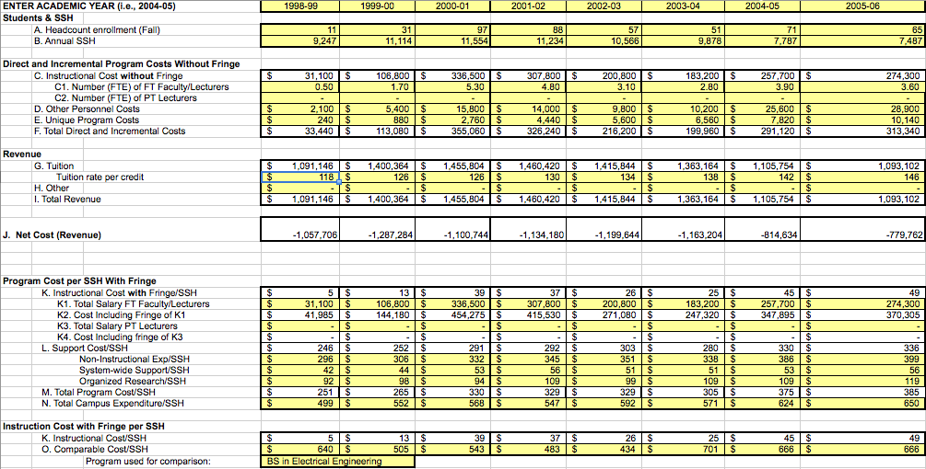  
Figure C.1: Costs & Revenues Spreadsheet, 1998 - 2005

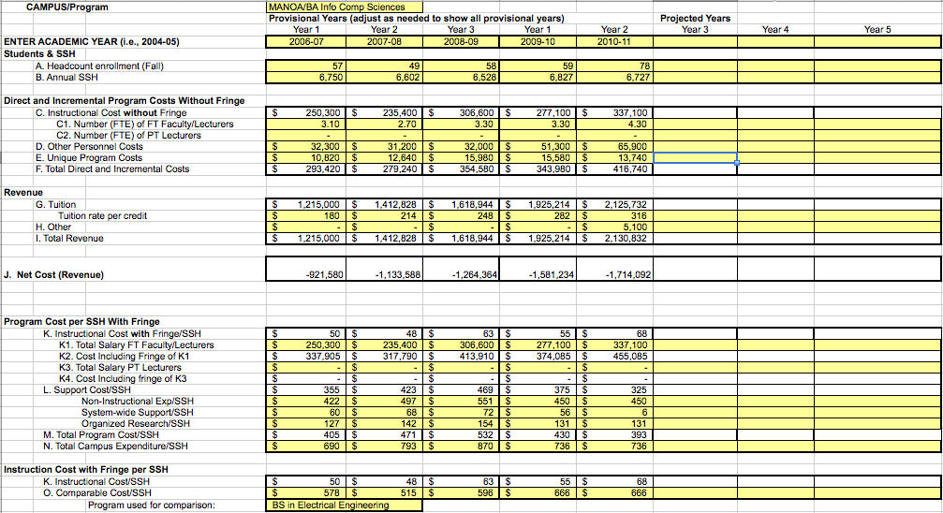  
Figure C.2: Costs & Revenues Spreadsheet, 2006 -2011

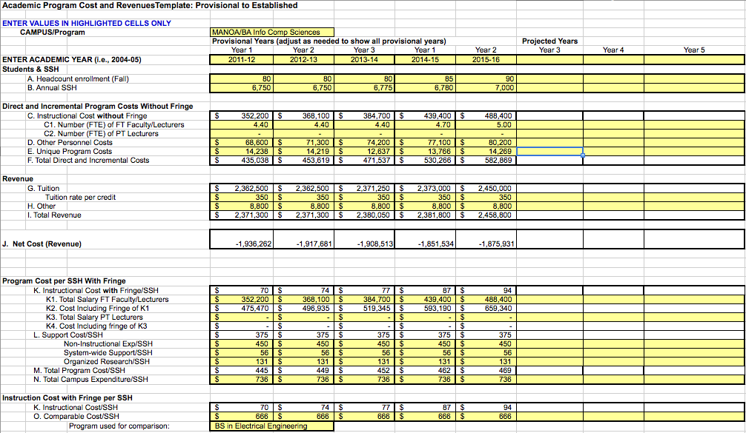  
Figure C.3: Costs and Revenues Spreadsheet, 2011 - 2016 (Projected)

# Appendix D: Employment trends

Italicized occupations below are those which might be appropriate for our B.A. graduates.

|  |  |  |  |
| --- | --- | --- | --- |
| **Fastest Growing Jobs** | **Employment change** |  |  |
| Occupation | 2000-2010 |  |  |
|  | Number (thousands) | Percent Increase | Most significant source of education or training |
| *Computer software engineers, applications* | *380* | *100* | *Bachelor’s degree* |
| Computer support specialists | 490 | 97 | Associate degree |
| *Computer software engineers, systems software* | *284* | *90* | *Bachelor’s degree* |
| *Network and computer systems administrators* | *187* | *82* | *Bachelor’s degree* |
| *Network systems and data communications analysts* | *92* | *77* | *Bachelor’s degree* |
| Desktop publishers | 25 | 67 | Postsecondary vocational award |
| *Database administrators* | *70* | *66* | *Bachelor’s degree* |
| Personal and home care aides | 258 | 62 | Short-term on-the-job training |
| *Computer systems analysts* | *258* | *60* | *Bachelor’s degree* |
| Medical assistants | 187 | 57 | Moderate-term on-the-job training |
| Social and human service assistants | 147 | 54 | Moderate-term on-the-job training |
| Physician assistants | 31 | 53 | Bachelor’s degree |
| Medical records and health information technicians | 66 | 49 | Moderate-term on-the-job training |
| Computer and information systems managers | 150 | 48 | Bachelor’s degree, plus work experience |
| Home health aides | 291 | 47 | Short-term on-the-job training |
| Physical therapist aides | 17 | 46 | Short-term on-the-job training |
| Occupational therapist aides | 4 | 45 | Short-term on-the-job training |
| Physical therapist assistants | 20 | 45 | Associate degree |
| Audiologists | 6 | 45 | Master’s degree |
| Fitness trainers and aerobics instructors | 64 | 40 | Postsecondary vocational award |
| Computer and information scientists, research | 11 | 40 | Doctoral degree |

# Appendix E: Distance education courses and enrollments

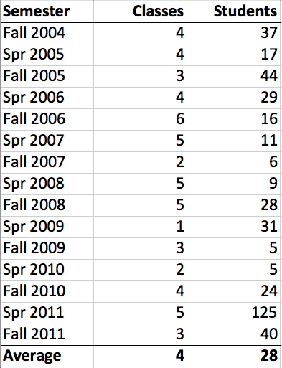

# Appendix F: Faculty extramural funding

This section provides a listing of extramural funding awards with ICS faculty participation as Principal or co-Principal Investigator during the past five years.

Kim Binsted, co-PI, Effects or retronasal smelling, variety, and choice on appetite and satiety, NASA, 2011, $395,000.

Kim Binsted, co-PI, UH-NASA Astrobiology Institute, NASA, 2008, $7,824,000.

Henri Casanova, PI, DiRT: A Testbed for Distributed Research, National Science Foundation, 2009, $31,764.

David Chin, co-PI, Coherence-Based Modeling of Cultural Change and Political Violence, National Science Foundation, 2007, $1,074,754.

David Chin, PI, Agent-based modeling for PMRF Intent Analysis, SAIC, 2006, $186,638.

Martha Crosby, PI, Teaching Strategic, Operational, and Defensive Cyber-security to the Next Generation from Sea to Shining Sea, National Science Foundation, 2011, $86,438.

Martha Crosby, PI, Broadening Studio-Based Learning in Computing Education, National Science Foundation, 2010, $220,299.

Martha Crosby, co-PI, PISCES 2006, 2010, 2014: Partnership in Securing Cyberspace Through Education and Service, National Science Foundation, 2010, $9,000,000.

Rich Gazan and Kim Binsted, co-PIs, Water and Habitable Worlds, NASA, 2009, $8,000,000.

Curtis Ikehara, co-PI, Center for Ohana and Self-Management of Chronic Illnesses in Hawaii, National Institutes of Health, 2008, $300,000.

Curtis Ikehara, co-PI, Development of Compact Teleoperated Robotic Minimally Invasive Surgery, National Institute of Health, 2008, $134,560.

Curtis Ikehara, co-PI, Magnetic Levitation Systems for Human Interaction, National Science Foundation, 2006, $95,248.

Stephen Itoga, PI, Historical Native Hawaiian Archive, US Department of Education, 2008, $191,593.

Philip Johnson, PI, Innovative Information Architectures for the Smart Grid, National Science Foundation, 2009, $397,000.

Michael-Brian Ogawa, co-PI, Pathways to excellence and achievement in research and learning, IMLS, 2009, $249,917.

Michael-Brian Ogawa, co-PI, Examining the link between informal social networks and innovation: Using netometrics to quantify the value of distributed heirarchical networks, National Science Foundation, 2007, $199,766.

Guylaine Poisson and Kyungim Baek, co-PIs, COBRE Pacific Center for Emerging Infectious Diseases Research, National Institutes of Health, 2010, $11,000,000.

Guylaine Poisson and Stephen Itoga, co-PIs, INBRE II, National Institutes of Health, 2010, $9,000,000.

Guylaine Poisson, co-PI, Diversity and ecology of marine RNA viruses, National Science Foundation, 2008, $498,325.

Nancy Reed, co-PI, Automated interpretation of pediatric heartsounds, a multi-site recording device, US Army, 2007, $195,000.

Scott Robertson, co-PI, Digital Deliberation: Search and deciding how to vote, National Science Foundation, 2006, $400,000.

Scott Robertson, PI, Social search and deliberation in digital political information and collaboration domains, National Science Foundation, 2011, $948,537.

Dan Suthers, co-PI, Traces: Understanding distributed socio-technical systems, National Science Foundation, 2009, $382,421.

Dan Suthers, co-PI, HiMax Research and Development, 2006, $1,034,927.

# Appendix G: Faculty publications

The following links provide access to the publications associated with our faculty.

Kyungim Baek, http://www2.hawaii.edu/~kyungim/research.html

Edo Biagioni, http://www2.hawaii.edu/~esb/cv/2010.html

Kim Binsted, http://www2.hawaii.edu/~binsted/papers/Publications.html

Henri Casanova, http://navet.ics.hawaii.edu/~casanova/homepage/vita.pdf

David Chin, http://www2.hawaii.edu/~chin/chin_vita.pdf

Martha Crosby, http://www.dblp.org/db/indices/a-tree/c/Crosby:Martha_E=.html

Rich Gazan, http://www2.hawaii.edu/~gazan/publications.html

Curtis Ikehara, http://www2.hawaii.edu/~cikehara/

Philip Johnson, http://csdl.ics.hawaii.edu/~johnson/CV/curriculum-vitae.pdf

Lipyeow Lim, http://www2.hawaii.edu/~lipyeow/#publications

Julia Patriarche, http://www2.hawaii.edu/~julia4/PatriarcheCV.pdf

Guylaine Poisson, http://navet.ics.hawaii.edu/~poisson/BiL/publications/index.html

Luz Quiroga, http://www2.hawaii.edu/~lquiroga/LuzMQuirogaVita.htm

Nancy Reed, http://www2.hawaii.edu/~nreed/nreed-cv.pdf

Scott Robertson, http://manoa.hawaii.edu/hichi/pubs.html

Jan Stelovsky, http://www.dblp.org/db/indices/a-tree/s/Stelovsky:Jan.html

Susanne Still, http://www2.hawaii.edu/~sstill/pubs.html

Kazuo Sugihara, http://www.dblp.org/db/indices/a-tree/s/Sugihara:Kazuo.html

Dan Suthers, http://lilt.ics.hawaii.edu/?page_id=42

# Appendix H: Assessing teamwork, communication, and critical review skills

## Overview

Studio-based learning SBL endeavors to build students’ skills in communication, teamwork, and critical review. However, the ways in which we are presently measuring the outcomes of SBL do not directly assess these skills. The department plans to remedy this deficiency by outlining a technique for more directly measuring communication, teamwork, and critical review skills. We plan to record student teams engaging in a team problem-solving activity relevant to the course at two points in the course: during the first week of the course, and again during the last week of the course. Multiple experts review the recordings (or transcripts of the recordings), rating the activity against structured rubrics designed to assist teamwork, communication, and critical review skills. Similar to our present pre/post assessment strategy for learning and attitude changes, this assessment strategy is designed to directly measure changes in three “soft” skills that SBL is purported to promote**.**

## Steps

*1. Devise a challenging problem that is both relevant to your course and appropriate for a team to work on collaboratively*. The problem should be nontrivial, have no clear solutions, and a rich design space. For example, in a human-computer interaction or software engineering course, the problem might involve the design of a new software application for a particular client or domain in need of one. In an algorithms course, the problem might involve the design of algorithms and data structures for a non-trivial problem. In a databases course, the problem might involve the design of a database schema for a complex set of business rules.

*2. Devise an deficient solution to a different problem for a team to critique collaboratively*. The problem you solve should be similar in spirit and difficulty to the problem you devised in step (1). You should deliberately seed the solution with errors of different types and degrees of severity. For example, if you provide a code solution to a software design problem, you might include errors of the following types: (a) logic errors that lead to incorrect output; (b) potential for division by zero; (c) "off by one" errors in iteration; (d) redundant code that could be made into a single function; (e) a case in which a different design pattern could make the code simpler and easier to maintain; (f) poor variable name choices; and (g) poor or missing comments.

*3. Group students into teams*. The target team size is four to five. Try to match students of equivalent abilities, so that there is a better chance that a single student won’t dominate the activity. If the team is mixed-gender, it is best if at least two women are on the team.

*4. Capture student teams’ problem-solving and critiquing activities*. Here, we have two choices: Either have students work on the problem asynchronously through a web-based collaboration environment (for an example of this, see <http://soa.asee.org/paper/conference/paper-view.cfm?id=9065>), or have students work on the problem face-to-face. If they work on it asynchronously, their dialog will be automatically captured. If they work on the problem face-to-face, we will need to (a) record their problem-solving activity using either audio or videotape, and (b) set a time limit of 40 minutes for their interaction.

*5. Transcribe student teams’ problem-solving activities.* If we had students solve the problem face-to-face, we may need to transcribe the recording that we made, so that it can be easily analyzed. However, a transcription may not be necessary, as it would also be possible for the expert raters to view or listen to the recording directly.

*6. Have a team of 2 to 3 experts review the transcriptions, recordings, or online dialog*. Below is both a protocol that the expert assessors can follow, and a provisional rubric that they could use for the assessment.

## Review Protocol

6a. Read and discuss professional skill definitions and criteria below with your rating group.

6b. Skim the student work without making written comments to get a sense for how well the student group addressed the professional skills.

6c. Review the student work again, marking specific passages where the team exhibited certain professional skills—for example, “Outcome (d).” A given passage may exhibit more than one skill simultaneously.

6d. Circle specific descriptors in the criteria below that express how well the student work as a whole exhibits a given skill.

6e. Note the rationale for the ratings in the comment boxes. For example, “The team identified a list of stakeholders but did not consider stakeholder perspectives, so I gave them a 3 on Outcome (f).”

## Rubric

**Outcome I (ABET Outcome d): Ability to function effectively on teams to accomplish a common goal.** Students work as a team to address the problem by acknowledging and building on each other’s ideas. Students collaboratively build an understanding of the issues involved and possible approaches to the problem. Students clearly frame the problem or issue and begin the process of resolution.

|  |  |  |  |  |  |
| --- | --- | --- | --- | --- | --- |
| 1 - Absent | 2 - Emerging | 3 -Developing | 4 –Competent | 5 - Effective | 6 - Mastering |
| Students do not interact with each other in ways that promote better understanding of the problem.  One person dominates or some team members are shut out. | | Students attempt to consider the problem at multiple levels and perspectives.  Students may lack the skill to fully balance everyone’s input or to actively support/clarify each other’s ideas. | | Students demonstrate the ability to effectively conceptualize the problem by probing it at multiple levels and from multiple perspectives.  Students encourage participation and actively help each other to clarify ideas. | |
| Students opt to follow the dominant voice as the most expedient method for developing a solution. | | Students attempt to reach consensus but have some difficulty in developing an approach that incorporates everyone’s perspectives equitably | | Students work together to reach a consensus before clearly framing the challenge and developing appropriate, concrete approaches to resolve the problem. | |
| Comments: | | | | | |

**Outcome II (ABET Outcome f): Ability to communicate effectively with a range of audiences.** Students value and integrate the diverse perspectives of stakeholders and other potential audiences beyond the student team. They discuss how they will communicate with stakeholders (e.g., employees, administrators, the public, etc.).

|  |  |  |  |  |  |
| --- | --- | --- | --- | --- | --- |
| 1 - Absent | 2 - Emerging | 3 -Developing | 4 –Competent | 5 - Effective | 6 - Mastering |
| Students do not consider the perspectives of multiple stakeholders. | | Students acknowledge that there are other stakeholders but do not always create adequate strategies for addressing these perspectives. | | Students thoughtfully consider perspectives of diverse stakeholders and discuss how they might be addressed. | |
| Students fail to recognize the ways in which the diverse perspectives of stakeholders will impact communication. | | Students consider the diverse perspectives of stakeholders but may be somewhat naïve in their approach to communicating with them. | | Students acknowledge the challenge of communicating with stakeholders who hold diverse perspectives. They work together and/or seek outside expertise in determining the best approach for communicating with target audiences. | |
| Comments: | | | | | |

**Outcome III (unique to SBL project): Ability to comprehend, identify issues with, and constructively review technical solutions at multiple levels of abstraction.**

*Students demonstrate grasp of peers’ technical solutions (e.g., software designs) and provide constructive feedback that both identifies the solutions’ strengths/weaknesses and suggests viable ways to improve the solutions .*

|  |  |  |  |  |  |
| --- | --- | --- | --- | --- | --- |
| 1 - Absent | 2 - Emerging | 3 -Developing | 4 –Competent | 5 - Effective | 6 - Mastering |
| (*Identification of issues with solutions*) Students fail to show an understanding of peers’ solutions to the problem; little or no attempt is made to understand peers’ solutions (by, e.g., asking questions) | | Students show some understanding of peers’ proposed solutions to the problem; they ask relevant questions to provide a basis for analyzing solutions | | Students grasp peers’ proposed solutions; they ask relevant and even insightful questions, perhaps with follow-up questions, that provide a sound basis for critical analysis of peers’ solutions | |
| (*Expression of issues with solutions*) Students fail to express strengths and weaknesses in their peers’ solutions in a constructive or precise way (e.g., “your variable names are great/suck!” or “this interface is nice/ugly”), or they fail to express relevant issues | | Students express relevant strengths and weaknesses in their peers’ solutions in a constructive and precise way (e.g., “Your variable names aren’t suggestive” or “your interface has a poor color scheme”) | | Students express key strengths and weaknesses in their peers’ solutions. Students justify their observations. Students’ communication is helpful and respectful (e.g., “Using a name like x for a sum impacts the readability of your code” or “your interface’s red/blue color scheme will make it difficult for color-blind individuals to use”). | |
| (Expression of ways to improve solutions, a.k.a., “constructive feedback” ) Students fail to express ways to improve peers’ technical solutions. | | Students provide some feedback on how to improve peers; technical solutions; feedback may be superficial or of little help to peers (“Change x to sum” or “consider making your variable names more suggestive.”) Feedback may not be grounded in a sound rationale. | | Students provide constructive feedback on how to improve peers’ technical solutions (e.g., “change x to sum and consider changing all of your other variable names to make them match their role.”). Students' feedback is based on a sound rationale. Students’ communication is helpful and respectful. | |

1. B.S., M.S. and Ph.D. degrees in CS; B.A. in ICS, MLISc and Ph.D. in CIS.
2. http://www.acm.org/education/curricula-recommendations
3. http://www.hawaii.edu/ecafe/published-results.html?id=1912
4. http://www.techhui.com
5. http://www.techhui.com/group/uhicsstudents/forum/topics/1702911:Topic:20091
6. http://www.techhui.com/group/uhicsstudents/forum/topics/1702911:Topic:20093
7. http://goo.gl/IGRrr