

Agentic SDLC — Software Factory
User Guide
An AI Foundry–based Software Factory: a responsive application that orchestrates specialized Azure AI Foundry agents across the software development lifecycle, with explicit human approval gates before any agent action advances to the next stage.

Version 1.0 · August 2026
Michael Yaacoub | Sr Solution Engineer, Microsoft

Quick links
GitHub repository: github.com/csdmichael/Foundry-Agentic-Workflow-SDLC
Application — Agentic SDLC — Software Factory: agentic-sdlc-ui-my.azurewebsites.net/login

Contents
1. About this guide | 4
1.1 Key links | 4
2. What the Software Factory does | 4
2.1 The seven phases | 4
2.2 Who is accountable | 5
2.3 Why the workflow is sequential | 5
3. Getting started | 6
3.1 Signing in | 6
3.2 Roles | 6
3.3 Creating and running a project | 7
4. The nine approval gates | 10
5. The agents | 11
5.1 Planning Agent — Plan & Scope | 11
5.2 Architecture Agent — Design | 14
5.3 Code Generation Agent — Build | 14
5.4 Test Automation Agent — Test | 15
5.5 Deployment Agent — Deploy | 16
5.6 Ops Monitoring Agent — Operate | 17
5.7 Insights Agent — Improve | 18
5.8 Agent configuration and identity | 18
5.9 The delivered application | 18
6. Where your work is stored | 21
6.1 Root locations | 21
6.2 What gets created per project | 21
6.3 If SharePoint is unavailable | 21
7. What the application gives you | 22
8. Security and governance | 22
9. Running the platform locally | 24
10. Live environment and deployment | 24
11. Technology stack | 25
12. Troubleshooting | 25
13. Reference | 25

1. About this guide
This guide explains how to use the Agentic SDLC Software Factory: what the platform does, how to sign in, how a project moves through the lifecycle, who approves what, and where every artifact the agents produce is stored. It is written for the people who run projects on the platform — business stakeholders, product owners, developers, testers, platform engineers, and operations — rather than for the engineers maintaining the codebase itself.
The repository keeps a single consolidated README covering architecture, data flow, configuration, security, and troubleshooting in full technical depth. This guide is the practical companion to that file. It follows the same structure and terminology, so you can move between the two without translating anything.

1.1 Key links
Repository — source code, configuration, and the consolidated README: github.com/csdmichael/Foundry-Agentic-Workflow-SDLC
Application — sign in to the Software Factory: agentic-sdlc-ui-my.azurewebsites.net/login

2. What the Software Factory does
The Software Factory is a responsive application that orchestrates specialized Azure AI Foundry agents across the software development lifecycle. Agents are built, run, and governed in Microsoft Foundry, orchestrated with Microsoft Agent Framework, and they reach the outside world only by calling systems of record through MCP servers and APIs. The defining characteristic is that no agent advances itself: every move from one stage to the next requires a named human approval, and that check runs on the server.
Seven lifecycle phases run in order, each with one owning agent and its own persisted state. A shared context and state bus runs underneath all seven, so an agent inherits what earlier phases produced instead of re-deriving it. This implementation adds an explicit security stage between deploy and operate, and fronts the seven phases with nine approval gates.

2.1 The seven phases
# | Phase | Owning agent | Produces
1 | Plan & Scope | Planning Agent | Requirements understanding, epics and user stories, estimates
2 | Design | Architecture Agent | Solution architecture, data and API contracts, security and threat model
3 | Build | Code Generation Agent | Code, unit tests, code-review suggestions
4 | Test | Test Automation Agent | Test cases and plans, execution, defect reports
5 | Deploy | Deployment Agent | Build and package, pipelines and GitHub Actions, deploy to Azure
6 | Operate | Ops Monitoring Agent | Health and performance, alerts and incident triage, auto-remediation
7 | Improve | Insights Agent | Metrics and feedback analysis, risks, next-action recommendations

2.2 Who is accountable
Six personas hold accountability across the lifecycle: business stakeholders, product owners and managers, developers, QA and testers, DevOps and platform engineers, and operations. Every persona maps to a role in the application and to the approver of one or more gates.

2.3 Why the workflow is sequential
Microsoft Agent Framework offers five multi-agent orchestration patterns. The platform uses the sequential pattern, extended with request and response semantics so the graph pauses at an approval gate and resumes after a human decision.
Pattern | Shape | Fit for a governed lifecycle
Sequential | Agents run one after another, each building on the previous output | Chosen. The lifecycle is inherently ordered — plan, design, build, test, security, deploy — and each stage needs a named approval gate between steps
Concurrent | Agents run in parallel on the same input, and the results are aggregated | No single accountable owner per step, so a gate is hard to place
Group Chat | Agents converse in a shared thread under a chat manager | Non-deterministic turn order; the audit trail is a transcript, not a state machine
Handoff | Agents dynamically transfer control to each other | Control transfers are agent-decided, which would bypass the human gates
Magentic | An orchestrator plans and delegates open-ended work | The plan is generated at runtime, so the approval sequence cannot be fixed in advance
That combination is what makes the lifecycle governable: stage order is deterministic, every transition is auditable, and no agent can advance itself. Pending requests and graph state are checkpointed, so a run can wait indefinitely for an approver without holding a connection open, and the API preserves a non-bypassable 403 response until the named gate is approved. Model execution stays behind API Management throughout.

3. Getting started

3.1 Signing in
Open the application and sign in. Two authentication flows are supported. Microsoft Entra ID validates an MSAL bearer token against the tenant JWKS. Email one-time passcode hashes codes with SHA-256, applies a time-to-live and rate limiting, and issues an application token on verification. Which flow you use depends on how your account was provisioned.
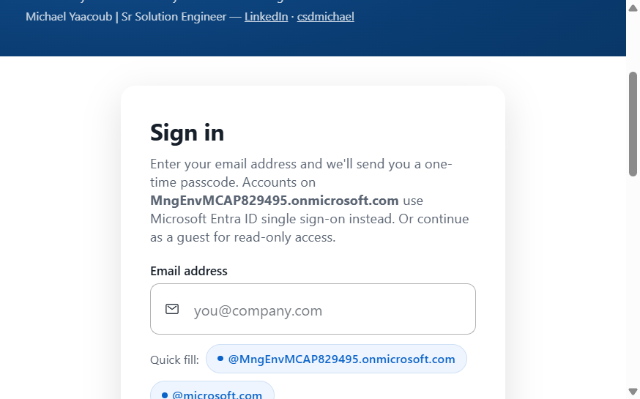
Figure 1 — Sign-in. Microsoft Entra ID for internal accounts, email one-time passcode for everyone else.
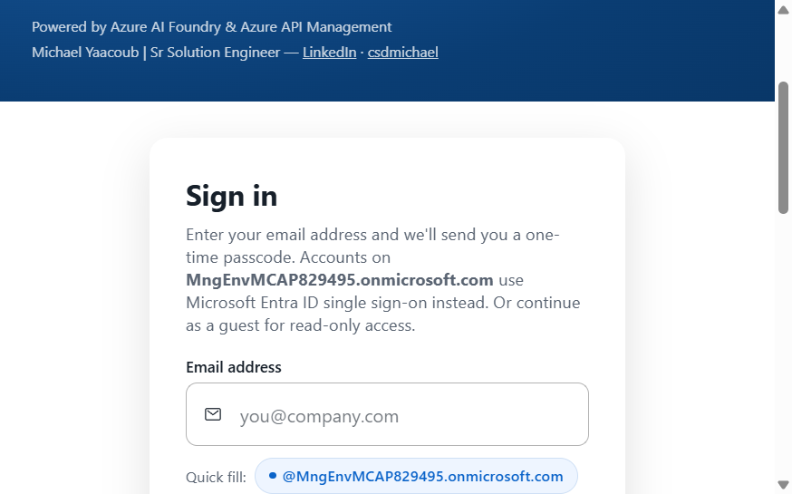
Figure 2 — Request access. A new requester submits for approval before any project work begins.

3.2 Roles
Four roles control what you can see and do. Navigation in the interface is role-aware, so you are shown the projects, runs, and gates that belong to you.
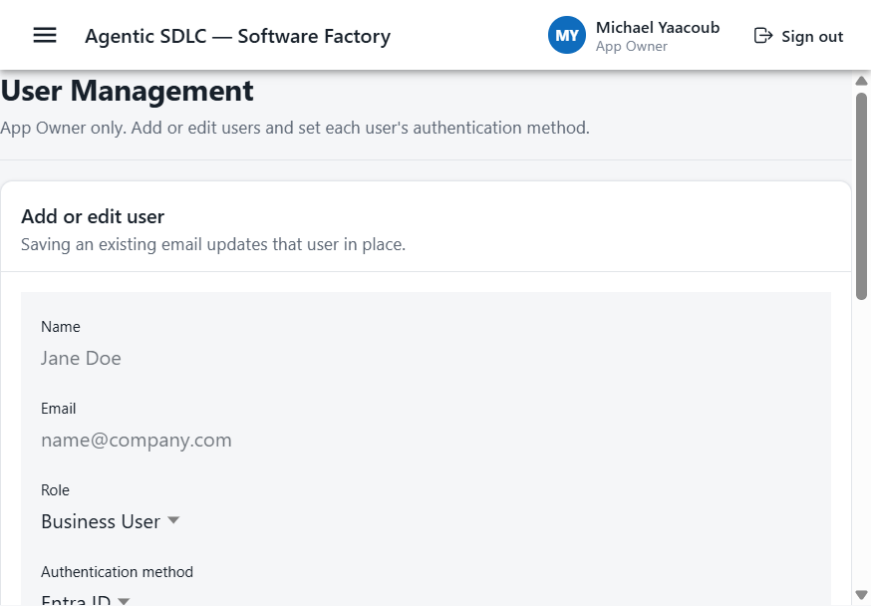
Figure 3 — User management. App Owners set the role and the authentication method for each user.
Role | Who it is for | What it allows
Business User | Stakeholders and requesters | Create projects, submit intake, review artifacts, and act on the gates assigned to them
IT User | Developers, testers, and platform engineers | Run agents, review generated artifacts, and act on the technical gates
Admin | Platform administrators | Configure agents, systems of record, and guardrails
App Owner | Platform owners | Everything above, plus user management covering roles and authentication method

3.3 Creating and running a project
The New Project wizard walks through intake and target selection. Once the project is submitted, the platform creates a workflow run with nine gates and the first one waiting on you.
- Complete intake: project name, business goal, and scope.
- Choose the requirement sources — SharePoint, OneDrive, or a local upload.
- Set the Azure DevOps and GitHub targets for the project.
- Select the environment and the agents the project should use.
- Submit. The workflow run is created with nine gates, with Plan & Scope awaiting approval.
- Approve Plan & Scope, then run the Requirements Agent.
From there the project advances one gate at a time. Before any agent call reaches the gateway, the server re-checks that the stage is approved, so approving in the interface is not a formality — it is the thing that unlocks the run. Each agent output passes content-safety, PII-redaction, and secret-scanning guardrails on the way out, and the finished artifact appears in the run alongside its audit record.
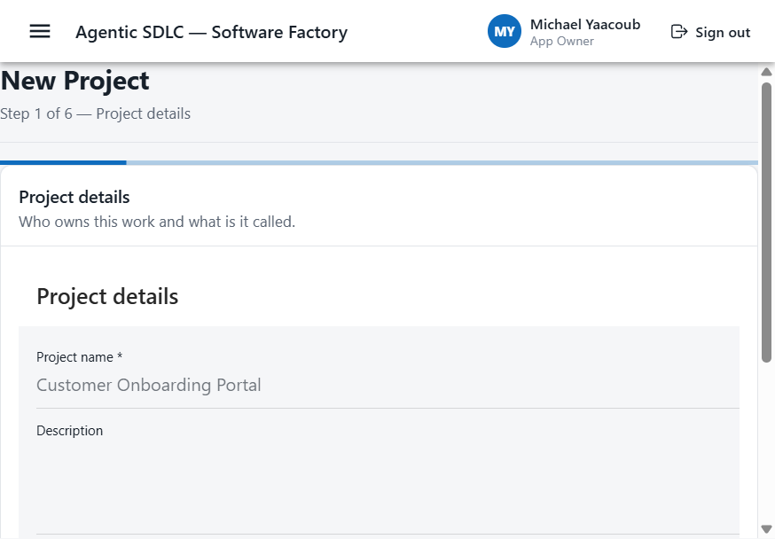
Figure 4 — Project intake: name, business goal, and scope.
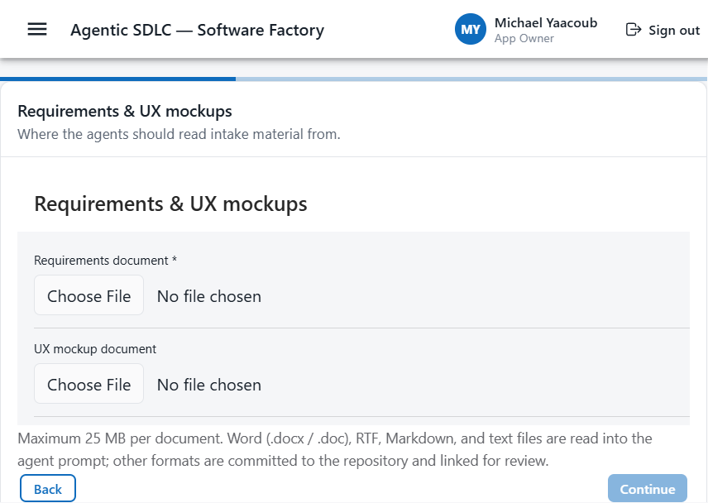
Figure 5 — Requirement sources. Documents and mockups are attached from SharePoint, OneDrive, or a local upload.
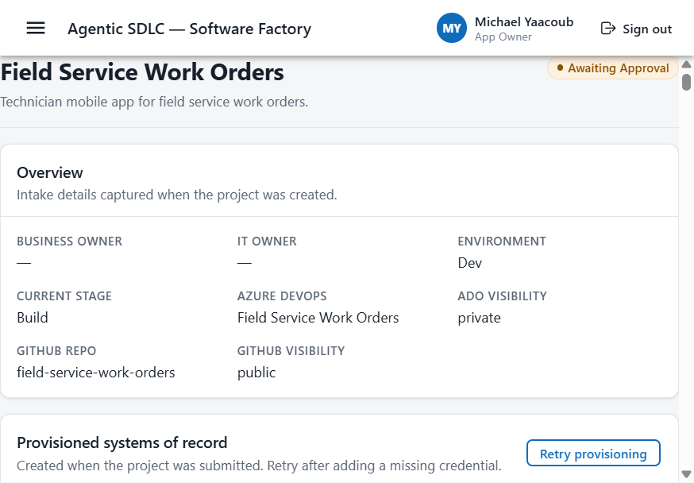
Figure 6 — Project overview, showing the systems of record and the stage the run has reached.

4. The nine approval gates
The gates run in this order:
# | Approval gate
1 | Plan & Scope
2 | Architecture & Design
3 | Backlog Generation
4 | Code Generation
5 | Pull Request
6 | Security Review
7 | Test Acceptance
8 | Release & Deployment
9 | Operate & Improve
No agent advances a stage while approval is required and missing. The rule is enforced server-side, so bypassing the interface cannot bypass approvals. At each gate you can approve, reject, request changes, or delegate the decision to someone else.
Every decision is recorded in full: the approver, their role, the timestamp, the decision, any comments, the previous and next state, and references to the artifacts involved. That record is what makes the lifecycle auditable end to end.
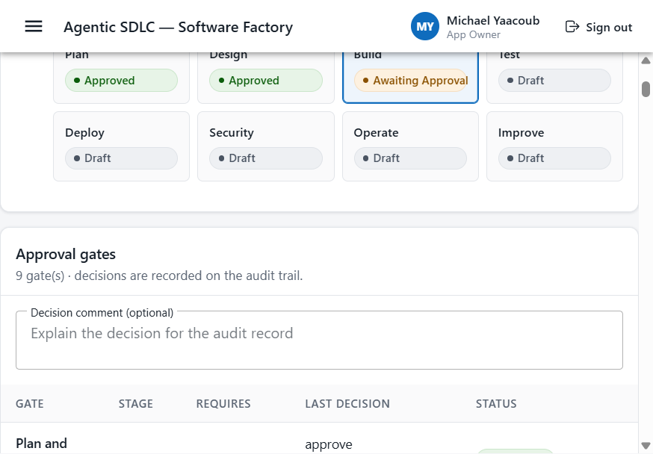
Figure 7 — Lifecycle gates, with the approve, reject, request-changes, and delegate actions on each.

5. The agents
Seven logical agents hand off in execution order. Each one consumes approved artifacts from the preceding phase together with the relevant systems of record, then persists outputs that become the next agent's inputs. The final Insights Agent feeds its recommendations back to planning, which is what turns the sequence into a continuous improvement loop rather than a one-way pipeline.
The runtime configuration can split a logical phase across more specialized agents — Requirements and Planning in the plan phase, for example, or Test Planning, Testing, and Test Automation in the test phase. Every one of those runs still goes through the same approval-gated execution path.
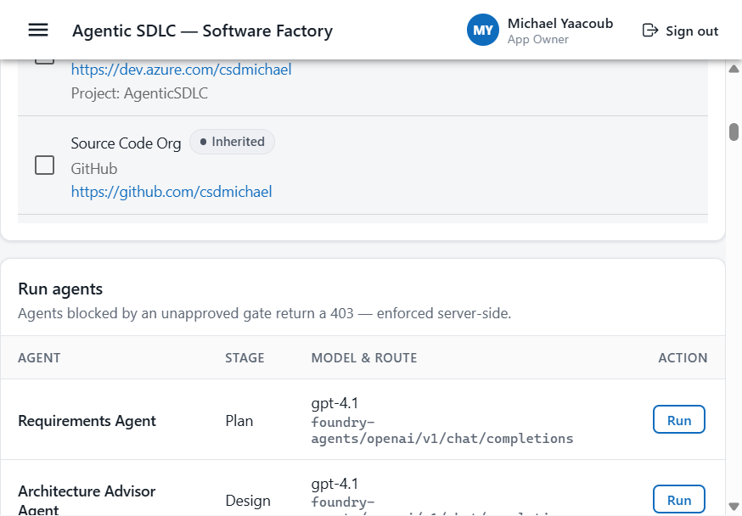
Figure 8 — Run agents. Each agent shows its stage, model, and gateway route. An agent blocked by an unapproved gate returns a 403.

Microsoft Foundry agent inventory
Before starting each role-specific agent sequence, verify that all 12 prompt agents are present and in Running status in the Microsoft Foundry project. The Requirements Agent is version 2; the remaining agents shown are version 1.
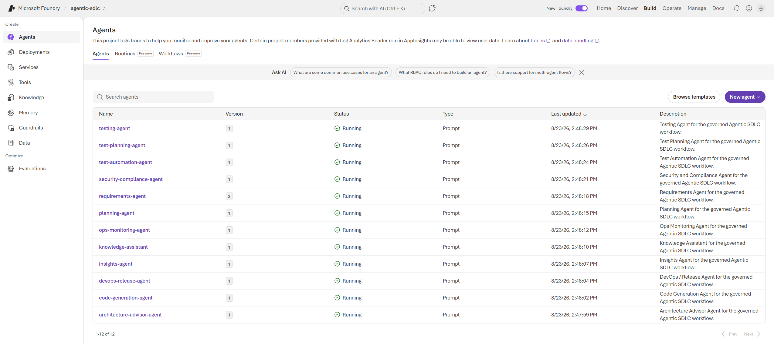
Microsoft Foundry agent inventory — all 12 Agentic SDLC prompt agents are running.

5.1 Planning Agent — Plan & Scope
Turns business intent and existing documentation into an actionable, prioritized delivery scope. It takes requirements, goals, constraints, and priorities from business stakeholders along with supporting SharePoint documentation; as the first agent in the sequence it has no previous-agent dependency. It produces Azure DevOps work items holding the approved scope — epics, features, user stories, tasks, estimates, and priorities — and hands those records, with their planning context, to the Architecture Agent.
Runtime agents: Requirements Agent, Planning Agent.
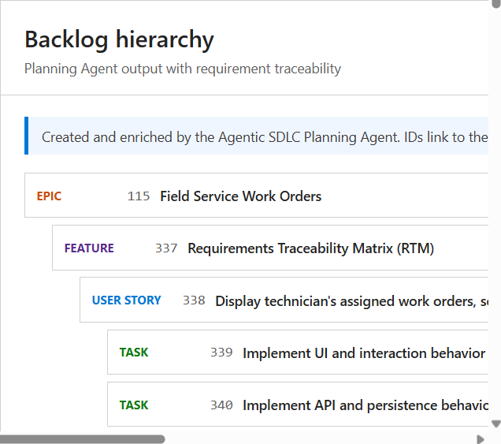
Figure 9 — Planning Agent: the generated Azure DevOps backlog.
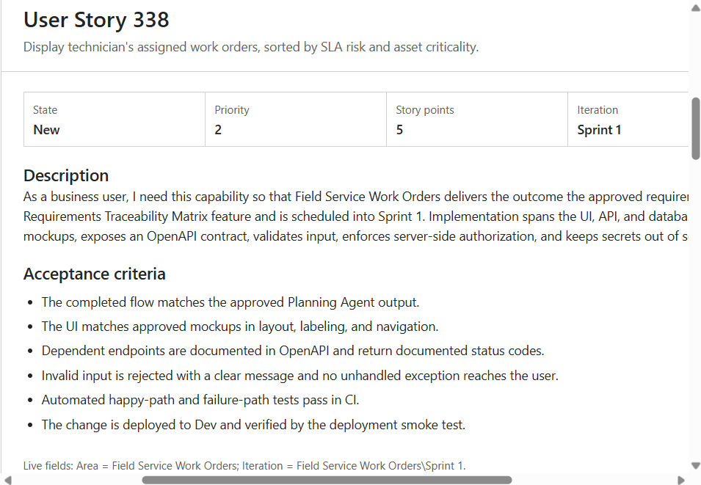
Figure 10 — Planning Agent: a generated work item with its acceptance criteria.
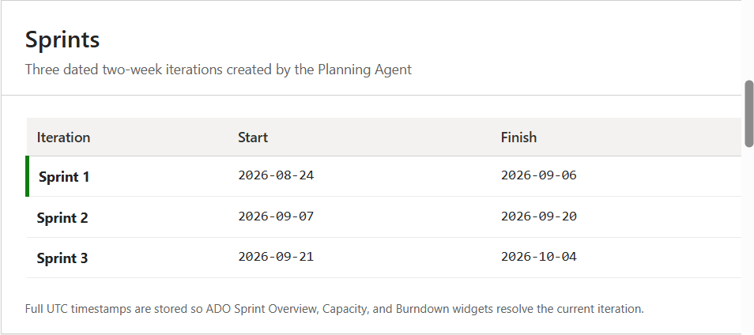
Figure 11 — Planning Agent: the sprints created for the project.
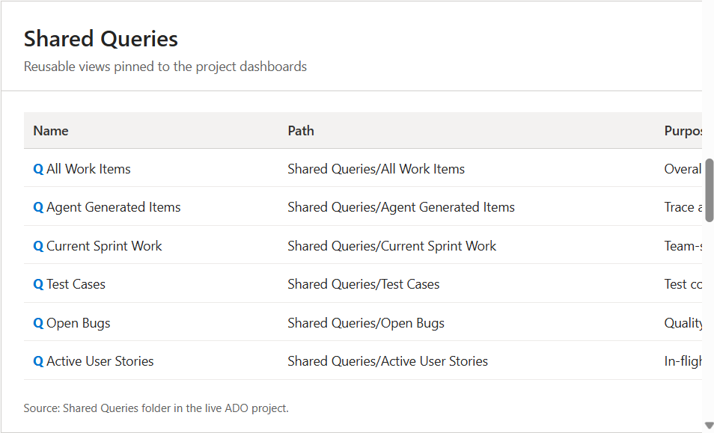
Figure 12 — Planning Agent: the saved Azure DevOps queries.
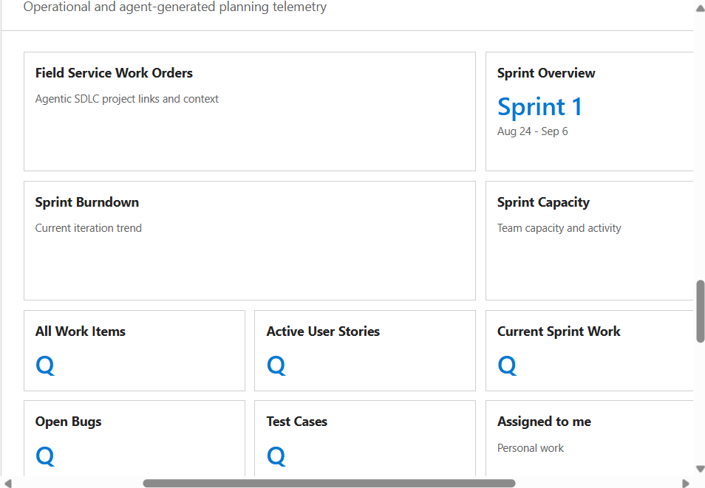
Figure 13 — Planning Agent: the project dashboard.
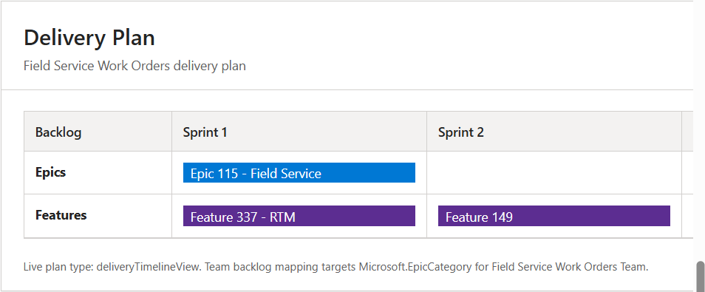
Figure 14 — Planning Agent: the delivery plan across sprints.

5.2 Architecture Agent — Design
Translates the approved plan into an implementable and secure technical design. It reads the approved backlog in Azure DevOps and the related requirements and reference documentation in SharePoint, then produces solution architecture, data models, API contracts, security design, and threat-model documentation in SharePoint, with the associated work-item updates. The approved design is handed to the Code Generation Agent.
Runtime agent: Architecture Advisor Agent.

5.3 Code Generation Agent — Build
Implements the approved design while keeping every source change traceable to the backlog. Inputs are the architecture decisions and acceptance criteria carried by Azure DevOps work items, plus the existing GitHub repository and source. Outputs are generated or updated GitHub source code, unit tests, and code-review suggestions, together with linked work-item updates. The resulting implementation is handed to the Test Automation Agent.
Runtime agent: Code Generation Agent.
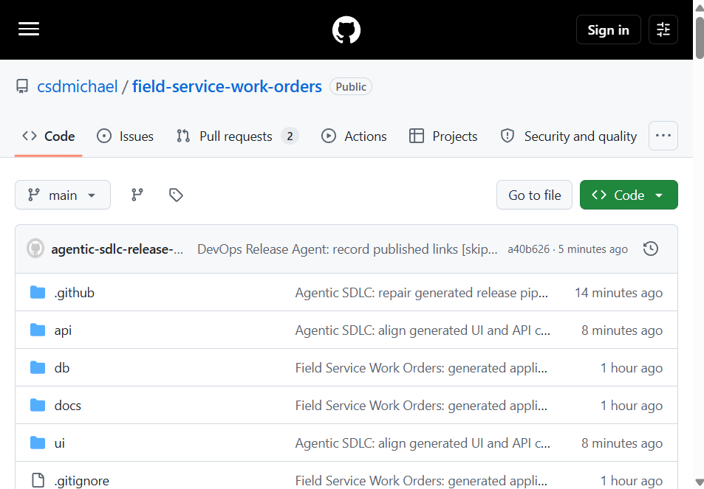
Figure 15 — Code Generation Agent: the generated repository on GitHub.

5.4 Test Automation Agent — Test
Verifies the implementation against the approved requirements and records the quality evidence. It takes the generated code and unit tests from GitHub plus the acceptance criteria and implementation work items from Azure DevOps, and produces Azure DevOps test plans and test cases, execution results, defect reports, and updated work items. Accepted test evidence is handed to the Deployment Agent.
Runtime agents: Test Planning Agent, Testing Agent, Test Automation Agent.
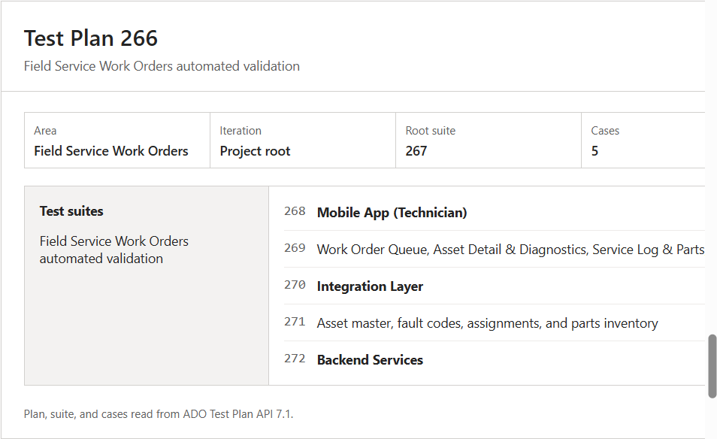
Figure 16 — Test Planning Agent: the generated Azure DevOps test plan.

5.5 Deployment Agent — Deploy
Packages validated code, runs the release pipeline, and deploys the approved build to Azure. It works from validated build and test evidence, Azure DevOps pipeline definitions, and release work items, and produces build and package artifacts, pipeline and deployment records, and the running application on Azure App Service. Deployment context is handed to the Ops Monitoring Agent.
Runtime agents: DevOps / Release Agent, Security and Compliance Agent.
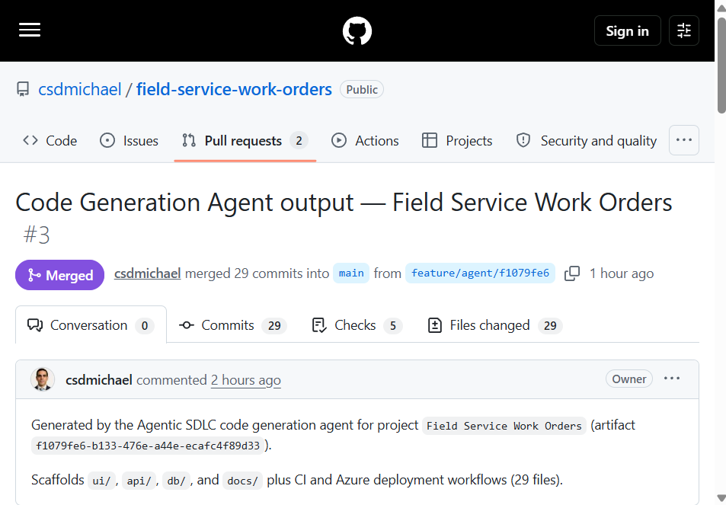
Figure 17 — The Pull Request gate: the merged pull request once the release approver signed off.
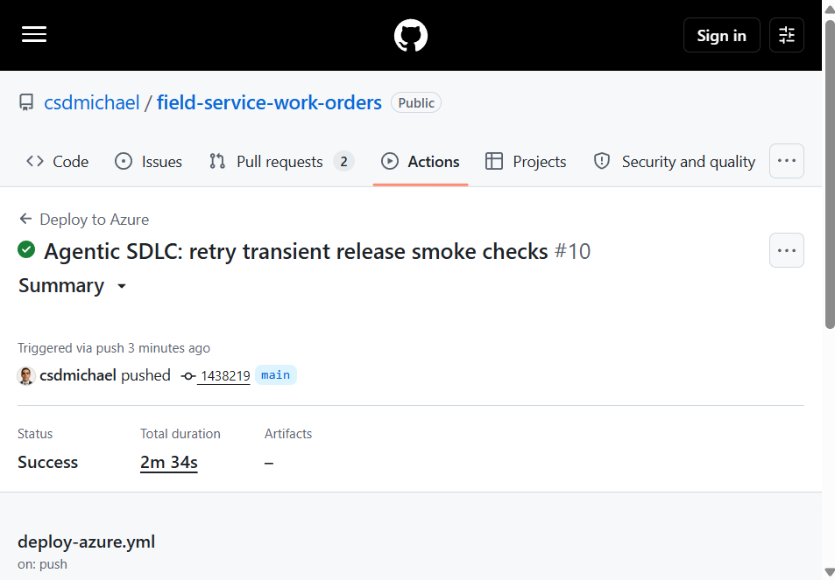
Figure 18 — DevOps / Release Agent: the GitHub Actions run that built and deployed the project.
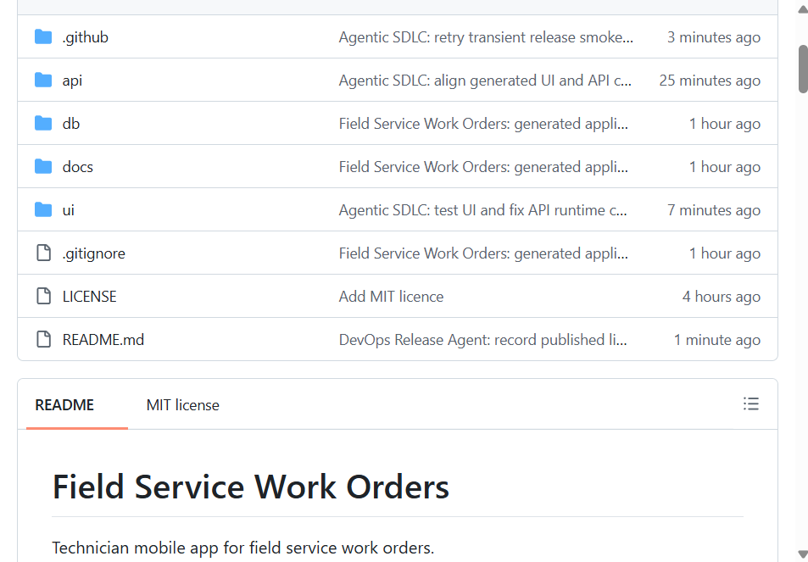
Figure 19 — DevOps / Release Agent: the published links written back into the project README.

5.6 Ops Monitoring Agent — Operate
Watches the deployed service and converts operational signals into actionable incidents and remediation guidance. Inputs are the deployment context, application telemetry from Azure Application Insights and Log Analytics, and the current Azure DevOps operational work items. The phase covers health and performance, alerts and incident triage, and auto-remediation.
Runtime agents: Ops Monitoring Agent, Knowledge Assistant.
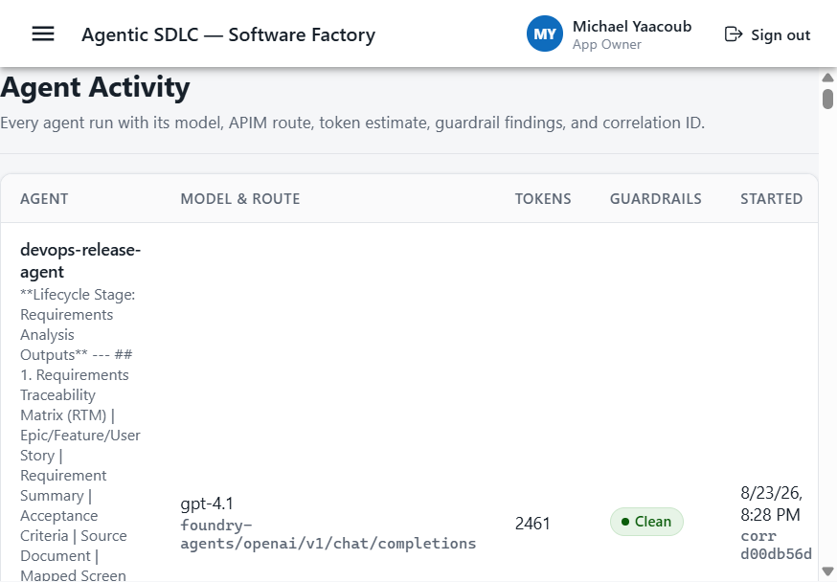
Figure 20 — Ops Monitoring Agent: recorded agent activity for the running service.

5.7 Insights Agent — Improve
Closes the loop. It analyses metrics and feedback, surfaces risks, and recommends the next actions, which feed back into planning for the following cycle.

5.8 Agent configuration and identity
The specialized agent catalog covers Requirements, Architecture Advisor, Code Generation, Test Automation, DevOps / Release, Security and Compliance, and Knowledge Assistant. Each one is defined in the agent configuration file and editable from Admin > Agent Configuration, where the model, API Management route, tools, MCP servers, guardrails, token limits, and approval requirements are all data-driven rather than hardcoded.
Each agent has its own Microsoft Entra identity and a stable Foundry Responses endpoint. Those linked resources mirror the runtime catalog for inspection and agent governance; application model execution stays behind the configured API Management gateway.
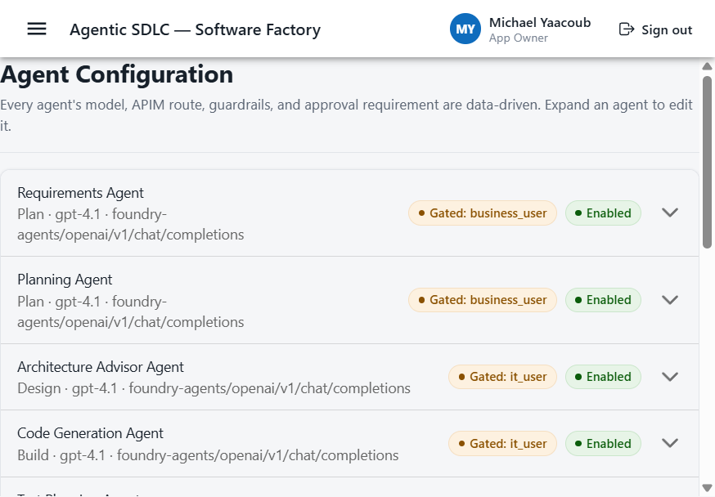
Figure 21 — Agent configuration. Model, gateway route, tools, guardrails, token limits, and approval requirements are all editable here.

5.9 The delivered application
The screenshots below show the output of one complete run. Field Service Work Orders began as a business request and finished as a running application with its own API, built and deployed entirely through the gated workflow.
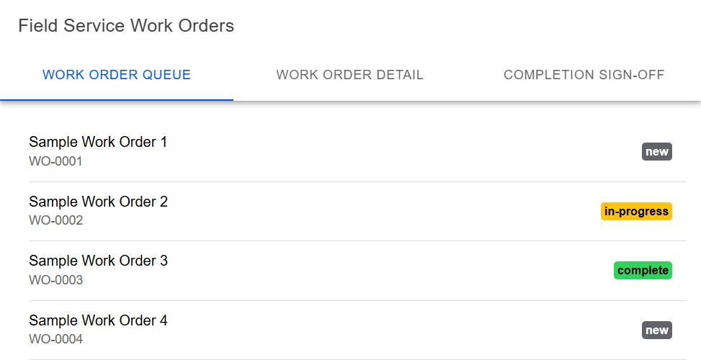
Figure 22 — The delivered application: the Field Service Work Orders interface.
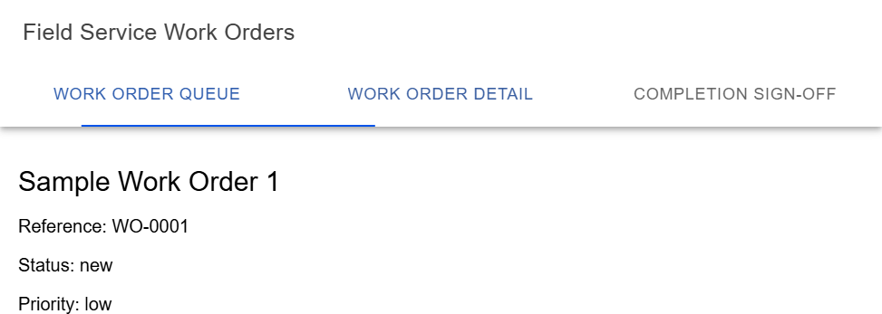
Figure 23 — The delivered application: a work order detail view.
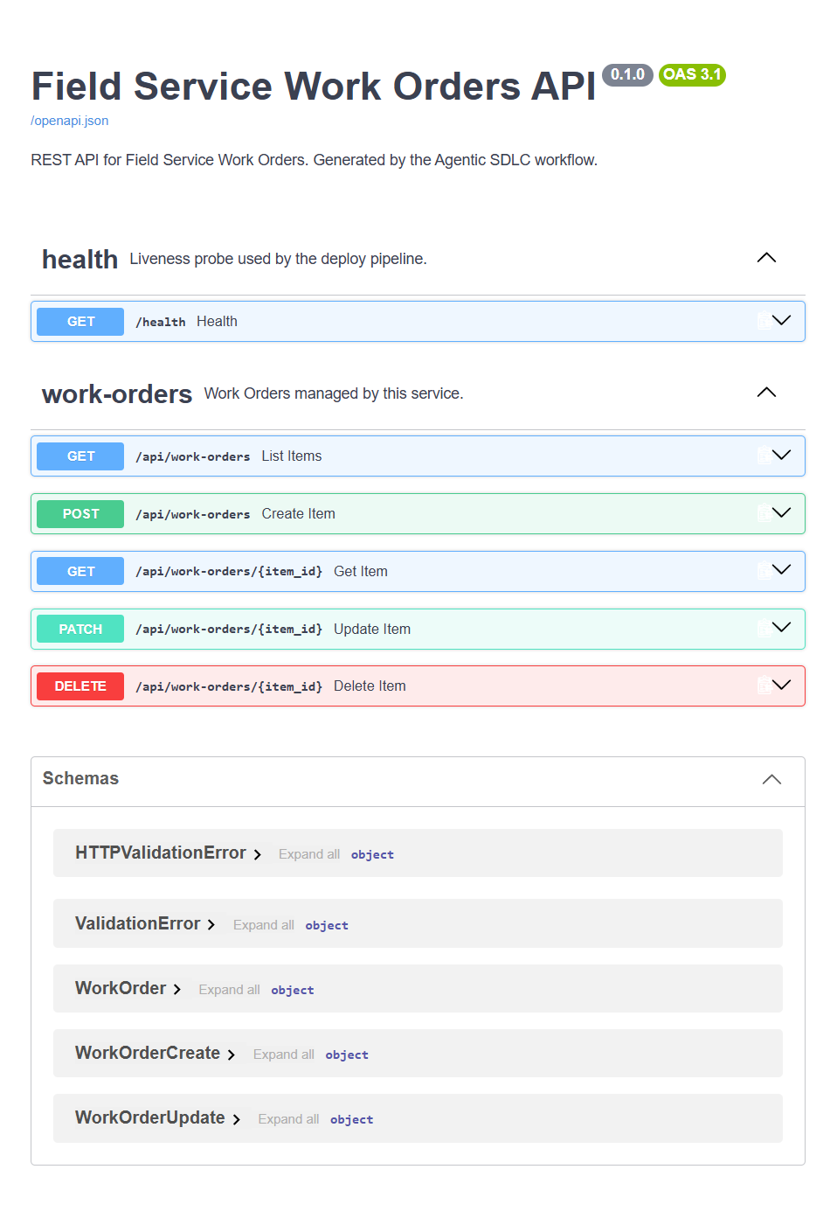
Figure 24 — The delivered API, documented from the generated OpenAPI schema.

6. Where your work is stored
Agents never own data. Every agent action lands in one of three root systems of record, and every new project gets its own child folder, project, or repository underneath them.
System of record | Purpose | Scope per project
SharePoint — documentation | Requirements, architecture, design, and threat-model artifacts | One folder per project
Azure DevOps — work items, test plans, pipelines | Epics → Features → User Stories → Tasks, test plans and cases, build and release pipelines | One project per SDLC project
GitHub — source code | Generated code, branches, and pull requests | One repository per SDLC project

6.1 Root locations
SharePoint: Projects folder in the SDLC Agentic Workflow library
Azure DevOps: dev.azure.com/csdmichael
GitHub: github.com/csdmichael
The roots are configuration rather than code. They live in the API configuration files, with per-class defaults that can be overridden globally and per project.

6.2 What gets created per project
System | Child artifact | Example
SharePoint | Projects / <project name> / | … /Projects/Contoso Claims Portal
Azure DevOps | <org> / <project name> | dev.azure.com/csdmichael/Contoso Claims Portal
GitHub | <owner> / <project-slug> | github.com/csdmichael/contoso-claims-portal

6.3 If SharePoint is unavailable
Documentation does not depend on SharePoint being reachable. A provider order lists the documentation providers in preference, and the first one that is both enabled and live wins. With SharePoint live, the requirements document uploads to the project folder. With SharePoint mocked and GitHub live, the same document is committed into the project's own repository on its default branch, which gives you a real, versioned, reviewable URL at no extra cost. If neither is live, the first enabled provider answers in mock mode with a deterministic URL so a demonstration still runs end to end.

7. What the application gives you
- A responsive interface for phone, tablet, and web, with role-aware navigation.
- Microsoft Entra ID and email one-time passcode authentication.
- A New Project wizard covering intake, requirement sources, Azure DevOps and GitHub targets, environment, and agent selection.
- Nine approval gates with approve, reject, request-changes, and delegate decisions.
- Configurable agents: model, API Management route, tools, MCP servers, guardrails, token limits, and approval requirements are all data-driven.
- An API Management gateway in front of Foundry, with full audit logging.
- Mock services for Azure DevOps, GitHub, SharePoint, OneDrive, local disk, Foundry and API Management, and Azure provisioning, so the platform runs with no cloud credentials.
- An audit trail for every user, agent, and approval action.
- App Owner user management covering roles and authentication method.

8. Security and governance
Content-safety, PII-redaction, and secret-scanning guardrails run before and after every agent output, and correlation IDs flow from the interface through the API, the gateway, the agents, and into the audit log.
All Azure AI Foundry calls route through Azure API Management; the backend never calls Foundry directly except under a local-development flag. Every call logs the prompt ID, agent ID, model name, token estimate, project ID, user ID, approval gate ID, workflow run ID, and correlation ID.
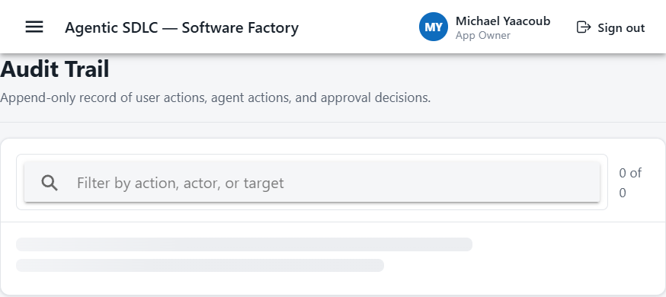
Figure 25 — Audit trail. Every user, agent, and approval action is recorded with its actor and timestamp.
The cross-cutting controls — role-based access control and least privilege, data policies and compliance, audit logging and observability, security scanning and guardrails, and cost controls — are enforced server-side and cannot be bypassed from the interface.
Configuration is strictly separated by tier, and business logic never hardcodes endpoints, keys, tenant IDs, or routes.
Tier | Configuration location
User interface | src/app/config/
API | api/src/config/
Database and persistence | api/src/persistence/config/
Agent orchestration | api/src/agents/config/

9. Running the platform locally
Prerequisite: Node.js 20 or later.
Step | What to do
1 | Start the API. From the api folder, run npm install, copy .env.example to .env, then npm run dev. The API listens on port 8080, with passcode bypass and file persistence as the development defaults.
2 | Start the interface. From the repository root in a second terminal, run npm install then npm start. The interface listens on port 8100 and proxies /api to port 8080.
3 | Sign in with any email address and the passcode 000000, or use one of the seeded App Owner accounts. The first run seeds those accounts from configuration.
Tests run from the api folder with python -m pytest -q.

10. Live environment and deployment
The platform is published to Azure App Service on a Linux B2 plan in the ai-myaacoub resource group in West US 2.
Resource | URL
Application (Angular / Ionic) | https://agentic-sdlc-ui-my.azurewebsites.net
API (FastAPI) | https://agentic-sdlc-api-my.azurewebsites.net
API health probe | https://agentic-sdlc-api-my.azurewebsites.net/api/health
API reference (Swagger) | https://agentic-sdlc-api-my.azurewebsites.net/docs
OpenAPI schema | https://agentic-sdlc-api-my.azurewebsites.net/openapi.json
Foundry agents project | https://002-ai-poc-private.services.ai.azure.com/api/projects/proj-default
Component-scoped GitHub Actions redeploy only the tier that changed, using Azure OIDC federated login so no secrets are stored. One workflow deploys the interface when src changes, a second deploys the API when api changes, and a third builds and tests both on pull requests. The repository variables UI_WEBAPP_NAME and API_WEBAPP_NAME and the secrets AZURE_CLIENT_ID, AZURE_TENANT_ID, and AZURE_SUBSCRIPTION_ID must be set.
The Python API migration is in progress. The published API currently exposes the health probe and the Swagger documentation, and the interface is served as a static single-page application — point its apiBaseUrl at the API host once the remaining endpoints are ported.

11. Technology stack
Layer | Technology
Frontend | Angular 18 (standalone) with Ionic 8, responsive
API | Python 3.13 and FastAPI, served by Uvicorn and Gunicorn
Persistence | Repository pattern — file store for local development, Azure Cosmos DB in the cloud
Authentication | Microsoft Entra ID and email one-time passcode via Azure Communication Services
Gateway | Azure API Management in front of Azure AI Foundry
Hosting | Azure App Service, Linux B2 plan

12. Troubleshooting
Most issues on this platform trace back to one of three things: a gate that has not been approved, a passcode that has expired, or a provider that fell back to a different system of record than you expected.
Symptom | What to check
An agent run returns 403 and does not start | The named gate for that stage has not been approved. The check is server-side, so the gate must be approved before the run will proceed.
Sign-in with a one-time passcode fails | Codes carry a time-to-live and are rate limited. Request a fresh code; in local development the bypass passcode is 000000.
The interface loads but no data appears | Confirm apiBaseUrl points at the API host, then check the API health probe.
A document did not appear in SharePoint | The documentation provider chain falls back to GitHub and then to mock mode. The artifact URL tells you which provider answered.
A deployment did not run | Workflows are path-filtered, so only the changed tier redeploys. Confirm the change touched src or api, and that the repository variables and Azure OIDC secrets are set.
For deeper technical detail on any of these, the repository README is the single consolidated reference for architecture, data flow, configuration, security, and troubleshooting.

13. Reference
Reference deck: docs/Microsoft-AI-Stack-for-SDLC.pdf in the repository.
The platform follows the AI Foundry–based Software Factory reference architecture and the Agentic SDLC operating model of human accountability with agent execution.
Licensed MIT, © 2026 Michael Yaacoub (Microsoft).

