Customer Testimonials

AI Powered Sales Full Stack App on Azure

  - SanDisk
Context: Azure application deployment workshop and live demo with ~40 attendees (onsite + remote, 3-hour session, Feb 13, 2026).
Customer feedback highlights:
- “This was very helpful and we truly appreciate your support and partnership.”
- “There were good interactions and questions happening throughout, so the content was on point.”
Readiness signal: Strong enterprise engagement, broad stakeholder participation, and concrete follow-up actions across architecture, security, operations, API governance, and AI integration.
Evidence Notes
- Full customer email threads and workshop notes are retained as supporting evidence.
- Personal contact details are intentionally omitted in this public-facing readiness summary.
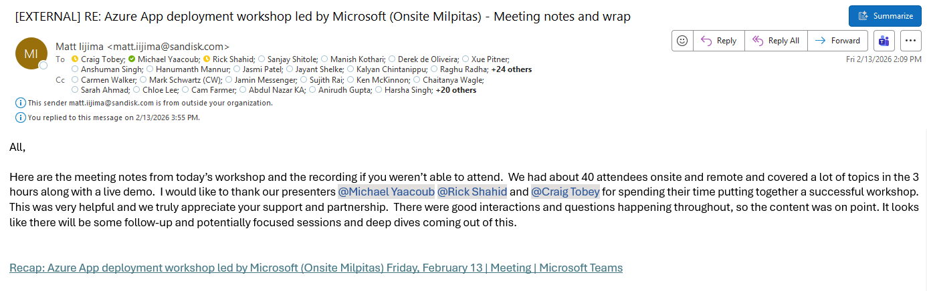
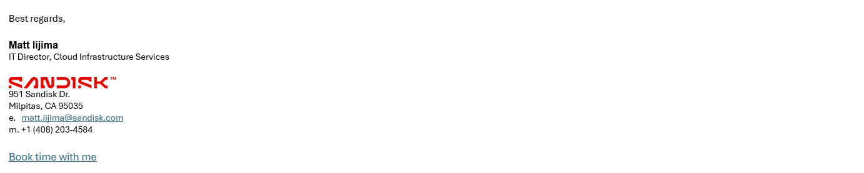
  - Arrow Electronics

Context: Follow-up on API Center and custom ruleset analysis demo (Feb 27, 2026).
Customer feedback highlight:
“Thank you for the great effort you put into this demo. The sample scenarios you created were very thorough, and I truly appreciate the work that went into it. I’m looking forward to resolving the remaining issues together.”
Readiness signal: Positive validation of scenario quality, practical depth, and continued joint execution on enterprise issues.

