Geombest Users Guide

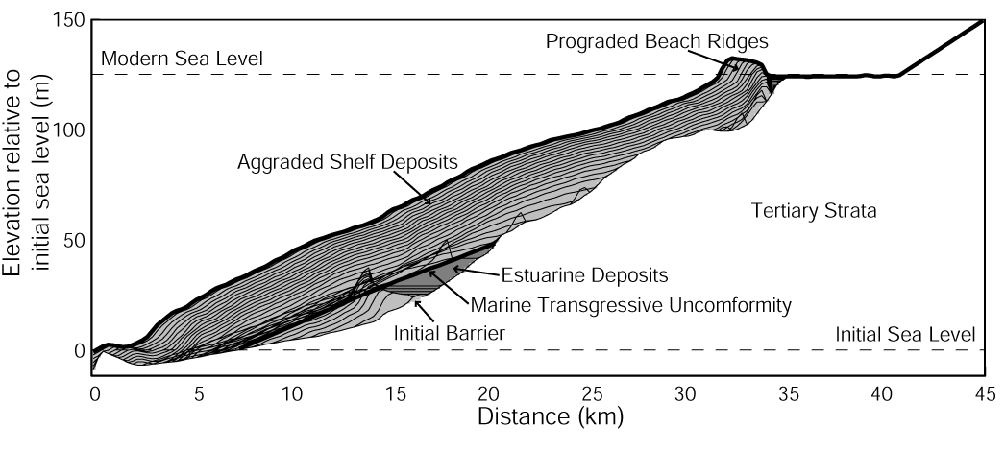
1: Introduction

Large-scale coastal evolution results from physical processes interacting with a volume of erodible sediment. Waves, currents and tides, rework the sediment to create shoreface morphology that attempts to attain an equilibrium profile with respect to these processes (Swift and Thorne, 1991; Wright, 1995; Cowell et al. 1999). The geological framework, however, may prevent development of an equilibrium profile through the presence of lithified stratigraphic units that outcrop on the shoreface (Riggs et al., 1995, Pilkey et al., 1993). The geological framework also defines the accommodation space, which in conjunction with sea level and sediment supply, controls shoreline transgression or regression (Curray, 1964; Roy et al., 1994).

This guide describes “GEOMBEST” (Geomorphic Model of Barrier, Estuarine, and Shoreface Translations), a new morphological-behaviour model that simulates the evolution of coastal morphology and stratigraphy, resulting from changes in sea level, and sediment volume within the shoreface, barrier and estuary. GEOMBEST differs from other large-scale behaviour models (e.g. Bruun, 1962; Dean and Maumeyer, 1983; Cowell et al., 1995; Niedoroda et al., 1995, Stive & de Vriend, 1995 and Storms et al., 2002) by relaxing the assumption that the initial substrate (i.e stratigraphy) is comprised of an unlimited supply of unconsolidated material (typically sand). The substrate is instead defined by distinct stratigraphic units characterized by their erodibility and sediment composition. Accordingly, the effects of geological framework on morphological evolution and shoreline translation can be simulated.

Model development aimed to create a numerical model flexible enough to quantify relevant coastal behavior with a minimum number of parameters. The first part of this guide describes these parameters and thereby synthesizes what are considered to be fundamental controls on large-scale coastal evolution. The second part of the paper describes how to install GEOMBEST and use it to a) quantitatively reconstruct coastal morphology and stratigraphy, and b) predict shoreline translation resulting from changes in sea level, sediment delivery, and other parameters.

2: Spatial domain and definitions

GEOMBEST simulates coastal evolution within a 3-dimensional grid where x, y and z represent cross-shore, long-shore and vertical dimensions respectively. The cross-shore dimension incorporates part or all of the continental shelf and the beach. Dunes, a washover plain, floodtide delta and estuarine basin are also included if present. These morphological sub-units have recently been defined as a “coastal tract” by Cowell et al. (2003a) to provide a single definition for the cross-shore coastal domain relevant to large-scale coastal evolution.

GEOMBEST divides the coastal tract into three functional realms defined as the shoreface, backbarrier, and estuary (Figure 1). Evolution of these realms is handled differently in GEOMBEST, although each are linked via sediment exchange to evolve the coastal tract. The shoreface extends from the seawards edge of the spatial domain to a cross-shore location corresponding to the highest elevation of marine-derived sediment. This location is defined as the crest and may represent the top of the dune, berm, or flood-delta depending on the application. The backbarrier incorporates the region from the crest to the landwards extent of marine-derived sediment, with the estuary continuing landwards beyond this point.

The long-shore dimension may comprise a single coastal tract or several adjacent coastal tracts for a quasi-3 dimensional application. Each coastal tract in a quasi-3D application would typically represent a long-shore region where it is assumed that, a) the long-shore morphology and stratigraphy are homogenous, and b) there are no gradients in long-shore sediment flux. These assumptions are made for the relevant modeling scales and would typically not involve sediment flux attributed to sub-decadal time scales or morphological variation at sub-kilometer space scales. Each coastal tract is represented in GEOMBEST as a vertical cross-section, which defines the dimensions of stratigraphic units comprising the coastal tract (see Section 4.3).

Feedback between cross-shore and long-shore evolution can be simulated by exchanging sediment volume between coastal tracts. This approach can be implemented using several simulations with existing 2-Dimenisonal (cross-shore) models (e.g. Dillengurg et al., 2000) but it is made easier with GEOMBEST since the evolution of several adjacent tracts can be examined in a single simulation.

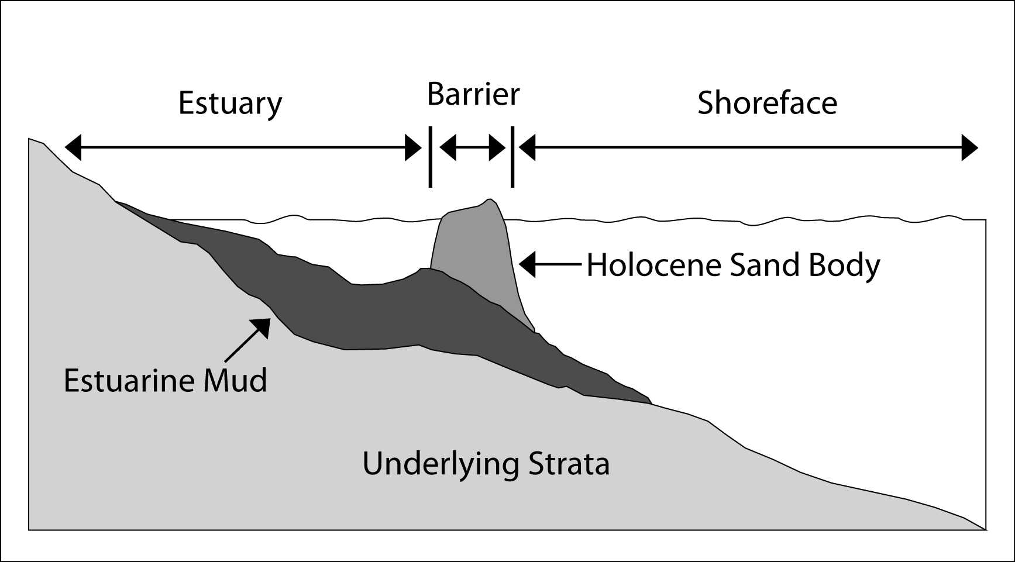

Figure 1: Cross-shore schematization of coastal morphology for a low-gradient barrier island coast. GEOMBEST’s three functional realms are defined as well as the distinct stratigraphic units that comprise this example of a coastal tract.

3: Conservation of Sediment Volume

The concept that coastal evolution can be quantified according to rules governing sediment conservation is fundamental to all morphological-behaviour models. GEOMBEST’s sediment conservation rules are similar to those of the Shoreface Translation Model (Cowell et al., 1995) and accordingly involve two sediment grain classes typically representing sand and mud. Sand volume is conserved within the study domain while mud volume is removed from the study domain if it is eroded at the shoreface. However, mud volume still exerts control over coastal evolution by altering the accommodation space below, and landwards of the shoreface. Mud volume may comprise a proportion of the initial stratigraphy or may be introduced to the tract through estuarine infilling (Section 4.5). All GEOMBEST calculations are based on volumes of compacted sediment since compaction is not simulated in the model.

4: Model parameters

4.1: Equilibrium profile

The assumption that cross-shore morphology will attempt to attain an equilibrium form in relation to oceanic forces and sea level is an established concept in coastal research. Bruun (1954) and Dean (1991) have, among others, represented the shoreface profile as a concave up curve of the form h = Ax^{m} where h = water depth, x is the distance offshore, A is a constant commonly related to grain size (Dean & Maumeyer, 1983) and m is a scaling parameter typically set to 2/3. Compound shorefaces, which divide the shoreface into a bar-berm section and a shorerise section, have also been presented by Inman et al. (1993) and Cowell et al. (1999). In GEOMBEST, a cross-shore equilibrium profile is specified for each coastal tract. This profile represents the form that the coastal morphology will attain assuming constant (or time-averaged) processes, an erodible substrate and instantaneous response to changing sea levels.

GEOMBEST’s equilibrium profile is specified by a series of points (x, z) interpolated by straight lines. Any number of points may be specified to allow adequate approximation of any theoretical or empirically-derived cross-shore equilibrium profile. The equilibrium profile may extend to the shelf edge and therefore seawards of the region typically defined as the shoreface. This seawards extension of the equilibrium profile is consistent with growing awareness that sediment flux across the entire shelf is important for understanding and predicting large-scale coastal change (Wright, 1995, Cowell et al., 2003). The equilibrium profile also extends landwards to define the surface of the subareal beach, dunes and the backbarrier portion of the Holocene sand deposits.

Pilkey et al. (1993) and Theiler et al. (1995, 2000) question the applicability of equilibrium profiles such as those described above to coastal modeling. They argue that cross-shore shoreface morphology may be dominated by the underlying geology and therefore never achieve an equilibrium profile. Cowell et al. (1995) and Niedoroda et al. (1995) also note that deeper and less energetic parts of the tract (i.e. the mid shelf) may take thousands of years to attain elevations in equilibrium with oceanic forces. GEOMBEST accounts for the factors leading to shoreface disequilibrium described above. Although a theoretical equilibrium profile is specified in the model this profile may never be achieved due parameters defining a) the geological framework, and b) the time dependant profile response. These factors are described in sections 4.3 and 4.4 respectively.

4.2: Sea Level Change

Predicting shoreface response to sea-level rise has its origins in the Brunn Rule. This analytical model assumes that a profile of invariant form is shifted vertically according to sea-level rise and landwards to a location where the volume of sediment eroded from the upper shoreface balances the volume of sediment deposited offshore (i.e. sediment is conserved). The Bruun Rule has also been generalized to account for “barrier island scenarios” where the shoreface translates over a substrate with lower gradient than the shoreface toe (Dean and Maumeyer, 1983). In this case, sediment eroded from the shoreface is balanced by sediment deposited to the backbarrier (via overwash and tidal inlet processes) rather than offshore. Numerical implementation of Bruun Rule concepts has more recently been provided by Cowell et al, (1995). In their model, behaviour resembling the original and generalized Bruun Rule emerges according to differences between the slopes of the shoreface and the underlying substrate.

Morphological evolution in GEOMBEST is driven by disequilibrium stress resulting from differences in elevation between the tract surface and the equilibrium profile. Sea-level change creates disequilibrium stress by vertically displacing the equilibrium profile. The resultant morphological evolution may involve a net loss or gain of sediment volume as the tract surface evolves to the elevations defined by the equilibrium profile. GEOMBEST’s numerical scheme searches for a horizontal location of the equilibrium profile resulting in a morphological response that conserves sediment volume within the spatial domain. A single solution exists in all cases where the shoreface translates over a seawards-sloping substrate. GEOMBEST’s approach to calculating shoreface evolution is therefore similar to the Bruun approach with an importance difference that the real morphology can be out of equilibrium with oceanic processes due to substrate characteristics and time-lag effects. Additional parameters provide flexibility to include the effect of estuarine infill, backbarrier deposition and open sediment budgets resulting from long-shore processes or beach nourishment.

4.3: Initial Morphology/Stratigraphy

Initial morphology and stratigraphy is represented in GEOMBEST via a series of discrete stratigraphic units (Figure 1). The boundaries of these stratigraphic units are defined by a series of points (x, z) interpolated with straight lines. Each stratigraphic unit is characterized by a) its sand/mud ratio, and b) its erodibility as represented by an erodibility index. The sand/mud ratio affects the evolution of tract morphology through the implementation of the sediment conservation rules outlined in Section 3. The erodibility index (in conjunction with a depth-dependant response rate described in Section 4.4) determines the rate at which sections on the coastal tract are able to erode.

The erodibility index of each stratigraphic unit ranges from 0 to 1. A value of 1 characterises stratigraphic units whose erosion is unconstrained by sediment cohesiveness. Conversely, a value of 0 characterises lithified stratigraphic units that cannot be eroded. A value of 0.5, for example, characterises stratigraphic units that are eroded at half the rate of units with a value of 1. The erodibility index and sand/mud ratio allows the model to simulate coastal evolution in the unconsolidated sand-rich environments that are typically modelled (e.g. Storms et al, 2002; Cowell et al, 2003b) as well as settings where cohesive strata outcrop on the shoreface surface (e.g. Riggs et al., 1995, Pilkey et al., 1993, Wright & Trembanis, 2003). Examples include the Outer Banks of North Carolina where Holocene Barriers are perched on Pleistocene sediment (Riggs et al., 1995), South-Eastern Australia where beaches are backed by lithified cliffs (Thom et al., 1992), and Cedar Island (Virginia, USA) where semi-lithified marsh deposits are exposed on the shoreface (Wright & Trembanis, 2003).

Tract stratigraphy affects shoreface morphology if the erodibility index of stratigraphic units outcropping on the shoreface is too low to allow the shoreface to erode to its equilibrium profile. In this case part of the shoreface will remain shallower than its equilibrium depth. The stratigraphy also affects the horizontal translation of the shoreline since this is controlled by rules conserving sediment volume. For example, the lithification of the shoreface prevents the release of sediment that may otherwise be transported to the beach. This results in increased shoreline transgression during periods of sea level rise. Similarly, the erosion of sand-rich stratigraphic units releases more sand than erosion of mud-rich stratigraphic units, which also reduces shoreline transgression.

4.4: Depth-Dependant Shoreface Response Rate

Rates of sediment erosion and resuspension depend on the total near-bed energy, which results predominately from wave orbital velocities on the inner shelf and geostrophic flows on the outer shelf (Wright, 1995). Total near-bed energy decreases offshore due to the attenuation of wave orbital velocities with increased water depth. Accordingly, the rate at which the shoreface morphology attains equilibrium decreases with increasing water depth since the energy required to evolve the shoreface profile is depth dependant. While the surfzone responds to changing water levels in hours the mid-shelf may take thousand of years to reach equilibrium (Wright, 1995, Cowell et al., 1999).

In GEOMBEST, a depth depth-dependant shoreface response rate is specified by a series of data points defining a function relating depth with the maximum vertical shoreface response. This flexible approach allows one to define the base of the shoreface (i.e. the depth below which significant morphological change does not occur over long timescales). Alternatively, it is possible to set the shoreface response to be proportional to total near-bed wave energy or any other depth-dependant relationship deemed appropriate for an application. The shoreface response could potentially be calibrated empirically from long-term offshore survey data (e.g. List et al., 1997, Gibbs & Gelfenbaum, 1999), or inversely by searching for parameter values that produce simulated outcomes consistent with measured morphology and stratigraphy (e.g. Cowell et al, 1995). This second option may be appropriate for estimating shoreface response at depths where morphological response cannot be measured directly.

4.5: Backbarrier Deposition and Estuarine Infilling

Backbarrier deposition results from the combined effect of overwash and tidal inlet processes, which deposit marine-derived sediment landwards of the crest. Backbarrier morphology is defined in GEOMBEST by the backbarrier portion of the equilibrium profile (landwards of the crest) and the maximum backbarrier width specified by the user. The equilibrium profile defines the surface of the overwash terraces, thereby providing an upper boundary to the backbarrier accommodation space. The width of the backbarrier is also determined in part by the gradient of the substrate over which the shoreface translates. Steeper substrates offer less backbarrier accommodation space than low-gradient substrates and may prevent the development of a backbarrier as wide as the maximum width specified by the user. This dependence of backbarrier conditions on substrate slope has been discussed by Roy et al. (1994), who show that cliffed coasts with no backbarrier evolve in settings where the underlying substrate is steeper than the active shoreface whereas barrier coasts evolve where the underlying substrate has a lower gradient than that of the active shoreface.

Estuarine infilling is represented in GEOMBEST as a rate at which the substrate landwards of the crest is accreted with fluvially derived or organic (e.g. saltmarsh) sediment. The sand/mud ratio of estuarine deposits can be specified and can vary through time to simulate different fluvial contribution relating to estuarine maturity (Roy, 1984). A resuspension depth can also be specified to simulate the effect that wind-waves may have in preventing the accretion of estuarine deposits (Nichols, 1989).

Estuarine infilling affects barrier translation by influencing estuarine accommodation space. High rates of estuarine infilling favour shallow estuaries with limited accommodation space whereas low rates of estuarine accretion are typically associated with deeper estuaries, which provide a larger accommodation space. The estuarine accommodation space in turn determines the volume of sand required to maintain a barrier of constant width during transgression. More sand must be transported to the backbarrier if the estuarine accommodation space is relatively large. This results in more shoreface transgression because the sand deposited in the backbarrier comes from shoreface erosion. Conversely high rates of estuarine infilling are associated with lower rates of shoreface transgression during a period of sea level rise.

5: Installing GEOMBEST

GEOMBEST is written in Matlab and reads in a series of Excel files containing the input data for simulations. Accordingly, both Matlab and Excel software are required to run GEOMBEST. To use GEOMBEST first set up a directory “C:\GEOMBEST” and then create subdirectories titled “Input1”, “Input2”, “Input3”, “Input4”, “Output1”, “Output2”, “Output3”, “Output4” and “Program.” The “Program” directory stores the GEOMBEST function files. All GEOMBEST Matlab files must be copied to this directory. The “Input” and “Output” directories contain the input and output data for simulations. Multiple input and output directories allows several simulations to run simultaneously and is helpful in tracking simulations when conducting numerous simulation experiments.

6: Input File Formats

A minimum of four excel files are required to run a GEOMBEST simulation: an “erosionresponse” file, an “accretionresponse” file, a “run#” file, and a “tract#” file. If the simulation involves a single coastal tract then the files must be titled “erosionresponse”, “accretionreponse”, “run1” file and “tract1.” Quasi-3D simulations require additional files with sequential numbers. For example a simulation involving 3 tracts within a littoral cell also requires a “run2” and “run3” file as well as a “tract2” and “tract3” file. These files must conform to the strict format outlined in the following sections. You may want to add something like… If you are running multiple simulation of the same tract, you can use the multiple input and output files to keep track of your simulations. Note that the run# and tract# files will be named the same so attention to organization is necessary. It is helpful to note the changes made in each simulation and to move the files into appropriately names folders…

6.1: “erosionresponse” file

The “erosionresponse” file specifies the maximum amount of erosion (vertical change) that can occur on the substrate. In the following example there is no erosion at a depth of 100 m and a possible 1 m/yr erosion rate at a depth of 5 meters (effectively instantaneous with regards to slow changes in sea level). The maximum erosion rates at elevations in between are determined through a linear interpolation of these two data points. Any number of data points may be entered in the “erosionresponse” file. Keep in mind that the elevation where the depth-dependent response rate becomes zero determines the shoreface depth. The profile will not be modified below this depth.

Depth-dependant response rate
Elevation (m) | Response rate (m/yr)
-100 | 0
-20 | 0
-5 | 1
100 | 1

6.2: “accretionresponse” file

The “accretionresponse” file specifies the maximum rate of accretion or deposition (vertical change) that can occur on the substrate. In the following example, there is no accretion at a depth of 100 m and a possible 1 m/yr accretion rate at a depth of 5 meters (effectively instantaneous with regards to slow changes in sea level). The maximum accretion rates at elevations between are determined through a linear interpolation of the data points. Any number of data points may be entered in the “accretionesponse” file. Remember that this file also affects the shoreface depth.

Depth-dependant response rate
Elevation (m) | Response rate (m/yr)
-100 | 0
-20 | 0
-5 | 1
100 | 1

6.3: “run#” file

The “run#” file defines the parameter values at each time step within a simulation. In the following example there is a simulation period of 500 years divided into 5 100-year steps. The number of substeps is 1, which means that there are no sub-steps between the user-defined 100-year intervals. If two substeps were specified then the time intervals would be reduced to 50 years. The user can enter any number of timesteps.

Sea-level elevation refers to the elevation of the sea at the end of the time interval relative to the original sea level of 0 meters at timestep 1. The change in sea-level elevation between timesteps is the rate of sea-level rise. In the example, the sea level rises 0.5 m in the first 100 years and then another 0.5 m in the second 100 years of the simulation.

Add something here about estuarine sedimentation…

Estuarine sand composition specifies the ratio of sand and mud that is deposited in the estuary. A value of 0 indicates that estuarine deposits are all mud while a value of 1 indicates all sand. A value of 0.5 indicates an equal mix of mud and sand.

The backbarrier width is the maximum width (in meters) that the backbarrier (region of marine-derived sediment landwards of the crest) can attain. Simulations involving steep substrates and balanced/negative sediment budgets, will favor the development of a backbarrier narrower than the maximum specified width.

The sediment supply rate specifies the rate at which sediment is added to, or subtracted from, the shoreface.

The resuspension depth specifies a depth within the estuary at which no sediment can accumulate beyond. In the example below the estuary can never become shallower than 1 meter.

Runfile1 | Substeps | 1
Time | Sea-level change (m) | Estuarine sedimentation (mm/yr) | Estuarine sand composition | Backbarrier Width | Sediment Supply Rate (m3/m tract width/yr) | Resuspension depth
100 | 0.522423 | 0 | 0 | 5500 | -25 | -1
200 | 1.044846 | 0 | 0 | 5500 | -25 | -1
300 | 1.567269 | 0 | 0 | 5500 | -25 | -1
400 | 2.089692 | 0 | 0 | 5500 | -25 | -1
500 | 2.612115 | 0 | 0 | 5500 | -25 | -1

6.4: “tract#” file

The “tract#” file defines the geometry of the stratigraphic units comprising the coastal tracts. The following example shows part of a “tract#” file. The first 3 rows define the dimensions of the grid cells. The cell length (x) corresponds to the horizontal dimension of the tract, the cell width (y) is the alongshore dimension, and the cell height (z) is the vertical dimension. Below these values the names, sand proportion, and erodibility index of each stratigraphic unit appear. The “Data points” entry specifies the number of points defining the shape of each stratigraphic unit. The data defining the shape of each stratigraphic unit comprises a series of (x, z) values that specify the upper surface of each stratigraphic unit. X values begin at the offshore edge of the grid (zero value) and increase onshore.

cell length (x) | 250
cell width (y) | 1
cell height (z) | 0.2
name | equilibrium morphology |  | Active sand body |  | estuary |  | strat1
sand proportion | 1 |  | 1 |  | 0 |  | 1
erodibility index | 1 |  | 1 |  | 1 |  | 1
Data points | 587 |  | 325 |  | 26 |  | 1031
 | 35580 | -0.40933 | 37920 | -1.72 | 109023.92 | 18.02 | 130065 | 35.00
 | 35560 | -0.40934 | 37900 | -1.57 | 108359.17 | 17.92 | 130064.00 | 23.89
 | 35540 | -0.42433 | 37880 | -1.57 | 107659.51 | 17.79 | 129580.00 | 23.89
 | 35520 | -0.40934 | 37860 | -1.57 | 106854.77 | 17.69 | 129560.00 | 23.89
 | 35500 | -0.40933 | 37840 | -1.57 | 106049.96 | 17.63 | 129540.00 | 24.39

7: Running GEOMBEST

To use the provided sample inputs, copy the contents of “C:\ GEOMBEST\Examples\
Sample SimulationInput” and paste into an “Input#” folder in “C:\GEOMBEST.” In order to view results of the sample simulation without running the simulation, the user may copy the contents of “C:\GEOMBEST\Example Inputs\Sample Simulation Output” and paste into an “Output#” folder in “C:\GEOMBEST.” Next, follow the procedures described in the following section to create representations of the results.

To run GEOMBEST, open Matlab and set the working directory to “C:\GEOMBEST\Program.” Then type main(1), main(2), main(3) or main(4) at the command prompt to start the simulation. The entered number specifies the input directory from which the input files are read and the output directory to which the output files are saved (this number is also known as the “filethread”), e.g., main(1) will read the input files from the input1 folder and save the results in the output1 folder, main(2) will run the simulation using files in the input2 folder and save the results in the output2 folder, etc. Several simulations can be conducted simultaneously on the same computer by opening additional instances of Matlab and executing GEOMBEST in each one. It is important to remember that the input files for different simulations will all have the same name. For this reason, it is imperative to develop an organizational filing system that input and output files can be copied to that will allow tracking of simulations with different input parameters (e.g., a name indicating the date and simulation number may be assigned to a separate folder to which input and output folders are saved after running the model and plotting output).

The program “removetemp” efficiently deletes the contents of all input and output files. Double-click on the file name to execute the function. Be sure to have transferred the contents of the input/output files to alternate locations before running this program in order to save information. Reformatting the name of the input/output folder will prevent it from being cleared by “removetemp.”

8: Viewing Results

There are three GEOMBEST functions that can be used to view simulation results, plottract, plotshore, and plotsurface. To use these functions, type the function name at the command prompt with the desired parameter values entered. All of the functions will automatically save the results in the “Output#” folder as a Matlab figure file (.fig), a JPEG image file (.jpg), and a portable document format (.pdf). Uses and input guidelines for each function are described below.

8.1 Plottractcolour Function

Plottractcolour (a,b,c,d,e) plots stratigraphic results in colour. Ghost surfaces allow the user to track the profile morphology throughout the simulation. The input parameters are identical for both functions and are as follows:

a = the filethread
(For example, filethread 1 will plot the simulation from the input1 folder and save in the output1 folder, while filethread 2 will plot the simulation from the input2 folder and save in the output2 folder)

b = the final timestep to plot
(If the simulation is to run for 5 timesteps with 2 substeps, the final timestep to plot is 11. This occurs because t = 0 (the initial condition) actually outputs as t=1, and then 10 additional timesteps will follow)

c = the tract number
(always = 1)

d = the first timestep to plot (as a ghost surface)

e = the number of timesteps to plot as ghost surfaces (for example e = 1 will plot every timestep as a ghost surface while e = 2 plots every second timestep as a ghost surface)

f = ‘modelrun’ (must be in single quotations)
(This will provide a title for the figure and will be included as be part of the filename when saved to the output folder Example: ‘11-04-08-01’: this indicates the date, November 4, 2008 and the model run number (01).)

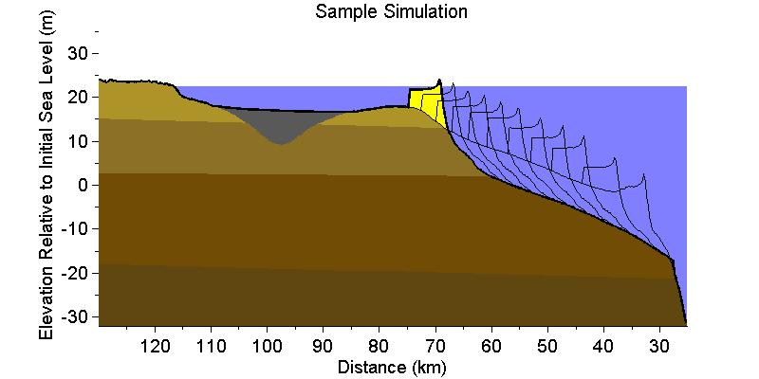

Input = plottractcolour(1,170,1,1,17,'Sample Simulation')

Several other matlab files are saved to the output file directory. These include;
shorelines.mat (the position of the shoreline at each timestep),
surface.mat (the surface elevations at each x centroid for each timestep),
strat.mat (a structure with the stratigraphic data for the tract),
xcentroids.mat (the value of each cell centroid along the x axis),
zcentroids.mat (the value of each cell centroid along the z axis),
celldim.mat (the cell dimensions), and
SL.mat (the sea level at each timestep).

The data contained within shorelines.mat is particularly useful since it records the shoreline location through time. To view this data, type load('C:\GEOMBEST\Output1\shorelines.mat') at the Matlab command prompt, or alternatively double click on the shorelines.mat file from within windows explorer.

8.2 Plotshore Function

Plotshore (a,b,c) creates a graph of shoreline position throughout the simulation. The plot also provides the average transgression rate and the precise final shore position. The input parameters are as follows:

a = the file thread (1-4): (For example, file thread 1 will plot the simulation from the input1 folder and save in the output1 folder, whilst file thread 2 will plot the simulation from the input2 folder and save in the output2 folder)

b = the number of years between timesteps (remember substeps, i.e. one substep =
100 yrs, two substeps = 50 yrs)
c = ‘modelrun’ (must be in single quotations)

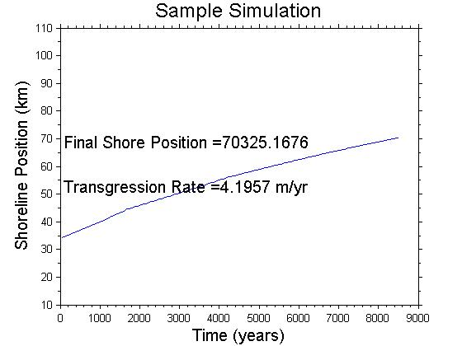

Input = plotshore(1,50,'Sample Simulation')

8.3 Plotsurface Function

Plotsurface_CI(a,b) displays several surface profiles overlain on the same plot including the initial model-generated surface, the final model-generated surface, and the actual modern surface determined by the user for a particular study area using bathymetric and topographic data. This function requires the user to create a file containing the (x, z) values of the modern surface (this can be extracted from the tract#.xls input file). This file should be placed in “C:\GEOMBEST\Program,” and for the sample is called “ModernSurface_SL8_5ka_nohead.” If this file is given a different name, the file name must be updated in “plotsurface_CI.m.”

The input paramters are as follows:

a = the file thread (1-4): (For example, file thread 1 will plot the simulation from the input1 folder and save in the output1 folder, whilst file thread 2 will plot the simulation from the input2 folder and save in the output2 folder)

b = ‘modelrun’ (must be in single quotations)

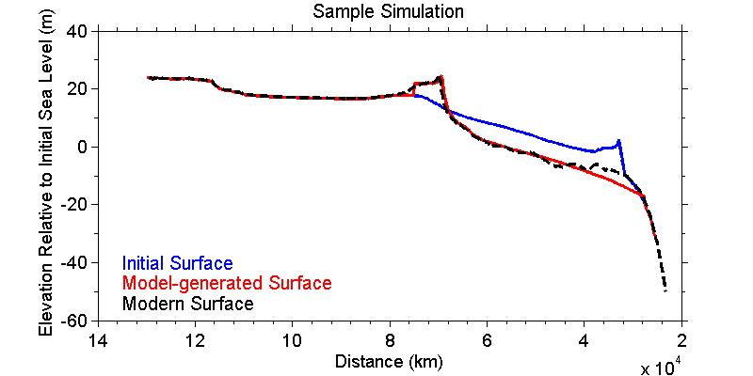

Input = plotsurface_CI(1,'Sample Simulation')

Runs that Crash

Use block = ts before crash in main.m and put a breakpoint at line 70 (break =0) to stop program before crash. Run saveblock.m using saveblock(filethread) to save the workspace and variables needed for plotting routines described above. Now the results prior to crash can be plotted for inspection.

Troubleshooting (still to be written…)

Use block = ts before crash to stop run just before crash, then follow instructions above to figure out why crash occurred.

If you get the following error:
??? Error using ==> interp1
The values of X should be distinct.

Error in ==> buildgrid at 61
horizon = interp1(strat(j,s + 1).elevation(:,1),strat(j,s + 1).elevation(:,2),xcentroids);

Error in ==> main at 38
buildgrid;
This error typically means that you have a repeating x value in one of your tract files. To fix this problem, open your tract file in excel. You can either visually search for a repeating x value or create a simple formula in a new column in excel which will find the difference between adjacent x-values. If this difference is 0, you have a repeating value. Once you have located the repeating value, delete that point. Be sure to change the data points count in the altered tract to reflect the new number of data points in that tract. Before you save and close your file, be sure you have deleted the new columns you added while troubleshooting.

References

Bruun, P. (1954). Coastal Erosion and the Development of Beach Profiles. Technical Memorandum No. 44, Beach Erosion Board, US Army Corps of Engineers, Washington, 79 pp.
Bruun, P. (1962). Sea-level rise as a cause of coastal erosion. Journal of the Waterways and Harbour Division. ASCE, 88, 117-130.
Cowell, P.J., Roy, P.S. & Jones, R.A. (1995) Simulation of large-scale coastal change using a morphological-behaviour model. Marine Geology, 126, 45-61.
Cowell, P.J., Hanslow, D.J. & Meleo, J.F. (1999). The Shoreface. In Handbook of Beach and Shoreface Morphodynamics. pp 39-71. John Wiley and Sons, Chichester.
Currray, J.R. (1964). Transgressions and Regressions. In Papers in Marine Geology, Shepard commemorative volume, ed R.L. Miller, pp. 175-203. Macmillan: New York.
Dillengurg, S.R., Roy, P.S., Cowell, P.J. & Tomazelli, L.J. (2000). Influence of Antecedent Topography on Coastal Evolution as Tested by the Shoreface Translation Barrier Model (STM). Journal of Coastal Research, 16(1), 71-81.
Dean, R.G. (1991). Equilibrium Beach Profiles: characteristics and applications. Journal of Coastal Reseach, 7, 53-84.
Dean, R.G. & Maumeyer, E.M. (1983). Models of Beach Profile Response. In Komar, P.D. and Moore, J (eds) CRC Handbook of Coastal Processes and Erosion. CRC Press, Boca Raton, FL: 151-165.
Gibbs, A.E. & Gelfenbaum, G. (1999). Bathymetric Change of the Washington-Oregon Coast, Proc. Coastal Sediments ’99, ASCE, Long Island, NY, 1627-1641.
List, J.H., Sallenger, A.H., Hansen, M.E. & Jaffe, B.E. (1997). Accelerated relative sea-level rise and rapid coastal erosion: testing a causal relationship for the Louisiana barrier islands. Marine Geology 140, 347-365.
Munóz-Perez, J.J., Tejedor, L., and Medina, R. (1999). Equilibrium Beach Profile Model for Reef-Protected Beaches. Journal of Coastal Research 15(4), 950-957.
Nichols, M.M. (1989). Sediment accumulation rates and relative sea-level rise in Lagoons. Marine Geology, 88, 201-219.
Niedoroda, A.W., Reed, C.W., Swift, D.J.P., Aroto, H & Hoyanagi, K. (1995). Modeling shore-normal large-scale coastal evolution. Marine Geology, (126) 181-199.
Pilkey, O. H., and Davis, T. W., 1987, An analysis of coastal recession models: North Carolina coast in Nummedal, D., Pilkey, O.,H., and Howard, J.D., eds., Sea-level Fluctuation and Coastal Evolution: SEPM (Society for Sedimentary Geology) Special Publication No. 41, Tulsa, Oklahoma, p. 59-68.
Pilkey, O.H., Young, R.S., Riggs, S.R., Sam Smith, A.W., Wu, H & Pilkey, W.D. (1993). The Concept of Shoreface Profile of Equilibrium: A Critical Review. Journal of Coastal Research, 9 (1), 255-278.
Riggs, S.R., Cleary, W.J. and Snyder, S.W. (1995). Influence of Inherited geological framework on barrier shoreface morphology and dynamics. Marine Geology, 126, 213-234.
Roy, P.S. (1984). New South Wales Estuaries: Their Origin and Evolution in Coastal Geomorphology in Australia. pp. 99-121. Academic Press Australia
Roy, P.S., Cowell, P.J., Ferland, M.A. & Thom, B.G. (1994). Wave-dominated coasts. In Coastal Evolution: Late Quaternary shoreline morphodynamics. pp. 121-186. Cambridge University Press, Cambridge.
Stive, M.J.F. & de Vriend, H.J. (1995). Modelling shoreface profile evolution. Marine Geology, 126, 235-248.
Storms, J.E.A., Weltje, G.J., van Dijke, J.J., Geel, C.R., & Kroonenberg, S.B. (2002) Process-Response Modeling of Wave-Dominated Coastal Systems: Simulating Evolution and Stratigraphy on Geological Timescales. Journal of Sedimentary Research, 72(2), 226-239.
Swift, D.J.P & Thorne, J. A. (1991). Sedimentation on continental margins. I. A general model for shelf sedimentation. In Shelf sand and sandstone bodies: geometry, facies and sequence stratigraphy, Special Publication No. 14 of the International Association of Sedimentologists, ed. D.J.P Swift, G.F. Oertel, R.W. Tillman & J.A Thorne, pp. 3-31. Oxford: Blackwell Scientific Publications.
Thieler, E.R., Brill, A.L., Cleary, W.J., Hobbs III, C.H., Gammisch, R.A. (1995) Geology of the Wrightsville Beach, North Carolina shoreface: Implications for the concept of shoreface profile of evolution. Marine Geology. 126, 271-287.
Thieler, E.R., Pilkey, O.H., Jr., Young, R.S., Bush, D.M., and Chai, F. (2000). The use of mathematical models to predict beach behaviour for U.S. coastal engineering: A critical review. Journal of Coastal Research, 16(1), 48-70.
Thom, B.G., Shepard, M.J., Ly, C., Roy, P.S., Bowman, G.M. & hesp, P.A. (1992). Coastal Geomorphology and Quaternary Geology of the Port Stephens-Myall Lakes Area. Department of Biogeography and Geomorphology, ANU monograph No. 6, Canberra, 407 pp.
Wright, L. D. (1995). Morphodynamics of Inner Continental Shelves. CRC Press, Boca Raton, FL: 256 pp.
Wright, L.D. and Trembanis, A. (2003). Complex Shoreface Morphology of a Rapidly Transgressing Barrier Island: Cedar Island Virginia. Proceedings of Coastal Sediments 2003 Conference. 9 pp.

