User Guide to TTLEM - Introduction
What is TTLEM? 1
Who should use TTLEM? 1
Installation 1
Where can I find a documentation? 2
Where can I report bugs or suggestions for enhancement? 2
How can I stay informed about updates? 2
Content 2
A note on TopoToolbox 2
References 3
Clean workspace 3
Load a DEM into Matlab 3
Set uplift 4
Set model parameter values 4
Run model 5
View results 6
History 7

What is TTLEM?
TTLEM is a grid based object oriented Landscape Evolution Model based on the TopoToolbox library. The aim of TTLEM is to provide an accurate numerical tool to simulate landscape evolution in eroding regions. TTLEM is multi-process based and hence allows a modular use of the code depending on the requirements of the end user. The LEM has a good overall computational performance and obtains a high numerical accuracy in solving the partial differential equations involved when simulating landscape evolution.

Who should use TTLEM?
TTLEM is developed to be easy accessible and adaptable and requires knowledge of the Matlab syntax. Users should be able to readily run TTLEM with both synthetic land evolution models and natural simulations, starting from an existing digital elevation model. With TTLEM, we target the same users than those who are using TopoToolpox and want to explore landscape functioning beyond present day topographic indices.

Installation
TTLEM comes as a part of the newest release of TopoToolbox and can be downloaded from the GitHub repository. Extract the package to a folder on your personal computer and add the TopoToolbox folder with its subfolders to the search path in the Matlab environment.

Where can I find a documentation?
TTLEM comes with a basic manual with a couple of examples on how to initialize model runs, change input source files and adapt model parameters. Nearly all functions are documented with a help section where the syntax of the function and the background of the used algorithm is described. We intentionally kept the user manual short and focus on the documentation of the source code in the models functions to allow for streamlined updates concerning both the algorithms and the documentation that comes with it. Further, the functionality and versatility of the model are presented in this discussion paper about TTLEM, published in GMD. All scripts used to produce the results and figures shown in this paper can be found here.

Where can I report bugs or suggestions for enhancement?
In case of bugs in the source code, any suggestions for model improvements or elaboration, you can contact us on the further indicated mail addresses.

How can I stay informed about updates?
Small updates will be posted straight on the GitHub repository. Major software updates will always be announced at this blog: topotoolbox.wordpress.com.

Content
This manual consists out of 3 tutorials. All of them can be executed in Matlab. E.g., for the first example just enter the comment: 'TTLEM_usersguide_1_intro' in the command window.
- TTLEM_usersguide_1_intro.m Short introduction to the use of TTLEM
- TTLEM_usersguide_2_Synthetic_model_run.m In this tutorial, we show how TTLEM can be used to simulate synthetic landscape evolution. We illustrate how the user can change between different algorithms to simulate hillslope response and how different numerical schemes can be set. Finally, we also show how modelled data can be processed and converted in a movie of an evolving landscape. Detailed information of parameters, their default values and units can be found in the help section of ttlemset.
- TTLEM_usersguide_3_Synthetic_Geological_Configuration One of the main advantages of LEMs is their potential to explore different geo-tectonic configurations and corresponding hypothesis at a very low cost. As an example, we simulated landscape evolution over a time span of 30 Myr. Successively, three spatial and temporally dependent uplift scenarios are imposed to the model. On top of this three scenarios, a horizontal shortening field is imposed over the simulated domain with high lateral displacements in the left upper corner, linearly decreasing in both x and y directions to the Southeastern bottom of the simulated domain.

A note on TopoToolbox
TopoToolbox provides a set of Matlab functions that support the analysis of relief and flow pathways in digital elevation models. The major aim of TopoToolbox is to offer helpful analytical GIS utilities in a non-GIS environment in order to support the simultaneous application of GIS-specific and other quantitative methods. TopoToolbox is written in the Matlab language and requires the Image Processing Toolbox for various functions. We refer to the user guides of TopoToolbox for details on this software package. The user guide for TT can be opened by executing this comment: usersguide_1_intro
See also: ttlemset, ttlem
Authors: Benjamin Campforts (benjamin.campforts[at]kuleuven.be) Wolfgang Schwanghart (w.schwanghart[at]geo.uni-potsdam.de)

References
- TTLEM: Campforts B., Schwanghart W., Govers G.: TTLEM 1.0 : a numerical package for accurate simulation of transient landscape evolution in MATLAB. Discussion paper in GMD.
- TopoToolbox: Schwanghart, W. and Scherler, D.: Short Communication: TopoToolbox 2 – MATLAB-based software for topographic analysis and modeling in Earth surface sciences, Earth Surf. Dyn., 2(1), 1–7,doi:10.5194/esurf-2-1-2014, 2014.
- TVD-FVM: Campforts, B. and Govers, G.: Keeping the edge: A numerical method that avoids knickpoint smearing when solving the stream power law, J. Geophys. Res. Earth Surf., 120(7), 1189–1205, doi:10.1002/2014JF003376, 2015.

Clean workspace
clc
close all force
clearvars

Load a DEM into Matlab
TopoToolbox 2 reads the ESRI ascii grid format and single band geotiffs into an instance of GRIDobj. Note that, throughout the use of TopoToolbox and TTLEM, it is assumed that the DEM has a projected coordinate system (e.g. UTM WGS84) and that elevation and horizontal coordinates are in meter units.
DEM = GRIDobj('srtm_bigtujunga30m_utm11.tif');
imageschs(DEM,[],'ticksToKm',true,'colorBarLabel','\bfm');
xlabel('\bfX Coordinate, km');
ylabel('\bfY Coordinate, km');
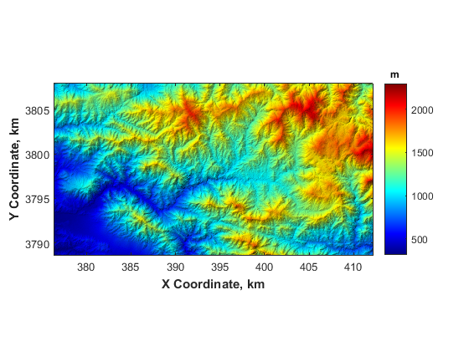

Set uplift
Uplift is provided to TTLEM as an instance of GRIDobj. Here, we illustrate the example of uniform uplift in space and time of 1 mm per year.
U = GRIDobj(DEM);
U.Z(2:end-1,2:end-1) = 1e-3;

Set model parameter values
Parameters for the model run are set as an instance of the class ttlemset. If no arguments are provided, default parameter values are used.
p = ttlemset %#ok show parameters<NOPTS>
p =
AreaThresh: 0
BC_Type: 'Dirichlet_Matrix_Ini'
BC_dir_DistSites: ''
BC_dir_Dist_Value: 1
BC_dir_value: 0
BC_nbGhost: 1
D: 0.0100
DiffToRiv: 0
DiffTol: 1.0000e-06
DrainDir: 'variable'
FlowBC: ''
K_weight: []
Kw: 3.0000e-06
NormPrecip: []
SS_Value: 0
Sc: 1.2000
Sc_unit: 'tangent'
TimeSpan: 2000000
TimeStep: 20000
cfls: 0.7000
diffScheme: 'imp_lin_sc'
fileprefix: 'res_'
implCFL: 0
m: 0.5000
m_var: 0
n: 1
parallel: 0
ploteach: 1
resultsdir: 'results\'
rho_rs: 1.3000
riverInc: 'implicit_FDM'
saveeach: Inf
short_x: []
short_y: []
shortening: 0
shortening_meth: 'Upwind_TVD'
steadyState: 0

Run model
TTLEM can be manually interrupted by pushing the 'Stop' Bottom. The current model run will quit without losing the information calculated so far.
output = ttlem(DEM,U,p);
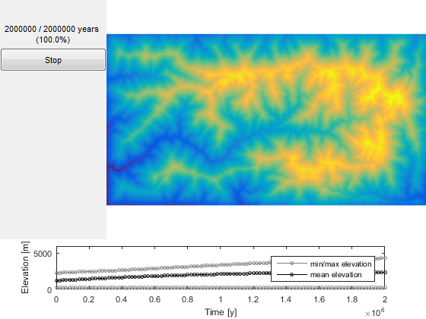

View results
figure('units','normalized','outerposition',[0 0 1 1])
H1=output.H1;
imageschs(H1,[],'ticksToKm',true,'colorBarLabel','\bfm');
xlabel('\bfX Coordinate, km');
ylabel('\bfY Coordinate, km');
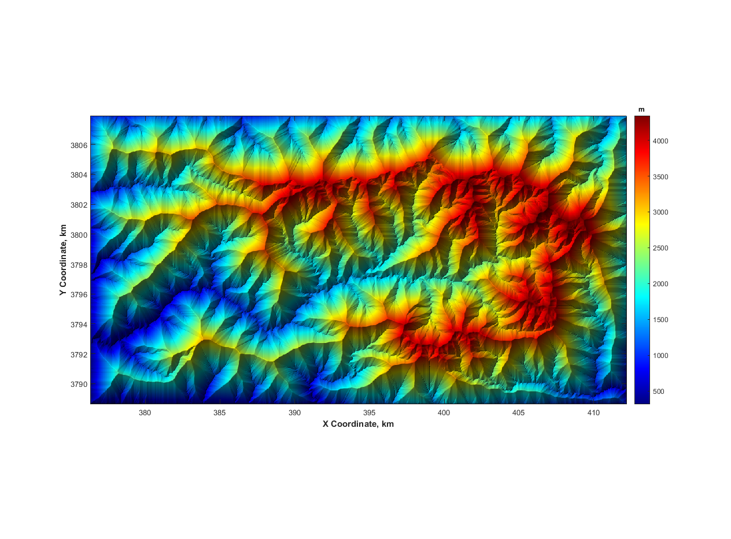

History
This user guide was updated last: June 12, 2016.
Published with MATLAB® R2015b

