User Guide to TTLEM 2 - Synthetic model run
Content 1
References 1
Clear environment 2
Initial Surface 2
Uplift 3
Temporal domain 3
Hillslope processes, parameters values 3
Set numerical accuracy 4
River incision parameters 4
Numerics river incision 4
Threshold slopes 4
Boundary conditions 4
Steady state 4
Output 5
Initialize parameter structure. 5
Model run 5
Show model output 6
Create simulation movie 7
History 10

Content
In this tutorial, we show how TTLEM can be used to simulate synthetic landscape evolution. We illustrate how the user can change between different algorithms to simulate hillslope response and how different numerical schemes can be set. Finally, we also show how modelled data can be processed and converted in a movie of an evolving landscape. Detailed information of parameters, their default values and units can be found in the help section of ttlemset.
See also: ttlemset, ttlem
Authors: Benjamin Campforts (benjamin.campforts[at]kuleuven.be) Wolfgang Schwanghart (w.schwanghart[at]geo.uni-potsdam.de)

References
- TTLEM: Campforts B., Schwanghart W., Govers G.: TTLEM 1.0 : a numerical package for accurate simulation of transient landscape evolution in MATLAB. Discussion paper in GMD.
- TopoToolbox: Schwanghart, W. and Scherler, D.: Short Communication: TopoToolbox 2 – MATLAB-based software for topographic analysis and modeling in Earth surface sciences, Earth Surf. Dyn., 2(1), 1–7,doi:10.5194/esurf-2-1-2014, 2014.
- TVD-FVM: Campforts, B. and Govers, G.: Keeping the edge: A numerical method that avoids knickpoint smearing when solving the stream power law, J. Geophys. Res. Earth Surf., 120(7), 1189–1205, doi:10.1002/2014JF003376, 2015.

Clear environment
clearvars
close all
clc

Initial Surface
Generate random initial surface of 0m ± 50m
dx=75;%m
Lx=50e3; %m
Ly=50e3;
x=dx:dx:Lx;
y=dx:dx:Ly;
Z=rand(numel(y),numel(x))*50; %Randomized initial condition
DEM=GRIDobj(x,y,Z);
% Display initial DEM
figure
imageschs(DEM)
[~,X_DEM,Y_DEM] = GRIDobj2mat(DEM);
[X_DEM,Y_DEM] = meshgrid(X_DEM,Y_DEM);
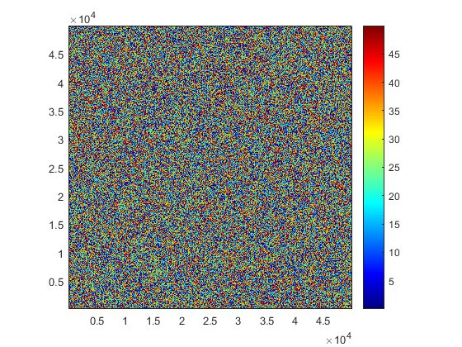

Uplift
Uplift is inserted in TTLEM as an instance of GRIDobj
U = GRIDobj(DEM);
grad = ones(DEM.size);
upl_rate=1e-3; %Aboslute vertical uplift rate in m/yr
U.Z(2:end-1,2:end-1) = grad(2:end-1,2:end-1)*upl_rate;

Temporal domain
p.TimeSpan=20e6;
p.TimeStep=5e4;

Hillslope processes, parameters values
%Set diffusivity parameter
p.D=0.03;
%Choose hillslope response scheme
% p.diffScheme = 'imp_lin';
p.diffScheme = 'imp_lin_sc';
% p.diffScheme = 'imp_nonlin_sc';
% p.diffScheme = 'only_sc';

Set numerical accuracy
p.DiffTol = 1e-4;

River incision parameters
p.Kw = 3e-6;
p.m = 0.5;
p.n = 1;
p.AreaThresh = 2e5; % channel contributing area threshold, m²
% (un)comment to get the drainage development type of choice
% Fixed or variable drainage netwrok through time
p.DrainDir='variable';
% p.DrainDir='fixed';
% Insert variability on m value, following Grimaldi et al. (2005)
p.m_var=.3;
% Insert variability on K value. This is not compatible with the nonlinear
% Q-imp diffusion algorithm. Comment the next lines out in the case that
% nonlinear hillslope diffusion is required.
K_weight = randn(size(DEM.Z));
K_weight = (K_weight-min(K_weight(:)))./(max(K_weight(:))-min(K_weight(:)));
p.K_weight = GRIDobj(DEM); p.K_weight.Z=K_weight;
% Correct K so that average K remains equal
avgK = mean(K_weight(:));
p.Kw =p.Kw*1/avgK;

Numerics river incision
(un)comment to get the numerical scheme of choice p.riverInc = 'TVD_FVM';
p.riverInc = 'implicit_FDM';
% p.riverInc = 'explicit_FDM';
p.cfls=0.95;

Threshold slopes
p.Sc=1; %%21°)
p.Sc_unit='tangent';

Boundary conditions
Set to default.

Steady state
Evaluate whether the model evolves towards a dynamic equilibrium where uplift balances erosion and absolute elevation differences between model time steps are minimal.
p.steadyState = true;
p.SS_Value = 1e-6*size(DEM.Z,1)*size(DEM.Z,2);%Max 1mm elevation change per cell allowed in steady state

Output
p.ploteach=1;
p.saveeach=1;
% Specify the location where the results can be stored (e.g.
% p.resultsdir='C:\...\'); The default folder is the result file where the
% main model structure is stored.
% p.resultsdir='C:\...';
p.fileprefix='syntheticRun';

Initialize parameter structure.
By making p an instance of ttlemset, the user ensures parameter values are set in the right way
p = ttlemset(p);

Model run
TTLEM can be manually interrupted by pushing the 'Stop' Bottom. The current model run will quit without losing the information calculated so far.
ttlem_out = ttlem(DEM,U,p);
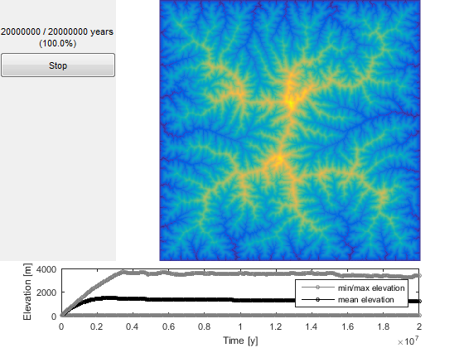

Show model output
figure('units','normalized','outerposition',[0 0 1 1])
H1=ttlem_out.H1;
imageschs(H1,[],'ticksToKm',true,'colorBarLabel','\bfm');
xlabel('\bfX Coordinate, km');
ylabel('\bfY Coordinate, km');
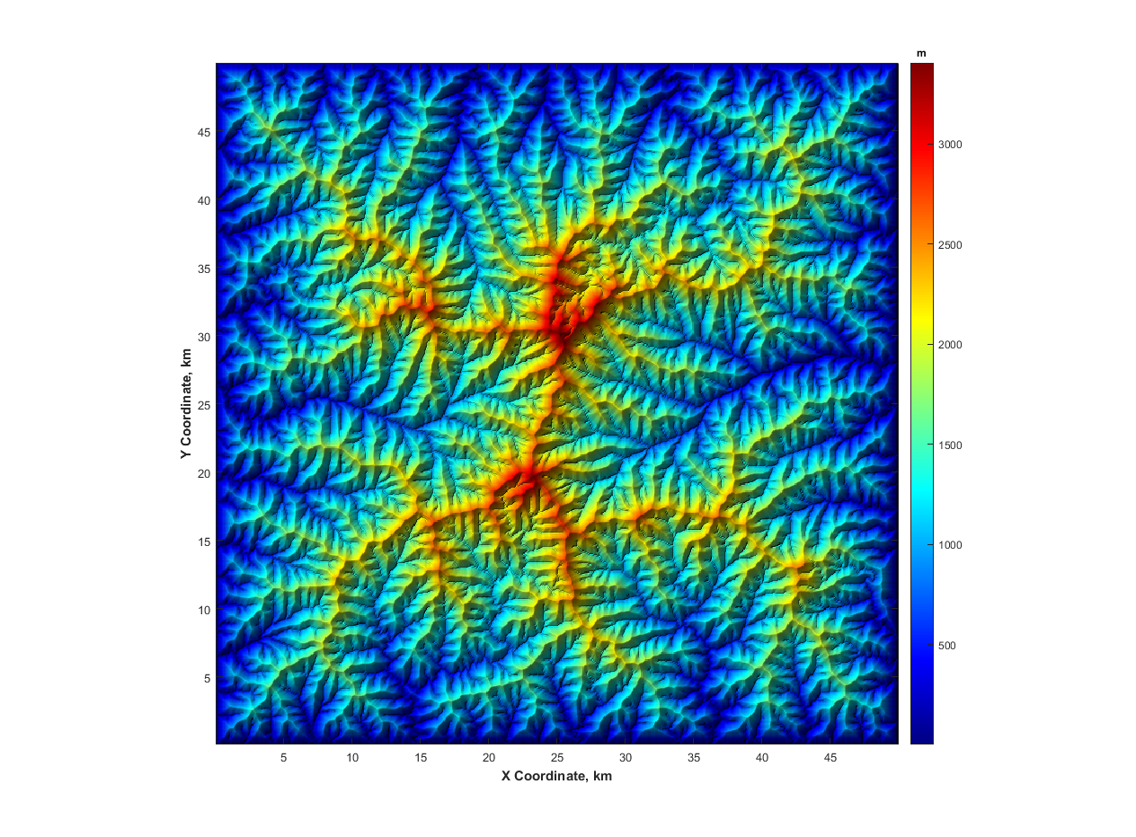

Create simulation movie
scrsz = get(0,'ScreenSize');
hFig = figure('OuterPosition',[0.1*scrsz(4) 0.1*scrsz(4) .7*scrsz(4) .7*scrsz(4)]);
if strcmp(p.diffScheme,'imp_nonlin_sc')
parameter=1e-10;
inc=max(max(U.Z(:)),1e-3);
dt_max=DEM.cellsize*DEM.cellsize/inc*max(p.Sc(:))*parameter/(p.D*p.Kw);
dt_max=min(dt_max,5000);
nbSteps=ceil(p.TimeSpan/dt_max);
if (p.TimeSpan/nbSteps)<p.TimeStep
p.TimeStep=p.TimeSpan/nbSteps;
p.TimeStep = p.TimeStep;
disp(['Timestep is decreased to ' num2str(round(p.TimeStep))...
' yr in order to keep the non linear solution stable, see Perron 2011, JGR']);
end
end
figure
files = dir([p.resultsdir p.fileprefix '*.mat']);
[~,ix] = sort([files.datenum]);
files = files(ix);
for r = 1:numel(files);
t = p.TimeStep*r;
load([p.resultsdir files(r).name],'H1');
imageschs(H1,[],'tickstokm',true,'colorBarLabel','\bfm');
hold on
FD = FLOWobj(H1,'preprocess','c');
S = STREAMobj(FD,flowacc(FD)>(p.AreaThresh/FD.cellsize^2));
S.x = S.x*1e-3;
S.y = S.y*1e-3;
plot(S,'k','linewidth',1)
hold off
xlabel('\bfX Coordinate, km')
ylabel('\bfY Coordinate, km')
title(['Standard Run ' num2str(round(t*1e-3)) 'k years']);
drawnow
end

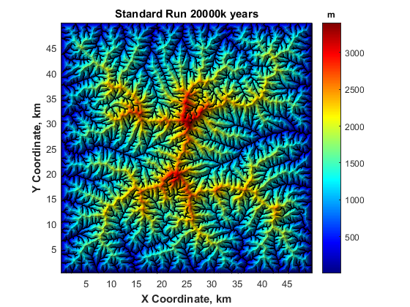

History
This user guide was updated last: June 12, 2016.
Published with MATLAB® R2015b

