User Guide to TTLEM 3 - Synthetic model run with complex geological configuration
Content 1
References 2
Clear environment 2
Initial Surface 2
Temporal domain 3
Vertical uplift 3
First uplift phase 3
Second uplift phase 4
Third uplift phase 5
Lateral tectonic displacement 6
Diffusion parameters 7
Boundary condition 7
River incision parameters 8
Numerics river incision 8
Boundary conditions 8
Threshold slopes 8
Output 8
Initialize parameter structure 8
Model run 8
Movie and overview figure 9
History 11

Content
One of the main advantages of LEMs is their potential to explore different geo-tectonic configurations and corresponding hypothesis at a very low cost. As an example, we simulated landscape evolution over a time span of 30 Myr. Successively, three spatial and temporally dependent uplift scenarios are imposed to the model. On top of this three scenarios, a horizontal shortening field is imposed over the simulated domain with high lateral displacements in the left upper corner, linearly decreasing in both x and y directions to the Southeastern bottom of the simulated domain.
See also: ttlemset, ttlem
Authors: Benjamin Campforts (benjamin.campforts[at]kuleuven.be) Wolfgang Schwanghart (w.schwanghart[at]geo.uni-potsdam.de)

References
- TTLEM: Campforts B., Schwanghart W., Govers G.: TTLEM 1.0 : a numerical package for accurate simulation of transient landscape evolution in MATLAB. Discussion paper in GMD.
- TopoToolbox: Schwanghart, W. and Scherler, D.: Short Communication: TopoToolbox 2 – MATLAB-based software for topographic analysis and modeling in Earth surface sciences, Earth Surf. Dyn., 2(1), 1–7,doi:10.5194/esurf-2-1-2014, 2014.
- TVD-FVM: Campforts, B. and Govers, G.: Keeping the edge: A numerical method that avoids knickpoint smearing when solving the stream power law, J. Geophys. Res. Earth Surf., 120(7), 1189–1205, doi:10.1002/2014JF003376, 2015.

Clear environment
clearvars
clc
close all

Initial Surface
Generate random initial surface of 0m ± 50m
dx=400;%m
Lx=200e3;
Ly=100e3;
x=dx:dx:Lx;
y=dx:dx:Ly;
Z=zeros(numel(y),numel(x));
Z(2:end-1,2:end-1) =rand(numel(y)-2,numel(x)-2)*50;
H1=GRIDobj(x,y,Z);
figure('units','normalized','outerposition',[0.1 0.1 .5 .5],'color','white');
imageschs(H1);
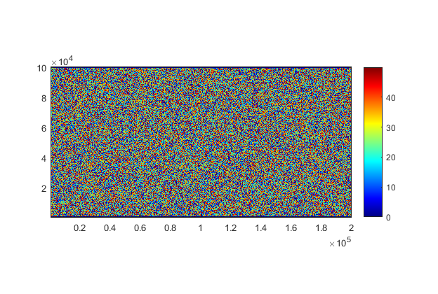

Temporal domain
p.TimeSpan=30e6;
p.TimeStep=1e5;

Vertical uplift
Vertical uplift rates are considered here as a sequence of three tectonic configurations. Vertical uplift is inserted in TTLEM as an instance of GRIDobj
U = GRIDobj(H1);

First uplift phase
In a first phase, the spatial domain is separated by a tectonic fault. In the eastern part, the surface experience a surface uplift of 3 mm/y whereas in the western part, uplift equals 1 mm/y.
fault_x=round(size(U.Z,2)/2);
spat_u_1=ones(size((U.Z)))*3e-3;
spat_u_1(:,fault_x+1:end)=1e-3;
spat_u_1(1,:)=0;spat_u_1(end,:)=0;spat_u_1(:,1)=0;spat_u_1(:,end)=0;
% This first pattern is simulated during 10 Myr. The temporal dimention of
% the inserted uplift is provided in the 3th dimension of the uplift
% matrix.
nbOfSteps1=10e6/p.TimeStep;
U.Z(2:end-1,2:end-1,1:nbOfSteps1) = repmat(spat_u_1(2:end-1,2:end-1),[1,1,nbOfSteps1]);
%Display first spatial uplift pattern
figure('units','normalized','outerposition',[0.1 0.1 .5 .5],'color','white');
imagesc(spat_u_1)
colorbar
title('First vertical uplift pattern (0 - 10 Myr)')
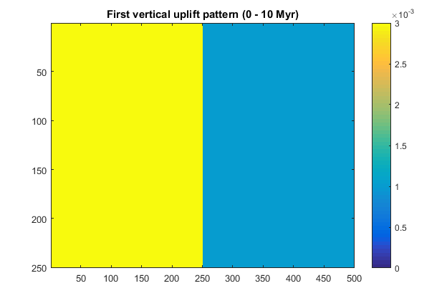

Second uplift phase
A constant uplift over 10 Myr over the entire spatial domain at 1 mm/y
spat_u_2=ones(size(U.Z,1),size(U.Z,2));
spat_u_2=spat_u_2*1e-3;
spat_u_2(1,:)=0;spat_u_2(end,:)=0;spat_u_2(:,1)=0;spat_u_2(:,end)=0;
nbOfSteps2=10e6/p.TimeStep;
U.Z(2:end-1,2:end-1,nbOfSteps1+1:nbOfSteps1+nbOfSteps2) = ...
repmat(spat_u_2(2:end-1,2:end-1),[1,1,nbOfSteps2]);
%Display first spatial uplift pattern
figure('units','normalized','outerposition',[0.1 0.1 .5 .5],'color','white');
imagesc(spat_u_2)
colorbar
title('Second vertical uplift pattern (10 - 20 Myr)')
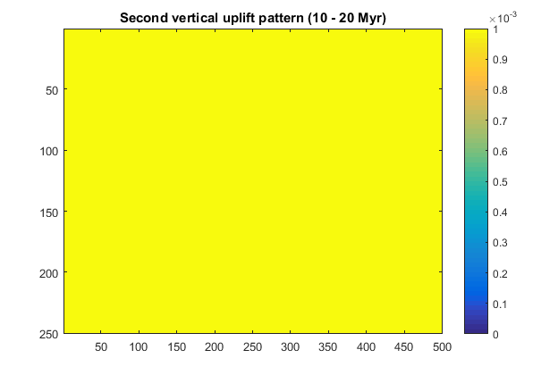

Third uplift phase
An uplift gradient of 10 Myr over the entire spatial domain at 1-5 mm/y
spat_u_3=repmat(linspace(1,0.5,size(U.Z,1))',1,size(U.Z,2))*5*1e-3;
spat_u_3(1,:)=0;spat_u_3(end,:)=0;spat_u_3(:,1)=0;spat_u_3(:,end)=0;
nbOfSteps3=10e6/p.TimeStep;
U.Z(2:end-1,2:end-1,nbOfSteps1+nbOfSteps2+1:nbOfSteps1+nbOfSteps2+nbOfSteps3) = ...
repmat(spat_u_3(2:end-1,2:end-1),[1,1,nbOfSteps3]);
%Display first spatial uplift pattern
figure('units','normalized','outerposition',[0.1 0.1 .5 .5],'color','white');
imagesc(spat_u_3)
colorbar
title('Third vertical uplift pattern (20 - 30 Myr)')
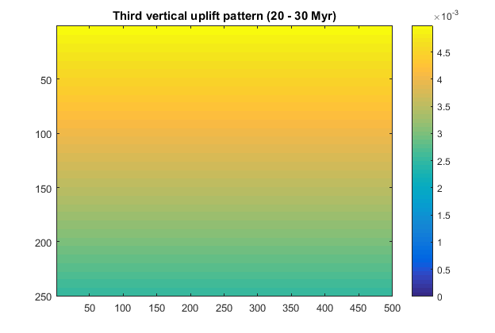

Lateral tectonic displacement
We insert a tectonic shortening field operational in two directions and temporally constant over the entire model simulation
p.shortening=true;
% p.shortening_meth='Upwind_FD';
p.shortening_meth='Upwind_TVD';
x_Speed_c=3e-3;%m/y
y_Speed_c=3e-3;%m/y
%Gradient
grad_x=repmat(linspace(1,0,size(U.Z,2)),size(U.Z,1),1);
grad_y=repmat(linspace(1,0,size(U.Z,1))',1,size(U.Z,2));
p.short_x=grad_x*x_Speed_c;%m/y
p.short_y=grad_y*y_Speed_c;
figure('units','normalized','outerposition',[0.1 0.1 .5 .5],'color','white');
resQv=25;
[xq, yq] =meshgrid(resQv:resQv:size(p.short_x,2),resQv:resQv:size(p.short_x,1));
xq=xq.*dx; yq=yq.*dx;
hq =quiver(xq, yq,p.short_x(resQv:resQv:size(p.short_x,1),resQv:resQv:size(p.short_x,2)),p.short_y(resQv:resQv:size(p.short_y,1),resQv:resQv:size(p.short_y,2)));
hq.Color='k';
set(gca,'ydir','reverse');
xlim([min(xq(:)) max(xq(:))])
ylim([min(yq(:)) max(yq(:))])
title('Lateral tectonic displacement');
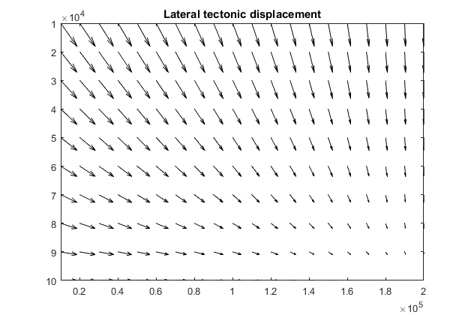

Diffusion parameters
p.D=0.02;
% p.diffScheme = 'only_sc';
p.diffScheme = 'imp_lin_sc';
% p.diffScheme = 'imp_nonlin_sc';
p.DiffToRiv=false; %If false, river elevations will only be altered by river incision
p.DiffTol=1e-4;

Boundary condition
p.BC_nbGhost=2;
p.BC_Type='Dirichlet';
p.BC_dir_value=100;
p.BC_dir_DistSites='tl';
p.BC_dir_Dist_Value=.5;

River incision parameters
p.Kw =7.5e-6;
p.m=0.5;
p.n=1;
p.AreaThresh=5e5; % channel contributing area threshold [m^2]
p.NormPrecip=[]; %effective rainfall grid

Numerics river incision
p.riverInc = 'TVD_FVM';
p.riverInc = 'implicit_FDM';
% p.riverInc = 'explicit_FDM';

Boundary conditions
Default

Threshold slopes
p.Sc=.7;
p.Sc_unit='tangent';

Output
p.ploteach=1;
p.saveeach=1;
p.fileprefix = 'GeologicalSimulation';

Initialize parameter structure
By making p an instance of ttlemset, the user ensures parameter values are set in the right way
p = ttlemset(p);

Model run
TTLEM can be manually interrupted by pushing the 'Stop' Bottom. The current model run will quit without losing the information calculated so far.
ttlem_out = ttlem(H1,U,p);
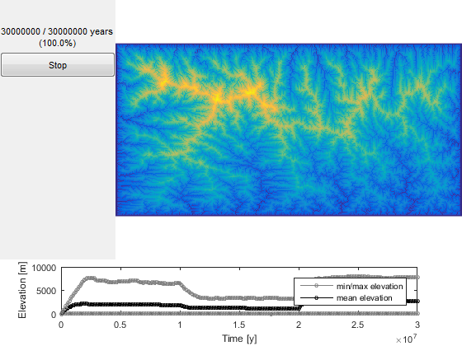

Movie and overview figure
Create simulation movie of the results and generate an overview figure illustration of the results
overviewFignbs=floor(linspace(1,nbOfSteps1+nbOfSteps2+nbOfSteps3,9));
scrsz = get(0,'ScreenSize');
movieTopo = figure('OuterPosition',[0.2*scrsz(4) 0.2*scrsz(4) scrsz(4) .5*scrsz(4)],'Name','Topo','color','white');
overv=0;
Z_prev=H1.Z;
ui=0;
OverviewT = figure('units','normalized','outerposition',[0.1 0.1 .9 .9],'color','white');
for t=p.TimeStep:p.TimeStep:p.TimeSpan
ui=ui+1;
figure(movieTopo)
load([p.resultsdir p.fileprefix num2str(t) '.mat'],'H1');
FD = FLOWobj(H1,'preprocess','c');
S = STREAMobj(FD,flowacc(FD)>(p.AreaThresh/FD.cellsize^2));
imageschs(H1,[],'ticksToKm',true,'colorBarLabel','\bfm');
hold on
S.x=S.x*1e-3;
S.y=S.y*1e-3;
plot(S,'k','linewidth',1.5);
hold off
xlabel('\bfX Coordinate, km')
ylabel('\bfY Coordinate, km')
title([num2str(round(t*1e-6)) ' Myr']);
movie1(ui)=getframe(gcf); %#ok<SAGROW>
if any(ui==overviewFignbs)
figure(OverviewT)
overv=overv+1;
subplot(3,3,overv)
imageschs(H1,[],'ticksToKm',true,'colorBarLabel','\bfm');
xlabel('\bfX Coordinate, km')
ylabel('\bfY Coordinate,k m')
title([num2str(round(t*1e-6)) ' Myr']);
drawnow
end
end
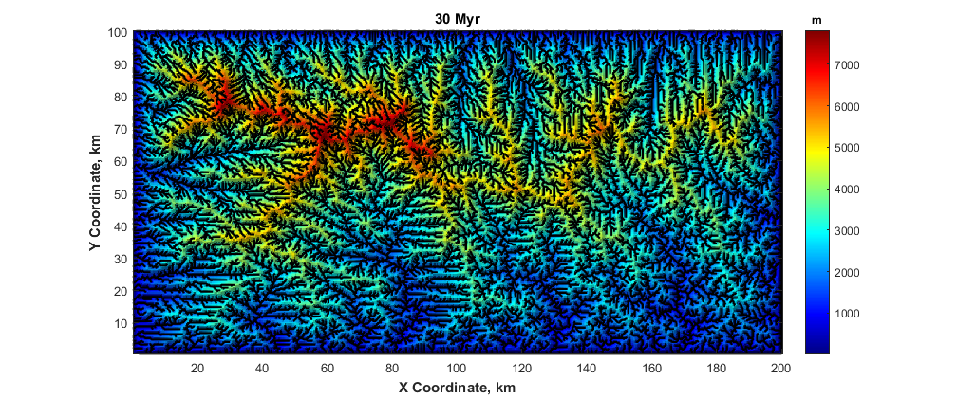
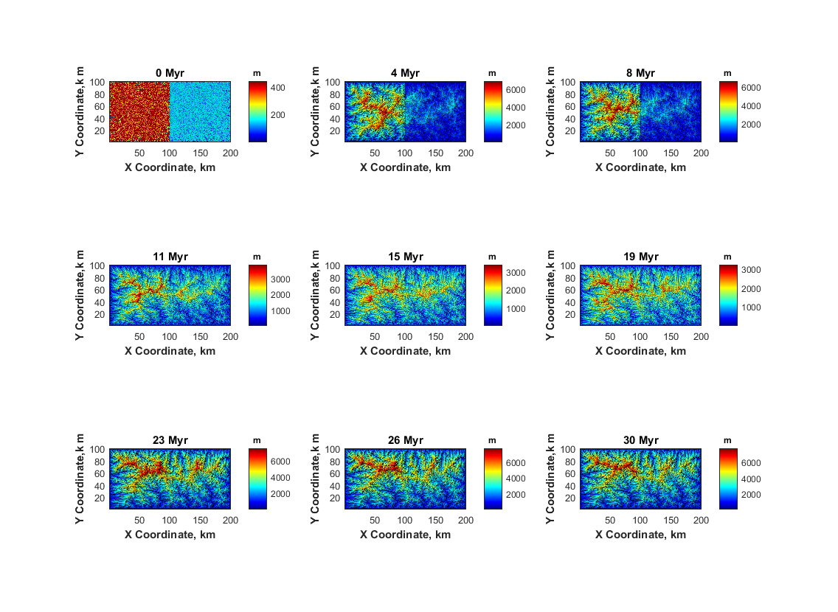

History
This user guide was updated last: June 12, 2016.
Published with MATLAB® R2015b

