User Guide to TopoToolbox - Introduction
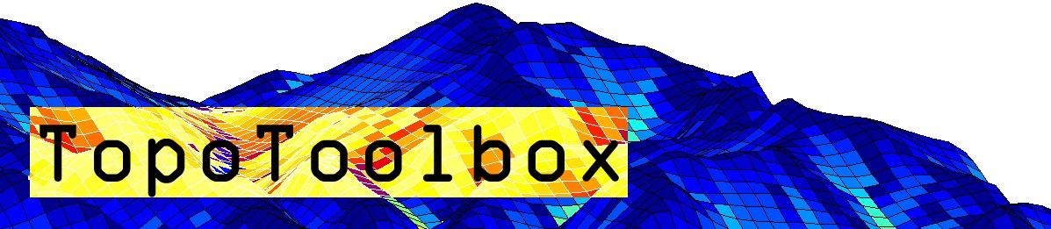

TopoToolbox provides a set of Matlab functions that support the analysis of relief and flow pathways in digital elevation models. The major aim of TopoToolbox is to offer helpful analytical GIS utilities in a non-GIS environment in order to support the simultaneous application of GIS-specific and other quantitative methods.
TopoToolbox is written in the Matlab language and requires the Image Processing Toolbox for various functions.
TopoToolbox 2 1
TopoToolbox 2: limitations 2
About the User Guide 2
Load a DEM into Matlab 2
View the DEM 4
Topographic attributes 6
Export an instance of GRIDobj to the disk 6
Fill sinks 6
FLOWobj and flow related functions 6
Methods associated with FLOWobj 7
STREAMobj - a class for stream networks 10
Reference 13
History 13

TopoToolbox 2
TopoToolbox version 2 is a major update to the Toolbox. The main difference to previous versions are
- the introduction of an Object Oriented Programming (OOP) approach and the implementation of new classes such as GRIDobj, FLOWobj and STREAMobj. All objects carry information (properties) on spatial referencing, information that was previously stored using coordinate matrices that required large memory space.
- a new representation of flow direction. TopoToolbox 1 used the sparse flow direction matrix to store flow direction and compute flow related variables. The new representation allows for much faster function evaluation that usually requires much less overhead memory.
- various GUIs mainly for geomorphological and geomorphometric applications which are intended to make various analyses easier and faster.
- higher computational efficiency by coding various functions as C-MEX files. Note that these functions should be compiled on your system. However, TopoToolbox runs without compilation, yet, less fast.

TopoToolbox 2: limitations
Flow related algorithms in TopoToolbox 2 recently only support the single flow direction (D8) representation. If you are a user of TopoToolbox 1, you may see this as a major limitation. Our advice is to keep both the last version (1.6) and version 2 on the search path. It will be shown in the next userguide how to use the multiple flow direction algorithm in version 2.

About the User Guide
This user guide is intended as a basic introduction to the TopoToolbox. It won't give a comprehensive overview on the functions available but serves a documentation for a sample session. In addition, this user guide provides an account for the command-line based tools of TopoToolbox only. It does not expand upon the use of the GUIs.

Load a DEM into Matlab
TopoToolbox 2 reads the ESRI ascii grid format and single band geotiffs into an instance of GRIDobj.
Note that, throughout the use of TopoToolbox, it is assumed that the DEM has a projected coordinate system (e.g. UTM WGS84) and that elevation and horizontal coordinates are in meter units.
DEM = GRIDobj('srtm_bigtujunga30m_utm11.tif');
DEM is now an instance of the class GRIDobj. DEM contains various properties that contain the gridded data and information on the spatial referencing of the grid.
DEM
DEM =
GRIDobj
Properties:
Z: [643x1197 single]
cellsize: 30
refmat: [3x2 double]
size: [643 1197]
name: 'srtm_bigtujunga30m_utm11'
zunit: []
xyunit: []
georef: [1x1 struct]
The data is stored in the property .Z. You can access it using linear indexing, subscripts or logical indexing as you are used to do with standard Matlab matrices and arrays. E.g. the upper-left 5x5 pixel in the grid can be accessed by following command.
DEM.Z(1:5,1:5)

ans =
945 952 960 966 969
944 951 956 959 957
936 943 948 949 948
929 935 939 941 940
921 926 929 934 930
GRIDobj is associated with various methods. Some of these methods overwrite existing builtin functions (e.g. plus, minus, isnan) or functions that ship with previous versions of TopoToolbox (e.g. gradient8, curvature, fillsinks). Here is an overview of the methods (functions) associated with GRIDobj
methods GRIDobj
Methods for class GRIDobj:
GRIDobj fillsinks ldivide resample
GRIDobj2ascii filter le roughness
GRIDobj2geotiff ge localtopography shufflelabel
GRIDobj2mat getcoordinates log snap2stream
acv gradient8 log10 sqrt
and gt log2 sub2coord
aspect hillshade lt surf
castshadow hypscurve max times
coord2ind identifyflats min uminus
coord2sub imagesc minus uplus
crop imageschs or validatealignment
curvature ind2coord plus xor
dilate info postprocflats
elevateminima inpaintnans power
eq interp rdivide
erode isnan reclassify

View the DEM
Matlab provides numerous ways to display gridded data (images). Among these are imagesc, surf, pcolor, imshow, etc. TopoToolbox overwrites only imagesc and surf

imagesc(DEM)

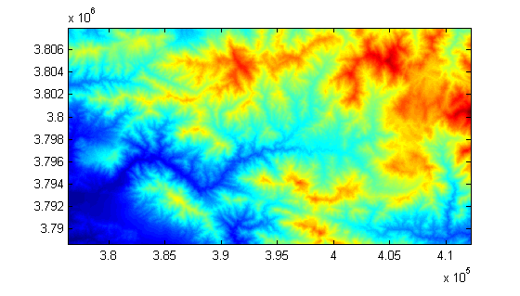

Note that the axes contain the x and y coordinates and that the axes are set to image (axis image).
Another useful function is imageschs which displays an instance of GRIDobj and overlays it with the DEM. Here we display the slope (see function gradient8) overlayn with the hillshade calculated from DEM. For visualization purposes the color range is restricted to slopes less than 1 m/m.
imageschs(DEM,min(gradient8(DEM),1))

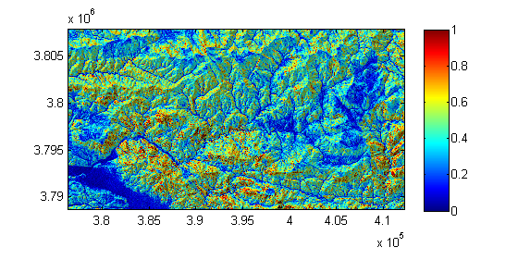
If none of the available visualization functions are what you are looking for, you can simply convert your DEM to the standard representation using GRIDobj2mat. The function returns two coordinate vectors and a matrix with values. Here we crop our DEM to a smaller extent beforehand.
DEMc = crop(DEM,sub2ind(DEM.size,[1 50],[1 50]));
[Z,x,y] = GRIDobj2mat(DEMc);
surf(x,y,double(Z))
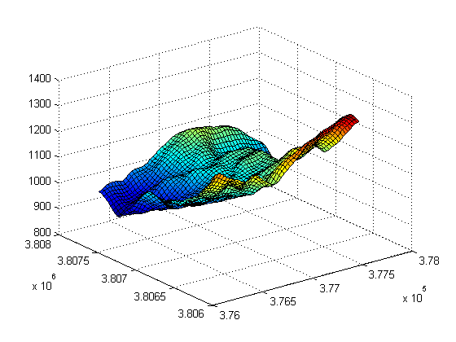
Note: See the help of the function crop on other ways to clip your data to a desired extent.

Topographic attributes
Topographic attributes are derivatives obtained from a DEM such as slope, exposition or curvature. We assume that you are familiar with the meaning of these attributes and you will notice must of the functions by their function name such as
- gradient8 -> as opposed to the Matlab builtin gradient function, gradient8 calculates the gradient in 8 possible directions for each cell.
- curvature -> the second derivative of a DEM.
- roughness -> allows you calculate various roughness indices related to intercell, topographic variability such as ruggedness etc.
- aspect -> slope exposition
- and many more

Export an instance of GRIDobj to the disk
TopoToolbox ships with two functions for writing instances of GRIDobj back the hard drive so that they can be read by standard GIS software such as ArcGIS etc.
GRIDobj2ascii(DEMc,'test.txt');
GRIDobj2geotiff(DEMc,'test.tif');
Note that writing geotiffs is possible without having the mapping toolbox available, however, TopoToolbox will then write an image with a tfw-file (worldfile). See help GRIDobj2geotiff for details.

Fill sinks
Often DEMs feature erroneous topographic depressions that should be filled prior to flow path computation. You can fill sinks using the function fillsinks. Note that in some situations it is more appropriate to not fill sinks but to carve the DEM which will be shown below (see section on FLOWobj).
DEMf = fillsinks(DEM);

FLOWobj and flow related functions
Users of previous versions of TopoToolbox will remember that flow direction was stored as a sparse matrix that contained the information of the directed acyclic graph of the flow network. TopoToolbox 2 uses a novel technique to store flow direction that allows for easy coding and fast performance. Flow direction is stored as a new object, FLOWobj, an instance of which is derived from an existing DEM (instance of GRIDobj).

Here is a fast way to calculate flow accumulation based on the previously sink filled DEM. The flow accumulation grid is dilated a little bit, so that flow paths are more easily appreciated in the figure.

FD = FLOWobj(DEMf);
A = flowacc(FD);
imageschs(DEM,dilate(sqrt(A),ones(5)),'colormap',flipud(copper));

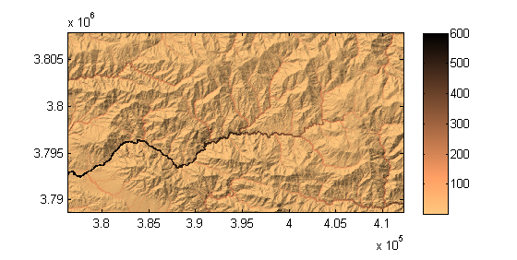
When creating an instance of FLOWobj, you can set numerous options that are summarized in the help of FLOWobj. Please see the usersguide_3_FLOWobj for additional information.

Methods associated with FLOWobj
Various methods exist that operate on instances of FLOWobj to obtain flow related variables such as drainage basin delineation, flow accumulation, etc. Here is an overview
methods FLOWobj
Methods for class FLOWobj:
FLOWobj flowacc multi2single
FLOWobj2GRIDobj flowconvergence saveobj
FLOWobj2M flowdistance streamorder
FLOWobj2gradient flowpathextract streampoi
coord2ind imposemin upslopestats
dependencemap ind2coord validatealignment
drainagebasins influencemap vertdistance2stream
find ismulti

Now, let's calculate the drainage basins of the DEM. This can be done using the function drainagebasins. You may want to shuffle the colors so that the drainage basins can be more easily distinguished in a plot (shufflelabel). As a small exercise, let's denote the area of each basin in the map.
DB = drainagebasins(FD);
DB = shufflelabel(DB);
Easy until here. Now let's get the area and display it together with the drainage basins map. Display only numbers for drainage basins larger than 10 km^2.
nrDB = numel(unique(DB.Z(:)))-1; % nr of drainage basins
STATS = regionprops(DB.Z,'PixelIdxList','Area','Centroid');
imageschs(DEM,DB);
hold on
for run = 1:nrDB;
if STATS(run).Area*DB.cellsize^2 > 10e6;
[x,y] = ind2coord(DB,...
sub2ind(DB.size,...
round(STATS(run).Centroid(2)),...
round(STATS(run).Centroid(1))));
text(x,y,...
num2str(round(STATS(run).Area * DB.cellsize^2/1e6)),...
'BackgroundColor',[1 1 1]);
end
end
hold off
title('drainage basins (numbers refer to drainage basin area in km^2)')
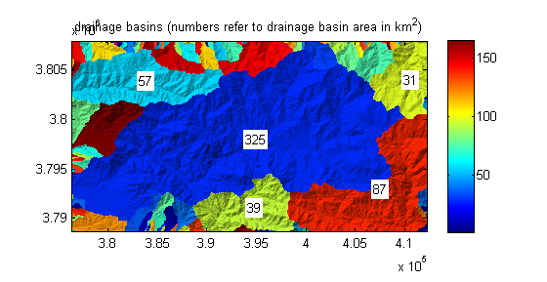

It may also be interesting to know the distance from each drainage basin outlet in upstream direction along the flow network.
D = flowdistance(FD);
imageschs(DEM,D);
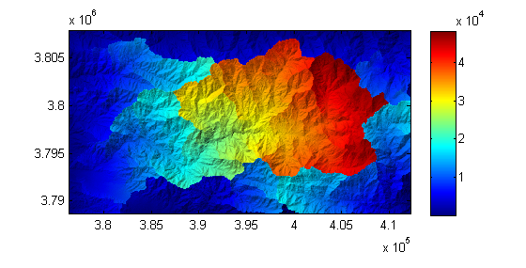
You can use the output of flowdistance to calculate the area function which is the distribution of flow distances to the outlet of a specific basin. Let's take the largest basin in our study site.
[~,IX] = max([STATS.Area]);
hist(D.Z(DB.Z == IX),1000);
xlabel('distance to outlet [m]');
ylabel('# cells');
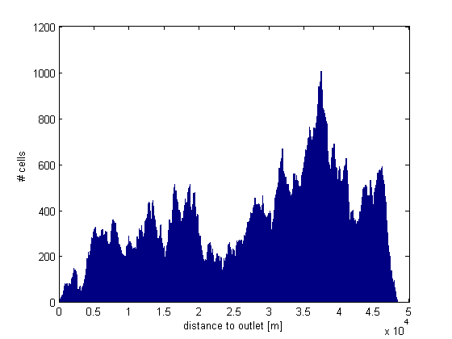

STREAMobj - a class for stream networks
While FLOWobj stores the information on the entire flow network on hillslopes and in channels, STREAMobj is a class that is used to analyze the channelized part of the flow network only. The storage strategy is very similar to the one of the class FLOWobj.
Again, various methods (functions) are associated with STREAMobj that allow for manipulating, plotting and retrieving information on the stream network geometry and patterns.
There are various ways to extract the channelized flow network from DEMs. In this example we simply use an area threshold.

% calculate flow accumulation
A = flowacc(FD);
% Note that flowacc returns the number of cells draining
% in a cell. Here we choose a minimum drainage area of 10000 cells.
W = A>10000;
% create an instance of STREAMobj
S = STREAMobj(FD,W);
% and plot it
plot(S)

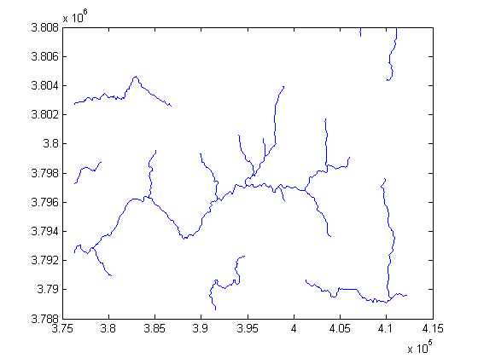
STREAMobj stores various properties some of which you might use to directly access if you want to customize your code or build your own functions. Please check the help of STREAMobj.
Now let's extract the largest subnetwork of the channel network.

S = klargestconncomps(S,1);
plot(S)

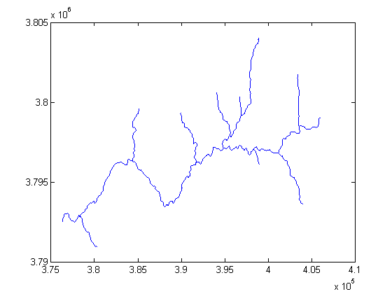
and let's plot flow distance along the stream network versus elevation.
plotdz(S,DEM)
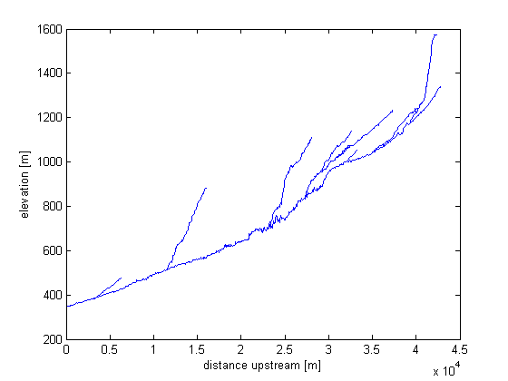

If you have a license of Matlab's Mapping Toolbox you can export the stream network to a shapefile to be read by other GIS software. First, you need to create a mapstruct, a structure array used by the mapping toolbox to store vector data. Then use shapewrite to write the mapstruct to a shapefile.
MS = STREAMobj2mapstruct(S);
shapewrite(MS,'testshape.shp')

Reference
Schwanghart, W., Kuhn, N.J. (2010): TopoToolbox: a set of Matlab functions for topographic analysis. Environmental Modelling & Software, 25, 770-781. [DOI: 10.1016/j.envsoft.2009.12.002]

History
This user guide was updated last: June 19, 2013.

