TopoToolbox 2 - calculating the multiple flow direction

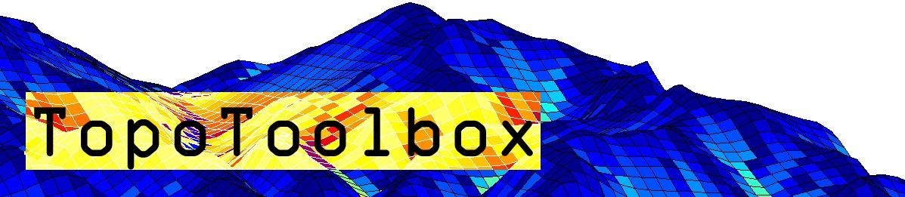

With the introduction of TopoToolbox 2, the new FLOWobj does only support the single (D8) flow direction algorithm. If you have been a user of TopoToolbox 1 and require the multiple flow direction (MFD) algorithm, please read these pages.

Requirements 1
Here is how to do it 1
Future developments 2

Requirements
If you want to use the MFD algorithm with TopoToolbox 2, you must have a previous version (e.g. TopoToolbox 1.6) on your search path.

Here is how to do it
% get the coordinate vectors and the DEM in the format required by the
% function flowdir
[dem,X,Y] = GRIDobj2mat(fillsinks(DEM));
% use meshgrid to calculate coordinate matrices
[X,Y] = meshgrid(X,Y);
% calculate the flow direction matrix M
M = flowdir(X,Y,double(dem));
Now you should calculate the desired topographic attribute directly from M, e.g. flow accumulation
A = flowacc(M,size(dem));
and convert the output back to a GRIDobj.

A = GRIDobj(X,Y,A);
% if there is projection information in the property .georef, you can copy
% it from the DEM.
A.georef = DEM.georef;
% and plot it
imageschs(DEM,log(A));

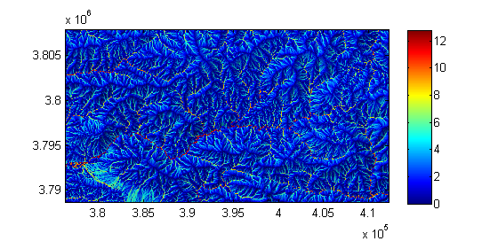
and this is it.

Future developments
The fact, that TT2 currently does not support the MFD algorithm is unsatisfactory. We are currently working on including MFD in future version of TT.

