**Preliminary Form to Add Social Determinants to CSDUL**

**Request date (2024-11-18):**

| **Researcher (name and affiliation):** | Anousheh Marouzi, Saskatchewan Health Authority |
| --- | --- |
| **Node Lead (name and affiliation):** | Charles Plante, Saskatchewan Health Authority |
| **Indicator or Model Name:** | Premature and Avoidable Mortality |

**Purpose of the document**

This document includes several questions that must be answered by the researcher interested in adding indicators or models into CSDUL. These questions pretend to briefly explain the mathematical and theoretical framework of the indicator or model being incorporated. The researcher must be able to fill out every question clearly and concisely, supporting their explanation with respectable academic sources.

The document will be added to the model or indicator documentation in CSDUL-OUT and CSDUL-RDC. It must serve as a quick and straightforward introduction to the indicator or model for anyone interested and give relevant references to guide the learning process to other researchers.

**To be completed by the responsible analyst.**

**If there are questions that cannot be answered because of the nature of the indicator/model, write N/A.**

**You can support your completion using the example document located in this link:** [**Documents - Add inputs to CSDUL - 02 - Example.docx - Google Docs**](https://docs.google.com/document/d/1t4_Bh5pRtHzd8GQ3ifJWY2zjjjch8DFf/edit)

1. **Will you share the inputs through CSDUL-RDC, CSDUL-OUT, or both?** CSDUL-OUT.

1. **Explanation of the indicator/model.** 
   1. **In simple words, explain what the indicator/model to be added consists of.**

The indicator is age-standardized annual mortality rates, from 2011 to 2015. 5 different mortality indicators were calculated: : 1) all-cause mortality, 2) premature mortality, 3) potentially avoidable mortality, 4) preventable mortality, and 5) treatable mortality. These mortality indicators were defined and calculated based on the definition proposed by the Canadian Institute of Health Information (CIHI) and the methodology suggested by the Association of Public Health Epidemiologists (APHEO) in Ontario [(CIHI, 2012; Jeremy Herring, John Barbaro, Elisa Candido, Sherri Deamond, Ramsey D’Souza, Andrew Harris, 2015)](https://paperpile.com/c/m0clz2/E7J2l+Edjsf). The underlying population in the calculations is all Canadian residents. The following figure illustrates how CIHI categorizes mortality indicators.

These indicators are defined as follows: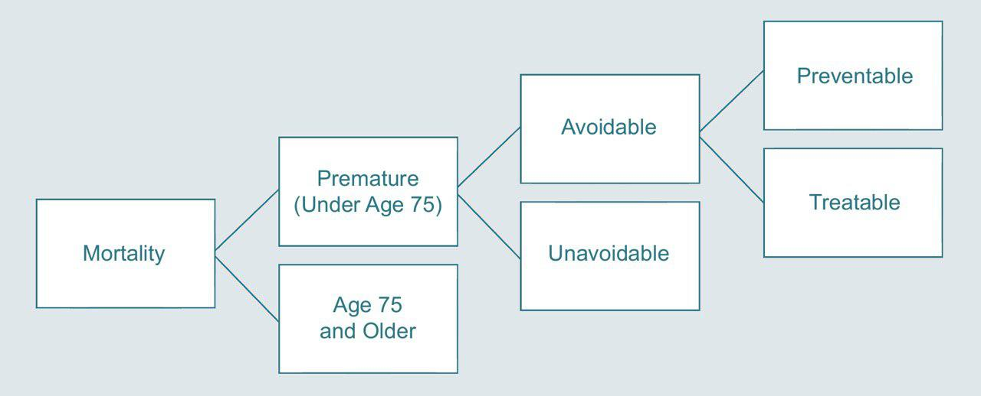

**All-cause mortality** is defined as any death event. The sum of all deaths that occurred in a geographic area was calculated to be used as the numerator.

**Premature mortality** is defined as any death that occurred before the age of 75, meaning at the age of 74 or younger. All deaths that occurred before the age of 75 were identified as premature death, using the age variable. The number of premature mortalities was then counted at municipal, provincial, and national levels. Premature mortality is further split into “Potentially Avoidable Mortality” and “Unavoidable Mortality”.

**(Potentially) avoidable mortality** is defined as premature deaths that could have been potentially avoided in the presence of timely and effective health care services and public health policies, that is, through all levels of prevention (primary, secondary, and tertiary). Based on the nature of intervention that could have prevented these mortalities, avoidable causes of deaths are categorized into two sub-indicators of preventable and treatable mortality.

**Preventable mortality** is a subset of avoidable mortality that could have been averted through primary preventions, such as vaccination and tobacco reduction policies. This subset of avoidable mortality informs efforts for incidence reduction.

**Treatable mortality** is the second subset of avoidable mortalities, which includes causes of death that could have been potentially prevented through secondary (e.g., screening and early detection of diseases) and tertiary (e.g., timely and effective treatments and health interventions) preventions. Treatable mortality informs efforts for case-fatality reduction.

* 1. **Are there assumptions associated with the indicator/model? If there are, please briefly describe them.** N/A.
  2. **How is the indicator/model derived? Support your explanation with formulas when possible.**

The age-standardized rates were calculated in three steps: In the first step, numerators (number of deaths) were measured at different geographic levels. Next, populatio n counts for the years 2011 to 2015 were estimated at different geographic levels, to be used as denominators in mortality rate formulas. Finally, age-standardized mortality rates were calculated. These steps are further explained in detail.

**1. Measuring numerators (number of deaths)**

The Canadian Vital Statistics Death Database (CVSD), for the years 2011 to 2015, were first restricted to Canadian residents by eliminating deaths whose usual place of residence were unknown or outside of Canada. Next, the number of deaths for each of five categories was calculated at CMA, provincial, and national levels.

Avoidable, preventable, and treatable mortalities were identified in CVSD by using the CIHI’s list of avoidable causes of death available in *2012 Health Indicators* by CIHI (submitted as a supporting file). This list presents ICD-9 and -10 of causes of death that CIHI recognizes as avoidable, which is further categorized into preventable and/or treatable causes.

After restricting data to the records with an age of 74 or younger, the variable cause of death was used to identify preventable and treatable deaths based on the list of avoidable causes of death developed by CIHI. In doing so, first, three variables of treatable, preventable, and avoidable were generated. Data were then coded based on the cause of death, presented by ICD-10; if the ICD-10 for an observation matched with an ICD-10 listed as preventable in the CIHI algorithm, then, for that observation, the preventable and avoidable variable took a value of one. Similarly, this procedure was carried out for the treatable causes of death. In case an ICD-10 matched with a cause of death recognized as 50% preventable and 50% treatable in the CIHI list (e.g., Diabetes mellitus with the ICD-10 code of E10–E14), both treatable and preventable variables took the value 0.5, and the avoidable variable took the value of one.

Data were then collapsed to the geography level of interest, and the annual number of avoidable, preventable, and treatable deaths were calculated at municipal, provincial, and national levels.

**2. Estimating denominators (population counts)**

The Canadian Census occurs every five years. As such, population counts are not known for intercensal years. We fitted a linear model between the observed census counts to estimate the intercensal population counts. For this purpose, population counts were extracted from the raw short-form Census 2011 and 2016 to calculate CMA, provincial, and national counts for the years 2012 to 2015. First, the difference between 2011 and 2016 counts was calculated at the geographic levels of interest, and then, the differences were divided by five, which is the number of years intervals. The result was then added to the 2011 population counts in an incremental fashion as shown in the following formula:

|  |  |
| --- | --- |

Where C is population count at year y, the year for which the population count is estimated, and g is the area, DA, municipal, provincial, and national levels, for which the count is calculated. This way, population counts were calculated and used as the denominators in the mortality rates formula, as described further.

It should be noted that, in this study, to calculate different mortality rates, different denominators were needed. Whereas the all-cause mortality rate was calculated over the entire population, premature mortality rate and other indicators were calculated over people aged under 75. The two types of population counts were estimated for the years 2012 to 2015; in equation 3.1, C took both ‘total population’ and ‘population aged 0 to 74 years of age’ to estimate the corresponding counts at the municipal, provincial, and national levels.

Additionally, as the age distribution in a geographic area is needed to be able to age-standardize rates, this method was also used to determine the age distribution across years 2012 to 2015 at municipal, provincial, and national levels. To do so, first, age groups were constructed by five-year intervals (i.e., 0 to 4, 5 to 9, 10 to 14, …. 85 to 89, 90 and older) for both 2011 and 2016 Censuses. Next, population counts for each age group were separately imputed for the intercensal period, using the above formula. For example, for the age group 0 to 4, first, the difference between 2011 and 2016 counts in this age group was calculated at the municipal and provincial levels, and then, the differences were divided by five. The result was then added to the 2011 population counts in this age group, in an incremental fashion. This procedure was done for all the age groups separately.

**3. Calculating mortality rates**

The calculated numerators were then used along with the estimated populations (denominators) to compute mortality rates annually. The following figure provides a summary of the steps taken in calculating mortality rates. The equations used to calculate rates are presented afterward.

**All-cause mortality:** The number of all-cause mortality and estimated total population were used to compute the annual all-cause mortality rate at the municipal, provincial, and national levels, by using the following equation.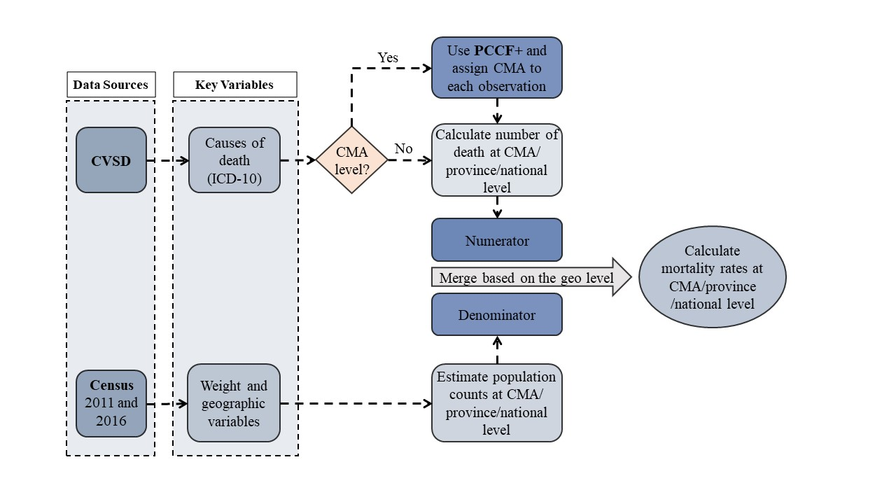

|  |  |
| --- | --- |

**Premature mortality:** Premature mortality rates were calculated by using the following equation.

|  |  |
| --- | --- |

**(Potentially) avoidable mortality:** The number of avoidable deaths and the previously estimated population younger than 75 years of age was used as the numerator and denominator in the following formula to compute (potentially) avoidable mortality rates at the geographic levels of interest.

|  |
| --- |

**Preventable mortality:** The number of preventable deaths and the previously estimated population younger than 75 years of age was used as the numerator and denominator, respectively, in equation 3.5 to calculate annual preventable mortality rates at the municipal, provincial, and national levels.

|  |
| --- |

**Treatable mortality:** The number of treatable mortalities and the previously estimated population younger than 75 years of age were used as the numerator and denominator in the following equation to calculate the annual treatable mortality rate at the municipal, provincial, and national levels.

|  |
| --- |

* 1. **What is the unit of analysis of the indicator/model? (e.g. households, persons, cities)**

The indicators are calculated per year, over three levles of geographies: Canada, province, and Census Metropolitan Area.

* 1. **How can the indicator be integrated with other datasets?**

The indicator can be merged with other datasets based on CMA, province, or for Canada in different years.

* 1. **What are the boundaries of the indicator/model?**

0 to 100,000.

* 1. **If you want to add a model to CSDUL, is this associated with a hypothesis? If yes, please describe their:**
     1. **Null hypothesis**
     2. **Alternative hypothesis**
     3. **The implications of rejecting the null hypothesis**

N/A

* 1. **What is the interpretation of the values of the indicator/model?**

The indicators can be used to compare mortality rates in different geographic areas, like provinces, which can lead to the next research questions to investigate the reason behind observed differences.

* 1. **Based on the literature and your experience working with this indicator/model, is it possible to identify weaknesses in its calculations or assumptions? To facilitate your answer, you can focus on:**

1. **Potential biases**
2. **Overestimation**
3. **Underestimation**
4. **Omitted variables**
5. **Endogeneity**
6. **Datasets’ problems**

* Mortality rates are age-standardized to ignore differences in age-distribution in different populations when comparing rates. However, they are not adjusted for sex, which could be a potential source of bias in this study.
* The intercensal popualation counts are estimates and not the true number of population. This could have resulted in underestimation or overestimation of the rates.
* For CMA-level rates, we used PCCF+ to assign CMAs to each death. PCCF+ assigns geographies probabilistically in some cases. This could be a source of bias in rate calculations. However, since CMA is a relatively large geography, we predict that there is no significant alteration of the rates due to this assignment.

1. **Does the indicator/model have other mathematical or computational versions (not syntax) to build it? (provide references)**

There are various ways to identify and calculate Premature and Avoidable mortality indicators. A scoping review on different definition of these indicators is submitted as a supporting file.[(Marouzi et al., 2024)](https://paperpile.com/c/m0clz2/flUC)

* 1. **Why are you building the indicator/model as you propose? Are there advantages compared to other versions?** We calculated the indicators according to CIHI’s methodology since that is the only standardized methodology proposed to use especifically in the Canadian context.

1. **Do you see potential improvements for the indicator/model? This could involve using other datasets, refining calculations, or modifying assumptions, among others.**

**This indicator could be improved by including other datasets, such as emergency data, to identify more substance use cases. The indicator can also be extended to cover the whole Canadian population and can be broken down into smaller geographies like CMAs. This can be done by modifying the Stata do-file submitted as a supporting file.**

**What inputs are to be added to CSDUL? Write “X”**

|  | Raw or intermediate datasets required to create the indicator/model. |
| --- | --- |
| **X** | Codes that create the indicator/model (be sure that your code is clear enough to be replicated in the future for yourself or any other researcher). |
| **X** | Documentation that explains step by step the entire process that builds the indicator or model. |
| **X** | Results, which consist of the list of variables, indicators, or model results. |
| **X** | Support files. They can be papers, chapter books, codes, etc. |

**References**

[CIHI. (2012). *Health Indicators 2012*. Canadian Institute for Health Information (CIHI).](http://paperpile.com/b/m0clz2/E7J2l)

[Jeremy Herring, John Barbaro, Elisa Candido, Sherri Deamond, Ramsey D’Souza, Andrew Harris. (2015). *3 Potentially Avoidable Mortality*. Association of Public Health Epidemiologists in Ontario.](http://paperpile.com/b/m0clz2/Edjsf) <http://core.apheo.ca/index.php?pid=288>

[Marouzi, A., Plante, C., & Neudorf, C. (2024). Application of the concept “avoidable mortality” in assessing the socioeconomic status related inequalities in health: a scoping review. *Discover Social Science and Health*, *4*(1), 1–21.](http://paperpile.com/b/m0clz2/flUC)