**All code is right,if it does not run,formatting it just**

**1/Manchester encoding**

**Clear;**

**Clc;**

**b = [0 1 0 0 1 0];**

**n = length(b);**

**t = 0:.001:n;**

**for i = 1:n**

**if (b(i) == 0)**

**b_p(i) = -1;**

**else**

**b_p(i) = 1;**

**end**

**end**

**for j = 1:n**

**bw(j*1000:(j+1)*1000) = b_p(j);**

**end**

**bw = bw(1000:end);**

**subplot(2,1,1)**

**plot(t, bw)**

**grid on;**

**title('Binary Pulse Signal');**

**for i = 1:n**

**if b(i) == 1**

**x(i*1000:(i*1000+500)) = 1;**

**x((i*1000+501):(i+1)*1000) = -1;**

**else**

**x(i*1000:(i*1000+500)) = -1;**

**x((i*1000+501):(i+1)*1000) = 1;**

**end**

**end**

**x = x(1000:end);**

**subplot(2,1,2)**

**plot(t, x)**

**grid on;**

**title('Manchester Encoded Signal');**

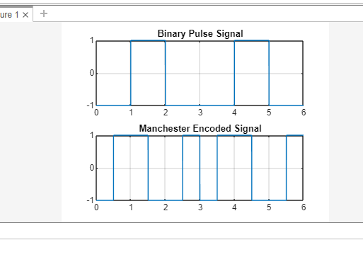

2/differential manchester

b = [0 1 0 0 1 0];

n = length(b);

t = 0:.001:n;

for i = 1:n

if (b(i) == 0)

b_p(i) = -1;

else

b_p(i) = 1;

end

end

for j = 1:n

bw(j*1000:(j+1)*1000) = b_p(j);

end

bw = bw(1000:end);

subplot(2,1,1)

plot(t,bw)

grid on;

last_level = -1;

for i=1:n

if (b(i) == 1)

x(i*1000:(i*1000+500)) = last_level;

last_level = -last_level;

x((i*1000+501):(i+1)*1000) = last_level;

else

last_level = -last_level;

x(i*1000:(i*1000+500)) = last_level;

last_level = -last_level;

x((i*1000+501):(i+1)*1000) = last_level;

end

end

x = x(1000:end);

subplot(2,1,2)

plot(t,x)

grid on;

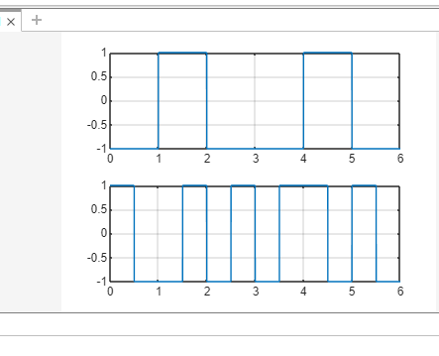

3/phase modulation

%Fs must be at least 2*Fc

clear;

clc;

t=0:0.005:1;

% Equation of carrier signal

fc=10;

x=sin(2*pi*fc*t);

subplot(3,1,1);

plot(t,x), grid on;% Graphical representation of Modulating signal

title ( ' Carrier signal ');

xlabel ( ' time(sec) ');

ylabel (' Amplitude');

% Equation of (modulating (mEssage) signal

fs=20;

yc=sin(2*pi*fs*t);

subplot(3,1,2);

plot(t,yc), grid on;

title ( ' modulating signal ');

xlabel ( ' time(sec) ');

ylabel (' Amplitude');

% Equation of modulated signal

phasedev = pi/2;

tx = pmmod(x,fc,fs,phasedev);

subplot(3,1,3);

plot(t,tx), grid on;

title ( ' Modulated Signal ');

xlabel ( ' time(sec) ');

ylabel (' Amplitude');

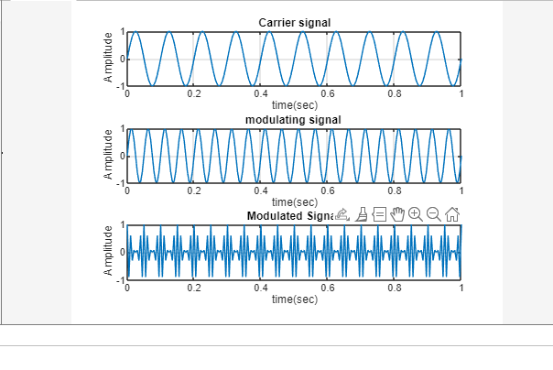

4/psedoternary

b = [0 1 0 0 1 0];

n = length(b);

t = 0:.001:n;

for i = 1:n

if (b(i) == 1)

b_p(i) = 0;

else

b_p(i) = 1;

end

end

for j = 1:n

bw(j*1000:(j+1)*1000) = b_p(j);

end

bw = bw(1000:end);

subplot(2,1,1)

plot(t,bw);

grid on;

lastbit = 1;

for i=1:n

if b(i)==0

x(i*1000:(i+1)*1000) = -lastbit;

lastbit = -lastbit;

else

x(i*1000:(i+1)*1000) = 0;

end

end

x = x(1000:end);

subplot(2,1,2)

plot(t,x)

grid on;

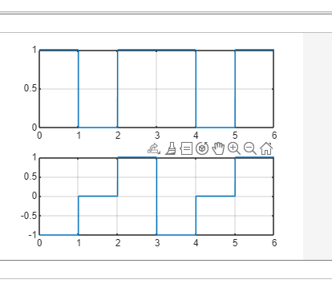

5/FSK

clear;

clc;

b = [0 1 0 1 1 1 0];

n = length(b);

t1 = 0:.01:n;

sint1=sin(2*pi*t1);

sint2=sin(2*pi*110*t1);

for i = 1:n

bm(i*100:(i+1)*100) = b(i);

end

bm = bm(100:end);

for i = 1:length(bm)

if bm(i)==0

bm(i) = -1;

end

end

% bm(bm==0)=-1

for i = 1:length(bm)

if bm(i) == -1

bw(i)=sint1(i);

else

bw(i)=sint2(i);

end

end

subplot(4,1,1)

plot(t1,bm)

grid on ;

axis([0 n -2 +2])

subplot(4,1,2)

plot(t1,sint1)

grid on ;

axis([0 n -2 +2])

subplot(4,1,3)

plot (t1, sint2);

grid on ;

axis([0 n -2 +2])

subplot(4,1,4)

plot (t1, bw);

grid on ;

axis([0 n -2 +2])

