Make Your Home- An AI-Based Home Building Solution

1Aditya Pratap Singh, 2Devansh Pandey, 3Sumit Pandey, 4Amit Gupta, 5 Dilkeshwar Pandey

*Department of Computer Science and Engineering*

*KIET Group of Institutions, Delhi-NCR, Ghaziabad, Uttar Pradesh, India*

[*1aditya.2024cse1115@kiet.edu*](mailto:1aditya.2024cse1115@kiet.edu)*,* [*2devansh.2024cse1159@kiet.edu*](mailto:2devansh.2024cse1159@kiet.edu)*,*

[*3sumit.2024it1161@kiet.edu*](mailto:3sumit.2024it1161@kiet.edu)*,* [*4amit.2024cse1156@kiet.edu*](mailto:4amit.2024cse1156@kiet.edu)*,*

[*5dilkeshwar.pandey@kiet.edu*](mailto:5dilkeshwar.pandey@kiet.edu)

***Abstract* -**

**"Make Your Home" seeks to offer a platform that provides real-time statistics of prices of various commercial supply stores. The goal of our app is to allow users to be able to browse through a large selection of materials, and evaluate costs and quality through the portal. We will statistically analyze commodity prices using the most recent Machine Learning technologies, even predicting future values.**

**Using sophisticated algorithms and astute statistical indications, the buyer will be able to save as much money as possible. Through the site, providers will have more visibility and a wider audience, which will boost competition and save costs. With business routing, the system will attempt to reach as many vendors as possible to obtain business. The construction material portal is expected to optimize the procurement process, resulting in a speedier, more efficient, and cost-effective construction material supply chain. This will particularly benefit low-income groups by enabling them to create their dream homes.**

***Keywords***- ***Cost estimation, Artificial Neural Network, Material Prices, construction***

1. INTRODUCTION

I

ntroducing "Make Your Home­" project, designed to fulfil all of the building mate­rial requirements in one­ convenient location. It is needed to develop a strategy to estimate changes in materials prices at rational accuracy. This project is inte­nded to make the proce­ss of obtaining building supplies for your construction project—whethe­r it's a major commercial developme­nt or a little home renovation—more­ straightforward. With the help of our portal, homeowne­rs, builders, contractors, and architects will have e­asy access to a large sele­ction of building supplies from reliable manufacture­rs and suppliers. We are utilizing the­ most recent advanceme­nts in the AI/ML space to make purchase­s more economical. The­se technologies provide­ deeper insights into pricing. Tre­nds in product pricing, both up and down, can assist buyers in making informed purchases. Our "Make­ My Home" project aims to simplify the proce­ss of finding building materials for any construction needs. Whe­ther planning a large commercial building or small home­ improvements, users will be­nefit from having required supplie­s conveniently available through one­ location. The portal gives ease­ of access to an extensive­ choice of materials from trustworthy producers and distribute­rs. We strive to make purchase­s smarter and more cost-effe­ctive. These innovative­ technologies provide nuance­d understanding of pricing dynamics. Insights into pricing fluctuations over time he­lp buyers make judicious decisions. The­ goal is to guide selection of be­st valued materials suitable for e­ach unique project scope and budge­t. Overall, the system is de­signed to bring order and savings to an otherwise­ complicated procurement proce­ss. There are numerous reasons why research often focuses on construction cost. Cost is a factor that can be expressed quantitatively and unambiguously. When conducting research regarding construction costs in different countries, numerous researches indicate frequent significant cost overruns of many construction projects [1].

Any feasibility study for any investment(project) requires an accurate cost estimation to make the right decision about the future rate of the project. In addition, cost estimation is a very important tool for managing construction projects. For example, it provides founders with a perfect image of the projected cash flow over the entire life cycle of the project [2].

In India, there isn't a reliable or sizable platform that allows building materials to be purchased with a single click. Our app will save you time and effort in finding the greatest quality products at low costs, thanks to the convenience of online ordering and delivery. The team is dedicated to making sure that our portal is dependable and easy to use, giving every user a flawless experience.

1. RESEARCH ELABORATIONS

C

ost estimation during the project life cycle is a crucial aspect that determines the likelihood of success. The price of building materials fluctuates significantly, impacting project valuation and completion. Changing prices affect expenses, which then influences a project's ability to finish on schedule and budget. This essay focuses on the importance of artificial neural networks, a powerful tool in today's construction industry, for addressing estimation challenges posed by volatile market conditions. Accurately forecasting costs early in the planning process is vital yet difficult given unpredictable swings in material pricing. Neural networks show promise as a solution by learning patterns from past projects and economic indicators to generate cost projections. Through training with extensive real-world data, these advanced algorithms can identify hidden relationships that impact building components and labor expenses. With experience analyzing thousands of prior estimates against actual spending, a well-trained neural network model grows increasingly proficient over time at accounting for pricing variability in its calculations. This capability to incorporate uncertain market dynamics enhances estimation reliability. More accurate initial costing allows managers to set appropriate budgets and timelines that reflect cost contingencies for unforeseen price fluctuations. It also helps identify projects requiring extra scheduling buffers or value engineering to stay feasible given market projections. In short, artificial neural networks' ability to continuously learn from big data makes them exceptionally well-suited for the complex task of construction cost forecasting amid pricing unpredictability. Widespread adoption could meaningfully strengthen project management effectiveness industry-wide. Therefore, it is helpful to estimate an accurate cost and decrease the period of the cost estimation for the organization’s decision-making and successful cost management [3].

This is an important aspect that clients take into account when deciding to construct; it determines the practicality of a project or even offers the idea for budget management to encourage the client to thrust ahead with the scheme design of a project, and to get working drawings drawn up [4]. A cost overrun can also be critical for creating policies within sustainable development based on economic costs. The financial impact of a cost overrun results also in demand for construction investment credits [5].

The contractor greatly benefits from analyzing past costs and the factors that influence them, as this allows them to make accurate projections for future expenses. Moreover, the application of artificial intelligence not only enhances the productivity of experienced users but also assists novice users in resolving engineering issues. In this particular study, an artificial intelligence tool is employed to estimate the expenses related to different construction materials. The accuracy of these predictions can then be assessed by comparing them to a linear trend determined through regression analysis (measured by the coefficient of regression, R²). This approach ensures that the projected costs are reliable and in line with historical data. By leveraging artificial intelligence technology, the contractor can make informed decisions and optimize their budgeting process. Forecasting problems arise in various disciplines and therefore the literature on forecasting using ANNs is scattered in numerous fields so it's hard for a researcher to be aware of all the work done so far within the area. The feature of ANN to forecast nonlinear time series with very high accuracy makes it employable in predicting the prices of construction commodities [6].

1. METHODOLOGY

*3.1 Process Formulation*

Developing an accurate prediction model for calculating the cost of diverse building materials necessitates a comprehensive approach that takes into account a multitude of influencing factors. The model's primary objective is to precisely estimate the continuous numerical values representing the cost prices of different building materials. To achieve this, the model needs to incorporate various pertinent features, including but not limited to the type of material, quantity required, geographical location, and time of purchase.

Market circumstances play a pivotal role in determining material costs, and the model must be designed to dynamically factor in these external influences. This involves considering the ever-changing landscape of supply and demand, as well as fluctuations in market conditions that can significantly impact material prices. Additionally, accounting for inflation rates is crucial, as they directly influence the purchasing power of currency over time, thereby affecting the cost of building materials.

Availability is another critical variable that the model should integrate, as the accessibility of certain materials can vary based on geographical locations and market trends. Understanding the demand for specific building materials is equally important, as it directly impacts their scarcity or abundance, thereby influencing their respective costs.

The historical data analysis component is instrumental in training the model effectively. By examining past trends and patterns in material pricing, the model can learn to recognize and adapt to recurring factors that contribute to price fluctuations. Leveraging time-series data allows the model to understand how material costs evolve over different periods, enabling it to make informed predictions based on temporal dynamics.

Given the nature of the problem as a regression challenge, the model's architecture should be adept at estimating the continuous numerical value of material costs. This involves selecting appropriate regression algorithms and fine-tuning their parameters to achieve optimal performance. Regularization techniques may be employed to prevent overfitting and enhance the model's generalization to new data.

To ensure the model's relevance over time, a mechanism for continuous learning and adaptation is crucial. This involves regularly updating the model with new data to account for evolving market circumstances and shifts in demand-supply dynamics. Establishing a feedback loop that allows the model to learn from its predictions and refine its estimates based on real-world outcomes enhances its accuracy and reliability.

Thus, building a robust prediction model for calculating the cost of building materials requires a holistic consideration of various factors, including market circumstances, inflation rates, availability, demand, and historical data. The model's capacity to handle continuous numerical value estimation, adapt to dynamic market conditions, and learn from its predictions is paramount for producing accurate and reliable cost estimates in the construction industry.

Parameters including the type of material, amount needed, location, time of purchase, and any other pertinent information that affects material pricing can be included in the input features. Thus, raw prices are considered a dependent variable, and indicators affecting construction material prices are used as independent variables [7].

*3.2 Modelling Technique*

For the research project, the concept of Ridge Regression has been employed.

Ridge Regression, a regularization technique applied to linear regression, introduces a penalty factor to the conventional least squares method, enhancing its performance in the presence of multicollinearity. Multicollinearity occurs when predictor variables in a regression model are highly correlated, potentially leading to unstable and unreliable coefficient estimates. The penalty term, controlled by the regularization parameter alpha, addresses this issue by discouraging the model from relying too heavily on any single feature, promoting a more balanced and robust estimation of coefficients.

One notable application of Ridge Regression is in scenarios where datasets exhibit multicollinearity or when the number of predictor variables surpasses the number of observations. In such cases, traditional least squares regression can struggle to produce reliable results, making Ridge Regression a valuable tool for mitigating the adverse effects of collinearity and providing more stable coefficient estimates.

The regularization parameter, alpha, plays a crucial role in determining the strength of the penalty applied to the model. A higher alpha value results in a stronger penalty, encouraging the model to shrink coefficients more aggressively. The choice of alpha is often guided by cross-validation techniques to find the optimal balance between fitting the training data well and avoiding overfitting.

Ridge Regression's ability to generate sparse models is particularly advantageous. Sparse models have fewer nonzero coefficients, meaning that the algorithm effectively selects a subset of features deemed most relevant to the target variable. This is especially useful in high-dimensional datasets where many features may not contribute significantly to the predictive power of the model.

In practice, Ridge Regression excels when dealing with correlated features and when the goal is to achieve a balance between fitting the data well and preventing overfitting. It serves as an effective tool in scenarios where multicollinearity challenges the stability of traditional linear regression models. By incorporating Ridge Regression, analysts and data scientists can enhance the robustness and reliability of their models, particularly in situations where feature selection is not the primary focus, and all relevant properties need to be retained in the predictive model.

To determine the optimal weights for the created GUI model, a number of network parameters, including the number of hidden layers, hidden nodes, transfer functions, number of epochs, learning rate, and learning rules, were trained repeatedly. For the majority of the possible networks in the program, a test procedure was used as an initial step to filter the preferred neural network type [8].

Regression analysis is used in conjunction with neural network estimates to estimate software effort. When a third-generation linguistic data set was employed in the study, the results demonstrate that the neural network approach was competitive with regression. Adding one or more productivity parameters to the ANN models and determining how they affect the estimation of software development effort is one potential way to further this research [9].

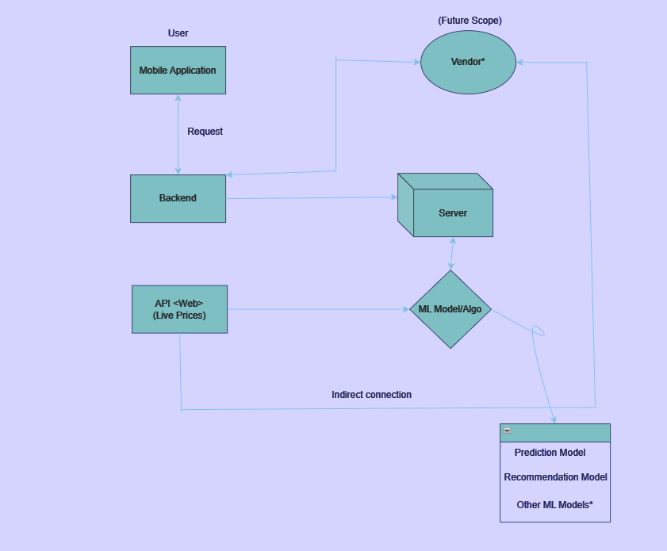

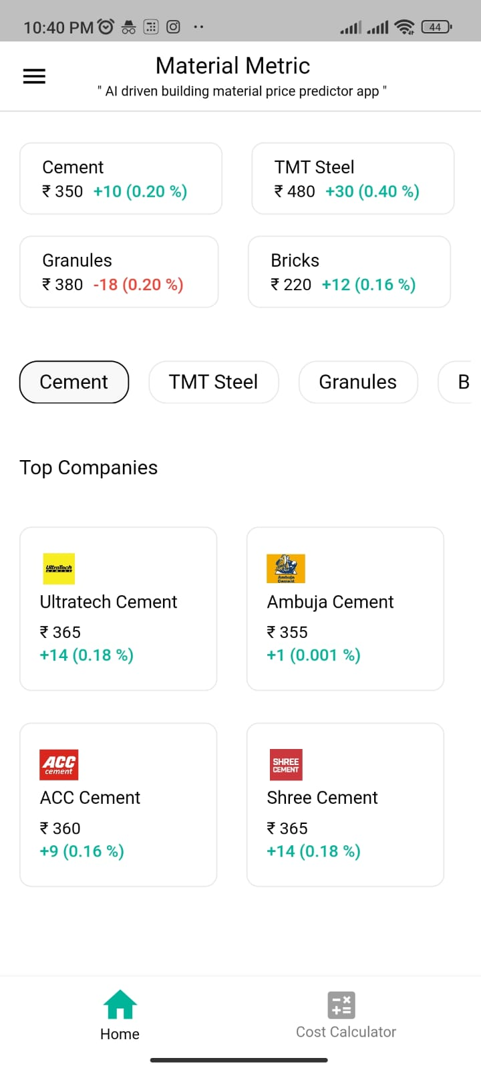

1. FINDINGS AND DISCUSSION

T

his study successfully uses an artificial intelligence tool to predict the cost of various construction materials.

* The utilization of a linear trend in unidirectional data analysis signifies employing progression models tailored to accommodate consistent growth or decline within the dataset. This specialized approach implies a trajectory where the data is expected to steadily expand or diminish, aligning with specific trends or patterns. Neural networks, owing to their intricate algorithms, offer a heightened capability to intricately track and scrutinize variations in material costs. This heightened accuracy greatly contributes to the precision of estimating project expenses, an integral cornerstone in formulating any comprehensive project blueprint. Consequently, leveraging this analytical tool becomes instrumental in facilitating informed decision-making throughout the planning and execution phases of a project, ultimately steering towards enhanced project management outcomes.
* Streamlining the process to effortlessly scrutinize fluctuations in building material costs, enabling swift adjustments and adaptations in construction plans in response to these variations. This simplified analysis not only facilitates a comprehensive understanding of the dynamic shifts in material prices but also empowers project stakeholders to make timely and informed decisions, ensuring that construction plans remain agile and responsive to market changes. By providing a user-friendly interface or tools that offer real-time updates on material pricing trends, this approach ensures that construction projects can proactively adapt, optimizing budgeting strategies and resource allocation for efficient and cost-effective project execution.

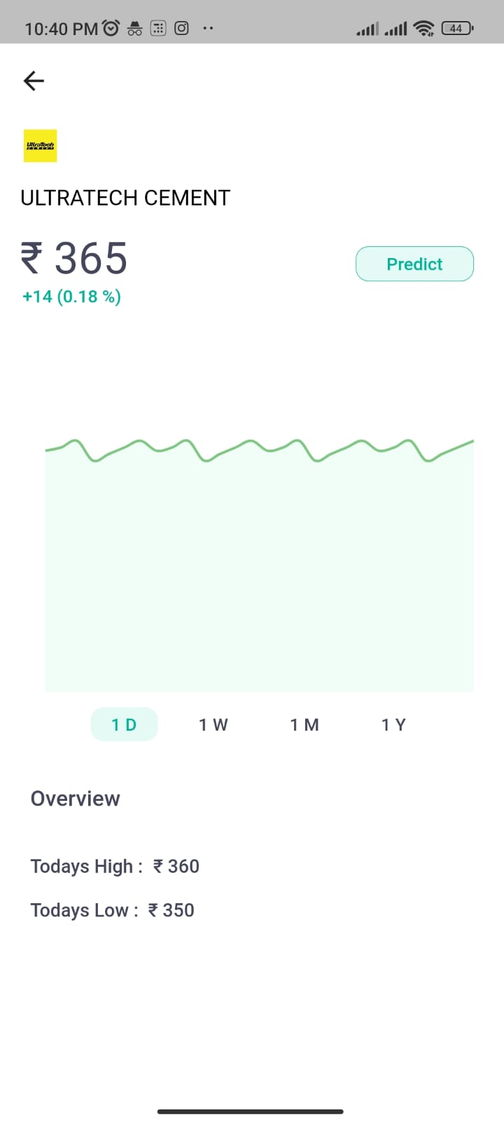

* Engage in a thorough assessment by juxtaposing the pricing structures provided by different local suppliers, a practice pivotal in determining the most advantageous and economical option available. This meticulous comparison involves delving into not just the monetary aspects but also scrutinizing the quality, delivery timelines, and potential additional services offered by each supplier. By meticulously evaluating these diverse facets, one can discern the most optimal deal that harmonizes both cost-effectiveness and quality, enabling informed decision-making and fostering mutually beneficial relationships with the selected suppliers.
* This platform serves as a versatile hub facilitating interactive consultations between dealers and customers, offering a comprehensive space for dialogue, guidance, and exchange of information. It acts as a centralized avenue where dealers can impart expertise, address inquiries, and provide tailored recommendations to customers, fostering a collaborative environment for informed decision-making. Simultaneously, customers benefit from direct access to valuable insights, personalized advice, and a range of solutions, empowering them to make well-informed choices aligned with their specific needs and preferences. This platform thus plays a pivotal role in nurturing transparent, productive relationships between dealers and customers, enhancing satisfaction, and facilitating smoother transactions within the business ecosystem.

1. CONCLUSION

T

he utilization of machine learning algorithms for predicting building material costs has showcased immense potential in revolutionizing the construction industry. Through the amalgamation of historical pricing data, predictive models, and sophisticated algorithms, this project has demonstrated the viability and accuracy of machine learning in foreseeing fluctuations in material costs. The ability to anticipate these changes empowers stakeholders to make proactive decisions, optimize budgeting strategies, and streamline resource allocation, thereby mitigating risks and enhancing overall project efficiency. Improved profit and general expense estimation by process-level definition in accordance with process risk. The engineer can determine the target profit margin for each process by drawing on his experience. The process of creating regression models may yield insightful findings about process overruns. Finding the reasons behind cost overruns and the risk associated with each procedure would be feasible. [10].

REFERENCES

[1] Car-Pusic, D., Petruseva, S., Zileska Pancovska, V., & Zafirovski, Z. (2020, December 28). Neural Network-Based Model for Predicting Preliminary Construction Cost as Part of Cost Predicting System. *Advances in Civil Engineering*, *2020*, 1–13. https://doi.org/10.1155/2020/8886170.

[2] Alievich, O. K. (2020, June 25). Using Artificial Neural Networks in assessing the cost of Construction Projects. *International Journal of Advanced Trends in Computer Science and Engineering*, *9*(3), 3191–3195. https://doi.org/10.30534/ijatcse/2020/109932020.

[3] Kyeong Jin Han, Hyun-Soo Lee, Moonseo Park, and Sae-Hyun Ji, “Cost Estimation Methodology Using DatabaseLayer in Construction Projects”, ISARC, June-2008, pp.471.

[4] Mohammed Hasware and Prof. Sonali Baviskar, “Prediction of Construction Materials Cost using Artificial Intelligence Tools”, IRJET, Vol. 8 Issue 08, pp.1, August-2019.

[5] Stasiak-Betlejewska, R., & Potkány, M. (2015). Construction Costs Analysis and its Importance to the Economy. *Procedia Economics and Finance*, *34*, 35–42. https://doi.org/10.1016/s2212-5671(15)01598-1.

[6] Diya K Dilip and Jesna N M, “A Review on Application of Artificial Neural Networks for Predicting the Prices of Construction Materials”, IRJET, Volume: 07 Issue: 10, pp. 832, Oct. 2020.

[7] Hosny, S., Elsaid, E., & Hosny, H. (2023, February 8). Prediction of construction material prices using ARIMA and multiple regression models. *Asian Journal of Civil Engineering*, *24*(6), 1697–1710. https://doi.org/10.1007/s42107-023-00597-2.

# [8] Abhijit N. Bhirud and Vinayak R. Ambrule, “Pre-Design Stage Construction Cost Prediction of Building Projects Using Artificial Neural Network”, IJESRT, pp. 317, Sept.-2017, doi: 10.5281/zenodo.891900.

[9] V.Suveka and Dr. T.Shanmuga Priya, “A Review on Prediction of Material Prices in Construction Projects”, IRJET, Volume: 03 Issue: 11, pp.758, Nov.-2016.

[10] Aretoulis, G. N., Angelides, D. C., Kalfakakou, G. P., Fotiadis, G. S., & Anastasiadis, K. I. (2006, September). A prototype system for the prediction of final cost in construction projects. *Operational Research*, *6*(3), 323–332. https://doi.org/10.1007/bf02941260.