

# KIET Group of Institutions, Ghaziabad

***BACHELOR OF TECHNOLOGY(CSE)***

**PROJECT SYNOPSIS**

**on**

**Stress management (Machine-Learning)**

**MAJOR PROJECT**

Submitted By:

Ajeet Kumar Singh(2000290100010) Akshita Agarwal(2000290100014)

Amisha Singh (2000290100016)

Course/Branch(Sem-Sec.) B-tech CSE - A

**Index**

1. Abstract/overview of Project.
2. Objective
3. Introduction of Project.
4. Literature review
5. Methodology-Detection/Analysis Techniques
6. Stress Detection with Machine Learning and Deep

Learning

1. Expected Conclusion or Outcome
2. References

Abstract

Stress assessment has been considered essential in the early stages because stress-related abnormalities tend to increase the risk of strokes, heart attacks, depression, and hypertension. This may also induce suicidal thought within the victims of this neurological state. The CAD (Computer Aided Diagnosis) have been a way forward for both medical experts and people with complications. The recent development of Machine learning revolution has proved to be substantial for medical diagnosis and prediction. This approach can further be used with neurological tools. The initial status of the brain activities would act as a window into the brain; which can be used as an insight. With the influence of machine learning more generalized way of discriminating stress activities with other normal activities can be possible.

Keywords: Stress-Assessment, Machine Learning

Objective

This project focuses on developing a stress detection and management system that utilizes advanced technology and research to help individuals better understand and manage their stress levels. The system will consist of a user-friendly app that uses sensors to monitor physiological responses such as heart rate variability and skin conductance, which are known to be indicators of stress. The app will also incorporate a questionnaire to gather additional information about the user's lifestyle, work, and other factors that could contribute to their stress levels.

Using this data, the system will provide users with personalized stress management techniques and resources, such as mindfulness exercises, breathing techniques, and cognitive behavioral therapy techniques. The system will also include a feature that allows users to track their progress over time, providing motivation and feedback on their stress management efforts.

The project will utilize existing research on stress detection and management, as well as conduct new studies to refine and validate the system's effectiveness. The goal is to create a tool that is accessible, effective, and customizable to individuals' unique needs, ultimately improving their mental and physical health by better-managing stress.

Introduction

Stress

Chronic stress has been identified as a factor for neuropsychiatric diseases. It has lasting neurological and physical effects. Stress is defined to be a state when the brain experiences high demands of activities in certain external or internal pressure, which can be psychological or sociological. To cope with this condition, the brain tries to utilize more resources which may lead to initial abnormal activities.

Constant experience of such state results in stress-related mental disorder which includes depressive and anxiety disorders. Stress can also put you at a high risk of heart attack, cardiac arrest and other similar physical effects. Stress assessment and diagnosis in the early stages can help to reduce the risk mentioned above.

*Stress Assessment*

When stress is a critical disease which is possibly a factor of major psychological and physiological complexity and abnormalities. It is an important task to detect and diagnose such stress symptoms and conditions at early stages. Clinically the methods which are in practice involves direct observation and interpretation by the examiner for stress assessment. These methodologies include questions related to the participant's life and the evaluator grades on the basis of the answers. In this manner, depending on the question interpretations are made regarding the stress status. Other than these clinical practices many different techniques have also been developed in order to recognize its patterns by evaluating the activities in the brain. Widely used equipment for this purpose is EEG, MEG, PET, MRI etc.

*The Use of the Machine Learning*

Until now algorithms used for predictions and classification were being developed and improved to perform with better efficiency and accuracy but does not have the ability of learning. The development in artificial intelligence enabled the researchers to develop algorithms which involve machine learning. This revolutionized the way computer systems were being used in the past decades. Expert systems were being used in order to facilitate humans and provide a helping hand in their lives.

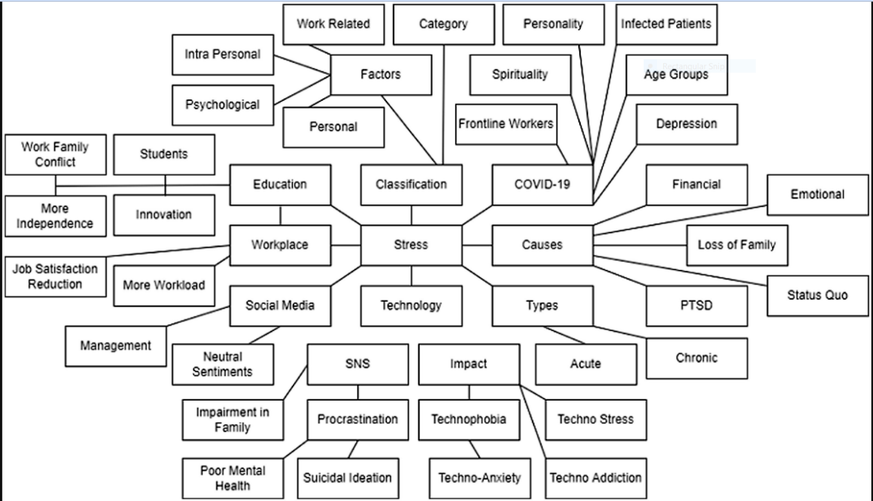

# LITERATURE REVIEW

*Machine Learning Approach for Stress Detection using Wireless Physical Activity Tracker*

The classical clinical techniques in practice involve examination of participants with the help of questionnaires and visual observations. [1]Various methodologies are available which consist of different questions, each question contains a ranking value which represents its impact on the evaluation of any neurological condition. Jeanne E. Dise- Lewis demonstrates the development of LECI (Life Events and Coping Inventory), which is being used as a tool to assess the experience of life stress. This methodology depends on many questions associated with ranks. Kyung Bong et. Discusses the development of the stress response inventory. This work includes a similar method which includes questions. These questions are associated with different emotions and identify the possibility of having a certain emotion. The evaluation of such method is performed using classical statistical tools i.e. standard deviations and means. E. Ron de Kloet et. al. shows different physical changes which occur as a result of stress and hormonal secretion due to stress. Kim L. Felmingham et. In his work relates the eye tracking and pupil dilation due to stress disorder. Sowjanya et.studied the effect of stress on a number of eye blinks and evaluates the level of stress. Such methodologies do provide knowledge regarding stress but all this information represents post stress effects, this is why real- time stress assessment is a substantial requirement to address this specific issue.

Methods for stress assessment are being used which are subjective to the technique and also to the examiner, which may lead to various different outcomes and results. The indicators for stress which are being considered for assessment are very sensitive and can easily be manipulated by the subject, resulting in wrong interpretations.

A study has been carried out on the behavioral symptoms of stress using a wireless physical activity tracker developed by FITBIT. Physical activity acts as a de-stress agent on human stress. Floors and sedentary minutes from the physical activity data set are significant and negative in nature. Therefore, by increasing the amount of physical activity in daily life, one can reduce his/her stress levels. Sleep shortage and insomnia are common signs ofstress. Our study shows the time in bed is a significant and positive indicator ofstress. The stress level is determined by the amount of sleep a person is getting in a day, but not on the number of awakenings. Similarly, working hours are a significant and negative indicator of stress. This means stress generated due to working hours depends on how a person handles his/her workload. Next, the average bpm indicates any fluctuations in heart rate, which is a significant and positive indicator of stress. Finally, the body mass index (BMI) is a significant and positive indicator of stress. Therefore, changes in heart rate and an increase in BMI increase the stress levels of individuals.

*Deep Neural Networks for Robust Stress Detection and Emotion Classification Using Physiological Signals*

Stress is a prevalent issue that affects a significant portion of the population, leading to adverse effects on both physical health and psychological well-being. Detecting and managing stress effectively is of paramount importance. Previous research in stress detection using traditional machine learning algorithms has yielded mixed results, primarily due to the reliance on hand-crafted features that can be prone to misidentification. To overcome this limitation, a study proposes the use of deep neural networks, specifically a 1-dimensional convolutional neural network (CNN) and a multilayer perceptron neural network (MLP), for stress detection and emotion classification based on raw physiological data collected from chest-worn and wrist-worn sensors.

The study focused on two tasks: binary stress detection and 3-class emotion classification. The deep neural networks were trained and tested using publicly available data from previous studies. The results demonstrated remarkable accuracy rates, with the 1D CNN achieving 99.80% accuracy for binary stress detection and 99.55% accuracy for 3-class emotion classification. Similarly, the MLP neural network achieved 99.65% accuracy for binary stress detection and 98.38% accuracy for 3-class emotion classification. These findings represent a significant improvement over traditional approaches in physiological signal analysis.

By utilizing deep neural networks, which extract features automatically from raw data, the study highlights their potential for developing robust, continuous, and noninvasive methods for stress detection and emotion classification. The high accuracy rates obtained by these networks offer promise in enhancing the quality of life for individuals by providing reliable and personalized stress monitoring.

However, it is important to note that further research is necessary to validate the generalizability of these models across diverse populations and real-world settings. Additionally, practical implementation of these methods would require considerations of sensor placement, data collection protocols, and ethical aspects surrounding data privacy and user consent.

The results of this study underscore the potential of deep neural networks in advancing stress detection and emotion classification. By eliminating the need for hand-crafted features, these networks provide a more efficient and accurate approach to analyzing physiological signals. The implications of this research are significant, as it paves the way for noninvasive and continuous monitoring techniques for stress-related conditions.

Implementing such methods in real-world scenarios could lead to early identification of stress and prompt interventions, ultimately improving individuals' well-being. The integration of deep neural networks into wearable devices and other monitoring technologies holds promise for widespread adoption and application in various domains, including healthcare, personal well-being, and mental health support.

In conclusion, this study demonstrates the potential of deep neural networks in developing robust and accurate methods for stress detection and emotion classification using physiological signals. The achieved high accuracy rates present a notable improvement over previous approaches, highlighting the importance of leveraging advanced machine learning techniques in addressing the pervasive issue of stress. Further research and real-world implementation will be essential for harnessing the full potential of these methods and promoting the well-being of individuals in society.

*Stress Detection with Machine Learning and Deep Learning using Multimodal Physiological Data*

Addressing the employees report on stress at work, Saskia Koldijk . Developed automatic classifiers to examine the relation between working conditions and mental stress related conditions from sensor data: body postures, facial expression, computer logging and physiology (ECG and skin conductance). [2]They found that the performance of the specialized model was just as well or better than a generic model in almost all cases when similar users are subgrouped, and models were trained on specific subgroups. In order to differentiate between a stressor and non-stressor working conditions, posture provides the most crucial information among the most useful modalities. Performance could be further improved by adding data about one’s facial expressions. They got an accuracy of 90% employing SVM classifier. Facial cues are another significant factor that can define a person’s stress. Adding to this, G. Giannakakisa etc. Developed a framework for detecting and analyzing emotional states of stress/anxiety via video-recorded facial cues. The investigated features were mouth activity, events related to the eye, camera-based photoplethysmographic estimation of heart rate, and parameters of head action. Participants were made to sit 50 cm apart in front of a camera-integrated computer monitor. Methods like Generalized Likelihood Ratio, Naive Bayes classifier, Support Vector Machines, K-nearest neighbors, and AdaBoost classifier were used and tested. In the social exposure process, the highest classification performance was achieved using the Ada boost classifier

# *How can machine learning be used in stress management: A systematic literature review of applications in workplaces and education*

Several studies have explored the application of machine learning techniques in stress management. In a study conducted by Hovsepian et al. (2015), participants were asked to wear wristbands equipped with biosensors to collect physiological data such as heart rate variability (HRV), skin temperature, and motion. The researchers then applied machine learning algorithms such as decision trees, support vector machines, and artificial neural networks to predict stress levels based on the collected data. The results showed that the machine learning models could accurately predict stress levels with high accuracy.

Another study by Gjoreski et al. (2017) focused on using machine learning to develop a stress management system that could automatically detect stress levels in real-time using smartphone sensors. The researchers developed an algorithm that combined the data collected from the smartphone sensors such as accelerometer, gyroscope, and GPS to detect stress levels accurately. The system also provided personalized recommendations for stress management, such as relaxation techniques, breathing exercises, and mindfulness meditation.

Machine learning has also been used in stress management for workplace settings. For example, in a study conducted by Kim et al. (2019), the researchers developed a machine learning model to predict employee stress levels using data collected from wearable devices. The model could identify potential stress triggers, such as workload, work intensity, and work duration, and provide personalized recommendations to employees to manage their stress levels effectively.

**Detection and Analysis of Stress using Machine Learning Techniques**

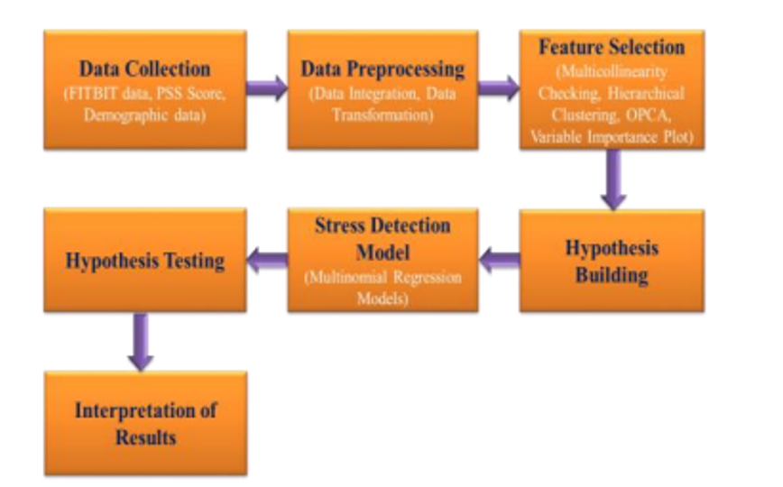

Research has been going on, since long to detect stress or stressed people. A lot of literature is available to study stress detection. There are traditional as well as scientific methods to detect people under stress. A) Questionnaire: Psychiatrist provides a big questionnaire and based on the answers, they decide whether one is under stress or not. This method has its own limitations and drawbacks because many times the answers are not factual. Sometimes some of the questions in the questionnaire are not appropriate. B) The other method is the sensor measuring method.

The limitation of this method is, it is time-consuming and a bit expensive. The other and the recent method to stress detection is social media. Stress detection is possible through social media, Based on one's write-up on social media, one's reacting on a particular problem on social media, one's liking and disliking help to detect stress. Through the continuous write up on social media, a psychiatrist can find people under pressure, crazy, mad after a typical subject. This also is an indication of stress.

or like liberty or under pressure. This is early detection of stress which in the long term will be helpful to avoid the severe problem.

This project focuses on developing a stress detection and management system using Machine Learning (ML) and Deep Learning (DL) techniques to help individuals better understand and manage their stress levels. The system will utilize advanced sensors to collect physiological data, such as heart rate variability and skin conductance, which will be used as input data for the ML/DL models.

The project will involve the following methodologies and techniques:

1. Data preprocessing: The collected data will be cleaned and preprocessed to remove noise and prepare it for use in training the ML/DL models. Techniques such as normalization, feature extraction, and data augmentation will be used to enhance the quality of the data.

2. Feature selection: The most relevant features or variables that are most predictive of stress levels will be selected using techniques such as Principal Component Analysis (PCA), Recursive Feature Elimination (RFE), and correlation analysis.

3. Classification models: ML/DL models, such as Support Vector Machines (SVM), Random Forests, and Neural Networks, will be trained using the selected features to predict stress levels accurately.

4. Hyperparameter tuning: The performance of the ML/DL models will be optimized using techniques such as Grid Search, Random Search, and Bayesian Optimization to improve their accuracy and precision.

5. Evaluation: The performance of the ML/DL models will be evaluated using metrics such as accuracy, precision, recall, F1-score, and confusion matrix, and the best performing model will be selected.

The stress detection and management system will be designed to provide users with personalized stress management techniques and resources, such as mindfulness exercises, breathing techniques, and cognitive behavioral therapy techniques, based on their stress level predictions. The system will also allow users to track their progress over time, providing motivation and feedback on their stress management efforts.

Overall, the project aims to develop a robust and effective stress detection and management system that leverages ML/DL techniques to improve individuals' mental and physical health.

# CONCLUSION

In this study, it is identified that a diagnosis of stress assessment at an early stage is essential. In order to make stress assessment efficient, fast.

and to provide an alternative to conventional clinical approaches information derived from this equipment is then being used to detect features which were not been considered previously. The need for such machines is critical because the process of evaluation from these aforementioned techniques consumes an enormous amount of time and is very much sensitive to error. Human expertise varies with respect to experience which makes diagnosis subjective to the examiner, this method is prone to errors and biases. Machine Learning provides a solution to this problem and could become a way to standardized diagnosis from various equipment.

Physical activity acts as a de-stress agent on human stress. Floors and sedentary minutes from the physical activity data set are significant and negative in nature. Therefore, by increasing the amount of physical activity in daily life, one can reduce his/her stress levels. Sleep shortage and insomnia are common signs of stress. Our study shows the time in bed is a significant and positive indicator of stress. The stress level is determined by the amount of sleep a person is getting in a day, but not on the number of awakenings. Similarly, working hours are a significant and negative indicator of stress. This means stress generated due to working hours depends on how a person handles his/her workload. Next, the average bpm indicates any fluctuations in heart rate, which is a significant and positive indicator of stress. Finally, the body mass index (BMI) is a significant and positive indicator of stress. Therefore, changes in heart rate and an increase in BMI increase the stress levels of individuals.

**REFERENCES**

1. [*Machine Learning Approach for Stress Detection using Wireless Physical Activity Tracker*](https://www.researchgate.net/publication/323588598_Machine_Learning_Approach_for_Stress_Detection_using_Wireless_Physical_Activity_Tracker)
2. *Stress Detection with Machine Learning and Deep Learning using Multimodal Physiological Data*
3. [*https://bmcmedinformdecismak.biomedcentral.com/articles/10.1186/s12911-020-01299-4#Abs1*](https://bmcmedinformdecismak.biomedcentral.com/articles/10.1186/s12911-020-01299-4#Abs1)
4. [*https://www.sciencedirect.com/science/article/pii/S2667096822000532?via%3Dihub*](https://www.sciencedirect.com/science/article/pii/S2667096822000532?via%3Dihub)