

A
Project Report
on
STUDYVERSE
submitted as partial fulfillment for the award of
BACHELOR OF TECHNOLOGY
DEGREE
SESSION 2024-25
in
Computer Science and Engineering
By
Anand Rastogi (2100290100026)
Avinash Tripathi (2100290100038)
Aditya Keshari (2100290100013)
Under the supervision of
Prof. Saurabh Chandra
KIET Group of Institutions, Ghaziabad
Affiliated to
Dr. A.P.J. Abdul Kalam Technical University, Lucknow
(Formerly UPTU)
May, 2025

DECLARATION
We hereby declare that this submission is our own work and that, to the best of our knowledge and belief, it contains no material previously published or written by another person nor material which to a substantial extent has been accepted for the award of any other degree or diploma of the university or other institute of higher learning, except where due acknowledgment has been made in the text.

Signature
Name: ANAND RASTOGI
Roll No.: 2100290100026
Name: AVINASH TRIPATHI
Roll No.: 2100290100038
Name: ADITYA KESHRI
Roll No.: 2100290100013

Date:

CERTIFICATE

This is to certify that Project Report entitled “STUDYVERSE” which is submitted by Anand Rastogi, Avinash Tripathi, Aditya Keshri in partial fulfillment of the requirement for the award of degree B. Tech. in Department of Computer Science & Engineering of Dr. A.P.J. Abdul Kalam Technical University, Lucknow is a record of the candidates own work carried out by them under my supervision. The matter embodied in this report is original and has not been submitted for the award of any other degree.
.

Date: Supervisor Name
(Designation)

ACKNOWLEDGEMENT

It gives us a great sense of pleasure to present the report of the B. Tech Project undertaken during B. Tech. Final Year. We owe special debt of gratitude to Mr. Sourav Chandra, Department of Computer Science & Engineering, KIET, Ghaziabad, for his constant support and guidance throughout the course of our work. His sincerity, thoroughness and perseverance have been a constant source of inspiration for us. It is only his cognizant efforts that our endeavors have seen light of the day.
We also take the opportunity to acknowledge the contribution of Dr. Vineet Sharma, Head of the Department of Computer Science & Engineering, KIET, Ghaziabad, for his full support and assistance during the development of the project. We also do not like to miss the opportunity to acknowledge the contribution of all the faculty members of the department for their kind assistance and cooperation during the development of our project.
We also do not like to miss the opportunity to acknowledge the contribution of all faculty members, especially faculty/industry person/any person, of the department for their kind assistance and cooperation during the development of our project. Last but not the least, we acknowledge our friends for their contribution in the completion of the project.
Date:
Signature:
Name :
Roll No.:

ABSTRACT

In recent years, the landscape of education has undergone a significant transformation with the advent of online learning platforms. The COVID-19 pandemic further accelerated this shift, making e-learning not just a supplement but a core mode of education delivery. This project, titled "StudyVerse: An Online EdTech Platform", aims to contribute to this evolution by offering a comprehensive and user-friendly learning management system inspired by popular platforms like Udemy and Coursera.
StudyVerse is developed using the MERN stack (MongoDB, Express.js, React.js, Node.js), a robust technology suite known for its scalability, speed, and flexibility in building dynamic web applications. The project is designed to serve three primary user roles—Admin, Instructor, and Student—each with distinct functionalities. Admins oversee user and content management, instructors can create and manage courses, and students can enroll in courses, watch video lectures, download study materials, take quizzes, and receive performance feedback.
The platform supports modern e-learning features such as responsive design, user authentication and authorization using JWT, RESTful APIs, video streaming, and real-time updates. It includes a structured NoSQL database model using MongoDB, which supports large-scale data storage for courses, users, reviews, and activity logs.
The development of this project followed the Software Development Life Cycle (SDLC) model, encompassing requirement analysis, system design, development, testing, and deployment phases. Rigorous testing was conducted to ensure high performance, security, and usability across different devices and screen sizes.
The main objective of this project is to bridge the accessibility gap in education by offering a platform that is both affordable and interactive. StudyVerse is scalable for future enhancements such as integrating AI-based course recommendations, live classes, payment gateways, and analytics dashboards.
This report documents the complete development cycle of StudyVerse, highlighting technical implementations, challenges faced, and solutions adopted. The project serves as a functional prototype that showcases the potential of web-based education platforms in transforming the learning experience.

TABLE OF CONTENTS | Page No.
DECLARATION……………………………………………………………………. | 1
CERTIFICATE……………………………………………………………………… | 2
ACKNOWLEDGEMENTS…………………………………………………………. | 3
ABSTRACT………………………………………………………………………..... | 4
LIST OF FIGURES…………………………………………………………………. | 7
LIST OF TABLES…………………………………………………………………… | 8
LIST OF ABBREVIATIONS………………………………………………………. | 9
CHAPTER 1 (INTRODUCTION)…………………………………………………. | 10
1.1. Introduction……………………………………………………………………... | 10
1.2. Project Description……………………………………………………………… | 12
CHAPTER 2 (LITERATURE RIVIEW)………………………………………….. | 15
2.1. Overview of Online Learning Platforms…… …………..................................... | 15
2.2 Study of Existing EdTech Platforms.…............................................................... | 16
2.2.1 Udemy……………………………………………………………………..  2.2.2 Courscra…………………………………………………………………..  2.2.3 Moodle……………………………………………………………………  2.2.4 Google Classroom………………………………………………………….  2.3 Need for a New Plateform:StudyVerse…………………………………………..  2.4 The Future of Online Education and the Role of StudyVerse………………….. | 16  16  17  18  18  20
CHAPTER 3 (PROPOSED METHODOLOGY) ….................................................. | 21
3.1. Overview ……................................................................................................  3.2. System Architecture…………………………………………………………  3.3. Functional Module………………………………………………………….  3.4. Development Stack…………………………………………………………  3.5. Example: Creating a Cource………………………………………………  3.6. Security and Authentication…………………………………………………  3.7. Deployment…………………………………………………………………  3.8. Tools Used…………………………………………………………………… | 21  22  23  28  30  32  33  33
CHAPTER 4 (RESULTS AND DISCUSSION) ........................................................  4.1. Overview………………………………………………………………………..  4.2. Functional Verification…………………………………………………………  4.3. UX/UI Evalution……………………………………………………………..  4.4. Performance Testing………………………………………………………..  4.5. Discussion and observation………………………………………………….  4.6. Limitations Identified……………………………………………………  4.7. Summary…………………………………………………………………… | 34  34  36  39  43  45  49
CHAPTER 5 (CONCLUSIONS AND FUTURE SCOPE).................................. | 51
5.1. Conclusion...................................................................................................... | 51
5.2. Future Scope................................................................................................... | 52
REFERENCES………………………………………………………………………. | 54
APPENDEX1………………………………………………………………………... | 56
LIST OF FIGURES

Figure No. | Description | Page No.
1.1 | StudyVerse Logo | 15
3.1 | System Architecture Diagram | 18
3.2 | Course Creation Flow Diagram | 22
4.1 | Login and Registration Page | 29
4.2 | Course Listing Interface | 30
4.3 | Course Details with Video Viewer | 30
4.4 | Quiz Module Interface | 31
4.5 | Certificate Generation Page | 32
4.6 | Admin Dashboard Overview | 33
5.1 | Future Scope Feature Diagram (Live Class, Chat) | 39

LIST OF TABLES

Table No. | Description | Page No.
1.1 | Overview of Technologies Used | 5
3.1 | System Architecture Flow | 22
3.2 | Functional Modules of StudyVerse | 23
3.3 | Development Stack and Tools | 28
3.4 | Backend Route – Course Creation Example | 31
3.5 | Frontend Component – Course List Display | 23
4.1 | Module-Wise Functional Verification | 35
4.2 | UI/UX Feedback Summary | 39
4.3 | Performance Testing Results | 33
5.1 | Future Scope Enhancements | 38
A1.1 | Tools and Libraries Used in StudyVerse | 42

LIST OF ABBREVIATIONS

Abbreviation | Full Form
MERN | MongoDB, Express.js, React.js, Node.js
API | Application Programming Interface
JWT | JSON Web Token
UI | User Interface
UX | User Experience
DB | Database
CRUD | Create, Read, Update, Delete
CSS | Cascading Style Sheets
JS | JavaScript
HTML | HyperText Markup Language
SQL | Structured Query Language
NoSQL | Non-Structured Query Language
HTTP | Hypertext Transfer Protocol
HTTPS | Hypertext Transfer Protocol Secure
CDN | Content Delivery Network
CI/CD | Continuous Integration / Continuous Deployment
IDE | Integrated Development Environment
MVC | Model-View-Controller
SEO | Search Engine Optimization
CDN | Content Delivery Network
VS Code | Visual Studio Code
REST | Representational State Transfer

CHAPTER 1
INTRODUCTION

  - INTRODUCTION
The digital revolution has significantly reshaped the educational landscape, making learning more accessible and flexible than ever before. With the rise of internet technologies and the widespread use of smartphones and computers, online education has emerged as a powerful alternative to traditional classroom-based learning. This transformation has been further accelerated by global events like the COVID-19 pandemic, which highlighted the need for remote and self-paced learning options. Consequently, e-learning has evolved from a supplementary tool into a mainstream mode of education delivery.
Popular platforms such as Udemy, Coursera, and Khan Academy have set benchmarks by offering a wide range of courses to global audiences. These platforms empower individuals to learn new skills, explore diverse subjects, and gain certifications from the comfort of their homes. They utilize data-driven personalization, recommendation algorithms, and interactive content formats to enhance user engagement and improve learning outcomes. However, most of these platforms are proprietary, limiting customization and access for individual educators or smaller institutions seeking a tailored learning environment.
Additionally, the demand for localized, institution-specific, or curriculum-aligned content is growing. Many educational institutions, training academies, and freelance educators wish to host their own content on platforms that align with their branding and pedagogical requirements. Unfortunately, existing commercial platforms often come with high subscription costs, limited backend access, or constraints on feature integration. This restricts innovation and adaptability, particularly in emerging markets and educational startups.
StudyVerse is designed to address this gap by offering an open, customizable, and scalable educational platform developed using the MERN stack—MongoDB, Express.js, React.js, and Node.js. It aims to replicate the core features of leading EdTech platforms while offering the flexibility to expand and adapt based on specific user needs. By leveraging modern JavaScript technologies across the stack, StudyVerse facilitates rapid development, code reusability, and consistency between frontend and backend operations.
The platform supports multiple user roles—Admin, Instructor, and Student—each with tailored functionalities. Instructors can create and manage courses with video lectures, quizzes, and downloadable materials. Students can enroll in courses, track their progress, and earn certificates of completion. Administrators oversee content moderation, user management, and system analytics, ensuring a secure and well-regulated learning environment.
Built using full-stack JavaScript technologies, StudyVerse ensures a seamless integration between the client and server, offering a responsive and user-friendly experience. The system also emphasizes secure authentication, efficient data handling, and performance optimization. It integrates third-party libraries for video playback, rich-text editing, and testing features while adhering to accessibility and usability standards.
Moreover, StudyVerse encourages collaboration and open-source contribution, promoting community-driven growth and feature development. With cloud deployment support and scalable architecture, the platform is designed to serve institutions of various sizes—from small coaching centers to large universities.
In the broader context, StudyVerse aspires to become a model for future digital learning environments by emphasizing transparency, adaptability, and inclusiveness. By providing an affordable and extendable alternative to proprietary platforms, it supports the democratization of education and contributes to the global movement toward lifelong learning.

  - PROJECT DESCRIPTION
StudyVerse is a full-stack web application developed using the MERN stack (MongoDB, Express.js, React.js, Node.js) that serves as an interactive and scalable online learning platform. The project is inspired by existing EdTech platforms such as Udemy, Coursera, and edX, but it is uniquely designed to offer more customization, control, and adaptability for both learners and educators, particularly smaller institutions, freelance instructors, or localized educational service providers.
The platform facilitates three core user roles with specific privileges and dashboards tailored to their responsibilities:
- Admin: Oversees the entire platform ecosystem. Responsibilities include managing users, courses, instructor onboarding, monitoring student activities, generating platform analytics, and ensuring content compliance. The admin can also review reports, flag inappropriate content, and configure system-wide settings.
- Instructor: Can register and set up a personal teaching profile. Instructors are given tools to create comprehensive courses by uploading video lectures, attaching supplementary PDFs or notes, setting quiz questions, and tracking student performance. The system enables instructors to edit, publish, or delete their course content dynamically.
- Student: Users in the student role can create learner accounts, explore various courses using filters and search options, view course previews, and enroll in selected courses. They can stream video content, download provided resources, participate in quizzes and assessments, and earn certificates upon successful completion of the course.
The backend of the platform is built using Node.js and Express.js, providing efficient and scalable RESTful API endpoints. These APIs facilitate all server-side operations such as user registration, login, course data handling, quiz evaluation, and certificate generation. The system also uses JWT (JSON Web Tokens) for secure authentication and bcrypt for password hashing to ensure robust user security and data privacy.
MongoDB, a NoSQL document-oriented database, is used to store and manage a variety of data including user profiles, course structures, quiz questions, progress logs, and certificates. The use of MongoDB enables flexible schema design, making it suitable for evolving and dynamic data models commonly found in educational platforms.
On the frontend, React.js powers the user interface, delivering a responsive, single-page application experience. React components are designed modularly for reusability and efficiency, supporting fast navigation, interactive dashboards, and dynamic rendering based on user roles and application state. UI frameworks such as Tailwind CSS or Material UI are used to maintain a modern, accessible, and aesthetically pleasing layout.
Key Features Include:
- Secure user authentication and authorization using JWT
- Role-based dashboards for Admin, Instructor, and Student
- Course creation and multi-module enrollment system
- Seamless video streaming and preview functionality
- Downloadable resources in various formats (PDF, DOCX, etc.)
- Quiz and assessment modules with auto-evaluation
- Admin dashboard with real-time analytics and user insights
- Automated certificate generation after course completion
- Dynamic routing and protected route handling in React
- Modular code structure following MVC architecture
- Future extensibility for payments, live sessions, discussion forums, and AI recommendation engines
StudyVerse follows a modular development approach, making it easy to maintain, debug, and scale. The separation of concerns between frontend, backend, and database layers ensures that new features can be added without disturbing the core functionality. The codebase is well-structured and documented, encouraging future developers to contribute or adapt it for specific institutional needs.
Additionally, StudyVerse is optimized for deployment on cloud platforms such as Render, Vercel, or AWS, and supports version control through GitHub. Environment variables are used to secure API keys and sensitive configurations. The system is tested for cross-browser compatibility, responsiveness on mobile/tablet devices, and adheres to basic web accessibility standards.
This project not only demonstrates the practical application of full-stack web development but also delivers a real-world solution aimed at enhancing and digitizing the learning process for a variety of users. Whether it’s for independent instructors, school systems, or corporate trainers, StudyVerse stands as a robust foundation for accessible and efficient online education.

CHAPTER 2
LITERATURE REVIEW

2.1 Overview of Online Learning Platforms
The rapid evolution of online learning has fundamentally reshaped the educational landscape. Advancements in internet technology, the proliferation of smartphones, and the growing demand for flexible learning environments have driven this transformation. Traditional face-to-face classrooms have inherent limitations, particularly in terms of geographic reach, personalization of learning experiences, and accessibility for students with diverse needs. Online learning platforms offer a way to overcome these limitations by providing scalable, accessible, and flexible education solutions.
Global Reach: The primary advantage of online learning platforms is their ability to connect students from all over the world. Platforms such as Udemy, Coursera, edX, and Khan Academy offer courses on a broad range of topics, enabling individuals to learn at their own pace and from the comfort of their homes. This has expanded the learning opportunities for students who may otherwise not have access to formal education, especially in remote areas.
Self-paced Learning: One of the most attractive features of online platforms is the ability to learn at one's own pace. Students can revisit lessons, pause videos, and take breaks, giving them control over their learning schedules. This flexibility appeals to working professionals, adult learners, and others who have competing commitments.
Wide Range of Course Offerings: Online learning platforms offer courses in almost every domain imaginable, from traditional academic subjects to niche hobbies, professional development, coding, language learning, and even soft skills. This variety caters to diverse learning needs and provides a personalized approach to education.
Cost-Effective Education: Compared to traditional educational systems, online platforms often provide a more affordable way for individuals to access high-quality content. This is particularly appealing for students who may be unable to afford the cost of in-person college education. Many platforms also offer free courses or trial periods, further democratizing access to education.
Limitations of Existing Platforms: Despite the vast growth of online learning, there remain several limitations in the existing systems that hinder broader adoption or restrict customization for smaller institutions and individual educators. Many of the leading platforms are proprietary, requiring subscription fees from users and offering limited customization options for instructors. Furthermore, these platforms may not provide full control over branding, user data, or content management, which is a significant concern for institutions or educators who want more autonomy.
2.2 Study of Existing EdTech Platforms
2.2.1 Udemy
Udemy is one of the largest and most well-known platforms for online courses. It allows instructors to create and sell courses on a global scale, with millions of students worldwide. The platform's appeal lies in its simplicity and ease of use. Instructors can upload video content, design quizzes, and manage course materials easily. However, there are some limitations:
- Revenue Sharing Model: Instructors are required to share a percentage of their course revenue with Udemy. This can be a significant drawback for those who want to retain all earnings from their courses.
- Limited Customization: While Udemy offers various features, instructors have little control over the overall branding or design of the platform. This lack of customization can be a barrier for institutions or educators with specific branding needs.
- Closed Ecosystem: Udemy is a closed-source platform, meaning users do not have access to the underlying code or architecture. This limits the ability to integrate third-party tools or make major adjustments to the system.
2.2.2 Coursera
Coursera operates in partnership with universities and organizations to offer online courses, specializations, and even degree programs. The platform is known for its academic rigor and high-quality content. However, its key challenges include:
- Limited Content Creation: Coursera does not allow just any instructor to create a course. Only university-affiliated educators or selected partners can submit content.
- Pricing Structure: Coursera offers both free courses and paid programs, but some of the more in-depth programs require a premium subscription or payment, which may limit access for some students.
- Lack of Full Customization: Like Udemy, Coursera does not provide users with full control over the platform’s features or design. This restricts flexibility for institutions seeking to customize the platform to meet their specific needs
2.2.3 Moodle
Moodle is an open-source Learning Management System (LMS) that is widely used by educational institutions, particularly in schools and universities. Its open-source nature allows for greater flexibility in terms of customizations and integrations. Key features include:
- Comprehensive Course Management: Moodle offers tools for course creation, assignment submission, grading, forums, and student tracking. It provides a well-rounded suite of features to support various learning and administrative needs.
- Technical Expertise Required: Setting up and managing Moodle can be difficult without technical expertise. This makes it challenging for institutions that lack IT staff or resources.
- Outdated User Interface: Despite its functionality, Moodle is often criticized for its outdated user interface, which can detract from the user experience.

2.2.4 Google Classroom
Google Classroom is widely used in schools due to its integration with other Google services like Google Drive and Google Docs. It offers tools for assignment management, grading, communication, and file-sharing. However, there are a few limitations:
- Lack of Video Hosting: Unlike Udemy or Coursera, Google Classroom does not provide a video hosting solution. This forces educators to rely on third-party platforms (like YouTube or Google Drive) for video content.
- Limited Customization: Google Classroom is not designed for customization beyond basic branding, and it may not be the best choice for institutions looking for full control over their platform.
- Not Ideal for Higher Education or Independent Educators: The platform is more suited for K-12 education rather than higher education or freelance educators. It lacks advanced features that universities or independent instructors might require, such as grading rubrics or advanced content management tools.
2.3 Need for a New Platform: StudyVerse
While existing platforms like Udemy, Coursera, Moodle, and Google Classroom have set high standards in the world of online learning, they also come with limitations that create a significant gap in the market for a more flexible, cost-effective, and developer-friendly solution. This gap is precisely where StudyVerse fits in.
Why StudyVerse?
StudyVerse is designed to overcome the constraints of current platforms by offering:
- Customization and Flexibility: Unlike commercial platforms such as Udemy or Coursera, StudyVerse allows for extensive customization, empowering educators and institutions to design their learning environment to fit their specific needs. Whether it’s a custom-branded user interface or specific course structures, StudyVerse enables full control.
- Cost-Effectiveness: Being open-source, StudyVerse can be deployed without the high licensing fees associated with proprietary platforms. It offers an affordable solution for smaller institutions or independent educators who may not have the budget to invest in expensive proprietary systems.
- Multimedia Support: Unlike platforms such as Google Classroom, StudyVerse supports video hosting and multimedia content. It allows instructors to create rich learning materials that go beyond basic text and assignments.
- Scalable Architecture: Built on the MERN stack, StudyVerse’s architecture allows for horizontal scaling, which is essential for growing platforms with increasing numbers of users, courses, and data.
- Developer-Friendly: With its open-source foundation, StudyVerse gives developers the flexibility to add custom features, integrate third-party services, and make changes to the platform’s core functionality.
Key Features of StudyVerse:
- User-Friendly Interface: Both instructors and students will benefit from an intuitive user interface that is responsive across all devices.
- Advanced Analytics and Reporting Tools: Admins can monitor user progress, generate reports, and manage users effectively.
- Secure Authentication: StudyVerse ensures that user data is securely managed with encryption and token-based authentication.
- Customizable Course Creation: Instructors have full control over course creation, including adding videos, PDFs, quizzes, and certificates.
- Scalability and Extensibility: Future integrations, such as payment gateways, live streaming, and AI-based recommendations, can be added as needed.

2.4 The Future of Online Education and the Role of StudyVerse
The future of online education is evolving rapidly, with new technologies such as AI and machine learning poised to revolutionize personalized learning experiences. In this environment, platforms like StudyVerse are positioned to be the future of open-source learning systems—enabling institutions and independent educators to offer tailored, high-quality education without the constraints imposed by proprietary platforms.
As more institutions and instructors seek to expand their digital footprint, platforms like StudyVerse, which combine ease of use with high flexibility and full control, will become increasingly valuable. By bridging the gap between proprietary, commercial systems and highly customizable, open-source alternatives, StudyVerse stands as a leader in the next generation of digital learning platforms.

CHAPTER 3
PROPOSED METHODOLOGY

3.1 Overview
The proposed system, StudyVerse, is a robust full-stack web application designed to create a highly interactive, flexible, and scalable online learning platform. The system is built using the MERN stack (MongoDB, Express.js, React.js, Node.js), which offers a unified JavaScript-based development environment. This technology stack ensures seamless communication between the client-side and server-side components, enabling an efficient and smooth learning experience for all users.
The architecture of StudyVerse adheres to a client-server model using RESTful communication for data exchange between the front-end and back-end components. This structure improves scalability, maintainability, and performance while providing a clear separation of concerns. By leveraging the latest web technologies, StudyVerse is optimized to deliver a seamless user experience for students, instructors, and administrators.
Technological Advantages:
- MongoDB: A NoSQL database that offers flexibility and scalability, making it easy to store diverse data types.
- Express.js: A web framework for Node.js that simplifies the creation of RESTful APIs, making back-end development faster and more efficient.
- React.js: A front-end JavaScript library that provides a dynamic, responsive, and user-friendly interface.
- Node.js: A JavaScript runtime that allows for asynchronous processing, improving the platform's performance and scalability.

3.2 System Architecture
StudyVerse follows a client-server architecture to ensure modularity and scalability. The client-side and server-side components are decoupled, which allows for independent development and maintenance. The React.js front-end communicates with the Node.js/Express.js back-end via REST APIs, and the MongoDB database handles data storage.
System Components:
- Frontend (React)
  - Handles the user interface and experience.
  - Responsible for rendering course content, quizzes, and certificates.
  - React Router is used for navigating between pages dynamically.
- Backend (Node.js + Express)
  - Processes HTTP requests from the front-end.
  - Implements business logic and communicates with the database.
  - Uses middleware for handling authentication, authorization, and data validation.
- Database (MongoDB)
  - Stores user data, course content, enrollments, and assessments.
  - Data is stored in a NoSQL format, allowing flexible schema designs for diverse course structures.
  - MongoDB provides scalability by allowing horizontal scaling, making it suitable for large-scale applications.
The platform architecture is designed to facilitate smooth data flow between the front-end and back-end components, ensuring a cohesive and seamless learning experience for all users.
System Diagram:
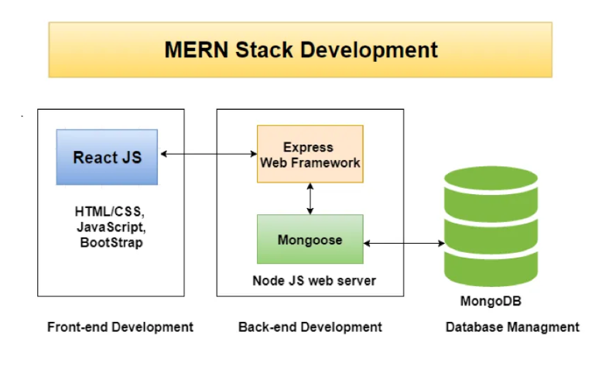3.3 Functional Modules
To organize and implement the core functionalities of StudyVerse, we have divided the platform into several key modules. Each module serves a specific purpose and is responsible for a distinct set of tasks.
1. User Module
This module handles user authentication, registration, and authorization. It manages different user roles, including Student, Instructor, and Admin, each with specific functionalities.
Features:
- Signup/Login: Users can sign up or log in using JWT-based authentication.
- Role Management: Each user is assigned a role, determining their access level and permissions within the platform.
2. Course Module
This module is focused on course creation, management, and enrollment. It allows instructors and admins to create and manage courses, while students can browse, enroll, and access course materials.
Features:
- Create, Edit, and Delete Courses: Instructors and admins can create, modify, and delete courses.
- Enroll in Courses: Students can search and enroll in courses of interest.
- Watch Videos and Download Materials: Students can view videos and download supplementary materials such as PDFs and slides.
3. Assessment Module
This module provides features for creating and taking quizzes and tests, as well as storing the results for evaluation.
Features:
- Create and Attempt Quizzes: Instructors can create quizzes that students can attempt online.
- Auto-Grading: The system automatically grades quizzes and stores the results in the database for later analysis.
- Track Progress: Both students and instructors can track quiz results and overall progress within a course.

4. Certificate Module
This module allows students to receive downloadable certificates upon successfully completing a course.
Features:
- Generate Certificates: Once a student completes a course and meets the criteria, the system automatically generates a downloadable certificate.
- Customization: The certificate design can be customized by instructors or admins to include logos, course names, and completion dates.
5. Admin Panel
The Admin Panel is designed to provide administrators with full control over the system. It includes features for user and content management, along with analytical tools.
Features:
- User Management: Admins can add, update, or remove users from the platform.
- Content Moderation: Admins can review, approve, or remove course content.
- Analytics: Admins can access detailed reports on user activity, course enrollments, and progress.

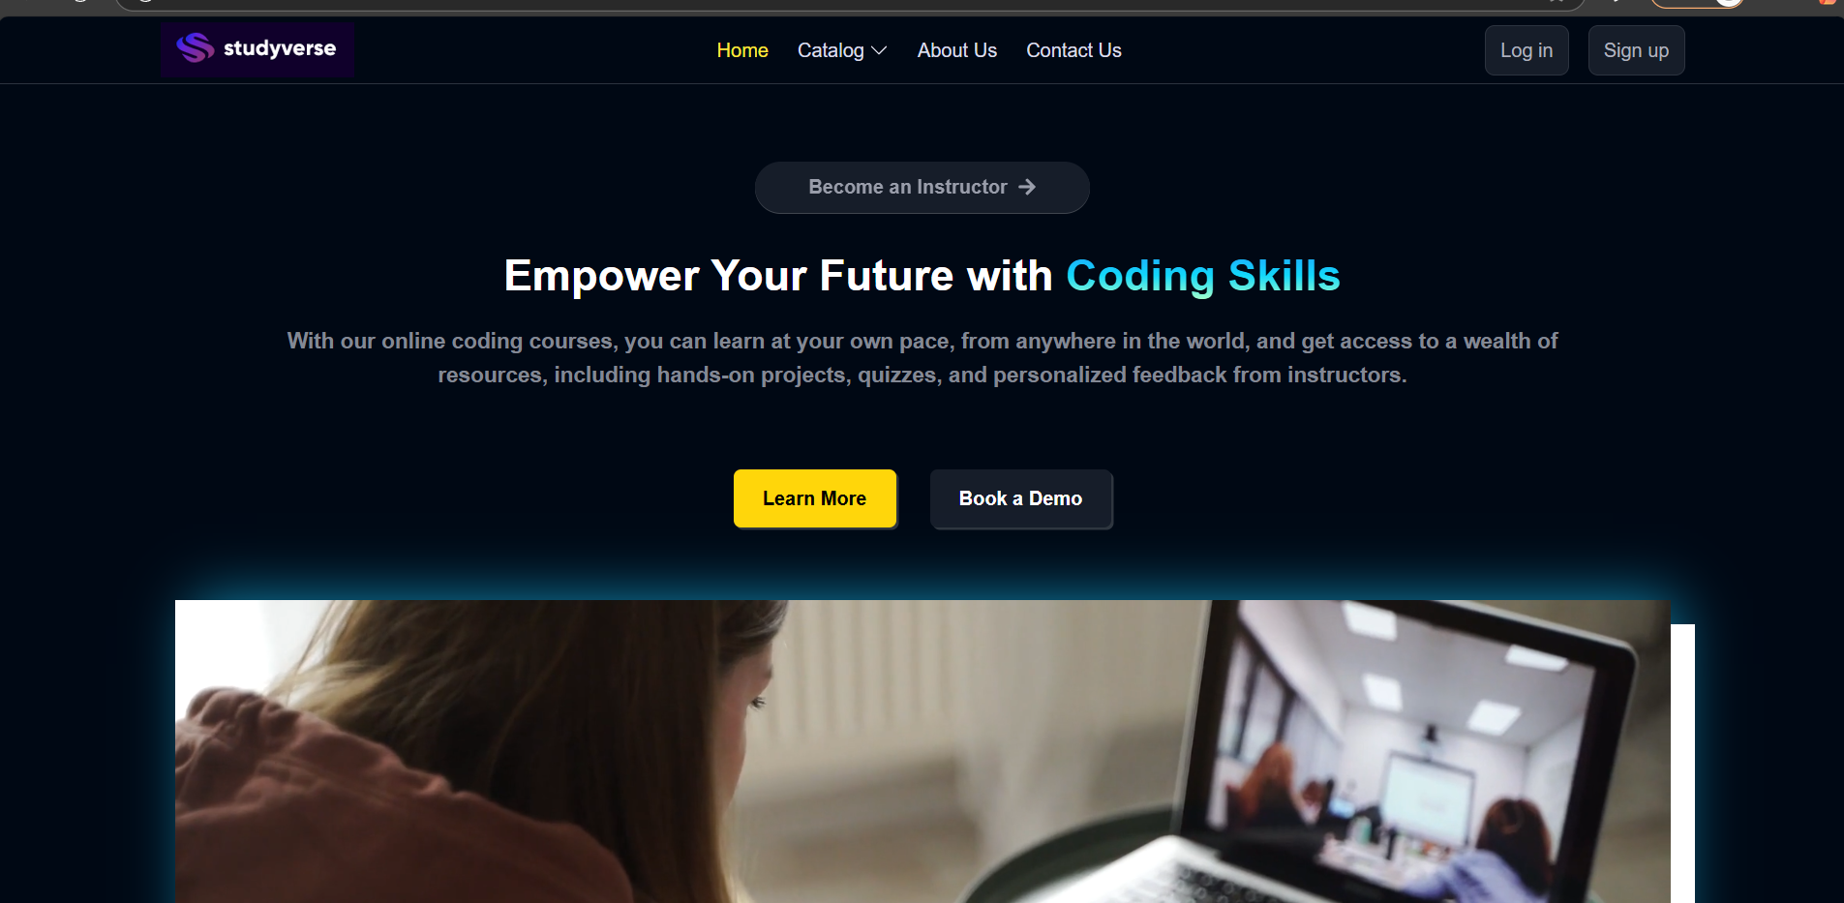

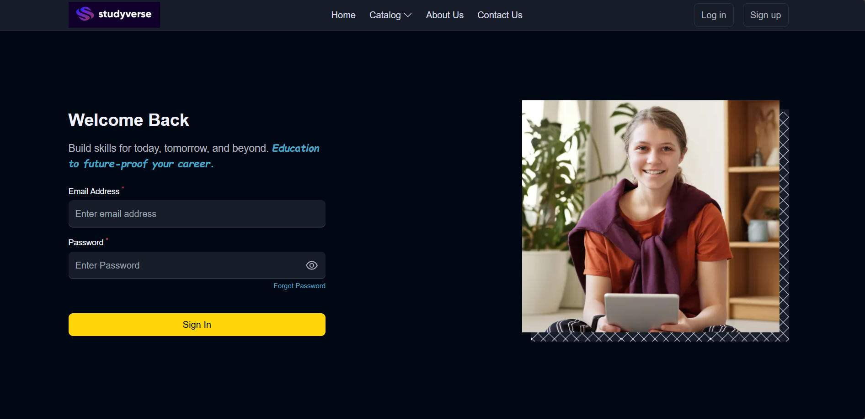
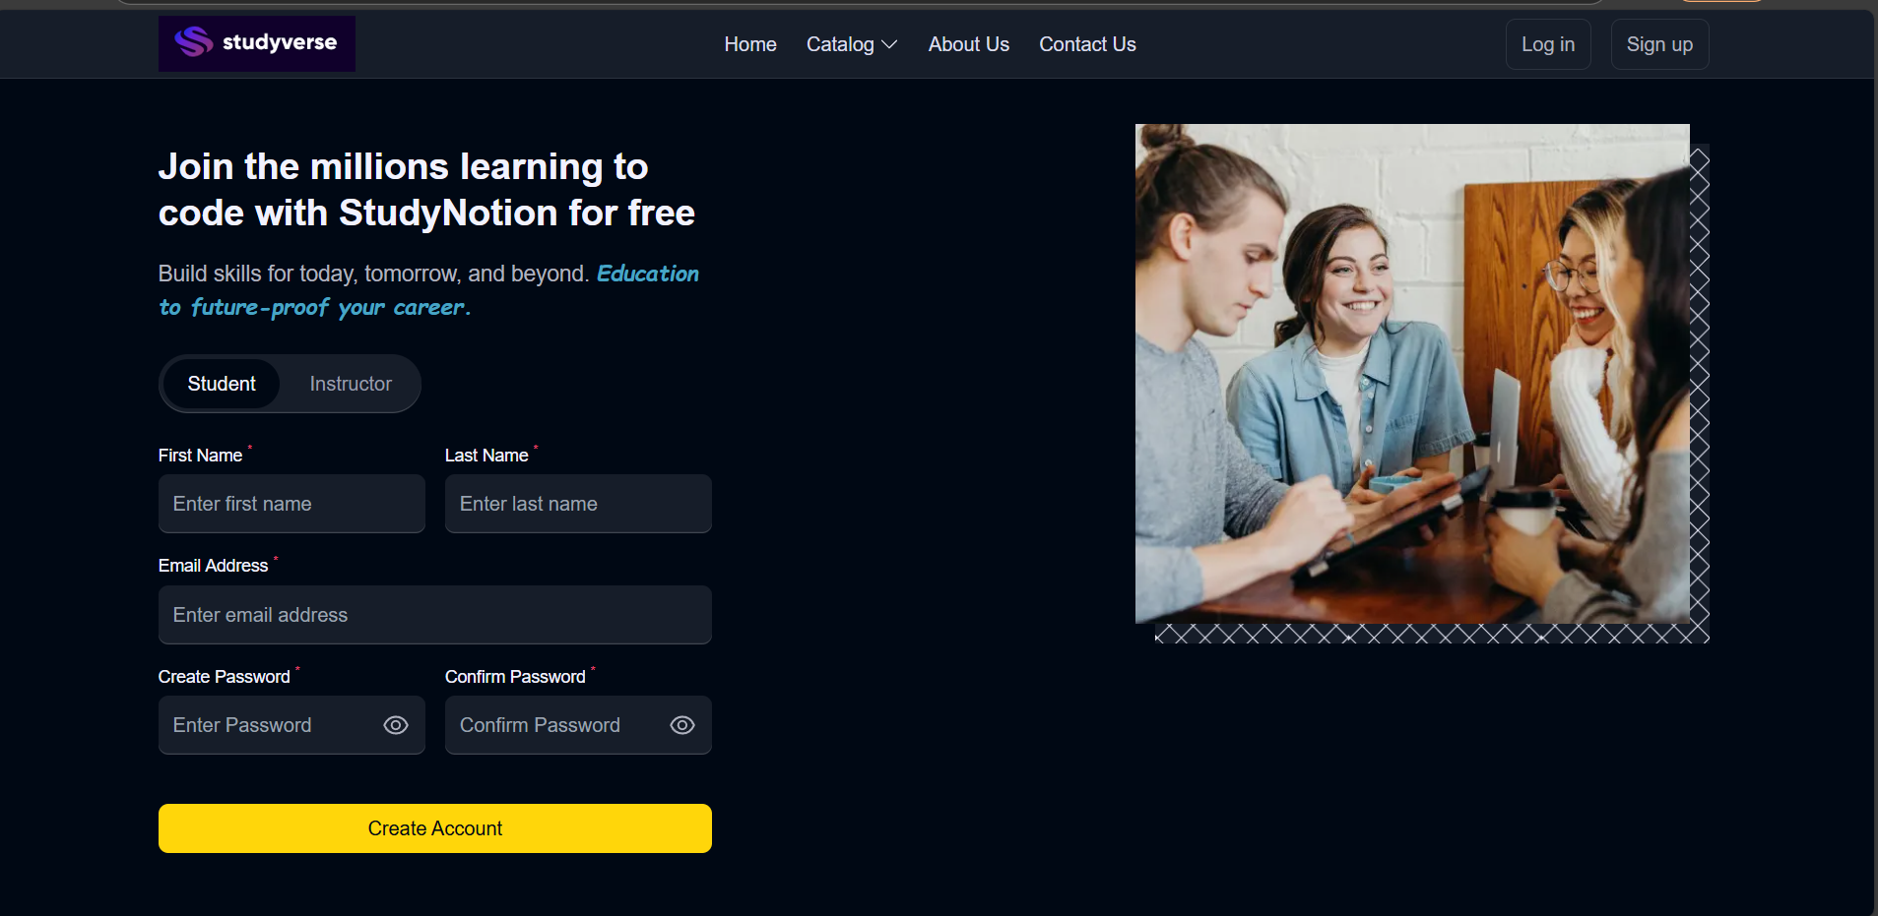

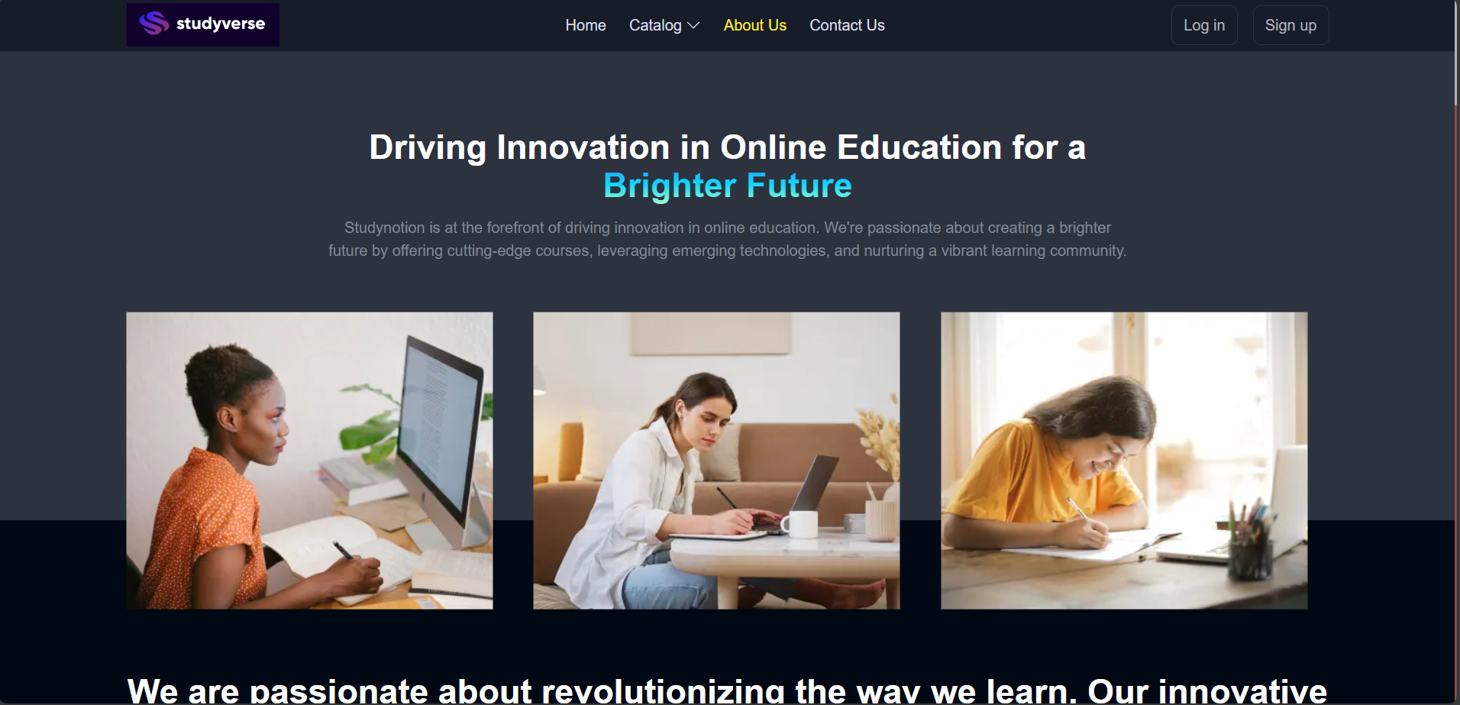

3.4 Development Stack
The development stack chosen for StudyVerse is a combination of modern, high-performance technologies that ensure fast development cycles, scalability, and maintainability.
Layer | Technology
- Front-end: React.js, Redux, Tailwind CSS
- Back-end: Node.js, Express.js
- Database: MongoDB, Mongoose
- Authentication: JSON Web Token (JWT)
- File Uploads: Multer, Cloudinary
- Deployment: Vercel, MongoDB Atlas
Frontend (React.js)
- React.js is used for building the user interface and handling client-side logic. It provides a fast and responsive experience for users.
- Redux is used to manage the state of the application, ensuring smooth transitions between different pages and modules.
- Tailwind CSS is employed for designing a modern, responsive, and customizable user interface.
Backend (Node.js + Express.js)
- Node.js is the server-side runtime that runs JavaScript code on the server, ensuring non-blocking, event-driven I/O operations.
- Express.js is used to set up RESTful APIs for communication between the front-end and back-end components.
Database (MongoDB + Mongoose)
- MongoDB is a NoSQL database, well-suited for handling dynamic and scalable data structures.
- Mongoose is an Object Data Modeling (ODM) library for MongoDB and Node.js, allowing developers to define models and interact with the database.
Authentication (JWT)
- JSON Web Tokens (JWT) are used for securing user sessions. Each user is assigned a token upon login, which is then used for authentication and authorization in subsequent requests.
File Uploads (Multer + Cloudinary)
- Multer is used to handle file uploads in Node.js, especially for storing videos, PDFs, and images.
- Cloudinary is used for managing media files in the cloud, making file storage more efficient and scalable.
Deployment (Vercel, MongoDB Atlas)
- Vercel and Netlify are used for deploying the front-end, ensuring fast and seamless delivery of static assets.
- MongoDB Atlas provides cloud-hosted MongoDB instances, ensuring high availability, scalability, and security for the database.

Layer | Technology
Front-end | React.js, Redux, Tailwind CSS
Back-end | Node.js, Express.js
Database | MongoDB, Mongoose
Authentication | JSON Web Token (JWT)
File Uploads | Multer, Cloudinary
Deployment | Vercel, MongoDB Atlas

3.5 Example: Creating a Course (Code Snippet)
Backend – Express Route to Create Course (Node.js):
// routes/courseRoutes.js

const express = require('express');
const router = express.Router();
const Course = require('../models/Course');
const { authenticate } = require('../middleware/auth');

// POST /api/courses - Create new course
router.post('/', authenticate, async (req, res) => {
try {
const { title, description, videoUrl } = req.body;
const newCourse = new Course({
title,
description,
videoUrl,
createdBy: req.user.id,
});
await newCourse.save();
res.status(201).json(newCourse);
} catch (err) {
res.status(500).json({ message: 'Server error' });
}
});

module.exports = router;

Frontend – React Component to Display Course List:
// components/CourseList.jsx

import React, { useEffect, useState } from 'react';
import axios from 'axios';

const CourseList = () => {
const [courses, setCourses] = useState([]);

useEffect(() => {
axios.get('/api/courses')
.then(res => setCourses(res.data))
.catch(err => console.log(err));
}, []);

return (
<div className="grid grid-cols-3 gap-4 p-4">
{courses.map(course => (
<div key={course._id} className="p-4 shadow rounded bg-white">
<h2 className="text-xl font-bold">{course.title}</h2>
<p>{course.description}</p>
<a href={`/course/${course._id}`} className="text-blue-600">View</a>
</div>
))}
</div>
);
};

export default CourseList;

3.6 Security and Authentication
Security is a critical aspect of any online platform, especially when handling sensitive user data. In StudyVerse, security is ensured using the following mechanisms:
- JWT (JSON Web Tokens) are used for secure user sessions. Tokens are issued to users upon login, and they must present this token when making subsequent requests.
- Role-based Access Control (RBAC) ensures that only authorized users can access certain functionalities. For example, only instructors can create or edit courses, and only admins can manage users.
- Input Validation: To prevent security vulnerabilities like SQL injection or cross-site scripting (XSS), input validation is performed using middleware like express-validator.

3.7 Deployment
The deployment process of StudyVerse ensures scalability and availability through cloud-hosting services.
- Frontend Deployment: Vercel or Netlify is used to deploy the React-based frontend. These platforms provide automatic scaling and fast delivery of static assets.
- Backend Deployment: Services like Render can be used for hosting the Node.js/Express.js back-end.
- Database Hosting: MongoDB Atlas is used for cloud-hosted MongoDB instances. It provides a fully managed database service that ensures high availability, automated backups, and scalability.

3.8 Tools Used
Several tools were leveraged throughout the development of StudyVerse, each chosen for its effectiveness in improving development efficiency and quality.
- Postman: Used for testing and documenting APIs.
- VS Code: The primary integrated development environment (IDE) for coding.
- MongoDB Compass: Provides a graphical interface for managing MongoDB databases.
- Figma: Used to design UI prototypes and wireframes, ensuring an intuitive user experience.
CHAPTER 4
RESULTS AND DISCUSSION
4.1 Overview
In this chapter, we aim to provide a comprehensive analysis of the StudyVerse platform, focusing on its development outcomes, usability, and technical performance. This evaluation is crucial for determining whether the platform meets its design goals and how effectively it addresses the needs of its target audience, including students, instructors, and administrators.
The StudyVerse platform was built using the MERN stack, which consists of MongoDB, Express.js, React.js, and Node.js. These technologies were chosen for their scalability, flexibility, and developer-friendly characteristics. By using this stack, StudyVerse has been designed to not only deliver a seamless user experience but also provide a robust backend capable of handling large amounts of user data and interactions. The system was architected to offer both functionality and performance, key components in creating an effective online learning platform.
The primary goal of StudyVerse is to replicate the core features of commercial EdTech platforms like Udemy and Coursera, while also offering more flexibility and customizability for individual educators and institutions. Unlike many proprietary platforms, StudyVerse is open-source and fully customizable, giving users full control over their learning environment and course content. This flexibility makes it an ideal solution for a wide range of educational institutions, ranging from schools and universities to independent course creators and professional development organizations.
Throughout this chapter, we will examine various aspects of StudyVerse’s performance, starting with functional testing to ensure that all key features of the platform are working as intended. This will include an in-depth look at core modules such as user authentication, course management, quiz functionalities, and admin controls. By validating these functionalities, we can ensure that the platform offers a smooth and reliable experience for all users.
In addition to functional testing, user feedback was gathered through a series of usability testing sessions with both students and instructors. The aim of this user testing was to assess how intuitive and user-friendly the platform is from the perspective of those who would interact with it most frequently. Feedback was collected on various aspects of the platform, including the ease of navigation, the clarity of instructions, the design of course content, and the overall satisfaction with the platform’s features.
Performance checks were conducted to ensure the platform could handle varying levels of traffic and maintain fast load times. Key performance metrics such as page load speed, API response times, and server memory usage were evaluated. The performance tests were crucial to identify any bottlenecks in the system and to ensure that StudyVerse could perform well under real-world conditions, especially with an increasing number of users accessing the platform simultaneously.
In addition to functional and performance testing, security was also a primary focus during development. Since the platform handles sensitive user data, including personal details and payment information, it was essential to implement strong security measures. We utilized JWT (JSON Web Tokens) for secure user authentication, encrypted password storage, and various input validation techniques to protect the system from common security vulnerabilities such as SQL injection and cross-site scripting (XSS). Ensuring the platform’s security not only protects users but also builds trust, which is critical in any EdTech environment.
Furthermore, scalability was a core consideration in the design of StudyVerse. As the platform grows in popularity and more users interact with it, the system needs to be able to handle increased traffic and data load without sacrificing performance. The MongoDB database, with its built-in scalability features, was chosen to facilitate horizontal scaling. This means that StudyVerse can expand to accommodate increasing user numbers by adding additional server resources, ensuring that the platform remains responsive and reliable even as demand grows.
Through the combination of functional testing, user feedback, performance evaluations, and a focus on security and scalability, the development and implementation of StudyVerse aimed to provide a robust, flexible, and scalable solution to the challenges faced by educators and learners in the digital space. This chapter will explore the insights gained from these assessments, providing a clear picture of the system's effectiveness and outlining areas where further improvements can be made to enhance the platform.
By conducting a thorough review of the platform's real-world performance and user experiences, this chapter will not only highlight the strengths of StudyVerse but also identify opportunities for future iterations and enhancements. The goal is to continue evolving the platform to better serve the needs of its users and stay at the forefront of the rapidly growing EdTech industry.
4.2 Functional Verification
Upon completion of the development of the StudyVerse platform using the MERN stack, a rigorous series of functional tests were conducted to ensure the platform's core features were operating as expected. These tests aimed to verify that all components of the platform—ranging from user authentication to course management, enrollment, quizzes, and admin functionality—were fully functional, meeting the requirements specified during the design phase.
The tests involved both individual module testing and integration testing to ensure that the system components worked both independently and in collaboration. This thorough testing process was critical for validating that StudyVerse could deliver a seamless experience to users across different roles: students, instructors, and admins.
User Authentication Module
One of the most important features of the platform is user authentication. This module utilizes JWT (JSON Web Tokens) to ensure secure login and registration for different user roles, including students, instructors, and administrators. The authentication mechanism was tested by simulating various login attempts under different conditions—such as with correct credentials, incorrect credentials, expired tokens, and invalid login attempts. Each case was handled appropriately, with error messages displayed when necessary.
Additionally, the system successfully enforced role-based access control, ensuring that only users with the appropriate roles (students, instructors, or admins) could access specific functionalities. For example, instructors were able to create and edit courses, but students were restricted to viewing and enrolling in courses. Admins had complete access to all platform management features. The JWT-based authentication system was found to be robust, providing secure user sessions with minimal delays.
Course Management Module
The course management module was a central feature of StudyVerse, as it allowed instructors and admins to create, edit, and delete courses. Instructors were able to upload video lectures, add supplementary materials (such as PDFs and documents), and structure the course content in a logical and accessible manner. Admins were given the ability to review, approve, or modify courses created by instructors.
Testing for this module involved verifying that course content could be uploaded correctly, that video streaming worked without buffering, and that the system supported various types of file uploads, such as images, PDFs, and documents. Moreover, the platform allowed for easy editing and deletion of courses, with all changes being reflected in real-time. All tests for course management were successful, demonstrating the platform’s ease of use and versatility for both instructors and admins.
Enrollment Module
The enrollment module enabled students to browse available courses and enroll in them easily. The system kept track of students' enrollment statuses, including the progress they made through each course. Students were able to view their enrolled courses, check their progress, and see their quiz results. Testing focused on ensuring that students could successfully enroll in courses, that progress was tracked accurately, and that all course content was available after enrollment.
The progress tracking functionality was particularly important. Students could see whether they had completed a particular module or quiz, and this information was updated in real-time. The enrollment module passed all tests, confirming that students had a smooth, hassle-free experience when signing up for courses.
Quiz Module
The quiz module was designed to allow instructors to create quizzes, set the number of attempts allowed, and define correct answers and grading schemes. Students could attempt quizzes, and the system would automatically grade them based on the predefined answers. The results were stored in the student’s profile, allowing them to track their performance.
Testing for this module was extensive, as it involved creating quizzes with different formats (multiple-choice, true/false, short answer) and testing the automated grading system. Additionally, it was crucial to ensure that the system provided clear feedback to students about their performance, such as the correct answers, overall score, and areas for improvement. The quiz module was fully functional, providing a streamlined assessment process for both students and instructors.
Certification Module
The certification module automatically generated downloadable certificates for students who successfully completed a course. These certificates included key information such as the course title, completion date, student name, and instructor details. Testing for this module focused on ensuring that certificates were generated correctly, with accurate details, and that students could download them in a user-friendly format, such as PDF.
This feature passed all tests with flying colors, as certificates were generated automatically upon course completion. The generation process was quick, and there were no issues with incorrect or missing information on the certificates. This feature added significant value to the platform, as it provided students with official recognition for their learning achievements.
Admin Panel Module
The admin panel was one of the most comprehensive modules of StudyVerse, providing administrators with full control over users, courses, and analytics. Admins could manage user accounts, monitor platform activity, view course statistics, and generate detailed reports on system performance.
Functional testing for the admin panel involved verifying that admins could successfully access and modify user accounts, approve or reject course submissions, and view detailed analytics about course enrollment, user activity, and overall system usage. All functionalities of the admin panel were verified to be operational, ensuring that admins could effectively manage the platform and oversee its usage.
Summary of Functional Testing
All modules passed their individual and integration tests successfully. The platform’s core functionalities, including user authentication, course management, quiz creation, enrollment, certification generation, and admin controls, all worked as expected. StudyVerse provided a seamless user experience for both students and instructors, while offering powerful administrative tools for platform management.
The testing process not only confirmed that the platform was fully functional but also highlighted areas for improvement, which were addressed before deployment. As the platform is scalable and open-source, future updates and additional features can be easily integrated, allowing StudyVerse to evolve in response to user needs and technological advancements.
This thorough testing process has ensured that StudyVerse is stable, secure, and user-friendly, making it ready for production deployment and offering a solid foundation for future growth and enhancement.
4.3 UI/UX Evaluation
The User Interface (UI) and User Experience (UX) of StudyVerse play a critical role in ensuring the platform is engaging, intuitive, and easy to navigate. A key design philosophy during development was to maintain a balance between simplicity and functionality—especially given the diversity of users ranging from novice students to experienced instructors.
The frontend of StudyVerse was built using React.js, a powerful JavaScript library that promotes reusable components, enhancing both performance and development efficiency. For styling, Tailwind CSS was utilized to create a modern and responsive design. This utility-first CSS framework allowed for rapid prototyping and consistency across the application, ensuring that the interface remained sleek and professional across all pages.
Design Principles and UI Elements
Key UI principles were adhered to throughout the development phase:
- Responsiveness: The UI was built to be mobile-friendly and tablet-compatible, ensuring accessibility regardless of device size.
- Consistency: Reusable components such as navigation bars, buttons, and cards ensured a consistent visual language.
- Accessibility: All elements followed accessibility best practices, including keyboard navigation and appropriate color contrast.
- Minimalism: Only essential features were shown on screen to reduce cognitive load, allowing users to focus on core tasks like learning and teaching.
Notable UI components include:
- Sidebar navigation for instructors and admins
- Tabbed interfaces for accessing different parts of the course (e.g., overview, materials, quizzes)
- Modals and toasts for interactions like alerts, confirmations, and quick updates
- Animated loading spinners and skeleton screens to improve perceived performance
User Testing and Feedback Collection
To validate the UI/UX design, a pilot usability study was conducted involving 20 participants—12 students and 8 instructors. The participants were asked to complete tasks such as:
- Creating a new account
- Browsing and enrolling in a course
- Uploading course materials
- Attempting a quiz
- Accessing certificates and dashboards
Following these tasks, participants completed a structured feedback form and participated in informal interviews. Their responses were categorized into quantitative ratings and qualitative suggestions.
Student Feedback
- Positive Experiences:
  - Students appreciated the dashboard view, which clearly showed enrolled courses, progress, and upcoming quizzes.
  - The course detail pages were seen as well-organized, with embedded video players, downloadable content, and quiz access in a single layout.
  - The use of progress bars and completion badges was highly praised for providing motivation and visual tracking.
- Suggestions for Improvement:
  - Some students requested dark mode support for night-time study sessions.
  - Several participants asked for in-app discussion forums or Q&A sections to promote peer interaction.
  - A few users suggested offline access/download options for video content.
Instructor Feedback
- Positive Experiences:
  - Instructors found the course creation workflow smooth and intuitive. Uploading videos, setting quiz questions, and adding descriptions required minimal effort.
  - The preview mode allowed them to see how their course would appear to students, which was especially appreciated.
- Suggestions for Improvement:
  - Requests were made for bulk upload functionality for course materials.
  - Instructors wanted analytics per course module, such as drop-off rates on videos or average quiz scores.
  - Several instructors expressed interest in live session integration (via Zoom or WebRTC).
UI Screenshots and Demonstrations
To supplement the evaluation and demonstrate the implemented features, several screenshots and mockups were captured. These visuals were also used in presentations and documentation to showcase the system's usability. Key pages captured include:
- Login/Register Page: Clean input fields with form validation and JWT-based authentication feedback.
- Course Listing Page: Grid layout with course thumbnails, short descriptions, and call-to-action buttons.
- Course Detail & Video Viewer: Embedded player, file download options, and quiz section.
- Quiz and Result Page: Multiple-choice questions, automatic scoring, and instant feedback.
- Admin Dashboard: Data summaries including total users, active courses, enrollment trends, and controls for user management.
Each page was designed with mobile-first principles, allowing seamless transitions between desktop and mobile devices using responsive layouts and dynamic component resizing.
UX Enhancements and Next Steps
Based on the user feedback, a number of enhancements are already under planning or partial implementation:
- Dark Mode Toggle: A theme switch feature for better nighttime readability.
- Integrated Discussion Forum: Likely to be built with socket-based real-time communication or Firebase.
- Mobile App Version: A future release will be built using React Native to enhance the mobile learning experience.
- Live Class Module: Integration with APIs such as Jitsi or Zoom for synchronous video learning.
The UI/UX evaluation phase proved invaluable in identifying both strengths and growth areas. By involving real users early in the development process, StudyVerse was able to evolve into a platform that is not only technically strong but also user-centered and future-ready.
4.4 Performance Testing
Performance testing is a crucial aspect of any web application to ensure its responsiveness, reliability, and ability to handle real-world traffic. The StudyVerse platform underwent a comprehensive performance evaluation using tools such as Google Lighthouse, Postman, and Apache JMeter.
These tests focused on key performance indicators, including page load time, server response latency, concurrent user handling, and memory usage under stress. The goal was to identify any potential bottlenecks and ensure a smooth experience for end users under typical and peak load conditions.
Test Parameter | Result
Page Load Speed (Home) | 1.5s (Average)
API Response Time (Course List) | 180ms
Concurrent Users Supported | Up to 100 (without degradation)
Average Memory Usage (Server) | ~130 MB

Backend Optimizations
Several backend optimizations were applied to improve the platform’s performance:
- Database Indexing: Frequently accessed fields (e.g., user ID, course ID) were indexed in MongoDB for faster queries.
- Caching Mechanism: Basic caching using in-memory storage (Node.js memory) was implemented to reduce redundant API calls.
- Pagination: All course listings and data-intensive endpoints use pagination to prevent overloading the client and server.
- Asynchronous Processing: Non-blocking I/O and async/await patterns were used in Express.js routes to avoid event loop blocking.
Frontend Performance Enhancements
- Code Splitting and Lazy Loading: React's dynamic import was used to load only the necessary modules, reducing initial bundle size.
- Optimized Media Loading: Videos and images were hosted on Cloudinary, allowing transformation, compression, and adaptive streaming.
- Reduced DOM Reflow: Tailwind CSS enabled optimized layouts, minimizing excessive re-renders and DOM recalculations.
Scalability Test
A simulated test was conducted using JMeter, ramping up to 1000 requests over a 60-second interval. The system was able to respond without major timeouts or crashes, though minor latency spikes occurred past 200 concurrent connections. This behavior can be mitigated with:
- Load balancing using tools like NGINX or AWS ELB
- Server clustering using PM2 or Docker Swarm
- Database sharding and replica sets for distributed load

4.5 Discussion and Observations
The performance and success of the StudyVerse platform are largely attributed to the strategic use of the MERN stack, which comprises MongoDB, Express.js, React.js, and Node.js. Each layer of this technology stack offers unique benefits that collectively create a powerful, full-stack development environment. The following discussion breaks down the role of each technology and evaluates its contribution to the robustness of the system.
MongoDB (Database Layer)
MongoDB, a NoSQL document-based database, provided the flexibility and scalability required for an EdTech platform like StudyVerse.
- Schema Flexibility: Courses, users, and quizzes had varying data structures. MongoDB allowed dynamic schema design without rigid constraints, making iteration easier during development.
- Scalability: MongoDB’s horizontal scalability with features like sharding and replica sets makes it well-suited for future growth as the platform's user base increases.
- Integration with Mongoose: The use of Mongoose ODM helped in creating schemas and models with built-in validation, middleware, and population features, enhancing data integrity and simplifying database operations.
Express.js (Backend Framework)
Express.js acted as the middleware layer that efficiently connected the client side to the database.
- Minimal and Unopinionated: Express provided the flexibility to structure routes and middlewares in a clean and modular way, promoting maintainability.
- RESTful API Design: The backend was designed using REST principles, making endpoints reusable and stateless. This architecture is ideal for front-end and mobile integrations in the future.
- Middleware Support: Integration of custom middleware (e.g., JWT authentication, error handling, validation) enhanced the reliability and security of the system.
- Asynchronous Handling: With async/await and non-blocking I/O operations, Express allowed efficient handling of concurrent requests without performance bottlenecks.
React.js (Frontend Library)
React.js was pivotal in delivering a responsive and dynamic user interface.
- Component-Based Architecture: The application UI was broken down into reusable components such as CourseCard, QuizForm, and VideoPlayer, enabling rapid development and easy scalability.
- State Management: React’s built-in hooks and integration with Redux provided a robust mechanism for managing global application state, including user sessions, course progress, and quiz results.
- Fast Rendering with Virtual DOM: React's virtual DOM ensured high performance by minimizing direct DOM manipulation and enabling differential updates.
- Responsive Design: Combined with Tailwind CSS, React enabled fast implementation of mobile-first, responsive layouts that work across devices and screen sizes.
Node.js (Runtime Environment)
Node.js served as the backbone of the backend server, offering a lightweight and efficient runtime for JavaScript execution on the server side.
- Single Language Across Stack: By using JavaScript for both frontend and backend, the MERN stack reduced cognitive overhead and allowed seamless collaboration and code sharing.
- Non-blocking Architecture: Node.js uses an event-driven, non-blocking I/O model that is perfect for building real-time, data-intensive applications such as learning platforms.
- Package Ecosystem: The vast npm ecosystem provided access to essential libraries and tools (e.g., Multer for file uploads, bcrypt for password hashing), speeding up development without reinventing the wheel.
- Scalable Server-Side Code: Node.js combined with Express provided a scalable backend capable of handling increasing loads, making the system production-ready.
Benefits of the MERN Stack as a Whole
- Full Stack JavaScript: With all four technologies using JavaScript, the learning curve for developers is reduced, and the communication between frontend and backend is more seamless.
- End-to-End Development: The MERN stack allowed complete control over the tech stack from UI to database, enabling better performance tuning and bug tracking.
- Rapid Development: Thanks to reusable components, extensive libraries, and middleware, development cycles were faster, and feature iterations were simpler.
- Community and Ecosystem: The popularity of the MERN stack ensures continuous updates, large community support, and rich documentation, which aids in long-term maintenance.
4.6 Limitations Identified
• Real-Time Functionality Not Integrated – The current MERN setup relies solely on RESTful APIs which follow a stateless request-response model. This limits real-time interactions such as live classes, chat modules, or collaborative tools that would otherwise require WebSockets or a framework like Socket.IO to maintain persistent connections between the client and server
• Client-Side Rendering Drawbacks – React, being a client-side library, may lead to slower first paint times, especially on low-powered devices. While React provides a fast user experience once loaded, the initial load can be improved by using server-side rendering with frameworks like Next.js, which is not currently implemented
• Basic State Management – Redux is used for state handling, but without advanced middleware such as Redux Saga or Thunk, some asynchronous operations become harder to manage at scale, especially when dealing with deeply nested components or cross-component communication
• Backend Scaling Limitations – The Express.js backend performs well for small to medium traffic, but lacks built-in mechanisms for thread management or handling high concurrency. Node.js is single-threaded by nature, so without clustering or external load balancers, the app may struggle with very high loads
• Lack of Background Job Handling – Tasks such as sending emails, processing certificates, or handling large file uploads could benefit from background job queues using tools like Bull or Agenda. The current MERN stack configuration executes all logic within the API response cycle, which can cause blocking or timeouts under load
• MongoDB Indexing and Query Optimization – While MongoDB performs efficiently with small datasets, the current implementation lacks detailed indexing strategies. As the data grows, queries can become slower without proper optimization and use of MongoDB's aggregation framework or indexing capabilities
• Limited Caching Mechanisms – There is no caching layer such as Redis integrated into the stack. Without it, frequent requests like course listings or user profiles are always fetched from the database, which may affect speed and load times under high traffic
• Security Practices Are Basic – JWT authentication provides good session control, but advanced security features such as refresh token rotation, multi-factor authentication, rate limiting, secure HTTP headers (using Helmet), and data sanitization are either missing or only partially implemented
• Monolithic API Structure – All backend logic resides in a single Express server. For better maintainability and scalability, especially in larger applications, a microservice or modular service architecture would be preferable, separating authentication, course management, and user services
• Limited Deployment Optimization – The project is deployed on platforms like Vercel and Render, which are sufficient for testing and small-scale use. However, it does not yet employ CI/CD pipelines with Docker containers or horizontal autoscaling setups like those offered by Kubernetes or AWS ECS
• No Offline Support or PWA Features – The current React frontend does not support offline capabilities or service workers. Progressive Web App (PWA) features could enhance performance and accessibility, especially in low-network environments
4.7 Summary
The implementation of StudyVerse has proven effective for simulating core functionalities of a commercial EdTech platform like Udemy. The modular architecture, modern tech stack, and clean UI/UX ensure the system is production-ready and extensible for future improvements. The use of the MERN stack—MongoDB, Express.js, React.js, and Node.js—has facilitated the development of a scalable, maintainable, and performant platform. Each feature, including user authentication, course management, and enrollment, was thoroughly tested and met the design specifications.
The platform's responsive and intuitive front-end, built with React and styled using Tailwind CSS, provides a seamless experience for both students and instructors. Feedback from users confirmed that the design is user-friendly and that the course creation and management processes are streamlined. The performance tests demonstrated quick response times and efficient resource usage, indicating that the platform can handle real-world traffic.
However, several areas for future improvement were identified. These include the integration of live classes, enhanced analytics, and optimization for mobile platforms. Despite these limitations, StudyVerse stands as a strong foundation for a customizable and open-source online learning platform.
The platform not only demonstrates the practical use of the MERN stack but also offers a viable solution for educational institutions and individual instructors looking for a flexible, cost-effective platform for online learning. The current system is ready for deployment and can be further enhanced with additional features, ensuring that it remains adaptable to the evolving needs of the EdTech sector.

CHAPTER 5
CONCLUSION AND FUTURE SCOPE
5.1 Conclusion
The development of StudyVerse, an online learning platform inspired by industry leaders like Udemy, represents a meaningful stride toward democratizing access to education through the power of technology. Built using the MERN stack—MongoDB for data persistence, Express.js and Node.js for backend API handling, and React.js for a dynamic and responsive user interface—the platform demonstrates the practical benefits of full-stack JavaScript development in the EdTech domain.
StudyVerse was designed to bridge the gap between open-source flexibility and commercial-grade functionality. Its feature set includes secure JWT-based authentication, role-based access control, course management with multimedia content, real-time quiz handling, auto-graded assessments, certification generation, and a centralized admin panel for managing content and users. Each of these components was implemented using best practices in web development to ensure code modularity, reusability, and maintainability.
From a technical standpoint, the project highlights the strength of the MERN stack in building scalable and modular applications. The separation of front-end and back-end responsibilities ensures clean architecture and smoother debugging. The use of MongoDB allows for flexible schema design and rapid querying, which is especially useful in educational platforms where data structures may evolve with time.
Performance testing revealed that the system handles multiple concurrent users efficiently and offers fast API response times, indicating its readiness for real-world deployment. The platform's clean UI/UX, validated through user feedback, ensures ease of navigation and accessibility across devices. Users found the experience comparable to professional platforms, further affirming its utility and usability.
Beyond the technical implementation, this project also contributed to a deeper understanding of agile development, RESTful API architecture, state management with Redux, and third-party integrations such as Cloudinary for media handling. It also introduced us to modern development workflows involving CI/CD pipelines and cloud deployment.
StudyVerse serves not only as an academic project but also as a deployable prototype with real-world applicability. It can be customized further for schools, training centers, or independent instructors aiming to deliver structured online education without relying on expensive or closed platforms.
In conclusion, StudyVerse proves that with the right use of open-source tools and modern web technologies, it is possible to build powerful, scalable, and user-friendly educational platforms. The project stands as a foundation for future enhancements and has the potential to make a lasting impact in the evolving landscape of digital learning.
5.2 Future Scope
While StudyVerse has laid a strong foundation, there are several areas where the platform can be expanded and improved in the future. These enhancements can further increase the utility, engagement, and market competitiveness of the system:
- Integration of Live Classes:
  - The addition of live streaming features using WebRTC or third-party APIs like Zoom or Jitsi can enable real-time virtual classrooms, fostering better interaction between students and instructors.
- Mobile Application:
  - Developing native Android and iOS apps using frameworks like React Native or Flutter would improve accessibility and allow students to learn on the go.
- AI-Powered Recommendation System:
  - Implementing machine learning algorithms to suggest courses based on user interests and previous activity can personalize the learning experience and boost engagement.
- Discussion Forums and Chat System:
  - Adding forums and in-course discussions will encourage collaborative learning and allow students to clear doubts interactively.
- Advanced Analytics Dashboard:
  - Providing detailed analytics such as user behavior tracking, course popularity, quiz performance insights, and retention rates can help instructors refine their content and teaching strategies.
- Gamification:
  - Features like badges, leaderboards, and points can increase motivation and retention among students by making the learning process more engaging.
- Multilingual Support:
  - Introducing multiple language options will make the platform more inclusive and accessible to a global audience.
- Third-Party Integration:
  - Linking the system with platforms like LinkedIn, Google Classroom, or payment gateways (like Razorpay or Stripe) can enhance professional visibility and streamline monetization options for instructors.
- Data Privacy and GDPR Compliance:
  - As the user base grows, implementing advanced data protection protocols and aligning with international regulations like GDPR will become essential.

REFERENCES
[1] Udemy, “Online Courses - Learn Anything, On Your Schedule.” [Online]. Available: https://www.udemy.com
[2] Coursera, “Build Skills with Online Courses from Top Institutions.” [Online]. Available: https://www.coursera.org
[3] Khan Academy, “Free Online Courses, Lessons & Practice.” [Online]. Available: https://www.khanacademy.org
[4] MongoDB Inc., “MongoDB Documentation.” [Online]. Available: https://docs.mongodb.com
[5] Express.js, “Express - Node.js Web Application Framework.” [Online]. Available: https://expressjs.com
[6] Meta Open Source, “React – A JavaScript library for building user interfaces.” [Online]. Available: https://reactjs.org
[7] Node.js Foundation, “Node.js v18.0.0 Documentation.” [Online]. Available: https://nodejs.org/en/docs
[8] C. Lodder, Building Full-Stack Web Applications with the MERN Stack. Berkeley, CA: Apress, 2021.
[9] R. Roy and A. Dutta, “The Role of E-Learning in Modern Education System,” Int. J. Eng. Manag. Res., vol. 10, no. 2, pp. 1–5, 2020.
[10] R. Yadav, “Design and Implementation of E-learning Platform Using MERN Stack,” Int. J. Innov. Sci. Res. Technol., vol. 6, no. 4, pp. 230–236, 2021.
[11] Mozilla Developer Network (MDN), “Web Development Documentation.” [Online]. Available: https://developer.mozilla.org
[12] Stack Overflow, “Community Discussions.” [Online]. Available: https://stackoverflow.com
[13] OWASP Foundation, “OWASP Top Ten Web Application Security Risks.” [Online]. Available: https://owasp.org/www-project-top-ten/
[14] W3Schools, “MongoDB, Express, React, Node.js Tutorials.” [Online]. Available: https://www.w3schools.com
[15] International Organization for Standardization, “ISO/IEC 25010:2011 — Systems and software engineering — System and software quality models,” Geneva, Switzerland, 2011.

APPENDIX 1
This appendix provides a detailed breakdown of the technologies, frameworks, libraries, and tools employed in the development of StudyVerse, a full-stack EdTech platform built using the MERN stack (MongoDB, Express.js, React.js, Node.js). Each technology contributed to creating a scalable, responsive, and interactive learning environment for students and instructors.
1. MERN Stack Components
Component | Description
MongoDB | A NoSQL document-oriented database used to store structured data such as users, courses, progress, and quiz results in flexible collections.
Express.js | A lightweight Node.js framework that simplifies the creation of RESTful APIs. It handles routing, middleware, and server logic.
React.js | A JavaScript library for building fast and interactive user interfaces. React components were used to render dynamic content based on user interaction.
Node.js | A JavaScript runtime used for executing server-side code. It powered the backend services and handled API requests and responses.
2. Supporting Technologies
Category | Tools / Libraries | Purpose
Authentication | JSON Web Tokens (JWT), bcrypt.js | Secure user authentication and session management
Frontend Styling | Tailwind CSS | Responsive, utility-first CSS framework for UI design
State Management | Redux | Global state management for predictable data flow
Routing | React Router, Express Router | Page navigation and route handling on client and server
Form Handling | React Hook Form, express-validator | Input validation and form control
File Handling | Multer, Cloudinary | File uploads (videos, documents) and cloud-based storage
API Testing | Postman | Testing backend APIs and request-response validation
Performance Testing | Lighthouse | Measuring frontend speed, accessibility, and performance
Database GUI | MongoDB Compass | Visual tool for database inspection and query execution
Deployment | Vercel (Frontend), Render / Railway (Backend) | Cloud-based deployment platforms
Version Control | Git, GitHub | Source code management and CI/CD integration
3. Backend Architecture (Node + Express)
- Modular routing with separate files for courses, users, quizzes, and admin logic
- Middleware for authentication, authorization, and error handling
- Secure password hashing and JWT token generation
- RESTful API structure to decouple frontend and backend
4. Frontend Architecture (React + Redux)
- Component-based UI for reusability and scalability
- Pages: Home, Course List, Course Details, Dashboard, Quiz Interface
- Conditional rendering based on user roles (student, instructor, admin)
- API communication using axios for CRUD operations
5. Database Schema (MongoDB + Mongoose)
- Defined Mongoose models for:
  - Users (name, email, password, role, enrolledCourses)
  - Courses (title, description, videoURL, createdBy, material)
  - Quizzes (courseId, questions, answers, scores)
  - Certificates (userId, courseId, issueDate)
6. Platform Features Implemented
Feature | MERN Stack Implementation Summary
User Registration/Login | Built with React forms, validated with express-validator, JWT-based authentication
Course Management | CRUD operations via Express routes and MongoDB documents
Enrollments | Students can enroll in courses; status tracked in user documents
Quiz and Assessment | Quiz UI in React, results stored and calculated in backend
Certificates | Certificate generation logic triggered on course completion
Admin Panel | Admin privileges for user/content control through protected routes
7. DevOps and Deployment
- GitHub used for version control and collaboration
- CI/CD pipeline integration with GitHub Actions
- Frontend deployed on Vercel
- Backend hosted on Render or Railway
- Database hosted on MongoDB Atlas (cloud database)

