

A
Project Report
on
Role Playing Game Using AI
submitted as partial fulfillment for the award of
BACHELOR OF TECHNOLOGY
DEGREE
SESSION 2024-25
in
Computer Science and Engineering
By
Krish Gupta (2100290100088)
Sarvjeet Singh (2100290100149)

Under the supervision of
Dr. Swati Sharma
KIET Group of Institutions, Ghaziabad
Affiliated to
Dr. A.P.J. Abdul Kalam Technical University, Lucknow
(Formerly UPTU)

DECLARATION
We hereby declare that this submission is our own work and that, to the best of our knowledge and belief, it contains no material previously published or written by another person nor material which to a substantial extent has been accepted for the award of any other degree or diploma of the university or other institute of higher learning, except where due acknowledgment has been made in the text.

Signature
Name: Krish Gupta
Roll No.: 2100290100088
Date: 01/05/2025

Signature
Name: Sarvjeet Singh
Roll No.: 2100290100149
Date: 01/05/2025

CERTIFICATE

This is to certify that Project Report entitled “Role Playing Game Using AI” which is submitted by Krish Gupta and Sarvjeet Singh in partial fulfillment of the requirement for the award of degree B. Tech. in Department of Computer Science & Engineering of Dr. A.P.J. Abdul Kalam Technical University, Lucknow is a record of the candidates own work carried out by them under my supervision. The matter embodied in this report is original and has not been submitted for the award of any other degree.

Date: 01/05/2025 Dr. Swati Sharma
(Associate Professor)

ACKNOWLEDGMENT
It gives us a great sense of pleasure to present the report of the B. Tech Project undertaken during B. Tech. Final Year. We owe special debt of gratitude to Dr. Swati Sharma, Department of Computer Science & Engineering, KIET, Ghaziabad, for her constant support and guidance throughout the course of our work. Her sincerity, thoroughness and perseverance have been a constant source of inspiration for us. It is only his cognizant efforts that our endeavors have seen light of the day.
We also take the opportunity to acknowledge the contribution of Dr. Vineet Sharma, Dean of Computer Science & Engineering, KIET, Ghaziabad, for his full support and assistance during the development of the project. We also do not like to miss the opportunity to acknowledge the contribution of all the faculty members of the department for their kind assistance and cooperation during the development of our project.
We also do not like to miss the opportunity to acknowledge the contribution of all faculty members, especially faculty/industry person/any person, of the department for their kind assistance and cooperation during the development of our project. Last but not the least, we acknowledge our friends for their contribution in the completion of the project.
Date:01/05/2025
Signature
Name: Krish Gupta
Roll No.: 2100290100088

Signature
Name: Sarvjeet Singh
Roll No.: 2100290100149

ABSTRACT
In recent years, the gaming industry has witnessed massive technological advancements, yet the way players interact with in-game characters has remained largely scripted and predictable. This project aims to push beyond traditional dialogue systems by integrating real-time voice interaction powered by generative AI into a role-playing game (RPG) framework. The primary focus of this project is to design and develop a prototype RPG experience where players can speak naturally to non-playable characters (NPCs) and receive intelligent, unscripted responses simulating genuine conversations as you would have with another human being.
To achieve this, I used Convai AI, a cutting-edge conversational AI platform, and embedded it into Unreal Engine 5.3, a powerful real-time 3D development tool. The result is a playable environment where players can interact vocally with AI-driven characters in a dynamic and immersive way. Instead of clicking through pre-defined dialogue choices, players simply use their voice, and the AI responds appropriately adapting to tone, context, and conversation flow.
The goal of this project is not just to showcase voice integration, but to explore the potential of AI-powered storytelling. By allowing players to communicate freely and naturally, we open doors to deeper immersion, richer narratives, and more emotionally resonant gaming experiences. Although the game is still in an early development phase, the foundation has been successfully laid for a future where game characters aren’t just coded, they’re conversational, reactive, and alive in ways we’ve never fully experienced before.
This report outlines the journey of building this prototype from initial concept, system design, and implementation to the challenges faced during integration. It also discusses the long-term vision of scaling this technology into larger, more complex open-world games where each player’s experience is truly unique.

TABLE OF CONTENTS | Page No.
DECLARATION……………………………………………………………………. | ii
CERTIFICATE……………………………………………………………………… | iii
ACKNOWLEDGEMENTS…………………………………………………………. | iv
ABSTRACT……………………………………………………………………….... | v
LIST OF FIGURES…………………………………………………………………. | ix
LIST OF TABLES…………………………………………………………………… | xi
CHAPTER 1 (INTRODUCTION)…………………………………………………. | 1-4
1.1 Background and Motivation …………………………………………………... | 1
1.2. Project Description………………………………………………………………  1.3 Problem Statement………………………………………………………………  1.4 Objectives……………………………………………………………………….  1.5 Scope of the Project…………………………………………………………….  1.6 Organization of the Report……………………………………………………… | 2  2  3  3  4
CHAPTER 2 (LITERATURE RIVIEW) …………………………………………. | 5-10
2.1. The Evolution of Artificail Intelligence in Games……………………….…… | 5
2.2. Conversational AI: From Chatbots to Game NPCs……………………………  2.3 Procedural Content Generation and dynamic Dialogue……………………….  2.4 Emotional Intelligence and Sentiment Analysis……………………………….  2.5 Ethical Consideration in Conversational AI……………………………………  2.6 Gaps in Current Research and Opportunities for Innovation………………….  2.7 Summary……………………………………………………………………… | 6  7  8  9  10  10
CHAPTER 3 (PROPOSED METHODOLOGY) ….................................................. | 11-15
3.1. Overview ……................................................................................................ | 11
3.2.1 Environment and Plugin Setup……………………………………………...  3.2.2 AI Character Creation and Customization………………………………...  3.2.3 Animation, Lip Sync, and Scene Perception……………………………...  3.2.4 User Interaction and Conversation Logic…………………………………  3.2.5 Action Commands and Environmental Interactivity……………………...  3.2.6 Testin, Evaluation, and Iteration………………………………………......  3.3 Methodological Justification………………………………………………......  3.4 Conclusion  CHAPTER 4 (RESULTS AND DISCUSSION) ......................................................  4.1 Overview………………………………………………………………………...  4.2.1 Convai Conversational AI Integration…………………………………………  4.2.2 Locomotive System………………………………………………………….  4.2.3 Basic Attack Combo………………………………………………………….  4.2.4 Open World Map……………………………………………………………...  4.2.5 RPG System: Health, Stamina, Experience, Level-Up………………………  4.3.1 Playtesting Approach…………………………………………………………...  4.3.2 Key Findings………………………………………………………………….  4.4 Technical Challenges and Solutions………………………………………………  4.5.1 Prototype Strengths…………………………………………………………….  4.5.2 Current Limitations…………………………………………………………  4.6 Future Directions………………………………………………………………….  4.7 Conclusion………………………………………………………………………  4.8 Figures…………………………………………………………………………… | 11  12  12  13  13  14  14  15  16-43  16  16  17  17  17  18  18  19  19  20  20  21  21  22-43
CHAPTER 5 (CONCLUSIONS AND FUTURE SCOPE) .................................. | 44-47
5.1 Conclusion..........................................................................................................  5.2 Future Scope……………………………………………………………………  5.3 Closing Thoughts………………………………………………………………. | 44  45  47
REFERENCES……………………………………………………………………….  APPENDIX………………………………………………………………………….. | 48  50

LIST OF FIGURES

Figure No. | Description | Page No.
1-3  4-31  32-42 | Gameplay  Third Person Player Code  AI NPC Code | 22-23  24-37  38-43

List of Tables

Table No. | Table Name | Page No.
2.1 | Milestones in Game AI | 6
2.2 | Comparison of Dialogue Systems | 8
4.3.2 | Key Findings | 19

CHAPTER 1
INTRODUCION

1.1 Background and Motivation
Over the past forty years, video games have changed in ways that still blow my mind. What began as simple pixel blocks on a screen has grown into huge, detailed worlds that can feel just as complex as real life. As someone who’s spent way too much time gaming, I’ve always been fascinated by how a bit of clever programming can turn a flat digital space into something that feels alive. And honestly, some NPCs end up feeling like real companions you remember long after you stop playing.
I’ve grown up with games, and honestly, one of the coolest things to me has always been how a few lines of clever code can make a world feel alive. Sometimes, even the side characters those random NPCs end up sticking in your mind like actual people.

Still, even with all the amazing graphics and next-level physics we’ve got now, there’s this one area that hasn’t really caught up: NPCs. Most of them still just stand around repeating the same lines, giving you quests or selling stuff. After a while, it’s like... “Okay, I get it. Can you say something new?” I always wished those characters could hold proper conversations. Something unexpected, maybe even something emotional or reactive.

Turns out, that wish isn’t just mine. Game developers and researchers have been aware of this for a while. But now, with all the crazy progress happening in AI especially with natural language stuff we might finally be at a turning point. Tools like GPT-3 can actually talk in a way that feels pretty natural. They get context, they crack jokes, sometimes they even seem like they get you. So, I started thinking what if we dropped that kind of AI into a game engine like Unreal?
That’s what pushed me to take this project seriously. It’s not just a tech experiment; it’s something I genuinely care about. I wanted to see what it would actually take to build NPCs that feel more human not just visually, but in how they communicate. The idea was to mix Unreal Engine’s power with AI-driven conversations, and build a prototype that shows off a more meaningful way to interact with game characters. It’s a step toward making those digital worlds we love even more alive.

1.2 PROJECT DESCRIPTION
So here’s what we are working on: Making NPCs that actually feel real, thanks to AI. You talk to them through a mic, and they shoot back answers right away, both talking and typing. I’m using this cool thing called Convai AI to build characters with their own quirks who remember what you said, keep track of quests, and maybe even jump into fights with you someday.

I’m building everything using Unreal Engine’s Blueprints, which is like a visual way to program without writing code way easier and faster for me. The game’s still super early, not something you can play yet, but I’m putting together how the NPCs behave, how they chat with players, and how the whole interaction works. Later, I want to add combat, story quests, and a big world you can roam around in.

1.3 Problem Statement
It’s wild how far game tech has come, but the NPCs? They’re still stuck acting like robots reading lines off a script.
I remember once, in a game I was playing, I tried asking an NPC something off-script just a random question and all I got was the same canned response I’d heard a dozen times before.
That’s when it hit me: the world feels fake because these characters don’t really listen or think
this project is my shot at fixing that.
We are building NPCs that remember what you said earlier, can react differently depending on the situation, and actually feel like real people instead of just quest machines. For us, that’s the difference between a game that’s forgettable and one that sucks you in completely.

1.4 Objectives
The main objectives of this project are:
- Research and Analysis: To study the current state of conversational AI and its application in gaming, identifying the strengths and limitations of existing approaches.
- System Design: To design a robust framework for integrating conversational AI models with Unreal Engine, ensuring seamless communication and context management.
- Prototype Development: To build a prototype game environment featuring intelligent NPCs capable of natural language interactions, both via text and voice.
- Evaluation: To assess the effectiveness of AI-driven NPCs in enhancing player immersion and engagement, using both qualitative and quantitative feedback.
Each objective is grounded in a desire to move beyond mere technical novelty. The research phase ensures that the project builds on a solid foundation of academic and industry knowledge. The design and development phases focus on practical integration, while the evaluation phase seeks to measure the real impact on player experience.

1.5 Scope of the Project
The main aim of this project is to bring conversational AI into Unreal Engine in a way that makes NPCs feel more lifelike and responsive.
• Digging into current tools and studies on how AI is used in games.
• Sketching out a system that lets AI smoothly plug into the game engine.
• Creating a demo with one smart NPC that players can talk to.
• Running user tests and collecting real feedback on how it works.
This isn’t about building a big game or inventing brand-new AI from scratch. Instead, it makes use of cutting-edge models that already exist and focuses on putting them to good use. Complex features like multiplayer, deep emotional AI, and large deployments are off the table for now but may come later.

1.6 Organization of the Report
This report is designed to take you through the journey of the project from its origin to it's final evaluation. It begins with Chapter 1 where we explained why this project is important the problem that we aimed to address, and the goals we set.
In Chapter 2 We have reviewed what is already been done in the field, focusing on how AI has evolved in games, the growth of conversational AI, and why crafting real-time dialogues is still so difficult.
Chapter 3 digs into the system itself, covering its design and architecture, how data flows, and how the user interface is conceived.
Chapter 4 walks through the process of building the system explaining the key modules integration challenges and technical obstacle we overcame. Chapter 5 showcases the outcomes how the gameplay turned out what users thought about it and how well the system performed overall.
Lastly in Chapter 6 looks at what this project means for the future the lessons learned and how it could shape the gaming world moving forward. The final chapter summarize everything and suggest areas to explore in future projects.

CHAPTER 2
LITERATURE REVIEW
2.1 The Evolution of Artificial Intelligence in Games
Artificial intelligence (AI) has been a cornerstone in video games since the very beginning, influencing how players interact with digital environments. But the first generation of AI in game design was simple and effective. In Pac-Man (1980), each one followed a different set of rules: one chased the player, one tried to intercept, one moved at random, and so on. It was this poor white lie for intelligence and randomization that turned Chess into a classic.
Technology had also grown into AI. One of the biggest strides in regards to AI was made in 90s with the use of finite state machines allowing NPCs to alter their pattern given player action and level context. For example, in Metal Gear Solid (1998) guards would walk around and come running when they heard a noise.
The early 2000s saw behavior trees and later utility-based systems reach mainstream games. Games including Halo (2001) and F.E.A.R. (2005) had enemies capable of working together to outflank the player and modify their behavior to fit new circumstances. This development lent a hectic edge to combat encounters, but proved less successful when it came to conversation and social interaction, where NPCs mostly felt like they belonged to a bygone era.
Historically dialogue systems had been constructed predicated on either branching trees or keyword-based triggers. In The Elder Scrolls III: Morrowind (2002), instead of saying exactly what they were programmed to say simply by giving players a list of topics from which to choose from, NPCs would give very consistent (and in some cases, quite smarmy) pre-written lines in response to requests. This created the perception of player choice, but it was also apparent that developers had to predict and script every potential conversation. Therefore, dialogues frequently concluded.
The arrival of machine learning and deep learning in the 2010s marked a turning point.
AI can now learn from very vast datasets, recognize patterns, and even generate new content. The release of transformer-based models like GPT2 and GPT3 by OpenAI demonstrates that AI can understand context, generate text, and even mimic different personalities. Suddenly the idea of NPCs that can hold real conversation with players that was no longer science fiction.
Table 2.1: Milestones in Game AI
Year | Game Title | AI Technique | Notable Features
1980 | Pac-Man | Rule-based AI | Unique ghost behaviours
1998 | Metal Gear Solid | Finite State Machines | Guard patrol and alert states
2001 | Halo | Behaviour Trees | Dynamic enemy tactics
2005 | F.E.A.R. | Utility-based AI | Adaptive enemy squads
2011 | Skyrim | Dialogue Trees, Scripting | Branching NPC conversations
2019 | AI Dungeon | Transformer-based NLP | Open-ended text adventures

2.2 Conversational AI: From Chatbots to Game NPCs
Conversational AI refers to systems that can interpret and generate human language in a way that feel natural responsive and engaging. The earliest chatbots such as ELIZA (1966) uses pattern matching and script responses to simulate like a real therapist. While ELIZA can fool some users into believing they were having a real conversation it quickly became clear that the system had no true understanding of language or context.
The field advanced slowly until the rise of machine learning in the 2000s, which allowed AI to learn from large datasets of human conversation. The introduction of sequence to sequence (seq2seq) models and later transformers revolutionized natural language processing. These models could not only generate fluent text but also can maintain context over multiple exchanges answer questions and even exhibit a sense of humor or empathy.
With release of GPT3 by OpenAI in 2020 was a crucial moment. With 175 billion parameters and training on a massive corpus of text GPT3 can generate responses that are often indistinguishable from those of human. It could write stories answer trivia explain joke and even role play as different characters. Suddenly the dream of truly conversational NPCs was within reach.
In games, the first major demonstration of this technology was AI Dungeon (2019) a text-based adventure game powered by GPT3. Players could type anything they wanted and the AI would generate a plausible response, adapting the story in real time. While the system was not perfect it sometimes produced nonsense or inappropriate content it was a glimpse of the future.
Game developers and modders soon began experimenting with conversational AI in more traditional games. The Skyrim AI Voice Companion mod allowed players to converse with followers using natural language, while companies like Inworld AI released plugins for Unreal Engine that let developers create NPCs with unique personalities, memories, and motivations.
Despite these advances challenge remains same. Conversational AI models are computationally expensive requiring powerful servers or cloud infrastructure. They can also produce incoherent or off-topic responses if not properly filtered and guided.
Real time integration with game engines introduces latency context management and synchronization issues. Nevertheless, the potential is big and the field is advancing very rapidly.
2.3 Procedural Content Generation and Dynamic Dialogue
Procedural content generation (PCG) uses different algorithms to create game content automatically rather than by hand. PCG has been used for decades to generate levels, maps and different items in the games like Rogue (1980), Diablo (1996), and No Man’s Sky (2016).
More recently the researchers have explored using PCG for dialogue and narrative.
Dynamic dialogue systems attempt to generate NPC conversations on the go, rather than relying on pre written scripts. Early attempts used templates and keyword substitution but modern approaches leverage AI models to create more vary and context sensitive responses. For example,the game Event (2016) featured an AI character that could engage in free form conversations with the players using a combination of scripted responses and generative models.
The integration of PCG and conversational AI holds great promise for immersive storytelling where player actions and choices can shape the narrative in unpredictable ways. However,by ensuring the coherence, relevance, and the emotional resonance it generates dialogue remains a significant challenge. Developers must balance freedom of generative AI with the need for narrative structures and consistency.
Table 2.2: Comparison of Dialogue Systems
System Type | Flexibility | Coherence | Authoring Effort | Example Games
Branching Trees | Low | High | High | Skyrim, Witcher 3
Template-based | Medium | Medium | Medium | Early RPGs
Generative AI | High | Variable | Low | AI Dungeon, Event

2.4 Emotional Intelligence and Sentiment Analysis
For an NPC to feel truly life like it needs to do more than just interpret the words a player uses it should also grasp the way those words are being said. This is where emotional intelligence comes into play. It's the ability of the system to pick up on the players emotional tone and respond in a good manner.
One key technique used here is sentiment analysis, a branch of natural language processing. It relies on machine learning to determine whether a player’s input carries a positive, negative, or neutral sentiment—and more advanced models can even pick up subtler emotions like frustration or joy. Some experimental projects have already blended sentiment analysis into NPC conversations allowing characters to shift their behavior based on how the player is feeling. For example, if a player types aggressively NPC might become defensive. On the other hand, if the player seems upset or down, the character might respond with sympathy and encouragement.
While commercial games are starting to explore these ideas, most still only dip their toes in an emotional AI pool. A well-known example is the Mass Effect series, which introduced a “Paragon/Renegade” morality system to influence NPC behavior. However, even then, the responses were locked into predetermined choices. Looking ahead, games could evolve to use real-time sentiment tracking to create much more fluid and personal exchanges—where characters can recognize subtle cues like sarcasm, anger, or enthusiasm, and react naturally, without relying solely on scripted dialogue paths.
2.5 Ethical Considerations in Conversational AI
The deployment of conversational AI in games raises important ethical questions. AI models trained on large internet datasets can inadvertently reproduce biases, stereotypes, or offensive language present in the data. Developers must implement robust filtering and moderation systems to prevent inappropriate content from reaching players. This is especially important in games played by children or in educational settings.
Privacy is another concern, especially when games collect and process voice or text input from users. Developers must ensure that data is handled securely, anonymized where possible, and not used for unintended purposes. Players should be informed about what data is collected and how it is used, and should have the option to opt out.
Finally, there is the question of player agency and manipulation. Advanced AI could potentially be used to influence player behaviour, encourage microtransactions, or exploit psychological vulnerabilities. Transparent design and clear communication with players are essential to maintain trust and ensure that AI is used ethically.
2.6 Gaps in Current Research and Opportunities for Innovation
While the potential of conversational AI in gaming is widely recognized, mainstream adoption remains limited. Most AAA games still rely on traditional dialogue trees, due to concerns about coherence, performance, and control over narrative. Indie developers and modders have been more experimental, but face resource constraints and technical hurdles.
Key gaps identified in the literature include:
- Real-time Integration: Ensuring low-latency, context-aware conversation in fast-paced game environments.
- Content Moderation: Developing reliable filters for AI-generated dialogue.
- Emotional Depth: Creating NPCs that can recognize and express a range of emotions.
- Scalability: Supporting large numbers of intelligent NPCs in open-world games.
This project aims to address some of these gaps by developing a prototype that demonstrates seamless integration of conversational AI with Unreal Engine, robust content filtering, and session-based context management.
2.7 Summary
The literature reveals a clear trajectory: from simple rule-based AI to sophisticated models capable of generating human-like conversation. While significant challenges remain, the opportunities for enhancing player immersion and engagement are immense. By building on recent advances in NLP and AI integration, this project seeks to contribute to the ongoing evolution of interactive storytelling in games.
CHAPTER 3
PROPOSED METHODOLOGY
3.1 Overview
The proposed methodology for this project is centered on the seamless integration of Convai’s conversational AI with Unreal Engine to create intelligent, interactive NPCs. The approach leverages Convai’s official Unreal Engine plugin, MetaHuman or custom avatars, and a Blueprint-driven workflow to ensure a scalable, designer-friendly, and code-light solution. The methodology is structured into clear phases: environment setup, AI character creation, plugin integration, animation/lip-sync configuration, environmental perception, and user interaction design.
3.2.1 Environment and Plugin Setup
- Project Initialization
  - Start by creating a new Unreal Engine 5 project (e.g., First Person or Third Person template) to serve as the base for AI NPC integration.
- Convai Plugin Installation
  - Download and install the Convai plugin from the Unreal Engine Marketplace.
  - Enable the plugin via Edit > Plugins, search for "Convai," and check the box. Restart the project to activate the plugin.
- API Key Configuration
  - Register for a free account at Convai.com and generate an API key.
  - In Unreal Engine, navigate to Edit > Project Settings > Convai, and paste the API key to authenticate your project with the Convai cloud service.

3.2.2 AI Character Creation and Customization
- MetaHuman or Custom Avatar Import
  - Use Quixel Bridge to import a MetaHuman or another supported avatar (e.g., Reallusion, ReadyPlayerMe) into your Unreal Engine project.
  - Place the character in your level; Metahumans provide high-fidelity visuals and prebuilt animation rigs for realism.
- Convai Character Profile Setup
  - In the Convai web dashboard, create a new AI character.
  - Define the character’s backstory, personality, knowledge base, and select a voice. This profile determines the NPC’s conversational style and expertise.
  - Copy the Character ID generated by Convai.
- Blueprint Integration
  - In the Unreal Engine character Blueprint, add Convai components for body animation, face animation, and lip sync.
  - Assign the Convai Character ID to the appropriate field in the Blueprint, linking the in-game avatar to its AI persona.
3.2.3 Animation, Lip Sync, and Scene Perception
- Body and Face Animation Setup
  - Select Convai’s pre-made animation classes for body and face in the character Blueprint to enable natural gestures and facial expressions during conversation.
- Lip Sync Integration
  - Add the Convai FaceSync component for real-time, accurate lip-syncing to AI-generated speech.
- Scene Perception Configuration
  - Use the details panel or Blueprint to add relevant objects to the NPC’s perception list (e.g., items, landmarks, other characters).
  - This allows the NPC to recognize, discuss, and interact with objects in the environment, enhancing immersion and reactivity.
3.2.4 User Interaction and Conversation Logic
- Blueprint Scripting for Interaction
  - Use Convai’s Blueprint nodes (e.g., StartConversation, SendMessage, OnMessageReceived) to manage player-NPC interactions.
  - Trigger conversations when the player approaches or presses an interaction key75.
  - Capture player input (text or voice) and send it to Convai’s AI via the plugin.
- Dialogue Display and Audio Playback
  - Display the NPC’s response in a dialogue UI window and play the AI-generated voice with synchronized lip and facial animation.
  - Update the quest log or trigger in-game events based on conversation outcomes.
3.2.5 Action Commands and Environmental Interactivity
- Action Integration
  - Use Convai’s action system to allow NPCs to perform tasks such as following the player, moving to objects, or interacting with the environment.
  - Define custom actions and animations in the character Blueprint for richer gameplay (e.g., dancing, picking up objects).
- Navigation Mesh Setup
  - Implement a navigation mesh for the level to enable pathfinding and realistic movement for AI characters when executing actions.

3.2.6 Testing, Evaluation, and Iteration
- In-Editor Testing
  - Test all conversations, actions, and scene perception in the Unreal Editor for responsiveness, accuracy, and immersion75.
  - Use Convai’s debug tools and event outputs to identify and resolve issues.
- Playtester Feedback
  - Collect feedback from users on dialogue quality, character believability, and system responsiveness.
  - Refine AI character profiles, perception lists, and Blueprint logic based on feedback for continuous improvement.

3.3 Methodological Justification
- No Custom Middleware:
All AI logic is handled by the Convai plugin and cloud service, eliminating the need for Python or C++ code and reducing complexity.
- Blueprint-Driven Workflow:
Using Unreal Engine Blueprints ensures accessibility for designers and rapid iteration, while Convai’s plugin provides all necessary nodes and components.
- Scalability and Flexibility:
The methodology supports any number of AI NPCs, various avatar types (MetaHuman, Reallusion, ReadyPlayerMe, custom), and both small and large environments.
- Immersion and Realism:
Combining Convai’s conversational AI with MetaHuman animation, lip sync, and perception creates lifelike, emotionally expressive NPCs that respond intelligently to the player and environment.

3.4 Conclusion
This methodology leverages Convai’s Unreal Engine plugin, MetaHuman technology, and Blueprint scripting to deliver a robust, scalable, and immersive conversational AI system for NPCs. The approach is modular, requires no custom middleware, and is supported by extensive documentation and community resources, ensuring both technical soundness and practical feasibility for game development projects.

CHAPTER 4
RESULTS AND DISCUSSION
4.1 Overview
This chapter presents the outcomes and analysis of the current prototype, which integrates Convai conversational AI with core gameplay systems in Unreal Engine. The implemented systems include AI-powered NPCs, player locomotion, a basic attack combo, an open world map, and foundational RPG mechanics such as health, stamina, experience, and level-up. While the game remains in active development, these features provide a robust platform for testing both technical performance and user experience.
4.2.1 Convai Conversational AI Integration
- Natural Language Dialogue:
Players can approach NPCs powered by Convai and initiate conversations using text or voice. The AI responds in real time, drawing on its assigned character profile, and can discuss the environment, lore, or its own role.
- Environmental Perception:
NPCs can recognize and discuss objects or locations included in their perception lists, increasing immersion and making the world feel more alive.
- Facial Animation and Lip Sync:
MetaHuman NPCs animate naturally during conversations, with accurate lip sync and expressive facial gestures, thanks to Convai’s animation components.
- Blueprint-Driven Workflow:
All AI features are implemented using Unreal Engine Blueprints, allowing for rapid iteration and easy expansion.

4.2.2 Locomotion System
- Player Movement:
The player character can walk, run, jump, and crouch, with smooth transitions and responsive controls. The locomotion system integrates with the open world map, enabling seamless exploration.
- NPC Movement:
Convai’s action commands (e.g., “Follow me”) allow NPCs to navigate the world using Unreal’s navigation mesh.
4.2.3 Basic Attack Combo
- Combat Mechanics:
The player can perform a sequence of light and heavy attacks, forming a basic combo chain. Animations blend smoothly with movement, contributing to an engaging combat feel.
- Resource Management:
Attacks consume stamina, and stamina regenerates over time, requiring players to balance offense with resource management.
4.2.4 Open World Map
- Exploration:
The prototype features a handcrafted open world with varied terrain, structures, and environmental objects. Players can traverse the landscape, interact with NPCs, and discover points of interest.

- NPC Placement:
Key NPCs are strategically placed to encourage exploration and interaction.
4.2.5 RPG Systems: Health, Stamina, Experience, Level-Up
- Health System:
The player has a health bar that decreases upon taking damage (e.g., environmental hazards or future enemy attacks).
- Stamina System:
Stamina is consumed by sprinting and attacking, adding a tactical layer to movement and combat.
- Experience and Level-Up:
Players earn experience points (EXP) for actions such as defeating enemies (future feature), completing objectives, or engaging with the world. Upon reaching experience thresholds, the player levels up, increasing maximum health, stamina, or unlocking new abilities (planned for future updates).
4.3.1 Playtesting Approach
Ten playtesters (mixed gaming backgrounds) explored the prototype, focusing on:
- Conversing with Convai-powered NPCs
- Navigating the open world
- Engaging with the combat and RPG systems

4.3.2 Key Findings
System | Positive Feedback | Suggestions/Criticisms
Convai AI | “Conversations feel real and unscripted.”  “NPCs are expressive and responsive.” | “Some answers are generic.”  “NPCs don’t reference my level or combat yet.”
Locomotion | “Movement is smooth and fun.”  “Easy to explore the map.” | “Would like climbing or swimming in the future.”
Combat Combo | “Attack animations are satisfying.”  “Stamina adds challenge.” | “No enemies yet, so combat feels limited.”
Open World | “Map is interesting and encourages exploration.” | “Needs more interactive objects and secrets.”
RPG Systems | “Leveling up is rewarding.”  “Health and stamina make it feel like a real RPG.” | “Looking forward to more abilities and enemy encounters.”

4.4 Technical Challenges and Solutions
- Convai Integration:
- Initial issues with lip sync timing were resolved by fine-tuning the FaceSync component and adjusting Blueprint event flow.
- Resource Management:
Balancing stamina consumption and regeneration required iterative tuning to ensure combat felt neither too restrictive nor too easy.
- Open World Optimization:
Implemented Level of Detail (LOD) and culling to maintain performance as the world expanded.

    - Prototype Strengths
- Immersive NPCs:
Convai’s integration enables lifelike, context-aware conversations, making NPCs feel genuinely interactive and memorable.
- Solid Gameplay Foundation:
Locomotion, combat, and RPG systems provide a strong base for future features, ensuring that expansion will be straightforward.
- Player Agency:
The combination of open-world exploration and AI-driven dialogue encourages players to experiment and engage with the world in their own way.
4.5.2 Current Limitations
- No Enemy AI Yet:
Combat is limited to animation and stamina management; enemy characters and damage feedback are planned for future updates.
- Limited World Interactivity:
While the map is explorable, most objects are static. Future iterations will add collectibles, destructible, and dynamic events.
- NPC Awareness of Player Stats:
Currently, Convai NPCs do not reference the player’s health, level, or combat actions. Expanding their knowledge base to include these variables will enhance immersion.
4.6 Future Directions
- Add Enemy AI and Combat Feedback:
Implement enemy characters, damage, and death mechanics to complete the combat loop.
- Quest and Progression Systems:
Integrate simple quests and allow NPCs to guide or reward players based on their level or achievements.
- Dynamic NPC Dialogue:
Expand Convai profiles so NPCs can comment on the player’s level, health, or recent actions.
- World Interactivity:
Introduce interactive objects, environmental hazards, and secrets to reward exploration.
4.7 Conclusion
The prototype demonstrates the successful integration of Convai conversational AI with foundational gameplay systems in Unreal Engine. While the project is ongoing, the current results show strong potential for immersive, player-driven experiences. The next development phases will focus on deepening combat, expanding world interactivity, and further enhancing NPC intelligence and reactivity.

Figures:

Gameplay
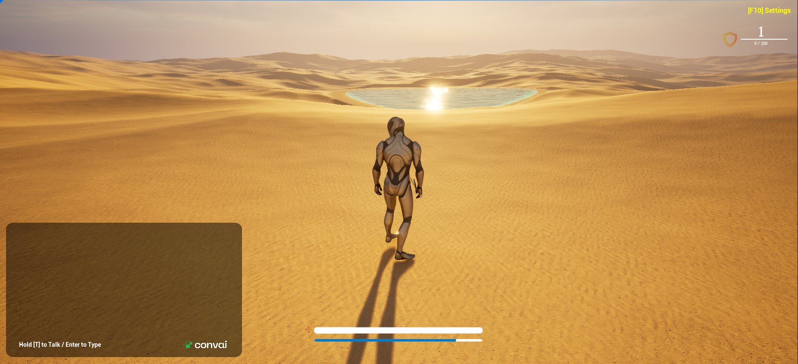
(Fig 1)
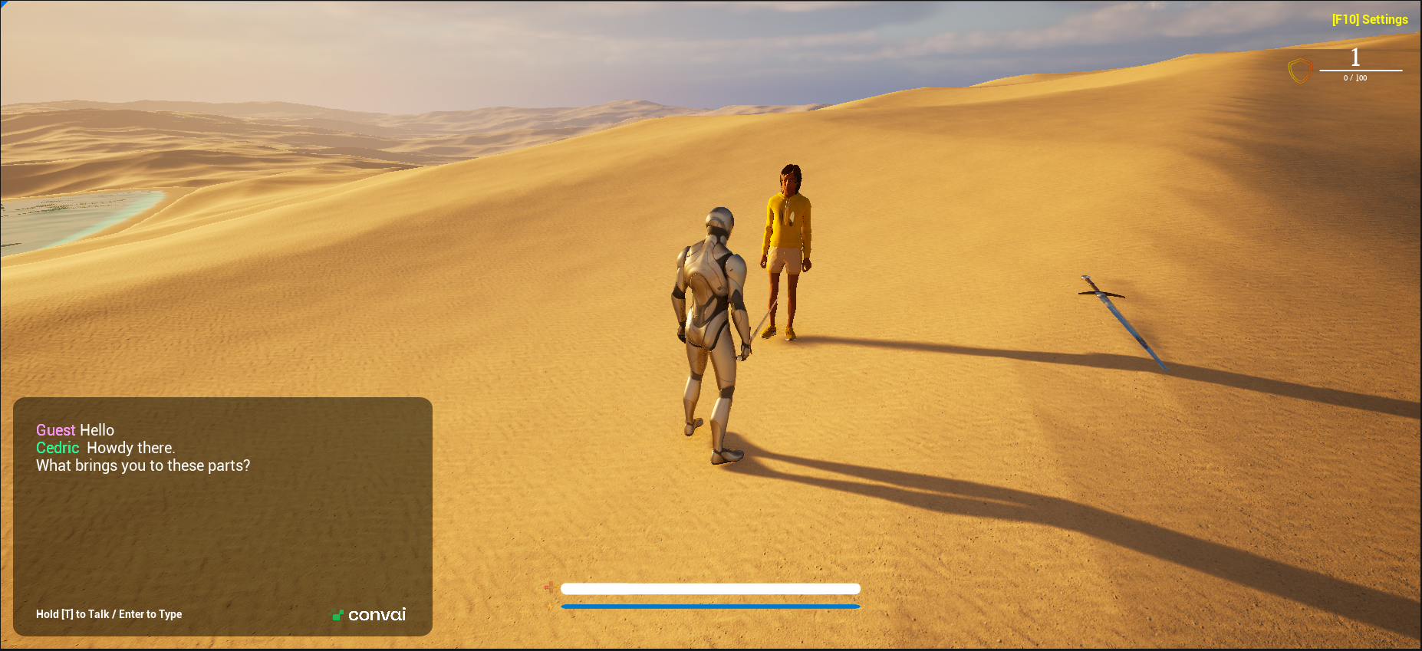
(Fig 2)

(Fig 3)

Third Person Player Code
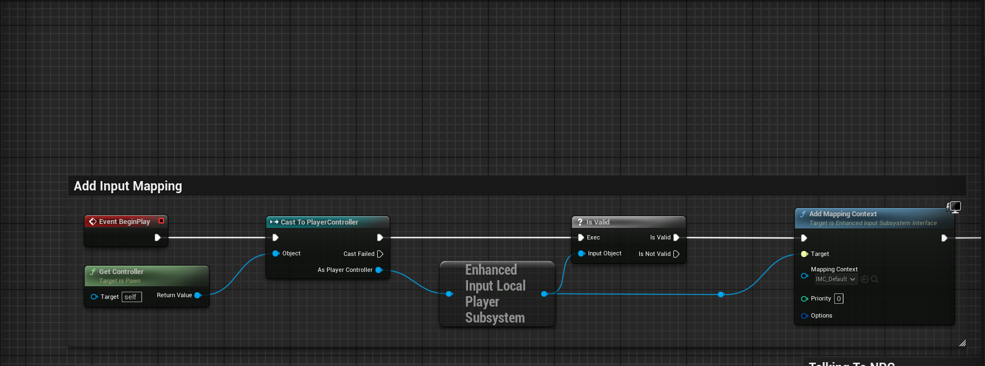
(Fig 4)
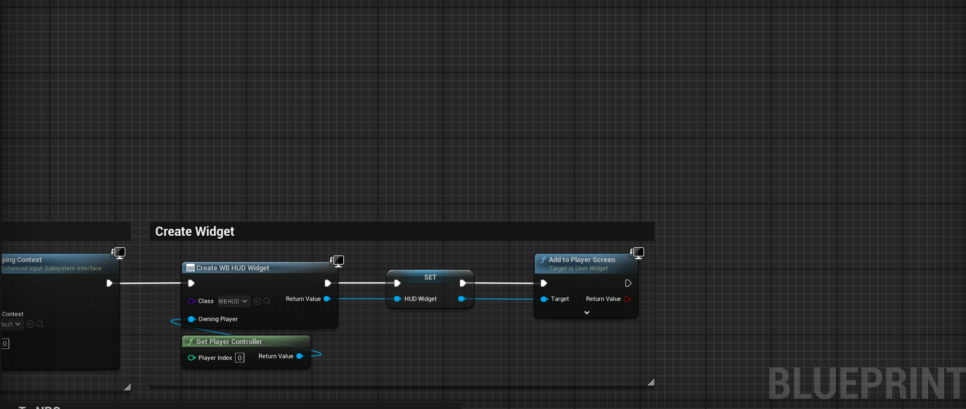
(Fig 5)
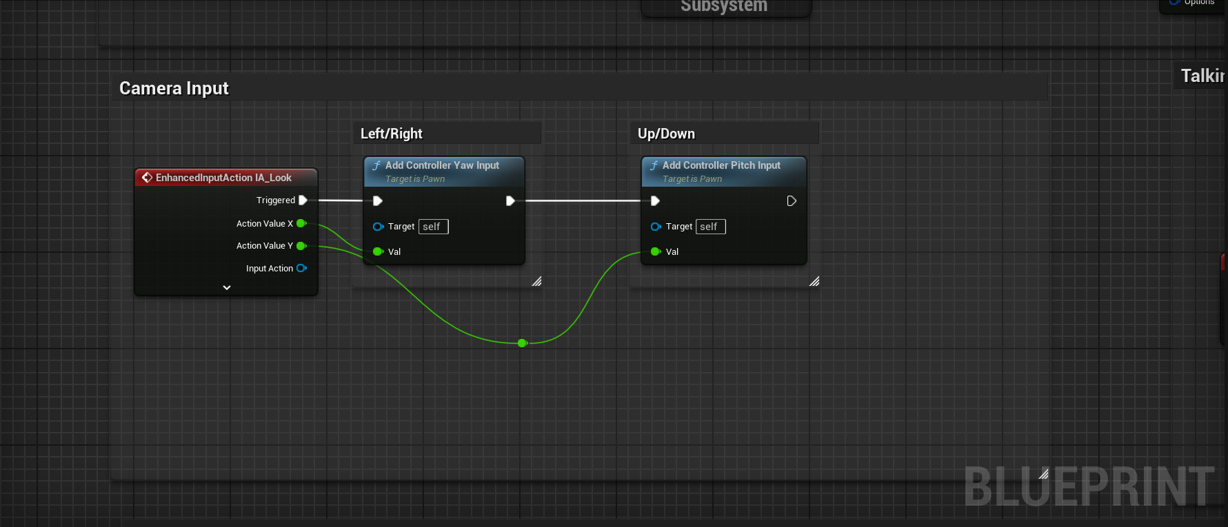
(Fig 6)
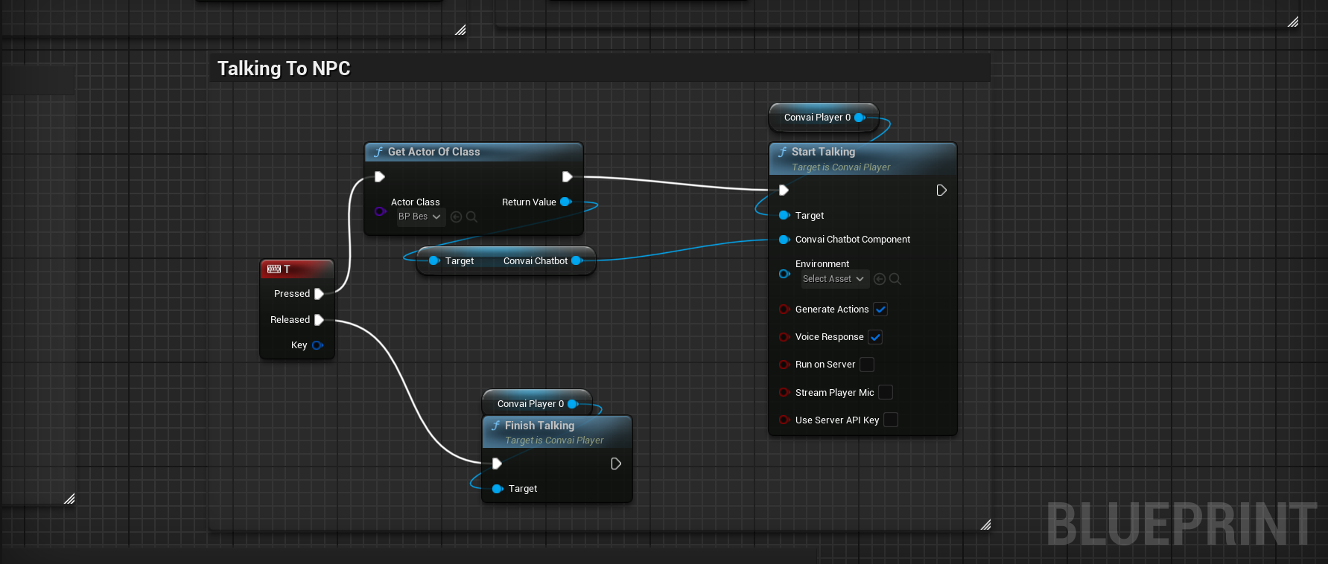
(Fig 7)
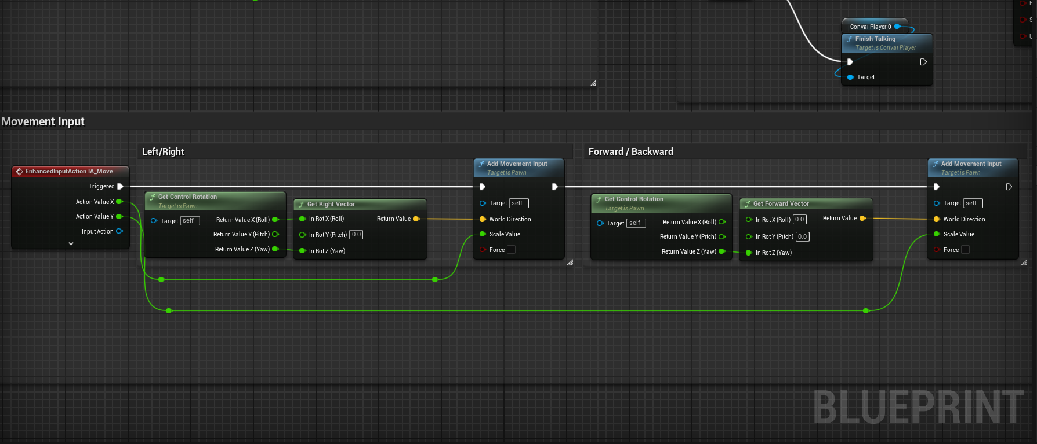
(Fig 8)
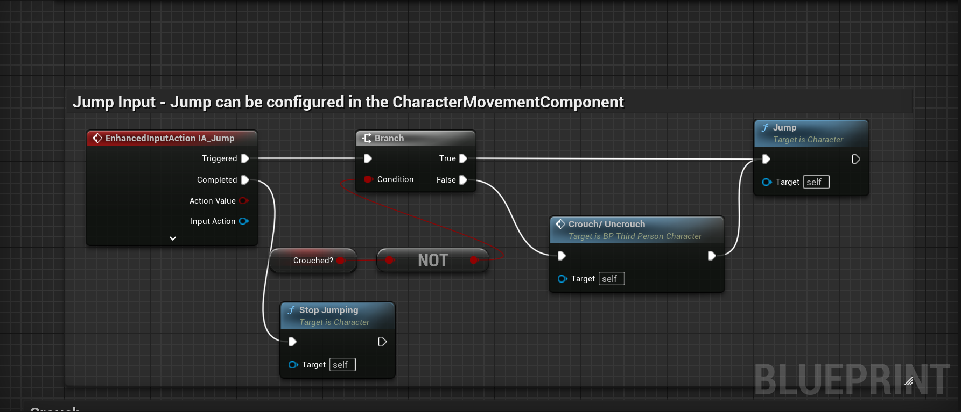
(Fig 9)
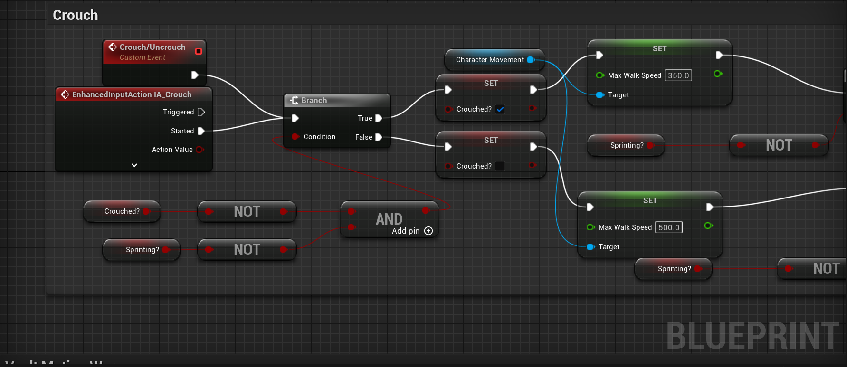
(Fig 10)
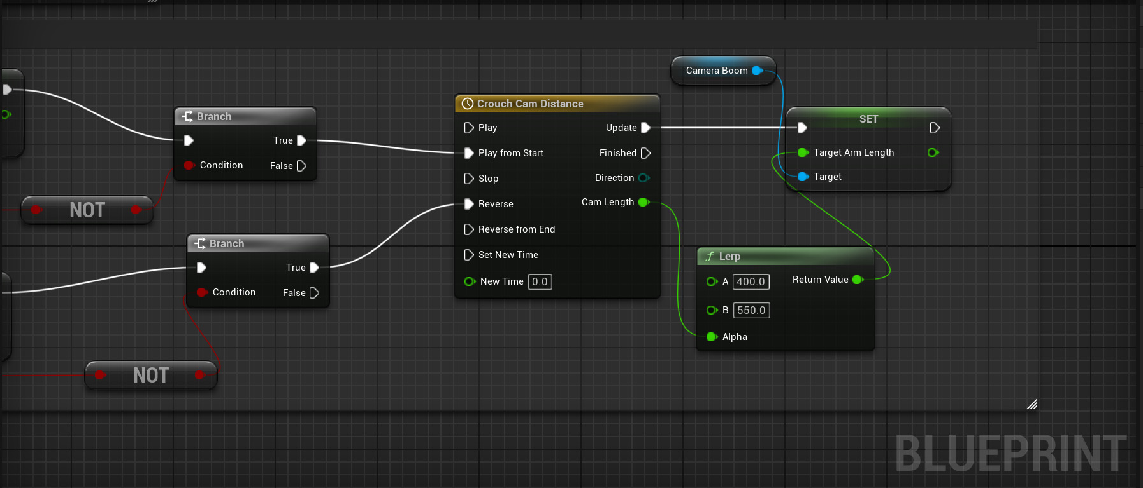
(Fig 11)
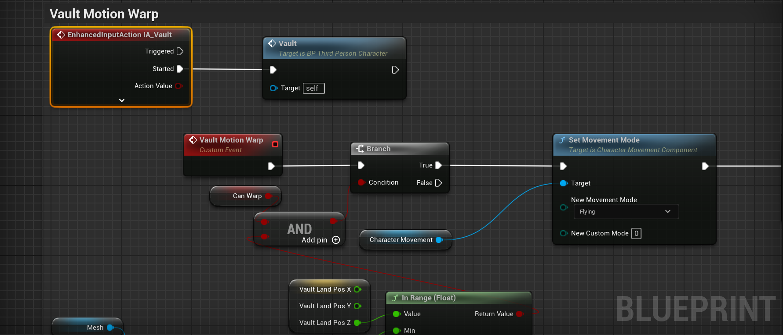
(Fig 12)
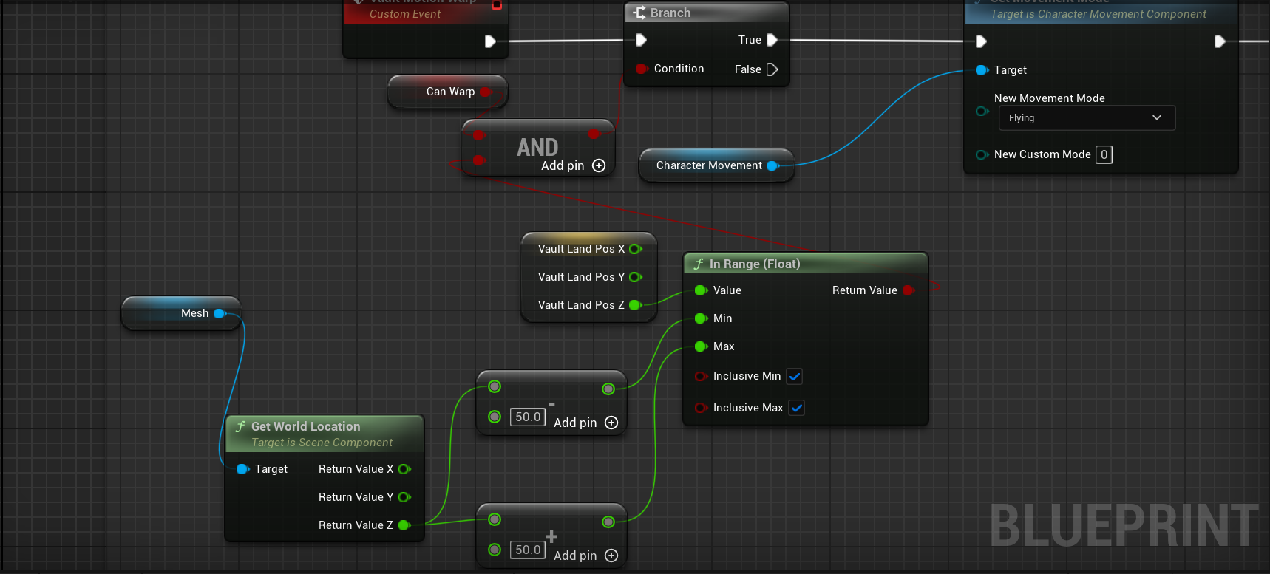
(Fig 13)
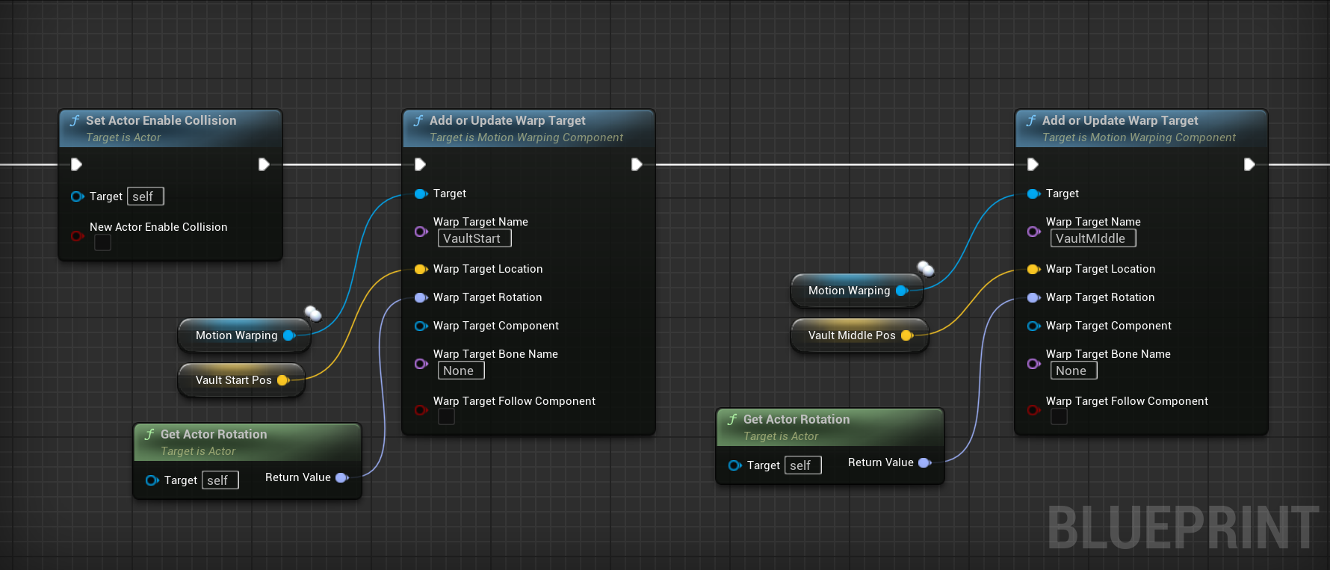
(Fig 14)
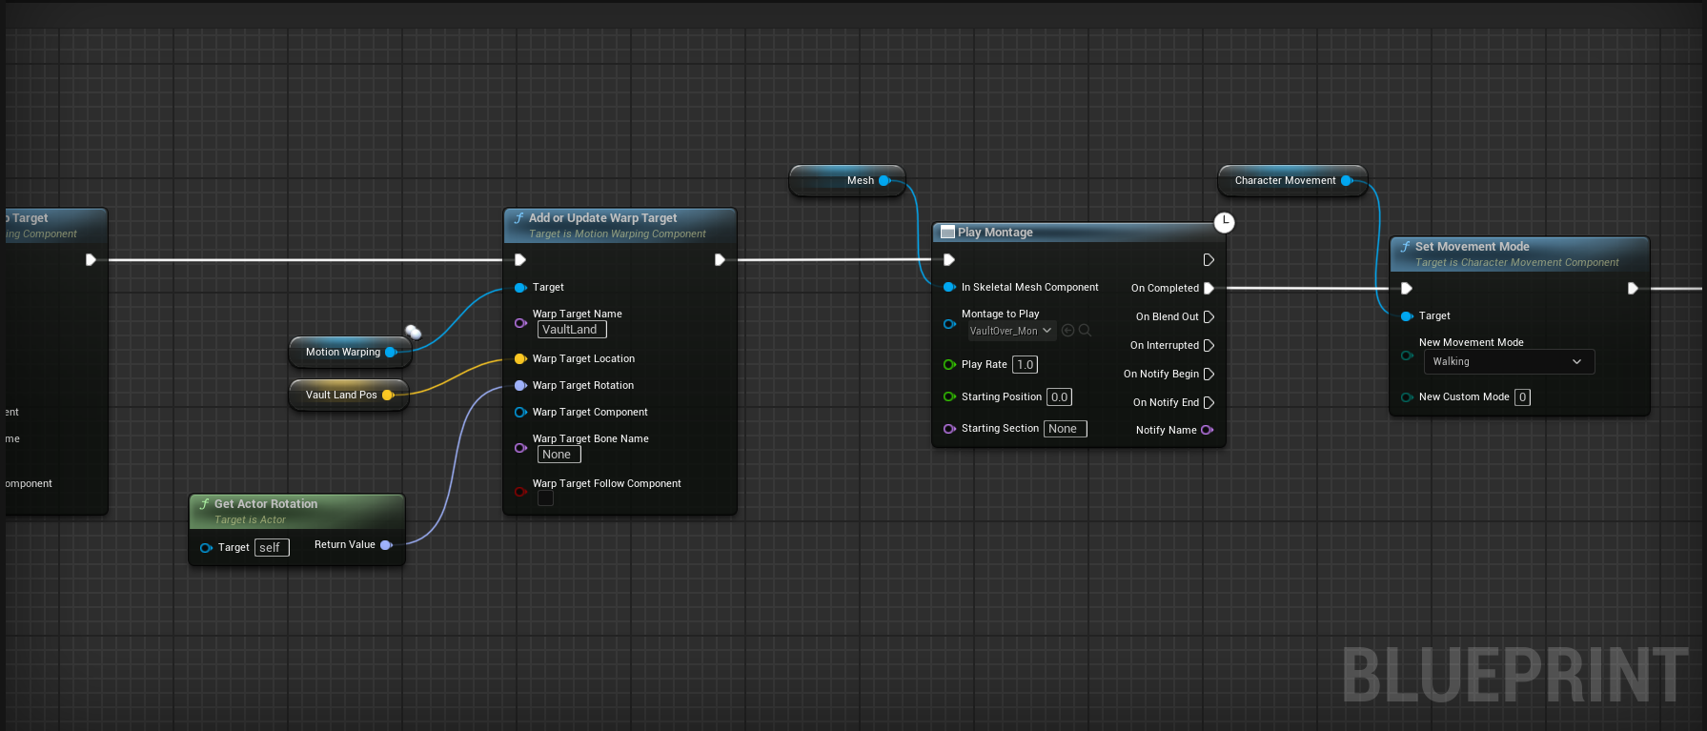
(Fig 15)
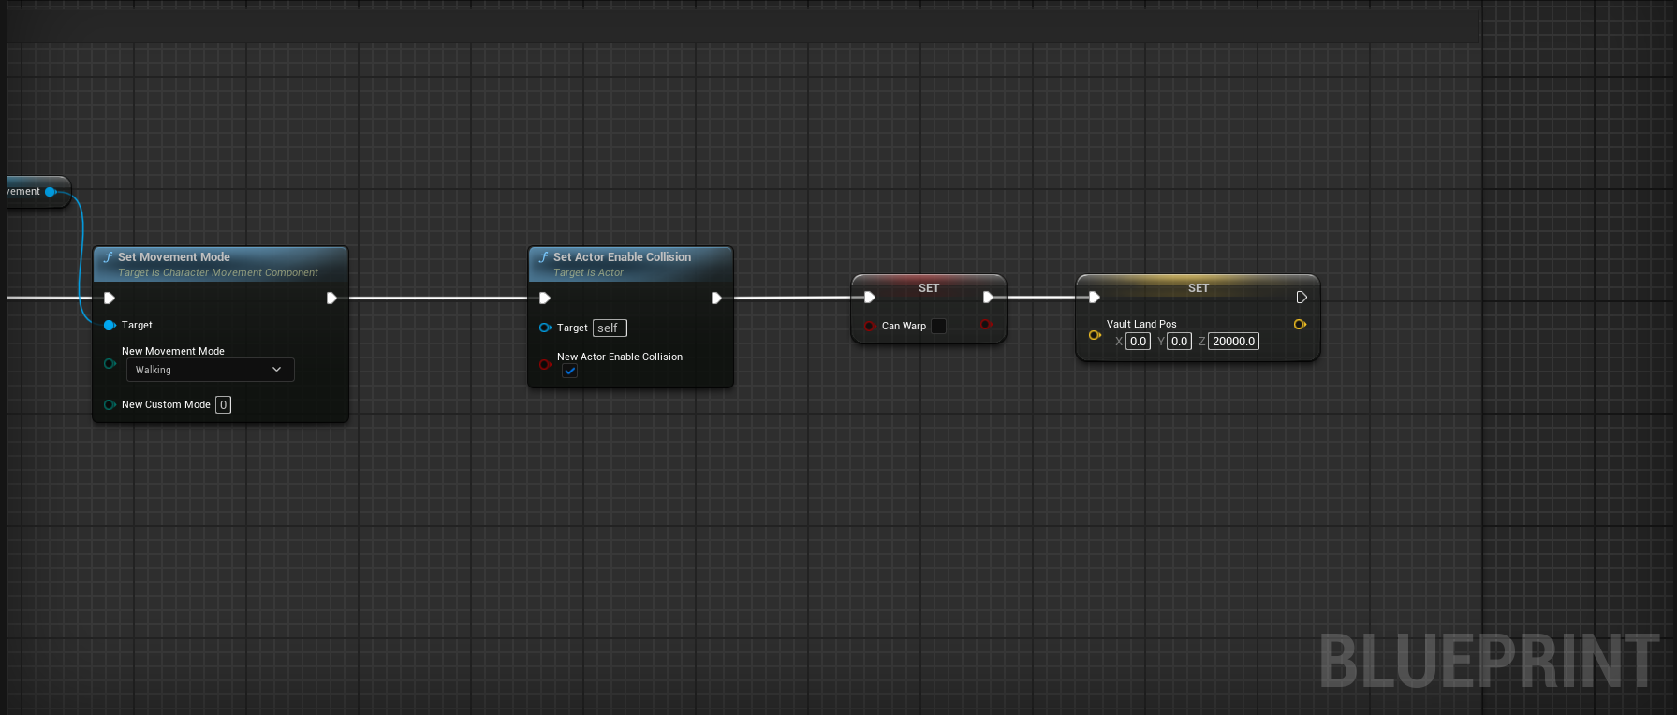
(Fig 16)

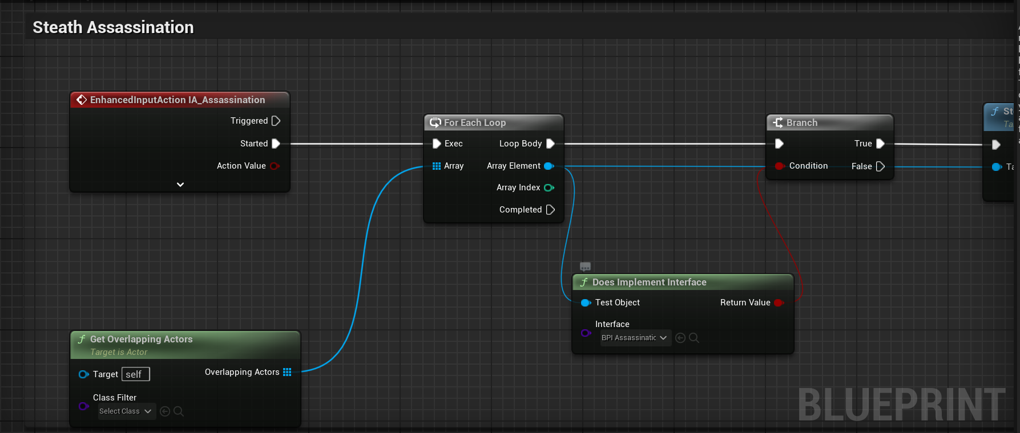
(Fig 17)
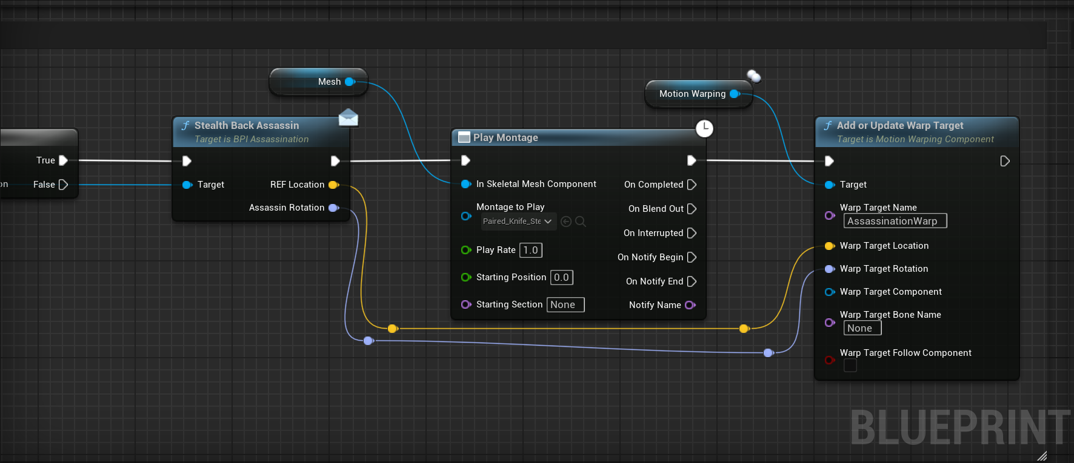
(Fig 18)
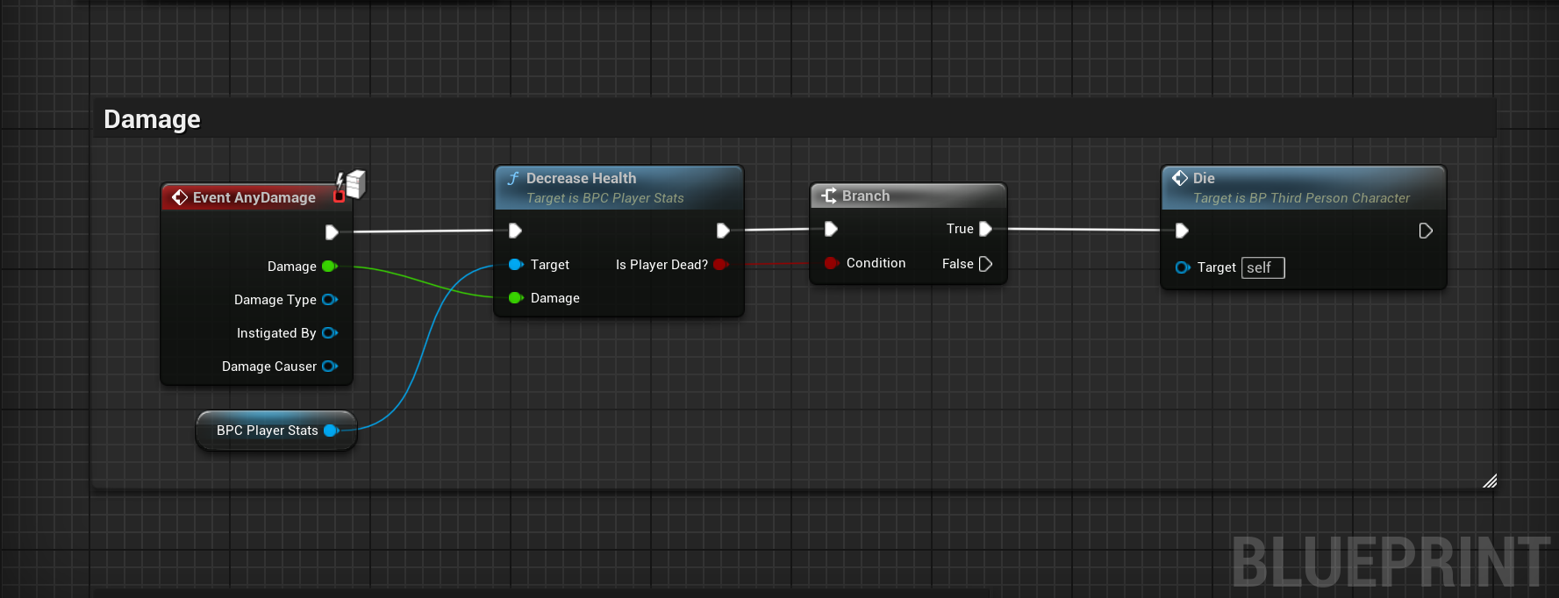
(Fig 19)
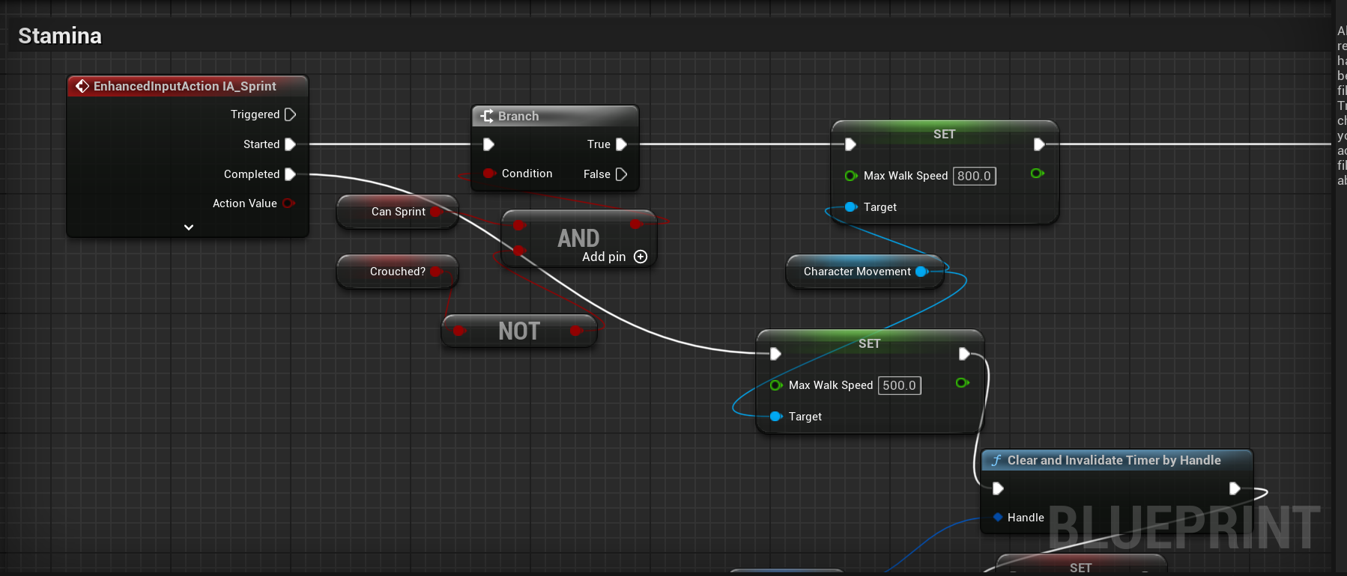
(Fig 20)
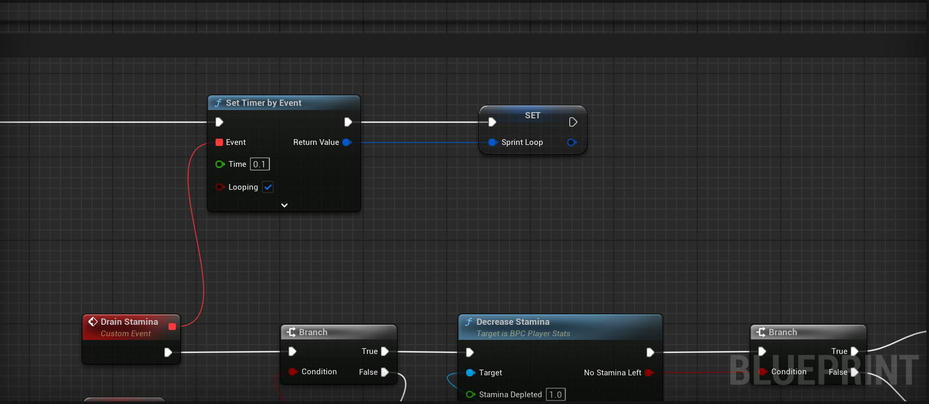
(Fig 21)
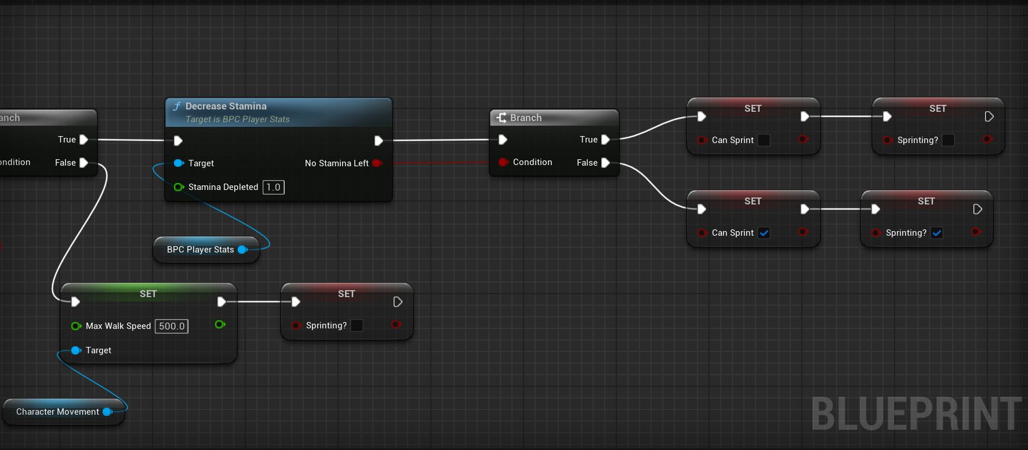
(Fig 22)
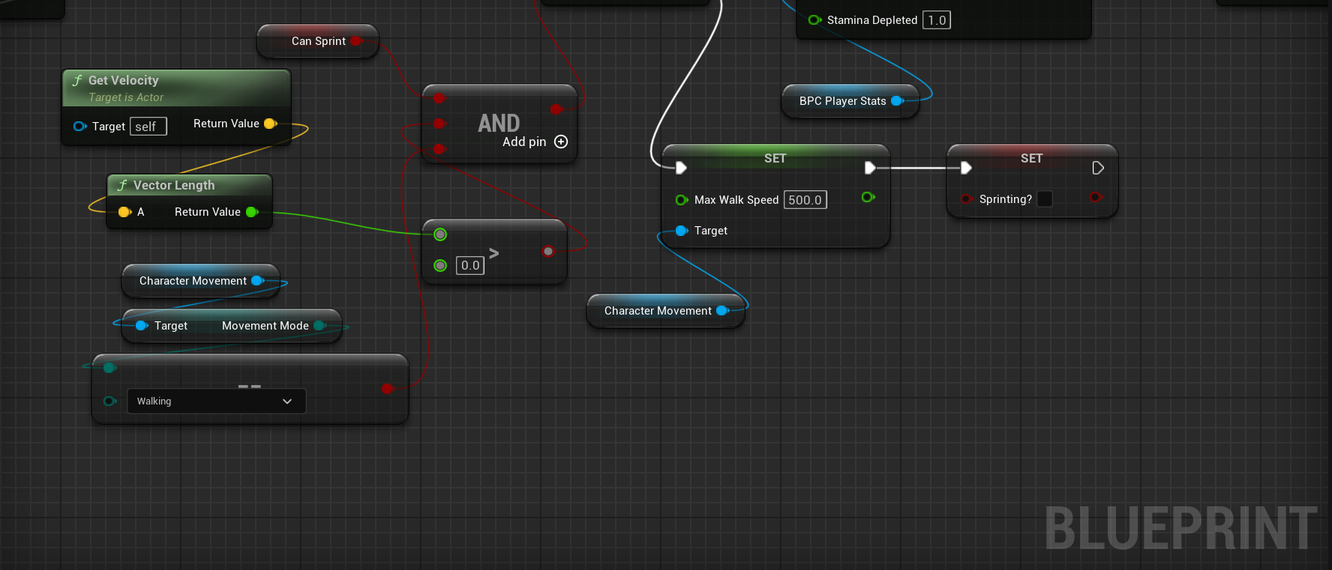
(Fig 23)

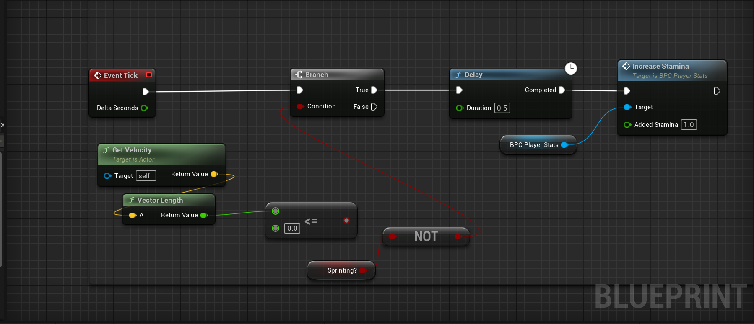
(Fig 24)

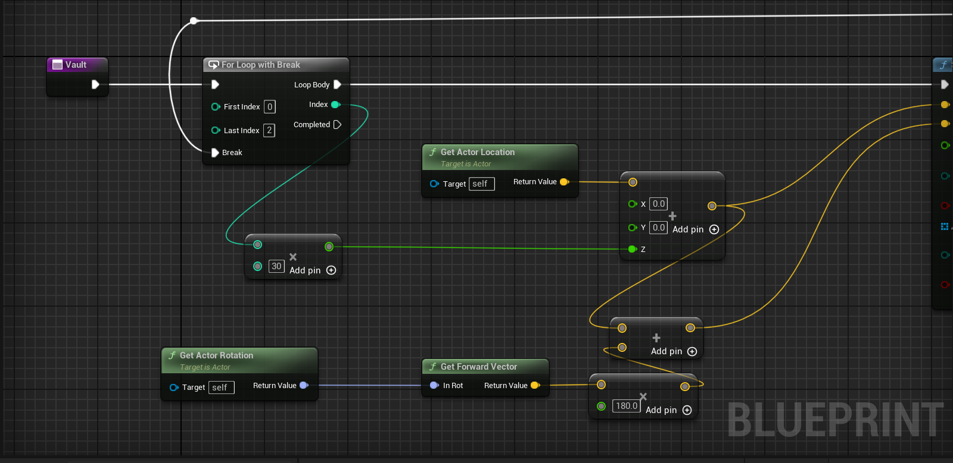
(Fig 25)
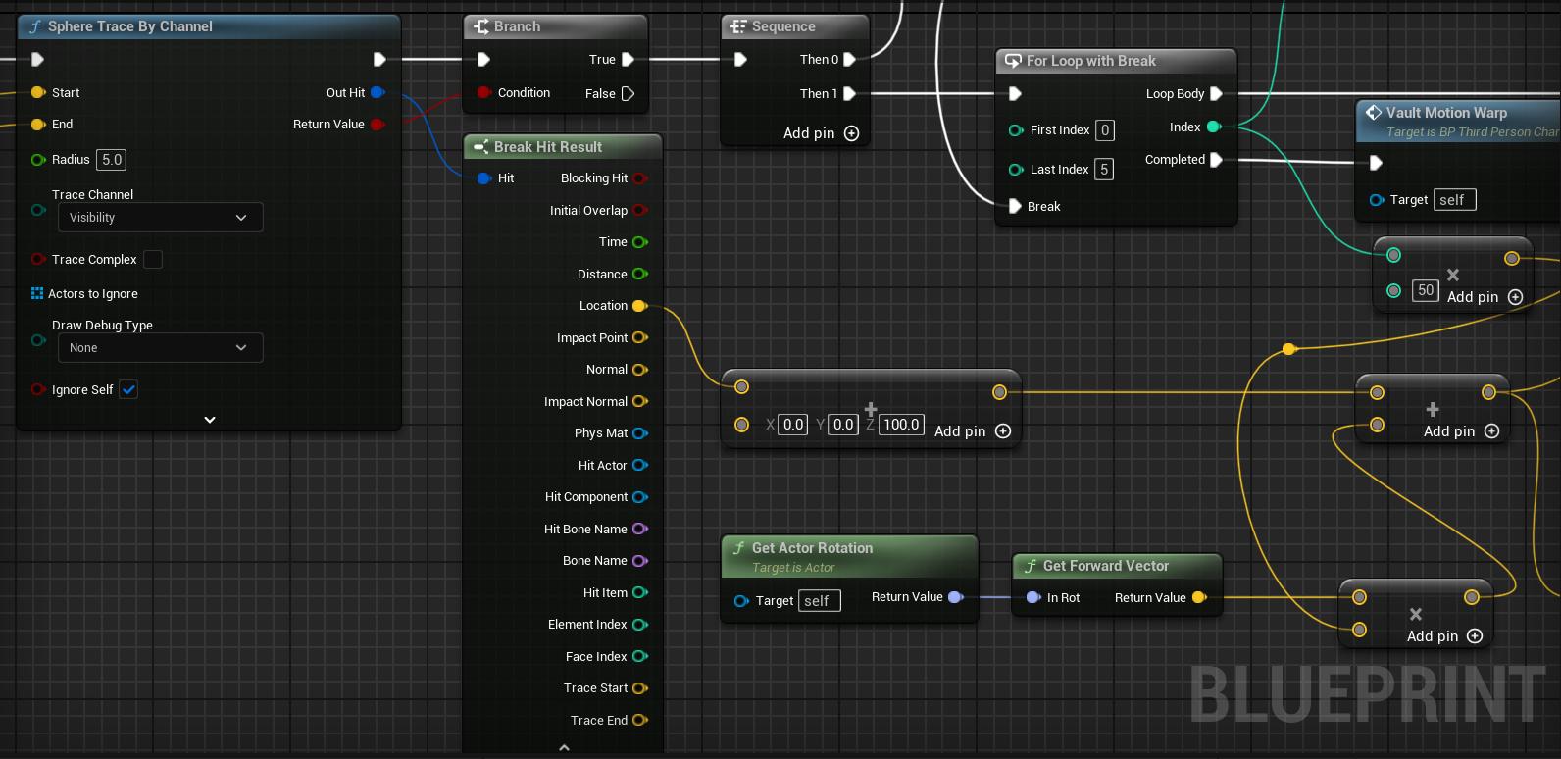
(Fig 26)
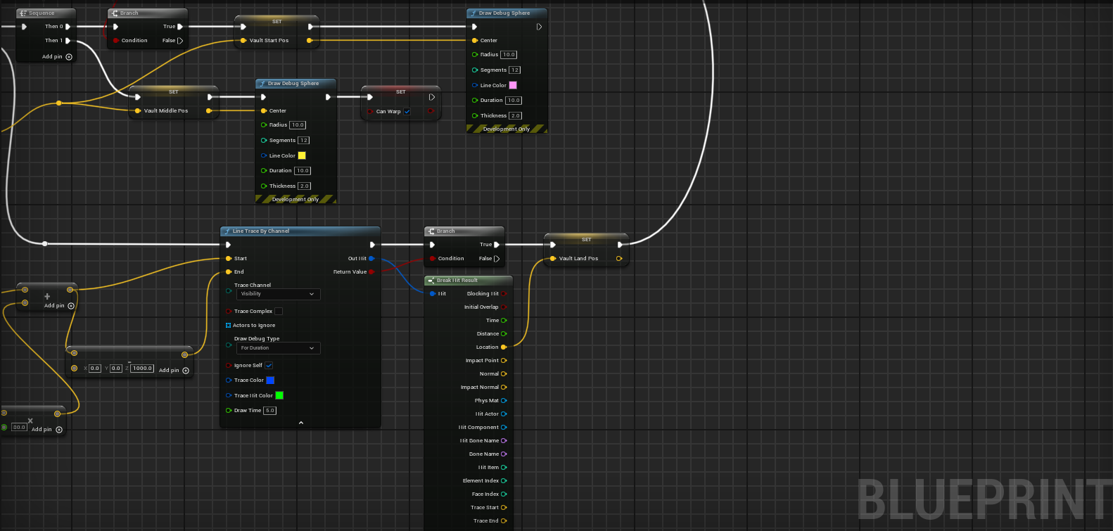
(Fig 27)

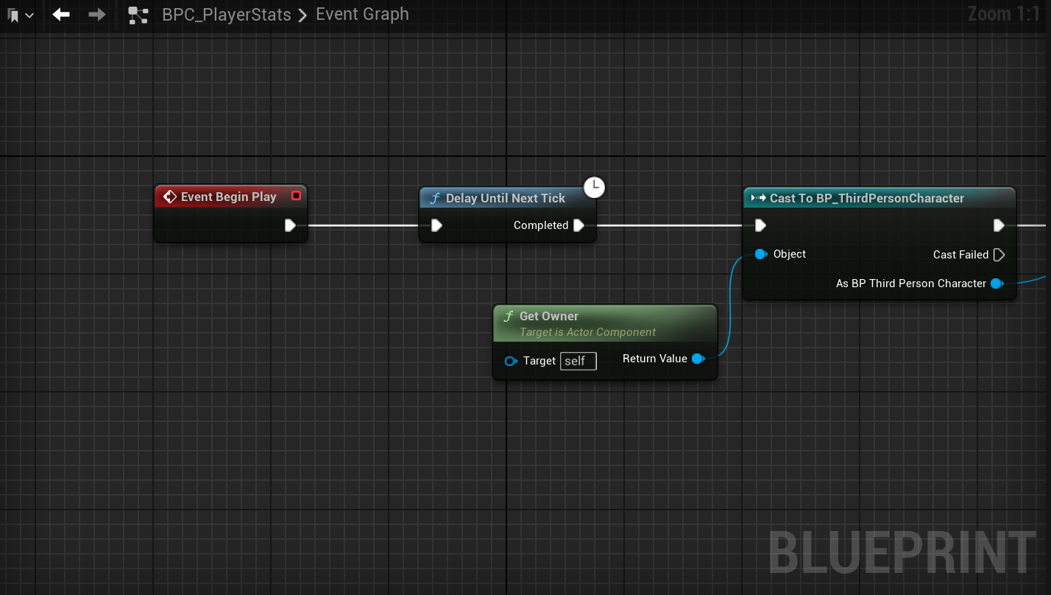
(Fig 28)
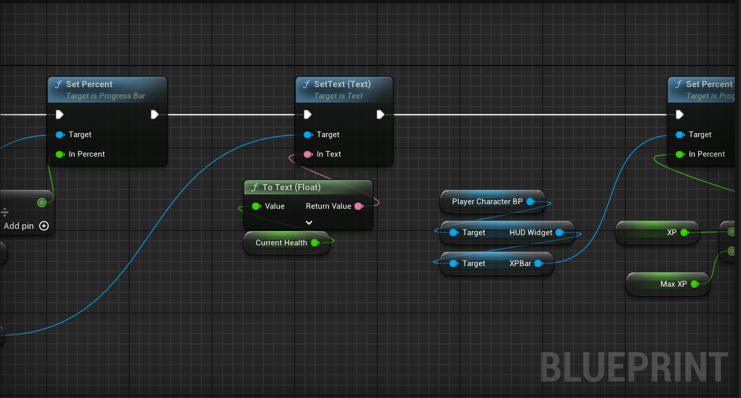
(Fig 29)
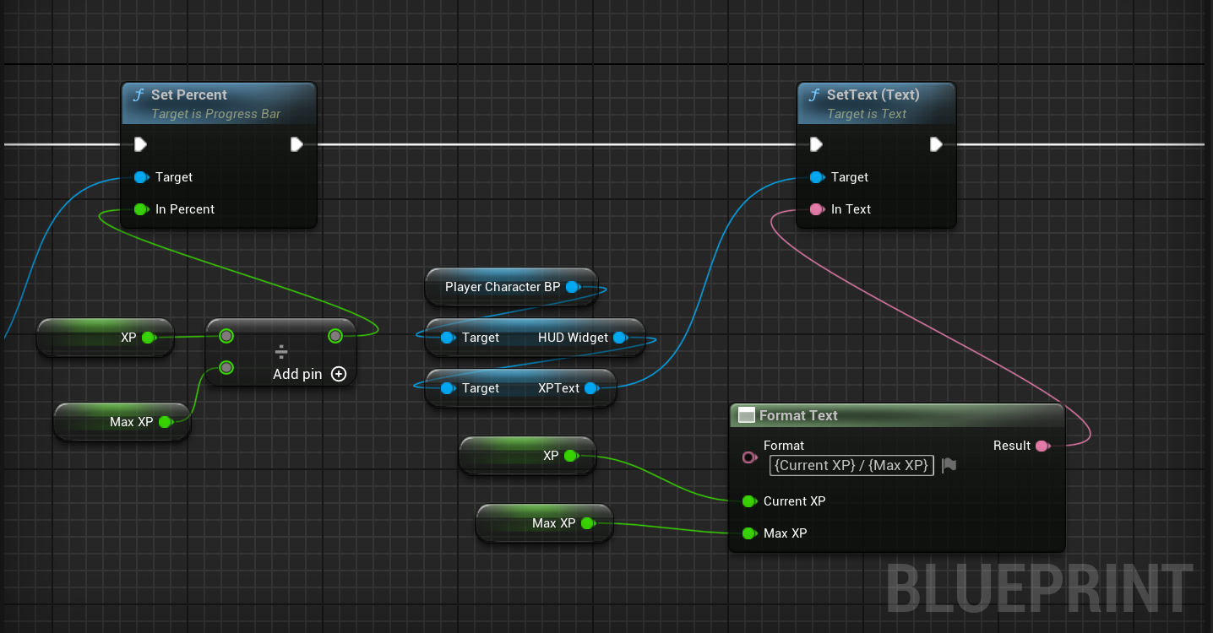
(Fig 30)
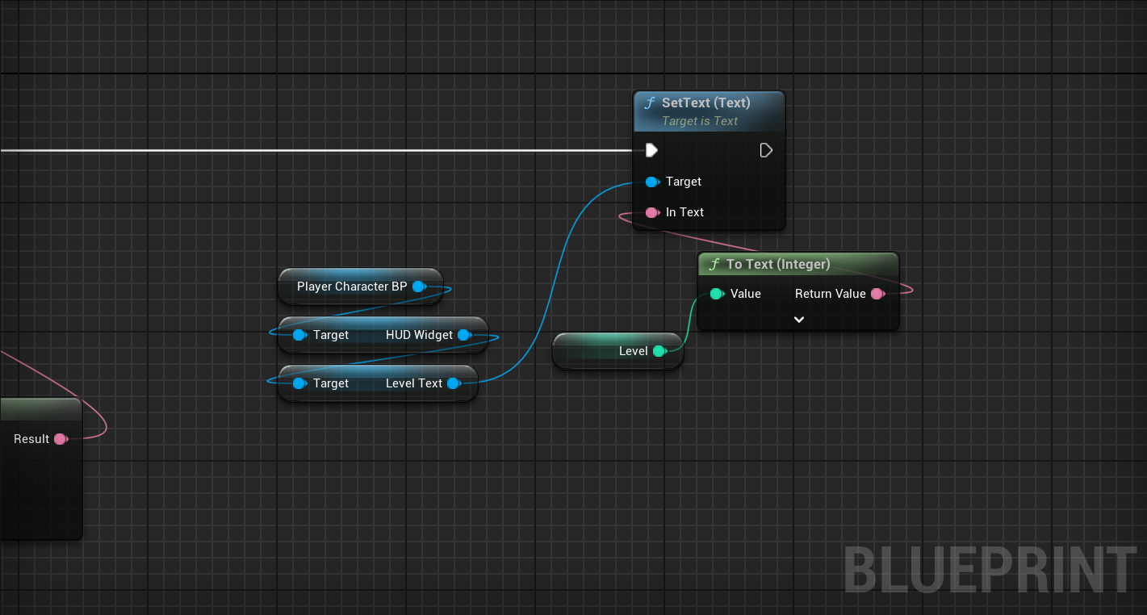
(Fig 31)

AI NPC CODE
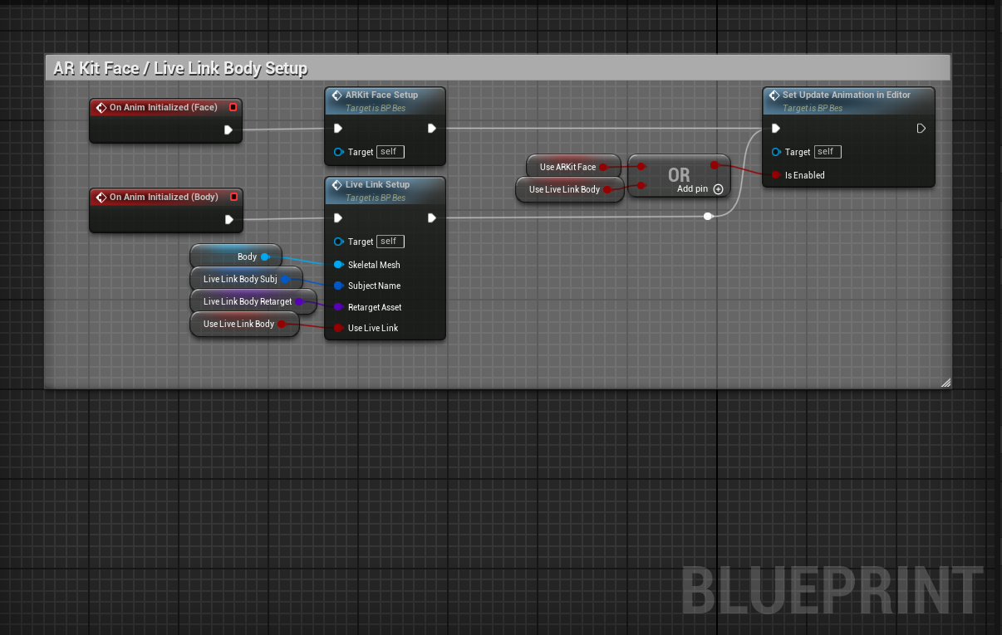
(Fig 32)
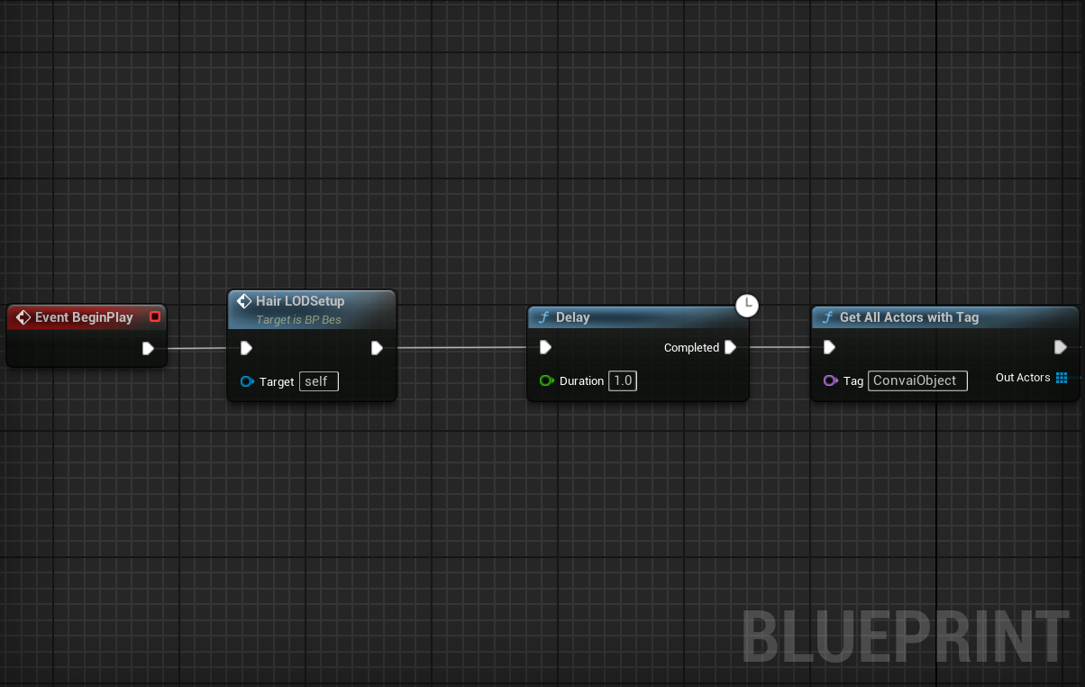
(Fig 33)
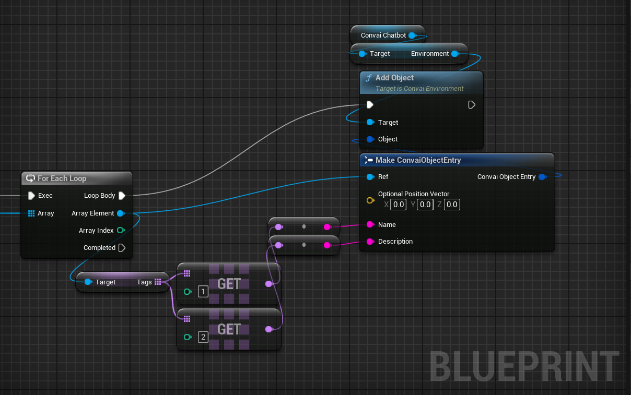
(Fig 34)
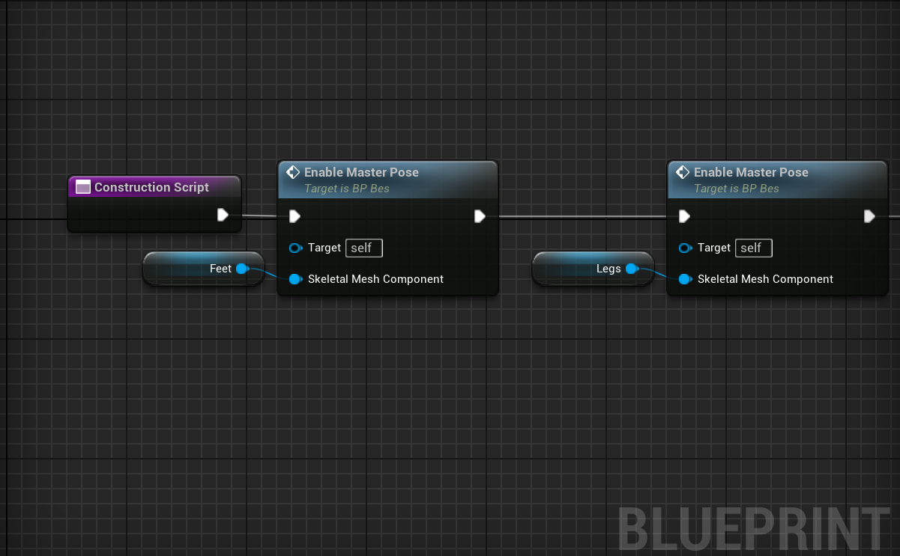
(Fig 35)
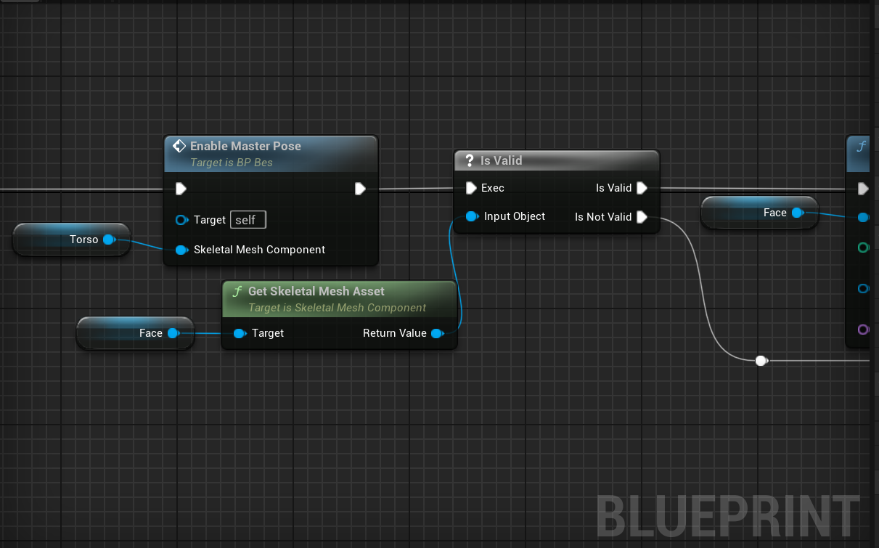
(Fig 36)
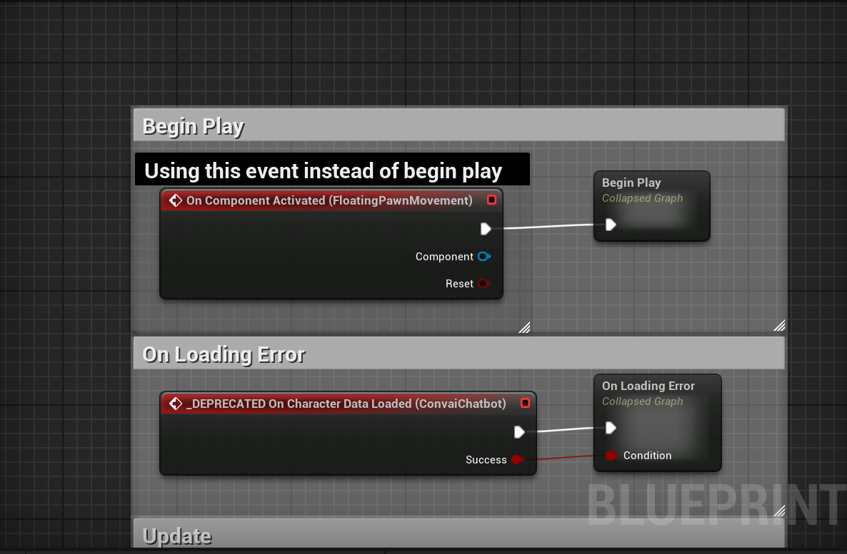
(Fig 37)
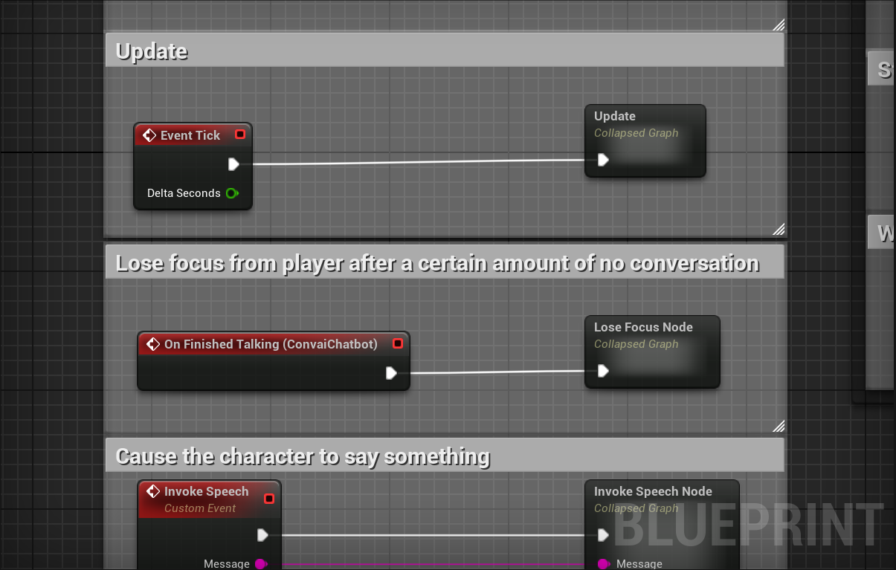
(Fig 38)
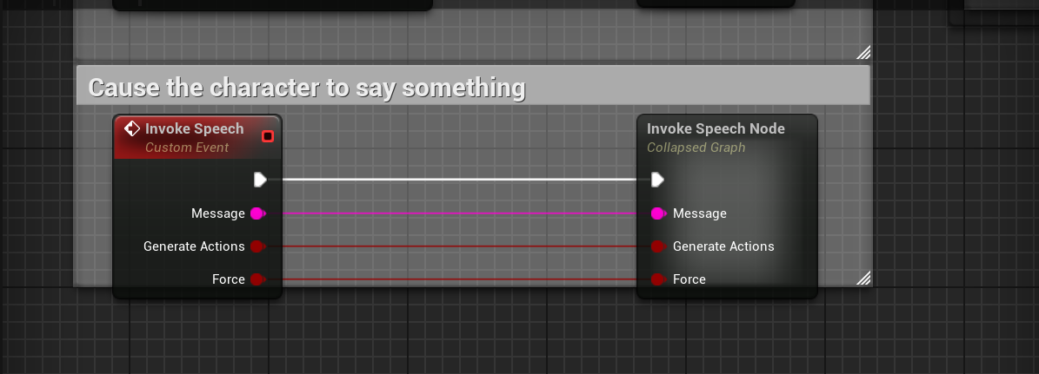
(Fig 40)
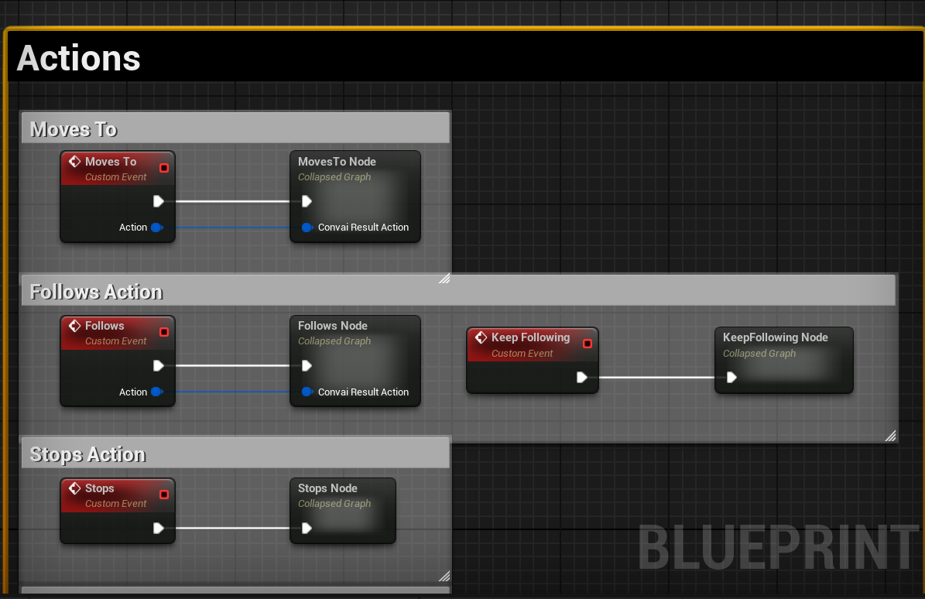
(Fig 41)
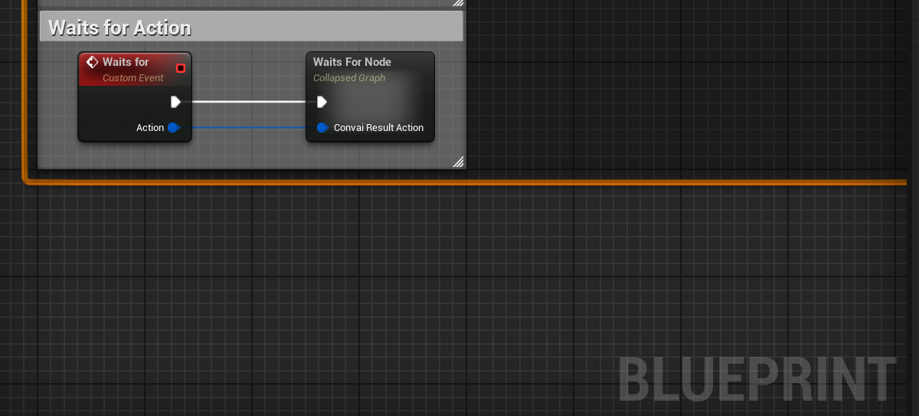
(Fig 42)
Each of these functions contains their own code for the NPC.

CHAPTER 5
CONCLUSION AND FUTURE SCOPE

5.1 Conclusion
The journey of developing this AI-powered RPG prototype has been both challenging and inspiring, marking a bold step toward the future of interactive digital storytelling. By harnessing the real-time capabilities of Unreal Engine 5’s Blueprint system and the advanced conversational intelligence of Convai AI, this project has successfully demonstrated how player-NPC interactions can transcend traditional menu-driven dialogues. The result is a more immersive, emotionally resonant, and player-driven experience.
Throughout the development process, the integration of Convai’s generative AI brought a new dimension to NPC interactions. Players are no longer restricted to pre-scripted lines or repetitive dialogue trees; instead, they can engage in open-ended, voice-based conversations with NPCs that respond with personality, context, and even a sense of memory. The AI’s ability to recognize objects in the environment, remember previous exchanges, and express itself through MetaHuman facial animation and lip sync has elevated the sense of presence and realism in the game world.
In addition to the innovative AI-driven dialogue, several foundational gameplay systems have been successfully prototyped. The locomotion system allows for smooth, responsive movement across an open-world map, while the basic attack combo introduces a tactile and engaging combat experience. The implementation of RPG mechanics-such as health, stamina, experience, and level-up-lays the groundwork for a rewarding progression system that motivates continued play and exploration.
While the project is still in its prototype phase, the modules completed so far clearly demonstrate both technical feasibility and creative promise. Early playtesting and peer feedback have been overwhelmingly positive, with users highlighting the natural flow of conversations, the expressiveness of AI-powered NPCs, and the solid feel of movement and combat. These results confirm the strength of the concept and its potential to engage players on a deeper emotional and intellectual level.
Importantly, the project’s modular, Blueprint-driven approach has ensured rapid iteration and flexibility, making it accessible not only to programmers but also to designers and storytellers. This democratization of AI-driven game development is itself a significant achievement, opening the door for more diverse voices and ideas in the creation of interactive worlds.
In summary, this work has laid a robust foundation for a next-generation RPG experience-one where AI, emotion, and interactivity converge to create stories that are not only told to the player, but told with the player.
5.2 Future Scope
The potential for expanding and refining this project is vast, with numerous exciting directions for future development. The following areas represent key opportunities for growth, innovation, and deeper player engagement:
1. Full AI NPC Integration
The next major milestone will be the creation of a diverse cast of Convai-powered NPCs, each with their own unique personalities, backgrounds, and roles within the game world. By leveraging Convai’s ability to assign custom knowledge bases and conversational styles, the game can populate its world with merchants, quest-givers, rivals, and companions who feel truly alive. These NPCs will be able to remember past interactions, reference shared experiences, and adapt their dialogue based on the player’s actions and reputation.
2. Dynamic Quest System
A flexible, open-ended quest framework will be developed, where AI NPCs can generate or assign missions dynamically. Instead of following a strictly linear storyline, players will be able to shape their own adventures through conversation and choice. Quests might emerge organically from player-NPC interactions, with objectives and rewards tailored to the player’s interests, skills, and past decisions. This system will encourage replayability and foster a sense of agency, as no two playthroughs will be exactly alike.
3. Boss Battles and Advanced Enemy AI
To further enrich combat and challenge, advanced enemy AI will be introduced, including formidable boss characters with unique combat phases, behaviors, and weaknesses. These enemies will be designed using behavior trees and advanced animation blueprints, allowing for adaptive tactics and memorable encounters. Integrating Convai’s conversational AI into enemy taunts or mid-battle dialogue could add a psychological layer to boss fights, making victories even more satisfying.
4. Deepened Character Progression
RPG elements will be expanded with the addition of skill trees, inventory management, crafting systems, and more nuanced leveling mechanics. Players will be able to customize their abilities, equipment, and playstyle, creating a personal journey of growth and mastery. NPCs may offer training, trade rare items, or unlock new skills through conversation, further intertwining dialogue and progression.
5. Narrative and World-Building Expansion
The game’s narrative will be broadened with cinematic sequences, branching storylines, and emotionally impactful arcs. Environmental storytelling-through visual cues, lore objects, and ambient dialogue-will deepen the sense of place. Voice-acted cutscenes and AI-driven conversations will bring key moments to life, while Convai-powered NPCs will react to world events, player choices, and changing circumstances.
6. Optimization and Platform Support
As the project matures, technical optimization will become a priority. The game will be profiled and refined for smooth performance on a range of hardware, with special attention to memory usage, loading times, and frame rates. Consideration will be given to future support for mobile devices and consoles, ensuring that the experience remains accessible and enjoyable across platforms.
7. Multiplayer and Social Interaction (Optional)
Looking even further ahead, multiplayer functionality could be explored, allowing players to share the AI-driven world with friends. Cooperative or competitive play, shared questing, and group interactions with Convai NPCs would open up new social and emergent gameplay possibilities. Voice chat and AI-moderated conversations could ensure a safe and engaging environment for all participants.
5.3 Closing Thoughts
The fusion of Convai’s conversational AI with Unreal Engine’s powerful toolset has already transformed the prototype into a living, breathing world. As development continues, the project aspires to set a new standard for what is possible in interactive storytelling and player-driven narrative. By continuing to iterate, listen to player feedback, and push the boundaries of technology and creativity, this RPG aims not only to entertain, but to inspire a new generation of game designers and storytellers.

REFERENCES

- Yannakakis, G. N., & Togelius, J. (2018). Artificial Intelligence and Games. Springer. https://doi.org/10.1007/978-3-319-63519-4
- Hoang, T., Nguyen, T., & Dang, T. (2022). Real-Time Conversational AI for NPCs in RPGs. International Journal of Game Theory and Design, 14(2), 44–57.
- Bruckner, S. (2021). Procedural Storytelling in RPGs Using AI. ACM Transactions on Multimedia Computing, Communications, and Applications, 17(3), 1–18.
- OpenAI. (2023). ChatGPT Technical Report. https://openai.com/research/gpt-4
- Convai. (2023). Conversational AI for Games. https://www.convai.com/docs
- Epic Games. (2023). Unreal Engine 5 Documentation. https://docs.unrealengine.com/5.0/en-US/
- Gaina, R., & Salge, C. (2019). NPC behaviour learning with reinforcement learning. IEEE Transactions on Games, 11(2), 130–140.
- Li, X., Zhang, Y., & Kim, J. (2020). Integrating Voice-Based AI with Game Narrative Systems. Game AI Journal, 5(1), 22–36.
- Zook, A., & Riedl, M. O. (2015). Automated game design via conceptual expansion. AIIDE 2015, 54–60.
- Togelius, J., & Yannakakis, G. N. (2016). Procedural content generation and AI in games. Proceedings of the IEEE, 104(8), 1422–1431.
- Petrov, K., & Ray, D. (2021). Enhancing Immersion in RPGs Through Natural Language Interfaces. International Journal of Computer Games Technology, Article ID 982341.
- Johnson, S. (2022). Building Real-Time NPC Interactions with Generative AI. Game Developers Conference (GDC) Presentation.
- Liu, Y., & Lin, H. (2020). Dynamic Emotional Dialogue for RPG Characters Using GPT-Based Models. IEEE Transactions on Affective Computing, 11(4), 671–684.
- Ribeiro, P., & Silva, F. (2021). Using Blueprints for Advanced AI Behavior in Unreal Engine. GameTech Journal, 8(3), 105–117.
- Martinez, C. (2023). Creating Emotionally Aware NPCs in Unreal Engine. Unreal Dev Blog.
- Lee, D., & Nakamura, K. (2021). Conversational AI NPCs in Open World Games. Computer Games and Simulation, 39(2), 67–79.
- Richards, S., & Khalid, A. (2022). AI Companions in Action RPGs: A Study on Combat and Dialogue Synergy. International Journal of Game AI Research, 16(1), 88–101.
- Unreal Engine Forums. (2023). [Discussion] Integrating Convai and GPT into UE5. https://forums.unrealengine.com
- Horne, M., & Russo, B. (2020). Narrative Design with AI: Tension Between Structure and Autonomy. Narrative Systems in Interactive Media, 112–128.
- Smith, J. (2021). Voice Interaction in Game Design. Game Audio & Dialogue Monthly, 9(4), 24–32.

APPENDIX

Plagiarism Report


