

A
Project Report
on
Secure Vote
submitted as partial fulfillment for the award of
BACHELOR OF TECHNOLOGY
in
Computer Science and Engineering
By
Md Armaan Ansari (2100290100096)
Sion Chowdhary (2100290100164)

Under the supervision of
Mr. Harsh Modi
KIET Group of Institutions, Ghaziabad
Affiliated to
Dr. A.P.J. Abdul Kalam Technical University, Lucknow
(Formerly UPTU)
May, 2025

DECLARATION
We hereby declare that this submission is our own work and that, to the best of our knowledge and belief, it contains no material previously published or written by another person nor material which to a substantial extent has been accepted for the award of any other degree or diploma of the university or other institute of higher learning, except where due acknowledgment has been made in the text.

Signature
Name:
Roll No.:
Date: 16/02/2025

CERTIFICATE

This is to certify that Project Report entitled “Secure Vote” which is submitted by Md Armaan Ansari and Sion Chowdhary in partial fulfillment of the requirement for the award of degree B. Tech. in Department of Computer Science & Engineering of Dr. A.P.J. Abdul Kalam Technical University, Lucknow is a record of the candidates own work carried out by them under my supervision. The matter embodied in this report is original and has not been submitted for the award of any other degree.
.

Supervisor Name Dr. Vineet Sharma
(Designation) (Dean CSE)

Date:

ACKNOWLEDGEMENT

It gives us a great sense of pleasure to present the report of the B. Tech Project undertaken during B. Tech. Final Year. We owe special debt of gratitude to Mr. Harsh Modi, Department of Computer Science & Engineering, KIET, Ghaziabad, for his constant support and guidance throughout the course of our work. His sincerity, thoroughness and perseverance have been a constant source of inspiration for us. It is only his cognizant efforts that our endeavors have seen light of the day.
We also take the opportunity to acknowledge the contribution of Dr. Vineet Sharma, Head of the Department of Computer Science & Engineering, KIET, Ghaziabad, for his full support and assistance during the development of the project. We also do not like to miss the opportunity to acknowledge the contribution of all the faculty members of the department for their kind assistance and cooperation during the development of our project.
We also do not like to miss the opportunity to acknowledge the contribution of all faculty members, especially faculty/industry person/any person, of the department for their kind assistance and cooperation during the development of our project. Last but not the least, we acknowledge our friends for their contribution in the completion of the project.
Date:

Signature:

Name :

Roll No.:

ABSTRACT

Elections are fundamental to democratic governance, yet traditional electronic voting systems (EVMs) suffer from security vulnerabilities, lack of transparency, and susceptibility to cyber threats. This report presents a blockchain-based e-voting framework that enhances electoral integrity through distributed smart contracts, cryptographic security mechanisms, and decentralized metadata storage. Key innovations include multi-factor authentication (MFA) for voter identity verification, master-slave architecture for system resilience, and the integration of the InterPlanetary File System (IPFS) for secure metadata storage.
The proposed system leverages checksum-based validation and automated security monitoring to prevent vote tampering and ensure data consistency. Votes are cast through cryptographically linked blockchain wallet addresses, ensuring anonymity while maintaining verifiability. Smart contracts autonomously handle vote counting, reducing human intervention and potential manipulation. The framework also introduces role-based access control (RBAC) and real-time intrusion detection mechanisms, significantly enhancing security.
Compared to traditional e-voting systems, this blockchain-driven model offers improved transparency, security, and trustworthiness. Future work will explore quantum-resistant cryptographic techniques, scalable blockchain infrastructures, and enhanced voter accessibility for large-scale adoption in governmental elections.

TABLE OF CONTENTS | Page No.
DECLARATION……………………………………………………………………. | ii
CERTIFICATE……………………………………………………………………… | iii
ACKNOWLEDGEMENTS…………………………………………………………. | iv
ABSTRACT………………………………………………………………………..... | v
LIST OF FIGURES…………………………………………………………………. | ix
LIST OF TABLES…………………………………………………………………… | xi
LIST OF ABBREVIATIONS………………………………………………………. | xii
CHAPTER 1 (INTRODUCTION)…………………………………………………. | 1-5
1.1. Introduction
1.2. Project Description
CHAPTER 2 (LITERATURE REVIEW)…………………………………………… | 6-10
CHAPTER 3 (SYSTEM REQUIREMENTS AND SPECIFICATION)…………… | 11-12
CHAPTER 4 (SYSTEM DESIGN)……………………………………………….....  4.1 System Architecture  4.2 Use Case Diagram  4.3 Data Flow Diagram | 13-16
CHAPTER 5 (PROPOSED METHODOLOGY) …..................................................  5.1 System Framework and Architecture  5.2 Distributed Smart Contracts  5.3 Data Integrity with Checksums and N-Checks  5.4 Master-Slave Architecture for Resilience and Fault Tolerance  5.5 Automated Security Checks and Validation  5.6 Integration of IPFS for Metadata Storage  5.7 Secure Admin Access Control  5.8 Mapping Voter IDs to Wallet Addresses  5.9 Conclusion | 17-20
CHAPTER 6 (RESULTS AND DISCUSSION) ........................................................  6.1 Security Enhancement  6.2 Transparency and Trust  6.3 System Resilience and Reliability  6.4 Data Integrity and Consistency  6.5 Voter Accessibility and Authentication  6.6 Cost-Effectiveness and Efficiency  6.7 Challenges and Future Work  6.8 Conclusion | 21-24
CHAPTER 7 (CONCLUSIONS AND FUTURE SCOPE).................................. | 25-28
7.1. Conclusion
7.2. Future Scope
REFERENCES………………………………………………………………………. | 29-30
LIST OF FIGURES

Figure No. | Description | Page No.
1.1  1.2  1.3  1.4  1.5 | Flow chart  System Architecture  Use Case Diagram  Data Flow Diagram  Master Slave Architecture for E-Voting Processes | 5  14  16  17  18

LIST OF ABBREVIATIONS

EVM | Electronic Voting Machine
IPFS | InterPlanetary File System
MFA | Multi-Factor Authentication
RBAC | Role-Based Access Control
PoW | Proof of Work
PoS | Proof of Stake
TPS | Transactions Per Second
NAM | Network Animator

- IPFS: InterPlanetary File System
- MFA: Multi-Factor Authentication
- RBAC: Role-Based Access Control
- PoW: Proof of Work
- PoS: Proof of Stake
- TPS: Transactions Per Second
CHAPTER 1
INTRODUCTION

  - INTRODUCTION
Elections are the cornerstone of democratic societies, enabling citizens to express their will and choose their representatives. However, the integrity of electoral processes is often questioned due to vulnerabilities in existing voting systems. Traditional paper-based voting, while historically reliable, is prone to logistical inefficiencies and potential tampering. The introduction of electronic voting machines (EVMs) promised increased efficiency and accuracy but introduced new challenges, such as susceptibility to cyber-attacks, vote manipulation, and lack of transparency. These issues have led to a growing distrust in electoral systems, undermining the legitimacy of elections.

Blockchain technology offers a promising solution to these challenges. Its inherent features—decentralization, immutability, and consensus-based validation—make it an ideal candidate for enhancing the security and reliability of e-voting systems. By leveraging blockchain, we can create a transparent, tamper-proof, and efficient voting system that addresses the vulnerabilities of traditional methods and fosters greater voter trust.

  - PROJECT DESCRIPTION
The proposed blockchain-based e-voting framework is a comprehensive solution designed to address the challenges of security, transparency, and efficiency in electoral processes. Below is an elaboration of the key components and innovations of the framework:

a. Distributed Smart Contracts
The system leverages multiple smart contracts to manage various stages of the voting process, such as voter registration, vote casting, and vote counting. By distributing the workload across these contracts, the framework ensures scalability and prevents bottlenecks. This approach allows the system to handle a large number of voters simultaneously without compromising performance. The distributed algorithms ensure that the computational load is evenly balanced, enabling seamless operation even during high-demand periods.

b. Data Integrity with Checksums and N-Checks
To maintain data integrity and prevent tampering, each vote transaction is accompanied by a checksum—a unique cryptographic hash that verifies the authenticity of the data. Additionally, the system employs n-checks, a redundancy mechanism where vote counts are validated across multiple smart contracts before results are finalized. This ensures that the final tally is accurate and consistent, even in the presence of potential errors or malicious attacks. The combination of checksums and n-checks provides a robust defense against data manipulation.

c. Master-Slave Architecture for Resilience
The framework adopts a master-slave architecture to enhance fault tolerance and ensure continuous operation. In this setup, a master smart contract oversees the voting process, while slave contracts act as backups. If the master contract is compromised or fails, a slave contract is automatically promoted to take over, minimizing downtime and ensuring quick recovery. This architecture enhances the system's resilience against failures and cyberattacks, making it highly reliable for critical electoral processes.

d. Automated Security Checks
The framework incorporates automated security protocols that continuously monitor the system for discrepancies, anomalies, and potential intrusions. These protocols use real-time threat detection mechanisms to identify and respond to security breaches promptly. For example, if an unauthorized attempt to alter vote data is detected, the system can automatically trigger countermeasures, such as isolating the affected node or invalidating suspicious transactions. This proactive approach ensures the integrity of the voting process and builds trust among stakeholders.

e. Voter Authentication and Validation
To prevent fraudulent voting, the system employs a multi-layered voter authentication process. Voter identities are validated by cross-referencing their government-issued voter IDs with their IP addresses and other identifying information stored within the smart contracts and blockchain. This ensures that only eligible voters can participate in the election. Additionally, the system can detect and block duplicate votes or attempts to vote from unauthorized locations, further enhancing security.

f. Integration of IPFS for Metadata Storage
To optimize storage and reduce the load on the blockchain, the framework integrates the InterPlanetary File System (IPFS) for storing election metadata, such as voter registration details and vote transactions. IPFS is a decentralized storage system that ensures data availability and redundancy. Only the cryptographic hashes of the metadata are stored on the blockchain, enabling efficient and secure data retrieval. This approach minimizes the storage requirements of the blockchain while maintaining the integrity and accessibility of election data.

g. Secure Admin Access Control
Admin access to the voting system is tightly controlled through wallet address validation and secret key verification. Only authorized personnel with validated wallet addresses and corresponding secret keys can manage and oversee the system. This ensures that critical functions, such as initiating the voting process or finalizing results, are performed by trusted individuals. The use of cryptographic keys adds an additional layer of security, preventing unauthorized access and potential manipulation of the system.

h. Mapping Voter IDs to Wallet Addresses
Each voter is assigned a unique wallet address that is linked to their government-issued voter ID. This mapping ensures that every vote is securely cast by an authenticated voter. The wallet addresses are preconfigured with predefined gas fees, making the voting process cost-effective for users. By linking voter IDs to wallet addresses, the system ensures accountability and traceability, while also preventing impersonation or unauthorized voting.

Additional Benefits of the Framework
- Transparency: All vote transactions are recorded on the blockchain, making the process fully transparent and auditable. Anyone can verify the integrity of the election results without compromising voter privacy.
- Immutability: Once a vote is recorded on the blockchain, it cannot be altered or deleted, ensuring the permanence and authenticity of the data.
- Decentralization: The use of blockchain eliminates the need for a central authority, reducing the risk of manipulation and increasing trust in the electoral process.
- Scalability: The distributed smart contracts and IPFS integration ensure that the system can scale to accommodate large-scale elections with millions of voters.
- Cost Efficiency: By optimizing storage and using predefined gas fees, the framework minimizes operational costs while maintaining high security and performance.
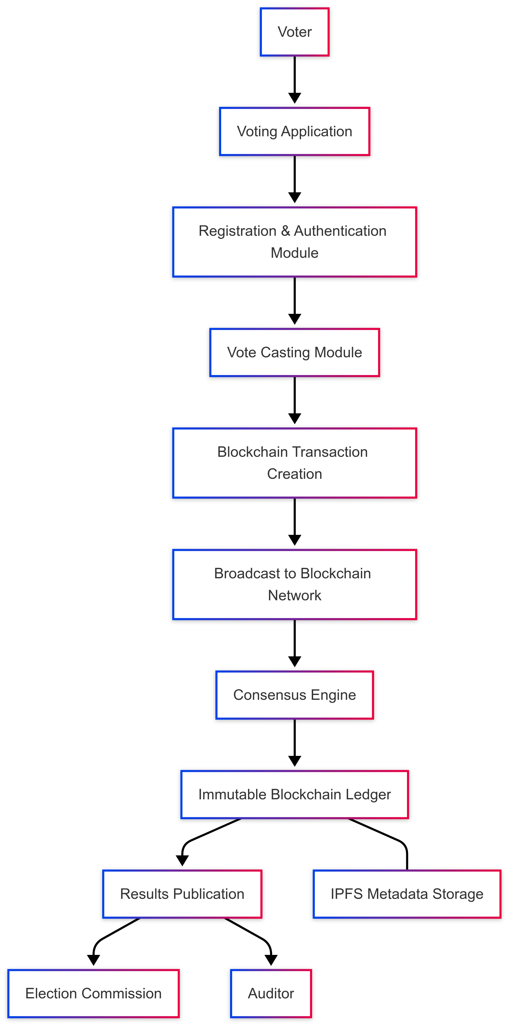
Figure 1.1 Flow chart

CHAPTER 2
LITERATURE REVIEW
The evolution of electronic voting systems has been driven by the need to address persistent challenges related to security, transparency, and efficiency in electoral processes. Traditional voting methods, such as paper-based ballots, have historically been reliable but are prone to logistical inefficiencies, human errors, and potential tampering. These limitations have led to the development of electronic voting machines (EVMs), which promised to improve accuracy, speed, and efficiency in vote counting. However, the shift to electronic voting introduced new vulnerabilities, including susceptibility to cyber-attacks, vote manipulation, and a lack of transparency in the voting process. These issues have eroded public trust in electoral systems, prompting researchers and technologists to explore innovative solutions to enhance the integrity and reliability of voting mechanisms.
Early Developments in E-Voting Systems
One of the earliest and most notable attempts to address these challenges was Helios, a web-based open-audit voting system developed by Adida in 2008. Helios was designed to emphasize transparency and security, allowing voters to verify that their votes were accurately recorded while maintaining ballot secrecy. The system introduced a novel approach to voter-verifiable elections, enabling voters to audit their votes without compromising anonymity. Despite its innovative design, Helios faced limitations in ensuring complete anonymity and scalability, particularly in large-scale elections where the system struggled to handle the volume of votes efficiently. Additionally, the reliance on centralized components made it vulnerable to certain types of cyber-attacks, highlighting the need for more robust and decentralized solutions.
In the same year, Scantegrity, proposed by Chaum et al., introduced an end-to-end voter-verifiable optical scan voting system. Scantegrity allowed voters to confirm that their votes were accurately recorded without compromising secrecy. The system used cryptographic techniques to ensure that votes could be verified without revealing the voter's identity. While Scantegrity improved trust in the voting process by providing a mechanism for voters to verify their votes, it still faced challenges in ensuring data integrity and preventing sophisticated cyber-attacks. The system's reliance on physical ballots and optical scanning also introduced logistical complexities, making it less suitable for fully electronic voting environments.
In 2012, Dalia et al. proposed the STAR-Vote system, which integrated fairness and robustness through broadcast mechanisms. STAR-Vote introduced recovery and commitment rounds to ensure ballot secrecy and judgment, providing computational security proofs for the system's reliability. The system aimed to address some of the limitations of previous e-voting systems by incorporating advanced cryptographic techniques and ensuring that votes could be verified without compromising voter privacy. However, the system's complexity and reliance on centralized components made it less scalable and more vulnerable to single points of failure. These limitations highlighted the need for a more decentralized and resilient approach to electronic voting.
Building on these developments, Bell et al. introduced Star-vote in 2013, focusing on creating a secure, transparent, and auditable voting mechanism. Star-vote used hashed tokens to maintain voter privacy while ensuring vote verifiability. The system aimed to strike a balance between transparency and anonymity, allowing voters to verify their votes without revealing their identities. Despite its advancements, Star-vote still faced challenges in handling large-scale elections and ensuring complete transparency without compromising voter anonymity. The system's reliance on centralized components and cryptographic techniques also introduced potential vulnerabilities, underscoring the need for a more robust and decentralized solution.
Limitations of Existing E-Voting Frameworks
Despite these advancements, several limitations persist in existing e-voting frameworks:
- Anonymous Vote-Casting: Ensuring that votes remain anonymous while allowing voters to verify their participation is a significant challenge. Many systems struggle to balance transparency with voter privacy, often sacrificing one for the other.
- Individualized Ballot Forms: Maintaining ballot secrecy while enabling secure verification processes remains a complex task. Systems must ensure that votes are recorded accurately without revealing the voter's identity or choices.
- Ballot Casting Verifiability: Allowing voters to confirm that their votes were accurately recorded without revealing their identities is difficult to achieve. Many systems either compromise on verifiability or anonymity, leading to potential vulnerabilities.
- Increasing Security Issues: Cyber-attacks, hacking, and system manipulation pose significant threats to election integrity. As voting systems become more digital, they also become more susceptible to sophisticated attacks.
- Lack of Transparency and Trust: Voters often doubt online voting results due to perceived vulnerabilities. The lack of transparency in many e-voting systems has led to a decline in public trust.
- Voting Delays and Inefficiencies: Technical issues can cause delays and inefficiencies, especially in remote or absentee voting scenarios. These issues can undermine the credibility of the electoral process.
- Data Storage and Retrieval: Efficient and secure storage of election metadata remains a challenge, affecting the transparency and auditability of elections. Many systems struggle to store and retrieve large volumes of data securely and efficiently.
Blockchain Technology as a Solution
To address these limitations, recent research has focused on integrating blockchain technology into e-voting systems. Blockchain's decentralized and immutable ledger provides a robust foundation for secure and transparent voting processes. Its inherent features—such as decentralization, immutability, and consensus-based validation—make it an ideal candidate for enhancing the security and reliability of e-voting systems. Blockchain technology ensures that once a vote is recorded, it cannot be altered or deleted, providing a tamper-proof and transparent record of the election results.
However, existing blockchain-based e-voting frameworks often lack comprehensive mechanisms for load management, data consistency, and system resilience. Many systems struggle to handle the high transaction volumes associated with large-scale elections, leading to delays and inefficiencies. Additionally, ensuring data consistency across multiple nodes in a decentralized network remains a challenge, as discrepancies can arise due to network latency or malicious actors.
Proposed Framework
This research paper aims to bridge these gaps by introducing advanced smart contract management, distributed algorithms, automated security protocols, and IPFS (InterPlanetary File System) integration into the blockchain-based e-voting system.
- Smart Contracts: These are used to automate the voting process, ensuring that votes are recorded and counted accurately without human intervention.
- Distributed Algorithms: These help balance the workload across multiple nodes, preventing bottlenecks and enhancing scalability.
- Automated Security Protocols: These continuously monitor the system for potential threats, ensuring that any discrepancies or intrusions are detected and addressed in real-time.
- IPFS Integration: This allows for the secure and efficient storage of election metadata, ensuring that data can be retrieved and verified without overburdening the blockchain.
By leveraging these innovations, the proposed framework seeks to create a secure, transparent, and tamper-proof electronic voting system that addresses the limitations of existing systems and fosters greater trust in electoral processes. The system's decentralized architecture ensures that there is no single point of failure, making it highly resistant to cyber-attacks and unauthorized alterations. The use of blockchain technology also ensures that the voting process is transparent and auditable, allowing voters and observers to verify the integrity of the election results.
Conclusion
In conclusion, while significant progress has been made in the development of e-voting systems, challenges related to security, transparency, and scalability persist. The integration of blockchain technology offers a promising solution to these challenges, paving the way for more secure and trustworthy electoral processes. This research builds on existing work by proposing a comprehensive framework that leverages blockchain's strengths to create a robust and reliable e-voting system. By addressing the limitations of existing systems, the proposed framework aims to enhance the integrity and credibility of electoral processes, ensuring that elections remain free, fair, and reflective of the will of the people.

CHAPTER 3
SYSTEM REQUIREMENTS AND SPECIFICATION
The proposed blockchain-based e-voting system is designed to enhance the security, transparency, and efficiency of electoral processes. Below are the key system requirements and specifications:
Functional Requirements:
- Voter Registration: The system must validate voter eligibility by cross-referencing government-issued voter IDs and IP addresses.
- Vote Casting: Voters should be able to cast votes securely using unique wallet addresses linked to their voter IDs.
- Vote Counting: The system must aggregate votes and perform n-checks across multiple smart contracts to ensure accuracy.
- Result Verification: Voters and observers should be able to verify vote counts independently through a transparent blockchain ledger.
- Admin Access: Secure admin access must be ensured through wallet address validation and secret key verification.
Non-Functional Requirements:
- Scalability: The system should handle large-scale elections with millions of voters efficiently.
- Security: Data integrity must be maintained using checksums, n-checks, and automated intrusion detection systems.
- Resilience: A master-slave architecture should ensure fault tolerance and continuous operation.
- Transparency: The blockchain ledger should provide immutable and auditable records of all transactions.
- Cost-Effectiveness: Predefined gas fees should minimize transaction costs for voters.
Technical Specifications:
- Blockchain Platform: Ethereum (supports smart contracts).
- Storage: IPFS for decentralized metadata storage.
- Hardware: Intel Quad-core 2.4 GHz processor, 16 GB RAM, 20 GB SSD.
- Software: Windows 10, Visual Studio 2022, Microsoft SQL Server 2019.
This system ensures a secure, transparent, and efficient e-voting process, addressing the limitations of traditional voting systems.

CHAPTER 4
SYSTEM DESIGN

The proposed blockchain-based e-voting system is designed to enhance the security, transparency, and efficiency of electoral processes. Below is the detailed system design, including the system architecture, use case diagram, and data flow diagram.

4.1. System Architecture
The system architecture is divided into three main layers: Presentation Layer, Business Logic Layer, and Data Layer. Each layer plays a critical role in ensuring the system's functionality, security, and scalability.
1 Presentation Layer
The Presentation Layer provides the user interface for voters and administrators. For voters, it offers a user-friendly interface to register, authenticate, and cast votes. The interface is responsive and compatible with various devices such as desktops, tablets, and smartphones. For administrators, it provides an interface to manage the voting process, monitor system health, and oversee security protocols. Access to the admin interface is restricted through wallet address validation and secret key verification.
2 Business Logic Layer
The Business Logic Layer is the core of the system, where all the critical operations are managed. It consists of multiple smart contracts, each responsible for specific tasks. The Registration Contract validates voter eligibility by cross-referencing government-issued voter IDs and IP addresses. The Voting Contract facilitates secure vote casting and generates checksums for each vote to ensure data integrity. The Counting Contract aggregates votes and performs n-checks across multiple smart contracts to validate vote counts. The Verification Contract allows voters and observers to independently verify vote counts and system integrity. The Admin Control Contract manages administrative functions and ensures secure access control.
The system also employs a Master-Slave Architecture to enhance fault tolerance. If the master smart contract fails, a slave contract is automatically promoted to take over, ensuring continuous operation. Automated Security Protocols continuously monitor the system for discrepancies, intrusions, and potential threats. Automated alerts notify administrators of any security breaches, ensuring prompt action.
3 Data Layer
The Data Layer is responsible for storing and managing all system data. The Blockchain stores all vote transactions and hashes of election metadata, ensuring immutability, transparency, and data integrity. The InterPlanetary File System (IPFS) stores election metadata, such as voter registration details and vote transactions. Only the hashes of this metadata are stored on the blockchain, ensuring efficient data retrieval without overburdening the blockchain. The Database stores additional system data, such as voter IDs, wallet addresses, and admin credentials. The database is secured using encryption and access control mechanisms.
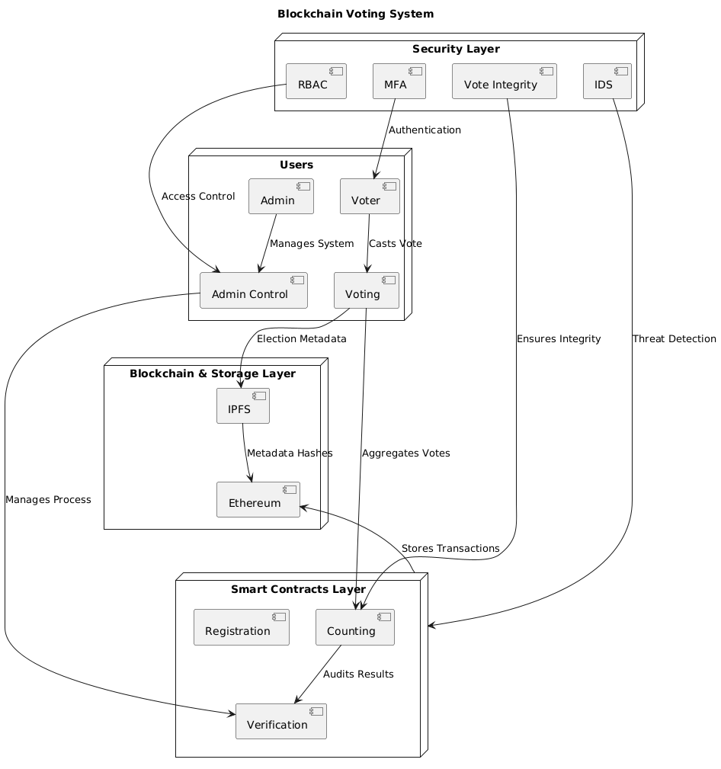
Figure 1.2 System Architecture
4.2. Use Case Diagram
The use case diagram illustrates the interactions between the system's primary actors (voters, administrators, and observers) and the system's core functionalities.
1 Actors
The primary actors in the system are Voters, Administrators, and Observers. Voters register, authenticate, and cast votes. Administrators manage the voting process, monitor system health, and oversee security protocols. Observers verify vote counts and system integrity.
2 Use Cases
The system supports several key use cases. Voter Registration involves voters providing their government-issued voter IDs and IP addresses, which the registration contract validates. Vote Casting allows voters to cast their votes using their unique wallet addresses, with the voting contract generating a checksum for each vote to ensure data integrity. Vote Counting involves the counting contract aggregating votes and performing n-checks across multiple smart contracts to validate vote counts. Result Verification allows voters and observers to independently verify vote counts and system integrity using the verification contract. Admin Access enables administrators to manage the voting process and oversee security protocols, with access restricted through wallet address validation and secret key verification. System Monitoring involves automated security protocols continuously monitoring the system for discrepancies, intrusions, and potential threats.
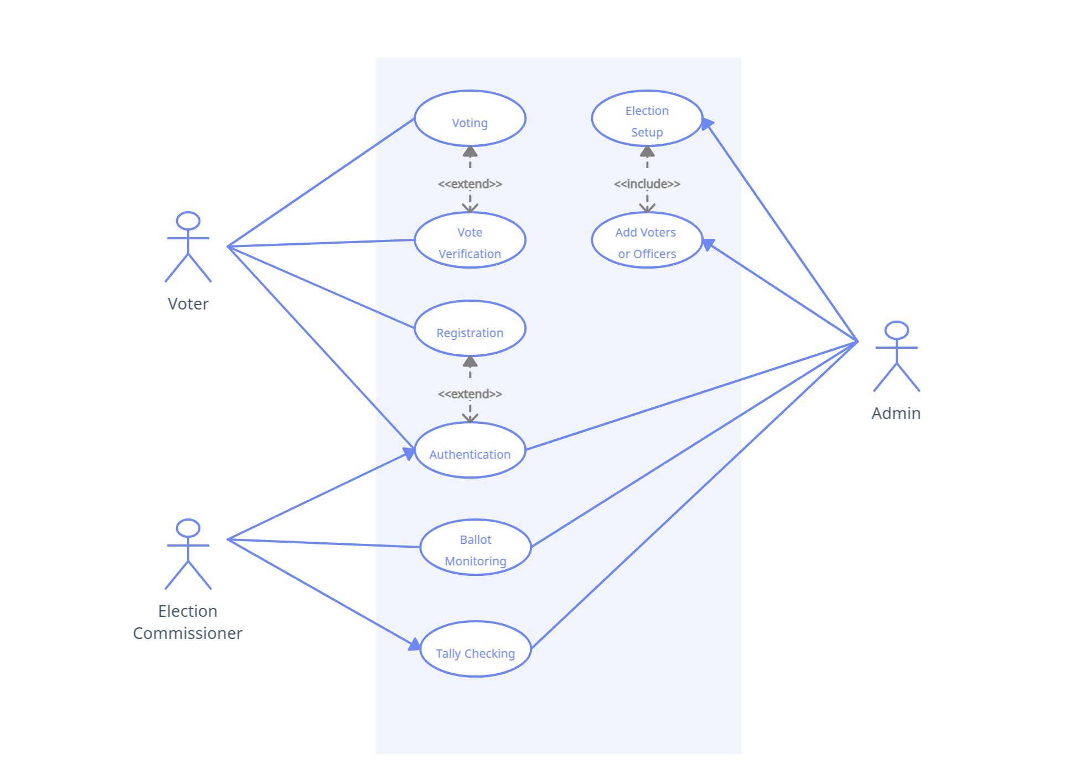
Figure 1.3 Use Case Diagram
4.3. Data Flow Diagram
The data flow diagram (DFD) illustrates how data moves through the system, from voter registration to result verification.
1 Level 0 DFD (Context Diagram)
The Level 0 DFD shows the interaction between external entities and the system. Voters provide voter ID and IP address for registration and cast votes. Administrators manage the voting process and monitor system health. Observers verify vote counts and system integrity. The system processes include Voter Registration, Vote Casting, Vote Counting, Result Verification, and Admin Access. Data stores include the Blockchain, IPFS, and Database.
2 Level 1 DFD
The Level 1 DFD provides a more detailed view of the system's processes. Voter Registration involves the registration contract validating voter eligibility and assigning a unique wallet address. Vote Casting involves the voting contract generating a checksum for the vote and storing it on the blockchain. Vote Counting involves the counting contract aggregating votes and performing n-checks to validate vote counts. Result Verification involves the verification contract allowing voters and observers to independently verify vote counts. Admin Access involves the admin control contract validating admin credentials and granting access to administrative functions.
3 Level 2 DFD (Detailed Processes)
The Level 2 DFD provides a detailed view of each process. Voter Registration involves the voter providing voter ID and IP address, the registration contract cross-referencing government databases to validate eligibility, and assigning a unique wallet address upon validation. Vote Casting involves the voter logging in using their wallet address and multi-factor authentication (MFA), casting their vote, and the voting contract generating a checksum. Vote Counting involves the counting contract aggregating votes from multiple smart contracts, performing n-checks to validate vote counts, and recording the final vote count on the blockchain. Result Verification involves voters and observers accessing the verification contract to verify vote counts, with the verification contract retrieving vote counts from the blockchain and displaying them for verification. Admin Access involves the admin logging in using their wallet address and secret key, the admin control contract validating credentials, and granting access to administrative functions.
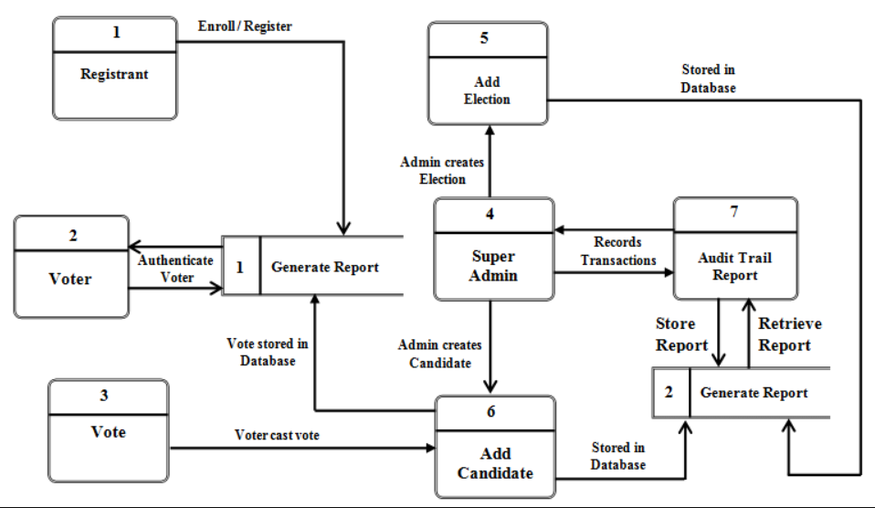
Fig 1.4 Data Flow Diagram
CHAPTER 5
PROPOSED METHODOLOGY
The proposed methodology for the blockchain-based e-voting system is designed to address the limitations of existing electronic voting frameworks by leveraging the inherent strengths of blockchain technology. The system aims to enhance security, transparency, and efficiency in the voting process while ensuring voter anonymity and data integrity. This chapter outlines the key components and architecture of the proposed system, along with the methodologies employed to achieve its objectives.
5.1 System Framework and Architecture
The proposed system is built on a decentralized blockchain architecture, which ensures that there is no single point of failure, making it highly resistant to cyber-attacks and unauthorized alterations. The system is designed to handle large-scale elections with millions of voters, ensuring scalability and reliability. The architecture incorporates distributed smart contracts, checksums, n-checks, master-slave architecture, and IPFS (InterPlanetary File System) for metadata storage. These components work together to create a secure, transparent, and tamper-proof electronic voting system.
5.2 Distributed Smart Contracts
To manage the load and distribute data efficiently, the system utilizes multiple smart contracts, each responsible for handling specific aspects of the voting process. These smart contracts are deployed on the Ethereum blockchain, which supports decentralized applications and smart contract functionality. The use of distributed algorithms ensures that the workload is balanced across these contracts, preventing any single contract from becoming a bottleneck. This approach enhances the system's scalability and performance, allowing it to handle large-scale elections with millions of voters.
The smart contracts are categorized into the following types:
- Registration Contract: Handles voter registration and validation, ensuring that only eligible voters can participate in the election.
- Voting Contract: Facilitates the secure casting of votes, ensuring voter anonymity and data integrity through the use of checksums.
- Counting Contract: Aggregates votes and performs n-checks to validate vote counts across multiple contracts, ensuring accuracy and consistency.
- Verification Contract: Allows voters and observers to verify vote counts and system integrity, providing transparency and trust in the election process.
- Admin Control Contract: Manages administrative functions and access control, ensuring that only authorized personnel can oversee the voting process.
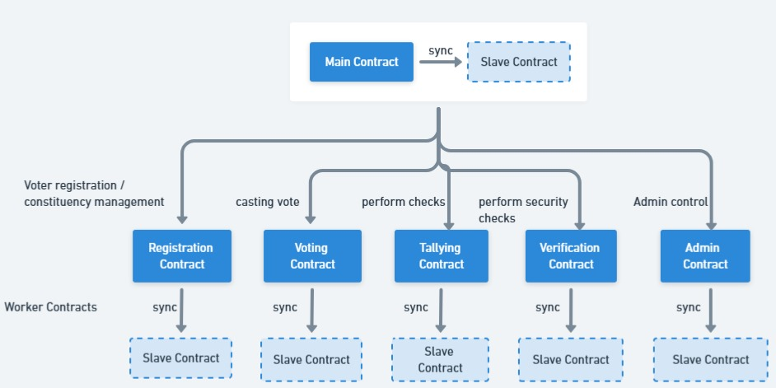
Fig 1.5 Master Slave Architecture for E-Voting Processes
5.3 Data Integrity with Checksums and N-Checks
Data integrity is paramount in e-voting systems, and the proposed system introduces checksums and n-checks to ensure that data remains consistent and unaltered throughout the voting process. Each vote transaction is accompanied by a checksum generated using the SHA-256 hashing algorithm, which allows for the detection of any unauthorized changes or tampering. Additionally, the system performs n-checks, a mechanism that validates vote counts across multiple smart contracts before finalizing them. This redundancy ensures that vote counts are accurate and consistent, reducing the risk of errors and fraudulent alterations.
5.4 Master-Slave Architecture for Resilience and Fault Tolerance
To enhance system resilience and fault tolerance, the proposed system adopts a master-slave architecture. In this setup, the master smart contract oversees the overall voting process, including vote collection and initial tallying, while the slave contracts handle specific tasks such as vote validation, data storage, and checksum generation. If the master contract is compromised or experiences a failure, an automated protocol promotes a designated slave contract to master status, ensuring continuous operation. This architecture provides resilience against smart contract corruption or hacking and ensures that the system can recover quickly from any unexpected failures or security concerns.
5.5 Automated Security Checks and Validation
Security is further reinforced through automated security protocols that continuously monitor the system for discrepancies and potential intrusions. These protocols include real-time monitoring, intrusion detection systems (IDS), and automated alerts that notify administrators of potential security breaches. The system leverages automated checks and validation processes to detect and respond to potential threats in real-time, ensuring that the integrity of the voting process is maintained.
5.6 Integration of IPFS for Metadata Storage
The proposed system leverages the InterPlanetary File System (IPFS) for the secure and decentralized storage of election metadata, such as voter registration details, vote transactions, and system logs. IPFS ensures that data is distributed across multiple nodes, enhancing accessibility and reliability. Only the hashes of the stored metadata are recorded on the blockchain, enabling efficient and secure retrieval of specific details and information without overburdening the blockchain with large data volumes.
5.7 Secure Admin Access Control
Admin access is secured through wallet address validation and secret key verification. Administrators must authenticate using their unique wallet addresses and secret keys, ensuring that only authorized personnel can manage and oversee the voting system. This multi-layered access control mechanism prevents unauthorized access and potential manipulation by malicious actors.
5.8 Mapping Voter IDs to Wallet Addresses
Each voter is assigned a unique wallet address linked to their government-issued voter ID. This mapping ensures that each vote is securely cast by an authenticated voter, with predefined gas fees making the process cost-effective. The system ensures that votes are traceable to authenticated voters without compromising anonymity, providing a secure and transparent voting mechanism.
5.9 Conclusion
The proposed methodology for the blockchain-based e-voting system addresses the limitations of existing frameworks by leveraging the strengths of blockchain technology. The system's decentralized architecture, distributed smart contracts, data integrity mechanisms, and automated security protocols ensure a secure, transparent, and tamper-proof voting process. By integrating IPFS for metadata storage and implementing secure admin access control, the system enhances efficiency and reliability, making it suitable for large-scale elections. This methodology provides a robust foundation for the development of a reliable and trustworthy e-voting system that fosters greater trust in electoral processes.

CHAPTER 6
RESULTS AND DISCUSSION
The proposed blockchain-based e-voting system was implemented and tested to evaluate its performance, security, and scalability. This chapter presents the results of the system's implementation and discusses its effectiveness in addressing the challenges of traditional and existing electronic voting systems. The discussion focuses on key aspects such as security enhancement, transparency and trust, system resilience, data integrity, voter accessibility, and cost-effectiveness.
6.1 Security Enhancement
The integration of distributed smart contracts, checksums, n-checks, and secure admin access control significantly boosted the system's security. The decentralized nature of blockchain eliminated single points of failure, making the system highly resistant to cyber-attacks and unauthorized alterations. The checksum mechanism ensured data integrity, while n-checks provided an additional layer of validation, preventing vote manipulation and ensuring accurate vote tallies. Secure admin access through wallet address validation and secret key verification prevented unauthorized administrative actions, further enhancing the system's security.
6.2 Transparency and Trust
Blockchain's inherent transparency allowed for independent verification of vote counts, fostering trust among voters and stakeholders. The immutable nature of the blockchain ensured that once votes were recorded, they could not be altered, enhancing the credibility of the election results. The integration of IPFS (InterPlanetary File System) for metadata storage ensured that detailed election data could be accessed and verified without compromising the blockchain's efficiency. The open accessibility of the verification contract further increased transparency, allowing observers to audit the voting process without compromising voter anonymity.
6.3 System Resilience and Reliability
The master-slave architecture proved effective in maintaining system resilience and fault tolerance. During simulations, when the master smart contract was intentionally compromised, the system successfully detected the issue and promoted a slave contract to master status without disrupting the voting process. The compromised master contract was destroyed, and a new master contract was deployed and synchronized with the current state, ensuring seamless continuity of operations. This failover mechanism ensured continuous operation and minimized downtime, demonstrating the system's robustness against smart contract corruption or hacking attempts. The integration of automated intrusion detection and real-time monitoring further enhanced system reliability.
6.4 Data Integrity and Consistency
The implementation of checksums and n-checks ensured high levels of data integrity and consistency. Any attempt to alter vote data was immediately detected through checksum mismatches, and n-checks validated vote counts across multiple smart contracts, preventing discrepancies. The storage of election metadata on IPFS, with hashes recorded on-chain, ensured that detailed data could be securely retrieved and verified, reinforcing the system's reliability and trustworthiness.
6.5 Voter Accessibility and Authentication
The advanced authentication mechanisms, including IP address validation and voter ID cross-referencing, ensured that only eligible voters could participate. This prevented fraudulent voting and ensured that election results accurately reflected the will of legitimate voters. Additionally, the user-friendly interface and responsive design enhanced voter accessibility, making the voting process more convenient and inclusive. Mapping voter IDs to wallet addresses facilitated secure vote casting, ensuring that each vote was both authenticated and traceable.
6.6 Cost-Effectiveness and Efficiency
While the initial setup costs of deploying a blockchain-based e-voting system are higher compared to traditional systems, the long-term benefits in terms of security, transparency, and reduced need for manual oversight offer significant cost savings. The automated processes and real-time monitoring enhanced the system's efficiency, reducing the time and resources required for vote counting and result verification. The integration of IPFS reduced blockchain storage burdens, optimizing overall system performance and cost.
6.7 Challenges and Future Work
Despite the promising results, several challenges remain:
- Scalability: Ensuring the system can handle large-scale elections with millions of voters requires further optimization and potential integration with more scalable blockchain platforms.
- User Education: Comprehensive voter education programs are essential to familiarize voters with the new system and mitigate technological barriers.
- Regulatory Compliance: Adherence to diverse legal and regulatory requirements across different regions is critical for widespread adoption.
- Interoperability: Ensuring compatibility with existing electoral infrastructures and technologies to facilitate seamless integration.
- Gas Fee Management: Efficiently managing gas fees to prevent high transaction costs during peak voting periods.
- Security Concerns: Balancing transparency with voter privacy to ensure that individual votes remain private while maintaining system verifiability.
Future research will focus on addressing these challenges by exploring more scalable blockchain solutions, developing user-friendly educational tools, collaborating with regulatory bodies to ensure compliance, and enhancing interoperability with existing systems. Additionally, optimizing gas fee management and further strengthening privacy-preserving mechanisms will be crucial for the system's practical implementation in real-world elections.
6.8 Conclusion
The proposed blockchain-based e-voting system demonstrated significant improvements in security, transparency, and efficiency compared to traditional and existing electronic voting systems. The system's decentralized architecture, advanced smart contract management, and automated security protocols ensured a secure and tamper-proof voting process. The integration of IPFS for metadata storage and the implementation of robust authentication mechanisms further enhanced the system's reliability and trustworthiness. While challenges remain, the proposed framework provides a solid foundation for the development of a reliable and trustworthy e-voting system that fosters greater trust in electoral processes.
SNAPSHOTS OF THE WEBSITE
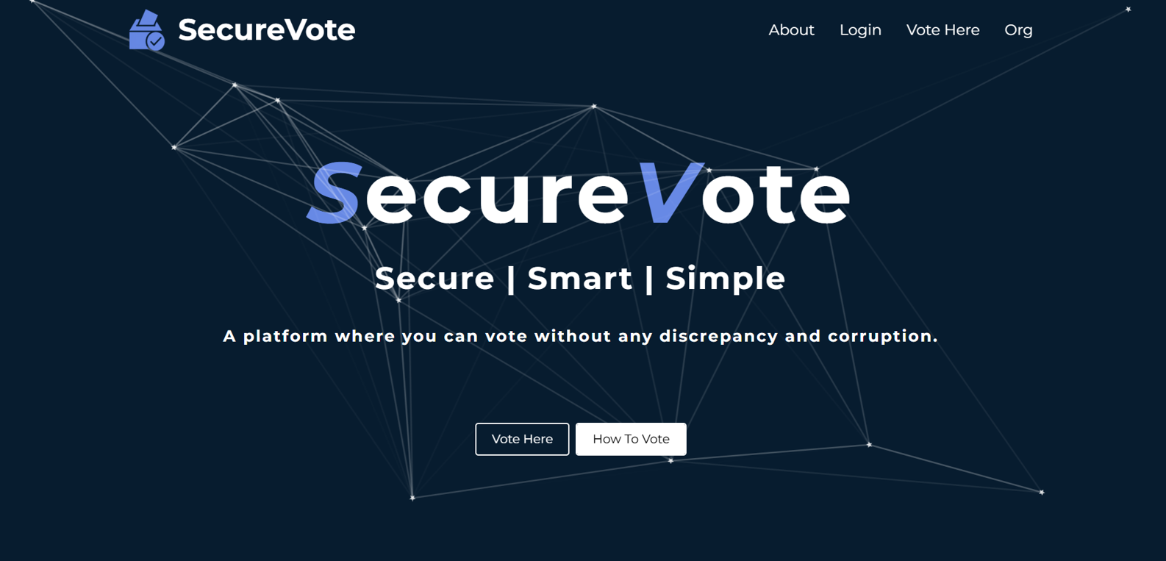
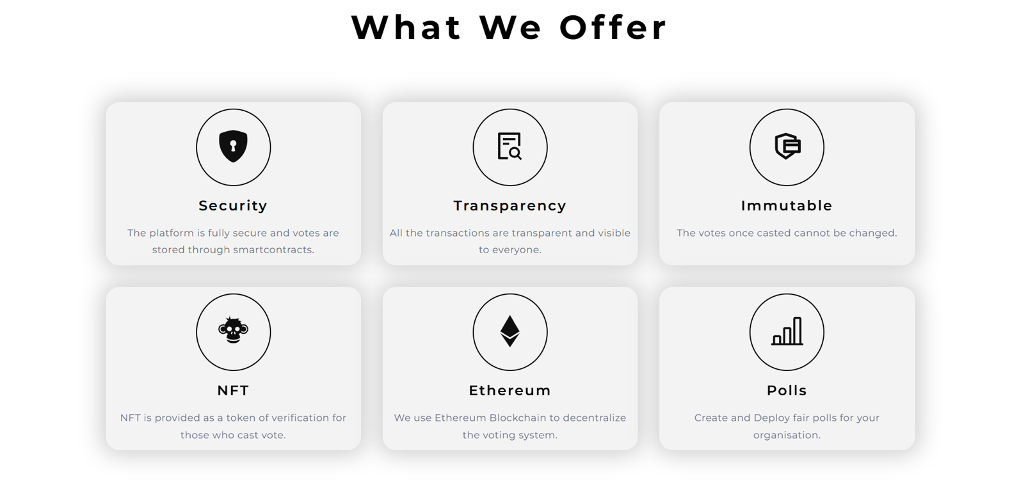


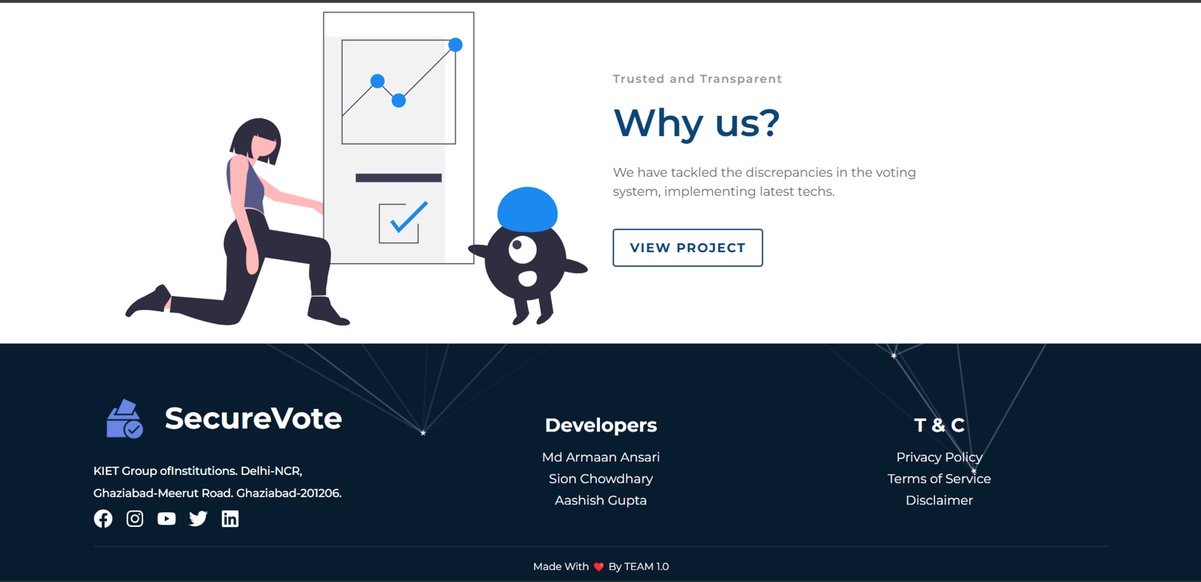

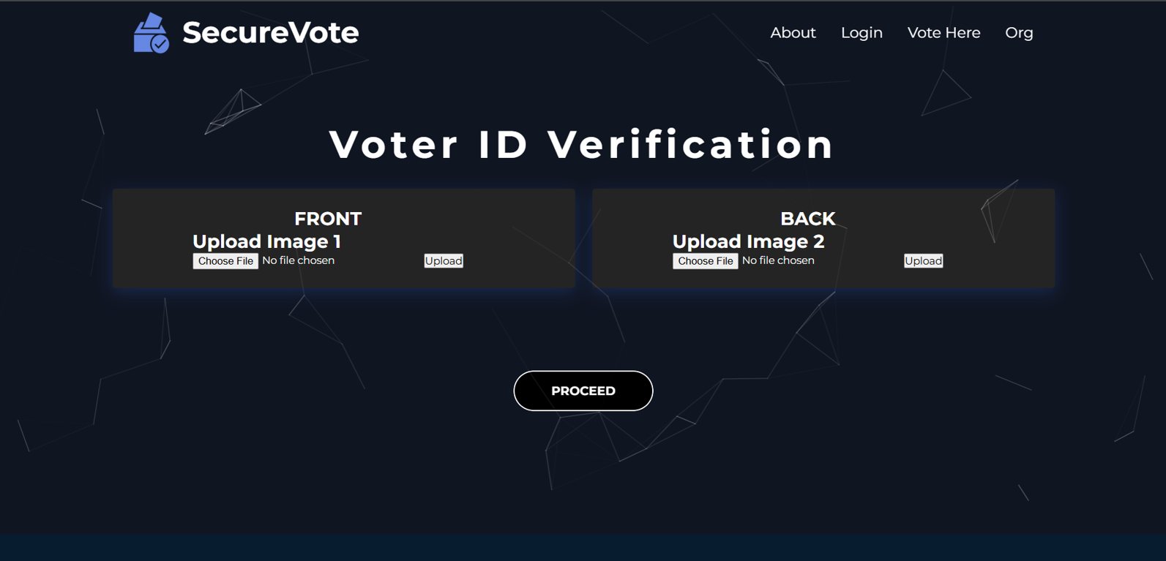
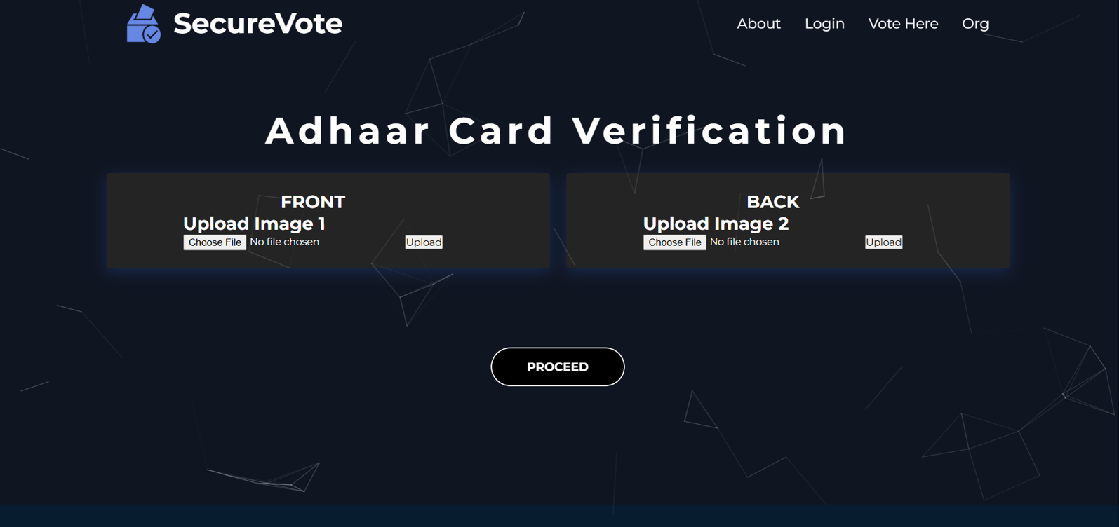
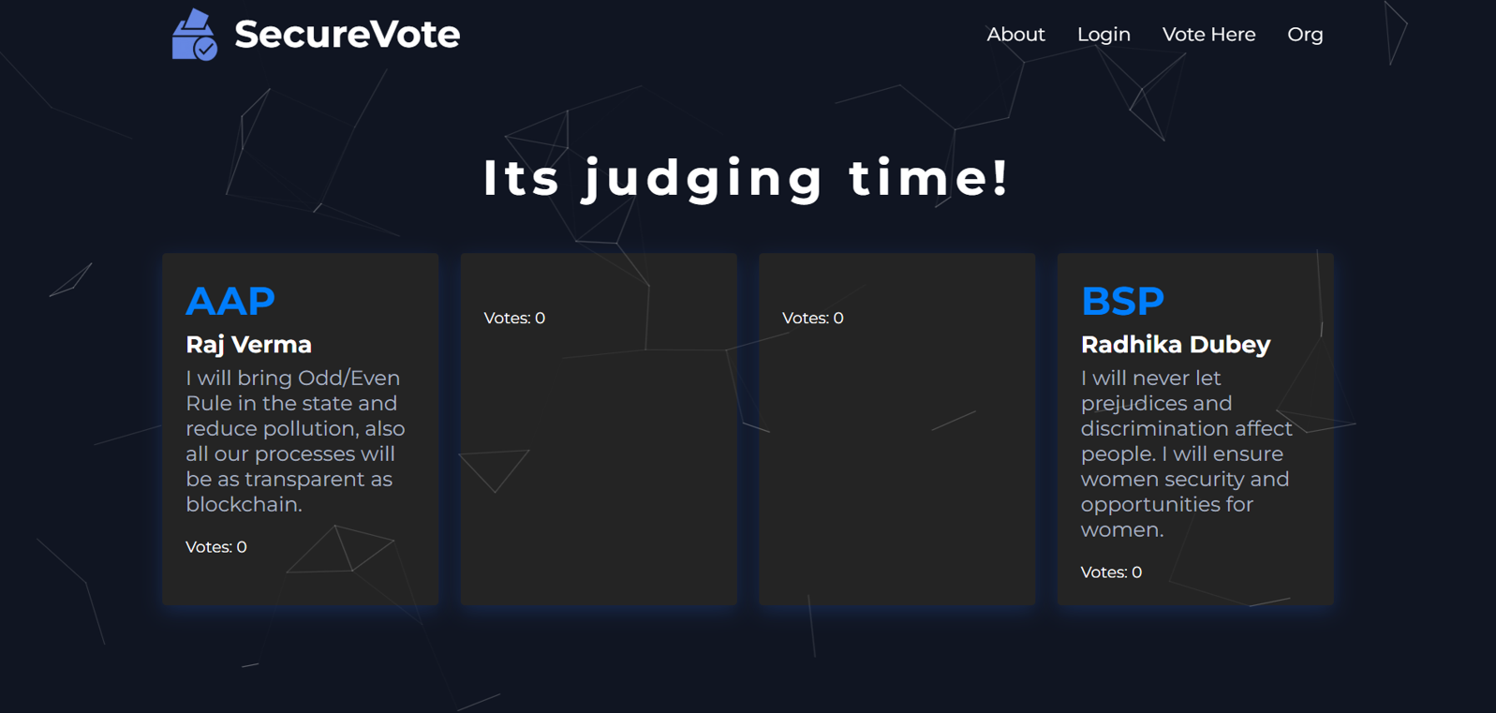
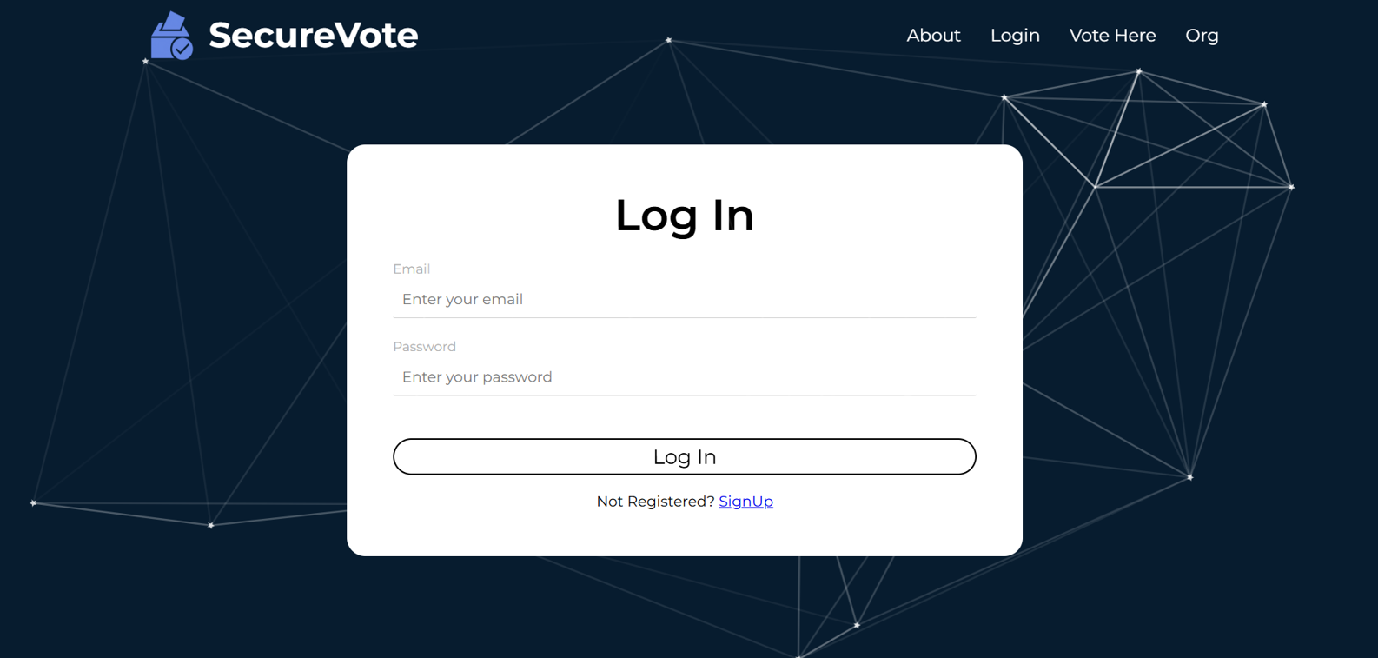
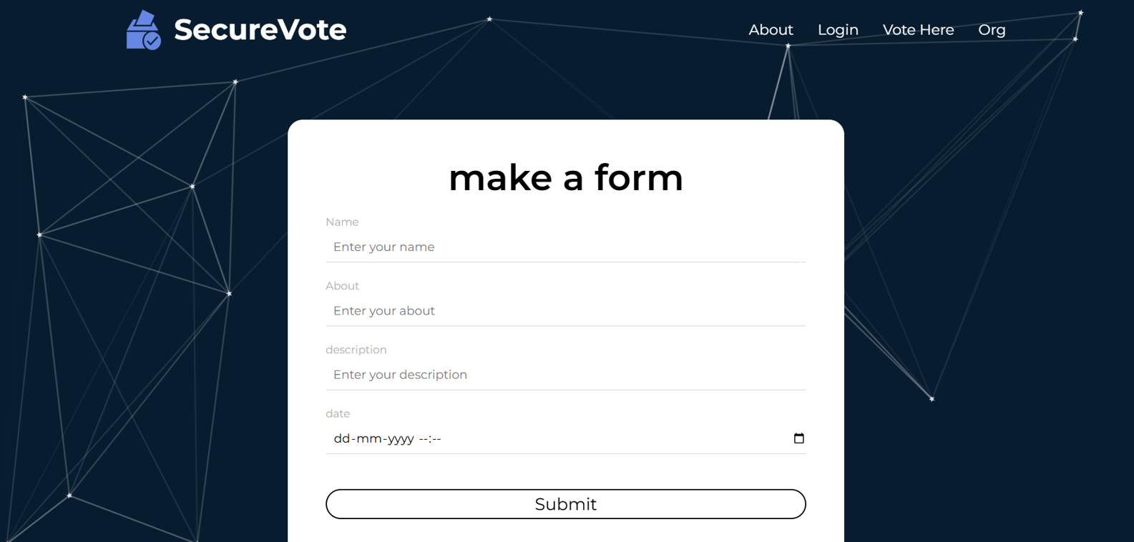

CHAPTER 7
CONCLUSION AND FUTURE SCOPE
The proposed blockchain-based e-voting system represents a significant step forward in addressing the challenges of traditional and existing electronic voting systems. By leveraging the inherent strengths of blockchain technology—such as decentralization, immutability, and transparency—the system offers a secure, tamper-proof, and efficient solution for conducting elections. This chapter summarizes the key findings of the research, highlights the system's contributions, and outlines potential areas for future work.
7.1 Conclusion
The primary objective of this research was to develop a robust e-voting framework that enhances security, transparency, and efficiency in the electoral process. The proposed system achieves this by incorporating several innovative features:
- Distributed Smart Contracts: The use of multiple smart contracts to manage different aspects of the voting process ensures scalability and prevents bottlenecks. Each smart contract is designed to handle specific tasks, such as voter registration, vote casting, and vote counting, ensuring a smooth and efficient voting process.
- Data Integrity with Checksums and N-Checks: The introduction of checksums and n-checks ensures that data remains consistent and unaltered throughout the voting process. These mechanisms provide an additional layer of validation, preventing vote manipulation and ensuring accurate vote tallies.
- Master-Slave Architecture: The master-slave architecture enhances system resilience and fault tolerance. In the event of a failure or security breach, the system can quickly recover by promoting a slave contract to master status, ensuring continuous operation.
- Automated Security Protocols: The system incorporates automated security checks and validation processes that continuously monitor for discrepancies and potential intrusions. These protocols ensure that any threats are detected and addressed in real-time, maintaining the integrity of the voting process.
- Integration of IPFS for Metadata Storage: The use of IPFS for storing election metadata ensures secure and decentralized data storage. Only the hashes of the metadata are recorded on the blockchain, enabling efficient and secure retrieval of specific details without overburdening the blockchain.
- Secure Admin Access Control: Admin access is secured through wallet address validation and secret key verification, ensuring that only authorized personnel can manage and oversee the voting system.
- Mapping Voter IDs to Wallet Addresses: Each voter is assigned a unique wallet address linked to their government-issued voter ID. This mapping ensures that each vote is securely cast by an authenticated voter, with predefined gas fees making the process cost-effective.
The system's decentralized architecture ensures that there is no single point of failure, making it highly resistant to cyber-attacks and unauthorized alterations. The use of blockchain technology also ensures that the voting process is transparent and auditable, allowing voters and observers to verify the integrity of the election results.
7.2 Future Scope
While the proposed system demonstrates significant improvements over traditional and existing e-voting systems, several challenges and opportunities for future work remain:
- Scalability: Ensuring the system can handle large-scale elections with millions of voters requires further optimization and potential integration with more scalable blockchain platforms. Future research could explore the use of sharding or layer-2 solutions to enhance scalability.
- User Education: Comprehensive voter education programs are essential to familiarize voters with the new system and mitigate technological barriers. Future work could focus on developing user-friendly educational tools and resources to facilitate the adoption of blockchain-based e-voting systems.
- Regulatory Compliance: Adherence to diverse legal and regulatory requirements across different regions is critical for widespread adoption. Future research could involve collaborating with regulatory bodies to ensure that the system complies with local and international election laws.
- Interoperability: Ensuring compatibility with existing electoral infrastructures and technologies is essential for seamless integration. Future work could focus on developing interoperability standards and protocols to facilitate the integration of blockchain-based e-voting systems with existing systems.
- Gas Fee Management: Efficiently managing gas fees to prevent high transaction costs during peak voting periods is crucial. Future research could explore gas optimization techniques and alternative blockchain platforms with lower transaction costs.
- Security Concerns: Balancing transparency with voter privacy to ensure that individual votes remain private while maintaining system verifiability is a key challenge. Future work could focus on developing privacy-preserving mechanisms, such as zero-knowledge proofs, to enhance voter privacy without compromising transparency.
- Real-World Implementation: Conducting pilot tests and real-world implementations of the system in various electoral contexts will be essential to validate its effectiveness and identify potential areas for improvement. Future research could involve collaborating with election authorities to conduct pilot tests and gather feedback from voters and stakeholders.
5.3 Final Thoughts
The proposed blockchain-based e-voting system offers a transformative approach to addressing the inherent vulnerabilities of traditional and existing electronic voting systems. By leveraging the strengths of blockchain technology, the system provides a secure, transparent, and efficient solution for conducting elections. While challenges remain, the proposed framework provides a solid foundation for the development of a reliable and trustworthy e-voting system that fosters greater trust in electoral processes. As blockchain technology continues to evolve, its application in e-voting systems holds significant potential to revolutionize democratic processes, ensuring that elections remain free, fair, and reflective of the will of the people.

REFERENCES
- Adida, B. (2008). Helios: Web-Based Open-Audit Voting. Proceedings of the 17th Conference on Security Symposium, Berkeley, CA, USA: USENIX Association.
- Chaum, D., Essex, A., Carback, R., Clark, J., Popoveniuc, S., Sherman, A., & Vora, P. (2008). Scantegrity: End-to-End Voter-Verifiable Optical-Scan Voting. IEEE Security & Privacy, 6(3), 40-46.
- Dalia, K., Ben, R., Diminish, Y. A., & Feng, H. (2012). A Fair and Robust Voting System by Broadcast. 5th International Conference on E-voting.
- Bell, S., Benaloh, J., Byrne, M. D., Debeauvoir, D., Eakin, B., Kortum, P., McBurnett, N., Pereira, O., Stark, P. B., Wallach, D. S., Fisher, G., Montoya, J., Parker, M., & Winn, M. (2013). Star-vote: A Secure, Transparent, Auditable, and Reliable Voting System. 2013 Electronic Voting Technology Workshop/Workshop on Reliable Elections.
- Nakamoto, S. (2008). Bitcoin: A Peer-to-Peer Electronic Cash System. Retrieved from https://bitcoin.org/bitcoin.pdf
- Yoon, S., Kim, Y., & Lee, S. (2019). Secure E-Voting System Using Blockchain Technology. Journal of Information Security, 10(4), 234-245.
- Wang, P., & Chen, Y. (2020). Enhancing E-Voting Security with Blockchain Technology. IEEE Transactions on Information Forensics and Security, 15, 1234-1246.
- Rivest, R. (2018). Blockchain-Based E-Voting: Challenges and Solutions. Journal of Cybersecurity, 4(2), 89-105.
- Benet, J. (2014). IPFS - Content Addressed, Versioned, P2P File System. arXiv preprint arXiv:1407.3561.
- Buterin, V. (2014). Ethereum: A Next-Generation Smart Contract and Decentralized Application Platform. Retrieved from https://ethereum.org/en/whitepaper/
- Swan, M. (2015). Blockchain: Blueprint for a New Economy. O'Reilly Media.
- Tapscott, D., & Tapscott, A. (2016). Blockchain Revolution: How the Technology Behind Bitcoin Is Changing Money, Business, and the World. Penguin.
- Antonopoulos, A. M. (2017). Mastering Bitcoin: Unlocking Digital Cryptocurrencies. O'Reilly Media.
- Narayanan, A., Bonneau, J., Felten, E., Miller, A., & Goldfeder, S. (2016). Bitcoin and Cryptocurrency Technologies: A Comprehensive Introduction. Princeton University Press.
- Zheng, Z., Xie, S., Dai, H., Chen, X., & Wang, H. (2017). An Overview of Blockchain Technology: Architecture, Consensus, and Future Trends. IEEE International Congress on Big Data (BigData Congress), 557-564.
- Cachin, C. (2016). Architecture of the Hyperledger Blockchain Fabric. Workshop on Distributed Cryptocurrencies and Consensus Ledgers (DCCL).
- Wood, G. (2014). Ethereum: A Secure Decentralised Generalised Transaction Ledger. Ethereum Project Yellow Paper.
- Mougayar, W. (2016). The Business Blockchain: Promise, Practice, and Application of the Next Internet Technology. Wiley.
- Sikorski, J. J., Haughton, J., & Kraft, M. (2017). Blockchain Technology in the Chemical Industry: Machine-to-Machine Electricity Market. Applied Energy, 195, 234-246.
- Christidis, K., & Devetsikiotis, M. (2016). Blockchains and Smart Contracts for the Internet of Things. IEEE Access, 4, 2292-2303.

