**TNP Process Automation**

**PROJECT SYNOPSIS**

OF MAJOR PROJECT

**BACHELOR OF TECHNOLOGY**

**SUBMITTED BY:**

Shubham Verma (CSE -C) 2100290100163

Abhishek Kumar Rai (CSE-A) 2100290100008

Parag Gupta (ECE-B) 2100290310101

**2025 BATCH**

Under the supervision of

**Mr. Gaurav Parashar**



## **KIET Group of Institutions, Delhi-NCR,**

## **Ghaziabad (UP)**

## **Department of Computer Science and Engineering**

INDEX

|  |  |  |
| --- | --- | --- |
| **S.no** | **Title** | **Page no** |
| 1 | Introduction | 1 |
| 2 | Rationale | 2 |
| 3 | Objectives | 3 |
| 4 | Literature Review | 3-5 |
| 5 | Methodology | 6 |
| 6 | Feasibility Study | 11 |
| 7 | Facilities Required | 12 |
| 8 | Expected Outcome | 12 |
| 9 | References | 12 |

**INTRODUCTION**

A **Training and Placement (TNP) Management System** is a software application that helps educational institutions to manage the training and placement process of their students. **TNP** provides a centralized platform for students, training and placement officers (TPOs), departments, and human resource (HR) professionals to collaborate and streamline the placement process.

This major project is based on a TPMS with four modules: Student, TNP, Department, and HR.

* **Student module**: Students can use this module to:
  + View details of upcoming **job opportunities**, including eligibility criteria, job description, and company profile.
  + Apply for job openings by uploading their resume and other relevant documents.
  + Track the **status of their job** applications.
  + Maintain their personal information for placement purposes, including **academic qualifications, skills, and experience**.
* **TNP module**: TPOs can use this module to:
  + **Post job** openings from visiting companies.
  + Schedule **interviews** between students and companies.
  + Generate reports on various aspects of the placement process, such as the number of students who **applied** for each job opening, the number of students who were **shortlisted** for interviews, and the number of students who were **placed**.
* **Department module**: Department heads can use this module to view and manage student records related to placement, such as **academic qualifications**, **skills**, and **experience**.
* **HR module**: HR professionals from visiting companies can use this module to:
  + **Post new job** openings.
  + View student profiles and shortlist candidates for interviews.

Overall, the TPMS developed in this major project is a comprehensive and user-friendly solution for managing the training and placement process of educational institutions.

**RATIONALE**

The rationale for developing a **Training and Placement Management System** (TPMS) is to streamline the placement process and improve its efficiency. TPMS is needed because the traditional placement process is often manual and time-consuming. This can be a challenge for educational institutions, especially those with large student populations.

A TPMS can help to address the following challenges:

* **Manual and time-consuming processes**: TPMS can automate many of the manual tasks involved in the placement process, such as posting job openings, scheduling interviews, and generating reports. This can free up TPOs and other staff members to focus on other important tasks, such as providing career counseling to students.
* **Lack of coordination between different stakeholders**: TPMS can provide a centralized platform for students, TPOs, departments, and HR professionals to collaborate and communicate with each other. This can help to improve coordination and reduce the risk of errors.
* **Limited access to information for students**: TPMS can provide students with easy access to information about upcoming job opportunities, their application status, and placement-related resources.

Here are some specific examples of how a TPMS can be used **to improve the placement process**:

* A TPO can use the TPMS to post a job opening from a visiting company. The job opening will be automatically posted on the student portal and students will be able to view it and apply online.
* A student can use the TPMS to view all upcoming job opportunities and apply for the ones they are interested in. They can also track the status of their applications and receive notifications about important updates.
* A TPO can use the TPMS to generate reports on the placement process, such as the number of students who applied for each job opening, the number of students who were shortlisted for interviews, and the number of students who were placed.
* An HR professional from a visiting company can use the TPMS to view student profiles and shortlist candidates for interviews. They can also contact students directly through the TPMS.

**OBJECTIVES**

* To develop a comprehensive and **user-friendly TPMS** that helps educational institutions to streamline the placement process and improve its efficiency.
* To develop a TPMS that provides a centralized platform for students, training and placement officers (TPOs), departments, and human resource (HR) professionals to collaborate and manage the placement process effectively.
* To develop a **TPMS** that benefits students by providing them with easy access to information about upcoming job opportunities, their application status, and placement-related resources.
* To develop a TPMS that helps companies to find qualified candidates for their job openings by providing them with access to a large pool of student profiles.

You can also choose to focus on a specific aspect of the placement process, such as:

* Developing a TPMS that helps to improve the efficiency of the job application process for students.
* Developing a TPMS that helps to improve the coordination between TPOs, departments, and HR professionals during the placement process.
* Developing a TPMS that helps to improve the transparency of the placement process for students.
* Developing a TPMS that helps to improve the accessibility of the placement process for students with disabilities

**LITERATURE REVIEW**

**Research Paper 1**

Title: Role of Training and Placement Cell to Enhance the Competitive Skills Among Students in Finding Right Opportunity

Author:- Aditya Vir Singh1 , Vinod Kumar Bishnoi2 , Dalbir Singh3

Training and Placement Cell Objectives

1 -To bridge the gap between the skills and knowledge required by employers and the skills and knowledge possessed by students, through a variety of training and development programs.

2-To prepare students for the competitive job market by equipping them with the necessary hard skills (such as technical skills and domain knowledge) and soft skills (such as communication, teamwork, and problem-solving skills).

To enable students to identify and develop their unique talents and potential, through career counseling and guidance services.

To enhance students' comprehensive and soft skills through workshops, seminars, and other activities. This includes developing their communication skills, both written and verbal; their teamwork and collaboration skills; their leadership skills; their problem-solving skills; and their critical thinking skills.

To mould students into corporate citizens by instilling in them the values and ethics that are essential for success in the corporate world.

**Research Paper 2**

Title: A Research on Placement Management System

Author: Maryam Sayyed, Faiza Umatiya,Seemab Zehera, Prof. Shiburaj Pappu

The paper proposes a technology that provides a quick and efficient placement management system for colleges.

It overcomes the disadvantages of the traditional placement system, such as insufficient details, less security, and problems with manual working.

The Placement Management System website enables students and placement officers to register online through the college's CMSys account.

Students can read and apply for the companies of their choice and get frequent updates regarding the placements from the college TPO.

There is no chance of missing the placement opportunity updates.

The college placement officers do not have to separately collect information of every student. It is automatically updated when the student registers.

The project is basically a website which can be easily accessed through mobile on the go.

Benefits of the Placement Management System website:

For students:

Easy and convenient to apply for jobs

Get timely updates on placement opportunities

For placement officers:

Reduced workload and paperwork

Improved efficiency and transparency of the placement process

**Research Paper 3**

Title: Research on Auto-Scaling of Web Applications in Cloud: Survey, Trends and Future Directions

Author: Parminder Singh, Kiran Jyoti (Guru Nanak Dev Engineering College, Ludhiana, India)

Auto-scaling is a key challenge for web applications in cloud computing due to the dynamic workload and unpredictable nature of web applications.

Auto-scaling in cloud computing is still in its early stages of development and requires further research.

The article presents a literature survey of auto-scaling techniques for web applications in cloud computing.

The survey includes a taxonomy of reviewed articles with parameters such as auto-scaling techniques, approach, resources, monitoring tool, experiment, workload, and metric, etc.

Based on the analysis, the article proposes new areas of research in this direction, such as:

Auto-scaling for dynamic workloads

Auto-scaling for multi-cloud environments

Auto-scaling for microservices and serverless architectures

Auto-scaling for energy efficiency

Auto-scaling for machine learning applications

**Research Paper 4**

Title:Auto-scaling Policies to Adapt the Application Deployment in Kubernetes

Author: Fabiana Rossi Department of Civil Engineering and Computer Science Engineering University of Rome Tor Vergata, Italy

**Goal**: To compare the default threshold-based scaling policy of Kubernetes against a model-based reinforcement learning policy.

**Approach**: The reinforcement learning policy learns a suitable scaling policy from the experience so to meet Quality of Service (QoS) requirements expressed in terms of average response time.

: Prototype-based experiments show that the reinforcement learning policy has the following benefits over the default Kubernetes scaling policy:

It is more flexible and can adapt to a wider range of workload patterns.

It can achieve better QoS guarantees, such as lower average response time.

It is less sensitive to the tuning of threshold parameters.

Conclusion: The reinforcement learning policy is a promising new approach to auto-scaling web applications in cloud environments. It is able to learn a suitable scaling policy from the experience, which can lead to better QoS guarantees and reduced operational overhead.

**METHODOLOGY**

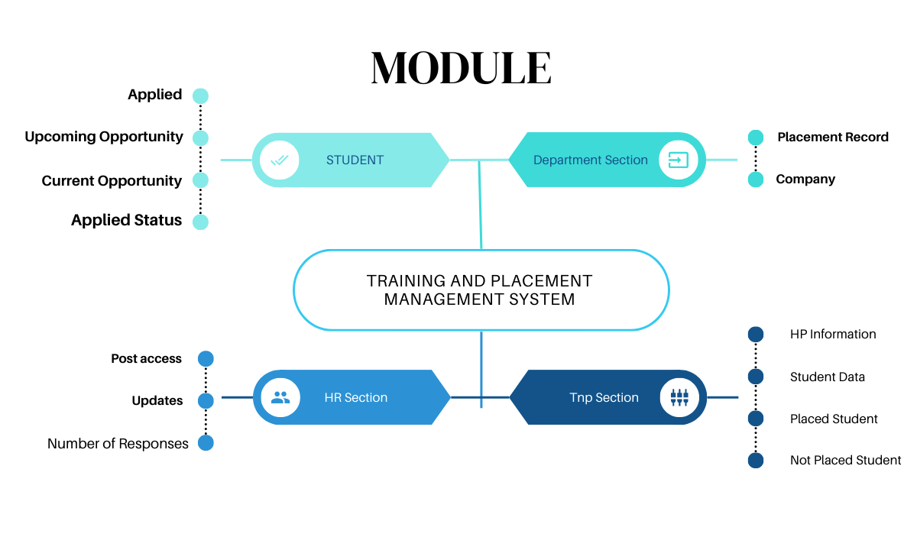

**TimeLine of Project**

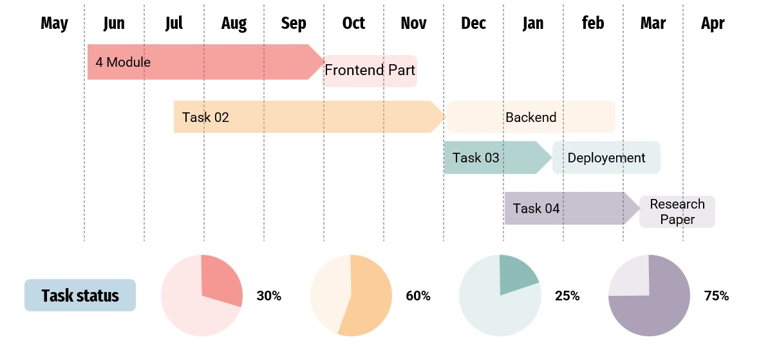

**FEASIBILITY STUDY**

A feasibility study is a process of evaluating the viability of a proposed project, taking into account its economic, technical, and operational feasibility.

**Economic feasibility:**

The economic feasibility of a TPMS project will depend on the cost of developing and implementing the system, as well as the benefits that it is expected to generate. The benefits of a TPMS can be both tangible and intangible. Tangible benefits include savings on staff time and costs, as well as increased revenue from placement fees. Intangible benefits include improved student satisfaction and employer relations.

The cost of developing and implementing a TPMS will vary depending on the size and complexity of the system, as well as the features and functionality that are required. However, there are a number of open-source and commercial TPMS solutions available that can be customized to meet the specific needs of an educational institution.

**Technical feasibility:**

The technical feasibility of a TPMS project will depend on the availability of the necessary hardware and software resources. The hardware requirements for a TPMS will vary depending on the number of users and the features and functionality that are required. However, most educational institutions will have the necessary hardware resources to implement a TPMS.

The software requirements for a TPMS include a web server, a database server, and a web application. There are a number of open-source and commercial TPMS software solutions available that can be used to develop and deploy a TPMS.

**Operational feasibility:**

The operational feasibility of a TPMS project will depend on the willingness and ability of the educational institution to adopt and use the system. The educational institution will need to provide training to its staff and students on how to use the TPMS. Additionally, the educational institution will need to develop and implement procedures for managing the TPMS and troubleshooting any problems that may arise.

Overall, the feasibility of a TPMS project will depend on the specific circumstances of the educational institution. However, a TPMS can be a valuable tool for educational institutions that are looking to improve the efficiency and effectiveness of their placement process.

**Feasibility study for the proposed TPMS project:**

To conduct a feasibility study for the proposed TPMS project, you will need to collect data on the following:

* The current placement process at the educational institution, including its strengths and weaknesses.
* The needs of the students, TPOs, departments, and HR professionals.
* The available budget for the project.
* The availability of the necessary hardware and software resources.
* The willingness and ability of the educational institution to adopt and use the system.

Once you have collected this data, you can use it to assess the economic, technical, and operational feasibility of the project.

If you find that the project is feasible, you can develop a detailed project plan that outlines the steps you need to take to develop and implement the TPMS.

**FACILITIES REQUIRED**

The following facilities are required for the development and implementation of a Training and Placement Management System (TPMS):

**Hardware**:

* + A web server to host the TPMS website.
  + A database server to store and manage the TPMS data.

**Software:**

* + A web application development platform, such as PHP, Java, or Python.
  + A database management system, such as MySQL or PostgreSQL.
  + A web server, such as Apache or Nginx.

Here are some additional considerations for the facilities required for a TPMS project:

* **Security**: The TPMS should be deployed in a secure environment to protect the confidentiality and integrity of the data stored in the system.
* **Scalability**: The TPMS should be scalable to accommodate future growth in the number of users and data.
* **Availability**: The TPMS should be highly available to ensure that students, TPOs, departments, and HR professionals can access the system whenever they need it.

The TPMS should also be designed to be user-friendly and easy to use for all stakeholders, including students, TPOs, departments, and HR professionals.

**EXPECTED OUTCOME**

The expected outcome of a Training and Placement Management System (TPMS) project is a comprehensive and user-friendly system that helps educational institutions to streamline the placement process and improve its efficiency. The system should benefit all stakeholders, including students, TPOs, departments, and HR professionals.

Here are some specific expected outcomes of a TPMS project:

* **Improved efficiency of the placement process**: The TPMS should automate many of the manual tasks involved in the placement process, such as posting job openings, scheduling interviews, and generating reports. This should free up TPOs and other staff members to focus on other important tasks, such as providing career counseling to students.
* **Improved coordination between different stakeholders**: The TPMS should provide a centralized platform for students, TPOs, departments, and HR professionals to collaborate and communicate with each other. This should help to improve coordination and reduce the risk of errors.
* **Improved access to information for students**: The TPMS should provide students with easy access to information about upcoming job opportunities, their application status, and placement-related resources. This should help students to stay informed and make informed decisions about their careers.
* **Improved ability for companies to find qualified candidates**: The TPMS should help companies to find qualified candidates for their job openings by providing them with access to a large pool of student profiles. This should save companies time and money on their recruitment process.
* **Increased student satisfaction**: Students may be more satisfied with the placement process if they have easy access to information and can track their application status online.
* **Improved employer relations**: Employers may be more likely to recruit from educational institutions that have a streamlined and efficient placement process.

**REFERENCES**

1. Chakraborty, S., Ghosal, A., & Banerjee, R. (2021). Digital transformation of placement management systems in higher education: A review. International Journal of Educational Technology in Higher Education, 18(1), 1-18.
2. Singh, A., & Patel, K. (2020). Comparative analysis of placement portals in Indian educational institutions. Journal of Education Technology, 15(3), 245-260.
3. Dragoni, N., Giallorenzo, S., Lafuente, A. L., Mazzara, M., Montesi, F., Mustafin, R., & Safina, L. (2022). Microservices: Yesterday, today, and tomorrow. In Present and Ulterior Software Engineering (pp. 195-216). Springer.
4. Kumar, V., & Sharma, P. (2023). Challenges in implementing microservices architecture in educational platforms. IEEE Transactions on Education, 66(2), 180-189.
5. Mehta, R., Jain, S., & Kapoor, R. (2023). Performance analysis of microservices-based educational platforms. Journal of Systems and Software, 185, 111151.
6. Zhang, Y., & Liu, X. (2022). A reference architecture for educational platforms based on microservices. IEEE Access, 10, 15230-15245.
7. Anderson, T., & Dron, J. (2021). Three generations of distance education pedagogy. International Review of Research in Open and Distributed Learning, 12(3), 80-97.
8. Gupta, M., & Sharma, R. (2022). Automating campus placement process: Challenges and opportunities. International Journal of Information Technology, 14(1), 45-58.
9. Johnson, E., & Williams, K. (2023). Microservices adoption in higher education: A case study. Journal of Computing in Higher Education, 35(1), 112-130.
10. Lewis, J., & Fowler, M. (2020). Microservices: A definition of this new architectural term. Retrieved from martinfowler.com/articles/microservices.html.