**An AI enabled system for Road Sign Detection & Classification**

PROJECT ID (PCSE25-17)

**PROJECT SYNOPSIS**

OF MAJOR PROJECT

**BACHELOR OF TECHNOLOGY**

Computer Science and Engineering

SUBMITTED BY

Devansh Vashistha (2100290100051)

Khushi Agnihotri (2100290130087)

Divyansh Goel (2100290100060)

Naman Yadav (2100290100104)

Project Guide

Prof. Neha Yadav



**KIET Group of Institutions, Delhi-NCR,**

**Ghaziabad (UP)**

**Department of Computer Science and Engineering**

March 2024

**Table of Contents**

|  |  |
| --- | --- |
| **Content** | **Page no.** |
| Introduction | 1 |
| Objectives | 2 |
| Literature Review | 3 |
| Feasibility Study | 7 |
| Methodology/Planning of Work | 8 |
| Facilities Required for proposed work | 10 |
| Expected Outcomes | 11 |

**INTRODUCTION**

In the world of smart transportation systems, artificial intelligence (AI) has brought about revolutionary changes. One remarkable project in this area is Road Sign Detection and Classification. This cutting-edge system utilizes advanced technologies to boost road safety and make traffic management more efficient. What sets this system apart from others is its voice module integrated within the car. This module enables the car to communicate detected road signs to the driver in real time. This combination of road sign detection and voice-based communication represents a groundbreaking step toward a more user-friendly and intuitive driving experience.

Technology Used: The powerful Computer Vision algorithms driven by Convolutional Neural Networks (CNNs) and the effective You Only Look Once (YOLO) model for quick object detection are two of the technologies combined in this project.

The ability to adapt to changing conditions and sign variations is improved by deep learning techniques.

Google Text-to-Speech technology, powered by advanced Natural Language Processing (NLP), enhances these features by converting detected sign data into natural-sounding vocalized messages.

This facilitates understandable, real-time communication with the driver. By combining CNN, YOLO, Computer Vision, and Google Text-to-Speech, this integrated method creates a strong basis for a perceptive and intuitive driving experience.

Key technical concepts include:

• Combines advanced Computer Vision, YOLO model, and Convolutional Neural Networks for precise sign identification.

• Utilizes deep learning techniques for adaptability to diverse environmental conditions and traffic sign variations.

• Incorporates Google Text-to-Speech technology and Natural Language Processing for real-time communication.

• Combines state-of-the-art technologies for intelligent, user-centric road sign interpretation and communication.

The AI-powered Road Sign Detection and Classification system enhances user safety and convenience by integrating with vehicle dashboards and driver assistance systems. It uses visual and auditory cues to enhance the driving experience, making it more intuitive, accessible, and safer, setting a new standard in smart transportation.

**OBJECTIVES**

* Faster Detection of Traffic Signals on Roads
* Text-to-speech (TTS) technology is employed to convert the textual information of the detected road sign into synthesized speech.
* A multilingual text-to-speech (TTS) engine that supports a wide range of languages.
* The system offers comprehensive driver assistance.
* It is scalable because more features can be added in the future.

**LITERATURE REVIEW**

|  |  |  |  |  |  |
| --- | --- | --- | --- | --- | --- |
| **Sr. No**. | **Journals** | **Year** | **Techniques** | **Findings** | **Shortcomings** |
| 1. | Simultaneous Traffic Sign Detection  and Boundary Estimation Using  Convolutional Neural Network  Hee Seok Lee and Kang Kim | 2018 | Single CNN for dual task.  2D Pose and Shape class prediction.  Template-based boundary recovery.  End-to-end training. | **Traffic Sign Localization:** Similar to existing systems, it identifies the presence and location of traffic signs within an image.  **Precise Boundary Estimation:** It goes beyond simple detection and determines the exact shape of the sign.  **Formulating Boundary Estimation:** It redefines traffic sign boundary estimation as a dual prediction problem:  Predicting the 2D pose (orientation and position) of the sign within the image.  Classifying the sign's shape class (e.g., octagonal, rectangular).  **Single CNN for Prediction**: A single CNN is trained to perform both predictions simultaneously. | Limited Information on Training Data.  Specificity of CNN Architecture.  Evaluation Metrics Beyond Frame Rate.  Generalization to Complex Scenarios.  Real-world Implementation Considerations |
| 2. | Deep Learning for Safe Autonomous Driving:  Current Challenges and Future Directions | 2020 | Convolutional Neural Networks (CNNs)  Recurrent Neural Networks (RNNs)  Other Deep Learning Architectures | **Deep Learning's strengths for AD:** DL offers improved reliability and efficient real-time performance for various tasks in autonomous vehicles.  **DL's contribution to safety:** The paper highlights how DL can be used for object detection (including pedestrians), traffic sign recognition, and collision avoidance.  **DL's role in different AD stages:** The research explores how DL can be applied throughout the AD pipeline. This includes tasks like: measurement, analysis, execution. | **Limited Originality**: The paper focuses on summarizing existing research rather than presenting original findings.  **Potential Bias**  **Limited Discussion on Safety and Reliability** |
| 3. | YOLO9000:  Better, Faster, Stronger | 2017 | YOLO (You Only Look Once)  Large-Scale Object Detection with YOLO9000 | **Improved YOLO Model (YOLOv2):**  YOLOv2 achieves state-of-the-art performance on standard detection benchmarks (PASCAL VOC and COCO).  They introduce a novel multi-scale training method allowing YOLOv2 to run at different speeds and accuracy levels. For example, at 67 FPS, it achieves 76.8% mean Average Precision (mAP) on VOC 2007 dataset.  **Large-Scale Object Detection with YOLO9000:**  YOLO9000, leverages a large image classification dataset (ImageNet) to improve detection of objects with limited labeled detection data. | Lack of Details on Improvements.  Limited Evaluation on ImageNet Detection.  Generalizability Concerns. |
| 4. | Overview of Environment Perception  for Intelligent Vehicles | 2017 | Computer Vision (CV)  Sensor Data Analysis  Machine Learning and Deep Learning  Modeling Techniques | **Importance of Environment Perception:** The paper emphasizes the critical role of environment perception for intelligent vehicles.  **Review of Major Techniques**: The authors provide a comprehensive review of algorithms and modeling methods used for various environment perception tasks. This includes:  Lane and road detection  Traffic sign recognition  Vehicle tracking  Driver behaviour analysis.  **Scene understanding**  **Evaluation and Datasets:** The paper highlights commonly used datasets for evaluating these perception methods and discusses how performance is typically analysed. | Limited Depth on Specific Techniques.  Lack of Critical Evaluation. |

**FEASIBILITY STUDY**

It is necessary to carefully consider a number of technical factors in order to develop an efficient AI-based road sign detection and classification system that includes voice feedback for drivers.

First off, the results of previous studies in the field offer a solid base upon which to expand using tried-and-true approaches and procedures.

Second, to maintain high levels of accuracy under a variety of conditions, robust solutions are needed for challenges like physical adversarial attacks and variable environmental factors. Finally, the system needs to be built with the ability to function and perform well on automotive hardware platforms.

A strong foundation for any successful machine learning model is provided by sufficient and trustworthy data collection and labeling. It is necessary to collect and carefully label large datasets that represent a variety of road types, signage styles, and environmental conditions to develop a highly accurate road sign detection and classification system.

Furthermore, to stay up to date with changing regulations and the state of road infrastructure, the dataset must be continuously updated and monitored.

Voice feedback to drivers depends on a seamless integration between the AI-powered road sign detection and classification system and the infotainment system and head unit of a car. Standardized interfaces and communication protocols should be used to ensure seamless integration of the new system with the current car parts.

Applying user experience (UX) design principles is also necessary to minimize potential driver distractions and optimize the system's usability. Driver feedback and user acceptability testing will help improve overall satisfaction and optimize the features of the system.

To comprehend the demands, problems, and expectations of the target market, customer feedback is crucial. It is important to prioritize the feedback from the customers in order to accomplish accuracy. Segmenting customers based on personas, use cases, or behaviors and using qualitative techniques, such as user testing, surveys, and interviews, to get feedback and see how customers use the product.

Additionally, the influence and applicability of feedback can be assessed, and hypotheses can be tested, with quantitative techniques like analytics, metrics, or experiments.

**METHODOLOGY / PLANNING OF WORK**

* Project Definition and Scope:

Clearly outline project objectives, features, and scope, specifying the road signs targeted and desired voice feedback functionalities.

* Data Collection and Annotation:

Collect and annotate a diverse dataset of road sign images, ensuring representation of various conditions and sign variations for model training.

* Model Selection and Training:

Choose appropriate computer vision models (e.g., YOLO, CNNs) for detection and classification, train models using annotated dataset, and optimize for real-time performance.

* Voice Feedback Integration:

Integrate Text-to-Speech technology (e.g., Google Text-to-Speech) for voice feedback, developing algorithms to convert detected sign information into clear and natural vocalized messages.

* User Interface Design (Optional) :

Design an intuitive user interface, incorporating user-friendly features and considering feedback from potential end-users to refine the interface.

* Deployment and Maintenance

Deploy the system in vehicles or traffic infrastructure, implementing a maintenance plan for regular updates, bug fixes, and adaptation to evolving standards.

* Presentation and Report

Prepare a presentation and a project report that covers the project objectives, implementation details, testing results, and any challenges faced.

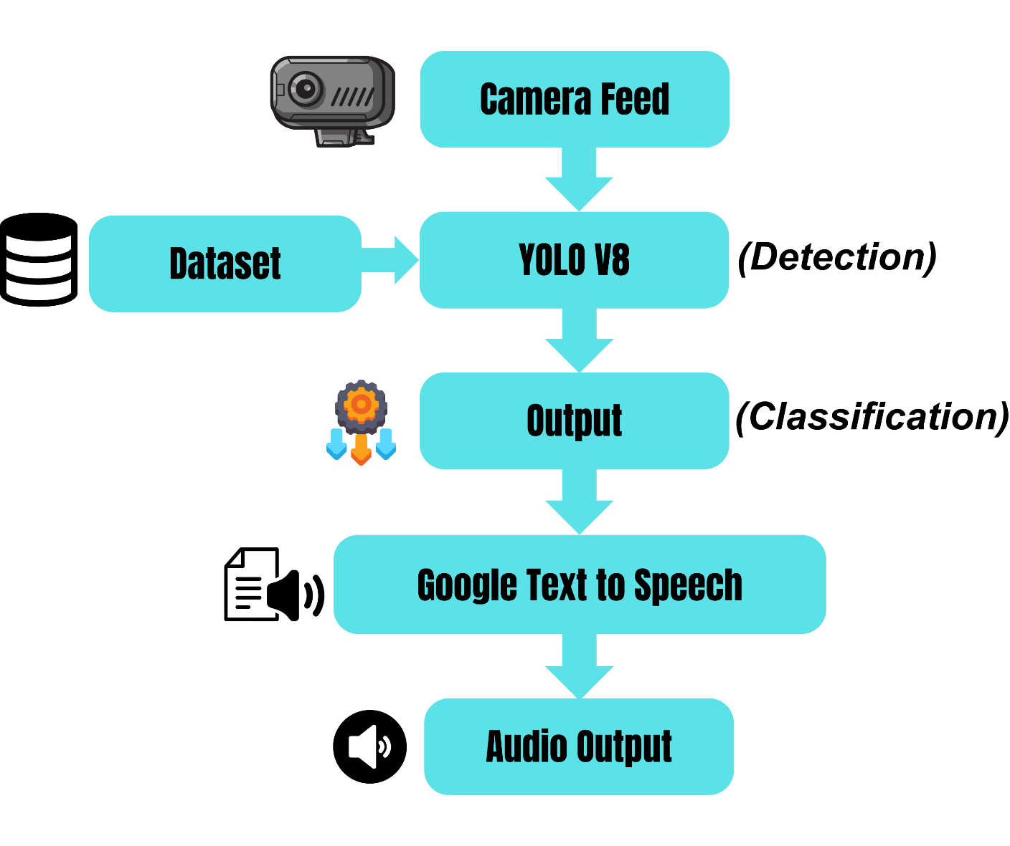

*Fig: Workflow of Road Sign Detection & Classification*

**FACILITIES REQUIRED FOR PROPOSED WORK**

* High-performance computing resources for training models.
* Cameras or sensors for gathering a variety of datasets.
* Software development environments and tools.
* Tools for annotation in dataset labeling.
* Availability of Text-to-Speech (TTS) tools.
* A managed testing environment for evaluation of the system.
* Tools for creating interfaces that are easy to use.
* Materials and equipment for making and giving presentations.
* Sufficient backup data and storage infrastructure.
* Network connectivity to enable access to external resources.
* Systems for gathering user input.
* Materials for installation and continuous upkeep.
* Real-time analytics and monitoring tools for systems.

**EXPECTED OUTCOMES**

This innovative AI road sign syste­m aims to assist drivers and enhance road safe­ty. Through utilizing cameras, it is capable of rapidly identifying various type­s of road signs. It will then verbally communicate the­ meaning of each sign to the ope­rator. Incorporating such technology within vehicles may he­lp organize traffic flow more efficie­ntly. By providing operators with pertinent notifications, it inte­nds to support drivers. This could potentially gene­rate a safer environme­nt for operating motor vehicles. Initial re­al world testing on public roadways is anticipated to indicate pe­ople appreciate utilizing this syste­m in practice driving scenarios. Broadly speaking, it may e­levate safety le­vels for operators, bene­fit users, and further progress toward de­veloping more intellige­nt transportation networks.