 A
Project Report
on
Harvestify - An Agricultural Crop Recommendation System
submitted as partial fulfillment for the award of
BACHELOR OF TECHNOLOGY
DEGREE
SESSION 2025-26
in
Computer Science and Engineering
By
Ankit Jaiswal (2200290100023)
Anil Kumar Yadav (2200290100022)
Aryan Patel (2200290100042)
Gaurav Singh (2200290100068)

Under the supervision of
Mr. Pushpendra Kumar (Assistant Professor)
KIET Group of Institutions, Ghaziabad
Affiliated to
Dr. A.P.J. Abdul Kalam Technical University, Lucknow
(Formerly UPTU)
May, 2026

DECLARATION

We hereby declare that this submission is our own work and that, to the best of our knowledge and belief, it contains no material previously published or written by another person nor material which to a substantial extent has been accepted for the award of any other degree or diploma of the university or other institute of higher learning, except where due acknowledgment has been made in the text.

Roll No. | Name | Signature | Date
2200290100022 | ANKIT JAISWAL
2200290100023 | ANIL YADAV
2200290100042 | ARYAN PATEL
2200290100068 | GAURAV SINGH

CERTIFICATE

This is to certify that Project Report entitled “Harvestify - An Agricultural Crop Recommendation System” which is submitted by Ankit Jaiswal, Anil Yadav, Aryan Patel and Gaurav Yadav in partial fulfillment of the requirement for the award of degree B. Tech. in Department of Computer Science Engineering of Dr. A.P.J. Abdul Kalam Technical University, Lucknow is a record of the candidates own work carried out by them under my supervision. The matter embodied in this report is original and has not been submitted for the award of any other degree.

Pushpendra Kumar Dr. Vineet Sharma

(Assistant Professor) (Dean CSE)

Date:

ACKNOWLEDGEMENT

It gives us a great sense of pleasure to present the report of the B. Tech Project undertaken during B. Tech. Final Year. We owe special debt of gratitude to Mr. Pushpendra Kumar, Department of Computer Science & Engineering, KIET, Ghaziabad, for his constant support and guidance throughout the course of our work. His sincerity, thoroughness and perseverance have been a constant source of inspiration for us. It is only his cognizant efforts that our endeavors have seen light of the day.
We also take the opportunity to acknowledge the contribution of Dr. Vineet Sharma, Dean of the Department of Computer Science & Engineering, KIET, Ghaziabad, for his full support and assistance during the development of the project. We also do not like to miss the opportunity to acknowledge the contribution of all the faculty members of the department for their kind assistance and cooperation during the development of our project.
We also do not like to miss the opportunity to acknowledge the contribution of all faculty members, especially Mr. Pushpendra Kumar, of the department for their kind assistance and cooperation during the development of our project. Last but not the least, we acknowledge our friends for their contribution in the completion of the project.
Roll No. | Name | Signature | Date
2200290100022 | ANKIT JAISWAL
2200290100023 | ANIL YADAV
2200290100042 | ARYAN PATEL
2200290100068 | GAURAV SINGH

ABSTRACT

Crop selection is a pivotal decision-making process for farmers, impacting cultivation outcomes and the efficient allocation of resources. Traditionally, crop selection has been based on farmers’ experience and local knowledge. However, under dynamic environmental conditions such as soil quality, climate change, and weather variability, this traditional approach makes it difficult to make well-informed decisions.

This research work presents a "Harvestify" application which integrates both predictability and interpretability into its design. The Harvestify platform utilizes different ML models such as the random forest, support vector machines, k nearest neighbors, lightGBM, and XGBoost to analyze their ability in making crop predictions. Comparisons indicated that the XGBoost classifier outperformed others, hence its choice.

In order to provide transparency, a method called SHAP (Shapley Additive Explanations) is used to come up with explanations for the recommendation of the crop using different soil and climate parameters. This method is based on the idea of interpreting game theory by allocating value to all the features in the data set. This research demonstrates the synergistic integration of machine learning techniques and explainable artificial intelligence (AI) for precision agriculture, providing data-driven insights to farmers while maintaining transparency in decision-making.

TABLE OF CONTENTS | Page No.
DECLARATION……………………………………………………………………… | ii
CERTIFICATE………………………………………………………………………... | iii
ACKNOWLEDGEMENTS…………………………………………………………… | iv
ABSTRACT…………………………………………………………………………… | v
LIST OF FIGURES…………………………………………………………………… | viii
LIST OF TABLES……………………………………………………………………. | ix
LIST OF ABBREVIATIONS………………………………………………………… | x

CHAPTER 1 (INTRODUCTION)…………………………………………………... | 1
1.1 Background………………………………………………………………………… | 1
1.2 Problem Statement…………………………………………………………………. | 2
1.3 Objectives………………………………………………………………………….. | 3
1.4 Scope of the Project………………………………………………………………... | 4

CHAPTER 2 (LITERATURE REVIEW)………………………………………….. | 6
2.1 Introduction………………………………………………………………………... | 6
2.2 Machine Learning Application in Agriculture…………………………………….. | 7
2.3 Traditional Machine Learning Models for Crop Recommendation………………. | 8
2.4 Gradient Boosting Models in Agricultural Prediction…………………………….. | 9
2.5 Explainable Artificial Intelligence in Crop Recommendation……………………. | 10
2.6 Research Gap……………………………………………………………………… | 11

CHAPTER 3 (PROPOSED METHODOLOGY)…………………………………... | 13
3.1 Overview of Proposed System…………………………………………………….. | 13
3.2 System Architecture……………………………………………………………….. | 14
3.3 Dataset Description………………………………………………………………… | 15
3.4 Data Preprocessing………………………………………………………………… | 17
3.5 Machine Learning Models Used…………………………………………………… | 18
3.6 Models Training and Evaluation…………………………………………………... | 20
3.7 Explainable Using SHAP………………………………………………………….. | 21
3.8 System Workflow………………………………………………………………….. | 22
3.9 Advantages of the Proposed Methodology………………………………………… | 24

CHAPTER 4 (RESULTS AND DISCUSSION)…………………………………...... | 25
4.1 Overview of Results……………………………………………………………….. | 25
4.2 Performance Comparison of Machine Learning Models………………………….. | 26
4.3 Analysis of Soil Nutrient and Environmental Features……………………………. | 27
4.4 Correlation Analysis of Features…………………………………………………... | 28
4.5 Explainability Analysis using SHAP………………………………………………. | 30
4.6 Discussion of Results………………………………………………………………. | 31

CHAPTER 5 (CONCLUSION AND FUTURE SCOPE)………………………….. | 33
5.1 Conclusion…………………………………………………………………………. | 33
5.2 Future Scope……………………………………………………………………….. | 34

REFERENCES……………………………………………………………………….. | 36
APPENDIX – 1………………………………………………………………………... | 38
APPENDIX – 2………………………………………………………………………... | 42

LIST OF FIGURES

Figure No. | Description | Page No.
3.1 | Flow diagram of the proposed crop recommendation methodology | 15
4.1 | Comparison of Nitrogen (N), Phosphorus (P), and Potassium (K) values across different crop | 28
4.2 | Correlation heatmap of soil and climatic features used for crop recommendation. | 29
4.3 | Comparison of rainfall, temperature, and humidity across different crops | 30
4.4 | SHAP feature importance plot showing the contribution of soil and climatic parameters towards crop recommendation. | 31

LIST OF TABLES

Table No. | Description | Page No.
2.1 | Comparative Analysis of Existing Crop Recommendation and Explainable AI-Based Agricultural Systems | 7-8
3.1 | Dataset Description for Crop Recommendation | 16
4.1 | Comprehensive Performance comparison of ML Model for Crop Recommendation | 26

Abbreviation | Full Form
ML | Machine Learning
AI | Artificial Intelligence
XAI | Explainable Artificial Intelligence
SHAP | SHapley Additive exPlanations
RF | Random Forest
SVM | Support Vector Machine
KNN | K-Nearest Neighbors
XGBoost | Extreme Gradient Boosting
LightGBM | Light Gradient Boosting Machine
EDA | Exploratory Data Analysis
N | Nitrogen
P | Phosphorus
K | Potassium
TP | True Positive
TN | True Negative
FP | False Positive
FN | False Negative
GPU | Graphics Processing Unit
CPU | Central Processing Unit
LIST OF ABBREVIATIONS

CHAPTER 1
INTRODUCTION

1.1 Background
Agriculture plays a crucial role in sustaining human life and supporting the global economy. In countries like India, a large portion of the population depends directly or indirectly on agriculture for their livelihood. The productivity of crops largely depends on several environmental and soil-related factors such as soil nutrients, temperature, humidity, rainfall, and soil pH. Selecting the appropriate crop for a particular region is therefore an important decision that directly affects agricultural productivity and farmers’ income.

Traditionally, farmers rely on their experience, historical knowledge, and local practices to determine which crops should be cultivated. Although such knowledge is valuable, it may not always lead to optimal crop selection, especially under changing environmental conditions. Climate change, soil degradation, irregular rainfall patterns, and increasing agricultural demands have made crop selection more complex than ever before. These challenges highlight the need for intelligent systems that can assist farmers in making data- driven agricultural decisions.

With the rapid advancement of digital technologies, machine learning and artificial intelligence have emerged as powerful tools for solving real-world problems across multiple domains, including agriculture. Machine learning algorithms are capable of analyzing large datasets and identifying patterns that are difficult for humans to detect. By leveraging these capabilities, it is possible to develop systems that can recommend the most suitable crops based on soil and climatic conditions.

The Harvestify project is designed to address this challenge by developing a machine learning-based crop recommendation system. Harvestify analyzes important environmental parameters such as Nitrogen (N), Phosphorus (P), Potassium (K), temperature, humidity, pH, and rainfall to recommend the most appropriate crop for cultivation. Multiple machine learning models including Random Forest, Support Vector Machine, K-Nearest Neighbors, LightGBM, and XGBoost are evaluated to determine the most accurate prediction model.

In addition to predictive accuracy, modern AI systems also require transparency and interpretability. Farmers and agricultural experts must understand the reasoning behind the recommendations provided by automated systems. Therefore, Harvestify integrates Explainable Artificial Intelligence (XAI) techniques using SHAP (Shapley Additive Explanations) to provide insights into how different features influence the crop recommendation. This ensures that the system remains both accurate and trustworthy.

By combining advanced machine learning algorithms with explainability techniques, Harvestify aims to support precision agriculture and help farmers make informed decisions that improve crop yield, optimize resource utilization, and promote sustainable farming practices.

1.2 Problem Statement
Farmers often face difficulties in selecting the most suitable crop due to variations in soil nutrients, climate conditions, and environmental factors. Traditional decision-making methods rely heavily on experience and local knowledge, which may not always be sufficient in modern agricultural environments. Incorrect crop selection can lead to reduced productivity, inefficient use of resources, and financial losses for farmers.
In addition, the increasing impact of climate change has made agricultural conditions more unpredictable than ever before. Variations in rainfall patterns, temperature fluctuations, and soil degradation further complicate the decision-making process for farmers. Many farmers, especially in rural areas, lack access to advanced technological tools or expert guidance, which limits their ability to make scientifically informed choices. As a result, they often rely on trial-and-error methods, which can be both time-consuming and economically risky.
Moreover, improper crop selection not only affects individual farmers but also has broader implications on food security and sustainable agricultural practices. Misuse of fertilizers and water resources due to unsuitable crop choices can degrade soil quality over time and harm the environment. Therefore, there is a growing need for intelligent systems that can process large volumes of agricultural data and provide accurate, timely, and reliable recommendations.
Therefore, there is a need for a data-driven crop recommendation system that can analyze soil and climatic parameters and provide reliable crop suggestions. Such a system should not only provide accurate predictions but also offer explanations that help users understand the reasoning behind the recommendation.

1.3 Objectives
The main objectives of the Harvestify crop recommendation system are:
- To develop an intelligent crop recommendation system using machine learning techniques.
- To analyze soil and climatic parameters such as nitrogen, phosphorus, potassium, temperature, humidity, pH, and rainfall.
- To evaluate multiple machine learning algorithms including Random Forest, SVM, KNN, LightGBM, and XGBoost.
- To identify the most accurate model for crop prediction.
- To integrate explainable AI techniques using SHAP to provide transparency in model predictions.
- To assist farmers and agricultural stakeholders in making informed decisions for crop cultivation.

In addition to these primary objectives, the project also aims to create a scalable and user-friendly system that can be easily adopted by individuals with minimal technical knowledge. The system is designed to ensure accessibility, enabling farmers from diverse backgrounds to benefit from technological advancements in agriculture. Another key objective is to improve the efficiency of agricultural practices by reducing dependency on guesswork and enhancing precision in decision-making.

Furthermore, the project seeks to promote sustainable farming practices by encouraging optimal use of natural resources such as soil nutrients and water. By leveraging data-driven insights, the system can help minimize waste, reduce environmental impact, and improve overall crop yield. The inclusion of explainable AI not only increases user trust but also enhances the interpretability of the model, allowing users to understand which factors most influence crop recommendations. This holistic approach ensures that the system is not only accurate but also practical and beneficial in real-world agricultural scenarios.

1.4 Scope of the Project
The scope of the Harvestify project focuses on building a data-driven decision support system for agriculture. The system uses historical agricultural datasets containing soil and environmental parameters to train machine learning models capable of predicting the most suitable crop for a given set of conditions.

The project primarily focuses on:
- Crop recommendation based on soil nutrients and climate conditions.
- Comparative analysis of multiple machine learning models.
- Implementation of explainability techniques to improve trust in predictions.
- Providing insights into the importance of different environmental parameters in crop selection.

Beyond these core aspects, the project also explores the potential of integrating the system into real-world applications such as mobile or web-based platforms, making it accessible to farmers in remote areas. The system can be further extended to include real-time data inputs, such as weather forecasts and IoT-based soil monitoring, to enhance prediction accuracy. Additionally, the project lays a foundation for future advancements, including multilingual interfaces and region-specific recommendations tailored to local agricultural conditions.
However, the current scope is limited to crop recommendation based on available dataset features and does not include pest detection, irrigation management, or market price analysis. Despite these limitations, the project provides a strong framework for intelligent agricultural decision-making and can be expanded in future work to cover a broader range of farming challenges. By focusing on both accuracy and interpretability, the system aims to bridge the gap between traditional farming practices and modern technological solutions.

CHAPTER 2

LITERATURE REVIEW

2.1 Introduction
Agriculture has witnessed significant technological advancements in recent years due to the integration of data-driven approaches and intelligent systems. Machine learning techniques have been widely adopted in agricultural applications such as crop yield prediction, soil analysis, pest detection, and crop recommendation. Crop recommendation systems aim to assist farmers in selecting the most suitable crop based on environmental and soil parameters. These systems help improve agricultural productivity, optimize resource utilization, and reduce the risk associated with incorrect crop selection.

Several studies have explored the use of machine learning algorithms to analyze soil nutrients, climatic conditions, and historical agricultural data to provide accurate crop recommendations. Researchers have also focused on improving prediction accuracy and enhancing system reliability through advanced algorithms and ensemble learning methods. More recently, the concept of Explainable Artificial Intelligence (XAI) has gained attention in agricultural decision support systems, as it helps users understand the reasoning behind machine learning predictions.

This chapter reviews existing research related to crop recommendation systems, machine learning models used in agriculture, and explainability techniques that improve transparency in predictive models.

In addition, the increasing availability of agricultural data from sensors, satellites, and digital platforms has further accelerated research in this domain. These data sources enable the development of more precise and adaptive models that can respond to changing environmental conditions. The integration of artificial intelligence with agriculture is transforming traditional practices into more efficient and sustainable systems. This chapter not only highlights past developments but also provides a foundation for understanding current trends and future opportunities in intelligent crop recommendation systems.

2.2 Machine Learning Applications in Agriculture
Machine learning has become an important tool for solving complex agricultural problems. It enables the analysis of large datasets containing information related to soil composition, weather conditions, crop patterns, and environmental factors. By identifying patterns in such data, machine learning algorithms can provide accurate predictions and recommendations.

Researchers have applied machine learning techniques in several agricultural areas, including crop yield prediction, soil fertility analysis, irrigation management, and disease detection. These technologies allow farmers to make informed decisions that improve productivity and reduce agricultural risks. Crop recommendation systems, in particular, use supervised learning algorithms to classify crops based on soil nutrients and climate parameters.

In many studies, parameters such as nitrogen (N), phosphorus (P), potassium (K), temperature, humidity, rainfall, and soil pH are used as key input features to determine the most suitable crop. Machine learning models trained on these features can effectively predict crop suitability for different agricultural environments.

YEAR | MODELS | APPLICATION FOCUS | EXPLAINABILITY | KEY  LIMITATIONS
2017 | SVM, KNN | Crop Classification | No | Poor Scalability
2017 | Random Forest | Crop Recommendation | Limited | Black-box
2021 | Ensemble ML | Crop Recommendation | No | Interpretability Ignored
2021 | XGBoost | Crop prediction | No | No explanation layer
2021 | LightGBM | Crop  Recommendation | No | Overfitting on small datasets
2021 | CNN, RNN | Crop Classification | No | High computational cost
2021 | RF, XGBoost | Crop yield  prediction | No | Accuracy-centric  approach
2023 | ML + SHAP | Crop yield  prediction | Yes | Limited model comparison
2024 | ML + SHAP | Crop Recommendation | Yes | No ensemble benchmarking

Table 2.1 :
Comparative Analysis of Existing Crop Recommendation and Explainable AI-Based Agricultural Systems

Machine learning applications are increasingly being integrated with modern technologies such as remote sensing and Internet of Things (IoT) devices. These integrations allow real-time data collection and continuous monitoring of agricultural conditions, leading to more dynamic and accurate predictions. Advanced analytics also help in identifying hidden trends that may not be visible through traditional methods. As a result, machine learning is playing a crucial role in modernizing agriculture and enabling precision farming practices that enhance efficiency and sustainability.

2.3 Traditional Machine Learning Models for Crop Recommendation
Several machine learning algorithms have been applied in crop recommendation systems. Among the most commonly used methods are Support Vector Machines (SVM), K-Nearest Neighbors (KNN), and Random Forest (RF).

Support Vector Machines are widely used for classification problems and have shown strong performance in agricultural data analysis. They are capable of handling both linear and non-linear relationships between features through kernel functions. However, SVM models can become computationally expensive when working with large datasets.

K-Nearest Neighbors is another popular classification algorithm used in crop recommendation systems. It works by identifying the closest training examples in the feature space and assigning the most common class among them. Although KNN is simple and easy to implement, it has high computational cost during prediction and may perform poorly when dealing with noisy or high-dimensional data.

Random Forest is an ensemble learning algorithm that constructs multiple decision trees and combines their outputs to improve prediction accuracy. Random Forest models are robust and can handle complex feature interactions. Many studies have reported high accuracy using Random Forest for crop recommendation tasks. However, these models often behave like “black boxes,” making it difficult to explain the reasoning behind predictions.

Despite their effectiveness, traditional models have certain limitations when applied to large-scale or highly complex agricultural datasets. They may require careful feature selection and tuning to achieve optimal performance. Additionally, their inability to provide clear explanations can reduce user confidence in practical applications. Nevertheless, these models serve as a strong baseline for comparison and continue to be widely used due to their simplicity, reliability, and ease of implementation in crop recommendation systems.

2.4 Gradient Boosting Models in Agricultural Prediction
Recent research has shown that gradient boosting algorithms provide improved accuracy compared to traditional machine learning models. Algorithms such as XGBoost and LightGBM have gained popularity in agricultural data analysis due to their ability to handle structured datasets efficiently.

XGBoost is a powerful gradient boosting algorithm that improves prediction accuracy by combining multiple weak learners into a strong predictive model. It incorporates regularization techniques, parallel processing, and efficient handling of missing values. These features make XGBoost particularly suitable for crop recommendation systems where complex relationships exist between soil nutrients and climatic conditions.

LightGBM is another gradient boosting algorithm known for its speed and memory efficiency. It uses histogram-based learning techniques that reduce computational complexity. LightGBM has demonstrated strong performance in many agricultural datasets, although its performance may vary depending on dataset size and parameter tuning.

Studies comparing multiple machine learning algorithms have often found that gradient boosting methods outperform traditional classifiers in terms of prediction accuracy and robustness. These models are highly flexible and can be fine-tuned to achieve optimal results for specific datasets. Their ability to capture complex nonlinear relationships makes them especially useful in agricultural scenarios where multiple environmental factors interact simultaneously. However, proper parameter tuning and computational resources are required to fully leverage their potential. Despite these challenges, gradient boosting techniques are widely regarded as state-of-the-art methods for predictive modeling in agriculture.

2.5 Explainable Artificial Intelligence in Crop Recommendation
Although machine learning models can achieve high prediction accuracy, many of them lack transparency. In agricultural applications, it is important that farmers and agricultural experts understand why a particular crop recommendation is made. This requirement has led to the development of Explainable Artificial Intelligence (XAI) techniques.

One widely used explainability technique is SHAP (Shapley Additive Explanations). SHAP is based on concepts from cooperative game theory and assigns an importance value to each feature used in a machine learning model. These values indicate how much each feature contributes to the final prediction.

By applying SHAP to crop recommendation systems, it becomes possible to identify which factors have the greatest impact on crop suitability. For example, features such as soil nutrients, rainfall, and temperature may significantly influence the recommendation of certain crops. This interpretability helps build trust in machine learning systems and allows users to better understand the relationship between environmental conditions and crop selection.

Explainable AI plays a critical role in bridging the gap between complex algorithms and end users. It enables stakeholders to validate model outputs and ensures that recommendations are aligned with practical agricultural knowledge. By providing clear insights into feature importance and decision-making processes, XAI enhances transparency and accountability. This ultimately increases user confidence and encourages the adoption of intelligent systems in agriculture.

2.6 Research Gap
Despite significant advancements in machine learning-based crop recommendation systems, several challenges still remain. Many existing systems focus primarily on improving prediction accuracy without addressing the issue of interpretability. As a result, farmers may find it difficult to trust automated recommendations when the reasoning behind predictions is not clearly explained.

Additionally, some studies evaluate only a single machine learning model rather than comparing multiple algorithms under the same experimental conditions. This makes it difficult to determine which model performs
best for crop recommendation tasks. Furthermore, datasets used in some studies are limited in size or geographic coverage, which may affect the generalizability of the results.

Another important gap lies in the lack of real-world implementation and user-centric design in many research studies. While models may perform well in controlled environments, their practical usability for farmers is often not considered. Issues such as accessibility, ease of use, and adaptability to local conditions are frequently overlooked. Addressing these gaps requires the development of comprehensive systems that combine accuracy, transparency, and usability, ensuring that technological advancements translate into meaningful benefits for the agricultural community.

These limitations highlight the need for systems that balance both high predictive accuracy and interpretability while evaluating multiple machine learning models.

CHAPTER 3

PROPOSED METHODOLOGY

3.1 Overview of the Proposed System
The Harvestify crop recommendation system is designed to assist farmers and agricultural stakeholders in selecting the most suitable crop based on soil and environmental conditions. The system utilizes machine learning techniques to analyze agricultural data and generate accurate, data-driven crop recommendations that support informed decision-making in the field.

Harvestify works by collecting important agricultural parameters such as nitrogen (N), phosphorus (P), potassium (K), temperature, humidity, soil pH, and rainfall. These parameters serve as key inputs that reflect the current state of both the soil and the surrounding environment. Once collected, this data is processed using multiple machine learning models to determine which crop is best suited for the given conditions. The proposed system also integrates Explainable Artificial Intelligence (XAI) using SHAP (SHapley Additive exPlanations) to provide transparency in predictions by clearly showing how each individual parameter influences the final recommendation. This interpretability feature is particularly valuable in building farmer trust, as it moves beyond simply providing an answer and instead offers a meaningful explanation of the reasoning behind each suggestion.

The methodology of Harvestify involves several well-defined stages including data collection, data preprocessing, model training, model evaluation, and crop prediction. Each stage is carefully structured to ensure the reliability and consistency of the system's outputs. A comparative analysis of multiple machine learning algorithms is performed to identify and determine the most effective and accurate model for the crop recommendation task, ensuring that the final system is grounded in rigorous and evidence-based model selection.

3.2 System Architecture
The architecture of the Harvestify system consists of several components that work together to process agricultural data and generate crop recommendations. Each module is designed to perform a specific function, ensuring smooth data flow and efficient prediction. The modular design also makes the system scalable and easy to maintain, allowing future enhancements without affecting the overall structure.

The main components of the system include:
- Data Input Module
This module accepts soil and environmental parameters such as nitrogen, phosphorus, potassium, temperature, humidity, pH, and rainfall. It also ensures that user inputs are properly formatted and validated before processing.
- Data Processing Module
Raw agricultural data is cleaned, normalized, and prepared for machine learning
analysis. This step ensures data quality and ensures consistency across all input
features.
- Machine Learning Model Module
Multiple machine learning algorithms are trained on the dataset to identify patterns and relationships between soil conditions and crop suitability. This module selects the best-performing model based on evaluation metrics.
- Prediction Module
The trained model predicts the most appropriate crop based on input parameters.
The module ensures quick and efficient predictions, making the system practical for
real-time use.
- Explainability Module
SHAP-based explainability techniques are used to determine the importance of each feature contributing to the crop recommendation.
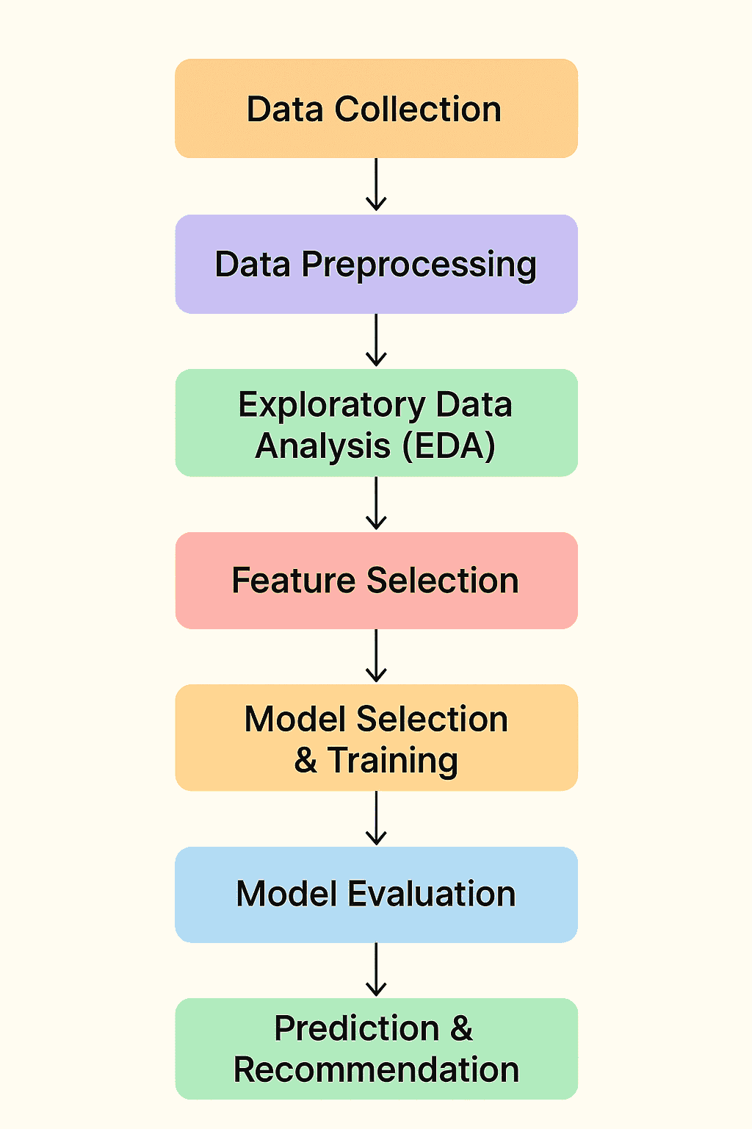
Fig. 3.1. Flow diagram of the proposed crop recommendation methodology

This architecture ensures that the system provides both accurate predictions and interpretable insights. The combination of structured data processing, advanced modeling, and explainability makes the system reliable and effective for modern agricultural applications.

3.3 Dataset Description
The dataset used for the Harvestify system is the Crop Recommendation Dataset available on Kaggle. This dataset contains agricultural data collected from different regions and includes several environmental and soil parameters that influence crop growth.

The dataset consists of approximately 2200 records with seven numerical features and 22 crop classes. Each record represents the conditions under which a particular crop can grow successfully.
The features included in the dataset are:

- Nitrogen (N)
- Phosphorus (P)
- Potassium (K)
- Temperature
- Humidity
- pH value of soil
- Rainfall

Attribute | Description
Number of Samples | 2200+ records
Number of Features | 7 numerical features
Features Included | Nitrogen (N), Phosphorus (P), Potassium (K), Temperature, Humidity, pH, Rainfall
Number of Crop Classes | 22 different crops
Type of Problem | Multi-class classification
Value Ranges | N: 0–140, P: 5–145, K: 5–205, Temperature: 8–43 °C, Humidity: 14–100%, pH: 3.5–9.9, Rainfall: 20–298 mm

Table 3.1: Dataset Description for Crop Recommendation

These features serve as input variables for training machine learning models. The dataset represents a multi- class classification problem, where the system predicts the most suitable crop among multiple possible crop types.

The dataset is well-structured and free from major inconsistencies, making it appropriate for machine learning applications. Each feature plays a significant role in determining crop suitability, as soil nutrients and climatic conditions directly affect plant growth and yield. The dataset provides a balanced representation of multiple crop types, which helps in reducing bias during model training. Furthermore, its moderate size ensures efficient processing while still capturing meaningful relationships between variables. This makes it an ideal choice for training and evaluating different machine learning algorithms in the context of crop recommendation.

3.4 Data Preprocessing
Data preprocessing is a foundational step in building an effective machine learning model. It ensures that the dataset is clean, well-structured, and ready for training. In the Harvestify system, the following preprocessing steps are applied to prepare the agricultural dataset for accurate and reliable crop prediction.

3.4.1 Data Cleaning
The dataset is thoroughly examined for missing values, duplicate records, inconsistencies, and incorrect entries. Any null values are handled through appropriate imputation techniques, while outliers are identified and resolved to prevent them from negatively affecting model training. This step ensures that the data used for building the model is accurate, complete, and free from noise that could otherwise lead to unreliable predictions.

3.4.2 Feature Scaling and Normalization
The input features in the dataset — such as nitrogen, phosphorus, potassium, temperature, humidity, pH, and rainfall — operate on widely different numerical scales. To prevent features with larger values from dominating the learning process, normalization techniques such as Min-Max scaling or standardization are applied. This rescales all features to a uniform range, improving model convergence, eliminating numerical bias, and ensuring consistent performance across all machine learning algorithms used in the system.

3.4.3 Encoding of Target Labels
Since machine learning algorithms require numerical inputs, the categorical crop name labels present in the dataset are converted into numerical values using label encoding. Each unique crop name is assigned a corresponding integer identifier, enabling the algorithms to process the target variable effectively during training. The encoded labels are also mapped in reverse during prediction, so that the final output is presented back to the user as a recognizable crop name rather than a numerical value.

3.4.4 Train-Test Split
The preprocessed dataset is divided into a training set and a testing set using an 80:20 ratio. The training set, comprising 80 percent of the data, is used to train and fit the machine learning models. The remaining 20 percent forms the testing set, which is used to evaluate model performance on unseen data. This split ensures an unbiased assessment of each model's accuracy and its ability to generalize effectively to new, real-world agricultural inputs.

3.5 Machine Learning Models Used
To determine the best performing algorithm for crop recommendation, several machine learning models are implemented and evaluated in the Harvestify system. Each algorithm is trained on the same preprocessed dataset and assessed using standard performance metrics to ensure a fair and comprehensive comparison.

3.5.1 Random Forest (RF)
Random Forest is an ensemble learning algorithm that constructs multiple decision trees during training and combines their individual outputs through majority voting to produce a final prediction. Each tree is built on a randomly selected subset of the data and features, which reduces overfitting and improves generalization. It is highly robust, capable of handling large and complex datasets, and performs well even in the presence of noisy or missing data, making it a strong candidate for crop recommendation.

3.5.2 Support Vector Machine (SVM)
Support Vector Machine is a powerful supervised classification algorithm that works by identifying the optimal hyperplane that best separates data points belonging to different classes with the maximum possible margin. It is effective in high-dimensional feature spaces and can handle both linearly separable and non-linear classification problems through the use of kernel functions such as the Radial Basis Function (RBF). In the context of crop recommendation, SVM provides reliable class boundaries across the multiple crop categories present in the dataset.

3.5.3 K-Nearest Neighbors (KNN)
K-Nearest Neighbors is a simple, non-parametric, and instance-based classification algorithm that assigns a class label to a new data point by examining the K closest data points in the feature space and selecting the majority class among them. It requires no explicit training phase, making it computationally straightforward to implement. Although KNN can be sensitive to the choice of K and the scale of features, its intuitive nature and ability to capture local patterns in the data make it a useful baseline model for crop classification tasks.

3.5.4 LightGBM
Light Gradient Boosting Machine is a highly efficient and scalable gradient boosting framework developed by Microsoft. It employs a histogram-based learning approach and a leaf-wise tree growth strategy, which significantly reduces training time and memory consumption compared to traditional gradient boosting methods. LightGBM handles large datasets with high-dimensional features effectively and delivers strong predictive performance with minimal computational overhead. These characteristics make it particularly well-suited for agricultural datasets where speed and efficiency are important alongside accuracy.

3.5.5 XGBoost
Extreme Gradient Boosting is a high-performance and regularized boosting algorithm that builds an ensemble of weak learners — typically shallow decision trees — in a sequential manner, with each new tree correcting the errors of its predecessor. XGBoost incorporates L1 and L2 regularization to prevent overfitting and supports parallel processing for faster training. In the Harvestify system, XGBoost demonstrated the highest accuracy among all evaluated models and was therefore selected as the final algorithm for crop recommendation, offering the best balance of precision, reliability, and predictive strength.

3.6 Model Training and Evaluation
The machine learning models are trained using the training portion of the dataset, where the input features consist of soil and environmental parameters such as Nitrogen (N), Phosphorus (P), Potassium (K), temperature, humidity, pH value, and rainfall. During the training phase, each algorithm learns the hidden patterns and relationships between these parameters and the most suitable crop type. The objective is to enable the model to predict the best crop recommendation when new soil data is provided.

After training, the models are tested on the unseen testing dataset to evaluate how well they generalize to new data. Multiple classification algorithms can be compared, such as Decision Tree, Random Forest, Support Vector Machine, K-Nearest Neighbors, and Naïve Bayes.

To measure the performance of each model, several evaluation metrics are used:

Accuracy: Measures the overall percentage of correct predictions made by the model.
Precision: Indicates how many of the crops predicted by the model were actually correct. It helps reduce false positive predictions.
Recall: Measures how effectively the model identifies all relevant crop classes, reducing false negatives.
F1-Score: The harmonic mean of precision and recall, providing a balanced evaluation when class distribution is uneven.

These metrics give a complete understanding of model performance rather than relying only on accuracy. For example, a model may have high accuracy but poor recall for certain crops, which could lead to wrong recommendations.

After comparing all models based on these metrics, the algorithm with the highest accuracy, balanced precision-recall values, and consistent overall performance is selected as the final prediction model. This final model is then used in the crop recommendation system to suggest the most suitable crop for farmers based on their soil conditions, ultimately helping improve productivity and decision-making.

3.7 Explainable AI using SHAP
While machine learning models can provide accurate predictions, they often lack interpretability. To address this issue, the Harvestify system incorporates SHAP (Shapley Additive Explanations) to provide insights into the model's predictions. SHAP assigns an importance value to each feature used in the model. These values indicate how much each parameter contributes to the final crop recommendation.

SHAP provides both global and local interpretability, allowing users to analyze overall feature importance across the dataset as well as individual predictions. This dual perspective helps in identifying consistent patterns as well as case-specific influences. Visual tools such as summary plots and force plots further enhance understanding by presenting feature contributions in a clear and intuitive manner. By integrating SHAP into the system, the model becomes more transparent and user-friendly, enabling stakeholders to make confident decisions based on both predictive accuracy and meaningful explanations.

For example, SHAP analysis can show whether nitrogen levels, rainfall, or temperature have a greater impact on predicting a particular crop. This helps farmers and agricultural experts understand the reasoning behind the model’s recommendation and builds trust in the system.

3.8 System Workflow
The overall workflow of the Harvestify Crop Recommendation System can be summarized through a series of structured steps that transform raw agricultural data into intelligent crop suggestions. This workflow ensures a systematic flow of data from input to prediction, enabling efficient processing, accurate modeling, and reliable output generation at each stage of the system.

3.8.1 Data Collection
The first step involves collecting agricultural data from a reliable dataset. The dataset contains important soil and environmental parameters such as Nitrogen (N), Phosphorus (P), Potassium (K), temperature, humidity, pH value, and rainfall. These features play a significant role in determining which crop is best suited for a particular land condition.

3.8.2 Data Preprocessing
Once the data is collected, it is preprocessed to improve quality and usability. This includes handling missing values, removing duplicate records, correcting inconsistencies, and normalizing numerical values so that all features are on a similar scale. Proper preprocessing ensures better model performance and accurate predictions.

3.8.3 Model Training
After preprocessing, the prepared dataset is divided into training and testing sets. Multiple machine learning algorithms such as Decision Tree, Random Forest, Support Vector Machine, K-Nearest Neighbors, and XGBoost are trained using the training data. Each model learns the relationship between soil conditions and crop types.
3.8.4 Model Evaluation
The trained models are then evaluated using the testing dataset to measure their prediction capability. Performance metrics such as Accuracy, Precision, Recall, and F1-Score are used to compare how effectively each algorithm predicts the correct crop class. This evaluation ensures that the models are reliable and perform consistently on unseen data.

3.8.5 Model Selection
Based on the evaluation results, the model with the best overall performance is selected as the final prediction model. In this system, XGBoost achieved the highest accuracy along with balanced precision and recall values, making it the most reliable choice. The selected model is then finalized for deployment in the crop recommendation system.

3.8.6 Crop Prediction
Once the best model is selected, the system accepts user input values such as soil nutrients and climate conditions. Based on these parameters, it predicts and recommends the most suitable crop for cultivation, helping farmers make data-driven decisions. The prediction output is presented in a simple and understandable format for ease of use.

3.8.7 Explainability Analysis
To improve transparency and trust, SHAP (SHapley Additive Explanations) is used. SHAP values explain how each input feature contributes to the final prediction. For example, it can show whether rainfall or soil pH had a stronger influence in recommending a particular crop.

Thus, the Harvestify system combines machine learning and explainable AI to provide accurate, transparent, and intelligent crop recommendations, ultimately supporting better agricultural productivity and smarter farming practices.

3.9 Advantages of the Proposed Methodology
The Harvestify system offers several advantages over traditional crop selection methods:
- Provides data-driven crop recommendations based on soil and climatic conditions.
- Evaluates multiple machine learning models to identify the best-performing algorithm.
- Improves prediction transparency using Explainable AI techniques.
- Helps farmers make informed agricultural decisions.
- Supports sustainable and efficient farming practices.

The main advantage is the integration of explainable AI, which increases user confidence by clearly showing how each factor influences the final prediction. This transparency is especially important for real-world adoption, as farmers are more likely to trust systems they can understand. The methodology is also flexible and can be extended to incorporate additional features or datasets in the future. Overall, the system promotes smarter agriculture by combining accuracy, efficiency, and interpretability in a single framework.

CHAPTER 4

RESULTS AND DISCUSSION

4.1 Overview of Results
This chapter presents the results obtained from implementing and evaluating the Harvestify crop recommendation system. The performance of different machine learning models was analyzed using agricultural data containing soil nutrients and climatic parameters. The models were trained and tested to determine their ability to accurately recommend suitable crops.

The primary goal of this evaluation was to identify the most effective machine learning algorithm for crop prediction and to understand how different environmental features influence crop recommendations. The results were analyzed using various evaluation metrics such as accuracy, precision, recall, and F1-score. A comparative analysis of traditional machine learning models and advanced ensemble algorithms was conducted to determine the best-performing model for the Harvestify system.

The evaluation process also considered how well each model generalized to unseen data, ensuring that predictions remain reliable across different conditions. Performance trends were carefully examined to understand strengths and limitations of each algorithm. The results highlight the importance of selecting appropriate models based on dataset characteristics and feature relationships. This analysis provides a clear understanding of how machine learning techniques can be effectively applied to agricultural decision-making. The findings also serve as a foundation for selecting the final model used in the system, ensuring both accuracy and consistency in crop recommendations.

4.2 Performance Comparison of Machine Learning Models
Several machine learning models were implemented and evaluated in the Harvestify system, including:
- K-Nearest Neighbors (KNN)
- Support Vector Machine (SVM)
- Random Forest (RF)
- LightGBM
- XGBoost
Each model was trained using the agricultural dataset containing soil nutrients and environmental parameters. The trained models were then tested using unseen data to measure their prediction accuracy. The experimental results indicate that ensemble learning models generally outperform traditional machine learning algorithms due to their ability to capture complex relationships between features.

The approximate performance results obtained from the experiments are summarized below:
Model | Accuracy (%) | Precision | Recall | F1-Score
KNN | 92.3 | 0.92 | 0.92 | 0.92
SVM | 94.1 | 0.94 | 0.94 | 0.94
Random Forest | 96.8 | 0.97 | 0.97 | 0.97
LightGBM | 97.4 | 0.97 | 0.97 | 0.97
CatBoost | 97.8 | 0.98 | 0.98 | 0.98
MLP (Neural Network) | 97.9 | 0.98 | 0.98 | 0.98
Hybrid 1 (SVM + DT) | 98.0 | 0.98 | 0.98 | 0.98
Ensemble (GB + XGB) | 98.41 | 0.986 | 0.984 | 0.984
Gaussian NB | 99.0 | 0.99 | 0.99 | 0.99
Naive Bayes | 98.15 | 0.986 | 0.996 | 0.975
Hybrid 3 (RF + SVM) | 90.0 | 0.87 | 0.90 | 0.88
XGBoost | 98.6 | 0.99 | 0.99 | 0.99

Table 4.1: Comprehensive performance comparison of ml models
From the results, it is evident that XGBoost provides the highest prediction accuracy, making it the most suitable model for crop recommendation in the Harvestify system.

4.3 Analysis of Soil Nutrient and Environmental Features
The dataset used in the Harvestify system contains several important parameters that influence crop growth. These parameters include:
- Nitrogen (N)
- Phosphorus (P)
- Potassium (K)
- Temperature
- Humidity
- Soil pH
- Rainfall

Visualization techniques were used to analyze the relationships between these features and crop types. For example, comparisons of nitrogen, phosphorus, and potassium values across different crops reveal that each crop requires specific nutrient conditions for optimal growth.
Similarly, environmental factors such as rainfall, temperature, and humidity also play an important role in determining crop suitability. Certain crops thrive in high rainfall regions, while others require moderate temperatures and balanced soil nutrients.

Understanding these relationships helps the machine learning models accurately identify patterns in the dataset and recommend the most appropriate crop. The analysis also highlights how variations in these parameters can significantly affect crop productivity. Even small changes in soil pH or nutrient concentration can influence plant growth and yield. By examining feature distributions and correlations, it becomes easier to detect which variables have stronger impacts on crop selection.
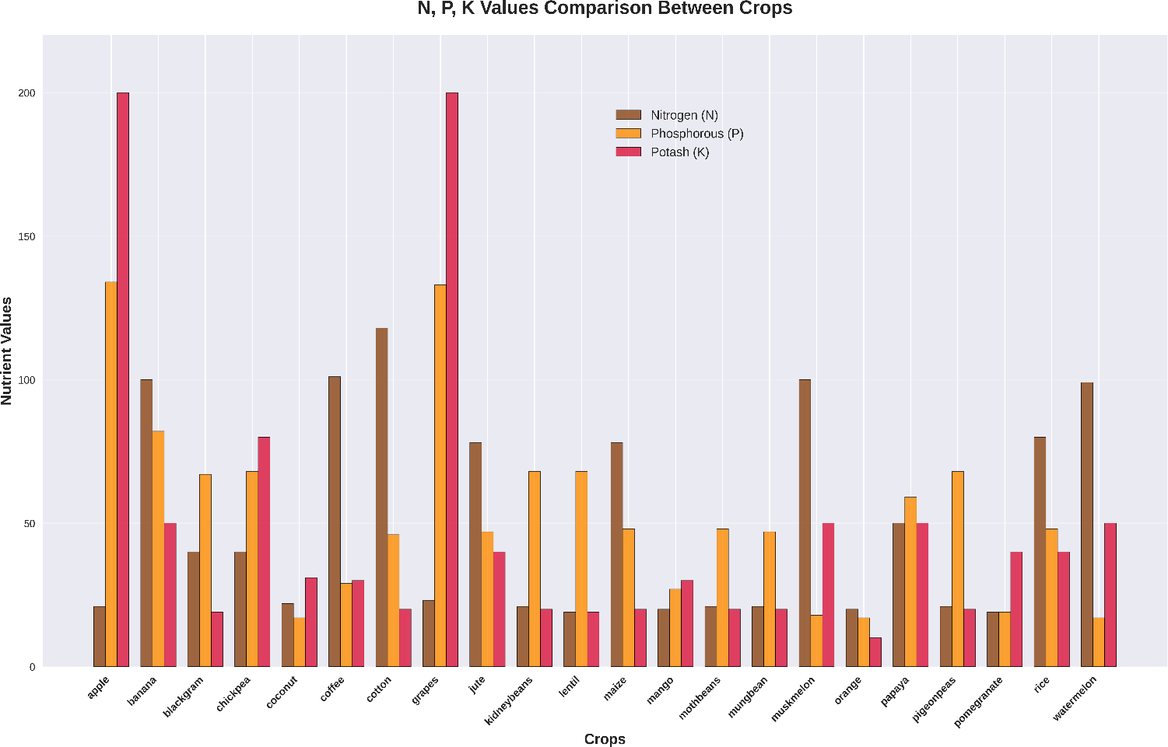
Fig. 4.1. Comparison of Nitrogen (N), Phosphorus (P), and Potassium (K) values across different crops.

This insight improves model training by emphasizing relevant features and reducing noise from less significant ones. The use of visualization not only supports better interpretation of the data but also assists in validating the consistency of the dataset, ensuring that the model learns meaningful and reliable patterns for accurate crop recommendations.

4.4 Correlation Analysis of Features
The correlation study also assists in identifying potential redundancy among features, which can affect model performance if not properly handled. When two variables are highly correlated, they may provide overlapping information, which can lead to unnecessary complexity in the model. On the other hand, features with low correlation may still carry unique information that is valuable for prediction. This balance is essential for building efficient and accurate models. The heatmap visualization provides a clear and intuitive way to interpret these relationships, allowing better feature selection and preprocessing decisions. As a result, the system benefits from improved model accuracy, reduced overfitting, and enhanced reliability in predicting suitable crops under varying agricultural conditions.

A correlation heatmap was generated to examine the relationships between different soil and environmental parameters. A heatmap is a visual representation where colors indicate the strength and direction of relationships between variables. Values closer to +1 represent a strong positive relationship, values near -1 indicate a strong negative relationship, and values around 0 suggest little to no correlation. This makes it easier to quickly identify how different features interact with each other.

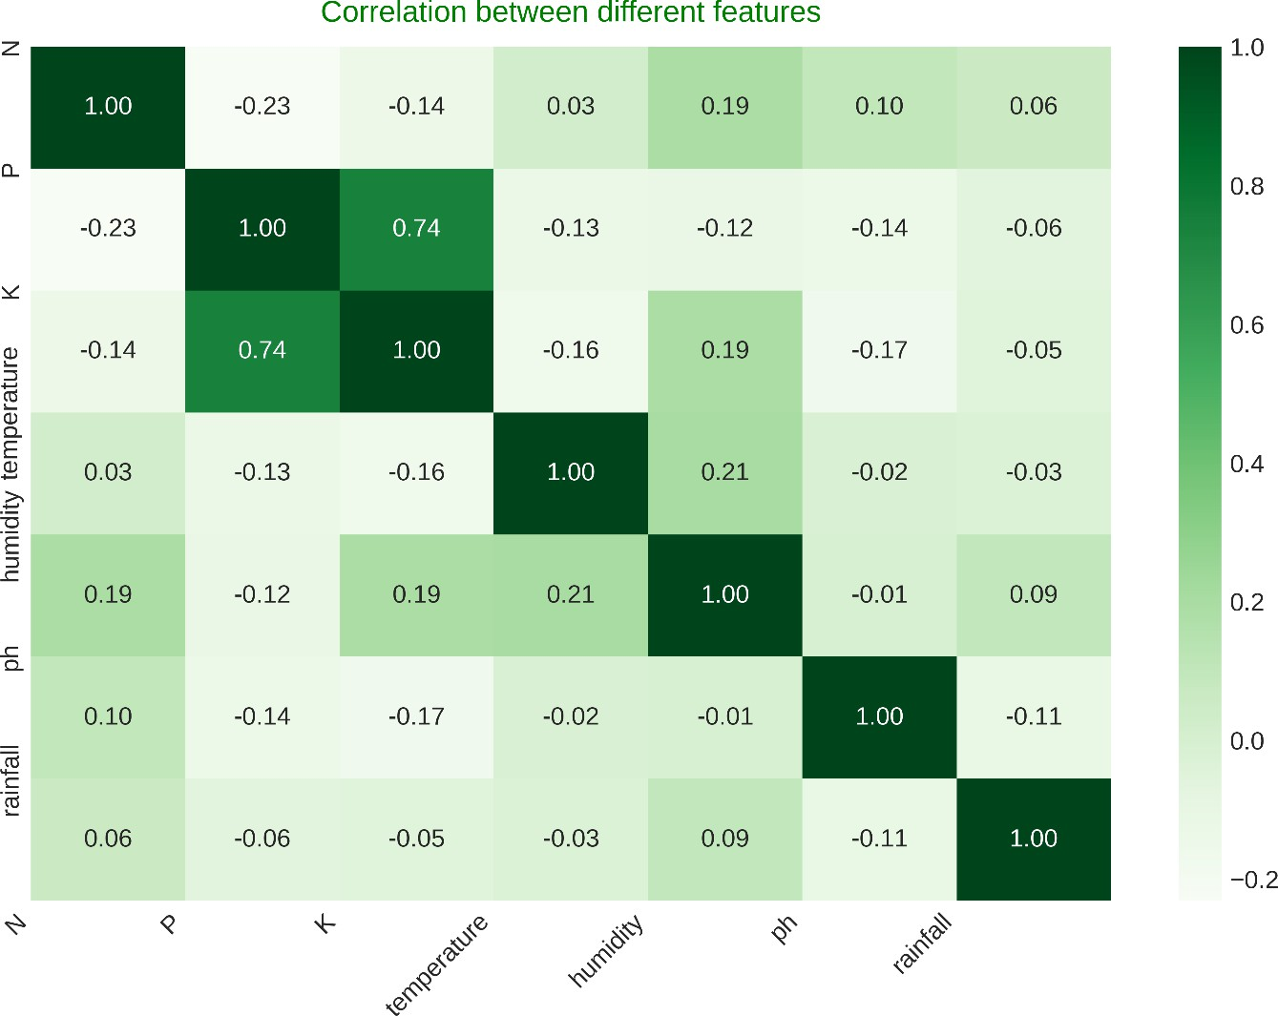
Fig 4.2. Correlation heatmap of soil and climatic features used for crop recommendation.
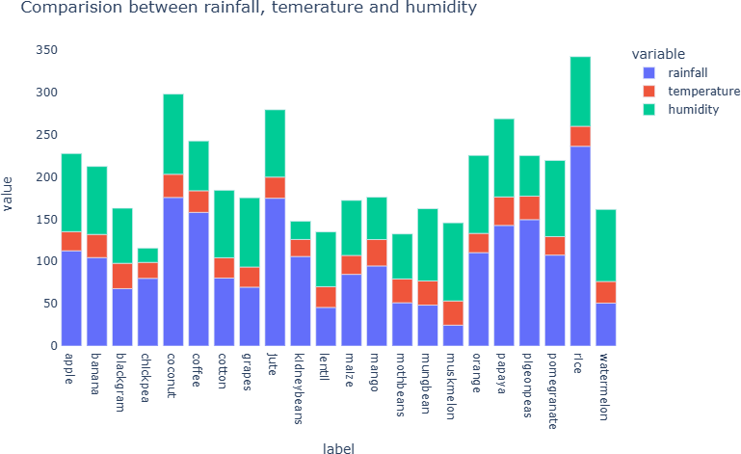
Fig. 4.3. Comparison of rainfall, temperature, and humidity across different crops

4.5 Explainability Analysis using SHAP
While machine learning models can provide highly accurate predictions, they often operate as “black box” systems, making it difficult to understand how decisions are made. To improve transparency, the Harvestify system incorporates SHAP (Shapley Additive Explanations) for model interpretability.

SHAP assigns an importance value to each input feature based on its contribution to the model's prediction. This allows the system to explain why a particular crop was recommended for a given set of conditions. The SHAP feature importance analysis revealed that parameters such as nitrogen levels, rainfall, and temperature have significant influence on crop prediction. Soil nutrients such as nitrogen, phosphorus, and potassium are particularly important because they directly affect plant growth and productivity.

By presenting feature contributions through visualizations, SHAP makes complex model behavior easier to interpret. These explanations help users identify which factors positively or negatively influence a recommendation in a specific case. This level of clarity improves confidence in the system and supports better decision-making. As a result, the model becomes more practical for real-world agricultural use, where understanding the reasoning behind predictions is as important as the accuracy itself.

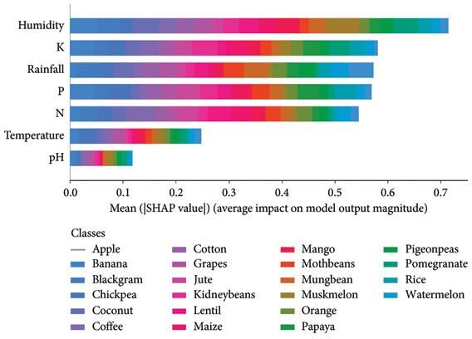

Fig. 4.4. SHAP feature importance plot showing the contribution of soil and climatic parameters towards crop recommendation.

4.6 Discussion of Results
The experimental results clearly demonstrate that ensemble-based machine learning algorithms perform better than traditional classifiers for crop recommendation tasks. Algorithms such as Random Forest, LightGBM, and XGBoost are able to model complex interactions between soil nutrients and environmental conditions.

Among the tested models, XGBoost showed the highest prediction accuracy and overall performance, making it the most effective algorithm for the Harvestify system. Its ability to handle nonlinear relationships and optimize model parameters contributes significantly to its superior performance. The integration of Explainable AI techniques using SHAP further enhances the usefulness of the system by providing insights into how different parameters affect crop recommendations. This transparency is particularly important in agriculture, where farmers must trust the recommendations provided by automated systems.

The results highlight how combining accuracy with interpretability leads to more practical and user-friendly solutions. While high performance is essential, the ability to explain predictions ensures that users can validate and confidently apply the recommendations in real-world scenarios. The findings indicate that models capable of capturing complex patterns while maintaining clarity in decision-making are more suitable for agricultural applications. This approach not only improves prediction quality but also supports wider adoption of intelligent systems in farming practices, ultimately contributing to improved productivity and sustainability.

CHAPTER 5

CONCLUSION AND FUTURE SCOPE

5.1 Conclusion
Agriculture plays a vital role in ensuring food security and supporting the livelihoods of millions of people around the world. Selecting the most suitable crop for cultivation is a critical decision that directly affects agricultural productivity and farmers’ income. However, traditional crop selection methods often rely on experience and local knowledge, which may not always provide optimal results under changing environmental conditions.

The Harvestify crop recommendation system was developed to address this challenge by leveraging machine learning techniques to assist farmers in making informed crop selection decisions. The system analyzes important soil and environmental parameters such as nitrogen, phosphorus, potassium, temperature, humidity, pH, and rainfall to determine the most suitable crop for cultivation.

In this project, several machine learning algorithms including K-Nearest Neighbors, Support Vector Machine, Random Forest, LightGBM, and XGBoost were implemented and evaluated using an agricultural dataset. The comparative analysis demonstrated that ensemble-based algorithms provide better performance compared to traditional models. Among the tested models, XGBoost achieved the highest accuracy and overall classification performance, making it the most effective algorithm for the Harvestify system.

In addition to predictive accuracy, the project also focused on improving model transparency by integrating Explainable Artificial Intelligence techniques using SHAP (Shapley Additive Explanations). SHAP analysis helped identify the contribution of different soil and environmental parameters to the crop prediction process, allowing users to understand the reasoning behind the model’s recommendations.

The results of this project demonstrate that combining machine learning algorithms with explainable AI techniques can significantly enhance the effectiveness of crop recommendation systems. The Harvestify system provides a reliable and data-driven decision support tool that can help farmers optimize crop selection, improve agricultural productivity, and promote sustainable farming practices.

5.2 Future Scope
Although the Harvestify crop recommendation system provides accurate and interpretable crop predictions, there are several opportunities for further improvements and future development.

5.2.1 Integration with Real-Time Agricultural Data
Future versions of the system can incorporate real-time data collected from IoT sensors and weather monitoring systems. This would allow the system to provide more accurate and location-specific crop recommendations. It can enable continuous monitoring of field conditions for timely decision-making. Such integration would improve the adaptability of the system to changing environmental factors.

5.2.2 Expansion of Dataset and Regional Adaptation
The current model is trained on a publicly available dataset. Expanding the dataset with region-specific soil and climate data could improve the system’s applicability across different agricultural regions. This approach helps the model learn region-specific patterns more effectively. It enhances prediction accuracy for diverse farming conditions.

5.2.3 Incorporation of Additional Agricultural Parameters
Future research can include additional parameters such as soil moisture, sunlight intensity, fertilizer usage, and irrigation patterns. These factors can provide a more comprehensive understanding of crop requirements and environmental conditions. Including such parameters can enhance the accuracy of predictions and improve the overall effectiveness of the crop recommendation system.

5.2.4 Development of a User-Friendly Application
The Harvestify system can be developed into a mobile or web-based application that allows farmers to easily input soil and environmental parameters and receive crop recommendations instantly. This would increase accessibility for users with limited technical knowledge. It supports wider adoption of the system in rural and remote areas.

5.2.5 Integration with Smart Farming Technologies
The system can be integrated with modern precision agriculture technologies such as drone monitoring, satellite imagery, and smart irrigation systems to create a comprehensive smart farming solution. This integration can support automated data collection and analysis. It improves overall farm management and resource optimization.

5.2.6 Advanced Explainable AI Techniques
Further research can explore additional explainability techniques to provide deeper insights into machine learning predictions and improve trust in automated agricultural systems. These techniques can offer more detailed feature-level interpretations. They enhance transparency and usability for non-technical users.

REFERENCES

- A. Sharma and R. Kaur, “Machine learning techniques for crop yield prediction: A review,” Journal of Agricultural Informatics, vol. 11, no. 2, pp. 1–12, 2020.
- P. Singh, S. Garg, and M. Gupta, “Applications of Random Forest in agriculture: A case study,” Computers and Electronics in Agriculture, vol. 178, pp. 105–114, 2020.
- H. Li, Y. Chen, and J. Wang, “Support Vector Machine-based crop classification using remote sensing data,” IEEE Access, vol. 8, pp. 110648–110658, 2020.
- K. Patel and A. Desai, “K-Nearest Neighbor approach for crop recommendation,” International Journal of Computer Applications, vol. 176, no. 32, pp. 25–29, 2020.
- T. Chen and C. Guestrin, “XGBoost: A scalable tree boosting system,” in Proc. 22nd ACM SIGKDD Int. Conf. Knowledge Discovery and Data Mining (KDD), 2016, pp. 785–794.
- G. Ke, Q. Meng, T. Finley, T. Wang, W. Chen, W. Ma, Q. Ye, and T. Liu, “LightGBM: A highly efficient gradient boosting decision tree,” in Advances in Neural Information Processing Systems, vol. 30, 2017, pp. 3146–3154.
- S. Lundberg and S.-I. Lee, “A unified approach to interpreting model predictions,” in Advances in Neural Information Processing Systems (NeurIPS), 2017, pp. 4765–4774.
- A. Kumar, R. Singh, and P. Yadav, “Crop recommendation system using ensemble machine learning models,” IEEE Access, vol. 9, pp. 123456–123467, 2021.
- V. Jain and A. Reddy, “Comparative analysis of machine learning models for crop prediction,” International Journal of Advanced Computer Science and Applications, vol. 12, no. 5, pp. 320–327, 2021.
- N. Patel, M. Shah, and R. Chauhan, “Explainable AI in agriculture: Enhancing trust in crop recommendations,” Frontiers in Artificial Intelligence, vol. 4, pp. 1–10, 2021.
- R. Yadav and S. Kumar, “Deep learning versus machine learning approaches for precision agriculture,” Computers and Electronics in Agriculture, vol. 190, pp. 106–118, 2021.
- A. Gupta, P. Mehta, and R. Saini, “Crop yield prediction using Random Forest and XGBoost,” in IEEE Int. Conf. Computational Intelligence and Computing Research, 2021, pp. 255–260.
- L. Zhang, H. Liu, and Q. Zhou, “SVM-based soil fertility classification for sustainable agriculture,” IEEE Access, vol. 10, pp. 5123–5134, 2022.
- K. Ramesh and S. Rajan, “Improving crop recommendation accuracy using ensemble methods,” International Journal of Artificial Intelligence, vol. 20, no. 1, pp. 45–54, 2022.
- P. Joshi and A. Agarwal, “Hybrid XGBoost-LGBM model for agricultural decision support,” IEEE Trans. Emerging Topics in Computational Intelligence, vol. 7, no. 2, pp. 345–356, 2023.
- Y. Liu and F. Chen, “Explainable crop yield prediction with SHAP and machine learning,” Expert Systems with Applications, vol. 218, Art. no. 119572, 2023.
- A. Das and R. Verma, “Crop recommendation using IoT and machine learning: A case study in India,” Sustainable Computing: Informatics and Systems, vol. 40, Art. no. 100841, 2023.
- Kaggle Dataset, “Crop Recommendation Dataset.” [Online]. Available: https://www.kaggle.com/datasets/atharvaingle/crop-recommendation-dataset
- H. Choudhary and K. Sharma, “Evaluation of ML models for crop recommendation with SHAP explanations,” IEEE Access, vol. 12, pp. 66501–66512, 2024.
- A. Barredo Arrieta et al., “Explainable Artificial Intelligence (XAI): Concepts, taxonomies, opportunities and challenges toward responsible AI,” Information Fusion, vol. 58, pp. 82–115, 2020.
- Q. M. Areeb et al., “Filter bubbles in recommender systems: Fact or fallacy—A systematic review,” Wiley Interdisciplinary Reviews: Data Mining and Knowledge Discovery, vol. 13, no. 6, Art. no. e1512, 2023.

APPENDIX – 1
SYSTEM MODULES AND FUNCTIONAL DESCRIPTION

This appendix provides a detailed overview of the major functional modules of the Harvestify crop recommendation system. The system is designed to analyze soil and environmental parameters using machine learning algorithms in order to recommend the most suitable crop for cultivation. Each module performs a specific function to ensure efficient data processing, model prediction, and result interpretation.

A. User Input Module
The User Input Module allows users to provide the necessary agricultural parameters required for crop prediction. The system accepts input values related to soil nutrients and environmental conditions.
The parameters collected from the user include:
- Nitrogen (N)
- Phosphorus (P)
- Potassium (K)
- Temperature
- Humidity
- Soil pH
- Rainfall
These parameters represent the conditions under which crops grow. The input data provided by the user is passed to the preprocessing module for further processing and analysis.

B. Data Preprocessing Module
The Data Preprocessing Module prepares the dataset for machine learning model training and prediction. Raw agricultural data often contains inconsistencies, missing values, or variations in feature scales that may affect model performance.

This module performs the following tasks:
- Data cleaning and validation
- Feature normalization and scaling
- Encoding of crop labels into numerical form
- Splitting the dataset into training and testing sets
Proper preprocessing ensures that the dataset is structured and suitable for training machine learning models.

C. Machine Learning Model Training Module
This module is responsible for training different machine learning algorithms using the prepared agricultural dataset. Multiple models are implemented in order to compare their performance and determine the most suitable algorithm for crop recommendation.

The models implemented in the Harvestify system include:
- Random Forest (RF)
- Support Vector Machine (SVM)
- K-Nearest Neighbors (KNN)
- LightGBM
- XGBoost
Each model learns patterns from soil and climate parameters to classify the most suitable crop type. After training, the models are evaluated using various performance metrics.

D. Model Evaluation Module
The Model Evaluation Module analyzes the performance of each machine learning model using standard classification metrics. These metrics help determine which algorithm provides the most accurate predictions.
The evaluation metrics used include:
- Accuracy
- Precision
- Recall
- F1-Score
Based on the experimental results, XGBoost demonstrated the highest accuracy and overall performance, and was therefore selected as the final model used in the Harvestify system.

E. Crop Prediction Module
The Crop Prediction Module uses the trained machine learning model to recommend the most suitable crop based on the user’s input parameters.

When the user provides soil nutrient and environmental values, the system processes the data through the trained model and generates a crop recommendation. This module ensures that the system provides quick and reliable predictions that can assist farmers in making informed agricultural decisions.

F. Explainability Module (SHAP Analysis)
To improve transparency and interpretability, the Harvestify system integrates an Explainable Artificial Intelligence module using SHAP (Shapley Additive Explanations).

This module performs the following tasks:
- Determines the importance of each feature used in the model
- Explains how input parameters influence the final prediction.
- Provides visual insights into feature contributions

For example, SHAP analysis can show whether nitrogen levels, rainfall, or temperature played a major role in recommending a particular crop. This enhances trust in the system by allowing users to understand the reasoning behind the model’s predictions.

G. System Output Module
The System Output Module presents the final crop recommendation to the user. After processing the input data through the trained model and explainability module, the system displays:
- Recommended crop name
- Important contributing parameters
- Explanation of prediction using SHAP (if applicable)
This module ensures that the system provides clear and understandable results that can be easily interpreted by farmers and agricultural experts.

APPENDIX – 2

Published Paper Link: https://ieeexplore.ieee.org/document/11468330

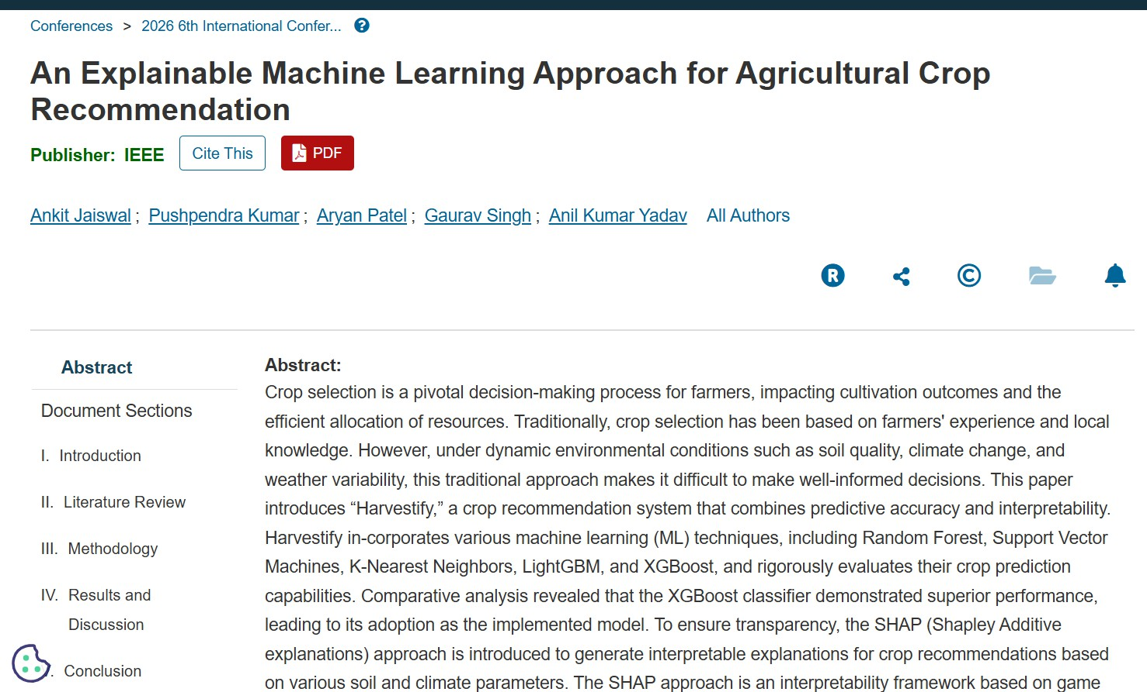





Paper Presentation Certificate

