



A

Project Report
on
EmoHealthNexus:Cross Domain Disease Detection
Submitted as partial fulfillment for the award of
BACHELOR OF TECHNOLOGY
DEGREE
SESSION 2025-26
in

Computer Science & Engineering
By
Aanchal Gupta (2200290100001)
Aryan Kumar (2200290100041)
Aastha (2200290100003)
Akanksha Choudhary (2200290100015)

Under the supervision of

Dr. Preeti Garg

KIET Group of Institutions, Ghaziabad
Affiliated to

Dr. A.P.J. Abdul Kalam Technical University, Lucknow
(Formerly UPTU)

May, 2026

DECLARATION

We hereby declare that this submission is our own work and that, to the best of our knowledge and belief, it contains no material previously published or written by another person nor material which to a substantial extent has been accepted for the award of any other degree or diploma of the university or other institute of higher learning, except where due acknowledgment has been made in the text.

Name: Aanchal Gupta
Roll No:2200290100001 | Signature:
Name: Aryan Kumar
Roll No: 2200290100041 | Signature:
Name: Aastha
Roll No: 2200290100003 | Signature:
Name: Akanksha Chaudhary
Roll No: 2200290100015 | Signature:

Date:

CERTIFICATE

This is to certify that the Project Report entitled “EmoHealthNexus: Cross Domain Disease Detection”, which is submitted by Aanchal Gupta, Aryan Kumar, Aastha, Akanksha Choudhary in partial fulfilment of the requirement for the award of degree B. Tech. in Department of Computer Science & Engineering of Dr A.P.J. Abdul Kalam Technical University, Lucknow, is a record of the candidate's own work carried out by them under my supervision. The matter embodied in this report is original and has not been submitted for the award of any other degree.

Dr. Preeti Garg Dr. Vineet Sharma
(Associate Professor, CSE) Dean(CSE)

Date:

ACKNOWLEDGEMENT

It gives us a great sense of pleasure to present the report of the B. Tech Project undertaken during B. Tech. Final Year. We owe special debt of gratitude to Dr. Preeti Garg, Associate Professor, Department of Computer Science &Engineering, KIET, Ghaziabad, for his constant support and guidance throughout the course of our work. His sincerity, thoroughness and perseverance have been a constant source of inspiration for us. It is only his cognizant efforts that our endeavors have seen light of the day.
We also take the opportunity to acknowledge the contribution of Dr. Vineet Sharma, Dean, Computer Science and Engineering Department, KIET, Ghaziabad, for his full support and assistance during the development of the project.
We also do not like to miss the opportunity to acknowledge the contribution of all the faculty members of the department for their kind assistance and cooperation during the development of our project. Last but not the least, we acknowledge our friends for their contribution in the completion of the project.
Date:

Signature:
Name: | Aanchal Gupta | Aryan Kumar | Aastha | Akanksha
Roll No: | 2200290100001 | 2200290100041 | 2200290100003 | 2200290100015

ABSTRACT

Digital health technologies are transforming modern healthcare by enabling continuous monitoring and preventive medical interventions. Traditional healthcare systems mainly focus on reactive treatment after symptoms appear, while modern digital health systems aim to identify risks at an early stage. But many existing digital health systems look at either physiological or emotional data, but not both, leading to limited health insights.

EmoHealthNexus is a cross-domain disease detection framework approach to healthcare that uses physiological data collected from wearable devices, along with emotional and self-reported health data. It integrates real-time physiological information (heart rate, sleep, activity) from wearable devices and emotional and self-reported health information (emotional states, symptoms) via structured patient self-reports and sentiment analysis.

The system uses machine learning techniques including Random Forest Classification, Decision Tree and Logistic Regression to process data and predict early symptoms of potential risks. The data is processed using Python backend, which extracts features and runs the predictive models. The processed results are stored in MySQL database and presented through a React.js dashboard, allowing patients and doctors to track their health each week.

The system also features a patient-doctor consultation interface, where doctor-approved automated predictions can be made. Our experiments show that the Random Forest model outperforms Decision Tree models in predicting outcomes when using the combined dataset.

In summary, EmoHealthNexus showcases the benefits of integrating physiological and emotional health information to enhance predictive accuracy, facilitate early diagnosis and improve patient-doctor consultation in the healthcare industry.

TABLE OF CONTENTS | PageNo.
DECLARATION...................................................................................... | ii
CERTIFICATE................................................................................. | iii
ACKNOWLEDGEMENTS....................................................................... | iv
ABSTRACT...................................................................................... | v
LIST OF FIGURES…………………………………………………………… | viii
LIST OF TABLES……………………………………………………………. | ix
LIST OF ABBREVIATIONS.………………………………………………... | x
CHAPTER 1(INTRODUCTION) ............................................................................. | 1
1.1.Introduction............................................................................................ | 1
1.2.ProjectDescription........................................................................................... | 2
CHAPTER 2(LITERATURE REVIEW).................................................................. | 3
CHAPTER 3(PROPOSED METHODOLOGY)..................................................... | 5
3.1.DataCollection................................................................................................. | 7
3.2.SecureDataFusionAndProcessing................................................................... | 8
3.3.CrossDomainAnalysis..................................................................................... | 8
3.4.Interactive Dashboard AndVisualization........................................................ | 9
3.5.DoctorReviewAndValidation......................................................................... | 9
CHAPTER 4(RESULTS AND DISCUSSION)............................................... | 11
4.1PerformanceMetrics......................................................................................... | 11
4.2ExperimentalResults........................................................................................ | 14
4.3Discussion........................................................................................................ | 14
CHAPTER 5(CONCLUSIONS AND FUTURE SCOPE).............................. | 15
5.1Conclusion…................................................................................................... | 15
5.2FutureScope..................................................................................................... | 15
REFERENCES................................................................................................ | 17
APPENDEXl.............................................................................................. | 18
RESEARCH PAPER ACCEPTANCE PROOF…….................................... | 20
PATENT PUBLICATION PROOF..............................................................  RESEARCH PAPER PRESENTATION PROOF…………………………... | 23  25
RESEARCH PAPER ………...................................................................... | 27

LIST OF FIGURES

Figure No. | Description | Page No.
3.1 | Architecture of Emo Health Nexus System | 6
3.2 | System Workflow | 10
4.1 | Precision Comparison | 11
4.2 | Recall Comparison | 12
4.3 | F1Score Comparison | 13

LIST OF TABLES

Table No | Description | Page No.
3.1 | Technologies Used in the System | 6
3.2 | Physiological Parameters Collected | 7

LIST OF ABBREVIATIONS

Abbreviation | Full Form
IOT | Internet of Things
NLP | Natural Language Processing
ML | Machine Learning
HRV | Heart Rate Variability
PPG | Photoplethysmography
API | Application Programming Interface
SQL | Structured Query Language
RF | Random Forest
DT | Decision Tree

CHAPTER1

INTRODUCTION

INTRODUCTION

The rapid advancement of digital healthcare technologies has significantly changed the way healthcare services are delivered. Wearable devices such as smartwatches, fitness bands, and smart rings allow continuous monitoring of physiological parameters including heart rate, sleep patterns, and physical activity. These devices transmit real-time health data to cloud platforms, enabling healthcare providers to monitor patients remotely and identify potential health risks earlier than traditional clinical methods.

Despite these technological developments, many existing digital health systems focus primarily on physiological measurements while ignoring emotional and psychological factors that significantly influence human health. Research studies indicate that mental conditions such as stress, anxiety, and depression can strongly affect physical health by disrupting metabolic balance and increasing cardiovascular risks.

However, most current health monitoring applications analyze physiological data and emotional data separately. This distinction constrains the capacity of health care to fully understand the state of a patient. This means that disease symptoms may be overlooked and preventive health strategies may be less effective.

To overcome this challenge, a cross-disciplinary perspective of health care is needed that considers both physical health measures and emotional states together.

PROJECT DESCRIPTION

This project introduces EmoHealthNexus, a holistic health management system that links physiological data with emotional health.

It gathers physiological data via wearable devices such as heart rate variability, sleep duration, and exercise. Meanwhile, patients also report subjective symptoms, emotions, and stress through a web portal. The information from these two sources is integrated to provide a holistic view of the patient's health.

The data is fed into a machine learning system that uses algorithms like Random Forest, Decision Tree, and Logistic Regression to examine the associations between emotional and physiological variables. It detects correlations that could indicate early onset of health problems and issues predictive warnings for preventive health care.

A dashboard developed with React.js enables users to view weekly health, activity, and emotional data patterns. It also includes a doctor consultation module, enabling doctors to access the AI-based predictions and offer professional medical feedback.

The major objectives of the EmoHealthNexus system are:
- To combine physiological and emotional health data for monitoring health.
- To enable early prediction of health risks through machine learning.
- To improve preventive care via continual monitoring and predictive modeling.
- To enable communication between patients and doctors.

Through the integration of artificial intelligence, wearables, and emotional health assessment, EmoHealthNexus seeks to deliver the first proactive and integrated healthcare monitoring system.

CHAPTER 2

LITERATURE REVIEW

The digital health ecosystem has transformed with the emergence of wearable devices, artificial intelligence and mobile health solutions. Wearable technologies allow for real-time tracking of health metrics such as heart rate, sleep quality, and activity, offering insights into preventive health. Bhaltadak et al. (2024) state that wearable technologies have transformed the way people monitor their cardiovascular health and enable health monitoring in non-clinical settings.

Numerous studies emphasise the value of multiple data sources in predictive models for healthcare. Conventional healthcare monitoring systems may use either a single data source such as wearable devices or clinical data. But studies demonstrate the advantage of using multiple data sources in healthcare prediction systems.
Machine learning is essential in healthcare. Machine learning models like Random Forest, Decision Trees and Logistic Regression are commonly applied in disease prediction due to their accuracy and simplicity. Iwendi et al. (2020) have shown the utility of Random Forest for predicting health through the analysis of complex data that spans physiological signals and patient data.
A crucial element of healthcare is the inclusion of psychological health. Sentiment and natural language processing have been applied to patient social media data such as health forums and conversations. Villanueva-Miranda et al. (2025) demonstrated sentiment analysis can be used to extract emotional indicators to understand patient well-being.
However, most current healthcare monitoring systems still separate the analysis of physiological and emotional data. This makes it difficult to establish links between emotional distress and health problems. Several studies have highlighted the importance of cross-domain integrated healthcare systems, which integrate wearable data, emotion, and supervision.
Several studies also advocate for human-in-the-loop approaches for AI in health care. Human-in-the-loop machine learning systems enable doctors to validate AI-generated predictions, enhancing system transparency and trustworthiness. These methods ensure that AI systems are not used to replace expert medical judgement.

The EmoHealthNexus approach builds on these research insights to combine wearable sensor data, emotional self-reports, and machine learning algorithms to build a predictive health system. Such a domain integration system allows early disease risk prediction and supports proactive health care.

CHAPTER 3

PROPOSED METHODOLOGY

The EmoHealthNexus system is designed to detect early indicators of health issues by linking physiological data from wearables with patients' emotional data. The method involves several steps, including data collection, data preprocessing, cross-domain analysis, visualisation and doctor validation. In the data collection phase, physiological data such as heart rate variability, sleep patterns, and activity levels are continuously gathered through wearable devices, while emotional inputs are recorded through user self-reports on the web portal.

During preprocessing, the collected data is cleaned, normalized, and synchronized to ensure consistency and accuracy before being used for analysis. The integrated dataset is then analyzed using machine learning models to identify patterns and correlations between physical and emotional health indicators, enabling early risk detection and supporting informed medical decisions.

Feature engineering techniques are applied to extract meaningful attributes such as stress levels, activity intensity, and sleep quality indices, which improve the performance of predictive models. Additionally, data fusion methods are used to combine heterogeneous data sources, ensuring that both emotional and physiological signals contribute effectively to the analysis.

The system also incorporates a continuous monitoring mechanism, where new incoming data is periodically evaluated to update predictions in real time. Finally, the results are presented through an interactive dashboard, and validated by medical professionals to ensure reliability, accuracy, and practical relevance in real-world healthcare scenarios.
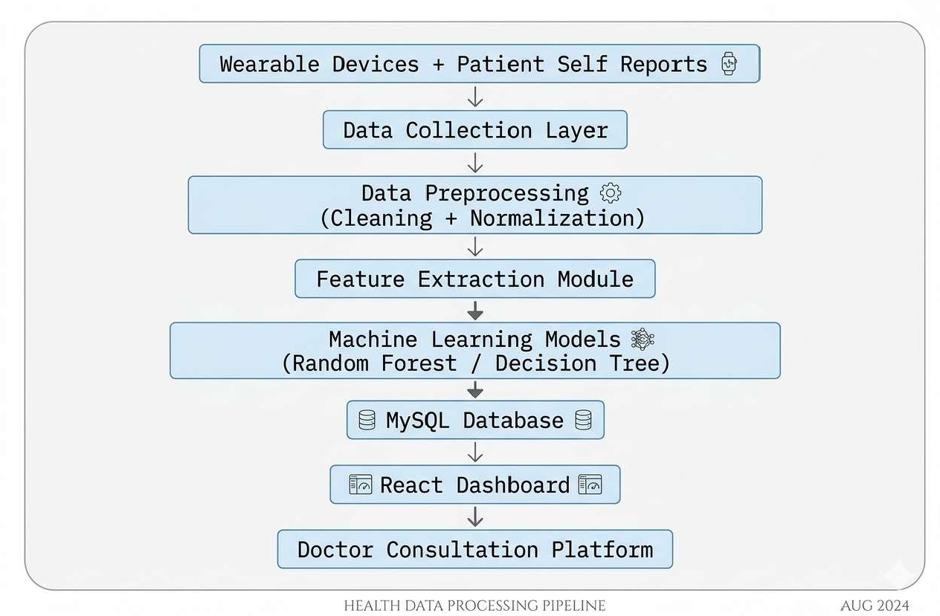

Figure3.1 Architecture of Emo Health Nexus System

Table 3.1: System Technologies

Component | Technology Used | Purpose
Wearable Devices | Smartwatch / Fitness Band | Collect physiological data
Backend | Python | Data processing and ML models
Database | MySQL | Store patient data
Frontend | React.js | Dashboard visualization
Machine Learning | Random Forest, Decision Tree | Disease prediction
Communication | REST APIs | Data exchange

  - DATA COLLECTION

The first stage of the methodology is the data collection of physiological and emotional data. The client's physiological data is collected from wearables such as smartwatches, fitness trackers and smart rings.

These sensors include accelerometers, gyroscopes and photoplethysmography (PPG) sensors. The physiological parameters collected include:
- Heart Rate Variability (HRV)
- Sleep Quality and Sleep Duration
- Physical Activity Levels
- Stress Indices from heart rate

The system not only collects physiological data, but also emotional and symptom data from self-reports. Users provide subjective data about levels of fatigue, stress, anxiety, headaches and other symptoms via a mobile or web portal. The use of sensor data and self-reported data gives a comprehensive picture of the user's health.

Table3.2: Physiological Parameters Collected

Parameter | Description
Heart Rate Variability | Measures cardio vascular activity
Sleep Duration | Monitors sleep cycles
Physical Activity | Tracks steps and movement
Stress Indicator | Derived from HRV patterns

  - SECURE DATA FUSION AND PROCESSING

Raw data obtained may be noisy, inconsistent or contain missing values. Thus, data preprocessing is needed to improve data quality. Preprocessing consists of the following steps:
Data Cleaning:
Invalid sensor readings, duplicate entries, and noise are removed from the dataset.
Missing Value Handling:
Incomplete sensor readings or missing self-reports are handled using statistical imputation techniques such as mean substitution or k-nearest neighbor imputation.
Normalization:
Different physiological measurements have different value ranges. Therefore, normalization techniques are applied to convert the data into a common scale to improve model performance.
Feature Extraction:
Important features such as average heart rate, sleep duration trends, and emotional sentiment scores are extracted from the cleaned dataset.

After preprocessing, the structured dataset is stored in a MySQL database, while unstructured data such as text inputs or voice recordings may be stored in flexible storage systems such as Firebase or MongoDB. Security measures including encryption and access control are implemented to protect sensitive healthcare data.

  - CROSS DOMAIN ANALYSIS

The core analytical component of the system uses machine learning algorithms to identify patterns between physiological and emotional indicators.
The following machine learning models are used:
- Decision Tree Model: Decision Trees analyze health indicators through a series of conditional rules. For example, the model may evaluate whether the patient’s heart rate exceeds a specific threshold while also considering reported fatigue levels. Based on these conditions, the model classifies the patient’s risk level.

- Random Forest Model: Random Forest is an ensemble learning technique that combines multiple decision trees. Each tree analyzes a different subset of the dataset, and the final prediction is obtained by aggregating the outputs of all trees. This approach reduces overfitting and improves prediction accuracy, especially for complex healthcare datasets.

By combining emotional indicators with physiological signals, the system is able to detect correlations that may otherwise remain hidden in single-domain analysis.
  - INTERACTIVE DASHBOARD AND VISUALIZATION

The processed health data and prediction results are presented to users through an interactive dashboard developed using React.js.
The dashboard provides several visual components including:
- Weekly heart rate trends
- Daily activity levels
- Sleep pattern visualization
- Emotional state tracking

Patients can easily monitor their health patterns through graphical charts and summary indicators. Healthcare professionals can access the same data through a more detailed interface, enabling them to analyze long-term health trends.
  - DOCTOR REVIEW AND VALIDATION

To ensure reliability and medical safety, the EmoHealthNexus system incorporates a human-in-the-loop healthcare model. The machine learning system first generates predictive alerts and health summaries based on the analyzed data. These predictions are then reviewed by medical professionals through an online consultation interface.
Doctors can evaluate the system’s predictions, verify potential risks, and provide personalized medical advice. This collaborative approach ensures that AI-based predictions are supported by expert clinical judgment.

.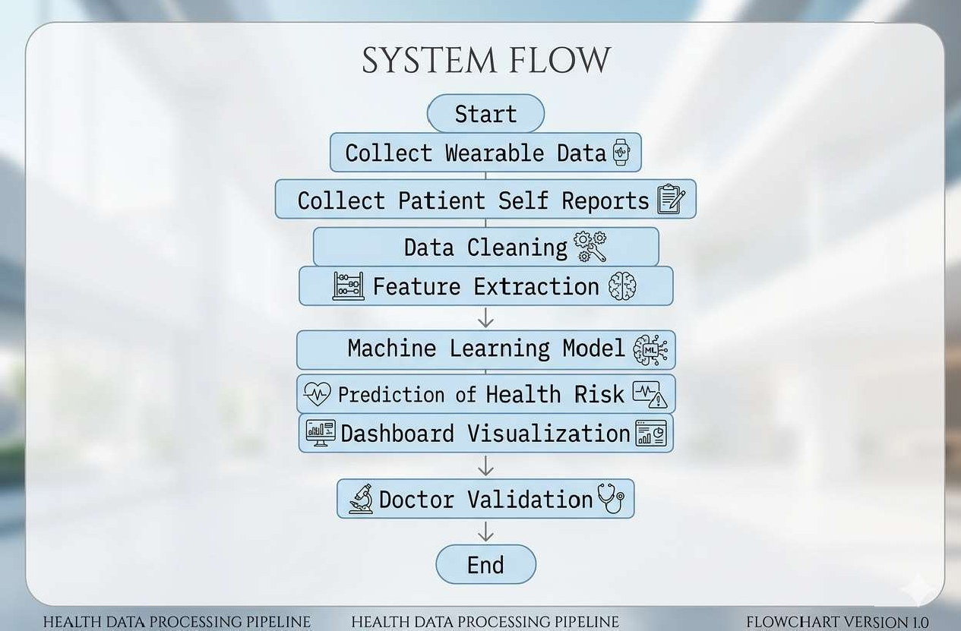

Figure3.2: Workflow of the Proposed EmoHealthNexus System.

CHAPTER 4
RESULTS AND DISCUSSION

To test how well the EmoHealthNexus system works, researchers performed experiments. They used datasets that they created to resemble real-world data collected from wearable sensors along with self-reported emotional inputs from patients. The purpose of this evaluation was to analyze how effectively different machine learning models can predict potential health risks by leveraging both physiological and emotional parameters.

  - Performance Metrics

By using multiple standard classification metrics, the researchers measured how the system performed. These metrics include precision, recall, F1-score, and accuracy. Each metric provides a different perspective on the effectiveness of the predictive models, ensuring a comprehensive evaluation.

- Precision:

Precision is the number of positive cases that the system predicted correctly when compared to all cases that the system predicted as positive.
$$c=\frac{|a ∩b|}{|b| }$$
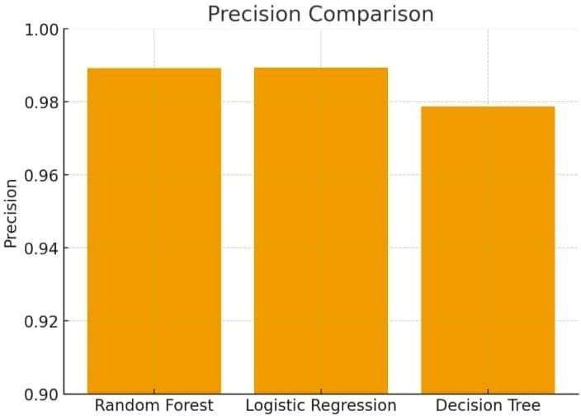

Figure4.1: Precision comparison of machine learning models

- Recall:

Recall is the number of positive cases that the system predicted correctly when compared to all cases that are actually positive.

$$d=\frac{|a ∩b|}{|a| }$$

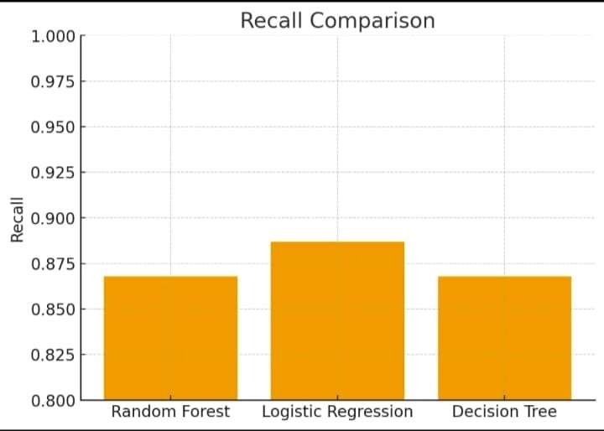
Figure4.2: Recall comparison of machine learning models.

- F1-Score:

To calculate the F1-score, the system finds the harmonic mean of precision and recall. It is a tool that describes how well a model performs in a balanced way.

$$FI=2x\frac{(c x d) }{(c+d}$$

FI=2𝑥

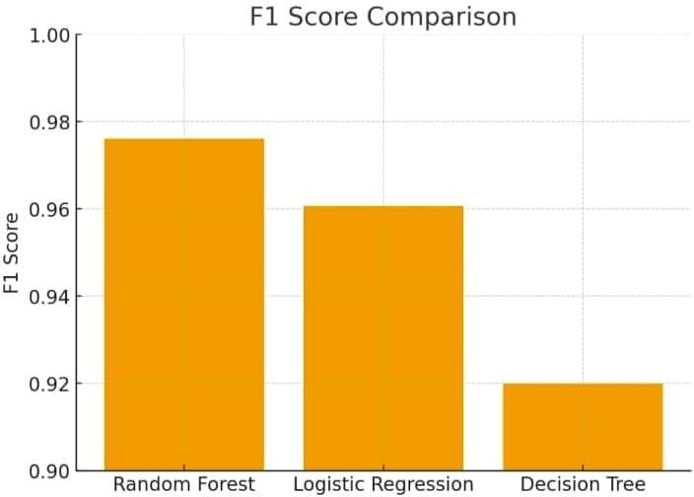
Figure 4.3: F1-score comparison among models.

- Accuracy:

As a measurement accuracy shows how often the model is correct when its predictions are compared to actual outcomes.
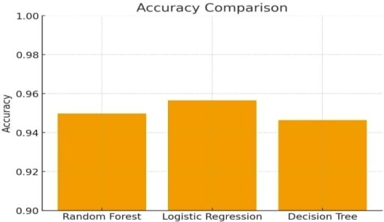
Figure 4.4: Accuracy comparison of machine learning models.

  - Experimental Results

For the machine learning models, the results are listed below:

Random Forest Model
Accuracy: 94.9%
F1Score:0.97

Decision Tree Model
Accuracy: 94.6%
F1Score:0.92

In those results the Random Forest model is more accurate at predicting outcomes than the Decision Tree model. With its ensemble structure, the Random Forest algorithm manages healthcare data that is complex and varied.

  - Discussion

By combining data from physiological sensors with emotional information from patients, the system increases its prediction accuracy. When the system integrates different types of data, it identifies small relationships between emotional stress plus physical health indicators.

To maintain a balance between false positives and false negatives, the system uses precision and recall as metrics. If an F1-score is high, the model is reliable but also makes few incorrect classifications.

And the results show that ensemble machine learning models are useful for healthcare. Due to their design, Random Forest models are effective at applying learned patterns to new data and they function well even when healthcare data has errors or missing parts
CHAPTER 5
CONCLUSION AND FUTURE SCOPE

Conclusion
The EmoHealthNexus system is a tool that shows how data about the body and emotions work together to monitor health and predict diseases. When researchers combine data from wearable sensors with information that patients provide about their feelings, the system creates a full picture of how a person is doing physically.
To find hidden patterns in health data from different areas, the system uses machine learning algorithms like Random Forest besides Decision Tree. If the system finds potential risks to health, it creates alerts for the user. By showing health trends on an interactive dashboard, the system helps users stay involved with their own data.
As a doctor consultation module is part of the system, medical professionals can check the predictions that the AI creates. Because of this verification process, the results are more reliable and doctors can trust the system more.
On the whole the EmoHealthNexus framework is a method for healthcare that focuses on finding problems early. For this purpose the system monitors patients continuously and delivers care that centers on the needs of the individual.

Future Scope
The EmoHealthNexus system produces results that indicate potential but researchers can change multiple parts of the system in the future.
In future versions, engineers might add more wearable sensors so that the system monitors more physiological signs. For instance the hardware could measure how much oxygen is in the blood and how hot the body is. By using advanced deep learning techniques, the system could make predictions that are correct more often.
To expand the system, developers could include large sets of healthcare data that people collect from hospitals and clinical trials. If the system connects with electronic health records, doctors can read full histories of patients - this is helpful when doctors must decide how to treat people.
And researchers could create personalized healthcare models - those models are useful because they give health recommendations that match the specific attributes of an individual patient.
As artificial intelligence, Internet of Things technologies and wearable devices improve constantly, systems like EmoHealthNexus are able to change healthcare. In this new approach, providers act before illnesses occur and focus on the specific needs of each person. There is a modular architecture in the system.

REFERENCES

- V. Bhaltadak, B. Ghewade, and S. Yelne, “A comprehensive review on advancements in wearable technologies: Revolutionizing cardiovascular medicine,” Cureus, vol. 16, no. 5, p. e61312, 2024.
- A.Doherty, M. Smith, and T. Jones, “Umbrella review of the accuracy of consumer wearables for heart rate monitoring,” British Journal of Sports Medicine, vol. 58, no. 2, pp. 79–87, 2024.
- D. Vit´azkov´a, P. Novak, and J. Horak, “Wearable devices for sleep monitoring: A comprehensive review,” Journal of Sleep Research, vol. 34, no. 1, p. e12345, 2025.
- T.Lu, L. Yang, and C. Chang, “Wearable technologies for healthcare: A narrative review,” Journal of Medical Internet Research, vol. 22, no. 10, p. e12345, 2020.
- A. Khan, S. Patel, and R. Gupta, “Integration of electronic health records and wearable data: Opportunities and challenges,” Journal of Medical Systems, vol. 45, no. 6, pp. 1–12, 2021.
- C.Iwendi, A. K. Bashir, A. Peshkar, R. Sujatha, J. Chatterjee, S. Pasupuleti, R. K. Mishra, and O.-Y. Jo, “Covid-19 patient health prediction using random forest and adaboost algorithm,” Health Information Science and Systems, vol. 8, no. 1, p. 37, 2020.
- P. Naik, K. Sharma, and M. Desai, “Heart disease prediction using machine learning with random forest classifier,” Procedia Computer Science, vol. 223, pp. 1123–1132, 2025.
- D.Bakker, N. Kazantzis, D. Rickwood, and N. Rickard, “Mental health smartphone apps: Review and evidence-based recommendations for future developments,” JMIR Mental Health, vol. 3, no. 1, p. e7, 2016.
- Y. Alnashwan, M. Khader, and S. Ahmed, “Analyzing lyme disease patient-generated content using machine learning,” BMC Public Health, vol. 23, p. 4567, 2023.
- J. Villanueva-Miranda, L. Hernandez, and R. Patel, “Sentiment analysis in healthcare: A systematic review,” IEEE Access, vol. 13, pp. 11234 11249, 2025.
- B.Walsh, D. Green, and S. Kumar, “Topic and sentiment modeling for healthcare forums,” Health Informatics Journal, vol. 30, no. 2, pp. 456–472, 2024.
- L.Piwek, D. A. Ellis, S. Andrews, and A. Joinson, “The rise of consumer health wearables: promises and barriers,” PLoS Medicine, vol. 13, no. 2, p. e1001953, 2016.
- S.R. Steinhubl, E. D. Muse, and E. J. Topol, “Can mobile health technologies transform health care?” JAMA, vol. 310, no. 22, pp. 2395 2396, 2013.
- E.J. Topol, Deep Medicine: How Artificial Intelligence Can Make Healthcare Human Again. New York, NY: Basic Books, 2019.
- E.Mosqueira-Rey, E. Hern´andez-Pereira, D. Alonso-R´ ıos, J. Bobes Bascar´an, and ´ A. Fern´andez-Leal, “Human-in-the-loop machine learn ing: a state of the art,” ArtificialIntelligence Review, vol. 56, pp. 3005 3054, 2023.
- B.J. Petek et al., “Consumer wearables in cardiovascular practice: Current evidence and future directions,” Circulation, vol. 148, no. 11, pp. 845–860, 2023.
- N. Obradovich and I. Rahwan, “Social media and mental health: Privacy, ethics, and policy implications,” Nature Human Behaviour, vol. 2, no. 7, pp. 485–491, 2018.
- R.Kumar and T. Sharma, “Supervised machine learning for disease prediction,” International Journal of Medical AI, vol. 8, pp. 22–29, 2019.
- A.SinghandR. Patel,“Sentimentanalysis of medicalforums,” IEEEAccess, vol. 9, pp. 66710–66718, 2021.
- World Health Organization, “Mental health and noncommunicable dis eases,” https://www.who.int/, 2022, WHO Reports

APPENDIX1
Technical Details and Supporting Materials
- System Architecture
EmoHealthNexus system that combines the analysis of emotions with the prediction of diseases. It is made of multiple parts that are connected to each other - those parts work together so that they can examine how emotions change over time and find risks for diseases in different areas of health.
When a person uses the system, they provide information about their feelings or their health through the interface. By sending this data, the process starts. It is then handled by the Emotion Analysis Module. To determine how the user feels, the module uses patterns that are already set or techniques where machines learn from data.
The system passes the data that shows emotions to the Cross Domain Disease Detection Module. In this module the system examines how emotional conditions relate to health risks that might follow. It uses models and datasets that it has trained to find how emotional states and diseases connect to each other.
By using the Prediction Module, the system produces the final information. With this module the system shows the user risks for diseases or suggestions on the interface.

- Dataset Description
The effectiveness of the EmoHealthNexus system depends on how well the datasets relate to the task and the quality of the data. To support the process where the system detects emotions plus analyzes how they correlate with diseases, the researchers considered multiple datasets.

Dataset | Description | Source
Emotion Dataset | If a user provides input, the system identifies the state of their emotions. | Public dataset/Kaggle
Disease Dataset | The system stores information which is about diseases, symptoms and how those factors relate to each other. | Health care datasets
As those datasets provide information, the system identifies patterns between states of emotion and the risks that diseases might occur. If the patterns exist, the system predicts outcomes across different domains.
- Algorithms and Technologies Used
For the implementation of the system, it uses various techniques that involve computation but also technology.

Algorithms/Techniques Used:
- Emotion classification techniques
- Machine learning-based prediction models
- Pattern analysis for disease correlation

Technologies Used:
- Programming Language: Python /JavaScript
- Framework: MERN/ML libraries
- Database: MongoDB/other database
- Visualization tools for displaying predictions

- Sample Code Snippet
The following text is a description of the way the system handles input data to create predictions.
def predict_disease(emotion_data):
model=load_model("emotion_model")
prediction=model.predict(emotion_data)
return prediction

To predict risks for diseases, this function loads the model that has finished training and examines data related to emotions.

- Sample Input and Output
On the system interface, users enter information about emotions or health. As the system performs an analysis, it generates predictions about the possibility that a disease will occur.
Examples include:
- User emotional input
- Detected emotional state
- Predicted disease correlation
- Suggested preventive recommendations

RESEARCH PAPER ACCEPTANCE PROOF



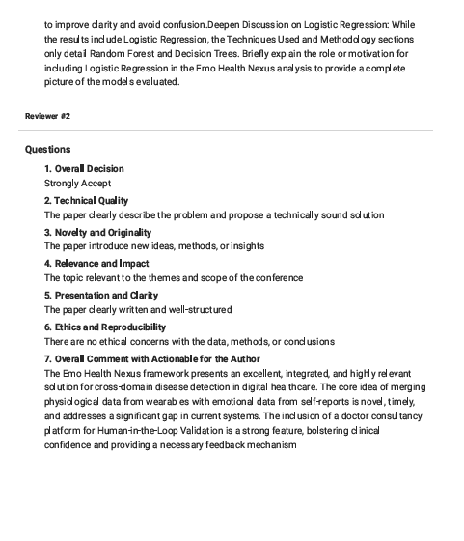

Patent Publication Proof



Research Paper Presentation Proof

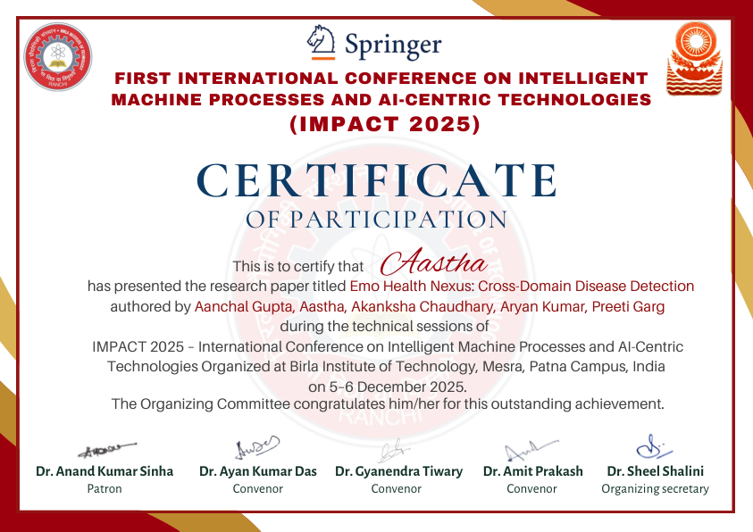

RESEARCH PAPER

