PATENT
Project Id: 42
Department: Computer Science and Engineering (CSE)
Ques.1. Title of your invention
Emo Health Nexus: Cross Domain Disease Detection
Ques.2. Type of Invention
Healthcare Technology (MedTech) Invention, AI & Machine Learning Invention
Ques.3. Brief Description of your invention
The proposed invention, “Emo Health Nexus: Cross-Domain Disease Detection,” is an AI-powered digital healthcare system designed to detect diseases by integrating emotional and physical health data. Unlike conventional systems that rely on a single domain (such as physical symptoms or wearable vitals), this invention introduces a cross-domain framework that analyses data from multiple sources—including wearable devices, user self-reported symptoms, and emotional cues—to provide a comprehensive health assessment. The system also connects patients with doctors for personalized consultancy, ensuring expert guidance alongside AI-driven predictions.
The system leverages machine learning models to process real time data, identify hidden correlations, and predict potential secondary disease risks. It provides patients and doctors with a real-time interactive dashboard that visualizes trends, symptoms, and prediction results. Based on their symptoms, patients can interact with specialized doctors through the system, and doctors can provide regular advice and guidance.
This invention is categorized as a preventive healthcare innovation, intended to improve early disease detection, personalized healthcare planning, and overall patient well-being. Its novelty lies in the integration of emotion-driven analytics with physiological health data, offering a more holistic approach to disease detection.
This system, Emo Health Nexus also has the platform which presents this data in the form of weekly graphical visualizations, including mood level fluctuations, heart rate monitoring, sleep quality analysis, and emotion distribution charts. These visual insights make it easier for both patients and doctors to track health variations.
Ques.4. Objective of your invention
The main objective of this project is to develop a healthcare system that integrates emotional and physical data to enable accurate cross-domain disease detection. By applying machine learning techniques, the system aims to analyse health information from wearable devices and user-reported symptoms, while also providing an interactive dashboard for real-time monitoring. In addition, the platform connects patients with specialized doctors, allowing them to receive regular medical advice and personalized care. It also integrates weekly graphical visualizations of mood levels, heart rate, sleep patterns, and emotion distributions, giving patients and doctors a clear view of health trends. Overall, the goal is to support early disease detection and improve patient well-being.

Ques.5. How to use the invention
The Emo Health Nexus system is designed to be user-friendly so that patients and doctors can easily benefit from it. To start, the patient registers on the platform and provides their basic details. Along with this, they can also enter any symptoms they are currently experiencing. The system is connected to wearable devices such as smartwatches or fitness bands, which automatically send health-related data like heart rate, sleep cycles, activity levels, and mood patterns.
Once the data is collected, the system processes it and presents it on an interactive dashboard. The dashboard shows simple and clear weekly graphical visualizations. These include mood levels, heart rate changes, sleep duration and quality, as well as overall emotion distributions.
One of the most important features of the system is that it allows direct interaction with specialized doctors. Patients can consult doctors regularly through the platform, and doctors can review the patient’s health charts and give personalized advice. This way, patients are not only relying on AI-based predictions but also receiving expert medical guidance.
Patients can use it daily to keep track of their well-being, while doctors can use it to monitor their patients remotely. Overall, the invention makes health management simple, reduces the chances of late disease detection, and supports patients in leading healthier lives with continuous medical support.

Ques.6. Problem your invention is solving
This invention addresses several major problems in the healthcare system today. One key issue is the late detection of diseases, as most existing systems only focus on single aspects of health, such as physical symptoms or medical test results. By not considering emotional and behavioural factors, important early warning signs are often missed.
Another challenge is the lack of cross-domain analysis. Current healthcare solutions usually work in isolation—wearables may show heart rate or sleep, while mental health tools may show mood levels—but there is no integrated system that connects emotional health with physical health. This limits the accuracy of predictions and reduces the chances of preventive care.
The project also solves the problem of patient-doctor communication .Many patients fails to get consultation from doctor regularly due to distance, time, or cost .Our system provides an easy way for patients to interact with specialized health care experts online, ensuring they get regular medical advice without delay and making it more genuine ,professional and real conversation.
Additionally, patients often find it difficult to understand their health data. The system overcomes this by providing clear graphical visualizations of one week’s wearable data—such as mood levels, sleep patterns, heart rate, and emotion distributions—so that both patients and doctors can easily interpret health changes.
Overall, the invention encourages preventive healthcare, improves doctor-patient communication, and provides a more holistic view of health by combining emotional and physical data.

Ques.7. Purpose and object of Invention
With the integration of artificial intelligence and smart technology, this invention aims to transform the healthcare sector by enabling early detection of diseases, improving patient–doctor communication. The system combines emotional and physical health data to optimize healthcare practices and promote preventive care.
Some of the main objectives of this invention include:
- To enable cross-domain disease detection by analysing emotional health, wearable data, and patient-reported symptoms together.
- To provide real-time monitoring and weekly graphical visualizations of health indicators such as mood levels, heart rate, sleep quality, and emotion distributions.
- To ensure continuous medical support by connecting patients with specialized doctors for regular consultancy and expert advice.
- To make health tracking simple and accessible by using easy-to-read charts and an interactive dashboard.
In other words, this invention integrates emotional analysis, wearable data monitoring, AI-based predictions, and doctor consultancy into one platform to directly address today’s healthcare challenges, such as late detection and limited access to expert care. After its implementation, patients will be equipped with a reliable tool that encourages early preventive care, and continuous medical guidance—leading to a healthier future.

Ques.8. Discuss potential commercial application of the invention.
The commercial potential of the Emo Health Nexus system is very high, as it can be used in many areas of healthcare. Hospitals, clinics, and private healthcare centre’s can adopt this system to improve patient monitoring, early disease detection, and regular consultancy services. It can also be marketed to health technology companies who can integrate it with their existing digital health platforms and wearable devices.
The system can be offered as a subscription-based service, where patients pay for access to real-time health monitoring, weekly reports, and direct interaction with specialized doctors. Insurance companies can also use this system to track patient health and encourage preventive care, which reduces treatment costs.
For individual users, the platform provides a low-cost, user-friendly solution to track daily health indicators such as mood, sleep, and heart rate without requiring expensive medical tests. It also benefits people in remote areas who cannot easily access doctors, as they can connect online and still receive expert medical advice.
In the long term, the invention can be applied in corporate wellness programs, mental health management, and telemedicine services, making it useful for organizations, healthcare providers, and individuals. Overall, this system has strong commercial potential in both personal healthcare markets and professional medical services, offering new opportunities for digital health businesses.

Ques.9. Provide any additional material (such as photographs, reports,publications, and references to texts or other information material) which may be helpful to an understanding of the invention identify and indicate the specific relevance of each.

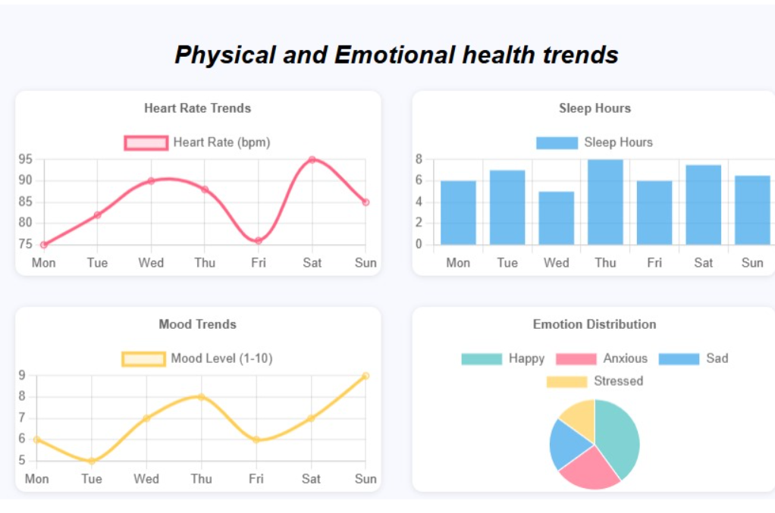
Ques.10. Abstract
The Emo Health Nexus: Cross-Domain Disease Detection System introduces a new approach to healthcare through the real-time monitoring of emotional and physical data. The system collects information from wearable devices, such as heart rate, sleep quality, and activity levels, along with patient-reported symptoms and emotional patterns. This data is processed using artificial intelligence to identify possible health risks across multiple domains.
The platform provides patients and doctors with an interactive dashboard that displays weekly graphical visualizations of mood levels, heart rate, sleep patterns, and emotion distributions. In addition, the system connects patients with specialized doctors, allowing regular medical advice.
By combining wearable data and emotional analytics into one integrated platform, the invention offers a preventive, accessible, and holistic healthcare solution that improves early disease detection and patient well-being.

Ques.11. Summary of the invention
The Emo Health Nexus system is an AI-based healthcare platform that integrates emotional and physical data for early disease detection and better patient care. It collects real-time information from wearable devices along with patient-reported symptoms and displays it through an interactive dashboard.
The system provides weekly graphical visualizations of mood levels, heart rate, sleep patterns, and emotion distributions. Patients can also connect with specialized doctors through the platform for regular medical advice. By combining AI-driven analysis, wearable monitoring, and expert consultancy, the invention offers a holistic, preventive, and accessible healthcare solution.

Ques.12. Detail description of invention with methodology
The Emo Health Nexus system is designed to solve healthcare challenges by combining artificial intelligence, wearable technology, and doctor consultancy into one platform. Its main purpose is to detect diseases early by analysing emotional and physical data together.
🔹 Data Collection
The system collects health data from two main sources:
- Wearable devices – These provide information such as heart rate, sleep quality, physical activity, and mood patterns.
- Patient input – Patients can enter their symptoms or emotional state directly into the system through the app or web platform.
This ensures that both automatic data (from devices) and manual data (from patients) are captured for better accuracy.
🔹 Data Transfer and Storage
All the collected data is securely transferred to the backend (SQL database and Python server). From there, it is processed and prepared for analysis.
🔹 Data Analysis (Methodology)
- The system uses AI models to process the data.
- It checks for patterns and abnormalities in heart rate, sleep cycles, mood levels, and reported symptoms.
🔹 Doctor Consultancy
One unique feature of the system is direct patient–doctor interaction. Patients can connect with specialized doctors through the platform. Doctors review the patient’s weekly reports and provide regular advice and treatment guidance.
🔹 Action and Benefits
- Patients get real-time updates about their health.
- Doctors receive continuous insights into patient conditions.
- Early detection of risks prevents serious health problems.
- The system reduces human error in self-diagnosis and makes healthcare more accessible.
🔹 Overall Methodology Flow
- Data Collection → Wearables + Patient Symptoms
- Data Transfer → Backend storage and processing
- Data Analysis → AI/ML detects patterns and risks
- Visualization → Weekly charts and graphs for easy understanding
- Doctor Interaction → Continuous medical advice and treatment support

Ques.13. Applicant and inventor details:
- Akanksha Choudhary -> KIET Group of Institutions Ghaziabad CSE
- Aanchal Gupta -> KIET Group of Institutions Ghaziabad CSE
- Aryan Kumar-> KIET Group of Institutions Ghaziabad CSE
- Astha -> KIET Group of Institutions Ghaziabad CSE

