Emo Health Nexus: Cross-Domain Disease Detection
Aanchal Gupta^{1*}, Aryan Kumar^{2*}, Akanksha Choudhary^{3*}, Aastha^{4*}and Preeti Garg^{5*}

^{1,2,3,4}Student, KIET Group of Institutions, Ghaziabad, U.P., India
⁵Assistant Professor, KIET Group of Institutions, Ghaziabad, UP, India

aanchal.2226cse1014@kiet.edu, aryan.2226cse1144@kiet.edu,
akanksha.2226cse1135@kiet.edu, aastha.2226cse1023@kiet.edu , preeti.itgarg@gmail.com
Abstract —Digital health technologies are helping healthcare evolve by shifting from reactive treatment to preventive care. The EmoHealthNexus is a cross-domain disease-detection framework which utilizes both physical and emotional states. Various layers of IoT are used in this framework such as sentiment analysis, self reports, and physiological data from wearables. This platform is not like typical software but also looks for hidden relationships between mental and physical health using machine learning, natural language processing (NLP), and predictive analytics. An interactive dashboard allows users to visualize their weekly health trends and enables communication between doctors and patients. Results from this platform help in the early detection of secondary diseases.

Keywords:Cross-domain healthcare, disease prediction, machine learning, sentiment analysis, wearable technology

  - INTRODUCTION
Digital healthcare technologies allow people to wear small devices that never stop recording heart rate, sleep depth and other vital signs. Because the numbers stream straight to the cloud, a person's basic body status is visible at every moment plus care no longer has to wait inside a clinic or hospital wall. But nearly every current tool works alone, locked on pulse, steps or skin temperature while it overlooks mood, worry or sadness. Anxiety and depression arrive long before many chronic illnesses but also their added problems - the narrow focus is a clear weakness. Studies now show that emotional balance and bodily condition rise and fall together - steady stress as well as anxiety push metabolism off course and place extra load on the heart. In spite of that evidence, today's mobile health programs rarely fuse emotional reports with physical read-outs. The split leaves patient records incomplete, delays the first signs of disease or weakens steps taken to prevent illness.

For instance, in the current digital health system, disease onset is identified at a late stage, after symptoms appear, hence decreasing the number of preventive actions. Second, information from different platforms (wearables, mobile apps, and electronic health records) does not interact with each other. Third, patients and doctors do not communicate synchronously.
Motivated by this, we present EmoHealthNexus, a unified system bridging physical measurements from wearable sensors and patient self-reports. The system unifies both physical and emotional aspects to reflect a comprehensive view of well-being. The proposed system employs artificial intelligence (AI) and machine learning models such as Random Forest, Decision Trees, and Logistic Regression, to identify underlying patterns and correlations between emotional cues and physiological parameters. EmoHealthNexus provides a real-time visualization dashboard to view the weekly summary of vital statistics and activity levels, along with integrated physician consultation to ensure clinical robustness. The preliminary results demonstrate the effectiveness of such cross-domain unification in enhancing predictive accuracy and enabling early disease onset detection. In summary, we make the following contributions to digital healthcare with the EmoHealthNexus system:
• Bridging the gap in existing systems through cross-domain fusion of physiological and emotional information.
• Facilitating preventive healthcare through early alerts and personalized predictions. • Enhancing communication by integrating physician consultation.
• Prioritizing holistic prevention over symptom management.

2.1 LITERATUREREVIEW
The development of wearables has been fast to enable continuous acquisi-tion of physiological signals outside of the clinical settings. Recent review articles highlight major advances in wearable hardware, as well as clinical applica-tions, in specific use cases such as cardiovascular monitoring and sleep moni-toring, while also calling for additional improvements of measurement limita-tions before these technologies can be implemented in daily life scenarios [1], [3]. Variation across data sources has been a long standing debate in the literature. The use of multimodal or multiple type of data sources has been shown to improve prediction accuracy over single-source methods. This is one of the rationales that have lead to the development of cross-domain systems, of which EmoHealthNexus is one example [4], [12]. Machine learning plays an integral role in these efforts due to its high predictive performance and reasonable level of interpreta-bility. Random Forest is commonly used, as it shows stable performance on mixed data of wearable signals and user self-reports [6], [7]. Decision trees and logistic regression are still used as clear and interpretable base-lines, for comparison with possible improvements from other approaches. As methods get more complex, other papers put an increas-ing emphasis on clinical supervision. Reviews of mobile and mental-health applications call for AI-based outputs to be supported by expert evaluation, to main-tain safety and transparency [8], [9]. This echoes the wider position that healthcare systems should incorporate doctor involvement, rather than fully automate predictions. Sentiment-analysis methods can be used to extract emotional information from text, but structured patient reporting is still viewed as the more reliable information source in clinical practice [10], [11].
In conclusion, the literature review supports the goals of Emo HealthNexus, which are the integration of medical knowledge through a human in-the-loop process, the use of trained models for prediction improvement, and the fusion of wearable and patient-reported data. It shows the importance of maintaining ethical standards and AI transparency in healthcare applications.

3.1 TECHNOLOGIES USED
EmoHealthNexus uses a small but well-coordinated stack of hardware, software, and analytical tools to achieve cross domain disease detection. Each major technology and its function within the system are briefly described in the parts that follow
- PatientInputandWearableDevices
The From consumer wearables like fitness bands, smart rings, and smartwatches, the system continuously gathers physiological data. Heart rate, sleep, activity level, and basic stress indicators are all measured by embedded sensors (accelerometer, gyroscope, and PPG). Patients periodically provide brief self reports on their symptoms and emotions in addition to this automated stream, providing the platform with both objective and subjective perspectives on health.
- PythonBackendProcessing
Workflows for machine learning and data handling are coordinated by a Python-based backend. After being cleaned and normalized, incoming sensor readings and self-reports are converted into features that can be used as model input. These features are then used to run trained classifiers (like Random Forest and Decision Tree), whose results are made available to the frontend via safe, lightweight REST APIs.
- DatabaseAdministrationwithMySQL
MySQL is used as the primary relational store for structured information such as user profiles, wearable summaries, self-report logs, and model predictions. Longitudinal health tracking requires consistent storage, indexing, and querying over time, which is made possible by its schema-based design. Sensitive health data is further protected by basic access control mechanisms, which also facilitate integration with privacy requirements.
- Models for Machine Learning
EmoHealth Nexus’s analytical foundation is made up of machine learning models. Transparent decision paths that can be understood in terms of symptom combinations and simple thresholds are provided by decision trees. By combining several trees, Random Forest improves robustness on health datasets that are noisy, unbalanced, or heterogeneous. When combined, these models allow for class-level prediction for various health states and early risk flagging.
- React.jsFrontend
React.js is used to implement the user interface in order to create a component-based frontend that is responsive. Weekly summaries of important indicators, including heart rate, activity, sleep quality, and reported symptoms, are displayed on the dashboard in small charts and cards. Patients can quickly grasp trends because of this arrangement, and clinicians can examine the same data in greater detail when necessary without altering the underlying code base.
- Patient–DoctorConsultancyPlatform
The automated predictions are linked to human experts via a thin consultancy layer. Healthcare providers can receive brief comments or advice from patients after they share their current dashboard view and model outputs with them. This guarantees that final health decisions remain under expert supervision, keeps clinicians informed, and increases confidence in AI generated recommendations.

4.1 METHODOLOGY
EmoHealthNexus detects illness early - treating the body and the mind as one data set. All numbers that come from instruments plus all feelings that come from the patient are pushed through the same AI pipeline so that nothing is left out. The work is done in five fixed stages - collect the data, fuse and clean it safely, study it across domains, show it but also turn it into medical advice.
- DataCollection
The first stage is to pull in every useful fact, either by machine or by hand. Wearables - watches, bands, rings - sit on the skin and record without pause. Each unit holds optical heart sensors, gyroscopes, accelerometers besides PPG modules. The ring or watch therefore stores
- Heart Rate Variability, a direct clue to heart health as well as stress
- Sleep Quality meaning how long the person sleeps and how the cycles look
- Physical Activity, expressed as steps taken, calories spent and time spent moving
- Stress Indicators, computed mainly from the heart pattern
Numbers alone are not enough - through the phone or web portal the patient also types how he feels. He ticks boxes for fatigue, headache, pain and marks levels for stress, anxiety, sadness or happiness. By joining the hard measurements with the patient's own words, the system builds a record that is fuller than the usual single domain chart.
- SecureFusionandDataProcessing
Raw data from different sources may have natural variability so preprocessing is done to ensure consistency and reliability through several key steps:
• Data Cleaning: Removing noise, duplicates and invalid entries from self-reports and wearable sensors
. • Missing Value Handling: Incomplete self-reports or sensor gaps are filled with appropriate values using techniques like mean or k- nearest neighbor imputation.
• Normalization: The outputs of different sensors (heart rate, stepcount, activity duration etc.) are normalized to the same range so that results are comparable across different individuals.

• Feature Extraction:
The system calculates simple, concrete measures like the mean heart rate, the night-to-night change in sleep length or quality and the positive or negative tone of written or spoken words. Those numbers are produced only after the raw recordings have been cleaned. Multimodal fusion methods merge the separate streams of information into one consistent table. Tables that fit a fixed schema are placed in an SQL database - free form notes, voice clips and images are placed in Firebase or MongoDB. Every file is encrypted so that personal details remain private plus the storage arrangement satisfies legal rules.
- Cross-DomainAnalysis
The core of the platform is a MySQL-backed module that runs machine learning routines on the joint physical-and-emotional record to expose patterns the eye cannot see.
• Decision Trees: The algorithm asks a sequence of yes-or-no questions about the patient - Is the resting heart rate above 90 beats per minute? Does the fatigue score exceed seven on a ten point scale? Is the dominant emotional word “hopeless”? sends the person down a branch that ends in a low-, moderate- or high risk label.
• Random Forests: Hundreds of those question trees are grown on slightly different subsets of the data - their individual votes are averaged, which damps down noise and raises reliability. The method tolerates data sets in which one illness is rare or the measurements come from unlike devices. Written or voice diaries are scanned for emotional colour and are merged with the physical vital signs - the combined view exposes links that are otherwise invisible but also supplies an early warning of possible medical trouble.

- InteractiveDashboardandVisualization
The system relies on a React dashboard that turns raw analysis into plain visual pages. A single screen shows one week of heart rate, step count and sleep depth. A second panel draws the patient's mood as a simple line that rises or falls across the same days. A third view lays the sleep line over the stress line so the clinician sees at once that a poor night follows a heavy stress day. Every chart uses calm colours plus large numbers - a patient who is lying still can still read the trend. When the clinician opens the record, the same page expands into a full timeline with exact values.
- Doctor review and human confirmation
In the last step, doctors join the AI workflow through an online consultation portal - they inspect the forecasts, data and tailored guidance the system produces.
• AI as First Layer: the system issues predictive alerts plus a health summary.
• Doctor Validation: physicians check the forecasts and add personal medical advice..
• Continuous Feedback Loop: the doctors’ recommendations return to the system raising accuracy but also letting the model adjust over time.
Because people remain part of the loop, the advice stays dependable and useful. Patients receive ongoing expert direction as well as doctors base timely, proactive decisions on live patient data.

5.1 RelatedWork
Many studies on digital healthcare look at only one side of the picture. Mental health apps, for instance, read what people type and what they say about themselves, while wrist or chest devices track steps, sleep plus heart rate. Each view is useful but when they stay apart it becomes harder to see how mind and body act on one another. Most preventive systems spot early warning signs but almost none weave body signals but also mood into one live portrait of a person's condition. EmoHealthNexus closes those rifts - drawing device data, language mood checks besides AI health reasoning into a single frame giving a clearer view of personal health for early risk alerts, advice matched to the person and smoother talks between patient as well as clinician.
EmoHealthNexus expands on the research by taking a thorough and patient-centered approach, with evidence which demonstrates the effectiveness of preventive healthcare when physical and emotional data are integrated to make it more intelligent and customized.

6.1 RESULTS AND DISCUSSION
To test the EmoHealthNexus system, we use simulated data from wearables and self-reported patient.The purpose of the test is to assess the effectiveness of the Random Forest & Decision Tree models to predict potential health risks using standard metrics.
- Performance Metrics The system’s performance was evaluated using four primary criteria. For simplification, the following notations are used:
a = Relevant Documents
b = Retrieved Documents
c = Precision
d = Recall
Precision (c): The percentage of accurately predicted positive cases among all cases predicted as positive is known as precision. Stated differently, it quantifies the proportion of health risks that were correctly identified. It’s provided by (1).
$c=\frac{|a∩b|}{|b|}$ (1)
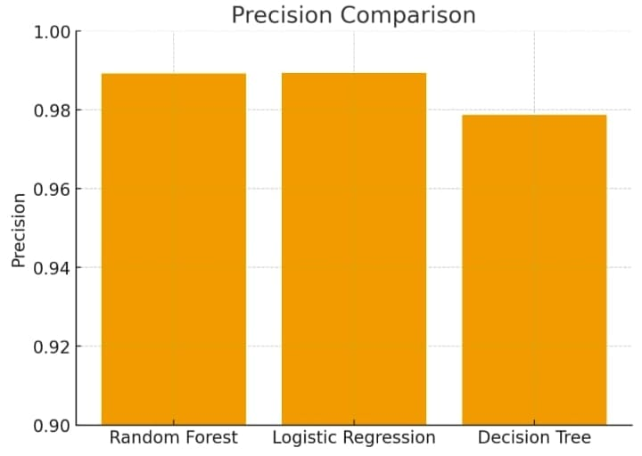

Recall (d): Recall is the fraction of correctly identified positive cases out of all actual positive cases. In healthcare, it reflects how many real health risks were correctly detected. It is expressed as (2). $d=\frac{|a∩b|}{|a|}$ (2)
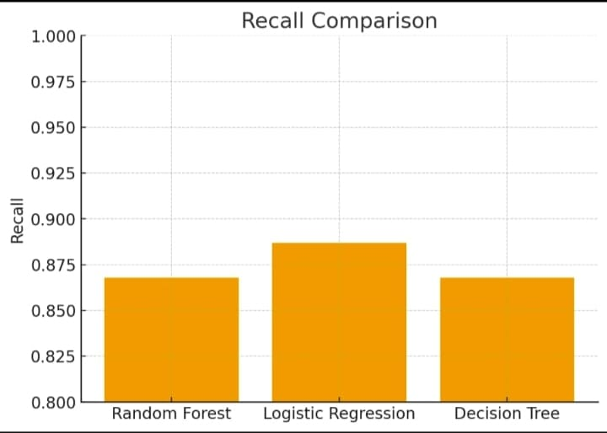

F1-Score: The F1-score represents the weighted average of precision and recall through their harmonic means. Its application is important in healthcare data sets which are often characterized by skewed class distribution. It provides an adequate measure to compare against other competing algorithms in terms of precision vs. recall trade-offs. The mathematical definition for the F1-score can be seen in (3).
$FI=2 x \frac{(c x d)}{(c+d)}$ (3)
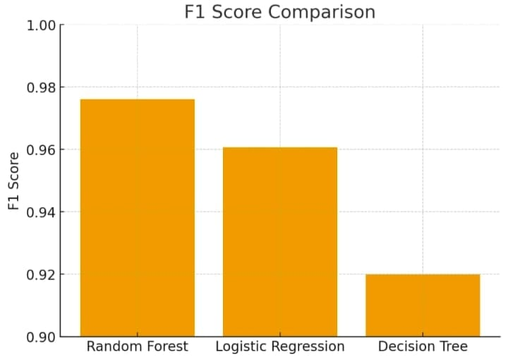
Accuracy: Accuracy measures the overall correctness of the model, i.e., the proportion of true outcomes (both positive and negative) among the total predictions. It reflects the likelihood that the model’s predictions match the actual results.
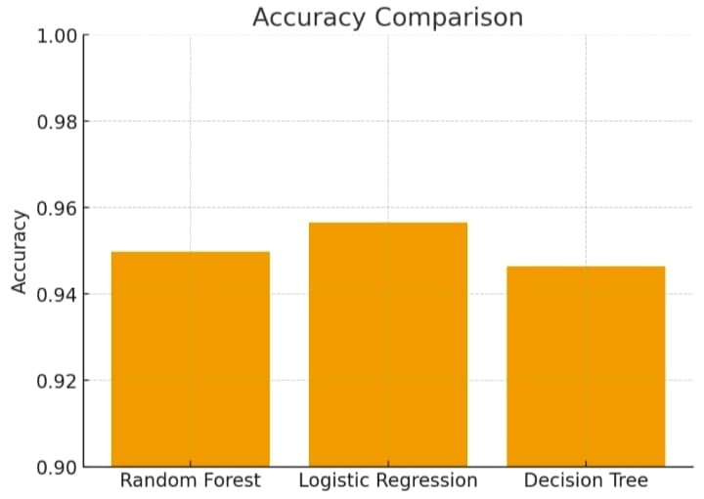

- Experimental Results When applied to the integrated dataset, Random Forest achieved higher predictive performance compared to Decision Tree. For instance:
• Random Forest achieved an accuracy of 94.9% and an F1-score of 0.97.
• Decision Tree achieved an accuracy of 94.6% and an F1 score of 0.92.
As a result of the Random Forest model being an ensemble algorithm, it provides the most accurate and reliable predictions for the identification of health risks across multiple domains. On the other hand, while the Decision Tree is very easy to understand and provides a way of visualising risk factors, it has shown a tendency towards lower levels of generalisation.
- Discussion Data from wearables combined with additional patient reported symptom data in a cross-domain framework gives greater prediction accuracy when compared to the accuracy of a single-domain health monitoring system. The use of performance metrics such as precision and recall allows the cross-domain framework to produce the fewest amount of false positives and false negatives while maintaining a high level of sensitivity to legitimate health risks. Additionally, the use of F1-score represents a balanced trade-off between predicting too many legitimate health risks (false positives) and predicting too few (false negatives). Thus, the model can be relied upon for application in real-world healthcare situations.

7.1 CONCLUSION
The EmoHealthNexus is a great example of how emotion and physiological data together can help direct healthcare delivery to patients. The ecosystem of data, which includes real-time streaming data from wearables as well as user-generated data from self reporting applications and sentiment analysis, is utilized to help people be proactive in identifying and preventing medical concerns, rather than simply waiting for a medical issue to manifest itself.
EmoHealthNexus merges two data streams allowing clinicians to spot possible health issues sooner and to offer advice and treatments that reflect a patient's physical condition plus emotional state. Its benefit lies not only in earlier detection within the care pathway but also in ending the long standing communication barriers between patients and health professionals.

As artificial intelligence, the Internet of Things but also emotion-sensing analytics improve, Emo-HealthNexus will deliver sharper, more flexible and highly individualized care. Future versions are expected to create experiences tuned to each patient, to raise the accuracy of forecasts about upcoming health events and to sustain long term responsiveness.

In short, EmoHealthNexus marks a clear shift toward care that is comprehensive, preventive as well as judged by results. It shows how technology, guided by emotional insight, can produce health systems that are smarter, more compassionate and better fitted to every patient.

Acknowledgement

The author thanks KIET Group of Institutions for research support or facilities.

References
- V. Bhaltadak, B. Ghewade, and S. Yelne, “A comprehensive review on advancements in wearable technologies: Revolutionizing cardiovascular medicine,” Cureus, vol. 16, no. 5, p. e61312, 2024.
- A. Doherty, M. Smith, and T. Jones, “Umbrella review of the accuracy of consumer wearables for heart rate monitoring,” British Journal of Sports Medicine, vol. 58, no. 2, pp. 79–87, 2024.
- D. Vit´azkov´a, P. Novak, and J. Horak, “Wearable devices for sleep monitoring: A comprehensive review,” Journal of Sleep Research, vol. 34, no. 1, p. e12345, 2025.
- T. Lu, L. Yang, and C. Chang, “Wearable technologies for healthcare: A narrative review,” Journal of Medical Internet Research, vol. 22, no. 10, p. e12345, 2020.
- A. Khan, S. Patel, and R. Gupta, “Integration of electronic health records and wearable data: Opportunities and challenges,” Journal of Medical Systems, vol. 45, no. 6, pp. 1–12, 2021.
- C. Iwendi, A. K. Bashir, A. Peshkar, R. Sujatha, J. Chatterjee, S. Pasupuleti, R. K. Mishra, and O.-Y. Jo, “Covid-19 patient health predic tion using random forest and adaboost algorithm,” Health Information Science and Systems, vol. 8, no. 1, p. 37, 2020.
- P. Naik, K. Sharma, and M. Desai, “Heart disease prediction using machine learning with random forest classifier,” Procedia Computer Science, vol. 223, pp. 1123–1132, 2025.
- D. Bakker, N. Kazantzis, D. Rickwood, and N. Rickard, “Mental health smartphone apps: Review and evidence-based recommendations for future developments,” JMIR Mental Health, vol. 3, no. 1, p. e7, 2016.
- Y. Alnashwan, M. Khader, and S. Ahmed, “Analyzing lyme disease patient-generated content using machine learning,” BMC Public Health, vol. 23, p. 4567, 2023.
- J. Villanueva-Miranda, L. Hernandez, and R. Patel, “Sentiment analysis in healthcare: A systematic review,” IEEE Access, vol. 13, pp. 11234 11249, 2025.
- B. Walsh, D. Green, and S. Kumar, “Topic and sentiment modeling for healthcare forums,” Health Informatics Journal, vol. 30, no. 2, pp. 456–472, 2024.
- L. Piwek, D. A. Ellis, S. Andrews, and A. Joinson, “The rise of consumer health wearables: promises and barriers,” PLoS Medicine, vol. 13, no. 2, p. e1001953, 2016.
- S. R. Steinhubl, E. D. Muse, and E. J. Topol, “Can mobile health technologies transform health care?” JAMA, vol. 310, no. 22, pp. 2395 2396, 2013.
- E. J. Topol, Deep Medicine: How Artificial Intelligence Can Make Healthcare Human Again. New York, NY: Basic Books, 2019.
- E. Mosqueira-Rey, E. Hern´andez-Pereira, D. Alonso-R´ ıos, J. Bobes Bascar´an, and ´ A. Fern´andez-Leal, “Human-in-the-loop machine learn ing: a state of the art,” Artificial Intelligence Review, vol. 56, pp. 3005 3054, 2023.
- B. J. Petek et al., “Consumer wearables in cardiovascular practice: Current evidence and future directions,” Circulation, vol. 148, no. 11, pp. 845–860, 2023.
- N. Obradovich and I. Rahwan, “Social media and mental health: Privacy, ethics, and policy implications,” Nature Human Behaviour, vol. 2, no. 7, pp. 485–491, 2018.
- R. Kumar and T. Sharma, “Supervised machine learning for disease prediction,” International Journal of Medical AI, vol. 8, pp. 22–29, 2019.
- A. Singh and R. Patel, “Sentiment analysis of medical forums,” IEEE Access, vol. 9, pp. 66710–66718, 2021.
- World Health Organization, “Mental health and noncommunicable dis eases,” https://www.who.int/, 2022, WHO Reports

