

Project Synopsis
on
Deep Learning for Climate Pattern Change Detection Using Time Series Satellite Data
submitted as partial fulfillment for the award of
BACHELOR OF TECHNOLOGY
DEGREE
SESSION 2022-23
in
Computer Science & Engineering
By
Akshat Shukla (2300290100030) (Team Leader)
Aditya Pandey (2300290100020)
Akshita Singh (2300290100035)
Anand Kumar Singh (2300290100045)

Under the supervision of
Mr. Om Prakash Kushwaha
KIET Group of Institutions, Ghaziabad
Affiliated to
Dr. A.P.J. Abdul Kalam Technical University, Lucknow
(Formerly UPTU)
Academic Year 2023-24

Abstract
This project focuses on developing a deep learning based framework for monitoring, identifying, and interpreting climate-driven changes using long-term satellite image time series. Climate change is altering land surface characteristics such as vegetation health, soil moisture, surface water distribution, snow cover duration, and land surface temperature. These variables can be observed at scale through satellite sensors like Landsat, Sentinel, and MODIS. However, the associated time series are often irregular, contain noise from atmospheric effects, and vary in spectral characteristics across sensors. Traditional change detection methods struggle to generalize across such conditions.
The proposed system aims to integrate multiple deep learning architectures, including Temporal Convolutional Networks, ConvLSTMs, and transformer-based models, to capture subtle temporal patterns and multivariate spectral relationships. The pipeline will include data preprocessing, cloud masking, harmonization across sensors, temporal normalization, and robust spatial-temporal modeling. The system will be evaluated on multi-year datasets to detect gradual shifts, abrupt anomalies, and extreme events. Expected outcomes include improved detection accuracy, interpretable climate indicators, and dynamic change maps suitable for policy and environmental monitoring agencies.

Introduction
Climate change is reshaping ecosystems and environments globally. Satellite remote sensing provides a continuous, objective, and large-scale view of Earth's surface, making it an essential tool for monitoring climate variability. Time series satellite data help examine how land cover, vegetation cycles, water bodies, snow cover, and temperature patterns evolve over time. However, translating raw image sequences into meaningful climate insights requires robust analytical methods.
Motivation
Climate variables interact in complex ways. For example, shifts in vegetation phenology may indicate temperature changes, while expansions in water bodies may reflect extreme rainfall or glacier melt. Conventional statistical approaches and index-based methods like NDVI thresholds work for simple cases but are limited in capturing multi-dimensional patterns, subtle trends, or long-term shifts. Deep learning models can learn richer representations from high-dimensional and multi-sensor satellite archives.
Existing gaps
Despite progress, current methods face several issues:
1. Many models assume complete time series, but real-world satellite data suffer from missing observations due to cloud cover or sensor gaps.
2. Multi-sensor archives require harmonization; differences in spatial resolution, revisit frequency, and spectral bands complicate analysis.
3. Interpretability remains a challenge, especially when models detect changes without explaining their cause.
4. Datasets focusing specifically on climate-driven changes are limited, and benchmarks often emphasize land use classification rather than climate signals.
Project contributions
This project aims to overcome these challenges by designing a flexible, modular framework that:
• Integrates harmonized Landsat and Sentinel time series.
• Uses temporal modeling techniques capable of handling incomplete sequences.
• Offers interpretable outputs such as importance maps and temporal attention plots.
• Provides case studies across multiple regions for stronger generalization.
The project uses Python, PyTorch, TensorFlow, rasterio, xarray, and geospatial platforms like Google Earth Engine. The domain lies at the intersection of remote sensing, deep learning, climate science, and time series modeling.
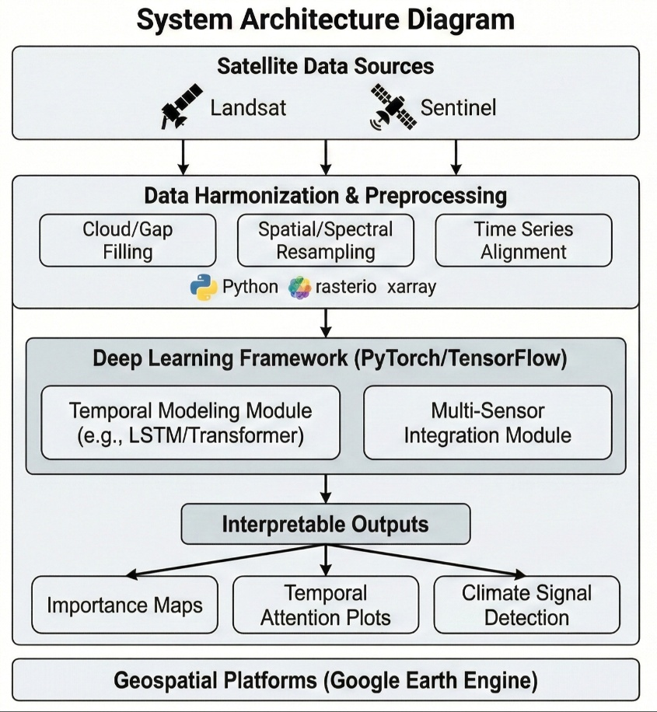

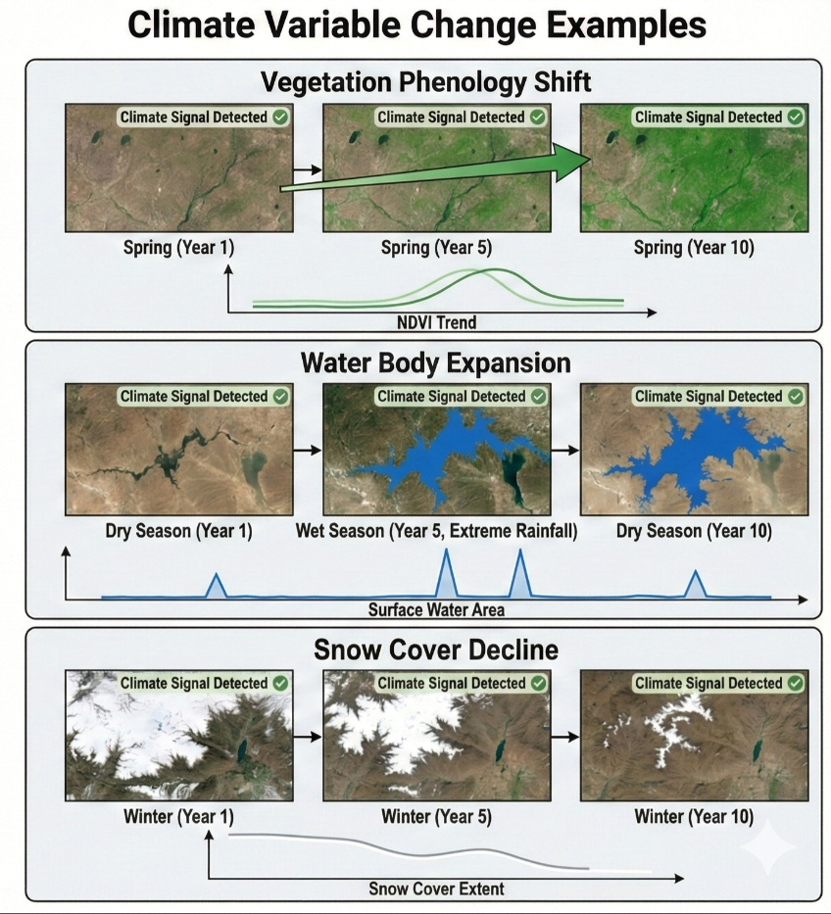

Literature Survey
A substantial body of work explores remote sensing based change detection and deep learning for temporal data. Early research primarily used pixel differencing, vegetation indices, and thresholding techniques to detect changes in land cover. These classical approaches often struggled with noisy inputs and multi-sensor inconsistencies.
Deep learning based approaches gained prominence with convolutional neural networks and recurrent architectures applied to satellite time series. Temporal convolution models demonstrated strong performance due to their ability to capture long-range temporal dependencies without heavy computational cost. ConvLSTM models extended this by preserving spatial correlations while modeling temporal evolution.
Transformer-based models represent a newer direction, allowing attention mechanisms to identify important time steps contributing to detected changes. Several survey papers highlight the importance of handling missing data, explaining model predictions, and incorporating ancillary climate variables.
Additionally, multi-sensor harmonization studies have produced methods to align spectral responses between Landsat and Sentinel systems, enabling more accurate long-term analyses. Recent generative models attempt to reconstruct missing or cloud-contaminated images, further improving data quality.

Methodology
The methodology includes several phases:
1. Data Collection and Preprocessing
Satellite images will be downloaded from Landsat and Sentinel repositories. Preprocessing includes atmospheric correction, cloud masking using established algorithms, geometric alignment, and spectral normalization. Time series will be aggregated to consistent intervals.
2. Baseline Model Implementation
Conventional change detection methods such as NDVI differencing, PCA-based change analysis, and simple machine learning classifiers will be used as benchmarks.
3. Deep Learning Model Development
Multiple architectures will be implemented including TempCNN, ConvLSTM, and transformer models. Missing data handling and multi-sensor fusion layers will be added.
4. Training and Evaluation
Models will be trained using labeled datasets where climate-related changes are known. Metrics will include accuracy, recall, precision, F1 score, and temporal change detection delay.
5. Interpretation and Visualization
Outputs will include change maps, variable importance plots, attention heatmaps, and temporal profiles. These visualizations will assist climate experts.

Facilities Required
Software:
• Python 3.9 or above
• PyTorch, TensorFlow
• rasterio, xarray, GDAL, scikit-learn
• Jupyter Notebook, Google Earth Engine access
Hardware:
• 16 GB RAM (minimum), GPU recommended
• 1 TB storage for satellite archives
Data:
• Landsat 5/7/8 and Sentinel 2 time series
• Cloud masks, climate indices where available

References
[1] C. Pelletier et al., “Temporal Convolutional Neural Network for Satellite Image Time Series Classification,” Remote Sensing, [Year].
[2] L. Miller, “Deep Learning for Satellite Time Series Analysis,” arXiv preprint, arXiv:[ID], [Year].
[3] E. J. Parelius, “Review of Deep Learning Based Change Detection,” Remote Sensing, [Year].
[4] S. F. Bolognesi Falanga, “Harmonized Landsat and Sentinel Data Studies,” [Journal/Publisher], [Year].
[5] Q. Shu, “Satellite Time Series Reconstruction Research,” [Journal/Publisher], [Year].

