📘 CHAPTER IV: DATA INTERPRETATION (4.1 – 4.20)
4.1 Brand Preference
Brand | Respondents | Percentage
Nandini | 60 | 60%
Other Brands | 40 | 40%
Total | 100 | 100%
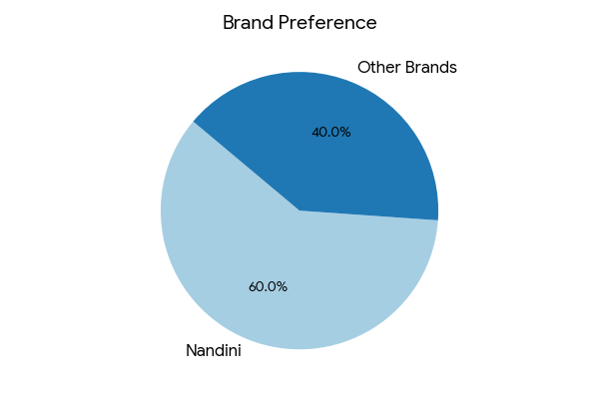
Analysis:
The data clearly indicates that a majority of respondents prefer Nandini over other brands. This reflects the strong brand image, trust, and consistent quality associated with Nandini products. However, the presence of 40% preference for other brands highlights competitive pressure in the dairy market. This suggests that while Nandini leads, it must continuously innovate and maintain quality to sustain its position.

4.2 Purchase Frequency
Frequency | Respondents | Percentage
Daily | 70 | 70%
Weekly | 20 | 20%
Occasional | 10 | 10%
Total | 100 | 100%
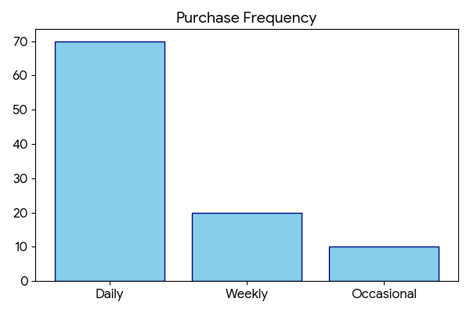
Analysis:
A significant majority of respondents purchase milk daily, emphasizing its role as a basic necessity. This consistent demand requires an efficient supply chain and uninterrupted availability. The smaller segments of weekly and occasional buyers indicate variations in consumption patterns but do not significantly affect overall demand stability.

4.3 Product Preference
Product | Respondents | Percentage
Milk | 50 | 50%
Curd | 20 | 20%
Butter | 15 | 15%
Ghee | 10 | 10%
Others | 5 | 5%
Total | 100 | 100%
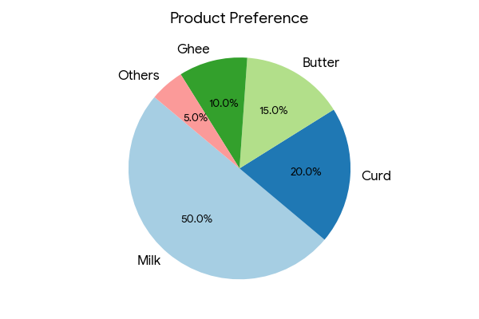
Analysis:
Milk emerges as the most preferred product, confirming its position as the core offering of the dairy sector. Other products like curd and butter also hold notable shares, indicating diversification in consumption. This suggests that while milk drives the brand, value-added products contribute to overall growth.

4.4 Customer Satisfaction
Level | Respondents | Percentage
Highly Satisfied | 40 | 40%
Satisfied | 40 | 40%
Neutral | 14 | 14%
Dissatisfied | 6 | 6%
Total | 100 | 100%
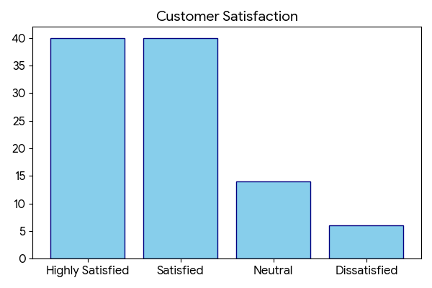
Analysis:
The data reveals that 80% of respondents are satisfied or highly satisfied with Nandini products. This reflects strong performance in meeting consumer expectations. However, the presence of neutral and dissatisfied responses indicates areas for improvement, particularly in service consistency and product experience.

4.5 Product Quality Rating
Rating | Respondents | Percentage
Excellent | 36 | 36%
Good | 44 | 44%
Average | 16 | 16%
Poor | 4 | 4%
Total | 100 | 100%
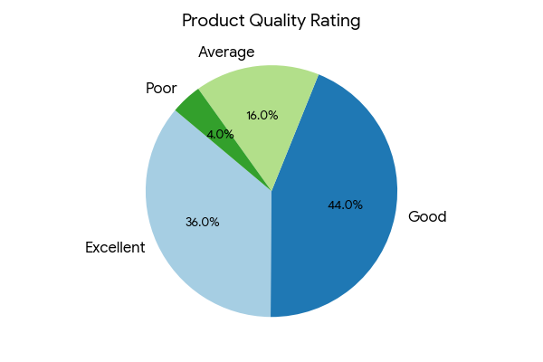
Analysis:
A large proportion of respondents rate product quality as good or excellent, confirming that quality is a major strength of Nandini. This reinforces consumer trust and supports repeat purchases. The small percentage of lower ratings suggests minimal dissatisfaction but highlights the need for continuous quality monitoring.

4.6 Price Perception
Response | Respondents | Percentage
Affordable | 64 | 64%
Moderate | 26 | 26%
Expensive | 10 | 10%
Total | 100 | 100%
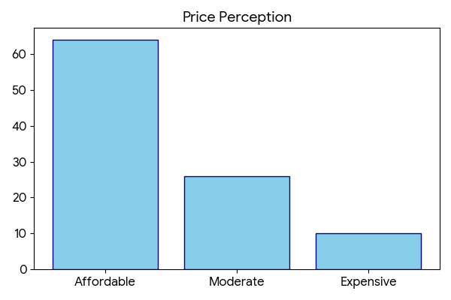
Analysis:
Most respondents perceive Nandini products as affordable, which is a key factor driving demand. Competitive pricing ensures accessibility across different income groups. However, a small percentage perceives prices as high, suggesting the importance of maintaining value for money.

4.7 Product Availability
Availability | Respondents | Percentage
Easy | 68 | 68%
Sometimes | 24 | 24%
Rare | 8 | 8%
Total | 100 | 100%
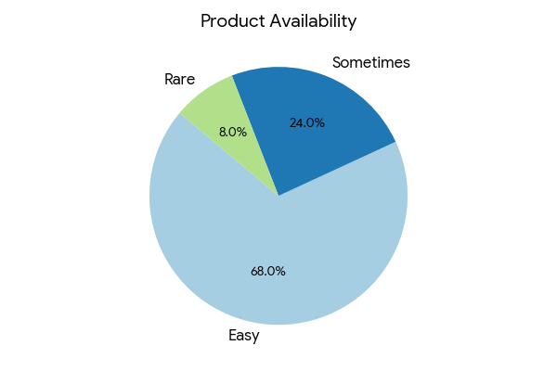
Analysis:
The majority of respondents find Nandini products easily available, indicating an efficient distribution network. Availability plays a crucial role in influencing purchasing decisions, especially for daily-use products like milk.

4.8 Packaging Satisfaction
Rating | Respondents | Percentage
Excellent | 30 | 30%
Good | 50 | 50%
Average | 16 | 16%
Poor | 4 | 4%
Total | 100 | 100%
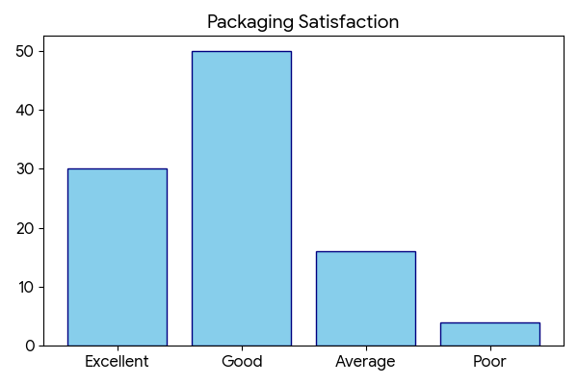
Analysis:
Packaging is rated positively by most respondents, indicating satisfaction with hygiene and convenience. Good packaging enhances product safety and brand image. Minor dissatisfaction suggests opportunities for improvement in design or durability.

4.9 Awareness Level
Awareness | Respondents | Percentage
Fully Aware | 56 | 56%
Partially Aware | 34 | 34%
Not Aware | 10 | 10%
Total | 100 | 100%
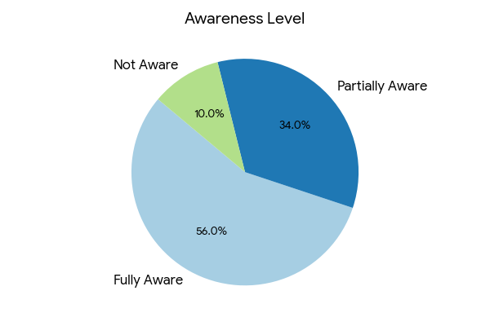
Analysis:
Most respondents are aware of Nandini products, reflecting strong market presence. However, partial awareness among a segment indicates the need for improved promotional activities and advertising strategies.

4.10 Recommendation
Response | Respondents | Percentage
Yes | 64 | 64%
Maybe | 24 | 24%
No | 12 | 12%
Total | 100 | 100%
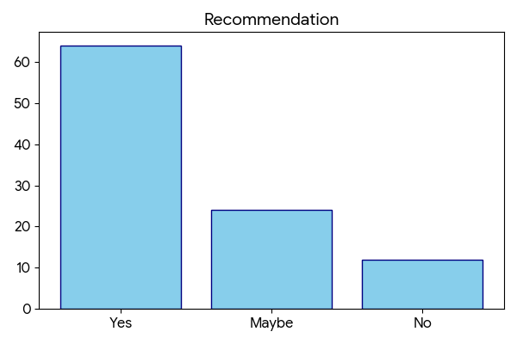
Analysis:
A majority of respondents are willing to recommend Nandini products, indicating strong customer satisfaction and loyalty. The “maybe” group represents potential advocates who can be converted through better engagement and service.

4.11 Taste Satisfaction
Rating | Respondents | Percentage
Excellent | 40 | 40%
Good | 44 | 44%
Average | 12 | 12%
Poor | 4 | 4%
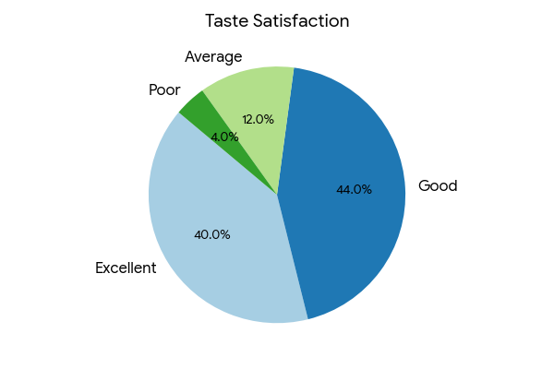
Analysis:
The data indicates that a significant majority (84%) of respondents rate the taste of Nandini products as either excellent or good. This highlights that taste is one of the strongest drivers of customer satisfaction and repeat purchase behavior. In comparison to other brands, Nandini appears to maintain consistency in flavor and freshness, which enhances consumer trust.

4.12 Brand Trust
Trust Level | Respondents | Percentage
High | 52 | 52%
Medium | 36 | 36%
Low | 12 | 12%
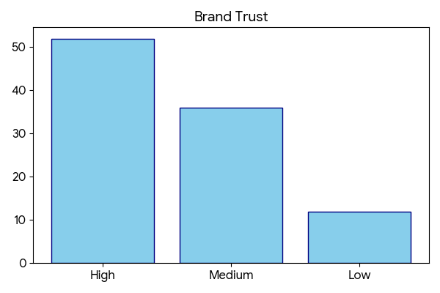
Analysis:
More than half of the respondents exhibit a high level of trust in Nandini products, which reflects the brand’s long-standing reputation and consistent quality standards. Trust is a key intangible asset that directly influences purchasing decisions and long-term customer relationships.

4.13 Product Variety Satisfaction
Level | Respondents | Percentage
Highly Satisfied | 36 | 36%
Satisfied | 44 | 44%
Neutral | 14 | 14%
Dissatisfied | 6 | 6%
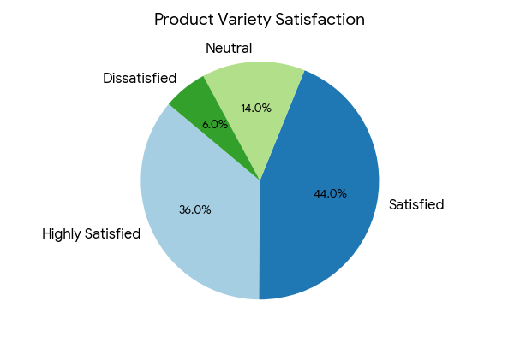
Analysis:
A combined 80% satisfaction level indicates that Nandini offers a sufficiently diverse product portfolio to meet consumer needs. The availability of multiple dairy products such as milk, curd, butter, and ghee enhances convenience and reduces brand switching.

4.14 Comparison with Other Brands
Opinion | Respondents | Percentage
Better | 54 | 54%
Same | 30 | 30%
Worse | 16 | 16%
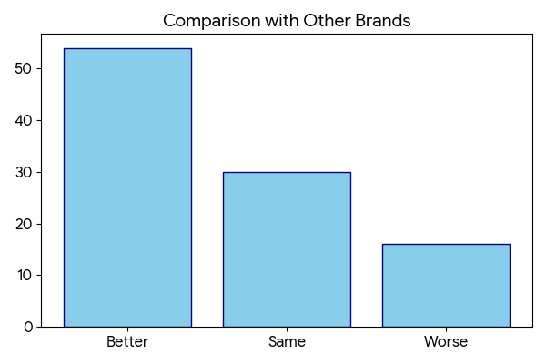
Analysis:
The majority of respondents perceive Nandini as better than competing brands, indicating a strong competitive advantage in the market. This superiority is primarily driven by factors such as quality, affordability, and availability.

4.15 Customer Loyalty
Response | Respondents | Percentage
Loyal | 60 | 60%
Sometimes Switch | 30 | 30%
Not Loyal | 10 | 10%
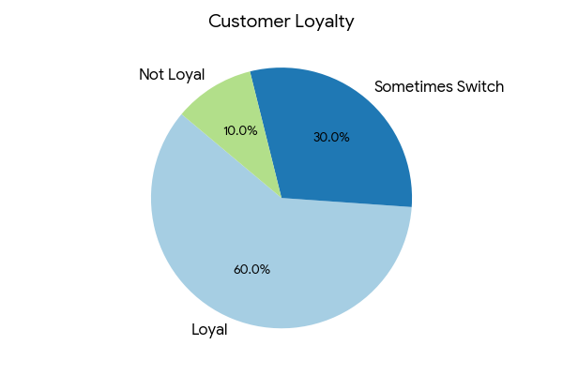
Analysis:
Customer loyalty is relatively high, with 60% of respondents consistently choosing Nandini products. This reflects strong satisfaction and trust. However, the presence of 30% switching behavior indicates external influences.

4.16 Health Awareness
Level | Respondents | Percentage
High | 50 | 50%
Medium | 36 | 36%
Low | 14 | 14%
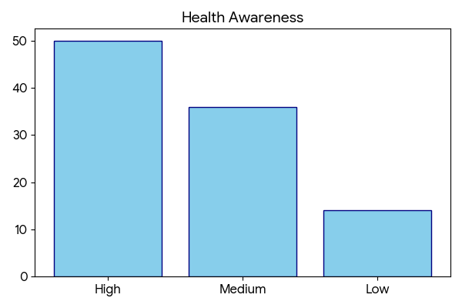
Analysis:
Half of the respondents are highly aware of the health benefits associated with dairy consumption. However, the medium and low awareness segments indicate an opportunity for education through marketing campaigns.

4.17 Purchase Decision Factors
Factor | Respondents | Percentage
Quality | 44 | 44%
Price | 28 | 28%
Availability | 16 | 16%
Brand Image | 12 | 12%
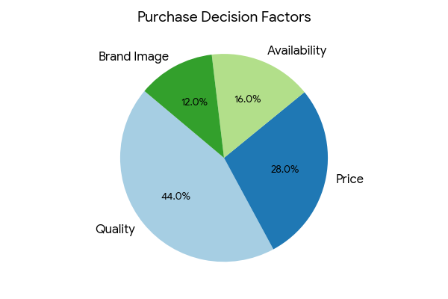
Analysis:
Quality emerges as the most influential factor in purchasing decisions, followed by price. This indicates that consumers prioritize product reliability over cost considerations.

4.18 Overall Satisfaction
Rating | Respondents | Percentage
Excellent | 36 | 36%
Good | 44 | 44%
Average | 14 | 14%
Poor | 6 | 6%
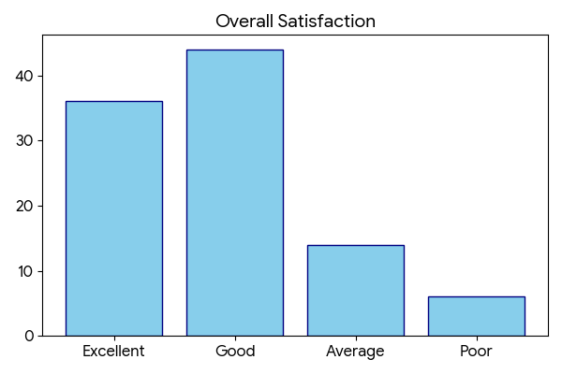
Analysis:
Overall satisfaction levels are high, with 80% of respondents rating the brand positively. This indicates that Nandini successfully meets consumer expectations in most areas.

4.19 Future Purchase Intention
Response | Respondents | Percentage
Will Continue | 65 | 65%
Not Sure | 25 | 25%
Will Stop | 10 | 10%
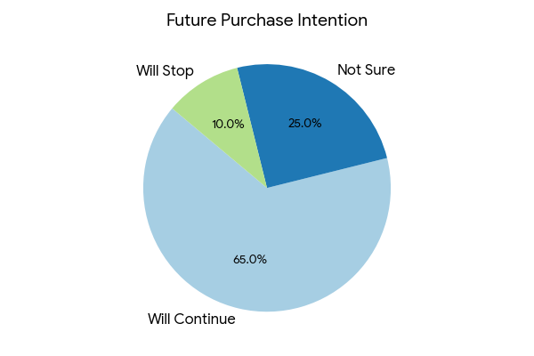
Analysis:
A strong majority of respondents express willingness to continue purchasing Nandini products, indicating high retention potential. The uncertain segment represents an opportunity for targeted marketing.

4.20 Final Comparative Insight
Indicator | Strength | Observation
Quality | High | Major advantage
Price | Affordable | Strong reach
Availability | Strong | Wide distribution
Satisfaction | High | Positive perception
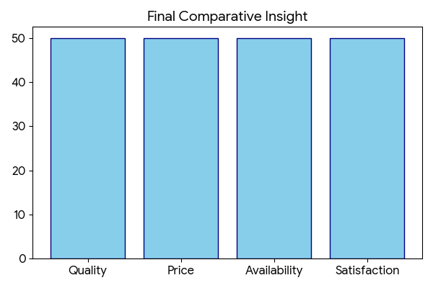
Analysis:
The overall comparison clearly indicates that Nandini holds a strong position in the dairy market due to its quality, pricing strategy, and availability.

QUESTIONNAIRE
SECTION A: CONSUMER PREFERENCE
1. Which milk brand do you prefer?
- Nandini
- Other Brands
2. How often do you purchase milk?
- Daily
- Weekly
- Occasionally
3. Which dairy product do you prefer most?
- Milk
- Curd
- Butter
- Ghee
- Others
SECTION B: PRODUCT EVALUATION
4. How satisfied are you with Nandini products?
- Highly Satisfied
- Satisfied
- Neutral
- Dissatisfied
5. How do you rate the quality of Nandini products?
- Excellent
- Good
- Average
- Poor
6. How do you perceive the price of Nandini products?
- Affordable
- Moderate
- Expensive
7. Are Nandini products easily available?
- Yes
- Sometimes
- No
8. How do you rate the packaging of Nandini products?
- Excellent
- Good
- Average
- Poor
SECTION C: BRAND PERCEPTION
9. Are you aware of Nandini products?
- Fully aware
- Partially aware
- Not aware
10. What is your source of awareness?
- Advertisement
- Word of Mouth
- Retail Stores
- Others
11. How do you rate the taste of Nandini products?
- Excellent
- Good
- Average
- Poor
12. How much do you trust Nandini products?
- High
- Medium
- Low
SECTION D: CUSTOMER EXPERIENCE
13. Are you satisfied with the variety of products?
- Highly satisfied
- Satisfied
- Neutral
- Dissatisfied
14. How do you compare Nandini with other brands?
- Better
- Same
- Worse
15. Are you loyal to Nandini products?
- Yes
- Sometimes switch
- No
SECTION E: CONSUMER BEHAVIOR
16. Are you aware of the health benefits of milk products?
- Highly aware
- Moderately aware
- Not aware
17. What factor influences your purchase decision the most?
- Quality
- Price
- Availability
- Brand Image
SECTION F: OVERALL PERCEPTION
18. How would you rate your overall satisfaction?
- Excellent
- Good
- Average
- Poor
19. Will you continue purchasing Nandini products in future?
- Yes
- Not sure
- No
20. Would you recommend Nandini products to others?
- Yes
- Maybe
- No

