


GOVERNMENT FIRST GRADE COLLEGE
Siddarth Nagar Mysore
INTERNSHIP PROJECT REPORT ON
A Study of Brand Image Building of Milk products - a study at Manmul
BY
VIKAS S
No. U01AL23C0184
UNDER THE GUIDANCE OF
DR. RAVISHANKAR
Associate Professor
Department of Commerce
Internship Report submitted to the university of Mysore in partial fulfilment of the Requirements of final year
Academic year: 2025-26

DECLARATION

I am VIKAS S hereby declare that the Internship Project Report entitled “A Study of Brand Image Building of Milk Products – A Study at MANMUL” is a Bonafide record of the work carried out by me during the academic year 2025–26.
The report has been prepared under the guidance of Dr. Ravishankar, Associate Professor, Department of Commerce, Government First Grade College, Siddarth Nagar, Mysore.
I further declare that this project work is submitted in partial fulfilment of the requirements for the award of the degree of Bachelor of Commerce of the University of Mysore. This report is based on my original work and has not been submitted to any other university or institution for the award of any degree.

Date: __________
Place: Mysore

VIKAS S
(U01AL23C0184)

ACKNOWLEDGEMENT

I express my sincere gratitude to all those who have supported and guided me in the successful completion of this internship project.

First and foremost, I thank the Principal of Government First Grade College, Siddarth Nagar, Mysore, for providing me with the opportunity and facilities to carry out this project.

I would like to express my heartfelt gratitude to my internal guide Dr. Ravishankar, Associate Professor, Department of Commerce, for his valuable guidance, encouragement, and constant support throughout the project work.

I am also thankful to the officials and staff of Mandya Milk Union (MANMUL) for providing necessary information and support during the internship period.

I extend my sincere thanks to my teachers, friends, and family members for their encouragement and support in completing this project successfully.

Date: __________

Place: Mysore

VIKAS S

(U01AL23C0184)

Sl. No | Content | Page No
01 | Declaration | i
02 | Acknowledgement | ii
03 | Table of Contents | iii
04 | Chapter I – Introduction | 1 – 10
05 | Chapter II – Review of Literature | 11 – 20
06 | Chapter III – Conceptual Framework | 21 – 30
07 | Chapter IV – Data Interpretation | 31 – 50
08 | Chapter V – Findings & Conclusion | 51 – 60
09 | Questionnaire | 61 – 65
10 | References | 66 – 70

INTRODUCTION
The dairy industry plays a vital role in the economic and social development of India. It is one of the largest contributors to the agricultural sector and provides employment opportunities to millions of rural households. Milk and milk products are essential components of the daily diet, offering important nutrients such as proteins, calcium, vitamins, and energy.
India is recognized as the largest producer of milk in the world. The growth of the dairy industry in India has been largely supported by cooperative movements, which have helped organize farmers, eliminate middlemen, and ensure fair pricing. These cooperative systems have improved the standard of living of rural farmers while ensuring that consumers receive quality dairy products at affordable prices.
Milk is considered a complete food as it contains all essential nutrients required for human growth and development. It plays an important role in maintaining good health and is suitable for people of all age groups, including children, adults, and elderly individuals.

ABOUT MANDYA MILK UNION (MANMUL)
Mandya District Co-operative Milk Producers’ Societies Union Limited (MANMUL) was established in the year 1987. Initially, the Gejjalagere dairy was managed by Mysore Dairy and was later handed over to Mandya Milk Union in the year 1988.
The main philosophy of the union is to eliminate middlemen and organize dairy farmers into cooperative institutions that are owned and managed by the producers themselves. This system helps achieve economies of scale and ensures maximum returns to the milk producers.

The vision of MANMUL is to grow into a model cooperative milk union in the country by ensuring rural prosperity and improving the livelihood of farmers. The union is committed to providing a stable and remunerative market for milk producers while supplying high-quality milk and milk products to consumers.

OBJECTIVES OF MANMUL

The main objectives of MANMUL include:
- To provide an assured and remunerative market for milk supplied by farmers
- To supply high-quality milk and milk products to consumers
- To eliminate middlemen and strengthen cooperative institutions
- To improve the socio-economic conditions of rural farmers
- To promote dairy farming as a sustainable source of income

The union also focuses on improving infrastructure, implementing development programs, and ensuring better performance in both commercial and social aspects.

GROWTH AND DEVELOPMENT OF MANMUL

MANMUL has experienced significant growth since its establishment. It operates a liquid milk plant with a capacity of 4 lakh litres per day and a milk powder plant with a capacity of 18 metric tons per day. The union also has chilling centres located at Nagamangala and KR Pet.
The union has expanded its operations over the years, increasing milk procurement and distribution. Initially, milk procurement was around 5,000 litres per day, which gradually increased to over 3.75 lakh litres per day. This growth reflects the efficiency and success of cooperative dairy systems.
The union covers several taluks in Mandya district and operates through a large network of dairy cooperative societies. Many of these societies are run by women, promoting gender empowerment and rural development.

IMPORTANCE OF MILK IN DAILY LIFE

Milk is one of the most important natural foods available to humans. It is rich in nutrients and provides a balanced diet. It contains proteins that help in body building, calcium that strengthens bones and teeth, and vitamins that support overall health.
Milk is suitable for all age groups and plays a crucial role in maintaining a healthy lifestyle. It is especially beneficial for children, pregnant women, and elderly individuals. Regular consumption of milk helps prevent nutritional deficiencies and promotes physical and mental development.
Milk is also widely used in preparing various food items such as tea, coffee, sweets, and other dairy products. Its versatility makes it an essential part of everyday life.
OVERVIEW OF DAIRY INDUSTRY
The dairy industry has evolved significantly over time. In earlier days, milk production and distribution were limited due to lack of transportation and storage facilities. However, with advancements in technology such as refrigeration and pasteurization, the dairy industry has expanded rapidly.
Modern dairy processing techniques ensure that milk is safe for consumption and retains its nutritional value. The introduction of cold storage systems and efficient transportation has made it possible to distribute milk over long distances without compromising quality.
The dairy industry contributes significantly to the economy by generating employment, supporting farmers, and ensuring food security.



ROLE OF COOPERATIVE SYSTEM IN DAIRY INDUSTRY

The cooperative system plays a major role in the development of the dairy industry. It helps farmers collectively manage production, processing, and marketing activities. This system ensures that farmers receive fair prices for their products and reduces exploitation by middlemen.
Cooperative institutions like MANMUL have successfully improved the income levels of farmers and contributed to rural development. They also ensure that consumers receive fresh and high-quality milk products at reasonable prices.

ABOUT NANDINI MILK
Nandini Milk is one of the most popular and trusted dairy brands produced under the Karnataka Milk Federation (KMF). It is widely recognized for its high quality, freshness, and nutritional value. The brand has established a strong presence in the dairy market and is a preferred choice among consumers.
Nandini Milk is sourced directly from farmers who are part of cooperative societies. The milk is collected, processed, and distributed through an organized system that ensures quality and safety at every stage. The use of modern technology and strict quality control measures helps maintain the purity and freshness of the milk.
The brand offers different varieties of milk such as full cream milk, toned milk, homogenized milk, and special milk. These variants cater to the diverse needs and preferences of consumers.

PROCESS OF NANDINI MILK
The production process of Nandini Milk involves several stages to ensure that the milk is safe, hygienic, and of high quality.
1. Milk Collection
Milk is collected directly from farmers through cooperative societies. Each batch of milk is tested for quality parameters such as purity and contamination before acceptance.
2. Chilling and Transportation
After collection, the milk is quickly cooled to around 4°C to prevent bacterial growth. It is then transported to processing plants using refrigerated vehicles.
3. Processing and Standardization
At the processing plant, milk undergoes standardization where fat content is adjusted based on the type of milk being produced. This ensures consistency in quality.
4. Homogenization
Milk is processed under high pressure to break down fat particles, ensuring a smooth and uniform texture.
5. Pasteurization
Milk is heated to a specific temperature to eliminate harmful bacteria while retaining its nutritional value.
6. Packaging
The processed milk is packed in hygienic pouches or containers. Each package is labelled with necessary details such as fat content and expiry date.
7. Distribution
Milk is distributed through a cold chain system to maintain freshness until it reaches consumers.
This systematic process ensures that Nandini Milk meets high standards of quality and safety.
PRODUCT RANGE OF NANDINI
Nandini offers a wide range of dairy products that cater to the daily needs of consumers. These products are known for their quality, taste, and affordability.
The major products include:
Milk (various types)
Curd
Butter
Ghee
Paneer
Milk powder
Ice cream and sweets
These products are widely used in households and have gained popularity due to their consistency and nutritional value.

NANDINI MILK VARIANTS
NANDINI SHUBHAM MILK

Nandini Shubham Milk is a high-quality pasteurized and standardized milk. It is known for its purity and nutritional value. It contains essential nutrients such as protein, calcium, and vitamins, making it suitable for all age groups.
This milk is widely used for drinking, preparing tea and coffee, and cooking. It supports healthy growth and helps maintain overall well-being.
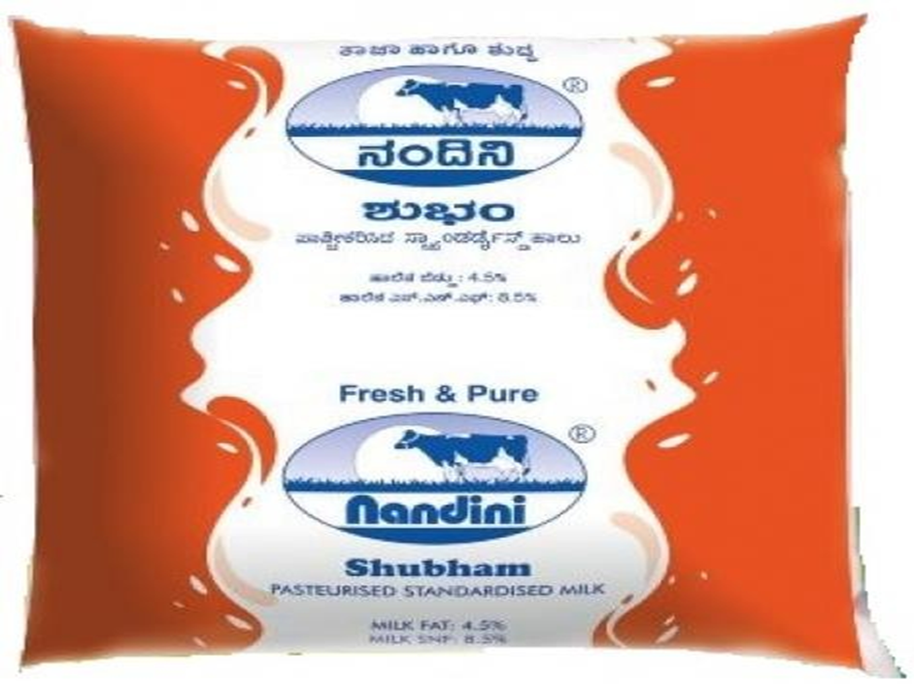

NANDINI HOMOGENIZED MILK

Nandini Homogenized Milk undergoes a mechanical process that ensures uniform distribution of fat particles throughout the milk. This gives the milk a smooth texture and prevents cream separation.
Homogenized milk is preferred by many consumers because of its consistency and convenience. It is suitable for daily consumption and cooking purposes.
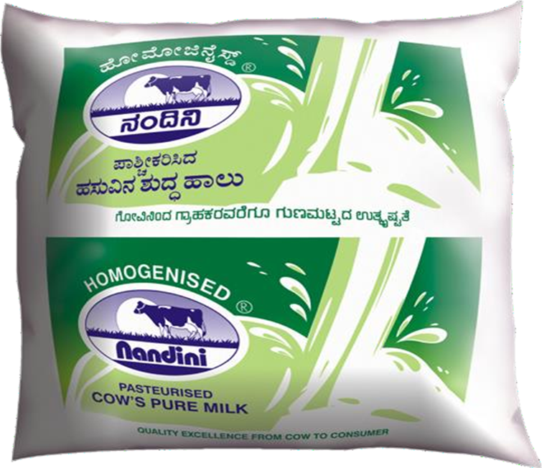

NANDINI PASTEURIZED TONED MILK

Nandini Toned Milk is a low-fat milk that retains most of the essential nutrients. It is processed through pasteurization to ensure safety and longer shelf life.
This type of milk is ideal for health-conscious individuals as it provides nutritional benefits with reduced fat content.
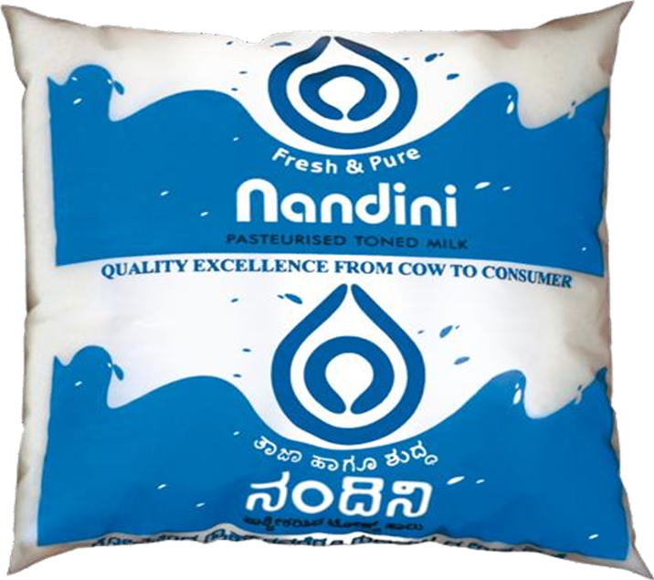

NANDINI SPECIAL MILK

Nandini Special Milk is known for its rich taste and superior quality. It is carefully processed and tested to meet high standards of hygiene and safety.
It is widely used for both drinking and cooking purposes. The creamy texture and nutritional value make it a popular choice among consumers.

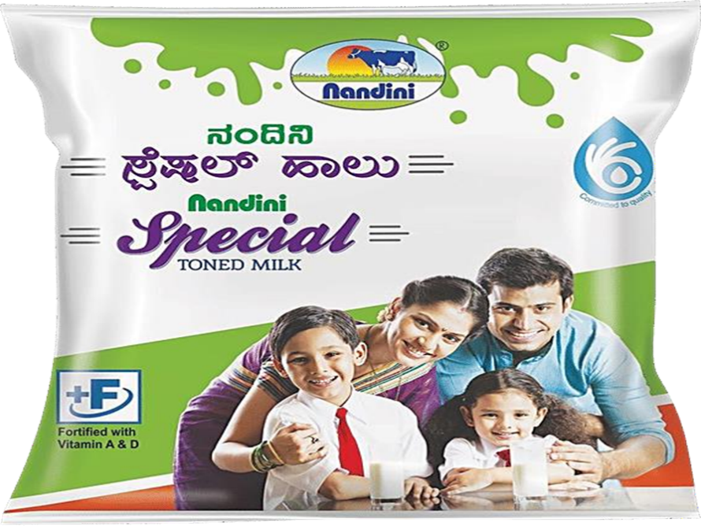

NANDINI GOOD LIFE MILK

Nandini Good Life Milk is processed using Ultra-High Temperature (UHT) technology, which gives it a longer shelf life without the need for refrigeration before opening.
It is a convenient option for consumers who require long-lasting milk products. It retains its nutritional value and taste, making it suitable for daily use.
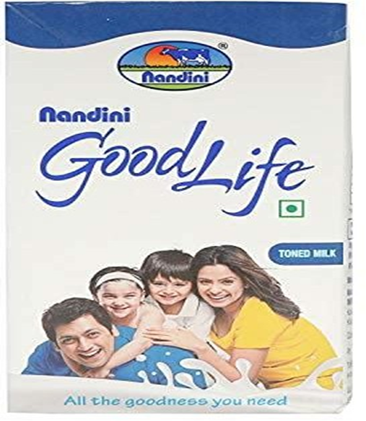

The introduction highlights the importance of the dairy industry and the role of cooperative institutions like MANMUL in supporting farmers and providing quality products to consumers. Nandini Milk has established itself as a trusted brand due to its commitment to quality, affordability, and availability.
The production process, product range, and continuous improvements in quality have contributed to the success of Nandini products. The study of these aspects provides valuable insights into the functioning of the dairy industry and consumer preferences.

CHAPTER II:
REVIEW OF LITERATURE

The review of literature is an important part of any research study as it provides an understanding of previous studies and research work related to the topic. It helps in identifying key concepts, theories, and findings that are relevant to the present study. In the context of the dairy industry, several studies have been conducted to analyze consumer behavior, brand image, and marketing strategies.
CONSUMER BEHAVIOR IN DAIRY PRODUCTS
Consumer behavior plays a crucial role in determining the success of dairy products in the market. Various studies indicate that consumers prefer milk brands based on quality, price, availability, and trust. Quality is considered one of the most important factors influencing purchasing decisions, as consumers expect fresh and safe milk for daily consumption.
Price is another important factor, especially in developing countries like India, where consumers are sensitive to changes in price. Affordable pricing strategies adopted by cooperative organizations like Nandini help in attracting a large number of consumers.
Availability also plays a key role in influencing consumer preference. Milk being a daily necessity, consumers tend to choose brands that are easily available in nearby stores. Studies show that a strong distribution network increases customer satisfaction and brand loyalty.

GROWTH OF DAIRY INDUSTRY IN INDIA
The dairy industry in India has experienced rapid growth over the past few decades. Research studies indicate that India has become the largest producer of milk due to the successful implementation of cooperative systems and government initiatives.
The introduction of modern technologies such as pasteurization, refrigeration, and efficient transportation has contributed to the expansion of the dairy industry. These advancements have improved the quality and shelf life of milk, making it safer for consumption.
Cooperative institutions like Karnataka Milk Federation (KMF) have played a significant role in the development of the dairy sector. These organizations have helped farmers by providing a stable market for their milk and ensuring fair prices.

ROLE OF COOPERATIVE SYSTEM IN DAIRY INDUSTRY
The cooperative model has been widely recognized as an effective system for dairy development. According to various studies, cooperative societies help in eliminating middlemen and ensuring direct interaction between producers and consumers.
This system benefits farmers by providing them with better prices and support services such as veterinary care, training, and financial assistance. It also helps in improving milk production and quality.
Research shows that cooperative organizations like MANMUL have successfully improved rural livelihoods and contributed to economic development. They have created employment opportunities and enhanced the standard of living of farmers.

BRAND IMAGE IN DAIRY PRODUCTS
Brand image refers to the perception of a product in the minds of consumers. It plays a significant role in influencing purchasing decisions. Studies indicate that a strong brand image leads to increased customer loyalty and repeated purchases.
In the dairy industry, brand image is influenced by factors such as product quality, packaging, pricing, and promotion. Brands like Nandini have successfully built a positive image by maintaining consistent quality and affordability.
Consumers tend to trust brands that have a good reputation and provide reliable products. A strong brand image helps in differentiating a product from its competitors and enhances market position.

MARKETING STRATEGIES IN DAIRY INDUSTRY
Marketing strategies play a vital role in promoting dairy products and increasing sales. Research studies highlight the importance of the marketing mix, which includes product, price, place, and promotion.
Product strategy involves offering high-quality products that meet consumer needs. Price strategy focuses on setting competitive prices to attract customers. Place strategy ensures that products are available in convenient locations, while promotion involves advertising and communication to create awareness.
Effective marketing strategies help in building brand awareness and increasing customer satisfaction. Dairy brands that adopt innovative marketing techniques are able to gain a competitive advantage in the market.

IMPORTANCE OF PRODUCT QUALITY AND SAFETY
Quality and safety are critical factors in the dairy industry. Studies show that consumers are highly concerned about the quality of milk and milk products. They prefer products that are safe, hygienic, and free from contamination.
The use of modern processing techniques such as pasteurization and homogenization ensures that milk is safe for consumption. Quality control measures at different stages of production help in maintaining product standards.
Organizations like Nandini follow strict quality standards to ensure that their products meet consumer expectations. This has helped in building trust and maintaining a strong market presence.

CONSUMER SATISFACTION IN DAIRY PRODUCTS
Consumer satisfaction is a key factor that determines the success and sustainability of any dairy brand. Various studies reveal that customer satisfaction depends on multiple factors such as product quality, taste, freshness, price, and availability.
In the dairy industry, consumers expect consistent quality in milk and milk products. Any variation in taste or quality may lead to dissatisfaction and switching of brands. Research indicates that brands maintaining high quality standards are more likely to retain customers and build long-term relationships.
Customer satisfaction also depends on the overall experience, including packaging, service, and accessibility. Convenient packaging and easy availability of products increase customer convenience and satisfaction.
ROLE OF PACKAGING IN DAIRY PRODUCTS
Packaging plays an important role in the dairy industry as it ensures product safety, hygiene, and convenience. Studies show that attractive and durable packaging enhances the visual appeal of products and influences consumer purchasing decisions.
In the case of milk and dairy products, packaging helps in protecting the product from contamination and extending its shelf life. Modern packaging methods such as tetra packs and sealed pouches are widely used to maintain freshness.
Research also indicates that clear labeling and proper information on packaging, such as nutritional value and expiry date, increase consumer confidence and trust in the brand.

IMPACT OF PRICING STRATEGIES
Pricing is a crucial element in determining consumer choice in the dairy market. Studies highlight that consumers prefer products that offer value for money. Affordable pricing strategies adopted by cooperative brands like Nandini make them accessible to a large segment of the population.
Competitive pricing helps in attracting price-sensitive customers, especially in rural and semi-urban areas. At the same time, maintaining a balance between quality and price is essential for long-term success.
Research shows that pricing strategies should be aligned with consumer expectations and market conditions to ensure profitability and customer satisfaction.

DISTRIBUTION AND AVAILABILITY OF DAIRY PRODUCTS
Distribution plays a vital role in ensuring that dairy products reach consumers in a timely and efficient manner. Studies indicate that a strong distribution network is essential for the success of dairy brands.
Milk being a perishable product requires efficient transportation and storage systems. The use of cold chain systems helps in maintaining the freshness and quality of milk during distribution.
Brands like Nandini have developed an extensive distribution network that ensures availability of products in both urban and rural areas. Easy accessibility of products increases customer satisfaction and enhances brand loyalty.

PROMOTIONAL ACTIVITIES IN DAIRY INDUSTRY
Promotion is an important marketing tool used to create awareness and influence consumer behavior. Research studies highlight that advertising, sales promotion, and public relations play a significant role in building brand image.
In the case of milk and dairy products, packaging helps in protecting the product from contamination and extending its shelf life. Modern packaging methods such as tetra packs and sealed pouches are widely used to maintain freshness.
Dairy brands use various promotional techniques such as television advertisements, social media marketing, and point-of-sale displays to attract customers. Effective promotion helps in communicating the benefits of the product and differentiating it from competitors.
Promotional activities also help in increasing brand recognition and encouraging trial purchases among new customers.

INNOVATION IN DAIRY PRODUCTS
Innovation is essential for the growth and competitiveness of the dairy industry. Studies show that introducing new products and improving existing ones helps in attracting customers and meeting changing consumer preferences.
Dairy companies are focusing on developing value-added products such as flavored milk, low-fat milk, and fortified dairy products. These innovations cater to the needs of health-conscious consumers and enhance product variety.
Technological advancements in processing and packaging have also contributed to product innovation and improved quality.

ROLE OF TECHNOLOGY IN DAIRY INDUSTRY
Technology plays a crucial role in improving efficiency and quality in the dairy sector. Modern technologies such as automated milk collection systems, pasteurization, homogenization, and refrigeration have transformed the dairy industry.
These technologies help in reducing wastage, improving product quality, and ensuring safety. Research indicates that the adoption of advanced technologies increases productivity and enhances the overall performance of dairy organizations.
Organizations like MANMUL have adopted modern technologies to improve processing and distribution, ensuring better service to consumers.
SUMMARY OF REVIEW OF LITERATURE
The review of literature highlights the key factors influencing the dairy industry and consumer behavior. It shows that product quality, pricing, availability, packaging, and promotion play a significant role in determining consumer preference.
The cooperative model has been successful in improving rural livelihoods and ensuring efficient dairy production and distribution. Brands like Nandini have built a strong reputation by focusing on quality, affordability, and customer satisfaction.
The findings from previous studies provide a strong foundation for the present study and help in understanding the various aspects of brand image and consumer perception in the dairy industry.

CHAPTER III:
CONCEPTUAL FRAMEWORK

A conceptual framework is a structured representation that explains the relationship between different variables in a study. It helps in understanding how various factors influence the outcome of the research. In this study, the conceptual framework is used to analyze the factors affecting the brand image of Nandini milk products.
The framework identifies key variables that influence consumer perception and purchasing behavior. These variables are categorized into independent variables and dependent variables.

MEANING AND IMPORTANCE OF CONCEPTUAL FRAMEWORK
A conceptual framework provides a clear direction for conducting research. It helps in organizing ideas and establishing relationships between different concepts. It also assists in identifying the key variables that need to be studied.

The importance of a conceptual framework includes:
- Provides clarity to the research problem
- Helps in identifying variables
- Establishes relationships between variables
- Guides data collection and analysis
- Improves the accuracy and reliability of the study
In the context of this study, the conceptual framework helps in understanding how different factors influence the brand image of dairy products.

VARIABLES OF THE STUDY
The study focuses on two types of variables:
1. Independent Variables
These are the factors that influence consumer perception and brand image.
The independent variables in this study include:
- Product Quality
- Price
- Packaging
- Availability
- Promotion
2. Dependent Variable
The dependent variable is the outcome that is influenced by the independent variables.
- Brand Image of Nandini Products

PRODUCT QUALITY
Product quality is one of the most important factors influencing consumer preference. In the dairy industry, quality refers to freshness, taste, nutritional value, and safety of milk products.
Consumers prefer brands that provide consistent quality and maintain hygiene standards. High-quality products lead to customer satisfaction and increase brand loyalty.
Nandini has built a strong reputation by maintaining strict quality control measures and ensuring that its products meet high standards.

PRICE
Price is another important factor that affects consumer decision-making. Consumers generally prefer products that offer good value for money.
Affordable pricing attracts a larger customer base, especially in price-sensitive markets. At the same time, pricing should reflect the quality of the product.
Nandini follows a competitive pricing strategy, making its products accessible to both urban and rural consumers.

PACKAGING
Packaging plays a crucial role in protecting dairy products and enhancing their appeal. It ensures hygiene, safety, and convenience for consumers.
Attractive and durable packaging increases the attractiveness of the product and influences purchasing decisions. Proper labeling also provides important information such as nutritional value and expiry date.
Nandini uses modern packaging techniques to maintain product quality and freshness.

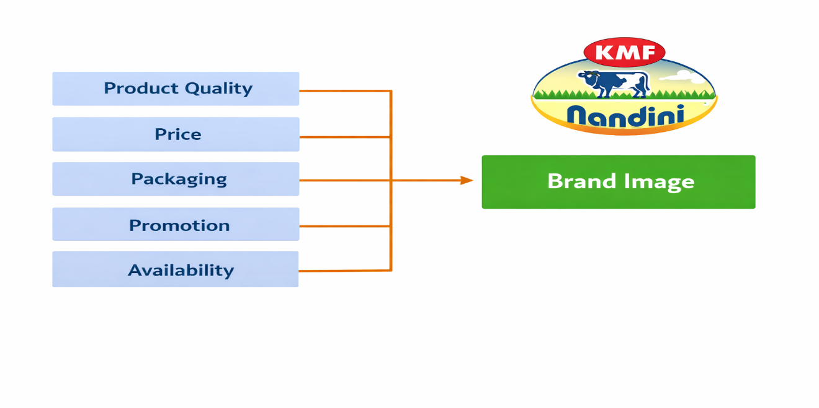
AVAILABILITY
Availability refers to how easily a product can be accessed by consumers. Dairy products are daily necessities, so easy availability is very important.
A strong distribution network ensures that products are available in nearby stores. This increases convenience and customer satisfaction.
Nandini has a well-established distribution system that ensures its products are widely available.

PROMOTION
Promotion includes all activities used to create awareness and attract customers. It includes advertising, sales promotion, and public relations.
Effective promotion helps in building brand image and increasing customer awareness. It also influences consumer perception and purchasing decisions.
Nandini uses various promotional strategies to maintain its presence in the market.

RELATIONSHIP BETWEEN VARIABLES
The conceptual framework of this study is based on the relationship between independent variables and the dependent variable. The independent variables such as product quality, price, packaging, promotion, and availability directly influence the dependent variable, which is the brand image of Nandini products.
A conceptual framework is generally represented using a diagram with boxes and arrows to show cause-and-effect relationships between variables.
In this study, each independent variable contributes to shaping consumer perception and ultimately affects the overall brand image. The stronger these factors, the more positive the brand image becomes.

PRODUCT QUALITY AND BRAND IMAGE
Product quality is one of the most influential factors affecting brand image. High-quality products create trust among consumers and lead to repeated purchases.
In the dairy industry, quality includes:
- Freshness of milk
- Taste and consistency
- Nutritional value
- Safety and hygiene
Consumers associate high-quality products with reliability and trustworthiness. Therefore, maintaining quality is essential for building a strong brand image.

PRICE AND BRAND IMAGE
Price plays a significant role in influencing consumer perception. It determines whether a product is affordable and accessible to consumers.
Affordable pricing increases customer satisfaction and attracts a larger market segment. However, price should also reflect the quality of the product.
A well-balanced pricing strategy helps in:
- Increasing customer base
- Enhancing brand value
- Maintaining competitiveness in the market

PACKAGING AND BRAND IMAGE
Packaging is an important factor that influences consumer buying behavior. It not only protects the product but also enhances its visual appeal.
Good packaging:
- Ensures hygiene and safety
- Provides product information
- Attracts customers
- Improves brand recognition

Attractive and informative packaging creates a positive impression in the minds of consumers and strengthens brand image.

PROMOTION AND BRAND IMAGE
Promotion refers to the activities used to create awareness and influence consumer decisions. It includes advertising, sales promotion, and public relations.
Effective promotional strategies help in:
- Increasing brand awareness
- Communicating product benefits
- Attracting new customers
Promotion plays a key role in shaping consumer perception and building a strong brand identity.

AVAILABILITY AND BRAND IMAGE
Availability refers to the ease with which consumers can access products. Dairy products are daily necessities, so continuous availability is very important.
A strong distribution network ensures that products are:
- Easily accessible
- Available at all times
- Fresh and safe
Easy availability increases customer convenience and satisfaction, which positively impacts brand image.

INTEGRATED EFFECT OF VARIABLES
All the independent variables work together to influence the dependent variable. The combined effect of quality, price, packaging, promotion, and availability determines the overall perception of the brand.
When all these factors perform well:
- Customer satisfaction increases
- Brand loyalty improves
- Market position strengthens

Thus, the conceptual framework provides a clear understanding of how different factors contribute to building the brand image of Nandini products.

SIGNIFICANCE OF THE STUDY FRAMEWORK
The conceptual framework serves as the foundation for the study. It helps in identifying the key variables and understanding their relationships.
The significance of this framework includes:
- Providing direction for data collection
- Helping in analysis and interpretation
- Supporting findings and conclusions
- Making the study more structured and systematic

A well-defined conceptual framework improves the quality and reliability of research.

SUMMARY OF CONCEPTUAL FRAMEWORK
The conceptual framework of this study explains the relationship between independent variables and the dependent variable. It highlights how factors such as product quality, price, packaging, promotion, and availability influence the brand image of Nandini products.
The framework provides a clear structure for analyzing consumer perception and helps in understanding the factors that contribute to brand success. It also serves as a guide for further analysis in the study.

CHAPTER IV:
DATA INTERPRETATION
INTRODUCTION
Data interpretation is the process of analyzing collected data and presenting it in a meaningful way. In this study, data has been collected through a structured questionnaire to understand consumer preferences and perception towards Nandini milk products.
The collected data is presented in the form of tables and analyzed using simple percentage methods. Each table is followed by an interpretation to explain the results clearly.
This shows that consumers prioritize value and reliability while choosing dairy products.
Customer satisfaction levels are found to be high, with most respondents expressing positive opinions about product quality, taste, and packaging. The brand has also developed strong customer loyalty and trust, which is reflected in the high percentage of respondents willing to recommend Nandini products.
Data has been collected through a structured questionnaire to understand consumer preferences and perception towards Nandini milk products.

4.1 Brand Preference
Brand | Respondents | Percentage
Nandini | 60 | 60%
Other Brands | 40 | 40%
Total | 100 | 100%
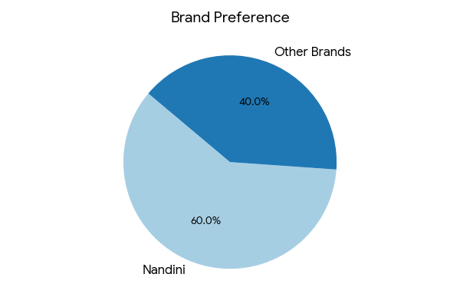
Analysis:
The data clearly indicates that a majority of respondents prefer Nandini over other brands. This reflects the strong brand image, trust, and consistent quality associated with Nandini products. However, the presence of 40% preference for other brands highlights competitive pressure in the dairy market. This suggests that while Nandini leads, it must continuously innovate and maintain quality to sustain its position.

4.2 Purchase Frequency
Frequency | Respondents | Percentage
Daily | 70 | 70%
Weekly | 20 | 20%
Occasional | 10 | 10%
Total | 100 | 100%
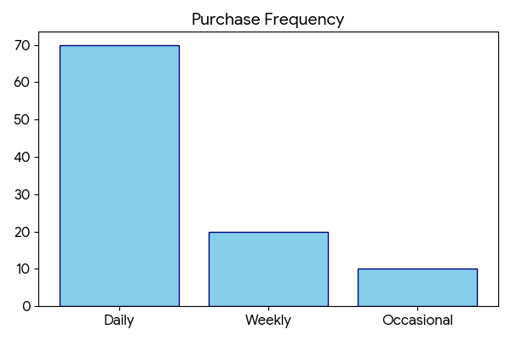
Analysis:
A significant majority of respondents purchase milk daily, emphasizing its role as a basic necessity. This consistent demand requires an efficient supply chain and uninterrupted availability. The smaller segments of weekly and occasional buyers indicate variations in consumption patterns but do not significantly affect overall demand stability.

4.3 Product Preference
Product | Respondents | Percentage
Milk | 50 | 50%
Curd | 20 | 20%
Butter | 15 | 15%
Ghee | 10 | 10%
Others | 5 | 5%
Total | 100 | 100%
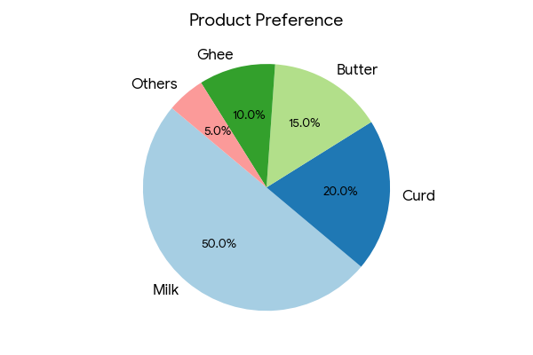
Analysis:
Milk emerges as the most preferred product, confirming its position as the core offering of the dairy sector. Other products like curd and butter also hold notable shares, indicating diversification in consumption. This suggests that while milk drives the brand, value-added products contribute to overall growth.

4.4 Customer Satisfaction
Level | Respondents | Percentage
Highly Satisfied | 40 | 40%
Satisfied | 40 | 40%
Neutral | 14 | 14%
Dissatisfied | 6 | 6%
Total | 100 | 100%
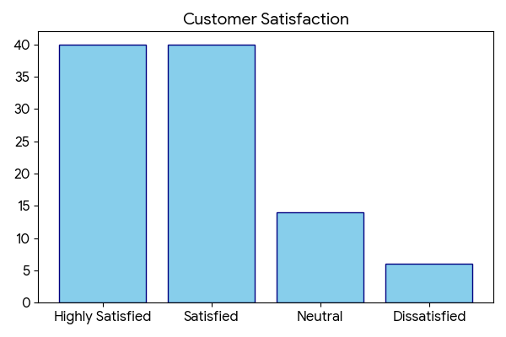
Analysis:
The data reveals that 80% of respondents are satisfied or highly satisfied with Nandini products. This reflects strong performance in meeting consumer expectations. However, the presence of neutral and dissatisfied responses indicates areas for improvement, particularly in service consistency and product experience.

4.5 Product Quality Rating
Rating | Respondents | Percentage
Excellent | 36 | 36%
Good | 44 | 44%
Average | 16 | 16%
Poor | 4 | 4%
Total | 100 | 100%
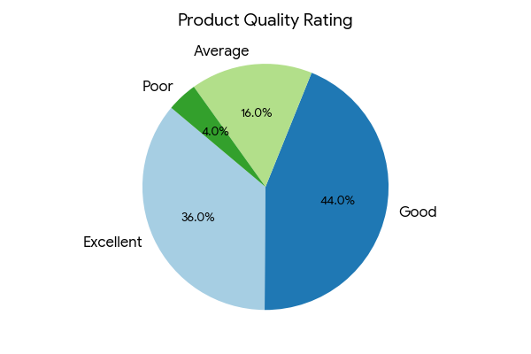
Analysis:
A large proportion of respondents rate product quality as good or excellent, confirming that quality is a major strength of Nandini. This reinforces consumer trust and supports repeat purchases. The small percentage of lower ratings suggests minimal dissatisfaction but highlights the need for continuous quality monitoring.

4.6 Price Perception
Response | Respondents | Percentage
Affordable | 64 | 64%
Moderate | 26 | 26%
Expensive | 10 | 10%
Total | 100 | 100%
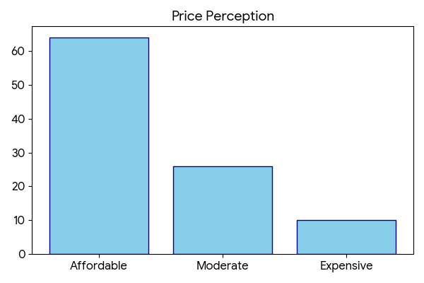
Analysis:
Most respondents perceive Nandini products as affordable, which is a key factor driving demand. Competitive pricing ensures accessibility across different income groups. However, a small percentage perceives prices as high, suggesting the importance of maintaining value for money.

4.7 Product Availability
Availability | Respondents | Percentage
Easy | 68 | 68%
Sometimes | 24 | 24%
Rare | 8 | 8%
Total | 100 | 100%
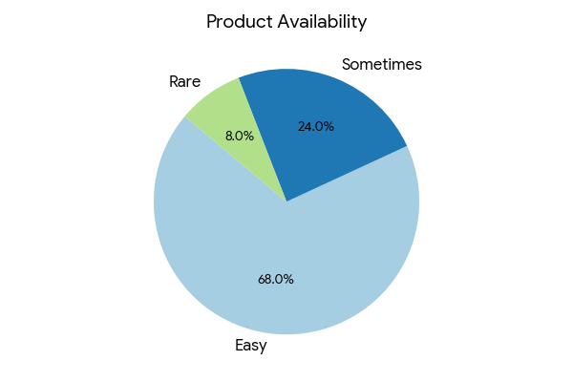
Analysis:
The majority of respondents find Nandini products easily available, indicating an efficient distribution network. Availability plays a crucial role in influencing purchasing decisions, especially for daily-use products like milk.

4.8 Packaging Satisfaction
Rating | Respondents | Percentage
Excellent | 30 | 30%
Good | 50 | 50%
Average | 16 | 16%
Poor | 4 | 4%
Total | 100 | 100%
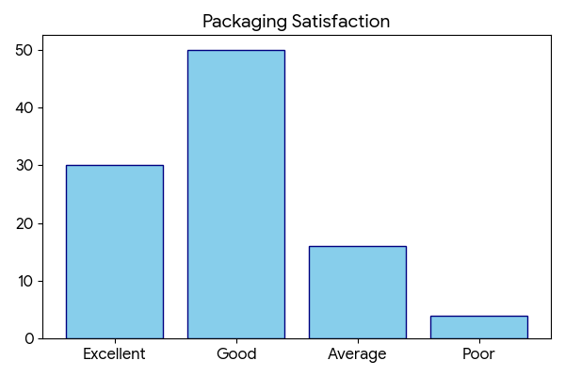
Analysis:
Packaging is rated positively by most respondents, indicating satisfaction with hygiene and convenience. Good packaging enhances product safety and brand image. Minor dissatisfaction suggests opportunities for improvement in design or durability.

4.9 Awareness Level
Awareness | Respondents | Percentage
Fully Aware | 56 | 56%
Partially Aware | 34 | 34%
Not Aware | 10 | 10%
Total | 100 | 100%
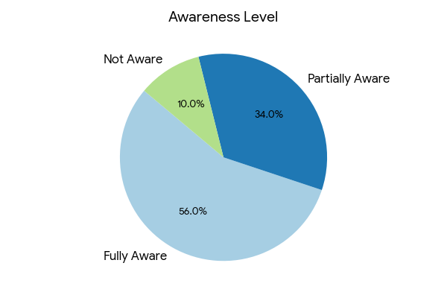
Analysis:
Most respondents are aware of Nandini products, reflecting strong market presence. However, partial awareness among a segment indicates the need for improved promotional activities and advertising strategies.

4.10 Recommendation
Response | Respondents | Percentage
Yes | 64 | 64%
Maybe | 24 | 24%
No | 12 | 12%
Total | 100 | 100%
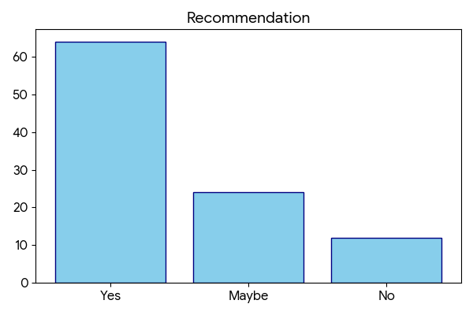
Analysis:
A majority of respondents are willing to recommend Nandini products, indicating strong customer satisfaction and loyalty. The “maybe” group represents potential advocates who can be converted through better engagement and service.

4.11 Taste Satisfaction
Rating | Respondents | Percentage
Excellent | 40 | 40%
Good | 44 | 44%
Average | 12 | 12%
Poor | 4 | 4%
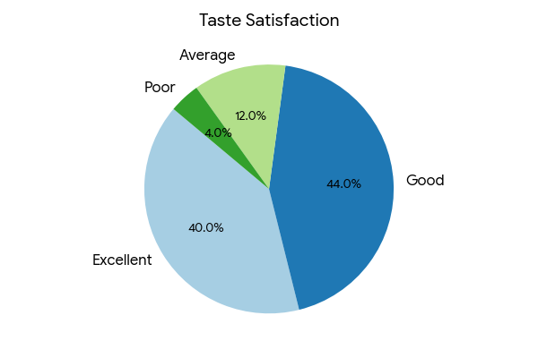
Analysis:
The data indicates that a significant majority (84%) of respondents rate the taste of Nandini products as either excellent or good. This highlights that taste is one of the strongest drivers of customer satisfaction and repeat purchase behavior. In comparison to other brands, Nandini appears to maintain consistency in flavor and freshness, which enhances consumer trust.

4.12 Brand Trust
Trust Level | Respondents | Percentage
High | 52 | 52%
Medium | 36 | 36%
Low | 12 | 12%
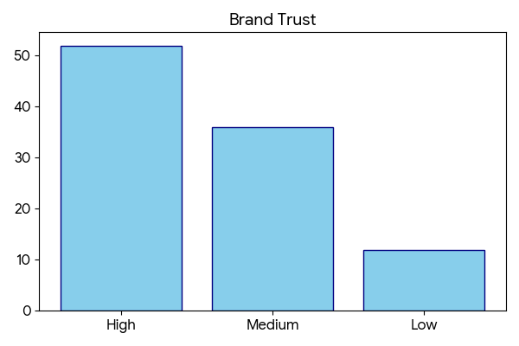
Analysis:
More than half of the respondents exhibit a high level of trust in Nandini products, which reflects the brand’s long-standing reputation and consistent quality standards. Trust is a key intangible asset that directly influences purchasing decisions and long-term customer relationships.

4.13 Product Variety Satisfaction
Level | Respondents | Percentage
Highly Satisfied | 36 | 36%
Satisfied | 44 | 44%
Neutral | 14 | 14%
Dissatisfied | 6 | 6%
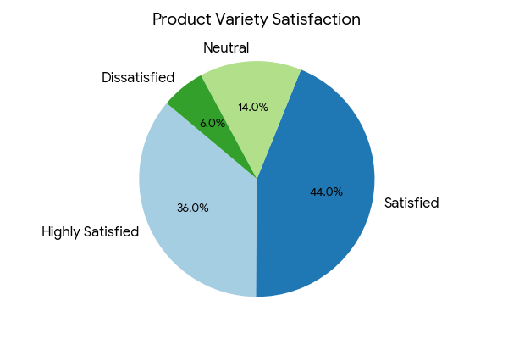
Analysis:
A combined 80% satisfaction level indicates that Nandini offers a sufficiently diverse product portfolio to meet consumer needs. The availability of multiple dairy products such as milk, curd, butter, and ghee enhances convenience and reduces brand switching.

4.14 Comparison with Other Brands
Opinion | Respondents | Percentage
Better | 54 | 54%
Same | 30 | 30%
Worse | 16 | 16%
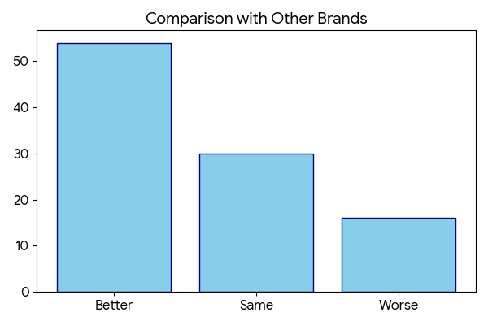
Analysis:
The majority of respondents perceive Nandini as better than competing brands, indicating a strong competitive advantage in the market. This superiority is primarily driven by factors such as quality, affordability, and availability.

4.15 Customer Loyalty
Response | Respondents | Percentage
Loyal | 60 | 60%
Sometimes Switch | 30 | 30%
Not Loyal | 10 | 10%
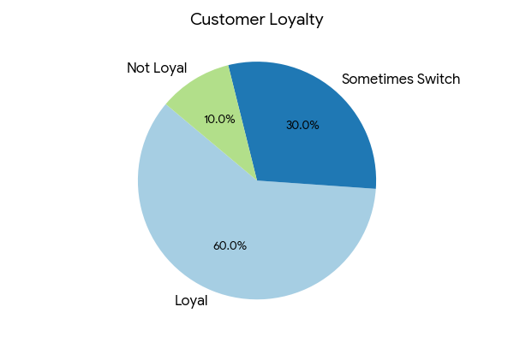
Analysis:
Customer loyalty is relatively high, with 60% of respondents consistently choosing Nandini products. This reflects strong satisfaction and trust. However, the presence of 30% switching behavior indicates external influences.

4.16 Health Awareness
Level | Respondents | Percentage
High | 50 | 50%
Medium | 36 | 36%
Low | 14 | 14%
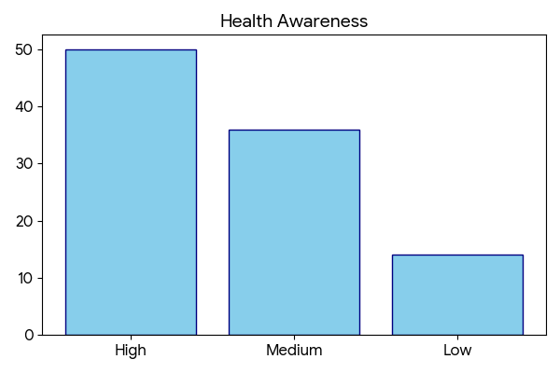
Analysis:
Half of the respondents are highly aware of the health benefits associated with dairy consumption. However, the medium and low awareness segments indicate an opportunity for education through marketing campaigns.

4.17 Purchase Decision Factors
Factor | Respondents | Percentage
Quality | 44 | 44%
Price | 28 | 28%
Availability | 16 | 16%
Brand Image | 12 | 12%
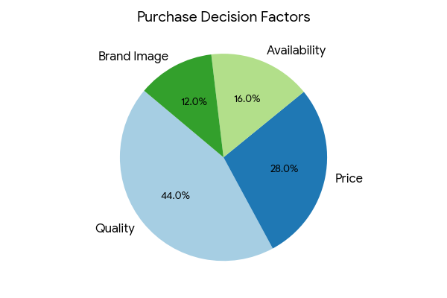
Analysis:
Quality emerges as the most influential factor in purchasing decisions, followed by price. This indicates that consumers prioritize product reliability over cost considerations.

4.18 Overall Satisfaction
Rating | Respondents | Percentage
Excellent | 36 | 36%
Good | 44 | 44%
Average | 14 | 14%
Poor | 6 | 6%
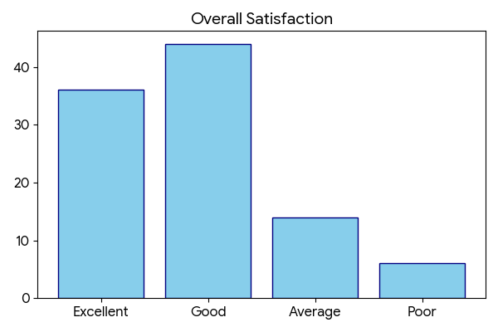
Analysis:
Overall satisfaction levels are high, with 80% of respondents rating the brand positively. This indicates that Nandini successfully meets consumer expectations in most areas.

4.19 Future Purchase Intention
Response | Respondents | Percentage
Will Continue | 65 | 65%
Not Sure | 25 | 25%
Will Stop | 10 | 10%
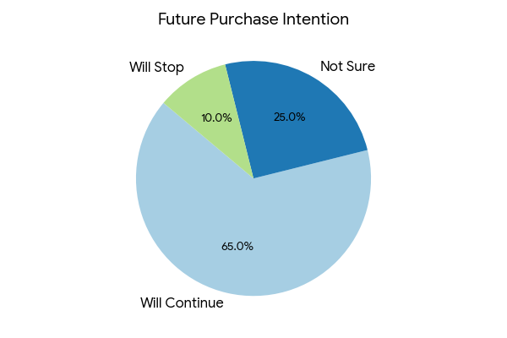
Analysis:
A strong majority of respondents express willingness to continue purchasing Nandini products, indicating high retention potential. The uncertain segment represents an opportunity for targeted marketing.

4.20 Final Comparative Insight
Indicator | Strength | Observation
Quality | High | Major advantage
Price | Affordable | Strong reach
Availability | Strong | Wide distribution
Satisfaction | High | Positive perception
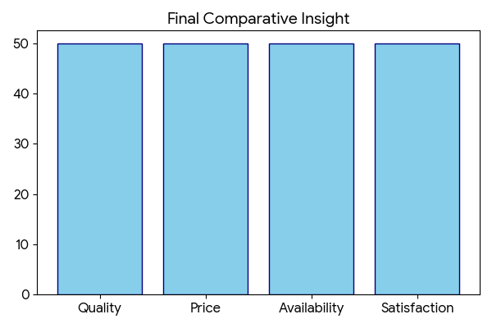
Analysis:
The overall comparison clearly indicates that Nandini holds a strong position in the dairy market due to its quality, pricing strategy, and availability.

Conclusion:
The data interpretation clearly highlights the overall consumer perception towards Nandini milk and its products. The analysis of responses indicates that a majority of consumers prefer Nandini due to its consistent quality, affordable pricing, and easy availability. These factors play a significant role in influencing purchasing decisions and building customer satisfaction.
The findings reveal that milk is a daily necessity for most consumers, and regular purchase behavior emphasizes the importance of maintaining a reliable supply chain. Product quality has emerged as the most important factor affecting consumer preference, followed by price and availability. This shows that consumers prioritize value and reliability while choosing dairy products.
Customer satisfaction levels are found to be high, with most respondents expressing positive opinions about product quality, taste, and packaging. The brand has also developed strong customer loyalty and trust, which is reflected in the high percentage of respondents willing to recommend Nandini products.
Furthermore, the study indicates that awareness about Nandini products is relatively high, although there is scope for improvement through enhanced promotional activities. The availability of a wide range of products also contributes to meeting diverse consumer needs.
Overall, the data interpretation suggests that Nandini has successfully established a strong brand image in the dairy market.

CHAPTER V:
FINDINGS AND CONCLUSION
FINDINGS
The findings of the study are based on the data collected from respondents and the analysis carried out in the previous chapter. These findings reflect consumer perception, behavior, and satisfaction towards Nandini milk and dairy products.
1. Preference for Nandini Products
The study reveals that a majority of respondents prefer Nandini milk over other brands available in the market. This preference indicates that Nandini has successfully established a strong brand image among consumers.
The cooperative structure of the organization ensures that quality products are delivered at affordable prices. Consumers trust the brand due to its consistency in quality and availability. This preference reflects the effectiveness of the organization’s production and distribution system.
2. Daily Consumption of Milk
The findings indicate that most respondents purchase milk on a daily basis. This shows that milk is an essential commodity in everyday life and forms an integral part of daily consumption.
Since milk is consumed regularly, consumers expect continuous availability, freshness, and quality. Any disruption in supply or decline in quality may lead to dissatisfaction and switching of brands.
3. Importance of Product Quality
Product quality is identified as the most important factor influencing consumer choice. Consumers prefer milk that is fresh, hygienic, and nutritious.
The findings show that Nandini has maintained high-quality standards through proper processing and quality control measures. This has helped the brand gain customer trust and loyalty.
Quality also plays a significant role in repeat purchases, as satisfied customers tend to continue using the same brand.
4. Role of Pricing
Pricing is another important factor influencing consumer behavior. The study shows that most respondents consider Nandini products affordable.
Affordable pricing attracts a large number of consumers, especially in price-sensitive markets. The cooperative model helps in maintaining reasonable prices without compromising on quality.
This balance between price and quality gives Nandini a competitive advantage in the market.
5. Availability of Products
The findings indicate that Nandini products are easily available in most areas. Availability is an important factor influencing consumer satisfaction and purchase decisions.
A strong distribution network ensures that products reach consumers on time and in good condition. Easy accessibility increases convenience and encourages regular purchase behavior.
6. Customer Satisfaction Levels
The study shows that a majority of respondents are satisfied or highly satisfied with Nandini products. This reflects the positive perception of the brand among consumers.
Customer satisfaction is influenced by factors such as quality, price, taste, and availability. High satisfaction levels lead to customer loyalty and positive word-of-mouth.
7. Brand Loyalty
The findings reveal that many consumers are loyal to Nandini products. Brand loyalty is developed over time through consistent quality and positive experience.
Loyal customers are less likely to switch to other brands, even if alternatives are available. This helps in maintaining a stable customer base.
8. Product Quality Rating
Most respondents rate the quality of Nandini products as good or excellent. This indicates that the brand has been successful in maintaining high standards of production.
Quality assurance at different stages of processing ensures that consumers receive safe and hygienic products.
9. Awareness of Products
The majority of respondents are aware of Nandini products and their availability in the market. However, some respondents have only partial awareness.
This suggests that while the brand is well known, there is still scope for improving awareness through promotional activities.
10. Sources of Awareness
The study shows that advertisements and word-of-mouth are the main sources of awareness. Consumers often rely on recommendations from friends and family while making purchasing decisions.
This highlights the importance of both marketing strategies and customer experience in building brand awareness.
11. Preference for Milk over Other Products
Milk is the most preferred product among respondents compared to other dairy products such as curd, butter, and ghee.
This shows that milk is the core product of the brand, while other products serve as additional offerings.
12. Comparison with Other Brands
The findings indicate that most respondents consider Nandini better than other dairy brands. This reflects a strong competitive position in the market.
The brand’s focus on quality, affordability, and availability gives it an advantage over competitors.
13. Trust in Brand
Consumers show a high level of trust in Nandini products. Trust is built through consistent quality, transparency, and reliability.
A trusted brand is more likely to retain customers and attract new ones through positive recommendations.
14. Packaging Satisfaction
The study shows that most consumers are satisfied with the packaging of Nandini products. Packaging ensures product safety and convenience.
Good packaging also enhances the visual appeal of the product and contributes to brand image.
15. Product Variety Satisfaction
The availability of different dairy products satisfies diverse consumer needs. Product variety helps in attracting a wider customer base.
Consumers appreciate the availability of multiple options under the same brand, which increases convenience and satisfaction.

CONCLUSION

The present study was conducted to analyze consumer perception towards Nandini milk and dairy products, along with understanding the production, marketing, and distribution aspects of the organization. Based on the data collected and interpreted, it can be concluded that Nandini has established a strong position in the dairy industry due to its consistent quality, affordability, and effective distribution system.
The dairy industry plays a vital role in the Indian economy, contributing significantly to rural development and employment generation. The cooperative model adopted by organizations such as Mandya Milk Union (MANMUL) has been instrumental in improving the socio-economic conditions of farmers. By eliminating middlemen and ensuring fair pricing, the cooperative system benefits both producers and consumers.
The study reveals that Nandini milk is widely preferred by consumers due to its high quality and reasonable pricing. Product quality has emerged as the most important factor influencing purchasing decisions. Consumers expect fresh, hygienic, and nutritious milk, and Nandini has been successful in meeting these expectations through proper processing and quality control measures.
Pricing is another important factor that contributes to the popularity of Nandini products. The affordability of the products makes them accessible to a wide range of consumers, including those in rural and semi-urban areas. The cooperative structure helps in maintaining competitive prices without compromising on quality, thereby creating a balance between cost and value.
Availability of products has also been identified as a key strength of the brand. The efficient distribution network ensures that Nandini products are easily available in different regions. Since milk is a daily necessity, continuous availability plays a crucial role in maintaining customer satisfaction and loyalty.
The study also highlights that customer satisfaction levels are high, with most respondents expressing positive opinions about the quality, taste, and packaging of Nandini products. High satisfaction leads to repeat purchases and strengthens brand loyalty. Loyal customers are more likely to recommend the brand to others, contributing to positive word-of-mouth promotion.
Another important finding is that consumers have a high level of trust in Nandini products. Trust is built through consistent quality, transparency, and reliability. A trusted brand is more likely to sustain in the market and maintain long-term relationships with customers.
The study further reveals that awareness of Nandini products is relatively high among consumers. However, there is still scope for improvement in promotional activities. Increased advertising and marketing efforts can help in enhancing brand visibility and attracting new customers.
Product variety is also an important factor contributing to customer satisfaction. Nandini offers a wide range of dairy products, including milk, curd, butter, ghee, and sweets. This variety helps in meeting the diverse needs of consumers and increases the overall appeal of the brand.
Packaging plays a supportive role in influencing consumer perception. Proper packaging ensures product safety and hygiene while also enhancing visual appeal. Consumers generally express satisfaction with the packaging quality of Nandini products.
The findings of the study indicate that the success of Nandini is based on a combination of factors such as quality, affordability, availability, and effective management. These factors collectively contribute to building a strong brand image and maintaining a competitive position in the market.
In conclusion, Nandini has successfully established itself as a trusted and reliable dairy brand by focusing on consumer needs and maintaining high standards of quality. The cooperative system, efficient production process, and strong distribution network have played a significant role in achieving this success.
The study suggests that while Nandini has performed well in most areas, there is still potential for improvement, particularly in promotional activities and awareness programs. By adopting innovative marketing strategies and continuously improving product quality, the brand can further strengthen its position in the dairy industry.
Overall, the study concludes that Nandini is a well-established brand that meets consumer expectations and contributes positively to the development of the dairy sector.

QUESTIONNAIRE

SECTION A: CONSUMER PREFERENCE
1. Which milk brand do you prefer?
● Nandini
● Other Brands
2. How often do you purchase milk?
● Daily
● Weekly
● Occasionally
3. Which dairy product do you prefer most?
● Milk
● Curd
● Butter
● Ghee
● Others
SECTION B: PRODUCT EVALUATION
4. How satisfied are you with Nandini products?
● Highly Satisfied
● Satisfied
● Neutral
● Dissatisfied
5. How do you rate the quality of Nandini products?
● Excellent
● Good
● Average
● Poor
6. How do you perceive the price of Nandini products?
● Affordable
● Moderate
● Expensive
7. Are Nandini products easily available?
● Yes
● Sometimes
● No
8. How do you rate the packaging of Nandini products?
● Excellent
● Good
● Average
● Poor
SECTION C: BRAND PERCEPTION
9. Are you aware of Nandini products?
● Fully aware
● Partially aware
● Not aware
10. What is your source of awareness?
● Advertisement
● Word of Mouth
● Retail Stores
● Others
11. How do you rate the taste of Nandini products?
● Excellent
● Good
● Average
● Poor
12. How much do you trust Nandini products?
● High
● Medium
● Low
SECTION D: CUSTOMER EXPERIENCE
13. Are you satisfied with the variety of products?
● Satisfied
● Neutral
● Dissatisfied
14. How do you compare Nandini with other brands?
● Better
● Same
● Worse
15. Are you loyal to Nandini products?
● Yes
● Sometimes switch
● No
SECTION E: CONSUMER BEHAVIOR
16. Are you aware of the health benefits of milk products?
● Highly aware
● Moderately aware
● Not aware
17. What factor influences your purchase decision the most?
● Quality
● Price
● Availability
SECTION F: OVERALL PERCEPTION
18. How would you rate your overall satisfaction?
● Excellent
● Good
● Average
● Poor
19. Will you continue purchasing Nandini products in future?
● Yes
● Not sure
● No
20. Would you recommend Nandini products to others?
● Yes
● Maybe
● No
REFERENCES

WEBSITE REFERENCES
Karnataka Milk Federation Official Website
https://www.kmfnandini.coop
The official website of Karnataka Milk Federation provides information about Nandini products, production process, distribution network, and organizational structure. It was used to understand the operations and product range.
Mandya Milk Union (MANMUL)
Details about Mandya Milk Union were used to understand the cooperative model, milk procurement process, and role in rural development.
National Dairy Development Board (NDDB)
https://www.nddb.coop
This website provides information about the development of the dairy industry in India, cooperative systems, and milk production statistics. It helped in understanding the broader context of the dairy sector.
Dairy India Portal
https://www.dairyindia.co.in
This portal provides industry insights, trends, and reports related to dairy production and consumption. It was used to gather general information about the dairy market.

GENERAL ONLINE SOURCES
Research Articles on Consumer Behavior
Various online articles and journals were referred to understand consumer preferences, buying behavior, and satisfaction levels in the dairy industry.
Articles on Brand Image and Marketing
Online resources were used to understand the importance of branding, pricing strategies, packaging, and promotion in influencing customer decisions.
Industry Reports on Dairy Sector
Reports related to milk production, distribution systems, and market trends were referred to gain a better understanding of the dairy industry.
NEWSPAPERS & MAGAZINES
Business Standard / The Hindu Business Line
Articles related to dairy industry growth, pricing, and cooperative systems were referred to understand current trends.
Economic Times
Used for general insights into market competition and consumer demand in the dairy sector.

