




Department of Computer Science and Engineering

|| Jai Sri Gurudev ||
Sri Adichunchanagiri Shikshana Trust®
SJB INSTITUTE OF TECHNOLOGY
An Autonomous Institute under VTU
Approved AICTE-New Delhi, Recognized by UGC with 2(f) & 12(B) No.67, BGS Health & Education City, Dr. Vishnuvardhan Road, Kengeri ,
Bengaluru, Karnataka 560060

FORMATIVE ASSESSMENT – 1

A report submitted in partial fulfilment of the requirements for the course Full Stack Development

“FULL STACK DEVELOPMENT – FOUNDATION MODULE”
DOMAIN: “RESEARCH GRANT PROPOSAL MANAGEMENT SYSTEM”

Subject Code: 23CSP623 Submitted by
Rakesh B 1JB23CS121

Faculty In-Charge Head of the Department Shilpashree S Dr. Krishna A.N
Academic Year: 2025-26

ACKNOWLEDGEMENT

I would like to express my profound grateful to His Divine Soul Jagadguru Padmabhu- shan Sri Sri Sri Dr.Balagangadharanatha Mahaswamiji and His Holiness Jagadguru Sri Sri Sri Dr. Nirmalanandanatha Mahaswamiji for providing us an opportunity to complete my academics in this esteemed institution.

I would also like to express my profound thanks to Revered Sri Sri Dr. Prakashnath Swamiji, Managing Director, BGS & SJB Group of Institutions, for his continuous sup- port in providing amenities to carry out this project work in this admired institution.

I express my gratitude to Dr. Puttaraju, Academic Director, BGS & SJB Group of Institutions, and Dr. K. V. Mahendra Prashanth, Principal, SJB Institute of Technol- ogy, for providing me with an excellent facilities and academic ambience, which have helped me with the satisfactory completion of project.

I extend my sincere thanks to Dr. Krishna A N, HOD, Computer Science and Engineer- ing, for providing me an invaluable support throughout the period of the course.

I extend my heartfelt gratitude to Dr. Babu N V, Dean Academics, for his unwavering support and inspiring academic environment all of which played a pivotal role in the successful completion.

I express my deepest gratitude and sincere thanks to faculty in-charge for the course Shilpashree S, Assistant Professor, Department of Computer Science and Engineer- ing, for her valuable guidance, suggestions and cheerful encouragement throughout the duration.

Finally, I take this opportunity to extend my earnest gratitude to my parents, Teaching & Non- teaching staffs of the department, all my friends, who have directly or indirectly supported me during the period of course.

Regards, Rakesh B 1JB23CS121

ABSTRACT

The Research Grant Proposal Management System is a conceptual academic project aimed at demonstrating the application of fundamental software engineering and full stack development concepts. The project focuses on understanding how a real-world grant proposal system can be designed by modelling users, interactions, and data flow, rather than implementing a complete functional application.
In research and academic environments, grant proposal systems are essential for man- aging the submission and evaluation of research funding requests. This project models such a system using object-oriented programming principles, semantic web technolo- gies, and database design concepts. The emphasis is placed on clarity of design, proper structuring of components, and adherence to standard development practices.
The project is divided into four milestones. The first milestone applies object-oriented programming concepts using Python to model different system users and their roles, demonstrating inheritance, method overriding, and polymorphism. The second mile- stone focuses on frontend structure using semantic HTML and HTTP concepts, where static web pages are designed to represent proposal submission and viewing processes, along with a justified use of the POST method for form submission.
The third milestone involves designing an Entity Relationship model that identifies key entities, their attributes, and relationships, with an emphasis on minimizing data redun- dancy. The fourth milestone demonstrates the use of the Command Line Interface and virtual environments to manage project setup and dependencies, highlighting the im- portance of environment isolation and reproducibility in collaborative development.
Overall, this project provides a structured overview of how different layers of a software system can be planned and organized. By integrating object-oriented design, web fun- damentals, data modelling, and development environment management, the Research Grant Proposal Management System serves as a comprehensive academic exercise aligned with real-world software development workflows.

TABLE OF CONTENTS

Acknowledgement i
Abstract ii
Table of Contents iii
List of figures v
List of Tables vi
Chapter 1
Milestone 1: Object-oriented design in Python
  - Identification of Classes 7
  - Object-Oriented Concepts Used 7
  - Source Code 8
  - Sample Output 10
  - Justification for the use of Inheritance 10
Chapter 2
Milestone 2: Semantic HTML and HTTP Concepts
  - Use of Semantic Html Elements 11
  - HTML Form Design 11
  - Use of HTTP POST Method 12
  - Justification for using POST in this Application 12
  - Comparison of GET And POST Methods 12
  - Source code 13
  - Screenshots 17
Chapter 3
Milestone 3: Entity Relationship Modeling
  - Identification of Entities 19
  - Summary of Primary and Foreign Keys 19
  - Entity Relationship Diagram 20
  - Redundancy Minimization 21
Chapter 4
Milestone 4: Command Line Interface and Virtual Environments
  - Use of Command Line Interface (CLI). 22
  - Purpose of Virtual Environments 22
  - Flow Role of Dependency Specification 22
  - Importance of CLI Proficiency in Collaborative Development 23
  - Screenshots 23
Conclusion 26

LIST OF FIGURES

SL NO | DESCRIPTION | PAGE NO
Fig 1.1 | Output of python OOP code | 10
Fig 2.1 | Research proposal submission page 1 | 17
Fig 2.2 | Research proposal submission page 2 | 17
Fig 2.3 | Review proposal page | 18
Fig 3.1 | ER Diagram of Grant Proposal Management System | 20
Fig 4.1 | Creating the project and verification of Python installation | 23
Fig 4.2 | Creating and Activating the Virtual Environment | 24
Fig 4.3 | Installing the requests library using pip | 24
Fig 4.4 | Requirements.txt file contents | 25

LIST OF TABLES

SL NO | DESCRIPTION | PAGE NO
Table 2.1 | Comparison of GET and POST methods | 12
Table 3.1 | Summary of Primary and Foreign keys | 19

CHAPTER 1

MILESTONE 1:
OBJECT-ORIENTED DESIGN IN PYTHON

IDENTIFICATION OF CLASSES
Existing systems are often complex or lack usability; the proposed web-based solution offers a simple, interactive, and automated approach. The following classes are identi- fied to model the system:
- User (Base Class): Represents a generic system user and contains common attrib- utes such as user ID, name, and email.
- Researcher (Derived Class): Represents users who submit grant proposals. This class extends the User class and includes additional attributes related to research specialization.
- Reviewer (Derived Class): Represents users who review submitted proposals. This class also extends the User class and includes attributes related to expertise.
The use of inheritance establishes an is-a relationship, where a Researcher and a Re- viewer are both types of Users.

OBJECT-ORIENTED CONCEPTS USED

Inheritance
Inheritance is used to share common attributes and methods through a base User class. The Researcher and Reviewer classes extend this base class by adding role- specific data, improving code reusability and maintainability.

Method Overriding
Method overriding allows derived classes to provide role specific behavior by rede- fining the same method. Although the method name remains unchanged, its imple- mentation differs for researchers and reviewers.

Polymorphism
Polymorphism is demonstrated by handling different user objects through a com- mon interface. The same method call invokes different implementations at runtime based on the object type, enabling flexible management of multiple user roles.

SOURCE CODE
The Python program demonstrates inheritance, method overriding, and polymorphism using a simple base class and derived classes, with a focus on clarity and readability.
# Grant Proposal Management System
# Milestone 1 – Object Oriented Programming in Python

class User:
def init (self, user_id, name, email): self.user_id = user_id
self.name = name self.email = email

def get_role_details(self): return "Generic system user"

def show_details(self): print("ID:", self.user_id) print("Name:", self.name) print("Email:", self.email)
print("Role:", self.get_role_details()) print("-" * 40)

class Researcher(User):
def init (self, user_id, name, email, research_area): super(). init (user_id, name, email) self.research_area = research_area
self.proposals = 0

def get_role_details(self):
return "Researcher working in " + self.research_area

def submit_proposal(self, title): self.proposals += 1
print(self.name, "submitted proposal:", title)

class Reviewer(User):
def init (self, user_id, name, email, expertise): super(). init (user_id, name, email) self.expertise = expertise
self.reviewed = 0

def get_role_details(self):
return "Reviewer with expertise in " + self.expertise

def review_proposal(self, title): self.reviewed += 1
print(self.name, "reviewed proposal:", title)

# Main execution
if name == " main ":

r1 = Researcher(1, "Dr. Rajesh Kumar", "rajesh@iitd.ac.in", "Artificial Intelli- gence")
r2 = Researcher(2, "Dr. Priya Sharma", "priya@aiims.edu", "Data Science")
v1 = Reviewer(3, "Prof. Ananya Rao", "ananya@iisc.ac.in", "Machine Learning") r1.submit_proposal("AI Based Traffic Management") r2.submit_proposal("Healthcare Data Analysis")
v1.review_proposal("AI Based Traffic Management")

users = [r1, r2, v1] print("\nUser Details:\n")

for user in users: user.show_details()

SAMPLE OUTPUT
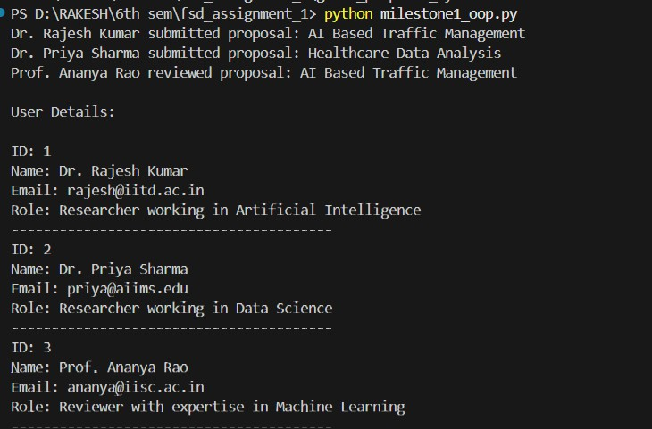

Fig 1.1: Output of python OOP code
The program processes Researcher and Reviewer objects together, where the same method call produces different outputs, demonstrating polymorphism and method over- riding.

JUSTIFICATION FOR THE USE OF INHERITANCE
In the Research Grant Proposal Management System, inheritance is used to model dif- ferent user roles with shared characteristics. A base User class stores common attributes such as user ID, name, and email. The Researcher and Reviewer classes inherit from this base class and implement role-specific behaviors, such as proposal submission and eval- uation. This approach improves code reusability, reduces redundancy, and provides a clear hierarchical structure, making the system easier to extend with additional user roles in the future.

CHAPTER 2

MILESTONE 2:
SEMANTIC HTML AND HTTP CONCEPTS

USE OF SEMANTIC HTML ELEMENTS
Semantic HTML elements describe the purpose of content rather than its appearance. In this project, semantic tags are used to clearly separate different parts of the web page, making the structure easier to understand and maintain.
The <header> element is used to display the title and description of the Research Grant Proposal Management System, providing context to the user. Navigation links are placed inside the <nav> element, allowing users to move between the proposal submission page and the proposal listing page.
The <main> element contains the primary content of the page, ensuring that the core information is clearly identified. Related content is grouped using <section> elements, while individual grant proposals are represented using <article> elements. The <footer> element is used to display copyright information and ownership details.
Using semantic HTML improves accessibility for screen readers, enhances search en- gine understanding, and follows best practices in modern web development.

HTML FORM DESIGN
The proposal submission page includes an HTML form designed to collect essential details required for a research grant proposal. The form contains input fields for proposal title, principal investigator details, institution name, research domain, requested funding amount, project duration, and a brief abstract.
Each form element is labeled clearly to ensure usability and avoid confusion during data entry. Required fields are marked to guide users and ensure that important information is not omitted. Different input types such as text fields, selection lists, numeric inputs, and text areas are used to represent various data formats.
Although the form is static and does not store data, its structure accurately represents how proposal submission would occur in a real-world grant management system.

USE OF HTTP POST METHOD
The HTTP POST method is used for submitting the proposal form. POST is designed to send data to the server in the request body, making it suitable for operations that create new records or modify existing data. In the Research Grant Proposal Management Sys- tem, proposal submission involves sending detailed and sensitive information such as project descriptions and funding requirements. Using POST ensures that this data is not exposed in the URL and allows larger amounts of data to be transmitted securely.
Even though backend processing is not implemented in this milestone, the correct use of POST demonstrates an understanding of standard web communication practices.

JUSTIFICATION FOR USING POST IN THIS APPLICATION
The POST method is chosen for this application because submitting a Research proposal results in the creation of a new system record. Additionally, proposal data includes sensitive information that should not be visible in the URL Using POST aligns with HTTP standards and reflects real-world implementation practices used in academic and research platforms. It ensures better data handling and prepares the system design for future backend integration.

COMPARISON OF GET AND POST METHODS

Aspect | GET Method | POST Method
Purpose | Used to retrieve data from the server | Used to submit  data to the server
Data Visibility | Data is appended to  the URL | Data is sent in  the request body
Security | Less secure for sensi- tive information | More suitable for confidential  data
Data Size | Limited by URL  length | Supports larger  data sizes
Typical Usage | Searching and filter- ing | Form submis- sion and data  creation

Table 2.1: Comparison of GET and POST methods

Table 2.1 Presents a comparison of the GET and POST HTTP methods, highlighting their differences in functionality, data handling, and use cases.

SOURCE CODE

Proposal_submission.html
<!DOCTYPE html>
<html lang="en">
<head>
<meta charset="UTF-8">
<meta name="viewport" content="width=device-width, initial-scale=1.0">
<title>Grant Proposal Submission</title>
<link rel="stylesheet" href="style.css">
</head>
<body>
<header>
<h1>Grant Proposal Management System</h1>
<p>Research Funding and Proposal Submission Portal</p>
</header>
<nav>
<a href="proposal_submission.html" class="active">Submit Proposal</a>
<a href="proposal_list.html">View Proposals</a>
</nav>
<main>
<section>
<h2>Submit Research Proposal</h2>
<p>Please provide accurate project details for funding consideration. All fields marked with <span class="required">*</span> are required </p>
<form id="proposalForm" method="POST">
<label for="title">Proposal Title <span class="required">*</span></label>
<input type="text" id="title" name="title" required placeholder="Enter your research proposal title">
<p class="form-hint">Provide a clear and concise title for your research project</p>
<label for="principal-investigator">Principal Investigator <span class="required">*</span></label>

<input type="text" id="principal-investigator" name="principal_investigator" required placeholder="Full name of lead researcher">
<label for="institution">Institution/Organization <span class="required">*</span></label>
<input type="text" id="institution" name="institution" required placeholder="Your affiliated institution">
<label for="domain">Research Domain <span class="required">*</span></label>
<select id="domain" name="domain" required>
<option value="">-- Select Research Domain --</option>
<option value="ai">Artificial Intelligence</option>
<option value="ml">Machine Learning</option>
<option value="ds">Data Science</option>
<option value="cs">Cyber Security</option>
<option value="iot">Internet of Things</option>
<option value="blockchain">Blockchain Technology</option>
<option value="quantum">Quantum Computing</option>
</select>
<label for="amount">Requested Funding Amount (₹) <span class="re- quired">*</span></label>
<input type="number" id="amount" name="amount" required min="100000" max="50000000" step="10000" placeholder="Enter amount in rupees">
<p class="form-hint">Minimum: ₹1,00,000 | Maximum: ₹5,00,00,000</p>
<label for="duration">Project Duration (months) <span class="re- quired">*</span></label>
<select id="duration" name="duration" required>
<option value="">-- Select Duration --</option>
<option value="6">6 months</option>
<option value="12">12 months</option>
<option value="18">18 months</option>
<option value="24">24 months</option>
<option value="36">36 months</option>
</select>
<label for="abstract">Project Abstract <span class="required">*</span></label>

<textarea id="abstract" name="abstract" required placeholder="Provide a brief summary of your research objectives and methodology"></textarea>
<p class="form-hint">Maximum 500 words</p>
<button type="submit">Submit Proposal</button>
</form>
</section>
</main>
<footer>
<p>© 2026 Grant Proposal Management System. All rights reserved. </p>
</footer>
</body>
</html>

Proposal_list.html
<!DOCTYPE html>
<html lang="en">
<head>
<meta charset="UTF-8">
<meta name="viewport" content="width=device-width, initial-scale=1.0">
<title>Submitted Proposals</title>
<link rel="stylesheet" href="style.css">
</head>
<body>
<header>
<h1>Submitted Grant Proposals</h1>
<p>Summary of proposals received for review</p>
</header>
<nav>
<a href="proposal_submission.html">Submit Proposal</a>
<a href="proposal_list.html" class="active">View Proposals</a>
</nav>
<main>
<section>
<h2>Active Proposals Under Review</h2>
<p>Total Proposals: 2 | Total Funding Requested: ₹18,00,000</p>

<article>
<h3>AI-Based Traffic Management System</h3>
<p><strong>Principal Investigator:</strong> Dr. Rajesh Kumar</p>
<p><strong>Institution:</strong> Indian Institute of Technology, Delhi</p>
<p><span class="badge">Artificial Intelligence</span></p>
<p><strong>Duration:</strong> 24 months</p>
<p><strong>Requested Amount:</strong> <span class="amount">₹10,00,000</span></p>
<p><strong>Status:</strong> Under Review</p>
</article>
<article>
<h3>Healthcare Data Analysis for Predictive Diagnostics</h3>
<p><strong>Principal Investigator:</strong> Dr. Priya Sharma</p>
<p><strong>Institution:</strong> All India Institute of Medical Sciences, Mumbai</p>
<p><span class="badge">Data Science</span></p>
<p><strong>Duration:</strong> 18 months</p>
<p><strong>Requested Amount:</strong> <span class="amount">₹8,00,000</span></p>
<p><strong>Status:</strong> Under Review</p>
</article>
</section>
</main>
<footer>
<p>© 2026 Grant Proposal Management System. All rights reserved.</p>
</footer>
</body>
</html>

SCREENSHOTS
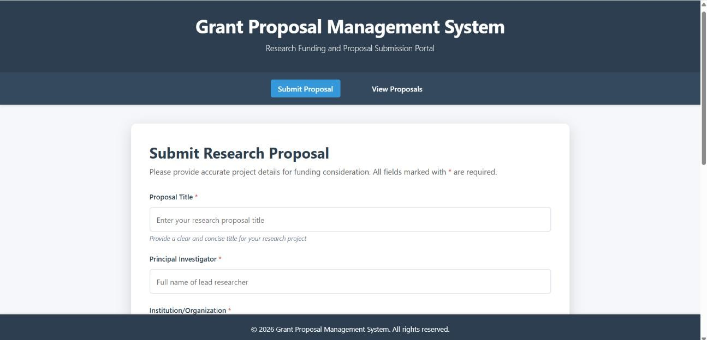

Fig 2.1: Research proposal submission page 1

Fig 2.1 Illustrates the first view of the research proposal submission page used to collect initial proposal details in the Research Grant Proposal Management System.
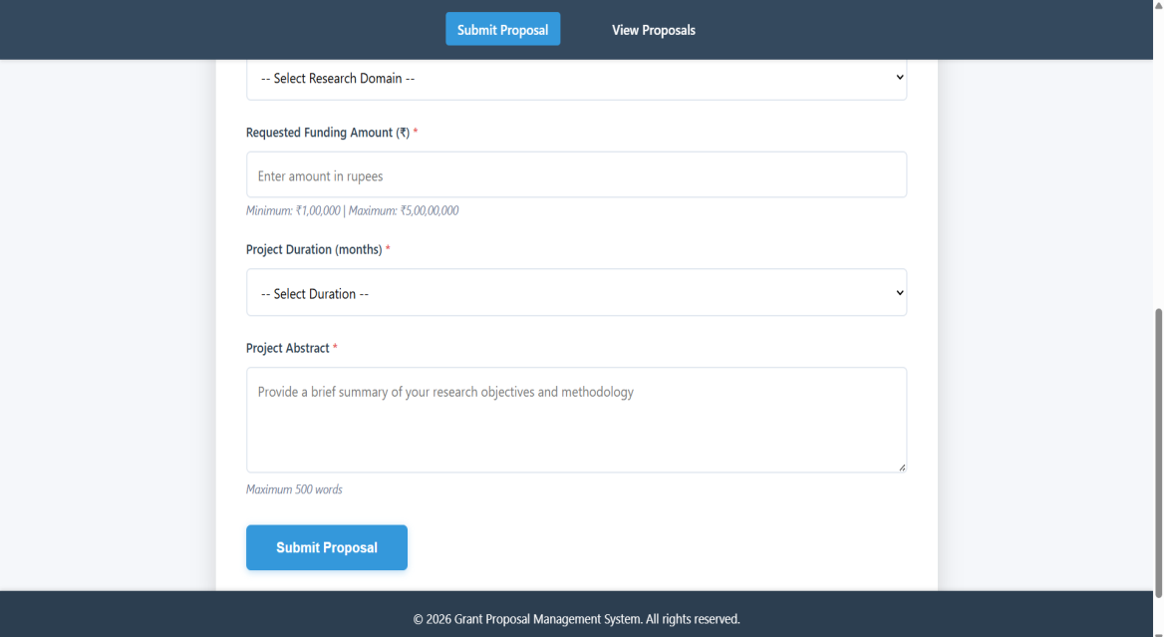

Fig 2.2: Research proposal submission page 2

Fig 2.2 Illustrates the research proposal submission page used for entering and submit- ting proposal details in the Research Grant Proposal Management System.

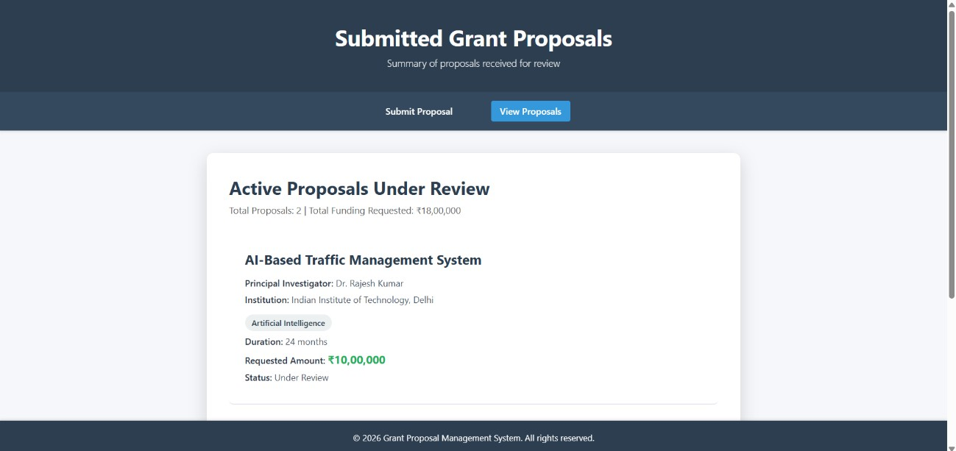

Fig 2.3: Review proposal page

Fig 2.3 Illustrates the review proposal page used to display submitted research proposals for evaluation in the Research Grant Proposal Management System.

CHAPTER 3

MILESTONE 3:
ENTITY RELATIONSHIP MODELING

IDENTIFICATION OF ENTITIES
Based on the system requirements, the following entities are identified:
    - Researcher: Represents users who submit research grant proposals.
    - GrantProposal: Represents research proposals submitted for funding considera- tion.
    - Reviewer: Represents users responsible for reviewing and evaluating submitted proposals.
These entities represent the core components of the system and are sufficient to model the main data requirements without unnecessary complexity.

SUMMARY OF PRIMARY AND FOREIGN KEYS

Entity Name | Primary Key | Foreign Key(s)
Researcher | researcher_id | —
Reviewer | reviewer_id | —
GrantProposal | proposal_id | researcher_id,reviewer_id

Table 3.1: Summary of Primary and Foreign keys
Table 3.1 Provides a summary of the primary and foreign keys used in the Entity Rela- tionship design of the Research Grant Proposal Management System.

Each entity in the Research Grant Proposal Management System is uniquely identified using a primary key. The researcher_id uniquely identifies each researcher, while the reviewer_id uniquely identifies each reviewer. The proposal_id uniquely identifies each grant proposal. Foreign keys are used in the GrantProposal entity to establish relation- ships with the Researcher and Reviewer entities. These keys ensure referential integrity by linking proposals to the users who submit and review them.

ENTITY RELATIONSHIP DIAGRAM
The ER diagram visually represents the identified entities, their attributes, and the rela- tionships between them. Rectangular boxes represent entities, attributes are listed within the entities, and relationships are shown using connecting lines with appropriate cardi- nalities.
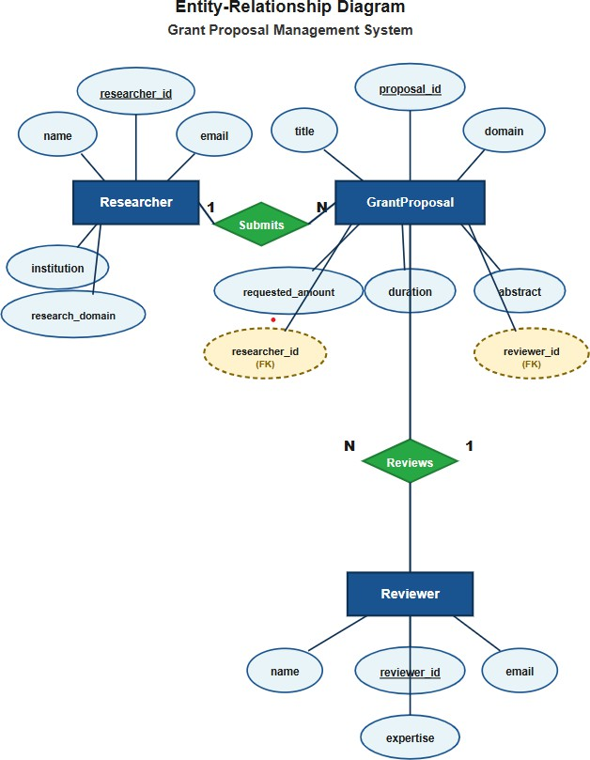

Fig 3.1: ER Diagram of Grant Proposal Management System

Fig 3.1 Illustrates the Entity Relationship diagram representing the data structure of the Research Grant Proposal Management System.

The diagram clearly highlights primary keys and foreign keys, providing a clear and structured view of the system’s data organization

REDUNDANCY MINIMIZATION
The ER design reduces data redundancy by storing researcher and reviewer details only once and referencing them in the GrantProposal entity using foreign keys. This avoids repeating information when multiple proposals are submitted or reviewed. As a result, data consistency is improved, updates are simpler, and storage usage is reduced. Overall, the design follows normalization principles and supports a scalable and maintainable database structure

CHAPTER 4

MILESTONE 4:
COMMAND LINE INTERFACE AND VIRTUAL ENVIRONMENTS

USE OF COMMAND LINE INTERFACE (CLI)
The Command Line Interface is used to perform all project setup tasks. Using the CLI al- lows developers to execute commands directly, automate repetitive tasks, and maintain better control over the development process.
In this milestone, the CLI is used to:
    - Create and navigate project directories
    - Verify Python installation
    - Create and activate a virtual environment
    - Install external libraries
    - List project files and folders
These operations demonstrate familiarity with basic yet essential command-line operations.

PURPOSE OF VIRTUAL ENVIRONMENTS
A virtual environment is used to create an isolated workspace for the project. It contains its own Python interpreter and installed libraries, separate from the system-wide Python installation.
The primary purpose of using a virtual environment is to avoid dependency conflicts between different projects. Each project can maintain its own set of libraries and ver- sions, ensuring predictable behavior. This is especially important when working on mul- tiple projects or collaborating with other developers.

ROLE OF DEPENDENCY SPECIFICATION
Dependency specification is achieved by generating a requirements.txt file using the pip freeze command. This file lists all installed libraries along with their versions.
The requirements.txt file allows other developers to recreate the same development en- vironment easily. By installing dependencies from this file, consistency is maintained

across different systems, reducing environment-related issues during development and testing.

IMPORTANCE OF CLI PROFICIENCY IN COLLABORATIVE DEVELOPMENT
Command Line Interface (CLI) proficiency is essential in collaborative software devel- opment as it provides a consistent way to perform tasks across different systems and environments. Developers use the CLI to manage directories, set up virtual environ- ments, install dependencies, and run scripts efficiently. It is also widely used in version control, build processes, and deployment workflows.
In team environments, CLI usage ensures consistent project setup, reduces configuration errors, and enables quick environment reproduction. Overall, CLI proficiency improves efficiency, supports automation, and enhances collaboration, making it a vital skill in professional software development.

SCREENSHOTS

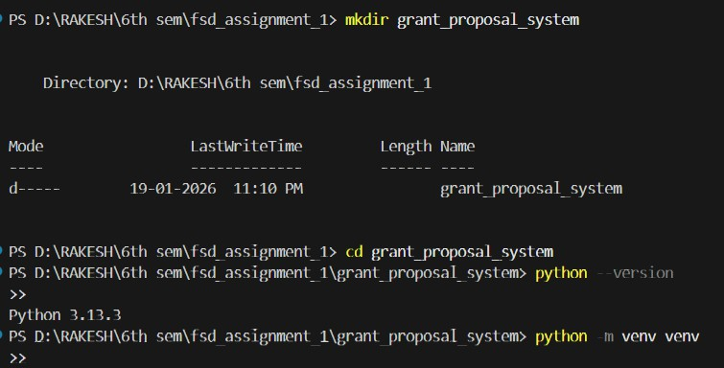

Fig 4.1: Creating the project and verification of Python installation

Fig 4.1 Illustrates the creation of the project directory and the verification of the Python installation required for the Research Grant Proposal Management System.

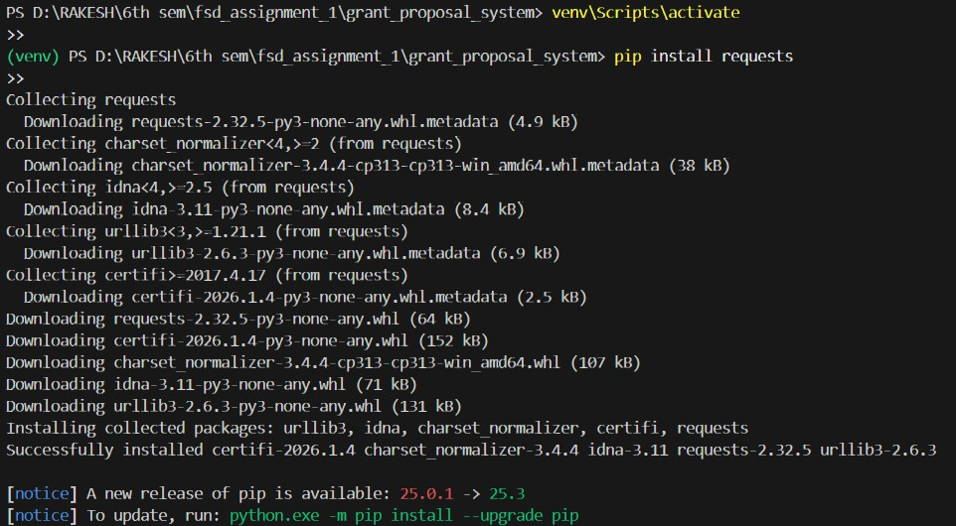

Fig 4.2: Creating and Activating the Virtual Environment

Fig 4.2 Illustrates the creation and activation of the virtual environment used for isolat- ing project dependencies in the Research Grant Proposal Management System.
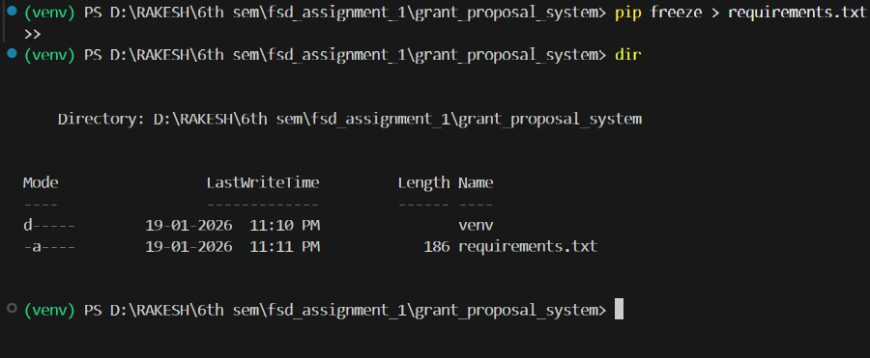

Fig 4.3: Installing the requests library using pip
Fig 4.3 Illustrates the installation of the requests library using pip within the virtual en- vironment for the Research Grant Proposal Management System.

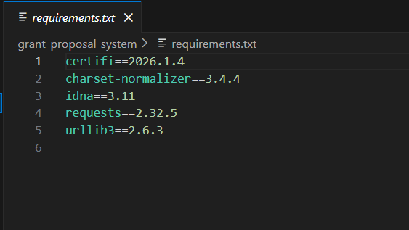

Fig 4.4: Requirements.txt file contents
Fig 4.4 Illustrates the contents of the requirements.txt file listing the project dependen- cies for the Research Grant Proposal Management System.

CONCLUSION

The Research Grant Proposal Management System project was carried out as part of the Full Stack Development with the objective of understanding and applying fundamental software engineering and web development concepts. The project focused on conceptual clarity, structured design, and adherence to standard development practices rather than building a fully functional system. Through the milestone-based approach, the project demonstrated how a real-world problem domain can be analyzed and modeled effec- tively. The first milestone applied object-oriented programming concepts using Python to represent system users and their roles. By using inheritance, method overriding, and polymorphism, the system design became modular, reusable, and aligned with real- world relationships. The second milestone focused on frontend structure using semantic HTML and HTTP concepts. Static web pages were designed to represent proposal sub- mission and viewing, and the use of the POST method was justified based on data sen- sitivity and system behavior. This milestone highlighted how user interaction is concep- tually modeled at the web interface level. The third milestone involved designing an Entity Relationship model to structure system data efficiently. Key entities, attributes, and relationships were identified, with an emphasis on minimizing redundancy and maintaining data consistency. This design forms a strong foundation for future database implementation. The final milestone demonstrated the use of the Command Line Inter- face and virtual environments to manage project setup and dependencies. By following standard CLI-based workflows, the project reinforced the importance of environment isolation, dependency management, and reproducibility in collaborative development. Overall, this project provided a comprehensive understanding of how different layers of a software system are planned and structured. The Research Grant Proposal Manage- ment System serves as a valuable academic exercise that strengthens foundational skills required for advanced full stack development and real-world software engineering prac- tices.

