Persona 1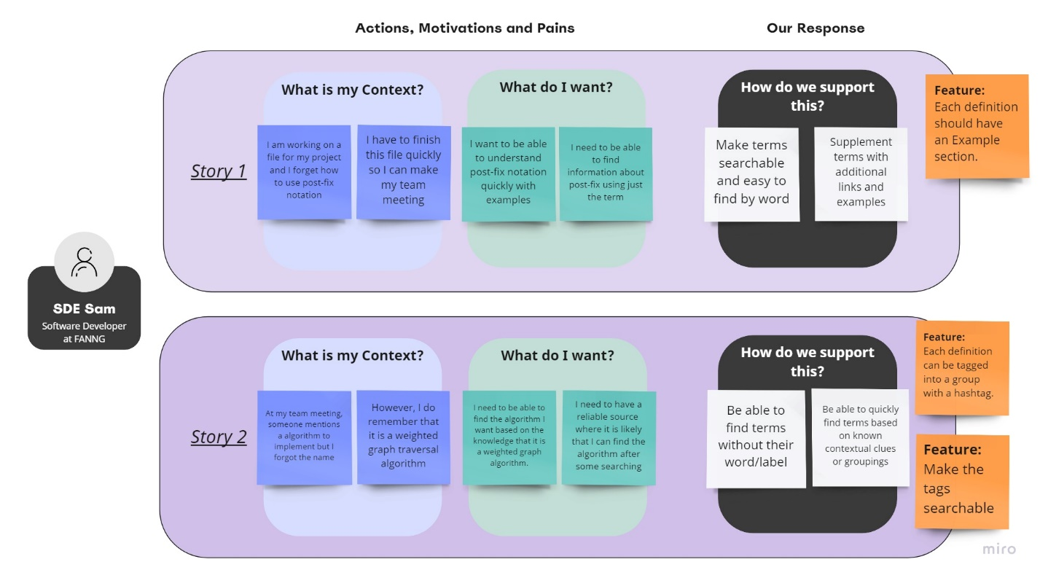

Persona 2

Competitor Apps

Technologies

Rabbit Holes

